Summary of Comments and Agency Decisions

Title: OAR 437-002-2253 Oxygen-Fuel Gas Welding and Cutting Preamble
Administrative Order Number: AO 6-2014
Adopted: October 28, 2014
Effective: May 1, 2015

Oxygen-Fuel Gas Welding and Cutting Preamble
(includes Compressed Gases and Acetylene)

History:

On July 7, 1989, Oregon OSHA adopted federal OSHA’s 29 CFR 1926.350 Gas Welding and Cutting for places of employment covered by Division 3 regulations. This adoption created OAR 437-003-1926.350 Gas Welding and Cutting which became effective on July 7, 1989.

Additionally, on September 28, 1990, Oregon OSHA adopted two federal OSHA regulations and seven Oregon initiated rules for processes related to oxygen-fuel gas welding and cutting at places of employment covered by Division 2 regulations. The following final rules had an effective date of December 1, 1990:
- 29 CFR 1910.251 Definitions. (creating OAR 437-002-1910.251)
- 29 CFR 1910.253 Oxygen-Fuel Gas Welding and Cutting. (creating OAR 437-002-1910.253)
- OAR 437-002-0290 Blowpipes/Torches.
- OAR 437-002-0291 Oxygen-Fuel Gas - General.
- OAR 437-002-0292 Oxygen-Fuel Gas – Operating Procedures.
- OAR 437-002-0293 Cylinder Storage.
- OAR 437-002-0294 Pressure-Reducing Regulators.
- OAR 437-002-0295 Hoses.
- OAR 437-002-0296 Hose Connections.

Finally, on February 6, 1992, Oregon OSHA adopted federal OSHA’s 29 CFR 1910.101 Compressed Gases (General Requirements) for places of employment covered by Division 2 regulations. This adoption created OAR 437-002-1910.101 Compressed Gases (General Requirements) which became effective on May 1, 1992.

These eleven regulations encompassed the core minimum requirements for employers to provide a safe working environment while welding and cutting using a combination of oxygen and fuel gas, referred to within this preamble as “oxy-fuel welding/cutting”. In the intervening years between the adoption of these eleven regulations and the final adoption of OAR 437-002-2253 on 10-28-2014, industrial gas distributers, manufacturers of welding equipment, and consensus standards development organizations identified additional workplace welding and cutting concerns. Many of these identified hazards were effectively addressed through engineering controls, enhanced safe work practices and employee education which became voluntary industry best practices but were not mandated by Oregon OSHA. These industry best practices had been published in manufacturer’s user manuals and modern consensus standards.

Near the end of 2010, informal discussions within Oregon OSHA and between employers and Oregon OSHA staff brought to light a need to modify the existing oxy-fuel welding/cutting regulations. It was decided early in the discussions that if the rule making process was to be opened, public involvement would be important for creating a protective yet fair final rule. Oregon OSHA eventually concluded that creating a comprehensive new rule rather than further amend existing rules presented the best opportunity to create a rule with a user friendly format and progression. The promulgation of OAR 437-002-2253 Oxygen-Fuel Gas Welding and Cutting is the final product that will be referred to as the “new rule” throughout the rest of this preamble.

The overarching need to create the new rule was two fold. First, points of confusion persisted around the existing oxy-fuel welding/cutting regulations. Second, the existing oxy-fuel welding/cutting regulations contained referenced consensus standards which were either obsolete or significantly dated.

Employer confusion: Even though the physical process of welding and cutting using oxygen and a fuel-gas, the related consumables, and the associated hazards are similar for both general industry and construction employers, the governing regulations were not the same. Construction employers are regulated by Division 3/J, while General Industry employers are regulated by Division 2/Q. It was confusing for employers when certain jobs tasks were covered by Division 2 rules while others were covered by Division 3 rules. The difference was experienced by employers who performed welding or cutting tasks that migrated between the two rules. For example, it is not uncommon for a construction contactor to perform welding or cutting at a job-site in the morning, then return to the company’s fabricating shop in the afternoon. The construction employer would need to comply with Division 3, Subdivision J, 1926.350 while welding or cutting at the construction job site, then within a few hours, need to comply with Division 2, Subdivision Q, 1910.253 while performing welding or cutting using the same equipment at their own fabrication shop. Further complicating the issue, the same construction employer may not understand which set of oxy-fuel welding/cutting regulations were to be followed while transporting cylinders on company vehicles between the two locations.

Within Division 2 and Division 3, relevant rules were further segregated into three subdivisions: Division 2/H Hazardous Materials, Division 2/Q Welding, Cutting & Brazing, and Division 3/J Welding and Cutting. These three subdivisions contained twelve core rules (the eleven previously identified at the start of this preamble and OAR 437-002-2102 Acetylene). Employers needed to navigate up to twelve individual rules based on the job task at hand. Oregon OSHA felt that a single oxy-fuel welding/cutting standard for both general industry employers as well as construction employers would reduce the efforts exerted to understand and comply with the regulations. Furthermore; Oregon OSHA wanted a regulation that would enable employers to use the rules as an effective training tool. The creation of the new rule enhanced the overall usability of the regulations as it took scattered requirements and pooled them into a single rule for oxy-fuel welding/cutting with easy to understand paragraphs laid out in a logical progression, a progression that could become a template for employee training.

The creation of the new rule reduces confusion as it produced a single standard applicable to all disciplines involved in oxy-fuel welding/cutting with the exception of Agriculture, Maritime and Forest Activities. General industry employers need to comply with paragraphs (1) through (15) of the rule while construction employers need to comply with paragraphs (1) through (13).

Consensus standards: When 1910.101, 1910.253, and 1926.350 were originally promulgated by federal OSHA and codified within Title 29 of the Code of Federal Regulations, federal OSHA referenced or incorporated by reference multiple consensus standards. Years later, when 1910.101, 1910.253, and 1926.350 were adopted by Oregon OSHA, the same consensus standard editions were brought into Oregon’s administrative rules. These consensus standards dated back to the late 1950s and 1960s. They represented the best work practices and technology available at the time. Within OAR 437-002-1910.101, OAR 437-002-1910.253, and OAR 437-003-1926.350 the following consensus standards were referenced:

OAR 437-002-1910.101:
- CGA Pamphlet C-6, 1968
- CGA Pamphlet C-8, 1962
- CGA Pamphlet P-1, 1965
- CGA Pamphlet S-1.1, 1963 and 1965 addenda
- CGA Pamphlet S-1.2, 1963

OAR 437-002-1910.253:
- CGA Regulator Connection Standards, 1958
- CGA Standard Hose Connection Specifications, 1957
- CGA Specification for Rubber Welding Hose, 1958
- NFPA 566, 1965
- NFPA 80, 1970
- Rubber Manufacturers Association (Standard Hose Connection Specifications, 1957)

OAR 437-003-1926.350:
- ANSI Z49.1, 1967
- CGA Pamphlet P-1, 1965

Through the years, several of the referenced consensus standards became obsolete, were incorporated into other consensus standards, or experienced an ownership change. Consensus standard tracking presented challenges to Oregon OSHA’s own research staff while drafting the new rule which highlighted the difficulties employers faced while striving for workplace safety and compliance. The following example occurred with NFPA 566:

- 1910.253 incorporated by reference the 1965 edition of NFPA 566, Installation of Bulk Oxygen Systems at Consumer Sites. The 1965 edition of NFPA 566, changed and became NFPA 50 Bulk Oxygen Systems at Consumer Sites in 1971. Consequentially, the 1965 edition of NFPA 566 was no longer available for purchase. Between 1971 and 2001, multiple editions of NFPA 50 were published. In 2005, NFPA 50 was incorporated into NFPA 55, the Compressed Gases and Cryogenic Fluids Code and NFPA 50 ceased to exist. Because of that, NFPA 50 was no longer available for purchase by employers. Ultimately, the 2010 edition of NFPA 55 was integrated into the new rule which had the result of lowering the threshold storage capacity of oxygen by 20% from that stated in the original 1965 edition of NFPA 566 which was incorporated by reference in 1910.253.

Further compounding employer misperceptions, many of the consensus standards referenced in 1910.101, 1910.253, and 1926.350, contained employer instructions in the form of “should” instead of “shall”. When the word “should” was used, the employer action was generally understood to be non-mandatory and could not be enforced by Oregon OSHA, whereas “shall” was generally understood as having the same meaning as “having/has a duty to” which could be enforced. The following is an example of a consensus standard instruction that used the word “should” as it was found in the obsolete Compressed Gas Association (CGA) Pamphlet P-1, 1965, Safe Handling of Compressed Gases that was incorporated by reference in 1910.101:

“3.1.12 Cylinders containing compressed gases should [emphasis added] not be subjected to a temperature above 125 F. A flame should [emphasis added] never be permitted to come in contact with any part of a compressed gas cylinder.”

Over the years, consensus standard development organizations revised there own publications and created newer editions that changed many of the original “shoulds” to “shalls”; however, since specific consensus standard editions were referenced within 1910.101, 1910.253, and 1926.350, Oregon OSHA was not able to enforce recommended consensus standard instructions that later became mandatory in subsequent editions.

When the rule making process began in 2010, a priority was placed on updating the referenced consensus standards that were in some cases sixty years old. In a few cases, the originally referenced consensus standards were obsolete or had changed ownership to completely different consensus standard development sponsors. The following is an example of this occurrence:

- 1910.253(e)(5)(i) contained the following language directing user to specific consensus standards:

“Hose for oxy-fuel gas service shall comply with the Specification for Rubber Welding Hose, 1958, Compressed Gas Association and Rubber Manufacturers Association, which is incorporated by reference as specified in §1910.6.”

Sometime after the collaborative writing of this 1958 consensus standard between the Compressed Gas Association (CGA) and the Rubber Manufacturers Association (RMA), the RMA became the sole sponsor of the consensus standard which went on to be known as “IP-7: Specification for Rubber Welding Hose”. In 2010, the RMA realigned and limited the organization’s scope to rubber tires. At that point in time, another consensus standard development sponsor known as the Association for Rubber Product Manufacturers (ARPM) gained ownership of IP-7 and subsequently released a 10th edition in 2011.

The following is a list of contemporary consensus standards now referenced within the new rule:

- ARPM IP-7. 2011, 10th edition
- ASME A13.1, 2007 edition
- ASME B31.1, 2010 edition
- CGA C-6 2013, 11th edition
- CGA C-8 2005, Reaffirmed 2010, 7th edition
- CGA E-1 2009, 6th edition
- CGA E-4 2010, 6th edition
- CGA P-1 2008, 11th edition
- CGA S-1.1 2011, 14th edition
- CGA S-1.2 2009, 9th edition
- CGA V-1 1994, 7th edition
- CGA V-7 2009, 5th edition
- NFPA 55, 2010
- NFPA 58, 2011
- NFPA 80-1970

Updating the referenced consensus standards to contemporary editions resulted in many of the recommended “shoulds” becoming “shalls”. Again, the word “shall” is understood as being equivalent to “having/has a duty to”. By adopting these contemporary consensus standards, worker protection was enhanced while aligning the regulations more closely with currently accepted industry practices that had already become commonplace. Using the previous example which contained the word “should” from the referenced 1965 edition of the Compressed Gas Association’s (CGA) Pamphlet P-1, Safe Handling of Compressed Gases, the employer direction found within the 2008 edition of the Compressed Gas Association’s (CGA) Pamphlet P-1, 11th edition, the instruction now reads:

“5.4 General precautions – Compressed gas containers shall [emphasis added] not be exposed to temperature extremes. High temperatures can result in excessive pressure. Never apply a flame or heat directly to any part of a compressed gas container or allow it to come in contact with an electrically energized system. High temperatures also can damage the physical integrity of the container. If ice or snow accumulates on a container, thaw at room temperature or with water at a temperature not exceeding 125ºF (51.7ºC);”

Public involvement: Consistent with the State of Oregon’s policy to involve the public whenever possible in the development and drafting of rules, Oregon OSHA established the Oxygen-Fuel and Compressed Gas advisory committee. The advisory committee’s purpose was to strengthen the partnership of Oregon OSHA and the private sector. The advisory committee’s mission was to address issues affecting the manufacturing and construction industries’ safe use, handling, storage and transport of oxygen and fuel gases. Members of the advisory committee included representatives of labor, employers, manufacturers, and governmental agencies. In July of 2010, the advisory committee started reviewing and proposing changes to the general industry and construction regulations. The principal standards discussed were Division 2/Subdivision Q - 1910.251Definitions, Division 2/Subdivision Q - 1910.253 Oxygen-Fuel Gas Welding and Cutting, and Division 3/Subdivision J - 1926.350 Gas Welding and Cutting.

Clear rule writing using plain language was considered in each draft revision. All of the changes to the proposed rule were written and rewritten based on the input of the advisory committee which met a number of times during the process of promulgating the new rule. The language appearing in the final rule was endorsed by the advisory committee.

Two public hearing were held to provide the public with an opportunity to comment on the proposed rule. The first public hearing was held on May 2nd, 2014 in Portland and there were no public comments. The second public hearing occurred on May 9th, 2014 in Eugene where there was one public comment. The public comment received at the May 9th public hearing is discussed in pa 6 of this preamble. No written public comments were received by Oregon OSHA during the open comment period.

Rule Actions Taken:

OAR 437-002-2253(2) Definitions replaced OAR 437-002-1910.251 Definitions.

OAR 437-002-2253 Oxygen-Fuel Gas Welding and Cutting replaced OAR 437-002-1910.253 Oxygen-Fuel Gas Welding and Cutting.

OAR 437-002-2253 Oxygen-Fuel Gas Welding and Cutting replaced OAR 437-003-1926.350 Gas Welding and Cutting.

OAR 437-002-2101 Compressed Gases (General Requirements) replaced OAR 437-002-1910.101 Compressed Gases (General Requirements). In order to update the referenced consensus standards in 1910.101, it was felt that creating a new regulation (OAR 437-002-2101) was a better process than amending 1910.101 which contained references to 1910.6 which would also need to be amended.

OAR 437-002-2102 Acetylene was amended to provide consistence with the new rule OAR 437-002-2253 Oxygen-Fuel Gas Welding and Cutting. The primary changes to OAR 437-002-2102 Acetylene include the following:

- The definition of “confined space” was updated.
- The definition of “enclosed space” was updated.
- A requirement to leak check cylinders prior to placement into a vehicle was added.
- A requirement for cylinders left in enclosed vehicles overnight must be leak checked at the end of the day and again prior to transportation was added.
- A clarification note was added to the storage requirements. Cylinders, with or without regulators, kept in or on vehicles will not be considered as being “stored” when a leak test is performed. The leak test must be performed at the end of the day for single shifts and at the end of each shift when multiple shifts exist.

The repealing of the following Oregon initiated rules was necessary as they are now written in their entirety within the new rule:

- OAR 437-002-0290 Blowpipes/Torches was repealed.
- OAR 437-002-0291 Oxygen-Fuel Gas – General was repealed.
- OAR 437-002-0292 Oxygen-Fuel Gas – Operating Procedures was repealed.
- OAR 437-002-0293 Cylinder Storage was repealed.
- OAR 437-002-0294 Pressure-Reducing Regulators was repealed.
- OAR 437-002-0295 Hoses was repealed.
- OAR 437-002-0296 Hose Connections was repealed.

Summary and explanation:

Section 1: OAR 437-002-2253(1) Scope and Application

The paragraph “Scope and Application” within the new rule applies to both General Industry and Construction employers. Previously, neither 1910.253 Oxygen-Fuel Gas Welding and Cutting, nor 1926.350 Gas Welding and Cutting contained scopes which lead to misperceptions about the rule’s applicability. Additionally, the terms “welding” and “cutting” as found in the titles of both rules or “brazing” as referenced in the title for subdivision Q were not defined contributing to further employer confusion.

It was felt by Oregon OSHA and the advisory committee that creating a clear scope and application for the new rule was fundamental in establishing the processes where the new rule applied and definitively identifying the industries where the application of the new rule was not appropriate. When creating the scope and application for the new rule, the processes covered were expanded to include allied processes other than just oxy-fuel welding/cutting. The new rule’s scope and application articulates the following activities as being subject to the rule when conducted using a combination of oxygen and a fuel gas:
- Welding,
- Cutting
- Soldering
- Brazing, and
- Flame coating (thermal spraying), and
- Related materials and equipment.

Absent from the rule’s scope is the practice of using a combination of fuel gas with ambient air instead of purified oxygen. The title of OAR 437-002-2253 is “Oxygen-Fuel Gas Welding and Cutting”; however, hazards may still persist even when purified oxygen is not being used. Oxygen is an accelerant which invigorates flammable fuel gas combustion. Acetylene fuel gas, as an example, only requires approximately a 10% concentration of oxygen to ignite. Ambient air contains approximately 20.9% oxygen. Employers, in OAR 437-002-2253(4)(a)(A), are required to guard against explosive mixtures of fuel gases with ambient air as well as with purified oxygen.

Furthermore, the scope and application expressly states that OAR 437-002-2253 does not apply to the following industries:
- Division 4 Agriculture
- Division 5 Maritime, or
- Division 7 Forest activities.

Brazing, flame coating (thermal spraying) and soldering are allied processes to welding and cutting. These are processes significantly similar in materials and equipment but do not meet the definition of welding or cutting. As allied processes, they are explicitly included in the applicability of the new rule’s scope. The terms “welding”, “cutting”, “soldering”, “brazing”, and “flame coating (thermal spraying)” are now defined in OAR 437-002-2253(2) Definitions. The terms “related materials” and “equipment” were not defined.

When determining rule coverage, a detailed work process evaluation needs to be completed. The evaluation should verify when a process uses similar materials and equipment and demonstrates similar hazards and exposures to the five that are listed in the scope. For example, the process of “babbitting” may or may not be covered by the scope and application of the new rule based on process specifics. Two babbitting process examples illustrating the need for a detailed assessment and evaluation are provided below:

Example 1: When babbitting compressor bearings to prevent frictional degradation is achieved by using a high velocity oxy-fuel (HVOF) coating process, the babbitting process would be covered by the scope of OAR 437-002-2253 because high velocity oxy-fuel (HVOF) coating processes are thermal spray coating processes.

Example 2: When babbitting occurs using the time tested “static pour” process, OAR 437-002-2253 should not be viewed as being applicable. Pour babbitting is often achieved using oxygen-fuel gas equipment to melt babbitt-alloy ingots in a pot by directing flame generated heat to the ingot and pot. Additionally, the oxy-fuel gas equipment may be used to preheat the parts undergoing babbitting. Once the part is appropriately heated and the ingot is fully melted, the oxygen-fuel gas equipment is generally removed and the liquefied babbitt material is poured into the part. The act of heating parts or melting ingots with oxy-fuel gas equipment would not be within the scope of OAR 437-002-2253 because the equipment is only used to raise the temperature, not weld, cut, braze, solder or thermal spray coat as identified in the scope. If acetylene was used as the fuel in this example, the provisions of OAR 437-002-2102, Acetylene would apply.

Furthermore, the interpretation of related materials and equipment was not intended to encompass processes which are broadly disassociated from the five processes listed in the scope. Disassociated processes are generally those that use oxygen-fuel gases in support of hobbyist, artists and work tasks not covered by the scope such as glass finishing, leather edging, food preparation, and the antiquing of wood.

Finally, employers periodically confuse the applicability of the acetylene rule (OAR 437-002-2102, Acetylene) with the oxygen-fuel gas welding and cutting rule (OAR 437-002-2253, Oxygen-Fuel Gas Welding and Cutting). A clear distinction between these two rules exists. OAR 437-002-2102 is limited to facilities that generate and distribute acetylene, generally in large quantities as well as employers that use acetylene for processes not covered by the scope of OAR 437-002-2253 such as the disassociated processes discussed in the previous paragraph. Diligence needs to be taken when establishing when OAR 437-002-2102 is applicable verses the new rule, OAR 437-002-2253.

Section 2: OAR 437-002-2253(2) Definitions

The paragraph “Definitions” within the new rule applies to both General Industry and Construction employers. Neither 1910.253 Oxygen-Fuel Gas Welding and Cutting, nor 1926.350 Gas Welding and Cutting defined words or terms found within either standard. 1910.251 defined terms as they applied to Division 2, subdivision Q Welding, Cutting & Brazing. The two defined terms were:

- Welder and welding operator
- Approved

It was decided by Oregon OSHA and the advisory committee that key words and terms used within the new rule should be defined as they apply to OAR 437-002-2253. In addition to the two terms that were originally defined within 1910.251, thirty-six additional words and terms were added for a total of thirty-eight. OAR 437-002-2253(1) Scope and Application identifies five specific work operations that are covered by this new rule. Paragraph (2) explains each of these five work processes to better assist the employer with clarity as well as for training purposes as they relate to the new rule.

Section 3: OAR 437-002-2253(3) Training and Evaluation

The paragraph “Training and Evaluation” within the new rule applies to both General Industry and Construction employers. Effective employee training is a fundamental component of safe oxy-fuel welding/cutting.

Oregon OSHA and the advisory committee recognized that the process of creating a new standard offered a unique opportunity to assist employers with their training obligations by using plain language and a logical progression when developing the rule’s fifteen paragraphs. The fifteen paragraphs can be used by employers as a template for training.

A significant change from previous oxy-fuel welding/cutting regulations is the qualifications of those tasked with training. It was recognized that a fundamentally sound training program must include an evaluation of the person(s) presenting the instruction. For a trainer to provide effective instruction, Oregon OSHA concluded that it was reasonable to require the employer to ensure that the trainer was familiar with the equipment, procedures, practices, hazards, precautions and control methods relevant for each oxy-fuel welding/cutting job task they were providing training for. In other words, the employer must verify that the individual(s) providing the training were competent with respect to the information being presented. The new rule establishes a requirement for employers to ensure that the individual(s) conducting training are competent. For consistency with other Division 2 and Division 3 safety regulations, competent person is defined within 437-002-2253(2) Definitions as:

“One who is capable of identifying existing and predictable hazards in the surroundings or working conditions which are unsanitary, hazardous, or dangerous to employees, and who has authorization to take prompt corrective measures to eliminate them.”

Another focus area Oregon OSHA and the advisory committee identified was the need for the employer to evaluate the employee engaged in oxy-fuel welding/cutting prior to allowing them to work alone. For general industry employers, 1910.253(a)(4) previously required the employer to train users and “judge” them as competent prior to allowing them to work alone. For construction employers, 1926.350 was silent on the topic of evaluation.

For general industry employers, OAR 437-002-2253(3) Training and Evaluation replaces the previous training requirements of 1910.253(a)(4) Personnel. The language has been changed but the content is basically the same with few exceptions. For construction employers, the new rule effectively expanded the basic training requirements originally found in 1926.350(d).

Finally, Oregon OSHA and the advisory committee felt that guidance should be provided to employers who hired skilled and previously trained oxy-fuel welding/cutting operators. A non-mandatory clarification note was added to 437-002-2253(3)(a) for this purpose. The note explains that new employee training is not required when the employer can confirm that a new employee is capable of performing their expected tasks safely. In order to evaluate a new employee, the employer must perform two actions. First, they must have discussions with the new employee. Second, they must observe the new employee. Both actions are necessary to verify that a new employee retains the knowledge and demonstrates the experience required to perform oxy-fuel welding/cutting operations safely while unsupervised.

Compared to the previous Division 2 oxy-fuel gas welding/cutting rule (OAR 437-002-1910.253), the following additional training and evaluation rules need to be followed by general industry employers:

- OAR 437-002-2253(3)(a)(A) |
- OAR 437-002-2253(3)(a)(B) |
- OAR 437-002-2253(3)(a)(C) | You must provide training:
- OAR 437-002-2253(3)(a)(D) |
- OAR 437-002-2253(3)(a)(E) |
- OAR 437-002-2253(3)(a)(F) |

Compared to the previous Division 3 oxy-fuel gas welding/cutting rule (OAR 437-003-1926.350), the following additional training and evaluation rules need to be followed by construction industry employers:

- OAR 437-002-2253(3)(a)(A) |
- OAR 437-002-2253(3)(a)(B) |
- OAR 437-002-2253(3)(a)(C) | You must provide training:
- OAR 437-002-2253(3)(a)(D) |
- OAR 437-002-2253(3)(a)(E) |
- OAR 437-002-2253(3)(a)(F) |
- OAR 437-002-2253(3)(b) Evaluate:

Section 4: OAR 437-002-2253(4) General Requirements

The paragraph “General Requirements” within the new rule applies to both General Industry and Construction employers. The intent for this paragraph was for the widely recognized and long established hazards associated with employers owning, leasing, or otherwise being in control of oxygen and fuel gases used for welding/cutting to be specifically addressed.

These general requirements are rudimentary oxy-fuel welding/cutting rules that apply to all activities covered by the scope of the new rule. Additional rules that are specific to other tasks such as transportation, storage, cylinders handling, pressure-reducing regulators, hoses, hose connections, torches, service piping, acetylene generation and calcium carbide storage are specifically addressed in more detail in topic specific paragraphs later within OAR 437-002-2253. Again, Oregon OSHA and the advisory committee concluded that plain language should be used to establish this paragraph. The paragraph was divided into two concise subparagraphs. The subparagraphs are, “You must:” and “You must not:”.

For general industry employers, this paragraph incorporated three requirements that were not previously within 1910.253 but existed in other rules found within Division 2 / Subdivision Q. The rule making took preexisting requirements that were scattered within 1910.253, OAR 437-002-0290, and OAR 437-002-0291 and consolidated them into a single, easy to understand section.

The pre-existing requirements incorporated into the new rule for general industry employers are as follows:

- OAR 437-002-2253(4)(a)(A)(ii) contains the requirements that were previously located within OAR 437-002-0290(1), Blowpipes/Torches which was repealed by the creation of OAR 437-002-2253 to avoid duplication.

- OAR 437-002-2253(4)(b)(O) contains the requirements that were previously located within OAR 437-002-0291(2), Oxygen-Fuel Gas – General which was repealed by the creation of OAR 437-002-2253 to avoid duplication.

- OAR 437-002-2253(4)(b)(P) contains the requirements that were previously located within OAR 437-002-0291(2), Oxygen-Fuel Gas – General which was repealed by the creation of OAR 437-002-2253 to avoid duplication.

Compared to the previous Division 2 oxy-fuel gas welding/cutting rule (OAR 437-002-1910.253), the following additional general requirement rules need to be followed by general industry employers:

- OAR 437-002-2253(4)(a)(G) instructs employers to follow paragraphs (13), (14), and (15) of the new rule when generating acetylene for immediate use at the work location. Oregon OSHA and the advisory committee felt that providing employers who generate acetylene for immediate use directions within this paragraph was important so that paragraphs (13), (14), and (15) are not overlooked.

- OAR 437-002-2253(4)(b)(I) instructs employers to only use a cylinder’s contents for the purposes intended by the supplier. This requirement was formally located in 1926.350(c)(2) but was not in the Division 2 regulations for general industry employers.

- OAR 437-002-2253(4)(b)(J) instructs employers to not use damaged cylinders. This requirement was formally found in 1926.350(c)(3) but was not in the Division 2 regulations for general industry employers.

Compared to the previous Division 3 oxy-fuel gas welding/cutting rule (OAR 437-003-1926.350), the following additional general requirement rules need to be followed by construction industry employers:

- OAR 437-002-2253(4)(a)(A) |
- OAR 437-002-2253(4)(a)(C) |
- OAR 437-002-2253(4)(a)(D) | General Requirements / You must:
- OAR 437-002-2253(4)(a)(E) |
- OAR 437-002-2253(4)(a)(G) |
- OAR 437-002-2253(4)(b)(A) |
- OAR 437-002-2253(4)(b)(B) |
- OAR 437-002-2253(4)(b)(C) |
- OAR 437-002-2253(4)(b)(D) | General Requirements / You must not:
- OAR 437-002-2253(4)(b)(E) |
- OAR 437-002-2253(4)(b)(F) |

Section 5: OAR 437-002-2253(5) Transportation of Compressed, Liquefied and
Dissolved Gas Cylinders

The paragraph “Transportation of Compressed, Liquefied and Dissolved Gas Cylinders” within the new rule applies to both General Industry and Construction employers. The intent for this paragraph was for the hazards associated with the act of transporting cylinders between physical locations to be specifically addressed.

Transportation is generally understood to involve the movement of oxygen and fuel-gas cylinders over a significant distance which generally includes, but is not limited to public roadways. Handling of cylinders around a site by hand, cart, crane, forklift and other methods is addressed in paragraph (7) of the new rule. Transportation across wide distances involves hazards that are unique when compared to handling cylinders at a fixed site. To assist employers with understanding the concepts of “transporting cylinders” and “handling”, these terms were defined in paragraph (2) of the new rule. The safe transportation of cylinders is a component of the rule that has been significantly enhanced over the previous oxy-fuel welding/cutting regulations. Oregon OSHA and the advisory committee, consistent with the clear rule writing and plain language directive, developed this paragraph with a cascading set of requirements, becoming more restrictive as the reader progresses. The cascading requirements are designated by subparagraphs (a), (b), and (c). Many of the new requirements in this paragraph where derived from contemporary Compressed Gas Association’s (CGA) consensus standards that contained specific employer instructions provided as “shalls” that were previously absent of instruction or where in the form of “should” in the originally referenced consensus standards within 1910.253 and 1926.350.

Subparagraph (a) speaks to transportation involving all vehicles, regardless of where the cylinders are stowed in the vehicle or the type of vehicle used.

Subparagraph (b) takes into consideration the action of choosing to use a vehicle’s enclosed space to transport a cylinder. To reduce confusion and assist employers, Oregon OSHA and the advisory committee included the following definition in paragraph (2) for “enclosed vehicle”:

- “Enclosed vehicle: Includes but is not limited to the interior of automobiles, automobile trunks, vans, or in any enclosed truck or trailer.”

Significant points within subparagraph (b) that were introduced into the new rule include instructions to perform leak checks on cylinders, prevent cylinder exposure to high temperatures by limiting the internal temperature of vehicles, preventing the use of cylinders while cylinders are within inside vehicle compartments, and adding direction for outside vehicle compartments to be opened when cylinder contents are withdrawn while the cylinder remains within the outside vehicle compartment.

OAR 437-002-2253(5)(b)(A) establishes that cylinders transported in enclosed vehicles must be leak checked. The term “leak checked” shall be understood to be the same as “leak tested” as defined in OAR 437-002-2253(2) Definitions.

Subparagraph (c) simply prohibits the use of passenger vehicle trunks for transporting cylinders.

Finally, as described in Note 2 of the definition of “Stored” in OAR 437-002-2253(2), cylinders, with or without regulators, kept in or on vehicles due to their frequency of use will not be considered as stored when a leak test is performed at the end of the day. When cylinders are used during multiple shifts, they must be leak tested at the end of each shift. Refer to the definition of “leak test” as found within OAR 437-002-2253(2) Definitions.

General industry employers will experience two key additions when comparing the pre-existing rules to 437-002-2253(5). Subparagraph (b) and subparagraph (c) now calls out the transportation of cylinders within enclosed vehicles as well as the use of passenger vehicles for cylinder transportation. Subparagraph (b) of the new rule specifically addresses the transportation of cylinders within enclosed vehicles. Employers who transport cylinders are required to either comply with all nine sub-subparagraphs, sub-subparagraphs (A) through (I) of paragraph (5), subparagraph (b) or chose to comply with the applicable USDOT hazmat transportation regulations of 49 CFR 172.204.

- NOTE: It is important for employers to understand that when they choose to comply with all nine points of paragraph (5), subparagraph (b) instead of 49 CFR 172.204, they will be in compliance with Oregon OSHA’s safe workplace rules; however, it should not be understood as achieving compliance with the US Department of Transportation’s (USDOT) hazardous materials (hazmat) transportation requirements found in the Code of Federal Regulations, Title 49, Parts 100-185.

Compared to the previous Division 2 oxy-fuel gas welding/cutting rule (OAR 437-002-1910.253), the following additional transportation rules need to be followed by general industry employers:

- OAR 437-002-2253(5)(a)(A) |
- OAR 437-002-2253(5)(a)(B) |
- OAR 437-002-2253(5)(a)(C) | Vehicles in general:
- OAR 437-002-2253(5)(a)(D) |
- OAR 437-002-2253(5)(b)(A) |
- OAR 437-002-2253(5)(b)(B) |
- OAR 437-002-2253(5)(b)(C) |
- OAR 437-002-2253(5)(b)(D) |
- OAR 437-002-2253(5)(b)(E) | Enclosed vehicles:
- OAR 437-002-2253(5)(b)(F) |
- OAR 437-002-2253(5)(b)(G) |
- OAR 437-002-2253(5)(b)(H) |
- OAR 437-002-2253(5)(b)(I) |
- OAR 437-002-2253(5)(c) Passenger vehicles:

Compared to the previous Division 3 oxy-fuel gas welding/cutting rule (OAR 437-003-1926.350), the following additional transportation rules need to be followed by construction industry employers:

- OAR 437-002-2253(5)(a)(F) Vehicles in general:
- OAR 437-002-2253(5)(b)(A) |
- OAR 437-002-2253(5)(b)(C) |
- OAR 437-002-2253(5)(b)(D) |
- OAR 437-002-2253(5)(b)(E) |
- OAR 437-002-2253(5)(b)(F) | Enclosed vehicles:
- OAR 437-002-2253(5)(b)(G) |
- OAR 437-002-2253(5)(b)(H) |
- OAR 437-002-2253(5)(b)(I) |
- OAR 437-002-2253(5)(c) Passenger vehicles:

Section 6: OAR 437-002-2253(6) Storage of Oxygen and Fuel Gas Cylinders

The paragraph “Storage of Oxygen and Fuel Gas Cylinders” within the new rule applies to both General Industry and Construction employers. The intent of this paragraph was for the hazards associated with the act of storing oxygen and fuel-gas cylinders to be specifically addressed.

This paragraph now contains eight subparagraphs, subparagraphs (a) through (h). Construction employers experience the greatest number of new requirements when compared to the previous regulations within 1926.350, however; general industry and construction employers jointly experience a change in the dimensional requirements when employers choose to use a noncombustible barrier for separating oxygen cylinders from fuel-gas cylinders and combustibles that may invigorate a fire.

Noncombustible storage separation barriers are an option that an employer can elect to use instead of choosing separation by distance. Concerns within Oregon OSHA and the advisory committee were brought up that the existing physical dimensions for noncombustible separation barriers within Division 2/Q and Division 3/J were inadequate when compared to contemporary consensus standards and those already required by OAR 437-002-2102 Acetylene. The concern was that there are cylinders available that are tall enough that they approach the minimum 5-foot height requirement of the pre-existing noncombustible barrier dimensions, limiting the barrier’s effectiveness during a fire. Additionally, Division 2/Q and Division 3/J were silent on horizontal dimensions for noncombustible separation barriers.

Figure 6-1 below depicts the horizontal component for noncombustible separation barriers configured to the requirements of 1910.253(b)(4)(iii) and 1926.350(a)(10) that were previously compliant.

Figure 6-1

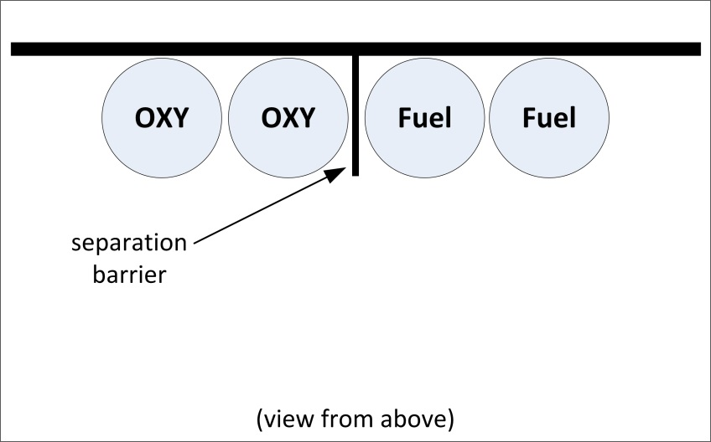

Oregon OSHA and the advisory committee felt that the horizontal dimension of noncombustible barriers in 1910.253 and 1926.350 needed to be reconsidered. The concern was that when a separation barrier is only as wide as the cylinders being separated, the barrier’s effectiveness is limited during a fire. Oregon OSHA and the advisory committee agreed that a change in horizontal barrier dimension should be derived from the Compressed Gas Association’s (CGA) Pamphlet, P-1, Safe Handling of Compressed Gases in Containers 2008, 11th edition which was consistent with the requirements already found in OAR 437-002-2102 Acetylene. The result was all noncombustible separation barriers must be as wide as the stored oxygen or fuel-gas cylinders plus extend horizontally an extra 18-inches to provide a buffer of protection.

Figures 6-2 depicts the new 18-inch horizontal extension for noncombustible separation barriers.
Figure 6-2

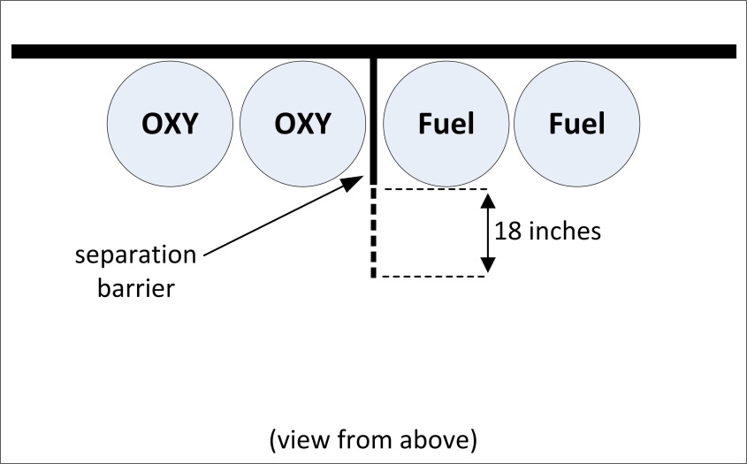

Figure 6-3 depicts the 18-inch horizontal measurement required to satisfy the new rule when additional cylinders or cylinders with a larger circumference are placed into storage.

Figure 6-3

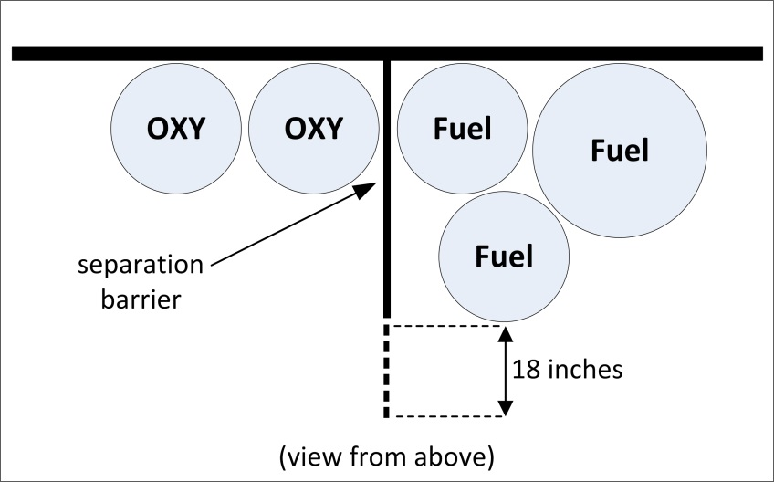

In addition to the concerns brought up over the horizontal effectiveness of noncombustible separation barriers, the vertical component was also addressed. The vertical concern was that when a separation barrier is only as tall as the minimum required, 5-feet, the barrier’s effectiveness is once again limited during a fire when the top of a cylinder approaches the height of the barrier. Oregon OSHA and the advisory committee agreed that a change in the vertical dimension should also be derived from the Compressed Gas Association’s (CGA) Pamphlet, P-1, Safe Handling of Compressed Gases in Containers 2008, 11th edition which was once again consistent with the requirements already found in OAR 437-002-2102 Acetylene. This decision reaffirmed that noncombustible separation barriers must be a minimum of 5-feet (60-inches) tall. It added a requirement for noncombustible barriers to extend above the height of the tallest stored oxygen or fuel-gas cylinder by 18-inches. The purpose was to ensure a minimum protective vertical buffer is maintained.

Figure 6-4 below depicts the previous requirements for noncombustible barriers within 1910.253 and 1926.350 to be a minimum of 60-inches (5-feet) tall regardless of the cylinder’s height which did not change in the new rule.

Figure 6-4

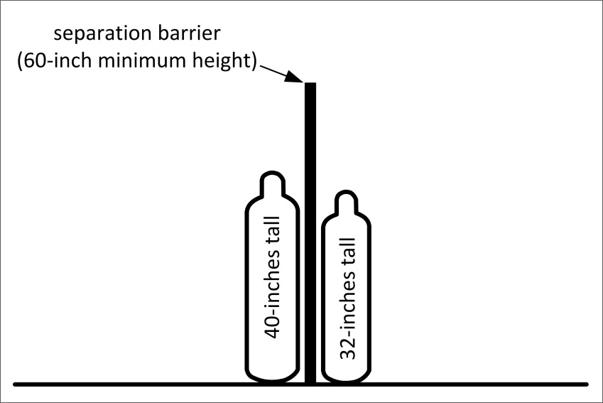

Figure 6-5 below illustrates the new 18-inch horizontal consideration required to satisfy paragraph (6) of the new rule when a cylinder’s height encroaches within 18-inches of the separation barrier’s overall height. Both cylinders shown below in Figure 6-5 do not encroach within 18-inches of the top of the 5-foot separation barrier; therefore, no additional action needs to be taken by the employer.

Figure 6-5

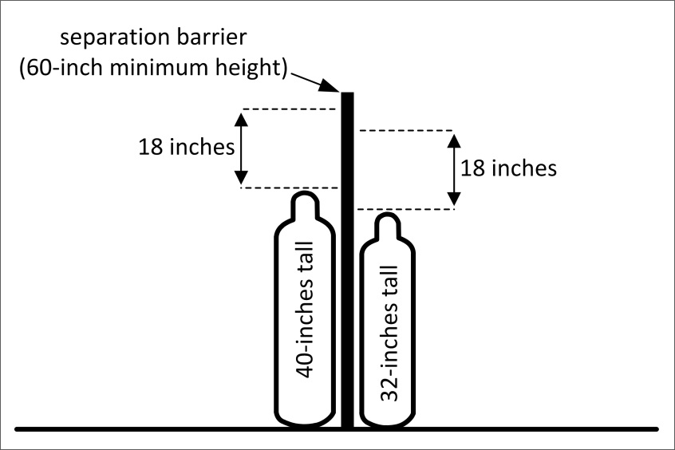

When a cylinder’s height encroaches within 18-inches of the separation barrier’s overall height as shown in Figure 6-6 below, the separation barrier must be replaced or be extended upward to ensure that there are at least 18-inches of barrier protection above the cylinder.

Figure 6-6

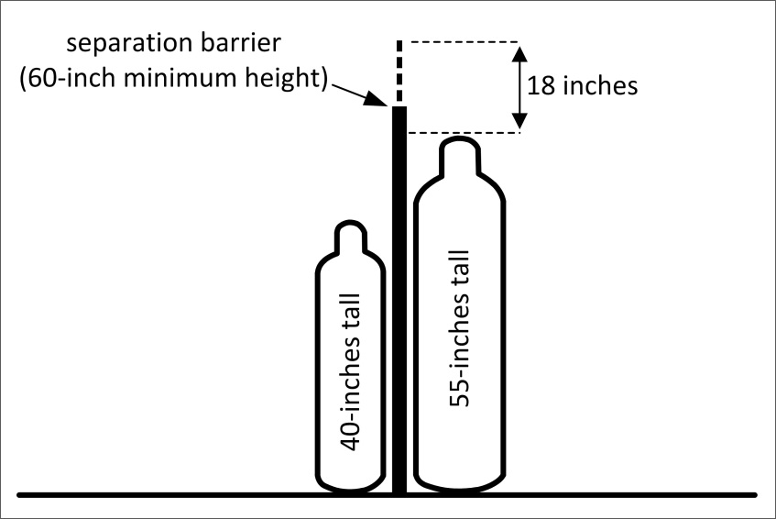

No changes were made to the fire-resistance rating of noncombustible barriers in the new rule; however, when an existing noncombustible separation barrier is significantly modified, the modification can not degrade the noncombustible barrier’s fire resistance rating to less than 30-minutes.

As a final point of clarification on the topic of noncombustible separation barriers, the 18-inch horizontal/vertical extension component of the new rule is not required for noncombustible separation barriers constructed prior to May 1st, 2015 unless the noncombustible separation barrier is significantly modified. Significant modification is not intended to include maintenance which is generally interpreted as making or keeping a structure, fixture or foundation in proper condition in a routine, scheduled, or anticipated fashion. For the purposes of the new rule, simply caulking or painting an existing noncombustible separation barrier should not be considered as a significant modification unless the scope and magnitude is great enough to be classified as construction work.

- Note: OAR 437-002-2102(1)(e)(B)(v)(I) and (II), effective February 19, 2010, also contains the 18-inch consideration for facilities engaged in processes covered by OAR 437-002-2102 Acetylene.

When the new rule was proposed, it contained language in subparagraph (a), sub-subparagraph (H) instructing employers to store cylinders “where full and empty cylinders are separated”. After receiving testimony during the second public hearing held in Eugene, Oregon on May 9th, 2014, this requirement was considered, and then removed from the final rule. The testimony suggested that the proposed language did not provide employers with enough direction. The testimony suggested that the language should be amended to indicate how the separation should occur, whether it was by marking or by distance. Separating full and empty cylinders was a best management practice that was not required by the previous rule, or any current consensus standard. Even though Oregon OSHA and the advisory committee recognized the value of separating full and empty cylinders for the benefit of emergency responders, the requirement would have placed an undue burden on employers by requiring separate storage areas. Oregon OSHA’s acetylene rule OAR 437-002-2102(1)(e)(B)(vi) requires that acetylene cylinders must be stored with full and empty cylinders separated. The separate storage requirement is due to the unique hazards associated with acetylene gas. To make acetylene gas safe for transportation, storage and use, acetylene gas has to be dissolved into liquid acetone or other suitable solvent. Liquid acetone containing dissolved acetylene is then injected under moderate pressure into specially built cylinders which have a solid filler material which contains a matrix of extremely small interconnected capillary holes. The purpose of the porous filler material is to prevent pockets within the cylinder from being large enough to permit an explosion from occurring. For this reason, full and empty acetylene cylinders are required to be stored separately to reduce the potential of empty cylinders being knocked over, damaging the critical inner porous filler material, potentially leading to a explosion. Oxygen and other fuel-gases do not share acetylene’s unique hazards.

A determination of the applicability of OAR 437-002-2253(6) needs to be undertaken when employers engage in cylinder transportation. The following clarifying notes exist within the new rule to assist with this determination:

- The definition of “Stored” within OAR 437-002-2253(2) contains two notes. Note 2 establishes that cylinders, with or without regulators, kept in or on vehicles due to their frequency of use will not be considered as stored when a leak test is performed at the end of the day. When cylinders are used during multiple shifts, they must be leak tested at the end of each shift. Refer to the definition of “leak test” as found within OAR 437-002-2253(2) Definitions.
- The definition of “transporting cylinders” within OAR 437-002-2253(2) contains two notes. Note 1 states that cylinders loaded into a vehicle for movement to a worksite or place of business are not in storage.

Finally, efforts were made to update the NFPA 80 consensus standard edition referenced within OAR 437-002-2253(6)(f)(D) from the 1970 version to the 2013 version, however, the supporting documentation that Oregon OSHA hoped to receive from the Oregon State Fire Marshal was not attainable.

Compared to the previous Division 2 oxy-fuel gas welding/cutting rule (OAR 437-002-1910.253), the following additional storage rules need to be followed by general industry employers:

- OAR 437-002-2253(6)(a)(F)
- OAR 437-002-2253(6)(a)(I) Storage locations:
- OAR 437-002-2253(6)(a)(Q)
- OAR 437-002-2253(6)(b)(E) Store in specific manner:
- OAR 437-002-2253(6)(h) Handling, storage and utilization:

Compared to the previous Division 3 oxy-fuel gas welding/cutting rule (OAR 437-003-1926.350), the following additional storage rules need to be followed by construction industry employers:

- OAR 437-002-2253(6)(a)(D) |
- OAR 437-002-2253(6)(a)(E) |
- OAR 437-002-2253(6)(a)(F) | Storage locations:
- OAR 437-002-2253(6)(a)(I) |
- OAR 437-002-2253(6)(a)(Q) |
- OAR 437-002-2253(6)(b)(C)
- OAR 437-002-2253(6)(b)(D) Store in specific manner:
- OAR 437-002-2253(6)(b)(E)
- OAR 437-002-2253(6)(d) Cylinder separation:
- OAR 437-002-2253(6)(e) Storage quantity limitation:
- OAR 437-002-2253(6)(f)(A) |
- OAR 437-002-2253(6)(f)(B) |
- OAR 437-002-2253(6)(f)(C) | Excessive storage quantity limitation:
- OAR 437-002-2253(6)(f)(D) |
- OAR 437-002-2253(6)(g) Liquid oxygen storage systems:
- OAR 437-002-2253(6)(h) Handling, storage and utilization:

Section 7: OAR 437-002-2253(7) Handling of Oxygen and Fuel Gas Cylinders

The paragraph “Handling of Oxygen and Fuel Gas Cylinders” within the new rule applies to both General Industry and Construction employers. The intent for this paragraph was for the hazards associated with the act of handling cylinders to be specifically addressed. This paragraph now specifically addresses the handling and movement of cylinders in plain language using easy to understand “do” and “do not” language.

Oregon OSHA and the advisory committee agreed that cylinder movement performed by hand, special truck, cart, forklift, crane and derrick would be specifically addressed. Additionally, a key focus point would be to provide direction to employers to ensure that leaks from cylinders are checked prior to use, storage, and transportation.

Oregon OSHA and the advisory committee used existing industry practices to develop two methods for discerning the presence of leaks. The two methods are 1) leak tests, and 2) drop tests. Both tests are defined in paragraph (2) of the new rule.

OAR 437-002-2253(7)(i)(L)(i) and OAR 437-002-2253(8)(a)(B) require drop testing to be performed. The drop test method uses the internal pressure from a compressed gas cylinder to test a “system” for leaks. The “system” being tested includes the cylinder, cylinder safety device, cylinder valve; pressure reducing regulator, hose, hose connections, O-rings, gauges, connection nuts, and the torch handle up to the final gas valve before the torch tip. Additionally, the method for performing a drop test is clearly prescribed in subparagraph (i), sub-subparagraph (L) of this paragraph [see OAR 437-002-2253(7)(i)(L)(i)] with the intent that it could be used as a training tool. Stakeholder concern about the amount of pressure and the length of time required to preform a drop test was brought to the attention of Oregon OSHA. Based on these concerns, the procedure for conducting a drop test was modified to describe the minimum pressure and the minimum time period required to perform a drop test.

Oregon OSHA and the advisory committee recognized that by nature, a properly performed drop test cannot reveal the exact location of a leak within a system. Therefore, Oregon OSHA and the advisory committee identified in the new rule when leak tests will need to be performed to identify the exact location of the leak. The leak test method utilizes the application of a liquid solution that is applied to the system. The solution must be compatible with the gases being used. A hole in a hose or a damaged O-ring at a torch handle will produce small bubbles when a leak test is performed, indicating where a leak is originating from. Leak tests are required by the new rule immediately after a failed drop test and prior to placing cylinders into a vehicle. Furthermore, the definition of “stored” in paragraph (2) has two notes. Note 2 explains that cylinders keep in or on vehicles are not considered stored when a leak test is performed at the end of the day. For cylinders on or in vehicles that are used over multiple work shifts, the cylinders will not be considered to be stored when a leak test is performed at the end of each shift.

The pre-existing requirements incorporated into the new rule for general industry employers are as follows:

- OAR 437-002-2253(7)(i)(D) contains the requirements that were previously located within OAR 437-002-0294(1), Pressure-Reducing Regulators which was repealed by the creation of OAR 437-002-2253 to avoid duplication.

- OAR 437-002-2253(7)(i)(N)(i) ) contains the requirements that were previously located within OAR 437-002-0292(1), Oxygen-Fuel Gas – Operating Procedures which was repealed by the creation of OAR 437-002-2253 to avoid duplication.

- OAR 437-002-2253(7)(i)(N)(ii) ) contains the requirements that were previously located within OAR 437-002-0292(1), Oxygen-Fuel Gas – Operating Procedures which was repealed by the creation of OAR 437-002-2253 to avoid duplication.

Compared to the previous Division 2 oxy-fuel gas welding/cutting rule (OAR 437-002-1910.253), the following additional handling rules need to be followed by general industry employers:

- OAR 437-002-2253(7)(a)(A) General handling and moving:
- OAR 437-002-2253(7)(a)(D)
- OAR 437-002-2253(7)(c)(A)
- OAR 437-002-2253(7)(c)(B) Portable bank / cylinder cradles:
- OAR 437-002-2253(7)(c)(C)
- OAR 437-002-2253(7)(d) Movement by forklift:
- OAR 437-002-2253(7)(e) Portable bank/cradle by crane:
- OAR 437-002-2253(7)(f)(A) Liquid cylinder lifting:
- OAR 437-002-2253(7)(f)(B)
- OAR 437-002-2253(7)(g)(B) Movement prior to storage:
- OAR 437-002-2253(7)(g)(C)
- OAR 437-002-2253(7)(h)(E) You must not:
- OAR 437-002-2253(7)(h)(J)
- OAR 437-002-2253(7)(i)(G)
- OAR 437-002-2253(7)(i)(L)(i) Connecting cylinders / you must:
- OAR 437-002-2253(7)(i)(M)
- OAR 437-002-2253(7)(j)(B) Connecting cylinders / you must not:
- OAR 437-002-2253(7)(j)(C)
- OAR 437-002-2253(7)(k)(C) Removing regulators:
- OAR 437-002-2253(7)(k)(D)

Compared to the previous Division 3 oxy-fuel gas welding/cutting rule (OAR 437-003-1926.350), the following additional handling rules need to be followed by construction industry employers:

- OAR 437-002-2253(7)(a)(A) General handling and moving:
- OAR 437-002-2253(7)(c)(A)
- OAR 437-002-2253(7)(c)(B) Portable bank / cylinder cradles:
- OAR 437-002-2253(7)(c)(C)
- OAR 437-002-2253(7)(f)(A) Liquid cylinder lifting:
- OAR 437-002-2253(7)(f)(B)
- OAR 437-002-2253(7)(h)(A) |
- OAR 437-002-2253(7)(h)(D) |
- OAR 437-002-2253(7)(h)(E) |
- OAR 437-002-2253(7)(h)(G) | You must not:
- OAR 437-002-2253(7)(h)(I) |
- OAR 437-002-2253(7)(h)(J) |
- OAR 437-002-2253(7)(h)(K) |
- OAR 437-002-2253(7)(i)(A) |
- OAR 437-002-2253(7)(i)(B) |
- OAR 437-002-2253(7)(i)(C) |
- OAR 437-002-2253(7)(i)(D) |
- OAR 437-002-2253(7)(i)(G) |
- OAR 437-002-2253(7)(i)(H) | Connecting cylinders / you must:
- OAR 437-002-2253(7)(i)(I) |
- OAR 437-002-2253(7)(i)(J) |
- OAR 437-002-2253(7)(i)(L)(i) |
- OAR 437-002-2253(7)(i)(L)(iii) |
- OAR 437-002-2253(7)(i)(L)(iv) |
- OAR 437-002-2253(7)(i)(L)(vi) |
- OAR 437-002-2253(7)(i)(M) |
- OAR 437-002-2253(7)(i)(N)(i) |
- OAR 437-002-2253(7)(i)(N)(ii) |
- OAR 437-002-2253(7)(j)(A)
- OAR 437-002-2253(7)(j)(B) Connecting cylinders / you must not:
- OAR 437-002-2253(7)(j)(C)
- OAR 437-002-2253(7)(k)(C) Removing regulators:
- OAR 437-002-2253(7)(k)(D)

Section 8: OAR 437-002-2253(8) Use of Oxygen and Fuel Gas Cylinders

The paragraph “Use of Oxygen and Fuel Gas Cylinders” within the new rule applies to both General Industry and Construction employers. The intent for this paragraph was for the hazards associated with the act of using oxygen and fuel gas cylinders to be specifically addressed.

The pre-existing requirements incorporated into the new rule for general industry employers are as follows:

- OAR 437-002-2253(8)(a)(H) contains the requirements that were previously located within OAR 437-002-0292(1), Oxygen-Fuel Gas – Operating Procedures which was repealed by the creation of OAR 437-002-2253 to avoid duplication.

- OAR 437-002-2253(8)(a)(I) contains the requirements that were previously located within OAR 437-002-0292(2), Oxygen-Fuel Gas – Operating Procedures which was repealed by the creation of OAR 437-002-2253 to avoid duplication.

- OAR 437-002-2253(8)(a)(J) contains the requirements that were previously located within OAR 437-002-0290(3), Blowpipes/Torches which was repealed by the creation of OAR 437-002-2253 to avoid duplication.

- OAR 437-002-2253(8)(a)(K) contains the requirements that were previously located within OAR 437-002-0290(3), Blowpipes/Torches which was repealed by the creation of OAR 437-002-2253 to avoid duplication.

- OAR 437-002-2253(8)(b)(I) contains the requirements that were previously located within OAR 437-002-0292(3), Oxygen-Fuel Gas – Operating Procedures which was repealed by the creation of OAR 437-002-2253 to avoid duplication.

- OAR 437-002-2253(8)(b)(J) contains the requirements that were previously located within OAR 437-002-0290(3), Blowpipes/Torches which was repealed by the creation of OAR 437-002-2253 to avoid duplication.

- OAR 437-002-2253(8)(b)(L) contains the requirements that were previously located within OAR 437-002-0290(3), Blowpipes/Torches which was repealed by the creation of OAR 437-002-2253 to avoid duplication.

Compared to the previous Division 2 oxy-fuel gas welding/cutting rule (OAR 437-002-1910.253), the following additional use of cylinder rules need to be followed by general industry employers:

- OAR 437-002-2253(8)(b)(L) Confined spaces

Compared to the previous Division 3 oxy-fuel gas welding/cutting rule (OAR 437-003-1926.350), the following additional use of cylinders rules need to be followed by construction industry employers:

- OAR 437-002-2253(8)(a)(B) |
- OAR 437-002-2253(8)(a)(E) |
- OAR 437-002-2253(8)(a)(H) |
- OAR 437-002-2253(8)(a)(I) | Cylinders / you must:
- OAR 437-002-2253(8)(a)(J) |
- OAR 437-002-2253(8)(a)(K) |
- OAR 437-002-2253(8)(b)(G) |
- OAR 437-002-2253(8)(b)(H) |
- OAR 437-002-2253(8)(b)(I) | Cylinders / you must not:
- OAR 437-002-2253(8)(b)(J) |

Section 9: OAR 437-002-2253(9) Pressure Reducing Regulators

The paragraph “Pressure Reducing Regulators” within the new rule applies to both General Industry and Construction employers. The intent for this paragraph was to specifically address the hazards associated with the use of pressure reducing regulators.

The pre-existing requirements incorporated into the new rule for general industry employers are as follows:

- OAR 437-002-2253(9)(a)(I) contains the requirements that were previously located within OAR 437-002-0294(1), Pressure-Reducing Regulators which was repealed by the creation of OAR 437-002-2253 to avoid duplication.

- OAR 437-002-2253(9)(a)(J) contains the requirements that were previously located within 437-002-0294(2), Pressure-Reducing Regulators which was repealed by the creation of OAR 437-002-2253 to avoid duplication.

- OAR 437-002-2253(9)(a)(K) contains the requirements that were previously located within OAR 437-002-0294(2), Pressure-Reducing Regulators which was repealed by the creation of OAR 437-002-2253 to avoid duplication.

Compared to the previous Division 2 oxy-fuel gas welding/cutting rule (OAR 437-002-1910.253), the following additional pressure reducing regulator rules need to be followed by general industry employers:

- OAR 437-002-2253(9)(a)(A) Regulators / you must:

Compared to the previous Division 3 oxy-fuel gas welding/cutting rule (OAR 437-003-1926.350), the following additional pressure reducing regulator rules need to be followed by construction industry employers:

- OAR 437-002-2253(9)(a)(A) |
- OAR 437-002-2253(9)(a)(B) |
- OAR 437-002-2253(9)(a)(C) |
- OAR 437-002-2253(9)(a)(D) |
- OAR 437-002-2253(9)(a)(E) | Regulators / you must:
- OAR 437-002-2253(9)(a)(F) |
- OAR 437-002-2253(9)(a)(G) |
- OAR 437-002-2253(9)(a)(H) |
- OAR 437-002-2253(9)(a)(I) |
- OAR 437-002-2253(9)(b)(A) Regulators / you must not:

Section 10: OAR 437-002-2253(10) Hose and Hose Connections

The paragraph “Hose and Hose Connections” within the new rule applies to both General Industry and Construction employers. The intent for this paragraph was for the hazards associated with hoses and hose connections to be specifically addressed.

Referenced consensus standards were updated in this paragraph due to the fact that those originally incorporated by reference within 1910.253 were obsolete.

As discussed in the history section of this preamble, sometime after the collaborative writing of the 1958 consensus standard between the Compressed Gas Association (CGA) and the Rubber Manufacturers Association (RMA), the RMA became the sole sponsor of the consensus standard which went on to be known as “IP-7: Specification for Rubber Welding Hose”. In 2010, the RMA realigned and limited the organization’s scope to rubber tires. At that point in time, another consensus standard development sponsor known as the Association for Rubber Product Manufacturers (ARPM) gained ownership of IP-7 and subsequently released a 10th edition in 2011. The ARPM IP-7, 2011, 10th edition is now referenced in this paragraph within the new rule.

When the language for the new rule was proposed, it contained a requirement in subparagraph (b) instructing employers to not “hang a torch from any hose”. This requirement was removed from the final rule as the protective intent was not clear and protecting hoses from damage was already addressed in 437-002-2253(10)(a)(J) and for general industry employers, previously existed in OAR 437-002-0295 Hoses.

The pre-existing requirements incorporated into the new rule for general industry employers are as follows:

- OAR 437-002-2253(10)(a)(J) contains the requirements that were previously located within OAR 437-002-0295, Hoses which was repealed by the creation of OAR 437-002-2253 to avoid duplication.

- OAR 437-002-2253(10)(b)(H) contains the requirements that were previously located within OAR 437-002-0295, Hoses which was repealed by the creation of OAR 437-002-2253 to avoid duplication.

- OAR 437-002-2253(10)(c)(C) contains the requirements that were previously located within OAR 437-002-0296, Hose Connections which was repealed by the creation of OAR 437-002-2253 to avoid duplication.

- OAR 437-002-2253(10)(c)(D) contains the requirements that were previously located within OAR 437-002-0296, Hose Connections which was repealed by the creation of OAR 437-002-2253 to avoid duplication.

Compared to the previous Division 2 oxy-fuel gas welding/cutting rule (OAR 437-002-1910.253), the following additional hose and hose connection rules need to be followed by general industry employers:

- OAR 437-002-2253(10)(a)(B) |
- OAR 437-002-2253(10)(a)(C) |
- OAR 437-002-2253(10)(a)(G) |
- OAR 437-002-2253(10)(a)(H) |
- OAR 437-002-2253(10)(a)(K) | Hoses / you must:
- OAR 437-002-2253(10)(a)(L) |
- OAR 437-002-2253(10)(a)(M) |
- OAR 437-002-2253(10)(a)(N) |
- OAR 437-002-2253(10)(b)(G) Hoses / you must not:
- OAR 437-002-2253(10)(b)(I)
- OAR 437-002-2253(10)(c)(E) Hose connections must:
- OAR 437-002-2253(10)(d) Hose connections / you must not:

Compared to the previous Division 3 oxy-fuel gas welding/cutting rule (OAR 437-003-1926.350), the following additional hose and hose connection rules need to be followed by construction industry employers:

- OAR 437-002-2253(10)(a)(A)
- OAR 437-002-2253(10)(a)(D) Hoses / you must:
- OAR 437-002-2253(10)(a)(J)
- OAR 437-002-2253(10)(b)(A) |
- OAR 437-002-2253(10)(b)(B) |
- OAR 437-002-2253(10)(b)(C) | Hoses / you must not:
- OAR 437-002-2253(10)(b)(D) |
- OAR 437-002-2253(10)(b)(E) |
- OAR 437-002-2253(10)(c)(A)
- OAR 437-002-2253(10)(c)(B) Hose connections must:
- OAR 437-002-2253(10)(c)(D)
- OAR 437-002-2253(10)(d) Hose connections / you must not:

Section 11: OAR 437-002-2253(11) Torches Used with Oxygen and Fuel Gas

The paragraph “Torches Used with Oxygen and Fuel Gas” within the new rule applies to both General Industry and Construction employers. The intent for this paragraph was for the hazards associated with the use of torches to be specifically addressed. Again, Oregon OSHA and the advisory committee concluded that plain language should be used to establish this paragraph. The paragraph was divided into two concise subparagraphs. The subparagraphs are, “You must:” and “You must not:”.

The pre-existing requirements incorporated into the new rule for general industry employers are as follows:

- OAR 437-002-2253(11)(a)(A) contains the requirements that were previously located within OAR 437-002-0290(1), Blowpipes/Torches which was repealed by the creation of OAR 437-002-2253 to avoid duplication.

- OAR 437-002-2253(11)(a)(E) contains the requirements that were previously located within OAR 437-002-0290(2), Blowpipes/Torches which was repealed by the creation of OAR 437-002-2253 to avoid duplication.

- OAR 437-002-2253(11)(b)(B) contains the requirements that were previously located within OAR 437-002-0290(2), Blowpipes/Torches which was repealed by the creation of OAR 437-002-2253 to avoid duplication.

Compared to the previous Division 2 oxy-fuel gas welding/cutting rule (OAR 437-002-1910.253), the following additional torch use rules need to be followed by general industry employers:

- OAR 437-002-2253(11)(a)(C) Torches / you must:
- OAR 437-002-2253(11)(a)(D)
- OAR 437-002-2253(11)(b)(A) Torches / you must not:

Compared to the previous Division 3 oxy-fuel gas welding/cutting rule (OAR 437-003-1926.350), the following additional torch use rules need to be followed by construction industry employers:

- OAR 437-002-2253(11)(a)(A)
- OAR 437-002-2253(11)(a)(B) Torches / you must:
- OAR 437-002-2253(11)(a)(E)
- OAR 437-002-2253(11)(b)(B) Torches / you must not:

Section 12: OAR 437-002-2253(12) Manifolds with Oxygen and Fuel Gas

The paragraph “Manifolds with Oxygen and Fuel Gas” within the new rule applies to both General Industry and Construction employers. The intent for this paragraph was for the hazards associated with the manifolding of oxygen and fuel gases to be specifically addressed.

The primary objective of Oregon OSHA was to update the consensus standards that were relied upon within the previous rules. The Compressed Gas Association’s (CGA) Pamphlet, P-1, Safe Handling of Compressed Gases in Containers 2008, 11th edition was used to establish the dimensional considerations when separation is achieved with a barrier rather than by distance. Refer to Section 6 of this preamble for discussion about the amendments to the dimensions of separation barriers.

Furthermore, NFPA 566, 1965 edition was the consensus standard for bulk oxygen supply systems and manifolds incorporated by reference in 1910.253 which needed to be updated. NFPA 566 had an oxygen threshold quantity of 25,000 cubic feet. As discussed in the history section of this preamble, the 1965 edition of NFPA 566 changed and became NFPA 50 Bulk Oxygen Systems at Consumer Sites in 1971. Consequentially, the 1965 edition of NFPA 566 was no longer available for purchase. Between 1971 and 2001, multiple editions of NFPA 50 were published. In 2005, NFPA 50 was brought into NFPA 55, the Compressed Gases and Cryogenic Fluids Code and NFPA 50 ceased to exist. Because of this, neither NFPA 566, nor NFPA 50 was available for purchase by employers. Ultimately, the 2010 edition of NFPA 55 was integrated into OAR 437-002-2253(12)(c)(F) which had the result of lowering the threshold storage capacity of oxygen by 20% from that stated in the original 1965 edition of NFPA 566.

Compared to the previous Division 2 oxy-fuel gas welding/cutting rule (OAR 437-002-1910.253), the following additional manifolds with oxygen and fuel-gas rules need to be followed by general industry employers:

- OAR 437-002-2253(12)(a)(A) |
- OAR 437-002-2253(12)(a)(B) |
- OAR 437-002-2253(12)(a)(I) | Manifolds / you must:
- OAR 437-002-2253(12)(a)(J) |
- OAR 437-002-2253(12)(a)(K) |
- OAR 437-002-2253(12)(b)(A)
- OAR 437-002-2253(12)(b)(B) Manifolds / you must not:
- OAR 437-002-2253(12)(b)(C)
- OAR 437-002-2253(12)(c) High-pressure oxygen manifolds:
- OAR 437-002-2253(12)(d) High-pressure oxygen manifolds:

Compared to the previous Division 3 oxy-fuel gas welding/cutting rule (OAR 437-003-1926.350), the following additional manifolds with oxygen and fuel-gas rules need to be followed by construction industry employers:

- OAR 437-002-2253(12)(a)(C) |
- OAR 437-002-2253(12)(a)(D) |
- OAR 437-002-2253(12)(a)(E) | Manifolds / you must:
- OAR 437-002-2253(12)(a)(F) |
- OAR 437-002-2253(12)(a)(G) |
- OAR 437-002-2253(12)(a)(H) |
- OAR 437-002-2253(12)(b)(C) Manifolds / you must not:
- OAR 437-002-2253(12)(c)(A) |
- OAR 437-002-2253(12)(c)(B) |
- OAR 437-002-2253(12)(c)(C) |
- OAR 437-002-2253(12)(c)(D) | High-pressure oxygen manifolds:
- OAR 437-002-2253(12)(c)(E) |
- OAR 437-002-2253(12)(c)(F) |
- OAR 437-002-2253(12)(d) High-pressure oxygen manifolds:
- OAR 437-002-2253(12)(e)(A) |
- OAR 437-002-2253(12)(e)(B) |
- OAR 437-002-2253(12)(e)(C) |
- OAR 437-002-2253(12)(e)(D) | Low-pressure oxygen manifolds:
- OAR 437-002-2253(12)(e)(E) |
- OAR 437-002-2253(12)(e)(F) |
- OAR 437-002-2253(12)(f)(A) |
- OAR 437-002-2253(12)(f)(B) |
- OAR 437-002-2253(12)(f)(C) |
- OAR 437-002-2253(12)(f)(D) | Portable outlet headers:
- OAR 437-002-2253(12)(f)(E) |
- OAR 437-002-2253(12)(f)(F) |
- OAR 437-002-2253(12)(f)(G) |
- OAR 437-002-2253(12)(f)(H) |
- OAR 437-002-2253(12)(g) Portable outlet headers / indoors:
- OAR 437-002-2253(12)(h)(A) |
- OAR 437-002-2253(12)(h)(B) |
- OAR 437-002-2253(12)(h)(C) | Manifold operation procedures:
- OAR 437-002-2253(12)(h)(D) |
- OAR 437-002-2253(12)(h)(E) |
- OAR 437-002-2253(12)(i) Manifold operation procedures:

Section 13: OAR 437-002-2253(13) Service Piping Systems, Materials and Design

The paragraph “Service Piping Systems, Materials and Design” within the new rule applies to both General Industry and Construction employers. The intent for this paragraph was for the hazards associated with the act of piping oxygen and fuel gases to be specifically addressed.

Consensus standards that were relied upon within the previous rules have been updated.
Service piping systems have typically been limited to permanent places of employment such as industrial fabrication shops, generally not construction sites. Construction projects have grown in size and complexity such that service piping systems are not unheard of on construction job sites. All of the requirements found within the new rule for general industry employers previously existed in other Division 2 rules. Service piping systems were not addressed in the previous construction rules found in Division 3.

The pre-existing requirements incorporated into the new rule for general industry employers are as follows:

- OAR 437-002-2253(13)(a)(L) contains the requirements that were previously located within OAR 437-002-0291(1), Oxygen-Fuel Gas – General which was repealed by the creation of OAR 437-002-2253 to avoid duplication.

- All other components of OAR 437-002-2253(13) were previously found within OAR 437-002-1910.253 which was repealed.

Compared to the previous Division 3 oxy-fuel gas welding/cutting rule (OAR 437-003-1926.350), the following additional service piping system rules need to be followed by construction industry employers:

- OAR 437-002-2253(13) All

Section 14: OAR 437-002-2253(14) Acetylene Generators

The paragraph “Acetylene Generators” within the new rule applies only to General Industry activities, not Construction activities. The intent for this paragraph was for the hazards associated with the act of generating acetylene to be specifically addressed.

Efforts were made to update the NFPA 80 consensus standard edition referenced within OAR 437-002-2253(14)(d)(I)(iii) from the 1970 version to the 2013 version, however, the supporting documentation that Oregon OSHA hoped to obtain from the Oregon State Fire Marshal was not received. The note found directly below OAR 437-002-2253(14)(d)(I)(iii) is not enforceable at this time. All requirements found within this paragraph are consistent with the previous requirements found in 1910.253. No additional acetylene generator requirements for general industry employers were created by the new rule.

Section 15: OAR 437-002-2253(15) Storage of Calcium Carbide

The paragraph “Storage of Calcium Carbide” within the new rule applies only to General Industry activities, not Construction activities. The intent for this paragraph was for the hazards associated with the act of storing calcium carbide to be specifically addressed.

All requirements found within this paragraph are consistent with the previous requirements found in 1910.253. No additional storage of calcium carbide requirements for general industry employers were created by the new rule.

