Oregon Administrative Rules

Chapter 437

Division 2
General Occupational Safety and Health
Cotton Dust | Subdivision
 | Z
 | Administrative Order 3-2019

Pursuant to Oregon Revised Statutes (ORS) 654, The Oregon Safe Employment Act (OSEAct), the Oregon Department of Consumer and Business Services, Occupational Safety and Health Division (Oregon OSHA), adopted these rules.
The Secretary of State designated Oregon Administrative Rules Chapter 437 as the Oregon Occupational Safety and Health Division Rules. Six subject areas are designated as “Divisions” of these rules.
• Division 1 Administration of the Oregon Safe Employment Act
• Division 2 General Occupational Safety and Health Rules
• Division 3 Construction
• Division 4 Agriculture
• Division 5 Maritime Activities
• Division 7 Forest Activities

Oregon-initiated rules are numbered in a uniform system developed by the Secretary of State. This system does not number the rules in sequence (001, 002, 003, etc.). Omitted numbers may be assigned to new rules at the time of their adoption.
Oregon-initiated rules are arranged in the following codification structure prescribed by the Secretary of State for Oregon Administrative Rules (OAR):
Chapter Division Subdivision Rule Section Paragraphs
437 002 N 0221 (1) (a)(A)(i)(I)
Cite as 437-002-0221(1)(a)

Many of the Oregon OSHA rules are adopted by reference from the Code of Federal Regulations (CFR), and are arranged in the following federal numbering system:
Part Subpart Section Paragraphs
(Subdivision)
1910 N .176 (a)(1)(i)(A)(1)(i)
Cite as 1910.176(a)(1)
The terms “subdivision” and “subpart” are synonymous within OAR 437, Oregon Occupational Safety and Health rules.

These rules are available for viewing in the Office of the Secretary of State, Oregon State Archives Building, Salem, Oregon.
These rules are available in electronic and printable formats at osha.oregon.gov.
Printed copies of these rules are available at:
Department of Consumer & Business Services
Oregon Occupational Safety & Health Division (Oregon OSHA)
350 Winter St. NE
Salem, OR 97301-3882
Or call the Oregon OSHA Resource Library at 503-378-3272.

Table of Contents
437-002-0360 Adoption by Reference 1
1910.1043 Cotton Dust 2
437-002-1043 Cotton Dust Respiratory Protection Program 8
Appendix A to 1910.1043 – Air Sampling and Analytical Procedures for Determining Concentrations of Cotton Dust 19
Appendix B-I – Respiratory Questionnaire 25
Appendix B-II to 1910.1043 – Respiratory Questionnaire for Non-Textile Workers for the Cotton Industry 35
Appendix B-III to 1910.1043 – Abbreviated Respiratory Questionnaire 45
Appendix C to 1910.1043 51
Appendix D to 1910.1043 – Pulmonary Function Standards for Cotton Dust Standard 53
Appendix E to 1910.1043 – Vertical Elutriator Equivalency Protocol 59
Historical Notes for Subdivision Z 61

437-002-0360 Adoption by Reference
In addition to, and not in lieu of, any other safety and health codes contained in OAR Chapter 437, the Department adopts by reference the following federal regulations printed as part of the Code of Federal Regulations, 29 CFR 1910, in the Federal Register:
(27) 29 CFR 1910.1043 Cotton dust, published 5/14/19, FR vol. 84, no. 93, p. 21416.
These standards are available at the Oregon Occupational Safety and Health Division, Oregon Department of Consumer and Business Services, and the United States Government Printing Office.
Stat. Auth.: ORS 654.025(2) and 656.726(4).
Stats. Implemented: ORS 654.001 through 654.295.
Hist: APD Admin. Order 13-1988, f. 8/2/88, ef. 8/2/88 (Benzene).
APD Admin. Order 14-1988, f. 9/12/88, ef. 9/12/88 (Formaldehyde).
APD Admin. Order 18-1988, f. 11/17/88, ef. 11/17/88 (Ethylene Oxide).
APD Admin. Order 4-1989, f. 3/31/89, ef. 5/1/89 (Asbestos-Temp).
APD Admin. Order 6-1989, f. 4/20/89, ef. 5/1/89 (Non-Asbestiforms-Temp).
APD Admin. Order 9-1989, f. 7/7/89, ef. 7/7/89 (Asbestos & Non-Asbestiforms-Perm).
APD Admin. Order 11-1989, f. 7/14/89, ef. 8/14/89 (Lead).
APD Admin. Order 13-1989, f. 7/17/89, ef. 7/17/89 (Air Contaminants).
OR-OSHA Admin. Order 1-1990, f. 1/11/90, ef. 1/11/90 (Formaldehyde-Temp).
OR-OSHA Admin. Order 3-1990, f. 1/19/90, ef. 1/19/90 (Asbestos & Non-Asbestiforms-Temp).
OR-OSHA Admin. Order 6-1990, f. 3/2/90, ef. 3/2/90 (Formaldehyde-Perm).
OR-OSHA Admin. Order 7-1990, f. 3/2/90, ef. 3/2/90 (Asbestos & Non-Asbestiforms-Perm).
OR-OSHA Admin. Order 9-1990, f. 5/8/90, ef. 8/8/90 (Labs).
OR-OSHA Admin. Order 11-1990, f. 6/7/90, ef. 7/1/90 (Air Contaminants).
OR-OSHA Admin. Order 13-1990, f. 6/28/90, ef. 8/1/90 (Asbestos-Temp).
OR-OSHA Admin. Order 14-1990, f. 6/28/90, ef. 8/1/90 (Lead).
OR-OSHA Admin. Order 19-1990, f. 8/31/90, ef. 8/31/90 (Asbestos-Perm).
OR-OSHA Admin. Order 20-1990, f. 9/18/90, ef. 9/18/90 (Lead).
OR-OSHA Admin. Order 21-1990, f. 9/18/90, ef. 9/18/90 (Air Contaminants).
OR-OSHA Admin. Order 7-1991, f. 4/25/91, ef. 4/25/91 (Air Contaminants, Asbestos, Formaldehyde).
OR-OSHA Admin. Order 13-1991, f. 10/10/91, ef. 10/10/91 (Lead, Formaldehyde).
OR-OSHA Admin. Order 15-1991, f. 12/13/91, ef. 12/13/91 (Asbestos).
OR-OSHA Admin. Order 1-1992, f. 1/22/92, ef. 1/22/92 (Formaldehyde).
OR-OSHA Admin. Order 4-1992, f. 4/16/92, ef. 4/16/92 (Formaldehyde).
OR-OSHA Admin. Order 5-1992, f. 4/24/92, ef. 7/1/92 (Bloodborne Pathogens).
OR-OSHA Admin. Order 6-1992, f. 5/18/92, ef. 5/18/92 (Asbestos).
OR-OSHA Admin. Order 10-1992, f. 9/24/92, ef. 9/24/92 (Lead-temp).
OR-OSHA Admin. Order 11-1992, f. 10/9/92, ef. 10/9/92 (Asbestos).
OR-OSHA Admin. Order 12-1992, f. 10/13/92, ef. 10/13/92 (Formaldehyde).
OR-OSHA Admin. Order 15-1992, f. 12/30/92, ef. 12/30/92 (Air Contaminants, BBP, Labs).
OR-OSHA Admin. Order 1-1993, f. 1/22/93, ef. 1/22/93 (Cadmium, MDA).
OR-OSHA Admin. Order 6-1993, f. 5/17/93, ef. 5/17/93 (Air Contaminants-Temp).
OR-OSHA Admin. Order 12-1993, f. 8/20/93, ef. 11/1/93 (remainder of 2/Z).
OR-OSHA Admin. Order 17-1993, f. 11/15/93, ef. 11/15/93 (Air Contaminants-Perm).
OR-OSHA Admin. Order 4-1995, f. 3/29/95, ef. 3/29/95 (Asbestos).
OR-OSHA Admin. Order 8-1995, f. 8/25/95, ef. 8/25/95 (Asbestos).
OR-OSHA Admin. Order 4-1996, f. 9/13/96, ef. 9/13/96 (Lead).
OR-OSHA Admin. Order 6-1996, f. 11/29/96, ef. 11/29/96 (Asbestos).
OR-OSHA Admin. Order 4-1997, f. 4/2/97, ef. 4/2/97.
OR-OSHA Admin. Order 6-1997, f. 5/2/97, ef. 5/2/97.
OR-OSHA Admin. Order 8-1997, f. 11/14/97, ef. 11/14/97 (Methylene Chloride).
OR-OSHA Admin. Order 1-1998, f. 2/13/98, ef. 2/13/98 (Methylene Chloride).
OR-OSHA Admin. Order 3-1998, f. 7/7/98, ef. 7/7/98.
OR-OSHA Admin. Order 1-1999, f. 3/22/99, ef. 3/22/99.
OR-OSHA Admin. Order 4-1999, f. 4/30/99, ef. 4/30/99.
OR-OSHA Admin. Order 6-2001, f. 5/15/01, ef. 5/15/01 (Cotton Dust).
OR-OSHA Admin. Order 1-2005, f. 4/12/05, ef. 4/12/05.
OR-OSHA Admin. Order 4-2006, f. 7/24/06, ef. 7/24/06.
OR-OSHA Admin. Order 10-2006, f. 11/30/06, ef. 11/30/06.
OR-OSHA Admin. Order 5-2009, f. 5/29/09, ef. 5/29/09.
OR-OSHA Admin. Order 4-2011, f. 12/8/11, ef. 12/8/11.
OR-OSHA Admin. Order 5-2011, f. 12/8/11, ef. 7/1/12.
OR-OSHA Admin. Order 5-2012, f. 9/25/12, ef. 9/25/12.
OR-OSHA Admin. Order 3-2013, f. 7/18/13, ef. 7/18/13.
OR-OSHA Admin. Order 4-2013, f. 7/19/13, ef. 7/19/13.
OR-OSHA Admin. Order 3-2019, f. 10/29/19, ef. 10/29/19.

1910.1043 Cotton Dust
(a) Scope and application.
(1) This section, in its entirety, applies to the control of employee exposure to cotton dust in all workplaces where employees engage in yarn manufacturing, engage in slashing and weaving operations, or work in waste houses for textile operations.
(2) This section does not apply to the handling or processing of woven or knitted materials; to maritime operations covered by 29 CFR Parts 1915 and 1918; to harvesting or ginning of cotton; or to the construction industry.
(3) Only paragraphs (h) Medical surveillance, (k)(2) through (4) Recordkeeping – Medical Records, and Appendices B, C and D of this section apply in all work places where employees exposed to cotton dust engage in cottonseed processing or waste processing operations.
(4) This section applies to yarn manufacturing and slashing and weaving operations exclusively using washed cotton (as defined by paragraph (n) of this section) only to the extent specified by paragraph (n) of this section.
(5) This section, in its entirety, applies to the control of all employees exposure to the cotton dust generated in the preparation of washed cotton from opening until the cotton is thoroughly wetted.
(6) This section does not apply to knitting, classing or warehousing operations except that employers with these operations, if requested by NIOSH, shall grant NIOSH access to their employees and workplaces for exposure monitoring and medical examinations for purposes of a health study to be performed by NIOSH on a sampling basis.
(b) Definitions. For the purpose of this section:
Assistant Secretary means the Assistant Secretary of Labor for Occupational Safety and Health, U.S. Department of Labor, or designee;
Blow down means the general cleaning of a room or a part of a room by the use of compressed air.
Blow off means the use of compressed air for cleaning of short duration and usually for a specific machine or any portion of a machine.
Cotton dust means dust present in the air during the handling or processing of cotton, which may contain a mixture of many substances including ground up plant matter, fiber, bacteria, fungi, soil, pesticides, non-cotton plant matter and other contaminants which may have accumulated with the cotton during the growing, harvesting and subsequent processing or storage periods. Any dust present during the handling and processing of cotton through the weaving or knitting of fabrics, and dust present in other operations or manufacturing processes using raw or waste cotton fibers or cotton fiber by-products from textile mills are considered cotton dust within this definition. Lubricating oil mist associated with weaving operations is not considered cotton dust.
Director means the Director of the National Institute for Occupational Safety and Health (NIOSH), U.S. Department of Health and Human Services, or designee.
Equivalent Instrument means a cotton dust sampling device that meets the vertical elutriator equivalency requirements as described in paragraph (d)(1)(iii) of this section.
Lint-free respirable cotton dust means particles of cotton dust of approximately 15 micrometers or less aerodynamic equivalent diameter;
Vertical elutriator cotton dust sampler or vertical elutriator means a dust sampler which has a particle size cut-off at approximately 15 micrometers aerodynamic equivalent diameter when operating at the flow rate of 7.4 ± 0.2 liters of air per minute;
Waste processing means waste recycling (sorting, blending, cleaning and willowing) and garneting.
Yarn manufacturing means all textile mill operations from opening to, but not including, slashing and weaving.
(c) Permissible exposure limits and action levels.
(1) Permissible exposure limits (PEL).
(i) The employer shall assure that no employee who is exposed to cotton dust in yarn manufacturing and cotton washing operations is exposed to airborne concentrations of lint-free respirable cotton dust greater than 200 µg/m³ mean concentration, averaged over an eight-hour period, as measured be a vertical elutriator or an equivalent instrument.
(ii) The employer shall assure that no employee who is exposed to cotton dust in textile mill waste house operations or is exposed in yarn manufacturing to dust from “lower grade washed cotton” as defined in paragraph (n)(5) of this section is exposed to airborne concentrations of lint-free respirable cotton dust greater than 500 µg/m³ mean concentration, averaged over an eight-hour period, as measured by a vertical elutriator or an equivalent instrument.
(iii) The employer shall assure that no employee who is exposed to cotton dust in the textile processes known as slashing and weaving is exposed to airborne concentrations of lint-free respirable cotton dust greater than 750 µg/m³ mean concentration, averaged over an eight hour period, as measured by a vertical elutriator or an equivalent instrument.
(2) Action levels.
(i) The action level for yarn manufacturing and cotton washing operations is an airborne concentration of lint-free respirable cotton dust of 100 µg/m³ mean concentration, averaged over an eight-hour period, as measured by a vertical elutriator or an equivalent instrument.
(ii) The action level for waste houses for textile operations is an airborne concentration of lint-free respirable cotton dust of 250 µg/m³ mean concentration, averaged over an eight-hour period, as measured by a vertical elutriator or an equivalent instrument.
(iii) The action level for the textile processes known as slashing and weaving is an airborne concentration of lint-free respirable cotton dust of 375 µg/m³ mean concentration, averaged over an eight-hour period, as measured by a vertical elutriator or an equivalent instrument.
(d) Exposure monitoring and measurement.
(1) General.
(i) For the purposes of this section, employee exposure is that exposure which would occur if the employee were not using a respirator.
(ii) The sampling device to be used shall be either the vertical elutriator cotton dust sampler or an equivalent instrument.
(iii) If an alternative to the vertical elutriator cotton dust sampler is used, the employer shall establish equivalency by reference to an OSHA opinion or by documenting, based on data developed by the employer or supplied by the manufacturer, that the alternative sampling devices meets the following criteria:
(A) It collects respirable particulates in the same range as the vertical elutriator (approximately 15 microns);
(B) Replicate exposure data used to establish equivalency are collected in side-by-side field and laboratory comparisons; and
(C) A minimum of 100 samples over the range of 0.5 to 2 times the permissible exposure limit are collected, and 90% of these samples have an accuracy range of plus or minus 25 per cent of the vertical elutriator reading with a 95% confidence level as demonstrated by a statistically valid protocol. (An acceptable protocol for demonstrating equivalency is described in Appendix E of this section.)
(iv) OSHA will issue a written opinion stating that an instrument is equivalent to a vertical elutriator cotton dust sampler if
(A) A manufacturer or employer requests an opinion in writing and supplies the following information:
(1) Sufficient test data to demonstrate that the instrument meets the requirements specified in this paragraph and the protocol specified in Appendix E of this section;
(2) Any other relevant information about the instrument and its testing requested by OSHA; and
(3) A certification by the manufacturer or employer that the information supplied is accurate, and
(B) if OSHA finds, based on information submitted about the instrument, that the instrument meets the requirements for equivalency specified by paragraph (d) of this section.
(2) Initial monitoring. Each employer who has a place of employment within the scope of paragraph (a)(1), (a)(4), or (a)(5) of this section shall conduct monitoring by obtaining measurements which are representative of the exposure of all employees to airborne concentrations of lint-free respirable cotton dust over an eight-hour period. The sampling program shall include at least one determination during each shift for each work area.
(3) Periodic monitoring.
(i) If the initial monitoring required by paragraph (d)(2) of this section or any subsequent monitoring reveals employee exposure to be at or below the permissible exposure limit, the employer shall repeat the monitoring for those employees at least annually.
(ii) If the initial monitoring required by paragraph (d)(2) of this section or any subsequent monitoring reveals employee exposure to be above the PEL, the employer shall repeat the monitoring for those employees at least every six months.
(iii) Whenever there has been a production, process, or control change which may result in new or additional exposure to cotton dust, or whenever the employer has any other reason to suspect an increase in employee exposure, the employer shall repeat the monitoring and measurements for those employees affected by the change or increase.
(4) Employee notification.
(i) The employer must, within 15 working days after the receipt of the results of any monitoring performed under this section, notify each affected employee of these results either individually in writing or by posting the results in an appropriate location that is accessible to employees.
(ii) Whenever the results indicate that the employee’s exposure exceeds the applicable permissible exposure limit specified in paragraph (c) of this section, the employer shall include in the written notice a statement that the permissible exposure limit was exceeded and a description of the corrective action taken to reduce exposure below the permissible exposure limit.
(e) Methods of compliance.
(1) Engineering and work practice controls. The employer shall institute engineering and work practice controls to reduce and maintain employee exposure to cotton dust at or below the permissible exposure limit specified in paragraph (c) of this section, except to the extent that the employer can establish that such controls are not feasible.
(2) Whenever feasible engineering and work practice controls are not sufficient to reduce employee exposure to or below the permissible exposure limit, the employer shall nonetheless institute these controls to reduce exposure to the lowest feasible level, and shall supplement these controls with the use of respirators which shall comply with the provisions of paragraph (f) of this section.
(3) Compliance program.
(i) Where the most recent exposure monitoring data indicates that any employee is exposed to cotton dust levels greater than the permissible exposure limit, the employer shall establish and implement a written program sufficient to reduce exposures to or below the permissible exposure limit solely by means of engineering controls and work practices as required by paragraph (e)(1) of this section.
(ii) The written program shall include at least the following:
(A) A description of each operation or process resulting in employee exposure to cotton dust at levels greater than the PEL;
(B) Engineering plans and other studies used to determine the controls for each process;
(C) A report of the technology considered in meeting the permissible exposure limit;
(D) Monitoring data obtained in accordance with paragraph (d) of this section;
(E) A detailed schedule for development and implementation of engineering and work practice controls, including exposure levels projected to be achieved by such controls;
(F) Work practice program; and
(G) Other relevant information.
(iii) The employer’s schedule as set forth in the compliance program, shall project completion of the implementation of the compliance program no later than March 27, 1984 or as soon as possible if monitoring after March 27, 1984 reveals exposures over the PEL, except as provided in paragraph (m)(2)(ii)(B) of this section.
(iv) The employer shall complete the steps set forth in his program by the dates in the schedule.
(v) Written programs shall be submitted, upon request, to the Assistant Secretary and the Director, and shall be available at the worksite for examination and copying by the Assistant Secretary, the Director, and any affected employee or their designated representatives.
(vi) The written program required under paragraph (e)(3) of this section shall be revised and updated when necessary to reflect the current status of the program and current exposure levels.
(4) Mechanical ventilation. When mechanical ventilation is used to control exposure, measurements which demonstrate the effectiveness of the system to control exposure, such as capture velocity, duct velocity, or static pressure shall be made at reasonable intervals.
(f) Respiratory protection.
(1) General. For employees who are required to use respirators by this section, the employer must provide each employee an appropriate respirator that complies with the requirements of this paragraph. Respirators must be used during:
(i) Periods necessary to install or implement feasible engineering and work-practice controls.
(ii) Maintenance and repair activities for which engineering and work-practice controls are not feasible.
(iii) Work operations for which feasible engineering and work-practice controls are not yet sufficient to reduce employee exposure to or below the permissible exposure limits.
(iv) Work operations specified under paragraph (g)(1) of this section.
(v) Periods for which an employee requests a respirator.
(2) Respirator program.
Oregon OSHA repealed 1910.1043(f)(2)(i). In Oregon, OAR 437-002-1043 applies.

437-002-1043 Cotton Dust Respiratory Protection Program
The employer must implement a respiratory protection program in accordance with Division 2/I, 1910.134(b) through (d) (except (d)(1)(iii), and (d)(3)(iii)(B)(1) and (2)), and (e) through (m) and (o), which covers each employee required by Division 2/Z, 1910.1043 Cotton Dust, to use a respirator.
Note: This is in addition to other respiratory protection and medical surveillance requirements specified in these Cotton Dust rules.
Stat. Auth.: ORS 654.025(2) and 656.726(4).
Stats. Implemented: ORS 654.001 through 654.295.
Hist: OR-OSHA Admin. Order 5-2011, f. 12/8/11, ef. 7/1/12.

1910.1043 (f)(2)(ii) Whenever a physician determines that an employee who works in an area in which the cotton-dust concentration exceeds the PEL is unable to use a respirator, including a powered air-purifying respirator, the employee must be given the opportunity to transfer to an available position, or to a position that becomes available later, that has a cotton-dust concentration at or below the PEL. The employer must ensure that such employees retain their current wage rate or other benefits as a result of the transfer.
(3) Respirator selection.
(i) Employers must:
(A) Select, and provide to employees, the appropriate respirators specified in paragraph (d)(3)(i)(A) of 29 CFR 1910.134; however, employers must not select or use filtering facepieces for protection against cotton dust concentrations greater than five times (5 x) the PEL.
(B) Provide HEPA filters for powered and non-powered air-purifying respirators used at cotton dust concentrations greater than ten times (10 x) the PEL.
(ii) Employers must provide an employee with a powered air-purifying respirator (PAPR) instead of a non-powered air-purifying respirator selected according to paragraph (f)(3)(i) of this standard when the employee chooses to use a PAPR and it provides adequate protection to the employee as specified by paragraph (f)(3)(i) of this standard.
(g) Work practices. Each employer shall, regardless of the level of employee exposure, immediately establish and implement a written program of work practices which shall minimize cotton dust exposure. The following shall be included were applicable:
(1) Compressed air “blow down” cleaning shall be prohibited where alternative means are feasible. Where compressed air is used for cleaning, the employees performing the “blow down” or “blow off” shall wear suitable respirators. Employees whose presence is not required to perform “blow down” or “blow of” shall be required to leave the area affected by the “blow down” or “blow off” during this cleaning operation.
(2) Cleaning of clothing or floors with compressed air shall be prohibited.
(3) Floor sweeping shall be performed with a vacuum or with methods designed to minimize dispersal of dust.
(4) In areas where employees are exposed to concentrations of cotton dust greater than the permissible exposure limit, cotton and cotton waste shall be stacked, sorted, baled, dumped, removed or otherwise handled by mechanical means, except where the employer can show that it is infeasible to do so. Where infeasible, the method used for handling cotton and cotton waste shall be the method which reduces exposure to the lowest level feasible.
(h) Medical surveillance.
(1) General.
(i) Each employer covered by the standard shall institute a program of medical surveillance for all employees exposed to cotton dust.
(ii) The employer shall assure that all medical examinations and procedures are performed by or under the supervision of a licensed physician and are provided without cost to the employee.
(iii) Persons other than licensed physicians, who administer the pulmonary function testing required by this section shall have completed a NIOSH-approved training course in spirometry.
(2) Initial examinations. The employer shall provide medical surveillance to each employee who is or may be exposed to cotton dust. For new employees, this examination shall be provided prior to initial assignment. The medical surveillance shall include at least the following:
(i) A medical history;
(ii) The standardized questionnaire contained in Appendix B; and
(iii) A pulmonary function measurement, including forced vital capacity (FVC) and forced expiratory volume in one second (FEV₁), the determination of FEV₁/FVC ratio shall be made. FVC, FEV₁, and FEV₁/FVC ratio values shall be compared to appropriate race/ethnicity-specific Lower Limit of Normal (LLN) values and predicted values published in Spirometric Reference Values from a Sample of the General U.S. Population, American Journal of Respiratory and Critical Care Medicine, 159(1): 179–187, January 1999 (commonly known as the NHANES III reference data set incorporated by reference, see 1910.6). To obtain reference values for Asian-Americans, Spirometric Reference Values FEV₁ and FVC predicted and LLN values for Caucasians shall be multiplied by 0.88 to adjust for ethnic differences. These determinations shall be made for each employee before the employee enters the workplace on the first day of the work week, preceded by at least 35 hours of no exposure to cotton dust. The tests shall be repeated during the shift, no less than 4 and no more than 10 hours after the beginning of the work shift; and, in any event, no more than one hour after cessation of exposure. Such exposure shall be typical of the employee’s usual workplace exposure.
(iv) Based upon the questionnaire results, each employee shall be graded according to Schilling’s byssinosis classification system.
(3) Periodic examinations.
(i) The employer shall provide at least annual medical surveillance for all employees exposed to cotton dust above the action level in yarn manufacturing, slashing and weaving, cotton washing and waste house operations. The employer shall provide medical surveillance at least every two years for all employees exposed to cotton dust at or below the action level, for all employees exposed to cotton dust from washed cotton (except from washed cotton defined in paragraph (n)(3) of this section), and for all employees exposed to cotton dust in cottonseed processing and waste processing operations. Periodic medical surveillance shall include at least an update of the medical history, standardized questionnaire (App. B-111), Schilling byssinosis grade, and the pulmonary function measurements in paragraph (h)(2)(iii) of this section.
(ii) Medical surveillance as required in paragraph (h)(3)(i) of this section shall be provided every six months for all employees in the following categories:
(A) An FEV₁ of greater than the LLN, but with an FEV₁ decrement of 5 percent or 200 ml. on a first working day;
(B) An FEV₁ of less than the LLN; or
(C) Where, in the opinion of the physician, any significant change in questionnaire findings, pulmonary function results, or other diagnostic tests have occurred.
(iii) An employee whose FEV₁ is less than 60 percent of the predicted value shall be referred to a physician for a detailed pulmonary examination.
(iv) A comparison shall be made between the current examination results and those of previous examinations and a determination made by the physician as to whether there has been a significant change.
(4) Information provided to the physician. The employer shall provide the following information to the examination physician:
(i) A copy of this regulation and its Appendices:
(ii) A description of the affected employee’s duties as they relate to the employee’s exposure;
(iii) The employee’s exposure level or anticipated exposure level;
(iv) A description of any personal protective equipment used or to be used; and
(v) Information from previous medical examinations of the affected employee which is not readily available to the examining physician.
(5) Physician’s written opinion.
(i) The employer shall obtain and furnish the employee with a copy of a written opinion from the examining physician containing the following:
(A) The results of the medical examination and tests including the FEV₁, FVC, and FEV₁/FVC ratio;
(B) The physician’s opinion as to whether the employee has any detected medical conditions which would place the employee at increased risk of material impairment of the employee’s health from exposure to cotton dust;
(C) The physician’s recommended limitations upon the employee’s exposure to cotton dust or upon the employee’s use of respirators including a determination of whether an employee can wear a negative pressure respirator, and where the employee cannot, a determination of the employee’s ability to wear a powered air purifying respirator; and,
(D) A statement that the employee has been informed by the physician of the results of the medical examination and any medical conditions which require further examination or treatment.
(ii) The written opinion obtained by the employer shall not reveal specific findings or diagnoses unrelated to occupational exposure.
(i) Employee education and training.
(1) Training program.
(i) The employer shall train each employee exposed to cotton dust in accordance with the requirements of this section. The employer shall institute a training program and ensure employee participation in the program.
(ii) The training program shall be provided prior to initial assignment and shall be repeated annually for each employee exposed to cotton dust, when job assignments or work processes change and when employee performance indicates a need for retraining.
(2) Access to training materials.
(i) Each employer shall post a copy of this section with its appendices in a public location at the workplace, and shall, upon request, make copies available to employees.
(ii) The employer shall provide all materials relating to the employee training and information program to the Assistant Secretary and the Director upon request.
(j) Signs.
(1) The employer shall post the following warning sign in each work area where the permissible exposure limit for cotton dust is exceeded:
DANGER
COTTON DUST
CAUSES DAMAGE TO LUNGS
(BYSSINOSIS)
WEAR RESPIRATORY PROTECTION IN THIS AREA
(2) Prior to June 1, 2016, employers may use the following legend in lieu of that specified in paragraph (j)(1) of this section:
WARNING
COTTON DUST WORK AREA
MAY CAUSE ACUTE OR DELAYED
LUNG INJURY
(BYSSINOSIS)
RESPIRATORS
REQUIRED IN THIS AREA
(k) Recordkeeping.
(1) Exposure measurements.
(i) The employer shall establish and maintain an accurate record of all measurements required by paragraph (d) of this section.
(ii) The record shall include:
(A) A log containing the items listed in paragraph IV(a) of Appendix A, and the dates, number, duration, and results of each of the samples taken, including a description of the procedure used to determine representative employee exposure;
(B) The type of protective devices worn, if any, and length of time worn; and
(C) The names, job classifications, and exposure levels of employees whose exposure the measurement is intended to represent.
(iii) The employer shall maintain this record for at least 20 years.
(2) Medical surveillance.
(i) The employer shall establish and maintain an accurate medical record for each employee subject to medical surveillance required by paragraph (h) of this section.
(ii) The record shall include:
(A) The name and description of the duties of the employee;
(B) A copy of the medical examination results including the medical history, questionnaire response, results of all tests, and the physician's recommendation;
(C) A copy of the physician’s written opinion;
(D) Any employee medical complaints related to exposure to cotton dust;
(E) A copy of this standard and its appendices, except that the employer may keep one copy of the standard and the appendices for all employees, provided that he references the standard and appendices in the medical surveillance record of each employee; and
(F) A copy of the information provided to the physician as required by paragraph (h)(4) of this section.
(iii) The employer shall maintain this record for at least 20 years.
(3) Availability.
(i) The employer shall make all records required to be maintained by paragraph (k) of this section available to the Assistant Secretary and the Director for examination and copying.
(ii) Employee exposure measurement records and employee medical records required by this paragraph shall be provided upon request to employees, designated representatives, and the Assistant Secretary in accordance with 29 CFR 1910.1020(a) through (e) and (g) through (i).
(4) Transfer of records.
(i) Whenever the employer ceases to do business, the successor employer shall receive and retain all records required to be maintained by paragraph (k) of this section.
(ii) The employer shall also comply with any additional requirements involving transfer of records set forth in 29 CFR 1910.1020(h).
(l) Observation of monitoring.
(1) The employer shall provide affected employees or their designated representatives an opportunity to observe any measuring or monitoring of employee exposure to cotton dust conducted pursuant to paragraph (d) of this section.
(2) Whenever observation of the measuring or monitoring of employee exposure to cotton dust requires entry into an area where the use of personal protective equipment is required, the employer shall provide the observer with and assure the use of such equipment and shall require the observer to comply with all other applicable safety and health procedures.
(3) Without interfering with the measurement, observers shall be entitled to:
(i) An explanation of the measurement procedures:
(ii) An opportunity to observe all steps related to the measurement of airborne concentrations of cotton dust performed at the place of exposure; and
(iii) An opportunity to record the results obtained.
(m) Washed Cotton.
(1) Exemptions. Cotton, after it has been washed by the processes described in this paragraph, is exempt from all or parts of this section as specified if the requirements of this paragraph are met.
(2) Initial requirements.
(i) In order for an employer to qualify as exempt or partially exempt from this standard for operations using washed cotton, the employer must demonstrate that the cotton was washed in a facility which is open to inspection by the Assistant Secretary and the employer must provide sufficient accurate documentary evidence to demonstrate that the washing methods utilized meet the requirements of this paragraph.
(ii) An employer who handles or processes cotton which has been washed in a facility not under the employer’s control and claims an exemption or partial exemption under this paragraph, must obtain from the cotton washer and make available at the worksite, to the Assistant Secretary, to any affected employee, or to their designated representative the following:
(A) A certification by the washer of the cotton of the grade of cotton, the type of washing process, and that the batch meets the requirements of this paragraph;
(B) Sufficient accurate documentation by the washer of the cotton grades and washing process; and
(C) An authorization by the washer that the Assistant Secretary or the Director may inspect the washer’s washing facilities and documentation of the process.
(3) Medical and dyed cotton. Medical grade (USP) cotton, cotton that has been scoured, bleached and dyed, and mercerized yarn shall be exempt from all provisions of this standard.
(4) Higher grade washed cotton. The handling or processing of cotton classed as “low middling light spotted or better” (color grade 52 or better and leaf grade code 5 or better according to the 1993 USDA classification system) shall be exempt from all provisions of the standard except the requirements of paragraphs (h) medical surveillance, (k)(2) through (4) recordkeeping – medical records, and Appendices B, C, and D of this section, if they have been washed on one of the following systems:
(i) On a continuous batt system or a rayon rinse system including the following conditions:
(A) With water;
(B) At a temperature of no less than 60 °C;
(C) With a water-to-fiber ratio of no less than 40:1; and
(D) With the bacterial levels in the wash water controlled to limit bacterial contamination of the cotton.
(ii) On a batch kier washing system including the following conditions:
(A) With water;
(B) With cotton fiber mechanically opened and thoroughly prewetted before forming the cake;
(C) For low-temperature processing, at a temperature of no less than 60 °C with a water-to-fiber ratio of no less than 40:1; or, for high-temperature processing, at a temperature of no less than 93 °C with a water-to-fiber ratio of no less than 15:1;
(D) With a minimum of one wash cycle followed by two rinse cycles for each batch, using fresh water in each cycle, and
(E) With bacterial levels in the wash water controlled to limit bacterial contamination of the cotton.
(5) Lower grade washed cotton. The handling and processing of cotton of grades lower than “low middling light spotted,” that has been washed as specified in paragraph (n)(4) of this section and has also been bleached, shall be exempt from all provisions of the standard except the requirements of paragraphs (c)(1)(ii) Permissible Exposure Limit, (d) Exposure Monitoring, (h) Medical Surveillance, (k) Recordkeeping, and Appendices B, C and D of this section.
(6) Mixed grades of washed cotton. If more than one grade of washed cotton is being handled or processed together, the requirements of the grade with the most stringent exposure limit, medical and monitoring requirements shall be followed.
(n) Appendices.
(1) Appendices B and D of this section are incorporated as part of this section and the contents of these appendices are mandatory.
(2) Appendix A of this section contains information which is not intended to create any additional obligations not otherwise imposed or to detract from any existing obligations.
(3) Appendix E of this section is a protocol which may be followed in the validation of alternative measuring devices as equivalent to the vertical elutriator cotton dust sampler. Other protocols may be used if it is demonstrated that they are statistically valid, meet the requirements in paragraph (d)(l)(iii) of this section, and are appropriate for demonstrating equivalency.
[43 FR 27394, June 23, 1978; 43 FR 35035, Aug. 8, 1978, as amended at 45 FR 67340, Oct. 10, 1980; 50 FR 51173, Dec. 13, 1985; 51 FR 24325, July 3, 1986; 54 FR 24334, June 7, 1989; 61 FR 5508, Feb. 13, 1996; 63 FR 1290, Jan. 8, 1998; 65 FR 76567, Dec. 7, 2000; 70 FR 1142, Jan. 5, 2005; 71 FR 16672, 16673, Apr. 3, 2006; 71 FR 50189, Aug. 24, 2006; 73 FR 75586, Dec. 12, 2008; 76 FR 33609, June 8, 2011; 77 FR 17782, Mar. 26, 2012; 84 FR 21416, May 14, 2019.]

Stat. Auth: ORS 654.025(2) and 656.726(4)
Stats. Implemented: ORS 654.001 through 654.295.
Hist: OR-OSHA Admin. Order 12-1993, f. 8/20/93, ef. 11/1/93.
OR-OSHA Admin. Order 3-1998, f. 7/7/98, ef. 7/7/98.
OR-OSHA Admin. Order 6-2001, f. 5/15/01, ef. 5/15/01.
OR-OSHA Admin. Order 1-2005, f. 4/12/05, ef. 4/12/05.
OR-OSHA Admin. Order 4-2006, f. 7/24/06, ef. 7/24/06.
OR-OSHA Admin. Order 10-2006, f. 11/30/06, ef. 11/30/06.
OR-OSHA Admin. Order 5-2009, f. 5/29/09, ef. 5/29/09.
OR-OSHA Admin. Order 4-2011, f. 12/8/11, ef. 12/8/11.
OR-OSHA Admin. Order 5-2011, f. 12/8/11, ef. 7/1/12.
OR-OSHA Admin. Order 5-2012, f. 9/25/12, ef. 9/25/12.
OR-OSHA Admin. Order 3-2019, f. 10/29/19, ef. 10/29/19.

Appendix A to 1910.1043 – Air Sampling and Analytical Procedures for Determining Concentrations of Cotton Dust
- Sampling Locations
The sampling procedures must be designed so that samples of the actual dust concentrations are collected accurately and consistently and reflect the concentrations of dust at the place and time of sampling. Sufficient number of 6-hour area samples in each distinct work area of the plant should be collected at locations which provide representative samples of air to which the worker is exposed. In order to avoid filter overloading, sampling time may be shortened when sampling in dusty areas. Samples in each work area should be gathered simultaneously or sequentially during a normal operating period. The daily time-weighted average (TWA) exposure of each worker can then be determined by using the following formula:
Summation of hours spent in each location and the dust
concentration in that location.
Total hours exposed
A time-weighted average concentration should be computed for each worker and properly logged and maintained on file for review.
II. Sampling Equipment
(a) Sampler. The instrument selected for monitoring is the Lumsden-Lynch vertical elutriator. It should operate at a flow rate of 7.4 ±0.2 liters/minute.
The samplers should be cleaned prior to sampling. The pumps should be monitored during sampling.
(b) Filter Holder. A three-piece cassette constructed of polystyrene designed to hold a 37-mm diameter filter should be used. Care must be exercised to insure that an adequate seal exists between elements of the cassette.
(c) Filers and Support Pads. The membrane filters used should be polyvinyl chloride with a 5-µm pore size and 37-mm diameter. A support pad, commonly called a backup pad, should be used under the filter membrane in the field monitor cassette.
(d) Balance. A balance sensitive to 10 micrograms should be used.
(e) Monitoring equipment for use in Class III hazardous locations must be approved for use in such locations, in accordance with the requirements of the OSHA electrical standards in Subpart S of Part 1910.
III. Instrument Calibration Procedure
Samplers shall be calibrated when first received from the factory, after repair, and after receiving any abuse. The samplers should be calibrated in the laboratory both before they are used in the field and after they have been used to collect a large number of field samples. The primary standard, such as a spirometer or other standard calibrating instruments such as a wet test meter or a large bubble meter or dry gas meter, should be used. Instructions for calibration with the wet test meter follow. If another calibration device is selected, equivalent procedures should be used:
(a) Level wet test meter. Check the water level which should just touch the calibration point at the left side of the meter. If water level is low, add water 1-2° F. warmer than room temperature of till point. Run the meter for 30 minutes before calibration;
(b) Place the polyvinyl chloride membrane filter in the filter cassette;
(c) Assemble the calibration sampling train;
(d) Connect the wet test meter to the train.
The pointer on the meter should run clockwise and a pressure drop of not more than 1.0 inch of water indicated. If the pressure drop is greater than 1.0, disconnect and check the system;
(e) Operate the system for ten minutes before starting the calibration;
(f) Check the vacuum gauge on the pump to insure that the pressure drop across the orifice exceeds 17 inches of mercury;
(g) Record the following on calibration data sheets:
(1) Wet test meter reading, start and finish;
(2) Elapsed time, start and finish (at least two minutes);
(3) Pressure drop at manometer;
(4) Air temperature;
(5) Barometric pressure; and
(6) Limiting orifice number.
(h) Calculate the flow rate and compare against the flow of 7.4 ±0.2 liters/minute. If flow is between these limits, perform calibration again, average results, and record orifice number and flow rate. If flow is not within these limits, discard or modify orifice and repeat procedure;
(i) Record the name of the person performing the calibration, the date, serial number of the wet test meter, and the number of the critical orifices being calibrated.
IV. Sampling Procedure
(a) Sampling data sheets should include a log of:
(1) The date of the sample collection;
(2) The time of sampling;
(3) The location of the sampler;
(4) The sampler serial number;
(5) The cassette number;
(6) The time of starting and stopping the sampling and the duration of sampling;
(7) The weight of the filter before and after sampling;
(8) The weight of dust collected (corrected for controls);
(9) The dust concentration measured;
(10) Other pertinent information; and
(11) Name of person taking sample
(b) Assembly of filter cassette should be as follows:
(1) Loosely assemble 3-piece cassette;
(2) Number cassette;
(3) Place absorbent pad in cassette;
(4) Weigh filter to an accuracy of 10 µg;
(5) Place filter in cassette;
(6) Record weight of filter in log, using cassette number for identification;
(7) Fully assemble cassette, using pressure to force parts tightly together;
(8) Install plugs top and bottom;
(9) Put shrink band on cassette, covering joint between center and bottom parts of cassette; and
(10) Set cassette aside until shrink band dries thoroughly.
(c) Sampling collection should be performed as follows:
(1) Clean lint out of the motor and elutriator;
(2) Install vertical elutriator in sampling locations specified above with inlet 4-1/2 to 5-1/2 feet from floor (breathing zone height);
(3) Remove top section of cassette;
(4) Install cassette in ferrule of elutriator;
(5) Tape cassette to ferrule with masking tape or similar material for air-tight seal;
(6) Remove bottom plug of cassette and attach hose containing critical orifice;
(7) Start elutriator pump and check to see if gauge reads above 17 inches of Hg vacuum;
(8) Record starting time, cassette number, and sampler number;
(9) At end of sampling period stop pump and record time; and
(10) Controls with each batch of samples collected, two additional filter cassettes should be subjected to exactly the same handling as the samples, except that they are not opened. These control filters should be weighed in the same manner as the sample filters.
Any difference in weight in the control filters would indicate that the procedure for handling sample filters may not be adequate and should be evaluated to ascertain the cause of the difference, whether and what necessary corrections must be made, and whether additional samples must be collected.
(d) Shipping. The cassette with samples should be collected, along with the appropriate number of blanks, and shipped to the analytical laboratory in a suitable container to prevent damage in transit.
(e) Weighing of the sample should be achieved as follows:
(1) Remove shrink band;
(2) Remove top and middle sections of cassette and bottom plug;
(3) Remove filter from cassette and weigh to an accuracy of 10 µg; and
(4) Record weight in log against original weight
(f) Calculation of volume of air sampled should be determined as follows:
(1) From starting and stopping times of sampling period, determine length of time in minutes of sampling period; and
(2) Multiply sampling time in minutes by flow rate of critical orifice in liters per minute and divide by 1000 to find air quantity in cubic meters.
(g) Calculation of Dust Concentrations should be made as follows:
(1) Subtract weight of clean filter from dirty filter and apply control correction to find actual weight of sample. Record this weight (in µg) in log; and
(2) Divide mass of sample in µg by air volume in cubic meters to find dust concentration in µg/m. Record in log.
Stat. Auth: ORS 654.025(2) and 656.726(4).
Stats. Implemented: ORS 654.001 through 654.295.
Hist: OR-OSHA Admin. Order 12-1993, f. 8/20/93, ef. 11/1/93.

Appendix B-I – Respiratory Questionnaire
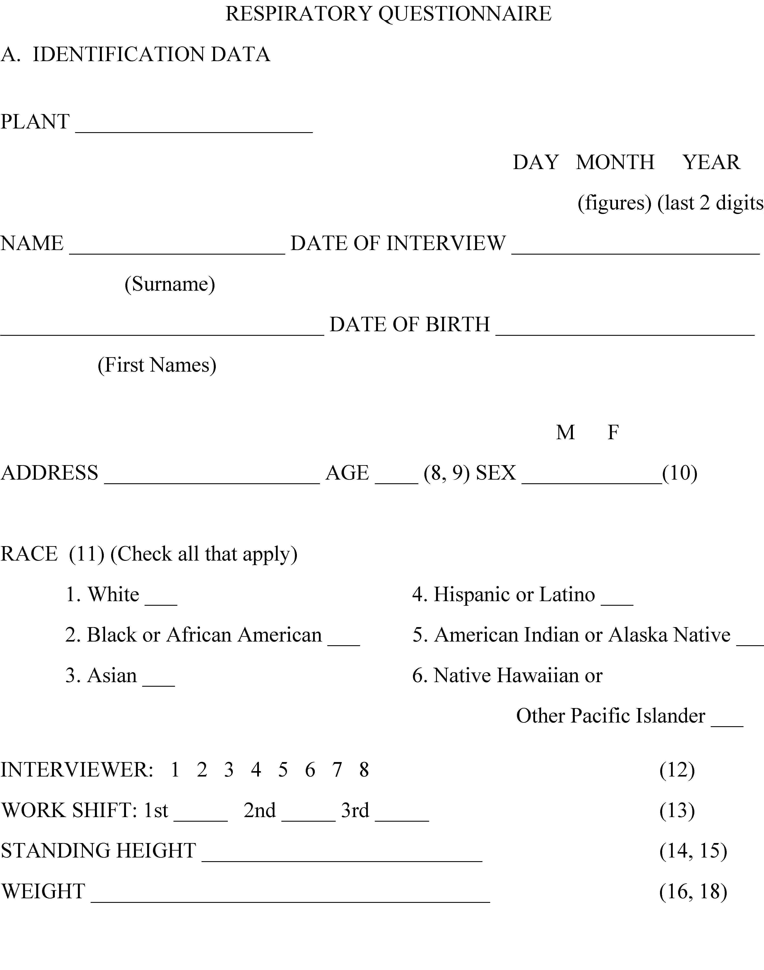
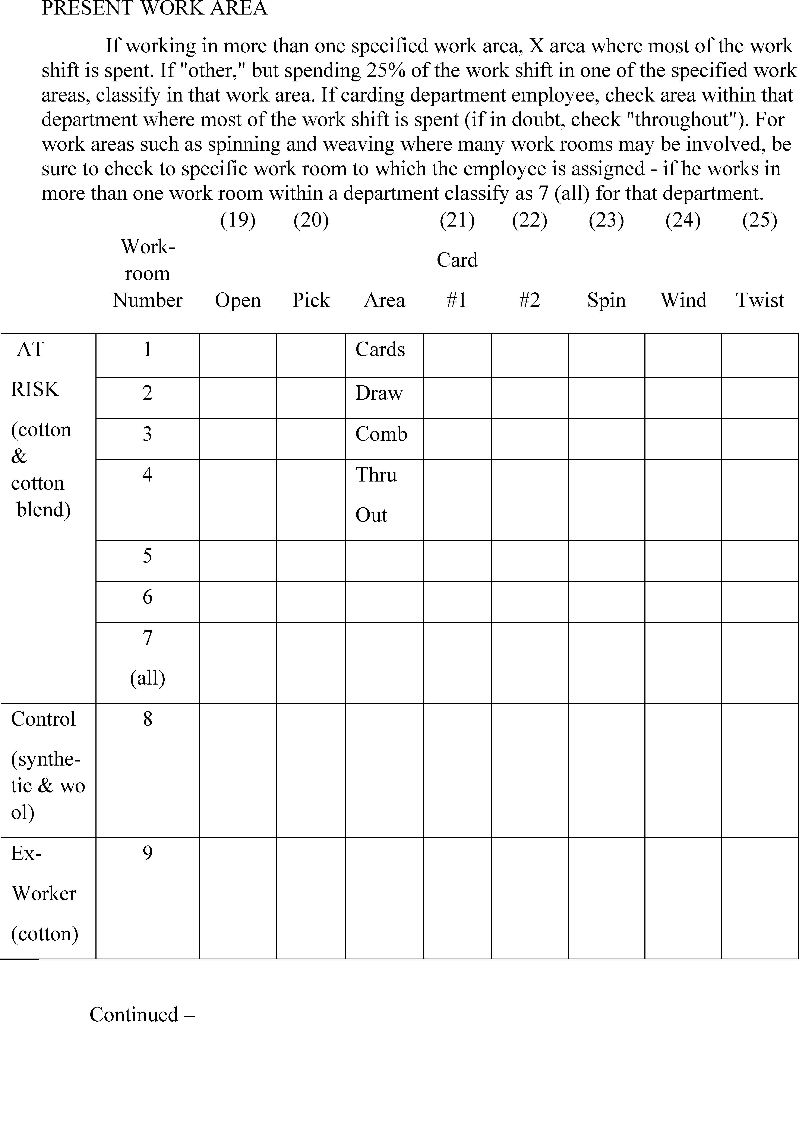
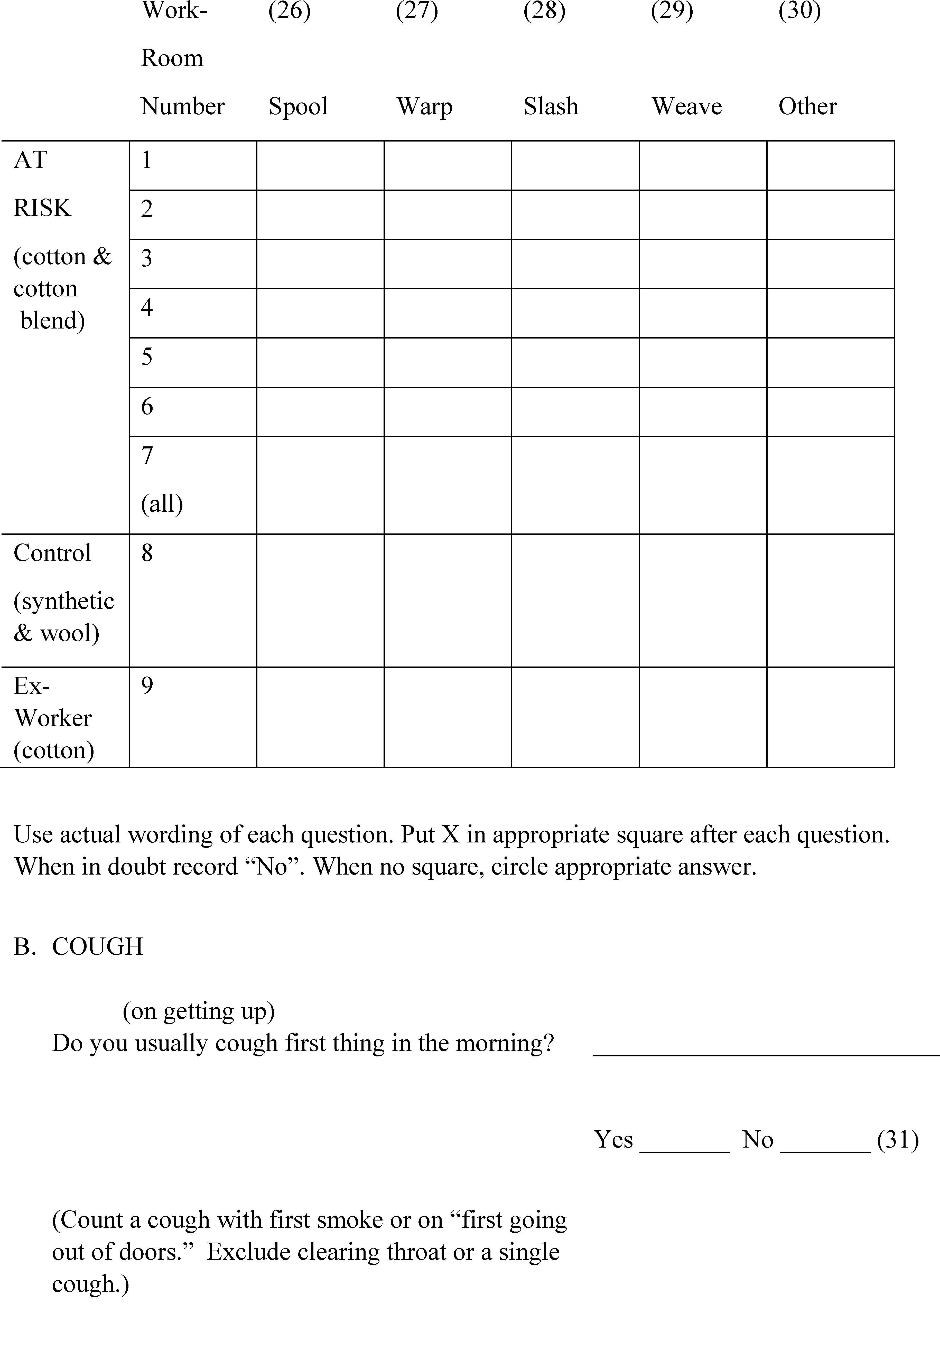
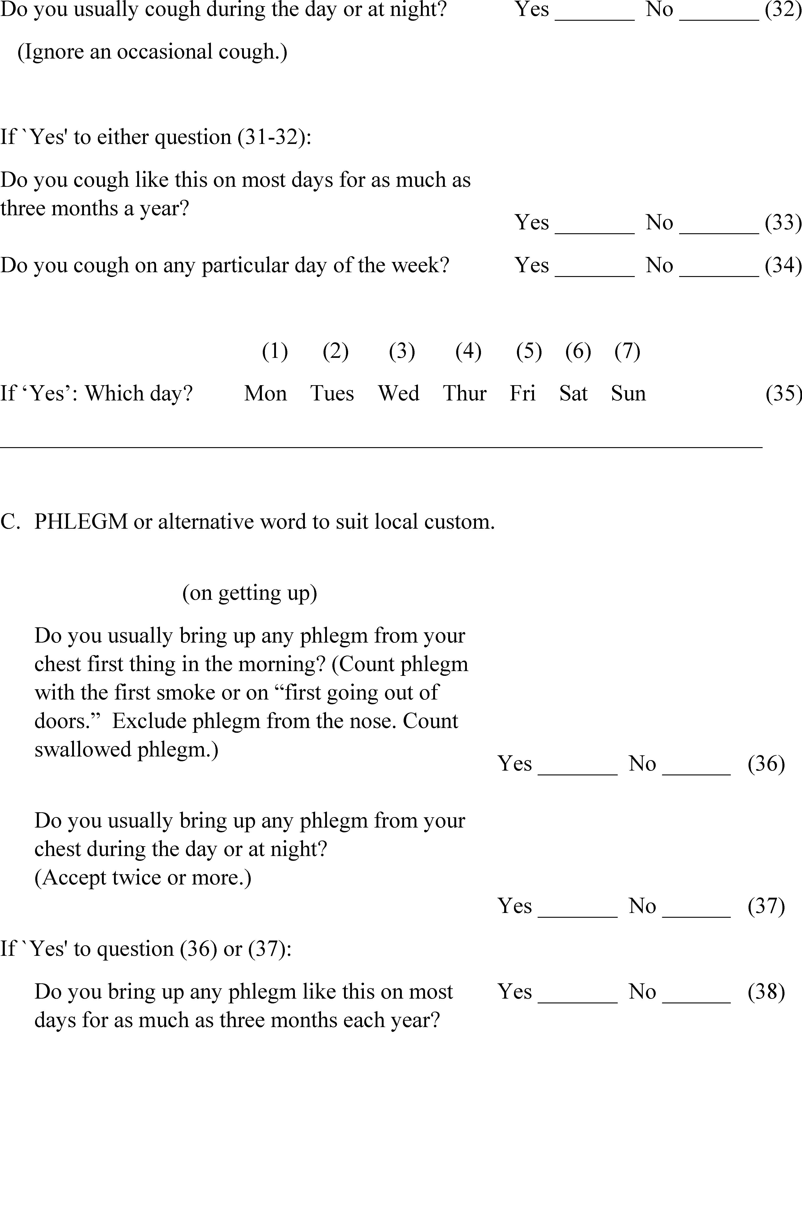
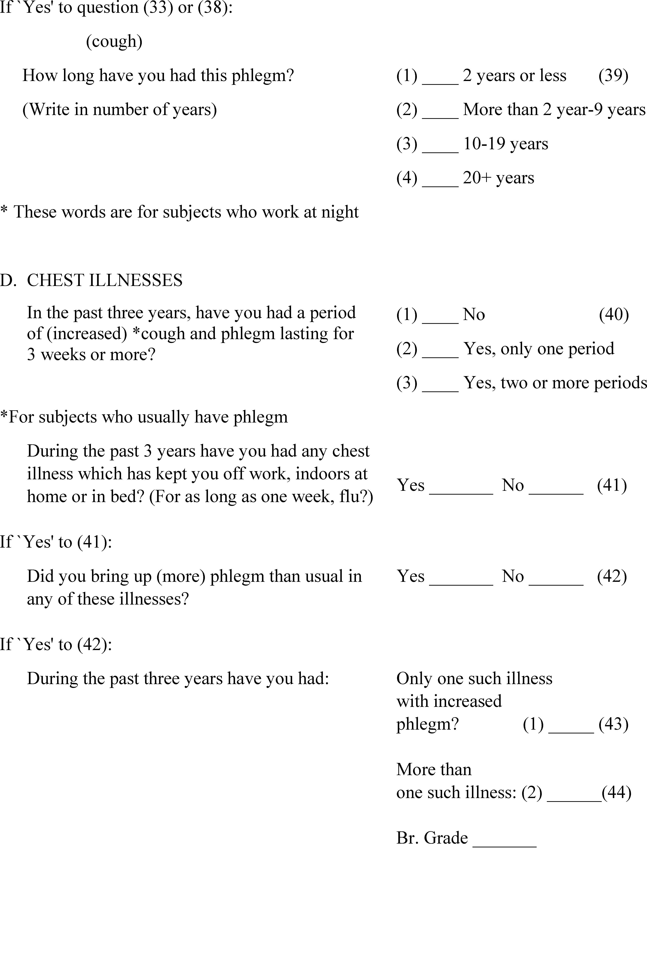
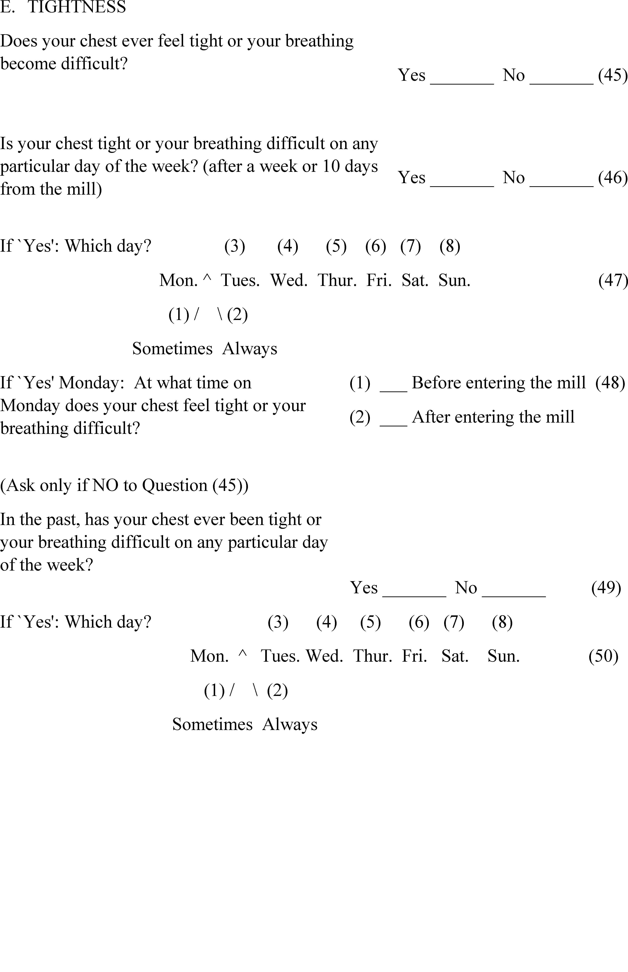
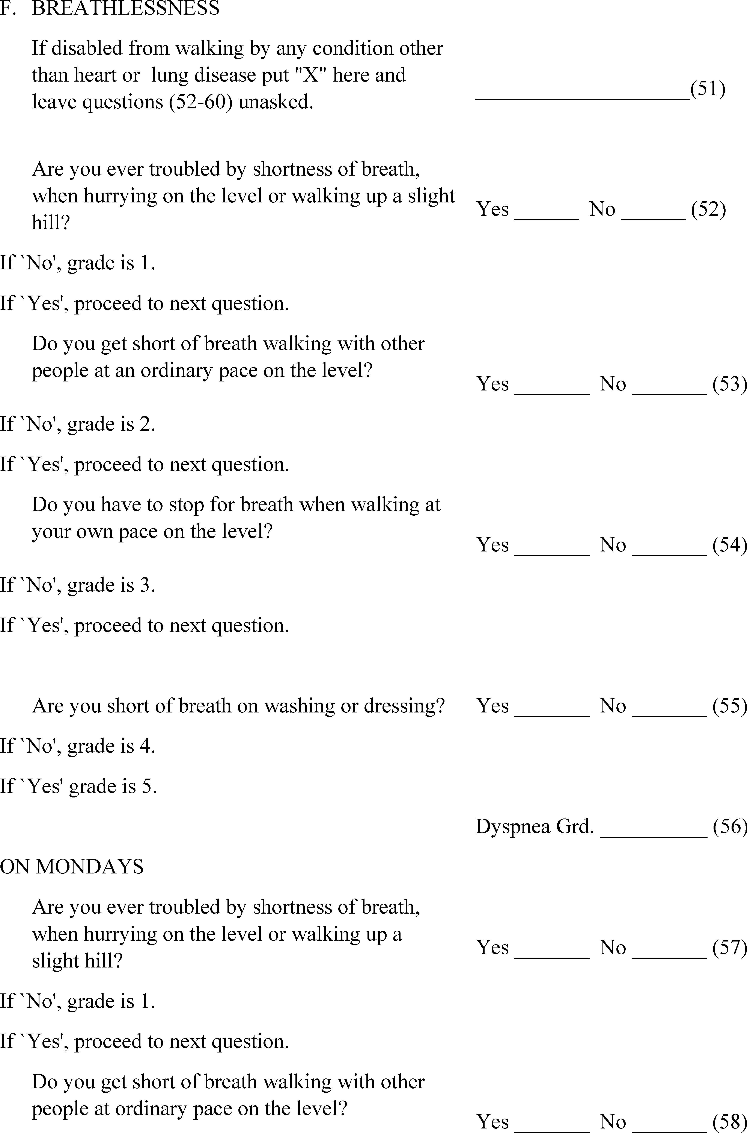
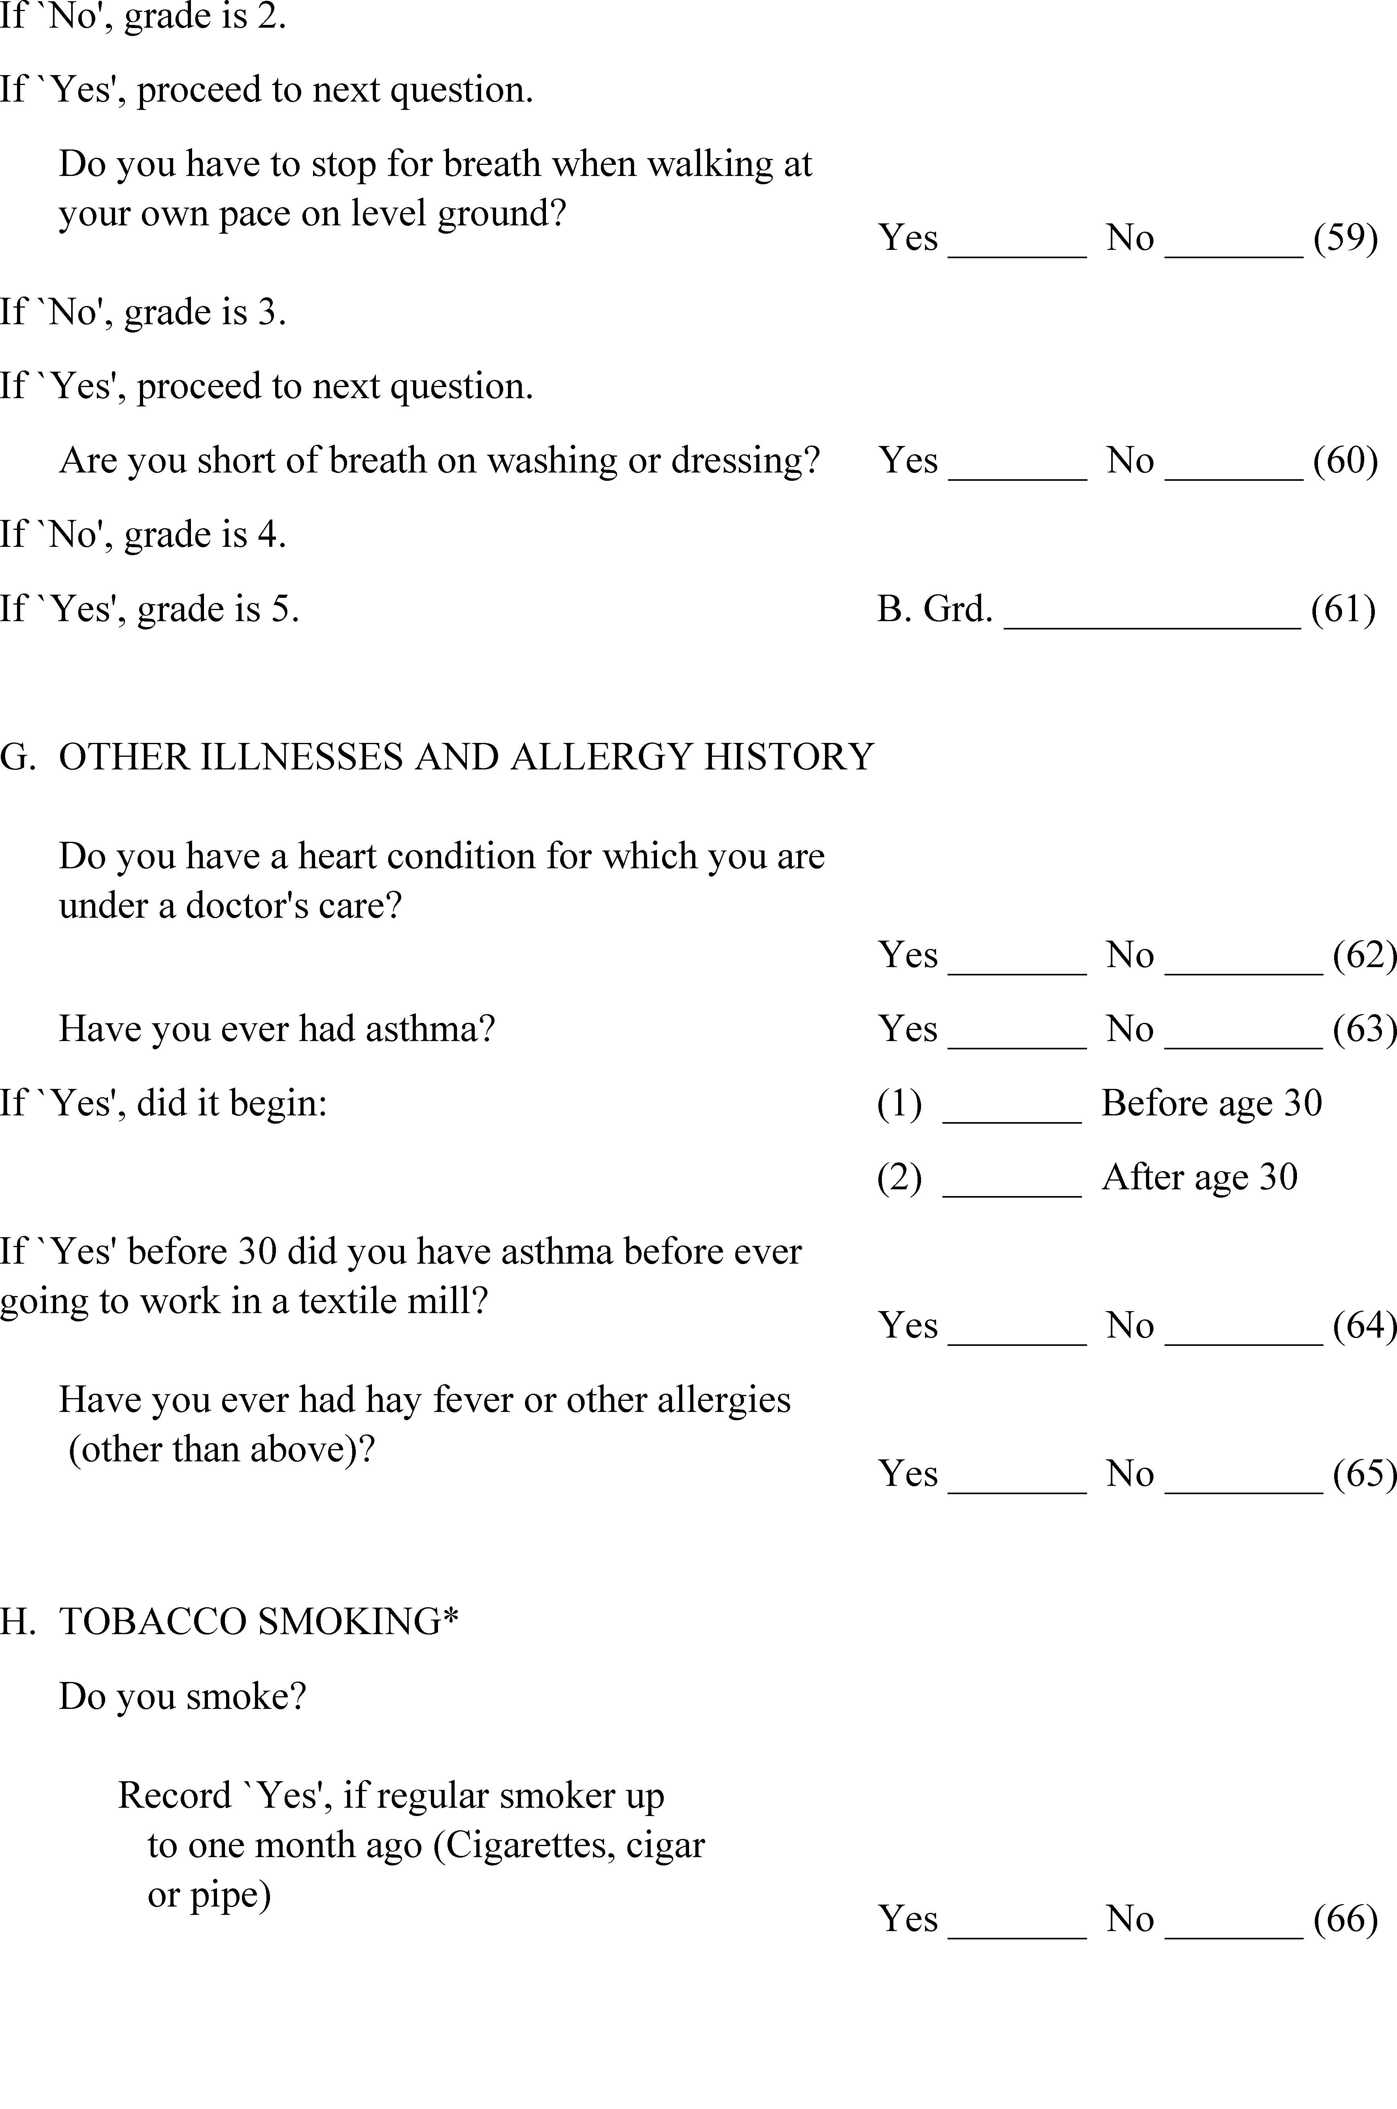
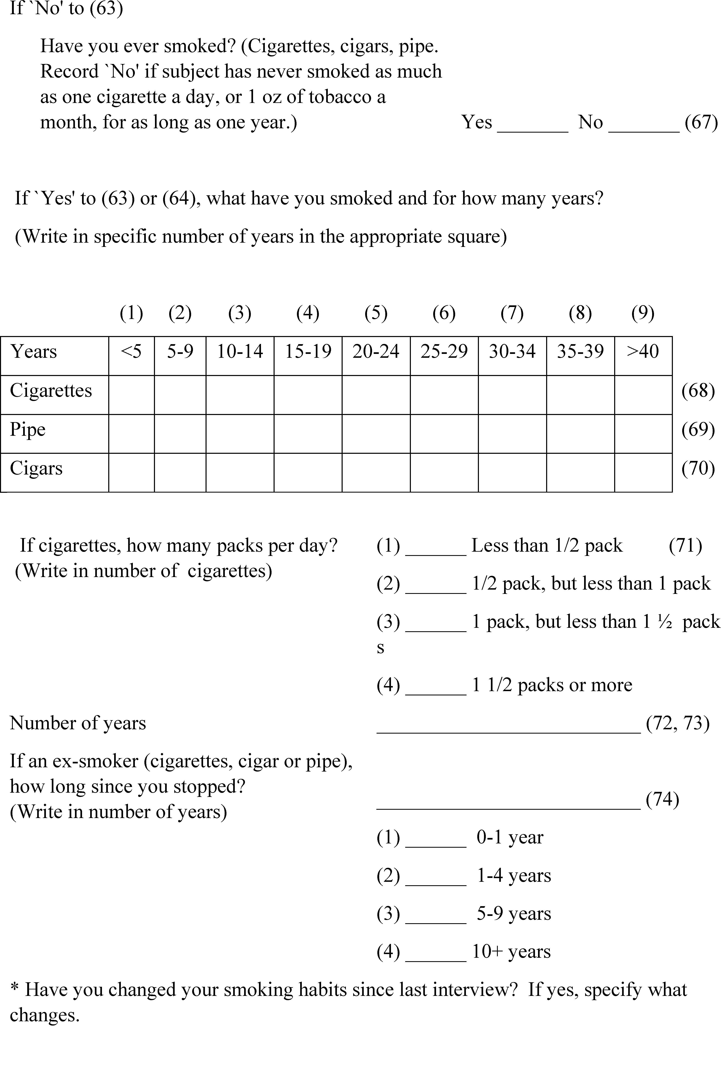
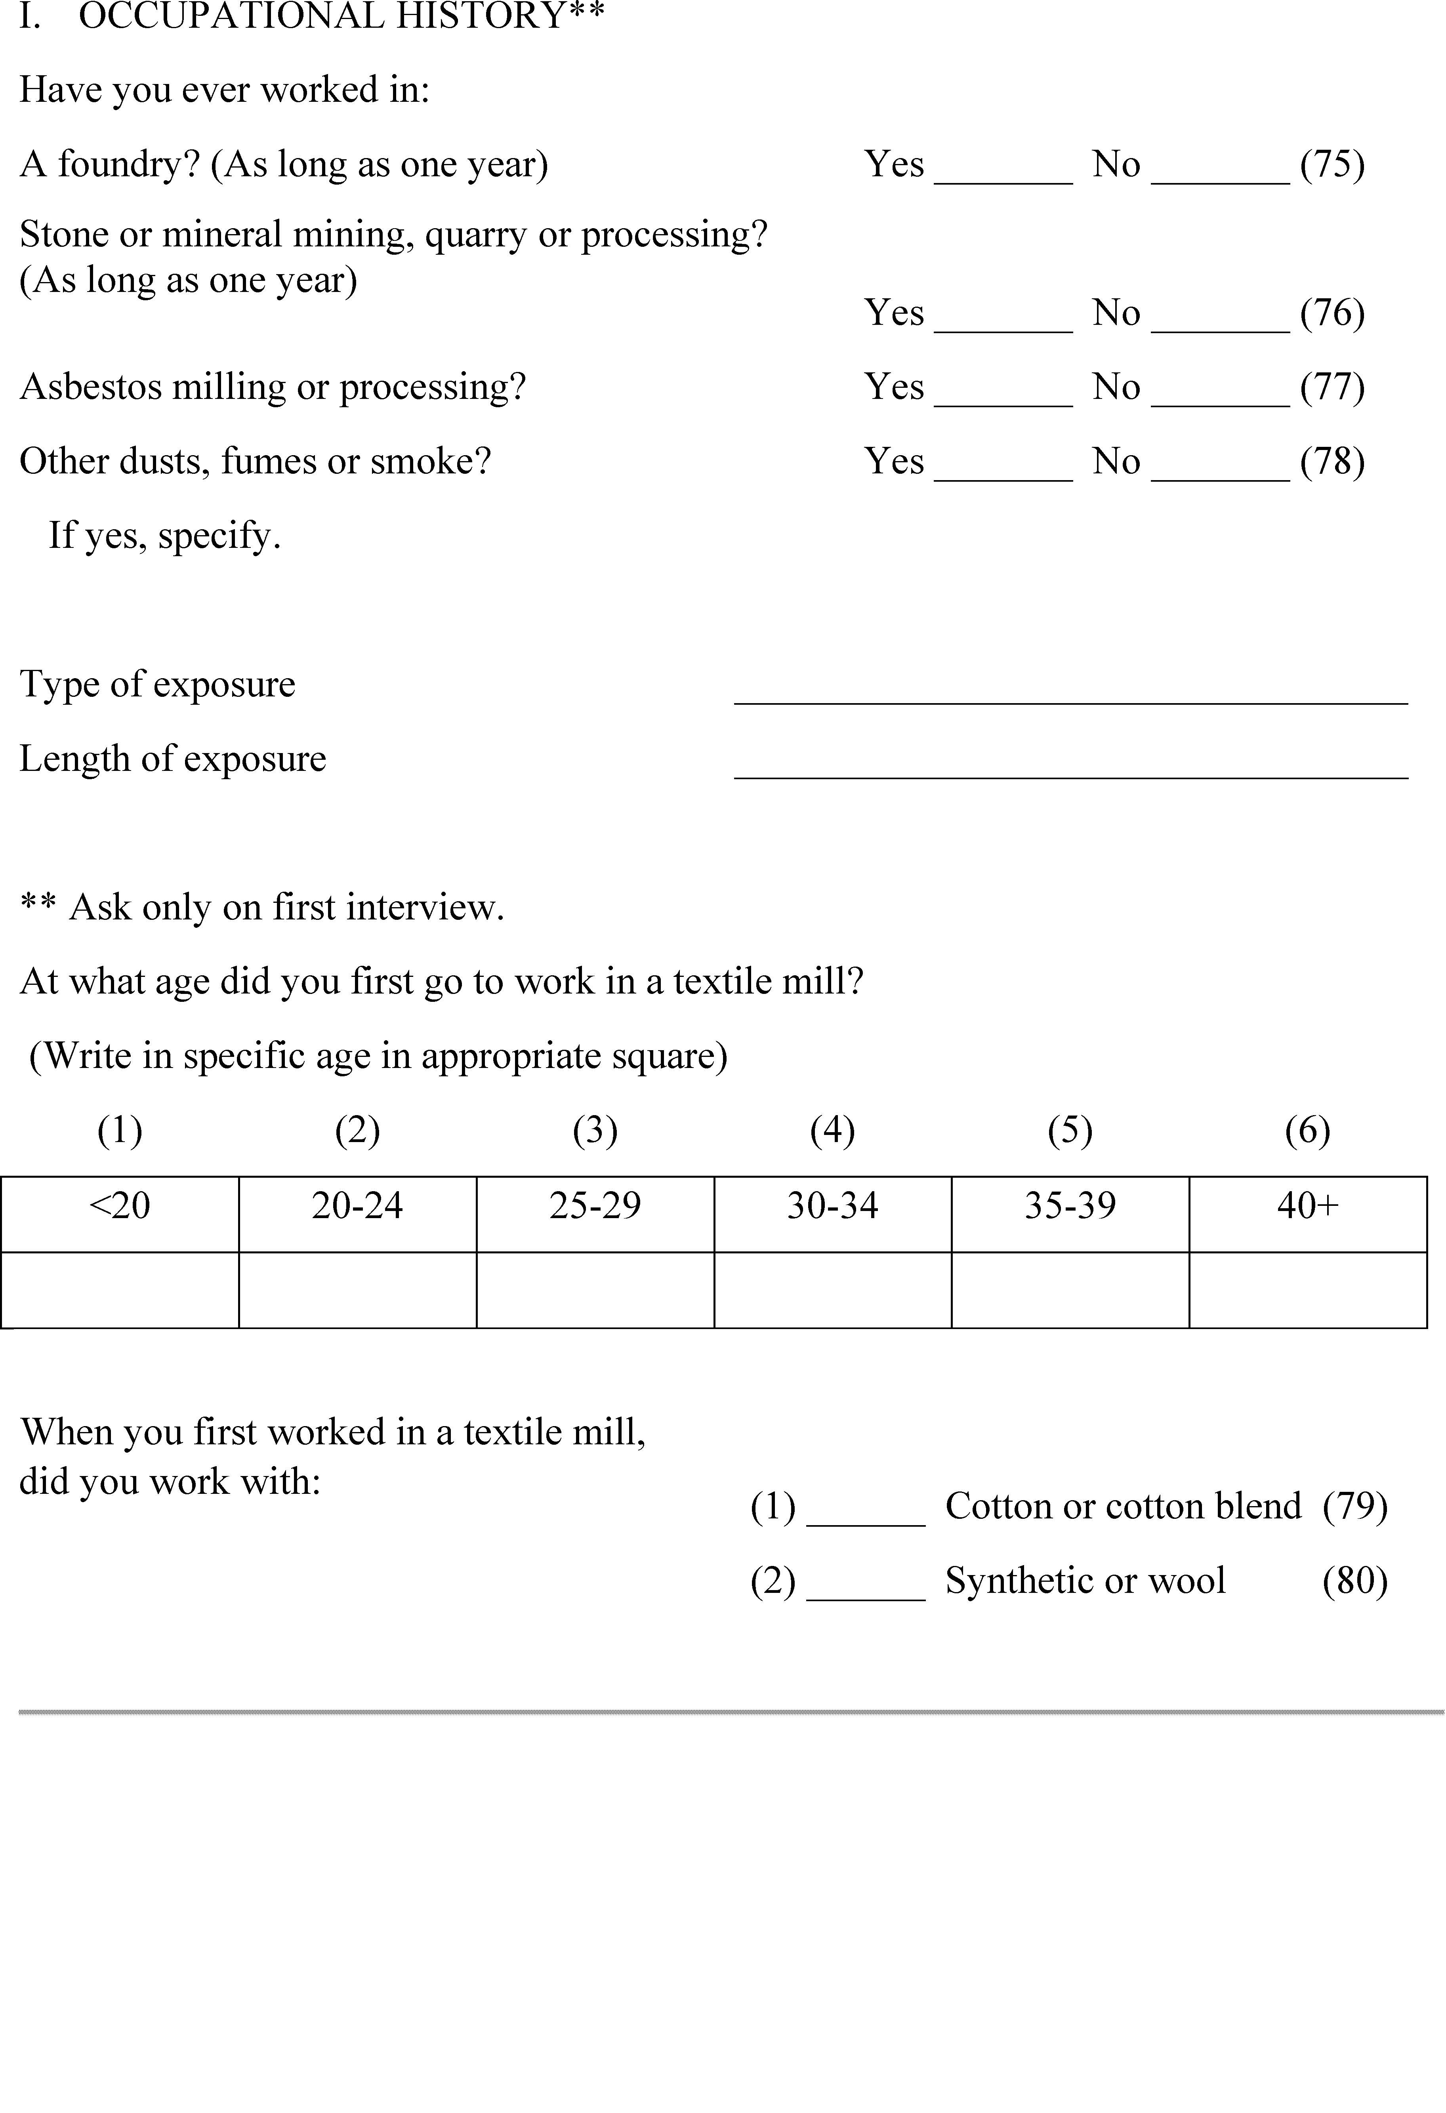

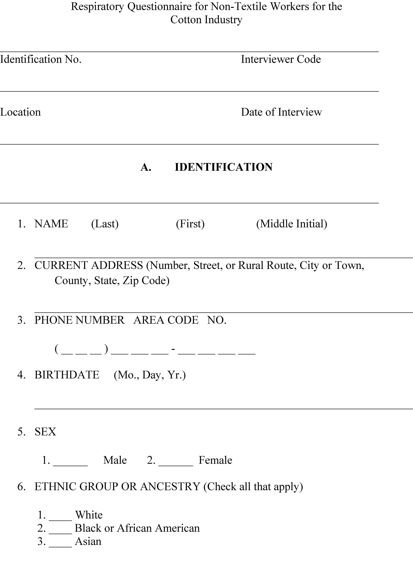
Appendix B-II to 1910.1043 – Respiratory Questionnaire for Non-Textile Workers for the Cotton Industry
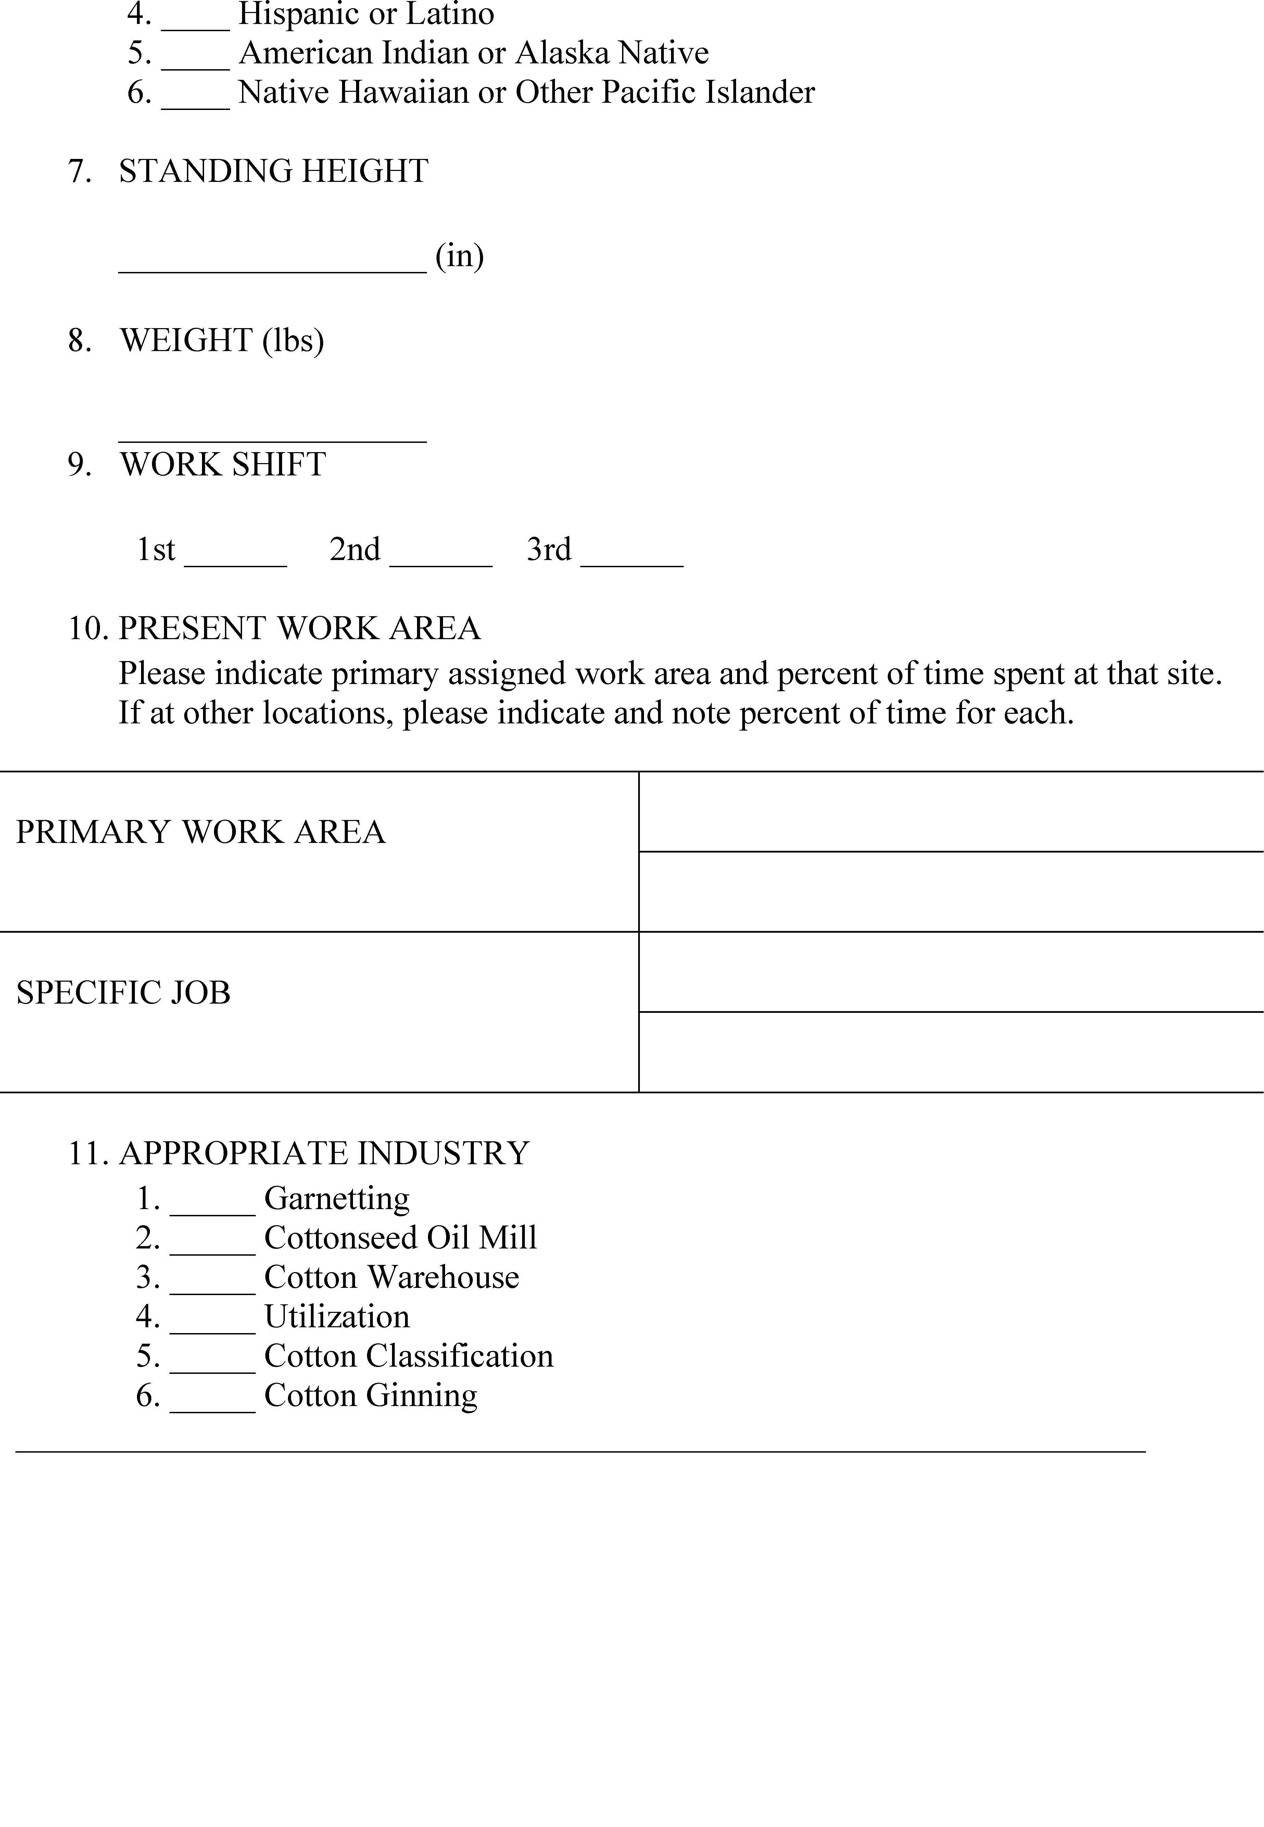
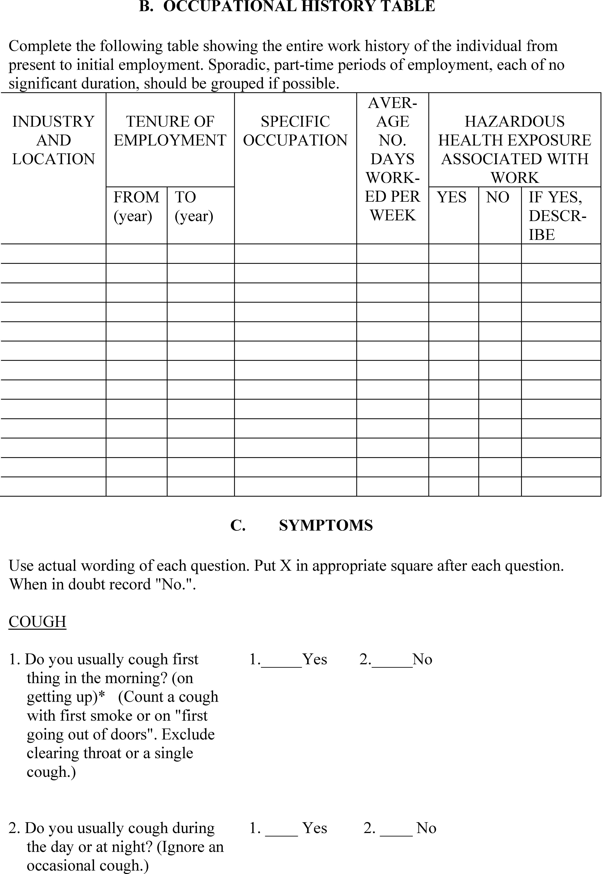
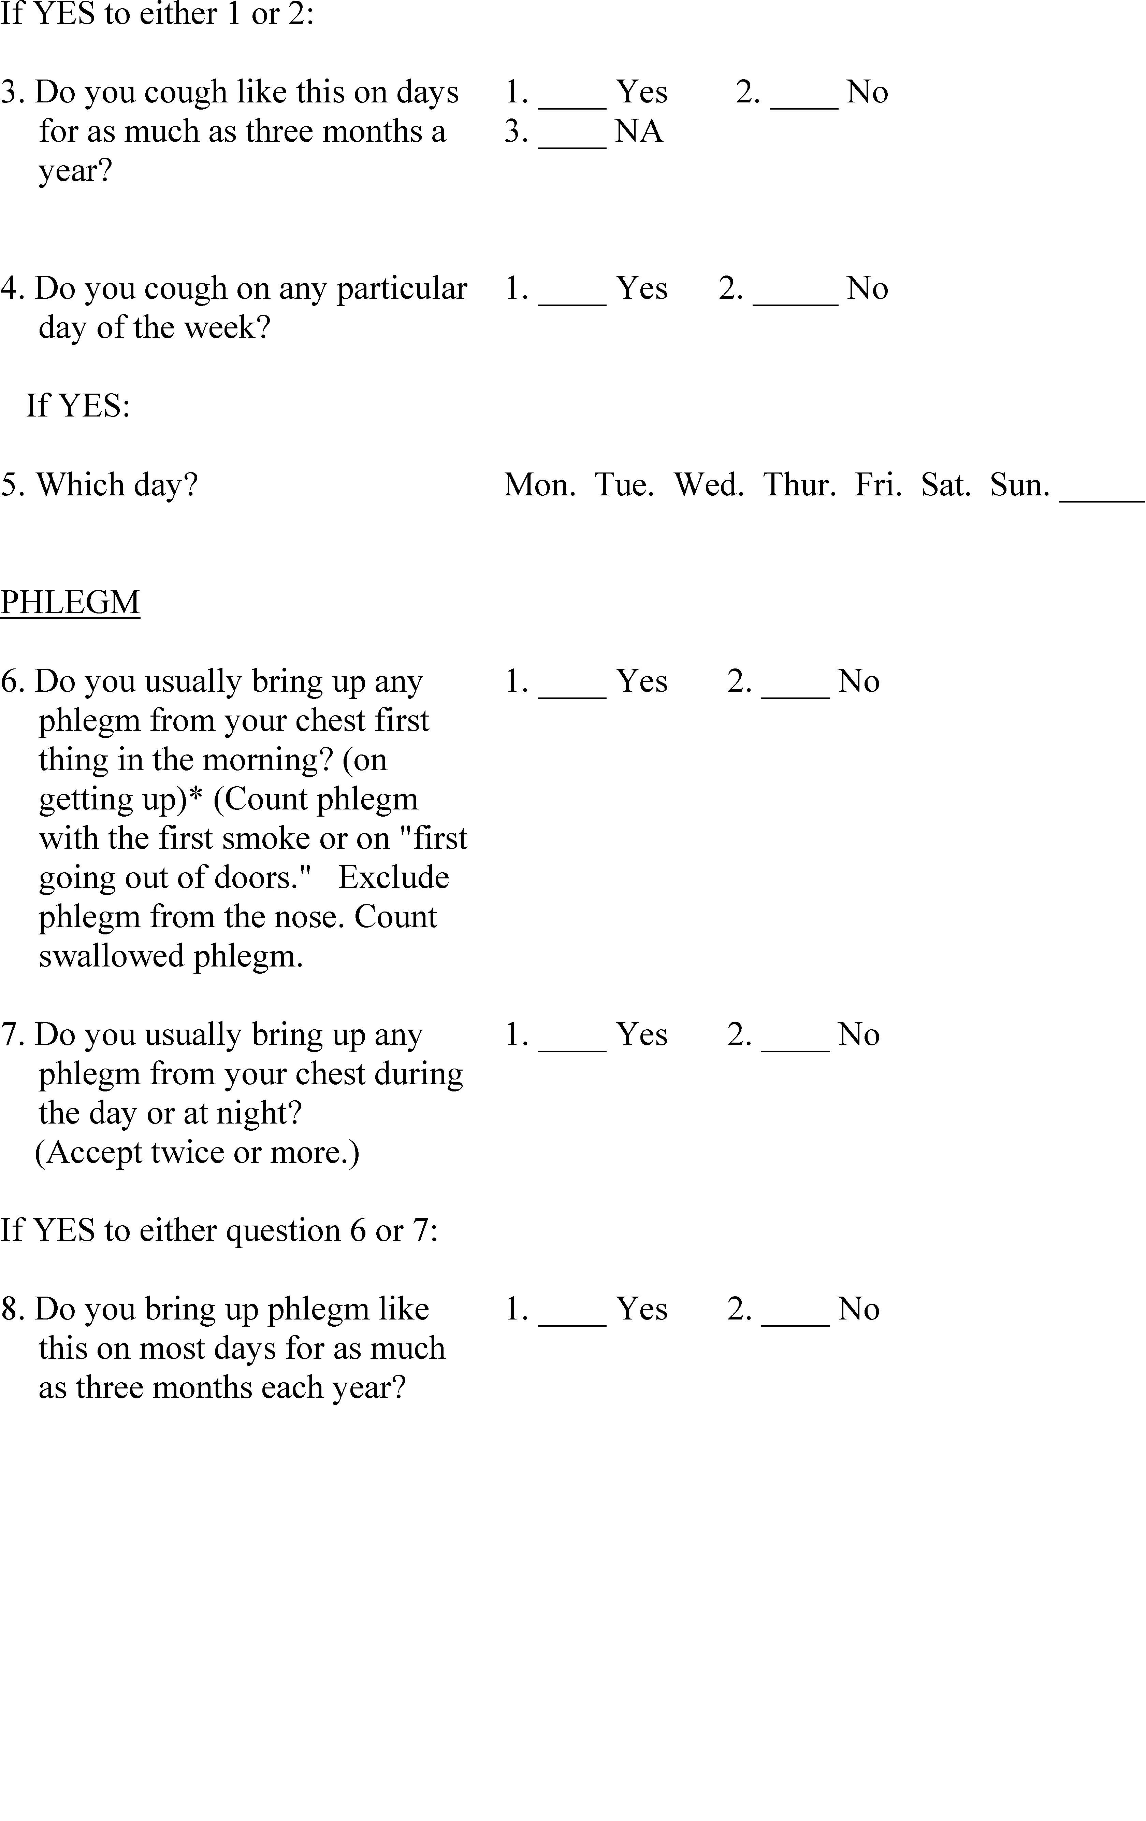
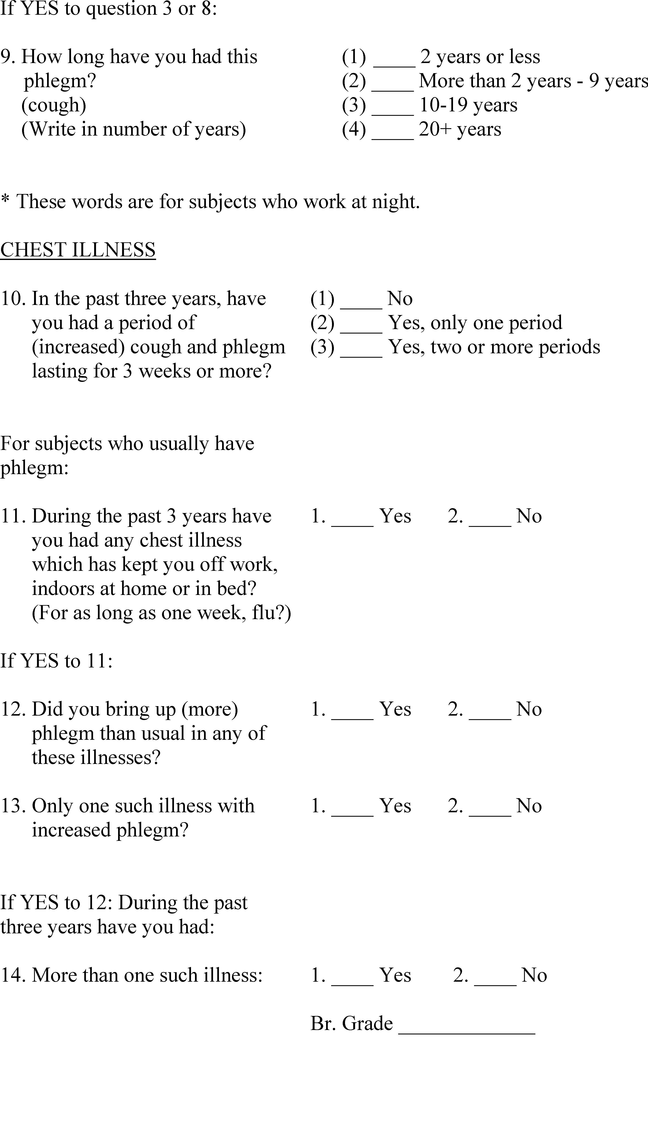
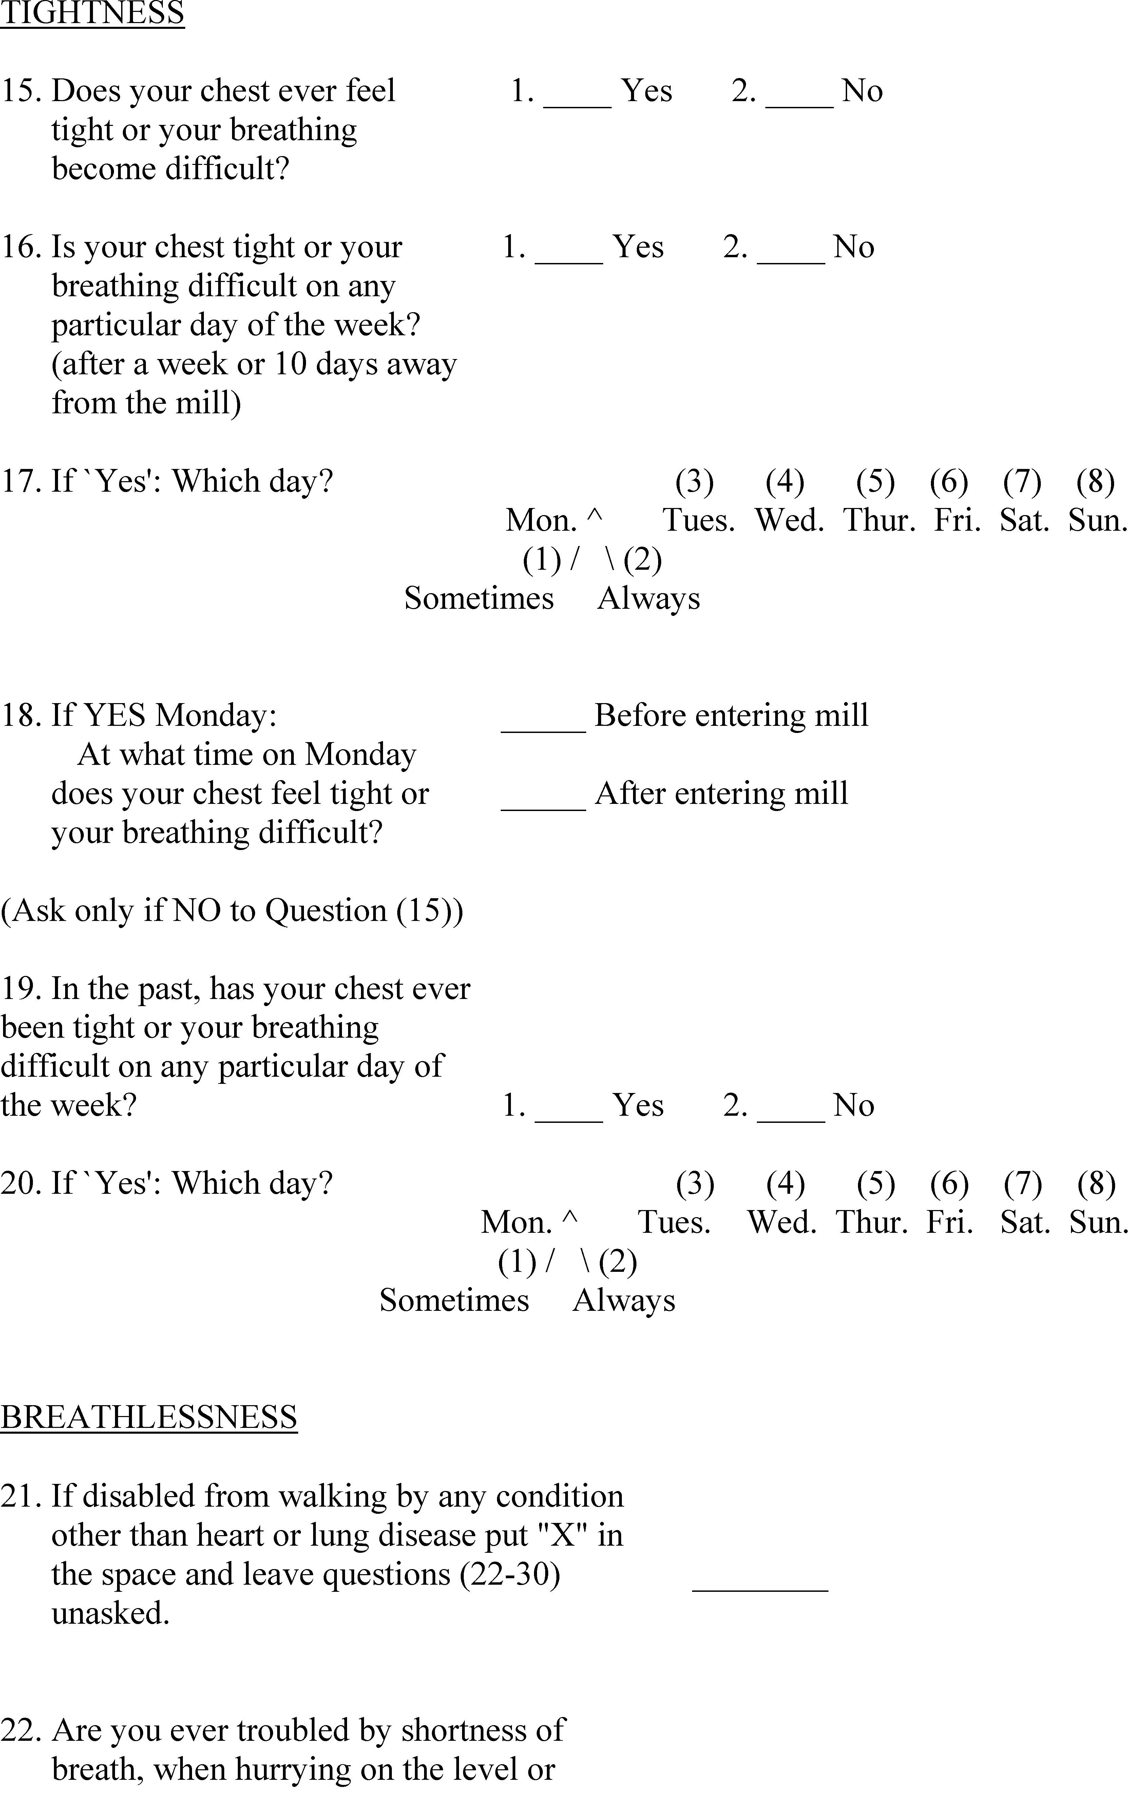
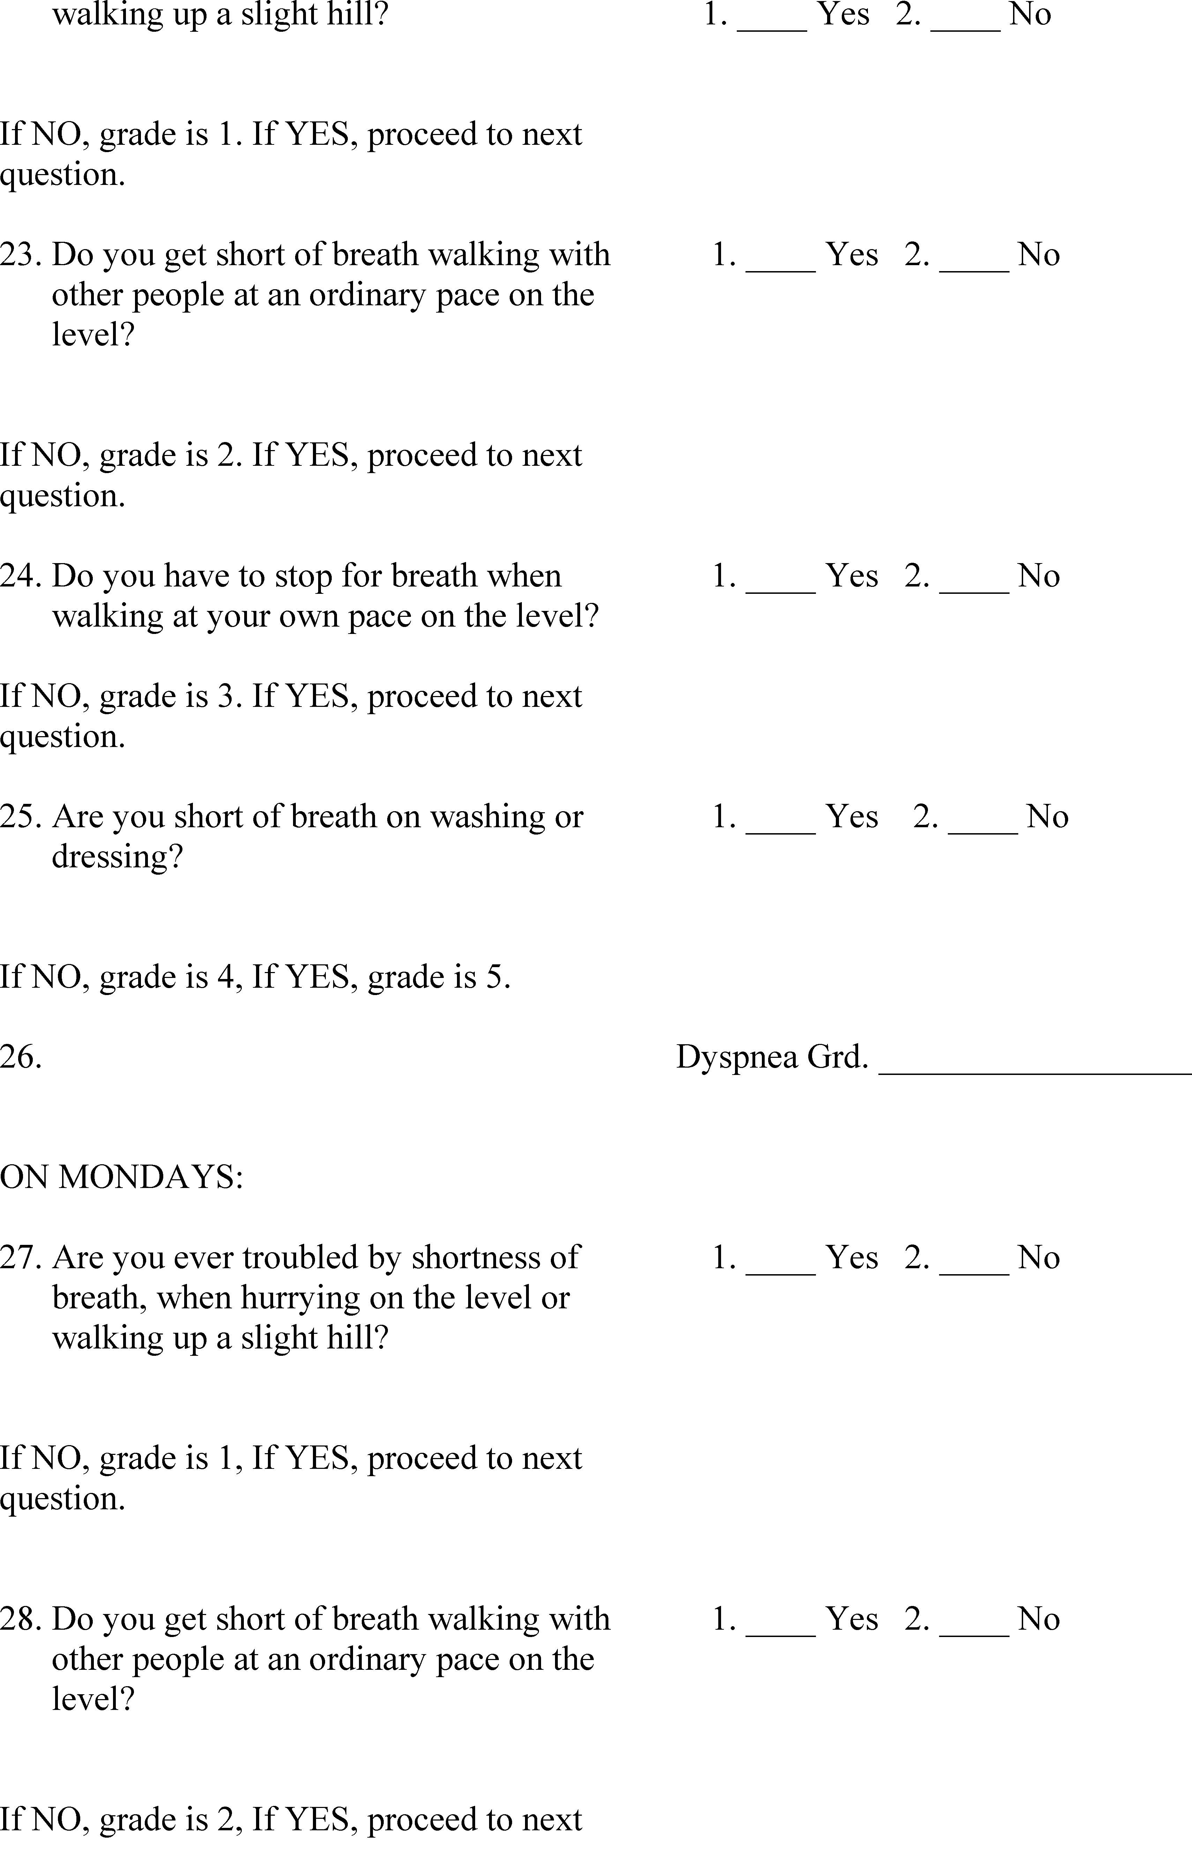
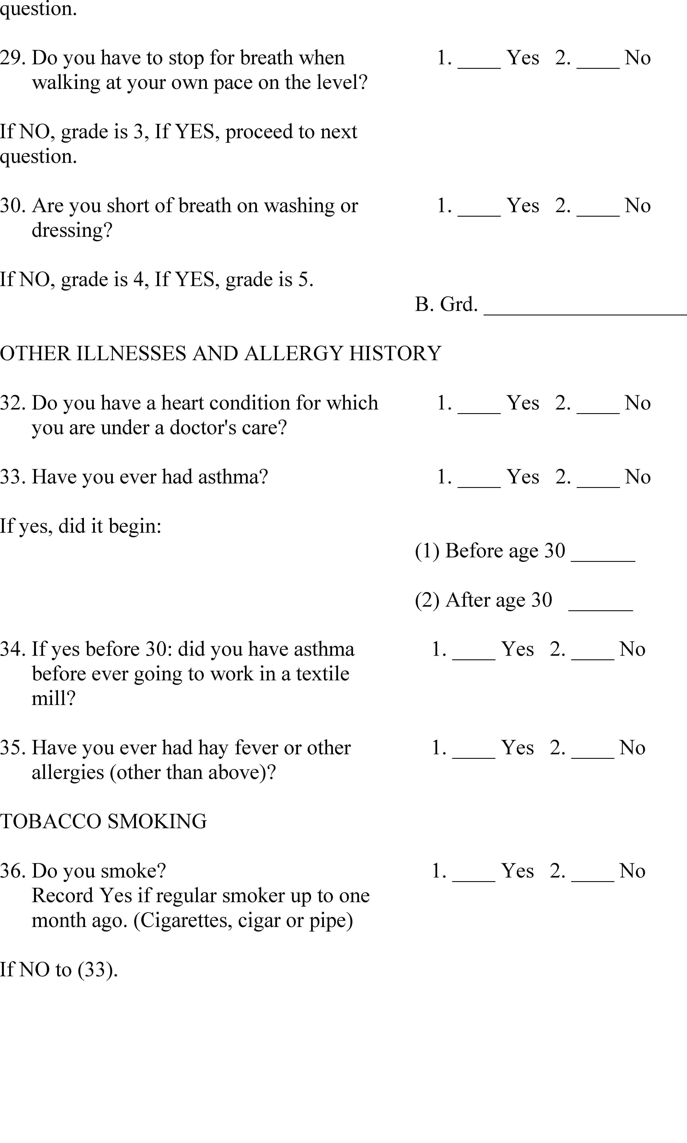
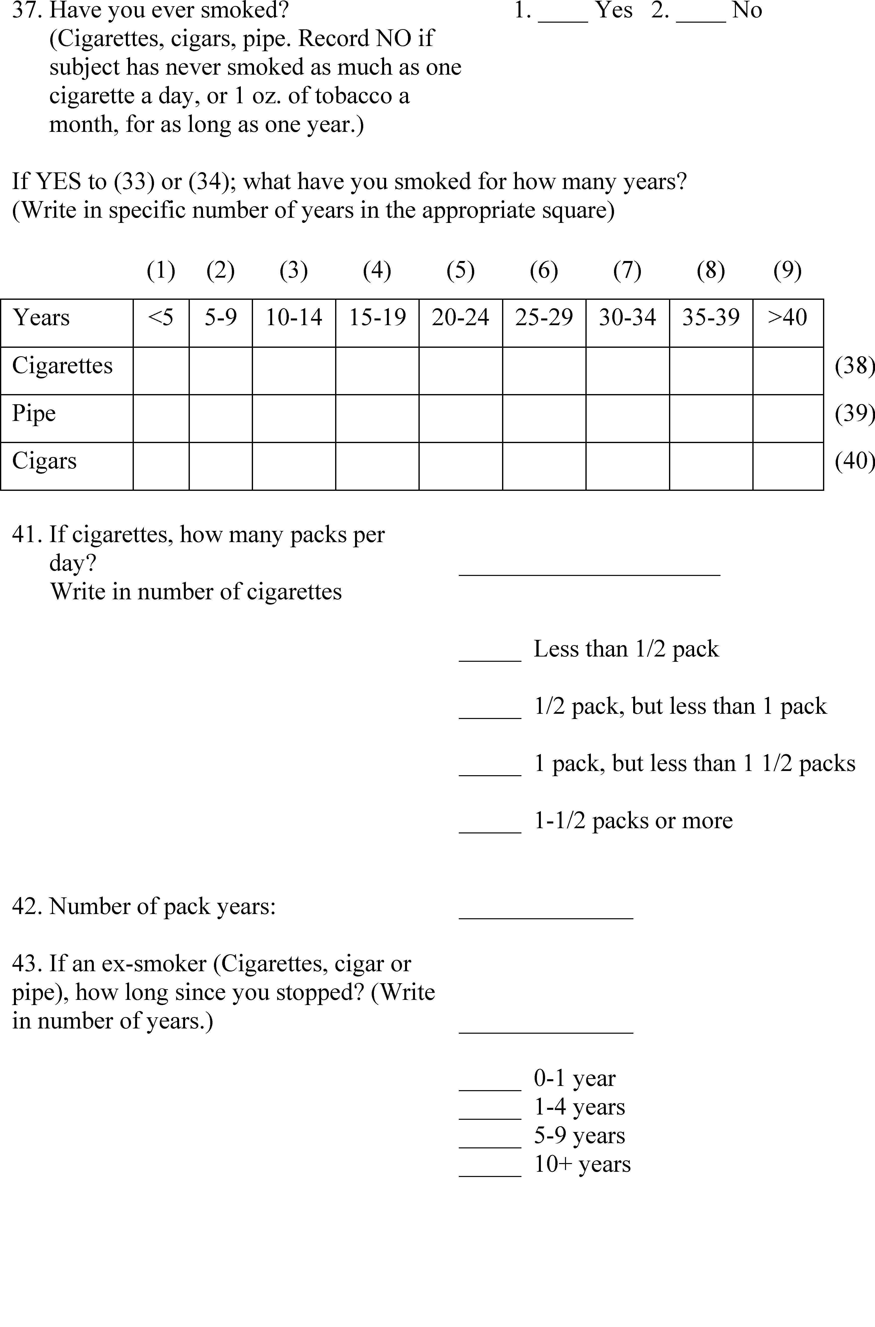
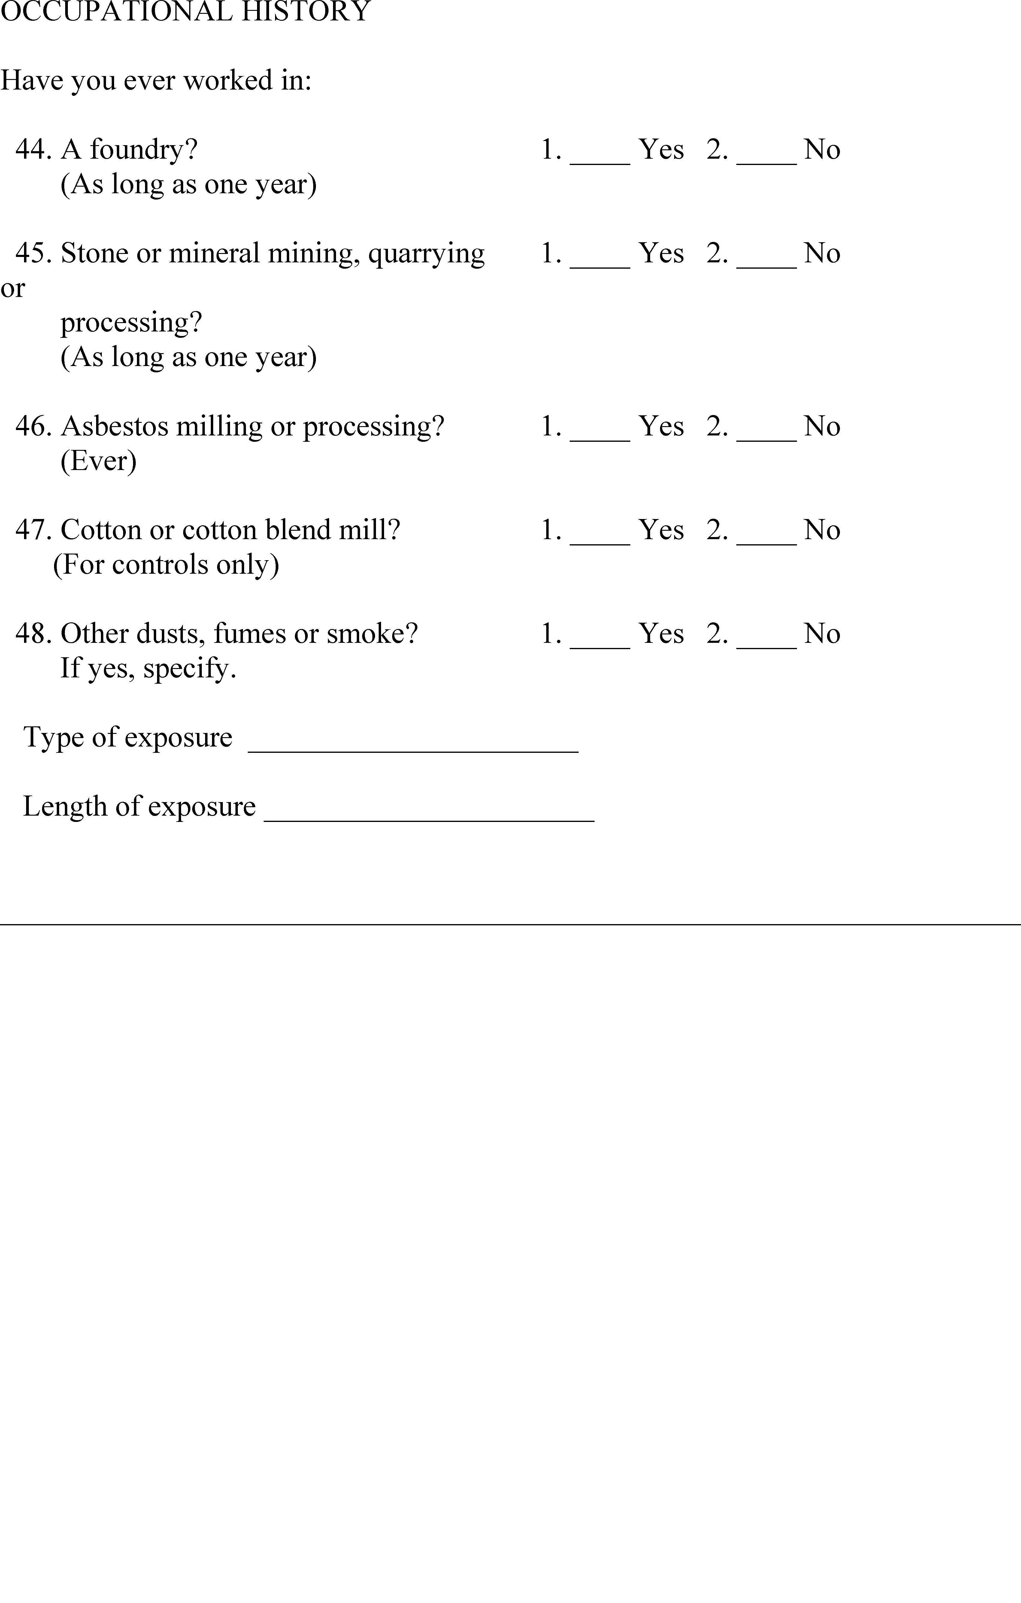

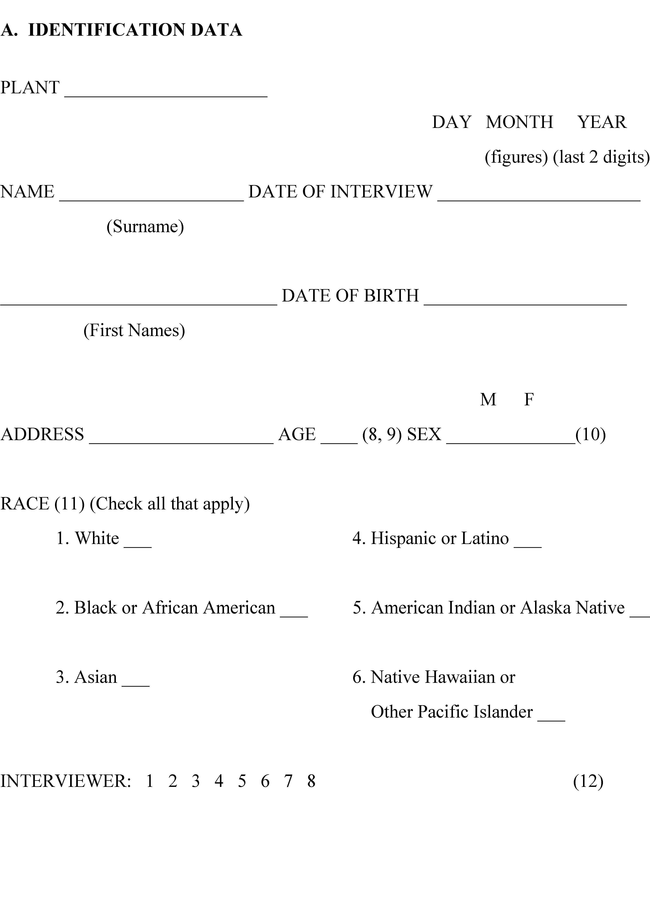
Appendix B-III to 1910.1043 – Abbreviated Respiratory Questionnaire
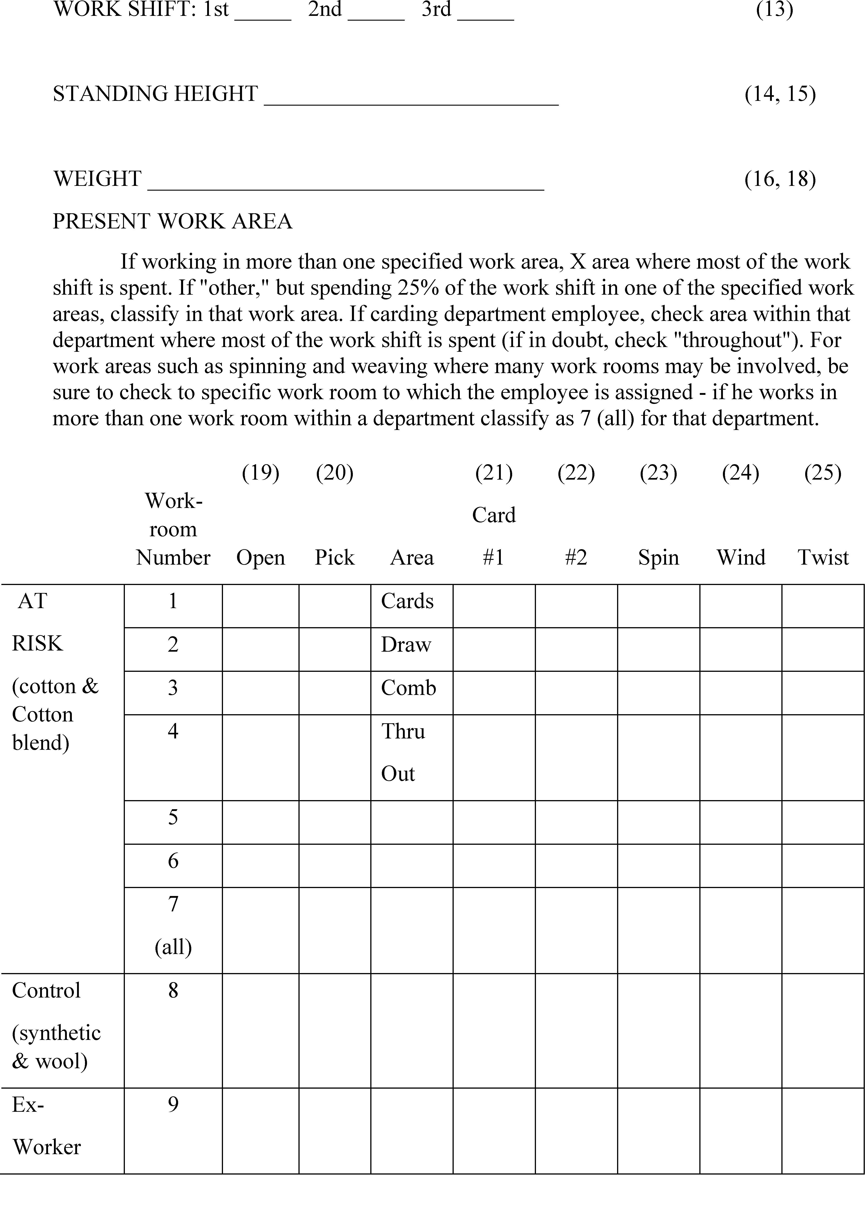
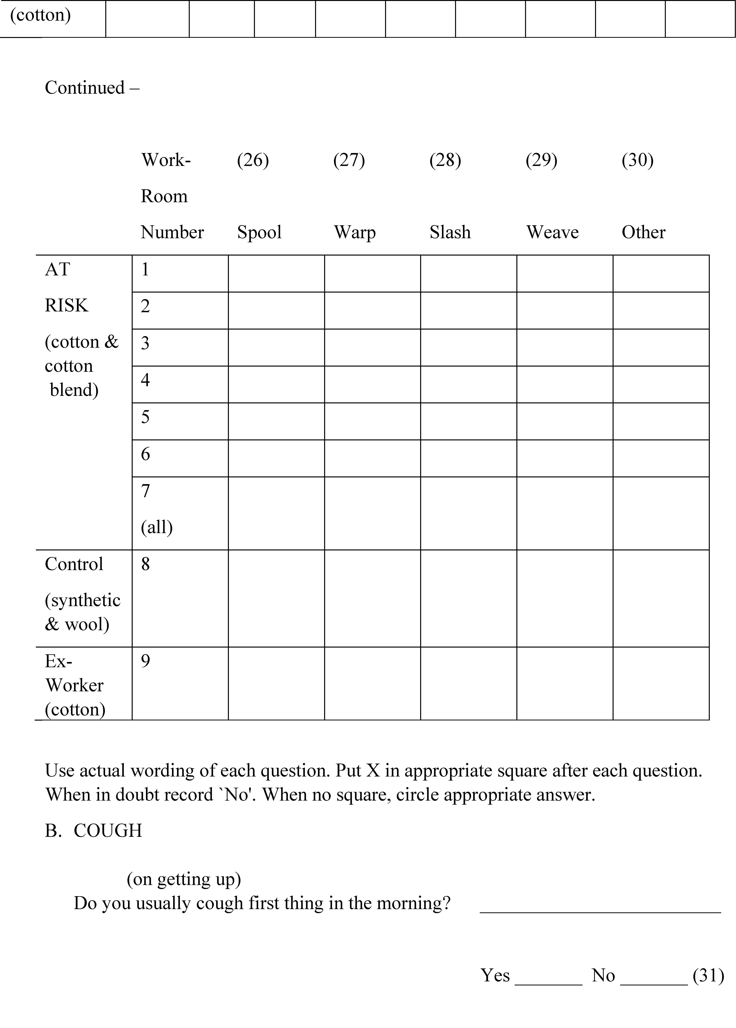
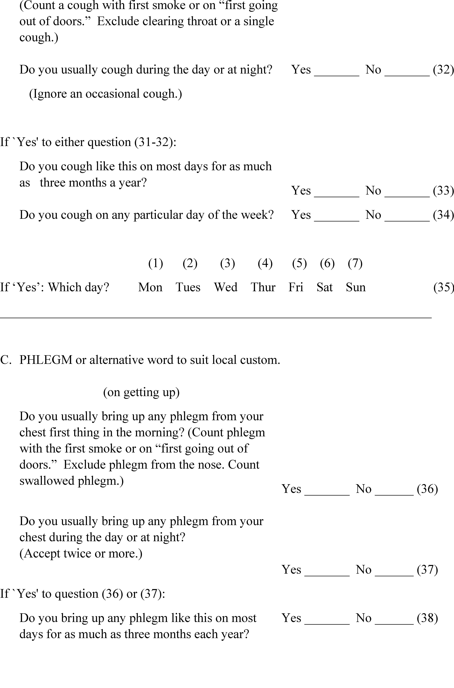
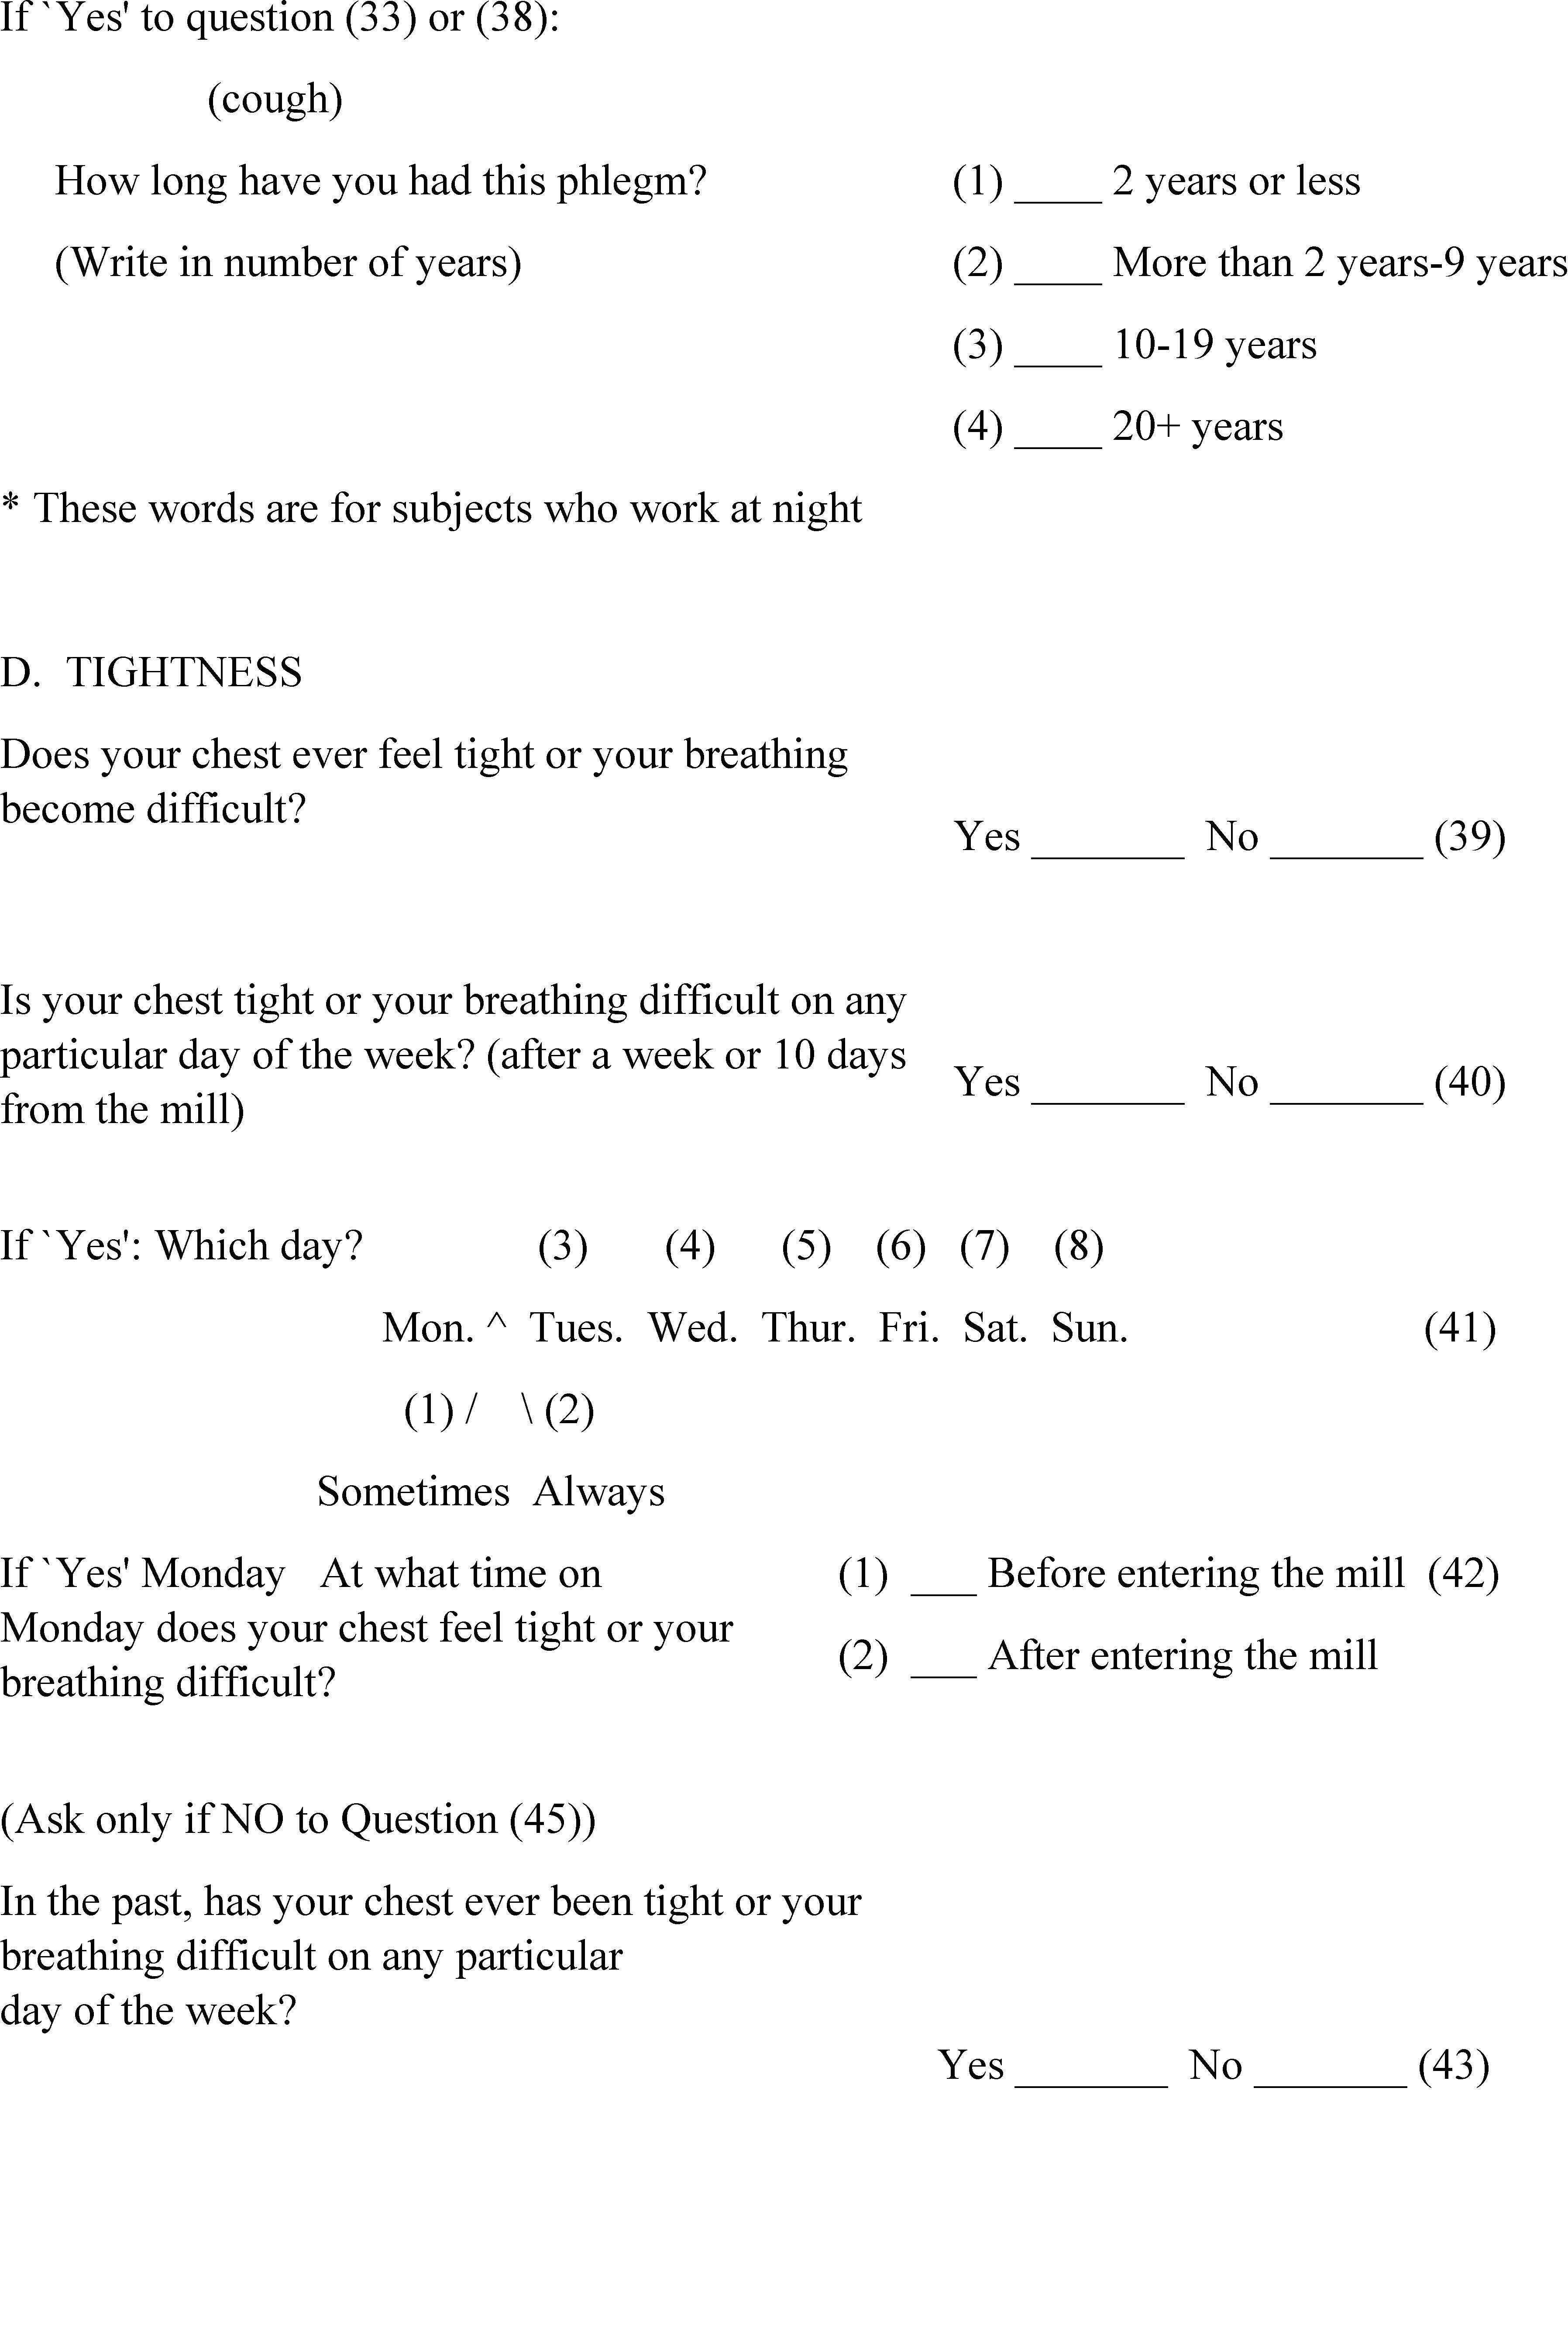

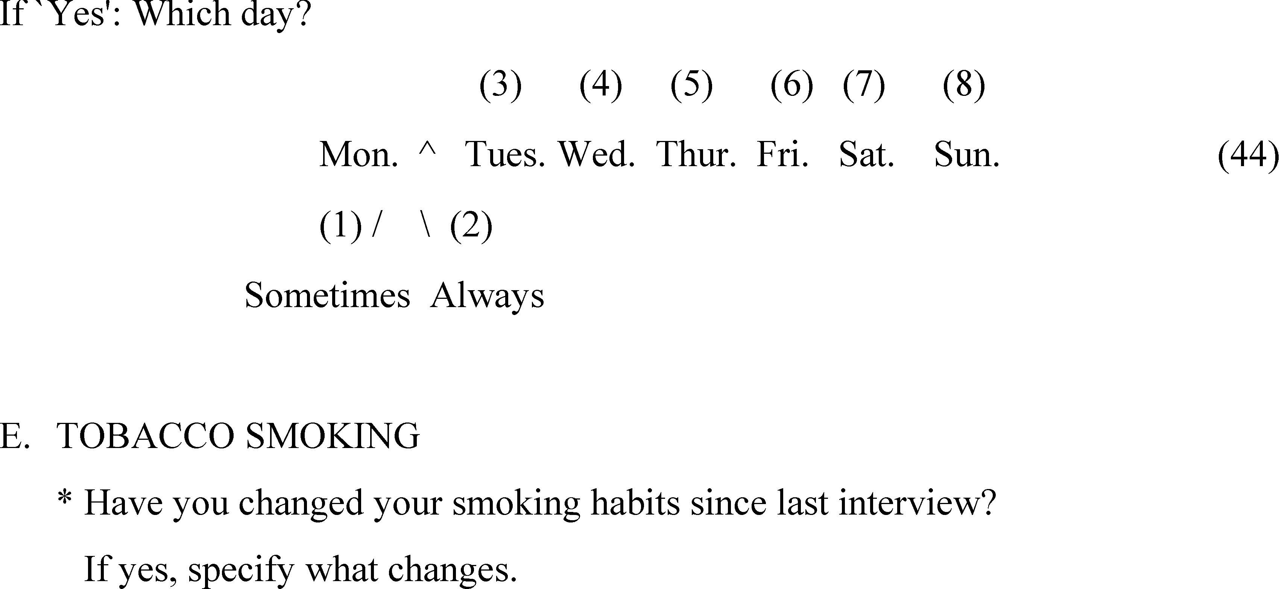

Appendix C to 1910.1043
[Reserved]

Appendix D to 1910.1043 – Pulmonary Function Standards for Cotton Dust Standard
The spirometric measurements of pulmonary function shall conform to the following minimum standards, and these standards are not intended to preclude additional testing or alternate methods which can be determined to be superior.
I. APPARATUS
a. The instrument shall be accurate to within ±50 milliliters or within ±3 percent of reading, whichever is greater.
b.
1. Instruments purchased on or before May 14, 2020 should be capable of measuring vital capacity from 0 to 7 liters BTPS.
2. Instruments purchased after May 14, 2020 should be capable of measuring vital capacity from 0 to 8 liters BTPS.
c. The instrument shall have a low inertia and offer low resistance to airflow such that the resistance to airflow at 12 liters per second must be less than 1.5 cm H₂O/(liter/sec).
d. The zero time point for the purpose of timing the FEV₁ shall be determined by extrapolating the steepest portion of the volume time curve back to the maximal inspiration volume (1, 2, 3, 4) or by an equivalent method.
e.
1. Instruments purchased on or before May 14, 2020 that incorporate measurements of airflow to determine volume shall conform to the same volume accuracy stated in paragraph (a) of this section I when presented with flow rates from at least 0 to 12 liters per second.
2. Instruments purchased after May 14, 2020 that incorporate measurements of airflow to determine volume shall conform to the same volume accuracy stated in paragraph (a) of this section I when presented with flow rates from at least 0 to 14 liters per second.
f. The instrument or user of the instrument must have a means of correcting volumes to body temperature saturated with water vapor (BTPS) under conditions of varying ambient spirometer temperatures and barometric pressures.
g.
1. Instruments purchased on or before May 14, 2020 shall provide a tracing or display of either flow versus volume or volume versus time during the entire forced expiration. A tracing or display is necessary to determine whether the patient has performed the test properly. The tracing must be stored and available for recall and must be of sufficient size that hand measurements may be made within the volume accuracy requirements of paragraph (a) of this section I. If a paper record is made it must have a paper speed of at least 2 cm/sec and a volume sensitivity of at least 10.0 mm of chart per liter of volume.
2. Instruments purchased after May 14, 2020 shall provide during testing a paper tracing or real-time display of flow versus volume and volume versus time for the entire forced expiration. Such a tracing or display is necessary to determine whether the worker has performed the test properly. Flow-volume and volume-time curves must be stored and available for recall. Real-time displays shall have a volume scale of at least 5 mm/L, a time scale of at least 10 mm/s, and a flow scale of at least 2.5 mm/L/s, when both flow-volume and volume-time displays are visible. If hand measurements will be made, paper tracings must be of sufficient size to allow those measurements to be made within the volume accuracy requirements of paragraph (a) of this section I. If a paper record is made it must have a paper speed of at least 2 cm/sec and a volume sensitivity of at least 10.0 mm of chart per liter of volume.
h.
1. Instruments purchased on or before May 14, 2020 shall be capable of accumulating volume for a minimum of 10 seconds and shall not stop accumulating volume before (i) the volume change for a 0.5-second interval is less than 25 milliliters, or (ii) the flow is less than 50 milliliters per second for a 0.5 second interval.
2. Instruments purchased after May 14, 2020 shall be capable of accumulating volume for a minimum of 15 seconds and shall not stop accumulating volume before the volume change for a 1-second interval is less than 25 milliliters.
i. The forced vital capacity (FVC) and forced expiratory volume in 1 second (FEV₁) measurements shall comply with the accuracy requirements stated in paragraph (a) of this section. That is, they should be accurately measured to within ±50 ml or within ±3 percent of reading, whichever is greater.
j.
1. Instruments purchased on or before May 14, 2020 must be capable of being calibrated in the field with respect to the FEV₁ and FVC. This calibration of the FEV₁ and FVC may be either directly or indirectly through volume and time base measurements. The volume calibration source should provide a volume displacement of at least 2 liters and should be accurate to within + or - 30 milliliters.
2. Instruments purchased after May 14, 2020 must be capable of having its calibration checked in the field and be recalibrated, if necessary, if the spirometer requires the technician to do so. The volume-calibration syringe shall provide a volume displacement of at least 3 liters and shall be accurate to within ±0.5 percent of 3 liters (15 milliliters).
II. TECHNIQUE FOR MEASUREMENT OF FORCED VITAL CAPACITY MANEUVER
a. Use of a nose clip is recommended but not required. The procedures shall be explained in simple terms to the patient who shall be instructed to loosen any tight clothing and stand in front of the apparatus. The worker may sit, but care should be taken on repeat testing that the same position be used and, if possible, the same spirometer. Particular attention shall be given to insure that the chin is slightly elevated with the neck slightly extended. The worker shall be instructed to make a full inspiration from a normal breathing pattern and then blow into the apparatus, without interruption, as hard, fast, and completely as possible. At least three and no more than eight forced expirations shall be carried out. During the maneuvers, the worker shall be observed for compliance with instruction. The expirations shall be checked visually for technical acceptability and repeatability from flow-volume or volume-time tracings or displays. The following efforts shall be judged unacceptable when the worker:
1. Has not reached full inspiration preceding the forced expiration,
2. Has not used maximal effort during the entire forced expiration,
3. Has not continued the expiration for at least 6 seconds and the volume-time curve shows no change in volume (<0.025 L)for at least one second,
4. Has coughed in the first second or closed the glottis,
5. Has an obstructed mouthpiece or a leak around the mouthpiece (obstruction due to tongue being placed in front of mouthpiece, false teeth falling in front of mouthpiece, etc.)
6. Has an unsatisfactory start of expiration, one characterized by excessive hesitation (or false starts), and therefore not allowing back extrapolation of time 0 (extrapolated volume on the volume time tracing must be less than 150 milliliters or 5 percent of the FVC, whichever is greater), and
7. Has an excessive variability between the three acceptable curves. The variation between the two largest FVC’s and FEV₁'s of the three satisfactory tracings shall not exceed 150 milliliters and the difference between the two largest FEV₁s of the satisfactory tracings shall not exceed 150 milliliters.
b. Calibration checks of the volume accuracy of the instrument for recording FVC and FEV₁ shall be performed daily or more frequently if specified by the spirometer manufacturer, using a 3-liter syringe. Calibration checks to ensure that the spirometer is recording 3 liters of injected air to within ±3.5 percent, or 2.90 to 3.10 liters, shall be conducted. Calibration checks of flow-type spirometers shall include injection of 3 liters air over a range of speeds, with injection times of 0.5 second, 3 seconds, and 6 or more seconds. Checks of volume-type spirometers shall include a single calibration check and a check to verify that the spirometer is not leaking more than 30 milliliters/minute air.
III. INTERPRETATION OF SPIROGRAM
a. The first step in evaluating a spirogram should be to determine whether or not the worker has performed the test properly or as described in section II of this appendix. From the three satisfactory tracings, the forced vital capacity (FVC) and forced expiratory volume in 1 second (FEV₁) shall be measured and recorded. The largest observed FVC and largest observed FEV₁ shall be used in the analysis regardless of the curve(s) on which they occur.
b. Reserved.
IV. QUALIFICATIONS OF PERSONNEL ADMINISTERING THE TEST
Technicians who perform pulmonary function testing should have the basic knowledge required to produce meaningful results. Training consisting of approximately 16 hours of formal instruction should cover the following areas.
a. Basic physiology of the forced vital capacity maneuver and the determinants of airflow limitation with emphasis on the relation to repeatability of results.
b. Instrumentation requirements including calibration procedures, sources of error and their correction.
c. Performance of the testing including worker coaching, recognition of improperly performed maneuvers and corrective actions.
d. Data quality with emphasis on repeatability.
e. Actual use of the equipment under supervised conditions.
f. Measurement of tracings and calculations of results.
Stat. Auth: ORS 654.025(2) and 656.726(4).
Stats. Implemented: ORS 654.001 through 654.295.
Hist: OR-OSHA Admin. Order 12-1993, f. 8/20/93, ef. 11/1/93.
OR-OSHA Admin. Order 3-2019, f. 10/29/19, ef. 10/29/19.

Appendix E to 1910.1043 – Vertical Elutriator Equivalency Protocol
a. Samples to be taken – In order to ascertain equivalency, it is necessary to collect a total of 100 samples from at least 10 sites in a mill. That is, there should be 10 replicate readings at each of 10 sites. The sites should represent dust levels which vary over the allowable range of 0.5 to 2 times the permissible exposure limit. Each sample requires the use of two vertical elutriators (VE’s) and at least one but not more than two alternative devices (AD’s). Thus, the end result is 200 VE readings and either 100 or 200 AD readings. The 2 VE readings and the 1 or 2 AD readings at each time and site must be made simultaneously. That is, the two VE’s and one or two AD’s must be arranged together in such a way that they are measuring essentially the same dust levels.
b. Data averaging – The two VE readings taken at each site are then averaged. These averages are to be used as the 100 VE readings. If two alternate devices were used, their test results are also averaged. Thus, after this step is accomplished, there will be 100 VE readings and 100 AD readings.
c. Differences – For each of the 100 sets of measurements (VE and AD) the difference is obtained as the average VE reading minus the AD reading. Call these differences D_{i}. Thus, we have:
D_{i} = VE_{i} - AD_{i}, i = 1,2, . . ., 100 (1)
Next we compute the arithmetic mean and standard deviations of the differences, using equations (2) and (3), respectively.

where N equals the number of differences (100 in this case), X_{D} is the arithmetic mean and S_{D} is the standard deviation.
We next calculate the critical value as T = KS_{D} + |X_{D}| + where K = 1.87, based on 100 samples.
d. Equivalency test. The next step is to obtain the average of the 100 VE readings. This is obtained by equation (4).
We next multiply 0.25 by X_{VE}. If T < 0.25 X_{VE}, we can say that the alternate device has passed the equivalency test.

[43 FR 27394, June 23, 1978; 43 FR 35035, Aug. 8, 1978, as amended at 45 FR 67340, Oct. 10, 1980; 50 FR 51173, Dec. 13, 1985; 51 FR 24325, July 3, 1986; 54 FR 24334, June 7, 1989; 61 FR 5508, Feb. 13, 1996; 63 FR 1290, Jan. 8, 1998]

Stat. Auth: ORS 654.025(2) and 656.726(4).
Stats. Implemented: ORS 654.001 through 654.295.
Hist: OR-OSHA Admin. Order 12-1993, f. 8/20/93, ef. 11/1/93.

Historical Notes for Subdivision Z
Note: Effective 11/1/93, Oregon OSHA has adopted by reference the remainder of the federal standards in Division 2/Z, Toxic and Hazardous Substances. This adoption replaces seven Oregon codes which are essentially identical to federal standards with the same titles. However, Oregon’s former Division 116, Carcinogens, which had groups these substances in one code, has been replaced by 16 separate federal standards for the individual carcinogens. One carcinogen not regulated by federal OSHA is MOCA. In Oregon, MOCA has been regulated since 1975. Therefore, Oregon OSHA will continue this regulation with Oregon-initiated rule 437-02-364. Oregon OSHA has also retained and renumbered rules from Division 116 which regulate the use of carcinogenic substances used in laboratory activities as OAR 437-02-391. Other Oregon rules which have been retained and renumbered are for Hazard Communication, pertaining to agriculture and subpoenas (437-02-377). Two Oregon codes will be retained in their entirety, renumbered, and redesignated as part of Division 2/Z. These are Division 130 (Thiram) and Division 153, Pipe Labelling. Two other Oregon codes have been repealed because they are no longer necessary. These are Division 140, Fumigation (of bedding), and Division 3-005, Railroad Sanitation and Drinking Water Facilities (PUC has jurisdiction over railroad employees).
This is Oregon OSHA Administrative Order 12-1993, filed August 20, 1993, effective November 1, 1993.

Note: Federal OSHA published in the Federal Register the new respiratory protection standard. The new standard replaces respiratory protection standards that were adopted in 1971 by OSHA. The new respiratory protection text is in general industry, 29 CFR 1910.134. The text previously in 1910.134 has been redesignated as 1910.139, respiratory protection for M. tuberculosis. Four subdivisions in the construction standard have also been amended.
This new standard requires employers to establish or maintain a respiratory protection program to protect workers that wear respirators. Other provisions include requirements for program administration; work site-specific procedures; respirator selection; employee training; fit testing; medical evaluation; respirator use; and respirator cleaning, maintenance, and repair. Addressed for the first time are atmospheres that are immediately dangerous to life or health, including interior structural firefighting. The standard also simplifies and updates previous respiratory protection requirements.
This is Oregon OSHA Administrative Order 3-1998, filed and effective July 2, 1998.

Note: Oregon OSHA adopted federal OSHA amendments to the standard for occupational exposure to cotton dust, as published in the December 7, 2000 Federal Register. The amendment adds one additional method of washing cotton to the methods the rule already permits employers to use to achieve partial exemption from the cotton dust standard, 1910.1043. In Oregon, the cotton dust standard is in general industry, Division 2/Z, Toxic and Hazardous Substances. The paragraph amended is 1910.1043(n)(4).
This is Oregon OSHA Administrative Order 6-2001, filed and effective May 15, 2001.

Note: Federal OSHA published in the January 5, 2005 Federal Register amendments to remove and revise provisions of its standards that are outdated, duplicative, unnecessary, or inconsistent, or can be clarified or simplified by being written in plain language. Most of these changes are in the health standards in general industry, construction, and shipyard employment. The December 6, 2004 Federal Register, makes a correction to a cross reference in Methylenedianiline in construction. We also repealed an Oregon-initiated rule that has effective dates that have passed a number of years ago and is no longer necessary. A non-mandatory appendix to OAR 437-002-0161, Medical and First Aid, was added. Oregon OSHA adopted all these changes to remain at least as effective as federal OSHA standards.
This is Oregon OSHA Administrative Order 1-2005, filed and effective April 12, 2005.

Note: Oregon OSHA adopted federal OSHA changes as they appear in the April 3, 2006 Federal Register. These revisions include updating references and removing obsolete effective dates and startup dates from existing rules in general industry, construction, and maritime activities. Two changes federal OSHA made that we do not include in this rulemaking are to remove effective dates in 1910.266 and 1926.1092, neither of which Oregon OSHA had adopted before.
This is Oregon OSHA Administrative Order 4-2006, filed and effective July 24, 2006.

Note: Oregon OSHA adopts the Federal OSHA changes as they appear in the August 24, 2006 Federal Register. These changes revise the existing rules on respiratory protection, adding definitions and new language that establishes assigned protection factors (APFs) and maximum use concentrations (MUCs) for respirator use. The revisions also supersede the respirator selection provisions of existing substance-specific standards with these new APFs (except for the respirator selection provisions of the 1, 3-Butadiene Standard).
Federal OSHA developed the final APFs after thoroughly reviewing the available literature, including chamber-simulation studies and workplace protection factor studies, comments submitted to the records, and hearing testimony. The final APFs provide employers with critical information to use when selecting respirators for employees exposed to atmospheric contaminants found in general industry, construction, shipyards, longshoring, and marine terminal workplaces. Oregon OSHA also adopted these changes into Division 4, Agriculture. Proper respirator selection using APFs is an important component of an effective respiratory protection program. Accordingly, federal OSHA concludes that the final APFs are necessary to protect employees who must use respirators to protect them from airborne contaminants.
This is Oregon OSHA Administrative Order 10-2006, filed and effective November 30, 2006.

Note: In this rulemaking, Oregon OSHA is amending its standards to add language clarifying that the personal protective equipment (PPE) and training requirements impose a compliance duty to each and every employee covered by the standards and that noncompliance may expose the employer to liability on a per-employee basis. The amendments consist of new paragraphs added to the introductory sections of the affected rules and changes to the language of some existing respirator and training requirements.
These federal OSHA changes are in general industry, construction, and maritime, and were published in the December 12, 2008 Federal Register.
This is Oregon OSHA Administrative Order 5-2009, filed and effective May 29, 2009.

Note: Oregon OSHA adopted changes to rules in general industry, construction, agriculture, and maritime. Federal OSHA published a number of rule changes in these industries in the June 8, 2011 Federal Register. This is Phase III of the Standards Improvement Project (SIP III), the third in a series of rulemaking by federal OSHA to improve and streamline the standards. This removes or revises individual requirements within rules that are confusing, outdates, duplicative, or inconsistent. Oregon OSHA adopted the majority of the federal changes that include: - personal protective equipment- remove requirements that employers prepare and maintain written training certification records. – Respiratory protection- revise requirements for breathing-gas containers. –Material handling/Slings- revise standards in general industry, construction, and maritime standards. – Commercial diving operations- Division 2/T, remove two obsolete recordkeeping requirements. – General industry and construction- remove requirements in numerous standards for employers to transfer specific records to the National Institute for Occupational Safety and Health (NIOSH). – Lead- amend trigger levels in general industry and construction.
In connection with rule changes in the SIP III rulemaking process, Oregon OSHA adopted additional changes to the subdivisions and rules opened during this rulemaking activity. We also made reference changes to underground installations in Division 3/P. Oregon OSHA repealed all of Division 2/I rules with the exception of 1910.134 respiratory protection, 1910.137 electrical protective equipment, 437-002-0138 additional Oregon rule for electrical protective equipment, 437-002-0139 working underway on water, and 437-002-1139, working over or in water. To replace them, we adopted new Oregon initiated rule 437-002-0134 personal protective equipment, that includes sections covering scope/application, hazard assessment, equipment, training, payment, fall protection, clothing, high visibility garments, eye, head, foot, let, hand and skin protection. The change in format simplifies the existing text while making little change to the overall rule requirements with the following exceptions: - modifies the hazard assessment requirement to clarify that employers must identify hazards to the entire body, including the torso and extremities, when performing the assessment. The assessment is currently limited to head, hands, eyes, and face and foot protection. – Change the fall protection component criteria to align with the systems criteria found in 1926.502 of the construction standards. The training requirement in this rule would also cover those parts not previously covered, such as fall protection.
As a logical extension of the federal OSHA SIP III changes to 1910.1003, we amended the Oregon rules for MOCA at Division 2/Z, 437-002-0364. The requirements for respiratory protection are updated and the requirements for transfer of records is simplified. Most transfer of medical records to NIOSH is eliminated with the SIP III rulemaking. The employer is required to follow the requirements of the respiratory protection rule and select appropriate respirators based on the selection criteria in 1910.134(d). (The type of respirator to use is no longer specified). We will also remove and reserve 437-002-0364(6)(a) which had a reporting requirement end date of December 1974.
This is Oregon OSHA Administrative Order 4-2011, filed and effective December 8, 2011.

Note: Oregon OSHA adopted changes to rules in general industry and construction. Federal OSHA published a number of rule changes in these industries in the June 8, 2011 Federal Register. This is Phase II of the Standards Improvement Project (SIP III), the third in a series of rulemaking by federal OSHA to improve and streamline the standards. This removes or revises individual requirements within rules that are confusing, outdated, duplicative, or inconsistent.
In connection with rule changes in the SIP III rulemaking process, Oregon OSHA adopted additional changes to the subdivisions and rules opened during this rulemaking activity.
We adopted new Oregon-initiated rules in Divisions 2/Z, 3/D, and 3/Z that replace the respiratory protection program paragraphs in the 1910 and 1926 substance specific rules referencing 1910.134 respiratory protection. The new rules expand the 1910.134 reference to include paragraphs (e) medical evaluation, and (o) appendices. Also, notes are added following each of these new rules to clarify that these requirements are in addition to other medical evaluation and respiratory protection related requirements in each rule. In most instances, that change in the requirement for a respirator medical evaluation (1910.134(e)) is a change in timing. Employers in many instances are already required to provide respirator medical evaluations based on contaminant exposure and required use of a respirator. Employers subject to the substance specific rules would be required to provide a respirator medical evaluation to determine the employee’s ability to wear a respirator without adverse health effects before the employee is fit tested or required to use a respirator in the workplace. By adding section (o) of 1910.134, the new rules specify that all the Appendices to 1910.134 apply, providing approved procedures and respirator protocols to employers. These include Appendix A, fit testing procedures, Appendix B-1, user seal check procedures; Appendix B-2, respirator cleaning procedures; Appendix C, OSHA respirator medical evaluation questionnaire; and Appendix D, information for employees using respirators when not required under the standard.
This is Oregon OSHA Administrative Order 5-2011, filed December 8, 2011 and effective July 1, 2012.

Note: Federal OSHA modified its Hazard Communication Standard (HCS) to conform to the United Nations’ Globally Harmonized System of Classification and Labelling of Chemicals (GHS). OSHA determined that the modifications will significantly reduce costs and burdens while also improving the quality and consistency of information provided to employers and employees regarding chemical hazards and associated protective measures. OSHA concluded this improved information will enhance the effectiveness of the HCS in ensuring that employees are apprised of the chemical hazards to which they may be exposure, and in reducing the incidence of chemical-related occupational illnesses and injuries.
The modifications to the standard include revised criteria for classification of chemical hazards; revised labelling provisions that include requirements for use of standardized signal words, pictograms, hazard statements, and precautionary statements; a specified format for safety data sheets; and related revisions to definition of terms used in the standard, and requirements for employee training on labels and safety data sheets. OSHA and Oregon OSHA are also modifying provisions of other standards, including standards for flammable and combustible liquids, spray finishing, reinforced plastics, dipping and coating, welding, cutting, and brazing, hazardous waste operations and emergency response, process safety management, pipe labelling, and most substance specific health standards, to ensure consistency with the modified HCS requirements. The consequences of these modifications will be to improve safety, to facilitate global harmonization of standards, and to produce hundreds of millions of dollars in annual savings nationally.
This rulemaking also repeals three Oregon-initiated rules: OAR 437-002-0289, Precautionary Labels, general requirements in Division 2/Q; 437-002-0361, regarding certain compliance dates for the ethylene oxide rule in Division 2/Z; and 437-003-0035, additional rules in hazard communication in Division 3/D. All three rules repealed are obsolete and unnecessary. The text of 1926.59 Hazard Communication in Division 3/D is repealed and a note added to refer the reader to 1910.1200 Hazard Communication in Division 2/Z (same as federal OSHA).
This is Oregon OSHA Administrative Order 5-2012, filed and effective September 25, 2012.

Note: Oregon OSHA is adopting changes to their administrative (recordkeeping), general industry, and construction standards, and updating references in the maritime activity standards in response to federal OSHA’s adoption of final rules published in the May 14, 2019 Federal Register. This is Phase IV of federal OSHA’s-Standards Improvement Project (SIP-IV), the fourth in a series of rulemakings to improve and streamline workplace safety and health standards. Oregon’s response removes or revises rules or requirements within our corresponding rules that are outdated, duplicative, or inconsistent. This rulemaking is anticipated to reduce regulatory burden and compliance costs while maintaining or enhancing worker safety and health as well as worker privacy protections.
In Division 2Z, Cotton Dust, Oregon OSHA removed requirements for employers to keep record of employee’s social security numbers while doing recordkeeping, updated rule references, and updated Appendix B medical forms.
This is Oregon OSHA Administrative Order 3-2019, filed and effective October 29, 2019.

