Section IV
(previously Section III of Oregon OSHA’s Technical Manual)

SAFETY HAZARDS

CHAPTER 1: OILWELL DERRICK
STABILITY: GUYWIRE
ANCHOR SYSTEMS

CHAPTER 2: PETROLEUM REFINING
PROCESSES

CHAPTER 3: PRESSURE VESSEL
GUIDELINES

CHAPTER 4: INDUSTRIAL ROBOTS AND
ROBOT SYSTEM SAFETY

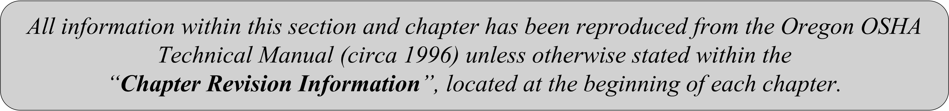

SECTION IV: CHAPTER 3
PRESSURE VESSEL GUIDELINES

Chapter Revision Information:

- This chapter was previously identified as Section III, Chapter 3 in Oregon OSHA’s circa 1996 Technical Manual. The section number was modified from Section III to Section IV in March 2014 to provide uniformity with the federal OSHA Technical Manual (OTM).

- In March 2014, the chapter’s multilevel listing format was modified from an alphanumeric system to a roman numeral system.

- In March 2014, several figures were updated for clarity. All content remains the same.

SECTION IV: CHAPTER 3
PRESSURE VESSEL GUIDELINES

TABLE OF CONTENTS
I. | INTRODUCTION . . . . . . . . . . . . . . . . . . . . . . . . . . . . . . . . . . . . . . . . . . |  |  | 4
II. | RECENT CRACKING EXPERIENCE IN PRESSURE VESSELS . . |  |  | 6
 | A. | Deaerator Service . . . . . . . . . . . . . . . . . . . . . . . . . . . . . . . . . . . . . . . . |  | 6
 | B. | Amine Service . . . . . . . . . . . . . . . . . . . . . . . . . . . . . . . . . . . . . . . . . . . |  | 7
 | C. | Wet Hydrogen Sulfide . . . . . . . . . . . . . . . . . . . . . . . . . . . . . . . . . . . . . |  | 7
 | D. | Ammonia Service . . . . . . . . . . . . . . . . . . . . . . . . . . . . . . . . . . . . . . . . |  | 8
 | E. | Pulp Digester Service . . . . . . . . . . . . . . . . . . . . . . . . . . . . . . . . . . . . . |  | 9
 | F. | Summary of Service Cracking Experience. . . . . . . . . . . . . . . . . . . . . . |  | 9
III. | NONDESTRUCTIVE EXAMINATION METHODS . . . . . . . . . . . . . . |  |  | 10
 | A. | Visual Examination (VT) . . . . . . . . . . . . . . . . . . . . . . . . . . . . . . . . . . |  | 10
 | B. | Liquid Penetrant Test (PT) . . . . . . . . . . . . . . . . . . . . . . . . . . . . . . . . . |  | 10
 | C. | Magnetic Practice Test (MT) . . . . . . . . . . . . . . . . . . . . . . . . . . . . . . . . |  | 11
 | D. | Radiography (RT) . . . . . . . . . . . . . . . . . . . . . . . . . . . . . . . . . . . . . . . . |  | 11
 | E. | Ultrasonic Testing (UT) . . . . . . . . . . . . . . . . . . . . . . . . . . . . . . . . . . . . |  | 12
 | F. | Detection Probabilities and Flaw Sizing . . . . . . . . . . . . . . . . . . . . . . |  | 12
IV. | INFORMATION FOR SAFETY ASSESSMENT . . . . . . . . . . . . . . . . . |  |  | 13
V. | BIBLIOGRAPHY . . . . . . . . . . . . . . . . . . . . . . . . . . . . . . . . . . . . . . . . . . . |  |  | 13
LIST OF APPDENENDICES
 | APPENDIX: 3-1 |  | Recordkeeping Data for Steel and Low-Pressure Storage Tanks . . . . . . . . . . . . . . . . . . . . . . . . . . . | 15

I. Introduction
Recent inspection programs for metallic pressure containment vessels and tanks have revealed cracking and damage in a considerable number of the vessels inspected. Safety and hazard evaluations of pressure vessels, as also presented in PUB 8-1.5, need to consider the consequences of a leakage or a rupture failure of a vessel. Two consequences result from a complete rupture:

- Blast effects due to sudden expansion of the pressurized fluid; and

- Fragmentation damage and injury, if vessel rupture occurs.

For a leakage failure, the hazard consequences can range from no effect to very serious effects:

- Suffocation or poisoning, depending on the nature of the contained fluid, if the leakage occurs into a closed space;

- Fire and explosion for a flammable fluid are included as a physical hazard; and

- Chemical and thermal burns from contact with process liquids.

Only pressure vessels and low pressure storage tanks widely used in process, pulp and paper, petroleum refining, and petrochemical industries and for water treatment systems of boilers and steam generation equipment are covered in this chapter. Excluded are vessels and tanks used in many other applications and also excludes other parts of a pressure containment system such as piping and valves.

The types and applications of pressure vessels included and excluded in this chapter are summarized in Table IV:3-1. An illustration of a schematic pressure vessel is presented in
Figure IV:3-1.

Pressure Vessel Design Codes. Most of the pressure or storage vessels in service in the United States will have been designed and constructed in accordance with one of the following two design codes:

- The ASME Code, or Section VIV of the ASME (American Society of Mechanical Engineers) Boiler and Pressure Vessel Code; or

- The API Standard 620 or the American Petroleum Institute Code which provides rules for lower pressure vessels not covered by the ASME Code.

In addition, some vessels designed and constructed between 1934 to 1956 may have used the rules in the "API-ASME Code for Unfired Pressure Vessels for Petroleum Liquids and Gases." This code was discontinued in 1956.

Vessels certification can only be performed by trained inspectors qualified for each code. Written tests and practical experience are required for certification. Usually, the compliance office is not equipped for this task, but is able to obtain the necessary contract services.

Table IV:3-1. Vessel Types
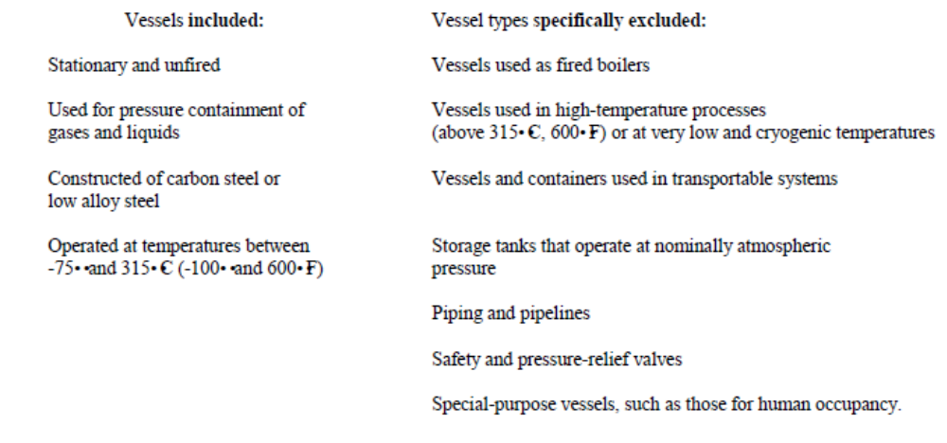

Figure IV:3-1. Some Major Parts of a Pressure Vessel
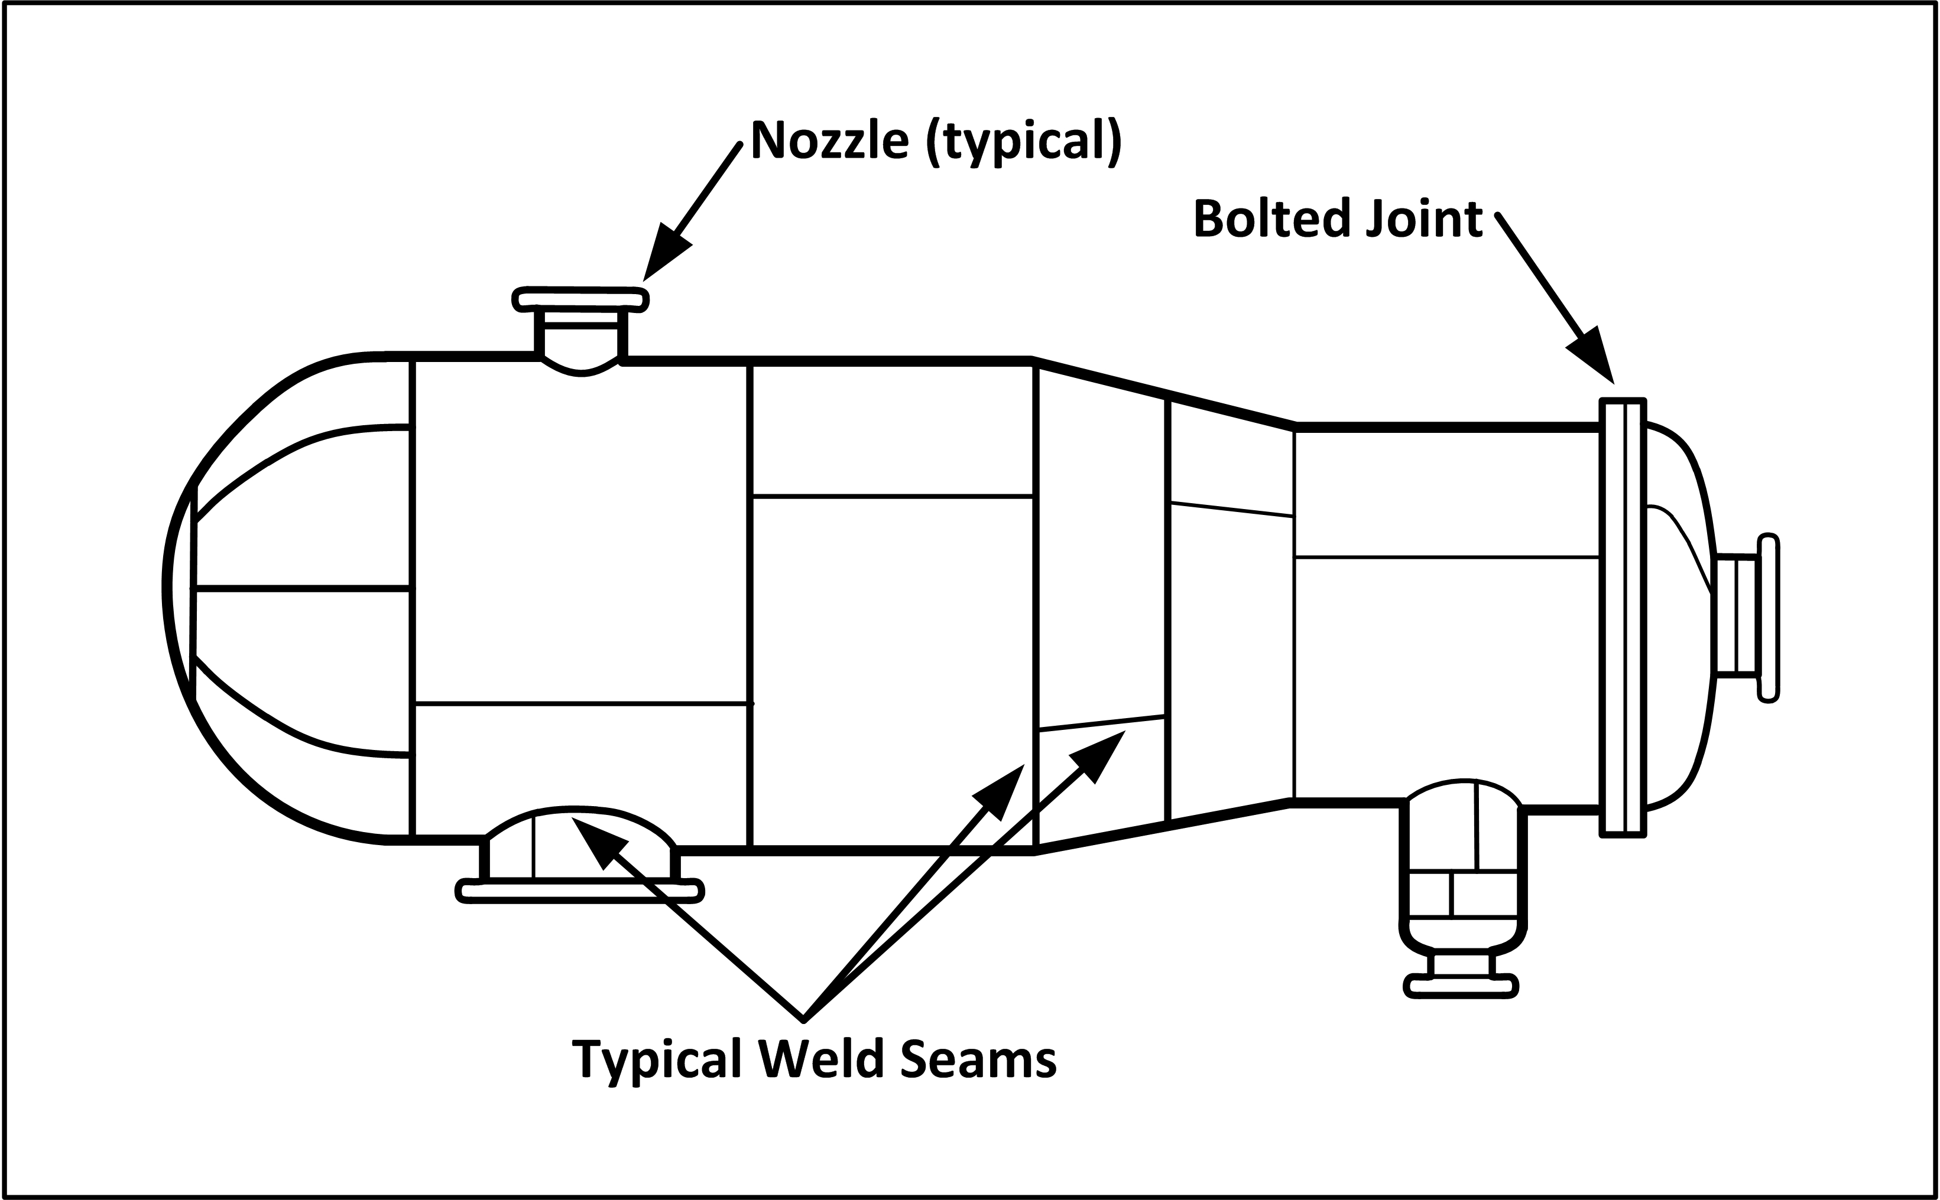

II. Recent Cracking Experience in Pressure Vessels
A. Deaerator Service

Deaeration refers to the removal of noncondensible gases, primarily oxygen, from the water used in a steam generation system.

Deaerators are widely used in many industrial applications including power generation, pulp and paper, chemical, and petroleum refining and in many public facilities such as hospitals and schools where steam generation is required. In actual practice, the deaerator vessel can be separate from the storage vessel or combined with a storage vessel into one unit.

Typical operational conditions for deaerator vessels range up to about 300 psi and up to about 150E C (300E F). Nearly all of the vessels are designed to ASME Code resulting in vessel wall thicknesses up to but generally less than 25 mm (1 in). The vessel material is almost universally one of the carbon steel grades.

Analysis of incident survey data and other investigations has determined the following features about the deaerator vessel cracking.

- Water hammer is the only design or operational factor that correlates with cracking.

- Cracking is generally limited to weld regions of vessels that had not been postweld heat treated.

- Corrosion fatigue appears to be the predominant mechanism of crack formation and growth.

The failures and the survey results have prompted TAPPI (Technical Association of Pulp and Paper Industry), the National Board of Boiler and Pressure Vessel Inspectors, and NACE (National Association of Corrosion Engineers) to prepare inspection, operation and repair recommendations.

For inspection, all recommendations suggest:

- Special attention to the internal surface of all welds and heat-affected zones (HAZ); and

- Use of the wet fluorescent magnetic particle (WFMT) method for inspection.

The TAPPI and the NACE recommendations also contain additional items, such as:

- Inspection by personnel certified to American Society for Nondestructive Testing's SNT-TC-1A minimum Level I and interpretation of the results by minimum Level II; and

- Reinspection within one year for repaired vessels, 1-2 years for vessels with discontinuities but unrepaired, and 3-5 years for vessels found free of discontinuities.

B. Amine Service

The amine process is used to remove hydrogen sulfide (H2S) from petroleum gases such as propane and butane. It is also used for carbon dioxide (CO2) removal in some processes. Amine is a generic term and includes monoethanolamine (MEA), diethanolamine (DEA) and others in the amine group. These units are used in petroleum refinery, gas treatment and chemical plants.

The operating temperatures of the amine process are generally in the 38E to 93EC (100E to 200EF) range and therefore the plant equipment is usually constructed from one of the carbon steel grades. The wall thickness of the pressure vessels in amine plants is typically about 25 mm (1 inch).

Although the possibility of cracking of carbon steels in an amine environment has been known for some years, real concern about safety implications was highlighted by a 1984 failure of the amine process pressure vessel. Overall, the survey found about 40% cracking incidence in a total of 294 plants. Cracking had occurred in the absorber/contactor, the regenerator and the heat exchanger vessels, and in the piping and other auxiliary equipment. Several of the significant
findings of the survey were:

- All cracks were in or near welds.

- Cracking occurred predominantly in stressed or unrelieved (not PWHT) welds.

- Cracking occurred in all amine vessel processes but was most prevalent in MEA units.

- WFMT and UT (ultrasonic test) were the predominant detection methods for cracks; internal examination by WFMT is the preferred method.

Information from laboratory studies indicate that pure amine does not cause cracking of carbon steels but amine with carbon dioxide in the gas phase causes severe cracking. The presence or absence of chlorides, cyanides, or hydrogen sulfide may also be factors but their full role in the cracking mechanism are not completely known at present.

C. Wet Hydrogen Sulfide

Wet Hydrogen Sulfide refers to any fluid containing water and hydrogen sulfide (H2S). Hydrogen is generated when steel is exposed to this mixture and the hydrogen can enter into the steel. Dissolved hydrogen can cause cracking, blistering, and embrittlement.

The harmful effects of hydrogen generating environments on steel have been known and recognized for a long time in the petroleum and petrochemical industries. In particular,
sensitivity to damage by hydrogen increases with the hardness and strength of the steel and damage and cracking are more apt to occur in high strength steels.

- Significant cracks can start from very small hard zones associated with welds; these hard zones are not detected by conventional hardness tests.

- Initially small cracks can grow by a stepwise form of hydrogen blistering to form through thickness cracks.

- NACE/API limits on weld hardness may not be completely effective in preventing cracking.

- Thermal stress relief (postweld heat treatment, PWHT) appears to reduce the sensitivity to and the severity of cracking.

Wet hydrogen sulfide has also been found to cause service cracking in liquified petroleum gas (LPG) storage vessels. The service cracking in the LPG vessels occurs predominantly in the weld heat affected zone (HAZ). The vessels are usually spherical with wall thickness in the 20 mm to 75 mm (0.8 in to 3 in) range.

Recommendations for new and existing wet hydrogen- sulfide vessels to minimize the risk of a major failure include:

- Use lower-strength steels for new vessels;

- Schedule an early inspection for vessels more than five years in service;

- Improve monitoring to minimize breakthrough of hydrogen sulfide; and

- Replace unsafe vessels or downgrade to less- severe, usually lower-pressure, service.

D. Ammonia Service

Commercial refrigeration systems, certain chemical processes, and formulators of agricultural chemicals will be sites of ammonia service tanks.

Careful inspections of vessels used for storage of ammonia (in either vapor or liquid form) in recent years have resulted in evidence of serious stress corrosion cracking problems.

The vessels for this service are usually constructed as spheres from one of the carbon steel grades, and they operate in the ambient temperature range.

The water and oxygen content in the ammonia has a strong influence on the propensity of carbon steels to crack in this environment.

Cracks have a tendency to be found to be in or near the welds in as-welded vessels. Cracks occur both transverse and parallel to the weld direction. Thermal stress relieving seems to be a mitigating procedure for new vessels, but its efficacy for older vessels after a period of operation is dubious partly because small, undetected cracks may be present.

E. Pulp Digester Service

The kraft pulping process is used in the pulp and paper industry to digest the pulp in the papermaking process. The operation is done in a relatively weak (a few percent) water solution of sodium hydroxide and sodium sulfide typically in the 110E to 140E C (230E to 285E F) temperature range. Since the early 1950s, a continuous version of this process has been widely used. Nearly all of the vessels are ASME Code vessels made using one of the carbon steel grades with typical design conditions of 175E to 180EC (350E to 360EF) and 150 psig.

These vessels had a very good service record with only isolated reports of cracking problems until the occurrence of a sudden rupture failure in 1980. The inspection survey has revealed that about 65% of the properly inspected vessels had some cracking. Some of the cracks were fabrication flaws revealed by the use of more sensitive inspection techniques but most of the cracking was service-induced. The inspection survey and analysis indicates the following features about the cracking.

- All cracking was associated with welds.

- Wet fluorescent magnetic particle (WFMT) testing with proper surface preparation was the most effective method of detecting the cracking.

- Fully stress-relieved vessels were less susceptible.

- No clear correlation of cracking and noncracking could be found with vessel age and manufacture or with process variables and practices.

- Analysis and research indicate that the cracking is due to a caustic stress corrosion cracking mechanism although its occurrence at the relatively low caustic concentrations of the digester process was unexpected.

Currently, preventive measures such as weld cladding, spray coatings, and anodic protection are being studied, and considerable information has been obtained. In the meantime, the recommended guideline is to perform an annual examination.

F. Summary of Service Cracking Experience

The preceding discussion shows a strong influence of chemical environment on cracking incidence. This is a factor that is not explicitly treated in most design codes. Service experience is the best and often the only guide to in-service safety assessment.

For vessels and tanks within the scope of this document, the service experience indicates that the emphasis of the inspection and safety assessment should be on:

- Vessels in deaerator, amine, wet H2S, ammonia and pulp digesting service;

- Welds and adjacent regions;

- Vessels that have not been thermally stress relieved (no PWHT of fabrication welds); and

- Repaired vessels, especially those without PWHT after repair.

The evaluation of the severity of the detected cracks can be done by fracture mechanics methods. This requires specific information about stresses, material properties, and flaw indications. Generalized assessment guidelines are not easy to formulate. However, fortunately, many vessels in the susceptible applications listed above operate at relatively low stresses, and therefore, cracks have a relatively smaller effect on structural integrity and continued safe operation.

III. Nondestructive Examination Methods

Of the various conventional and advanced nondestructive examination (NDE) methods, five are widely used for the examination of pressure vessels and tanks by certified pressure vessel inspectors. The names and acronyms of these common five methods are:

- VT Visual Examination,

- PT Liquid Penetrant Test,

- MT Magnetic Particle Test,

- RT Gamma and X-ray Radiography, and

- UT Ultrasonic Test.

VT, PT and MT can detect only those discontinuities and defects that are open to the surface or are very near the surface. In contrast, RT and UT can detect conditions that are located within the part. For these reasons, the first three are often referred to as "surface" examination methods and the last two as "volumetric" methods. Table II of PUB 8-1.5 summarizes the main features of these five methods.

A. Visual Examination (VT)

A visual examination is easy to conduct and can cover a large area in a short time.

It is very useful for assessing the general condition of the equipment and for detecting some specific problems such as severe instances of corrosion, erosion, and hydrogen blistering. The obvious requirements for a meaningful visual examination are a clean surface and good illumination.

B. Liquid Penetrant Test (PT)

This method depends on allowing a specially formulated liquid (penetrant) to seep into an open discontinuity and then detecting the entrapped liquid by a developing agent. When the penetrant is removed from the surface, some of it remains entrapped in the discontinuities. Application of a developer draws out the entrapped penetrant and magnifies the discontinuity. Chemicals which fluoresce under black (ultraviolet) light can be added to the penetrant to aid the detectability and visibility of the developed indications. The essential feature of PT is that the discontinuity must be "open," which means a clean, undisturbed surface.

The PT method is independent of the type and composition of the metal alloy so it can be used for the examination of austenitic stainless steels and nonferrous alloys where the magnetic particle test is not applicable.

C. Magnetic Particle Test (MT)

This method depends on the fact that discontinuities in or near the surface perturb magnetic flux lines induced into a ferromagnetic material. For a component such as a pressure vessel where access is generally limited to one surface at a time, the "prod" technique is widely used. The magnetic field is produced in the region around and between the prods (contact probes) by an electric current (either AC or DC) flowing between the prods. The ferromagnetic material
requirement basically limits the applicability of MT to carbon and low- alloy steels.

The perturbations of the magnetic lines are revealed by applying fine particles of a ferromagnetic material to the surface. The particles can be either a dry powder or a wet suspension in a liquid. The particles can also be treated to fluoresce under black light. These options lead to variations
such as the "wet fluorescent magnetic particle test" (WFMT).

MT has some capability for detecting subsurface defects. However, there is no easy way to determine the limiting depth of sensitivity since it is highly dependent on magnetizing current, material, and geometry and size of the defect. A very crude approximation would be a depth no more than 1.5 mm to 3 mm (1/16 in to 1/8 in).

A very important precaution in performing MT is that corners and surface irregularities also perturb the magnetic field. Therefore, examining for defects in corners and near or in welds must be performed with extra care. Another precaution is that MT is most sensitive to discontinuities which are oriented transverse to the magnetic flux lines and this characteristic needs to be taken into account in determining the procedure for inducing the magnetic field.

D. Radiography (RT)

The basic principle of radiographic examination of metallic objects is the same as in any other form of radiography such as medical radiography. Holes, voids, and discontinuities decrease the attenuation of the X-ray and produce greater exposure on the film (darker areas on the negative film).

Because RT depends on density differences, cracks with tightly closed surfaces are much more difficult to detect than open voids. Also, defects located in an area of a abrupt dimensional change are difficult to detect due to the superimposed density difference. RT is effective in showing defect dimensions on a plane normal to the beam direction but determination of the depth dimension and location requires specialized techniques.

Since ionizing radiation is involved, field application of RT requires careful implementation to prevent health hazards.

E. Ultrasonic Testing (UT)

The fundamental principles of ultrasonic testing of metallic materials are similar to radar and related methods of using electromagnetic and acoustic waves for detection of foreign objects. The distinctive aspect of UT for the inspection of metallic parts is that the waves are mechanical, so the test equipment requires three basic components.

- Electronic system for generating electrical signal.

- Transducer system to convert the electrical signal into mechanical vibrations and vice versa and to inject the vibrations into and extract them from the material.

- Electronic system for amplifying, processing and displaying the return signal.

Very short signal pulses are induced into the material and waves reflected back from discontinuities are detected during the "receive" mode. The transmitting and detection can be
done with one transducer or with two separate transducers (the tandem technique).

Unlike radiography, UT in its basic form does not produce a permanent record of the examination. However, more recent versions of UT equipment include automated operation and
electronic recording of the signals.

Ultrasonic techniques can also be used for the detection and measurement of general material loss such as by corrosion and erosion. Since wave velocity is constant for a specific material, the transit time between the initial pulse and the back reflection is a measure of the travel distance and the thickness.

F. Detection Probabilities and Flaw Sizing

The implementation of NDE (nondestructive examination) results for structural integrity and safety assessment involves a detailed consideration of two separate but interrelated factors.

- Detecting the discontinuity.

- Identifying the nature of the discontinuity and determining its size.

Much of the available information on detection and sizing capabilities has been developed for aircraft and nuclear power applications. This kind of information is very specific to the nature of the flaw, the material, and the details of the test technique, and direct transference to other situations is not always warranted.

The overall reliability of NDE is obviously an important factor in a safety and hazard assessment. Failing to detect or undersizing existing discontinuities reduces the safety margin
while oversizing errors can result in unnecessary and expensive outages. High reliability results from a combination of factors.

- Validated procedures, equipment and test personnel.

- Utilization of diverse methods and techniques.

- Application of redundancy by repetitive and independent tests.

Finally, it is useful to note that safety assessment depends on evaluating the "largest flaw that may be missed, not the smallest one that can be found."

IV. Information for Safety Assessment
This chapter and PUB 8-1.5 has a large amount of information on the design rules, inspection requirements, and service experience, relevant to pressure vessels and low pressure storage tanks used in general industrial applications. Though the compliance officer is not usually qualified as a pressure vessel inspector, as a summary and a reminder, Appendix IV:3-1

outlines the information, data, and recordkeeping that are necessary, useful, or indicative of safe management of operating vessels and tanks.

These records, besides the construction and maintenance logs usually are kept by the plant engineer, maintenance supervisor, or facility manager, will be indicative of the surveillance activities around safe operation of pressure vessels.

V. Bibliography

Chuse, R. 1984. Pressure Vessels: The ASME Code Simplified. 6th ed. McGraw-Hill: New York.

Forman, B. Fred. 1981. Local Stresses in Pressure Vessels. Pressure Vessel Handbook Publishing, Inc.: Tulsa.

Hammer, W. 1981. Pressure Hazards in Occupational Safety Management and Engineering. 2nd ed. Prentice-Hall: New York.

McMaster, R. C. and McIntire, P. (eds.) 1982-1987. Nondestructive Testing Hand-book. 2nd ed., Vols. 1-3. American Society for Metals/American Society of Nondestructive Testing: Columbus.

Megyesy, E. F. 1986. Pressure Vessel Handbook. 7th ed. Pressure Vessel Handbook Publishing Inc.: Tulsa.

OSHA Instruction Pub 8-1.5. 1989. Guidelines for Pressure Vessel Safety Assessment. Occupational Safety and Health Administration: Washington, D.C.

Thielsch, H. 1975. Defects and Failures in Pressure Vessels and Piping. 2nd ed., Chaps. 16 and 17. Reinhold: New York.

Yokell, S. 1986. Understanding the Pressure Vessel Code. Chemical Engineering 93(9):75-85.

APPENDIX IV:3-1.
Recordkeeping Data for Steel and Low-Pressure Storage Tanks

INTRODUCTION AND SCOPE
This outline summarizes information and data that will be helpful in assessing the safety of steel pressure vessels and low pressure storage tanks that operate at temperatures between -75 and 315 C (-100 and 600 F).

VESSEL IDENTIFICATION ANDDOCUMENTATION

Information that identifies the specific vessel being assessed and provides general information about it include the following items:

- Current owner of the vessel

- Vessel location
-- Original location and current location if it has been moved

- Vessel identification
-- Manufacturer's serial number
-- National Board number if registered with NB

- Manufacturer identification
-- Name and address of manufacturer
-- Authorization or identification number of the Manufacturer

- Date of manufacture of the vessel

- Data report for the vessel
-- ASME U-1 or U-2, API 620 form or other applicable report

- Date vessel was placed in service

- Interruption dates if not in continuous service.

DESIGN AND CONSTRUCTION INFORMATION

Information that will identify the code or standard used for the design and construction of the vessel or tank and the specific design values, materials, fabrication methods, and inspection methods used include the following items:

- Design code
-- ASME Code Section and Division, API Standard or other design code used

- Type of construction
-- Shop or field fabricated or other fabrication method

- VIV, division 1 or 2 vessels
-- Maximum allowable pressure and temperature
-- Minimum design temperature

- API 620 vessels
-- Design pressure at top and maximum fill

- Additional requirements included such as
-- Appendix Q (Low-Pressure Storage Tanks For Liquified Hydrocarbon Gases) and
-- Appendix R (Low-Pressure Storage Tanks for Refrigerated Products)

- Other design code vessels
-- Maximum design and allowable pressures
-- Maximum and minimum operating temperatures

- Vessel materials
-- ASME, ASTM, or other specification names and numbers for the major parts

- Design corrosion allowance

- Thermal stress relief (PWHT, postweld heat treatment)
-- Design code requirements
-- Type, extent, and conditions of PWHT performed

- Nondestructive examination (NDE) of welds
-- Type and extent of examination performed
-- Time when NDE was performed (before or after PWHT or hydrotest)

SERVICE HISTORY

Information on the conditions of operating history of the vessel or tank that will be helpful in safety assessment include the following items:

- Fluids handled
-- Type and composition, temperature and pressures

- Type of service
-- Continuous, intermittent or irregular

- Significant changes in service conditions
-- Changes in pressures, temperatures, and fluid compositions and the dates of the changes

- Vessel history
-- Alterations, reratings, and repairs performed
-- Date(s) of changes or repairs

IN-SERVICE INSPECTION

Information about inspections performed on the vessel or tank and the results obtained that will assist in the safety assessment include the following items:

- Inspection(s) performed
-- Type, extent, and dates

- Examination methods
-- Preparation of surfaces and welds
-- Techniques used (visual, magnetic particle, penetrant test, radiography, ultrasonic)

- Qualifications of personnel
-- ASNT (American Society for Nondestructive Testing) levels or equivalent of examining and supervisory personnel

- Inspection results and report
-- Report form used (NBIC NB-7, API 510 or other)
-- Summary of type and extent of damage or cracking
-- Disposition (no action, delayed action or repaired)

SPECIFIC APPLICATIONS

Survey results indicate that a relatively high proportion of vessels in operations in several specific applications have experienced in service related damage and cracking. Information on the following items can assist in assessing the safety of vessels in these applications:

- Service application
-- Deaerator, amine, wet hydrogen sulfide, ammonia, or pulp digesting

- Industry bulletins and guidelines for this application
-- Owner/operator awareness of information

- Type, extent, and results of examinations
-- Procedures, guidelines and recommendations used
-- Amount of damage and cracking
-- Next examination schedule

- Participation in industry survey for this application

- Problem mitigation
-- Written plans and actions

EVALUATION OF INFORMATION

The information acquired for the above items is not adaptable to any kind of numerical ranking for quantitative safety assessment purposes. However, the information can reveal the owner or user's apparent attention to good practice, careful operation, regular maintenance, and adherence to the recommendations and guidelines developed for susceptible applications. If the assessment indicated cracking and other serious damage problems, it is important that the inspector obtain qualified technical advice and opinion.

