A User’s Guide to Lean Safety
By SafeBuild Alliance
&
The SafeBuild Alliance Lean Safety Subcommittee

Contents:

Introduction
The Lean Foundation on a Construction Project
What is Lean Safety?
Lean Safety Metrics
Lean Safety Training for Professional Contractors
Lean Safety Training for Supervisors of Professional Contractors
Lean Safety BKMs

Introduction:

In this user’s guide we will be providing you with many tools to use on any construction project. The tools will be focused primarily on delivering concepts relative to enabling efficient practices with safety in mind.
This user’s guide was developed by a collaboration with local general contractors, trade contractors, owners and members of SafeBuild Alliance.
The vision was from design to delivery, to create a partnered work environment that fosters collaboration, relationships and diverse ideas that provide the most efficient, effective and safest work environment for our people
The mission was to develop a continuous improvement movement leveraging SafeBuild Alliance and the lean construction community using a unified understanding, means and methods and best known construction practices to achieve our vision.

The Lean Foundation on a Construction Project

LEAN has limitless applications on construction projects.
Continuous improvements to processes, decision making, requirements and procedures reduce wasted time and effort and allow project team members to be more productive.
Continuous improvements to the way the work is sequenced and schedule can save considerable time by empowering the workers who actually are responsible for the installation to be an integral part of the planning and delivery of the project.
Continuous improvements to building products, installation and delivery methods reduce jobsite labor and results in a more efficient and safe project.
For LEAN to be a foundation of the project, LEAN must be applied at all levels, from the top down. Without full buy-in from the project executive team, there is little flexibility allowed for project teams to look for ways to improve. The executive leadership team also play a critical support role to insure project teams have the necessary resources and latitude to “change” in order to seek out and affect the improvements.
Project Teams must understand it is their responsibility to embrace and affect change. And by change, we mean to continually improve. Without change, there can be no improvement.

WHY LEAN?
End product:
- Design and construction of a project is only the start of a project. If you look at the design / construction phase of a project, it is literally the tip of an ice-burg in the life of a project. Owners and operators will live with what is created for 30-50x the amount of time it takes to design and build.
- Decisions made during design significantly affect how the project is constructed. Decisions made during construction significantly affect how the project is delivered and operated.
- Having an integrated approach to the design and construction can offer a much improved delivery and end product.

Process:
Applying LEAN to the process of a project can eliminate wasted time and effort. It should be no surprise that significant effort during design and construction is wasted, either duplicating tasks or “guessing” what is the right direction only to learn there was an more efficient means. The project team must look at ways to make the best decisions early. And this applies to both design and construction.
LEAN should apply to design to help reduce rework and provide clear direction at the earliest possible moment. By including the construction teams with the owner and design team up front, the design-estimate-value engineer-redraft cycle can be streamlined. In addition, construction teams can provide valuable constructability input during design to capture efficiencies for the trade contractors. The result is a less cost project that can be provided quicker and with less effort.
During the construction phase, LEAN can be applied to many areas to reduce waste and streamline the installation of the work. While LEAN is typically thought of as a production tool, other benefits include a cleaner, safer jobsite as well as increasing quality control.

WHAT IS LEAN?
Very simply put, LEAN seeks to eliminate waste through constant improvement. There has been much written on the “8-wastes” but here they are:
- Defects
- Overproduction
- Waiting
- Non Value Added Processing
- Transportation
- Inventory
- Motion
- Unused Employee Creativity
You are not going to eliminate these. The key is to pull together as a project team to constantly improve on these wastes. You may also be thinking that these primarily relate to manufacturing and delivery products being provided and installed on a project. But, these directly apply to the design and construction phase. For instance, overproduction could relate to the detailing provided by the design team that will then be re-done by sub trades as part of their shop-drawing process. Not to say some level of detail isn’t required, you just want to produce the minimal amount.
Overproduction can also be seen as a construction issue. Who hasn’t seen the pallet of embedded steel that got shipped to the job site prior to the first pour but also contained enough embeds to do all 10 floors? The pallet then gets opened, picked over, spread out and then items are either lost or damaged and then you have to create more. This is also becomes wasted effort to continually relocate the pallet and the tripping hazard presented by the excess material being on site.
Each project team should be introduced to LEAN with some training and knowledge of what it is and what it means to the design and construction teams. Without some base knowledge and how it applies and can make each individual on the team better, LEAN becomes a useless buzzword that people get tired of hearing.

WHEN IS LEAN APPLICABLE?
It is never too early or late to apply LEAN. The earlier the better, however.
One thing to consider is that LEAN is a process, a journey. It is not a set of tasks that can be started or completed. That may be one of the hardest ideas to understand in the design and construction industry. We are governed by start dates, deadlines, milestones and activities. LEAN is an ongoing effort, to constantly improve the processes that affect the final product.

HOW DO YOU DO LEAN?
Well, there are some tools out there, some work better than others.
The first key to success is to get buy-in from the top. As noted earlier, if the top is not completely committed, the project teams have little opportunity for success.
Pull Scheduling:
Sometimes referred to as LAST PLANNER (a trademarked “system” developed by the LEAN CONSTRUCTION INSTITUTE), pull planning shifts the planning effort from the office to the trades. It utilizes key milestones as the guideline schedule but leaves the day to day and weekly schedule in the hands of the jobsite foreman or design leads (the “LAST PLANNERs”). The main goal of pull planning is to get to reliable commitments.
Kaizen:
Kaizen simply means “change for the better”. Kaizen, as it is typically applied to design and construction, focuses heavily on repetitive tasks. Kaizen groups look at particular task or activity and work to simplify the steps, tools or movements necessary to produce a piece of work. These may be large or small changes. Design may use Kaizen for setting up file saving / sharing to reduce lost time looking or waiting for drawing updates. Construction may use Kaizen for streamlining the effort when new trade workers are brought onto the project (orientation) or how they plan to pre-assemble parts to save time and waste. Kaizen could be applied to just about every aspect of everything design and construction does. Kaizen does take time and resources so choosing the right activities to design a Kaizen event around should be looked at closely. A good place to start are the really annoying things or the items showing the most obvious forms of the 8-wastes.
Value Stream Mapping:
Process mapping visually displays Value-Added and Non-Value Added steps using only a few clear symbols and lines. This will require a fairly deep dive into how the design and construction process will work. Each step can be mapped and all stakeholders given an opportunity to weigh in if there is value added or not.
Value Stream Mapping is used to illustrate the flow and relationship between work processes. A key component of VSM is differentiating value adding activities from non-value adding activities.
Reducing or eliminating non-value adding activities is critical and a principle goal of Lean Manufacturing. Upon examination of your processes through VSM, it soon becomes obvious where improvement opportunities lie.

GOALS OF LEAN
When project teams can be more efficient, the work they perform is at a higher level and with greater accuracy.
These efficiencies can be seen at the owner / design level as well as the trade contractor and trade worker level. The goal for implementing LEAN is to reduce waste and improve the delivery of the project. Of course improved delivery may mean different things to different entities or people involved in the project. The power of LEAN is amplified, however, when EVERYONE associated with the project is interested in the improved delivery at EVERY level.
Building a LEAN team is not easy. It is not conventional. There has to be an intrinsic desire to want to do things better. For example, the owner must desire to improve their trade partner’s efficiencies. Trade partners must desire to produce a better and quicker project that improves the owner’s pro-forma. This takes trust, mutual respect and mutual benefit.

What is Lean Safety?

- Eliminating wasteful steps
  - Using an ergonomic evaluation to reduce movements and strain to the worker.
    - Motion – Overexertion, poor ergonomic design
  - Defects – Increased maintenance activities, hazardous material exposure, machine exposure
  - Overproduction – Overexertion, extra handling, unnecessary machine interaction
  - Waiting – Setups/Changeovers – hazardous energy exposure
  - Not Using Employee Ideas – The company misses out on potential safety improvements
  - Transportation – Extra handling, slip, trip and fall hazards, exposure to fork lift traffic
  - Inventory – Falling loads, traffic congestion, trip hazards, extra handling
  - Extra Processing – Unnecessary machine interaction

- Work Planning/Coordination
  - Focusing on the activities and how each trade fits in with each other – forward looking – this creates a safer environment for all
  - Better planning to avoid variance and change
  - Through worker involved planning, Using lean tools that promote a safer environment

- Creating a culture of all people involved to drive lean principles
  - Respecting the knowledge of everyone involved to achieve a common goal.
  - Empowering collaboration and creativity by listening to everyone
- Safety by Design
  - Develop a design that leads to improved construction efficiency and productivity while preserving workers’ long-term mobility, and quality of life
  - Incorporate elements that lead to a safely sustainable factory
  - Look at the design through the eyes of the workers
  - Eliminate “What were they thinking” statements and rework
  - Evaluate the challenges each trade will be faced with during the construction of the design and the owner will be faced with during operation of the facility
The below Time/Safety influence curve indicates that that the ability to influence safety is highest during the design process
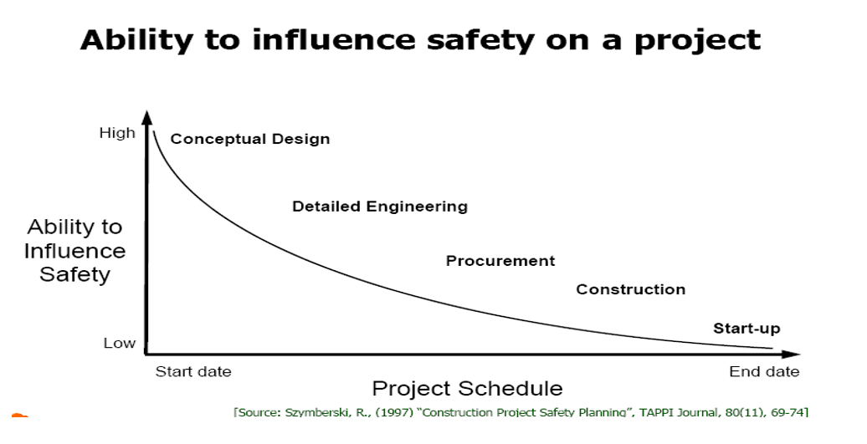

Lean Safety Metrics
We believe there are 3 main metrics to measure the effectiveness of Lean Safety. The 3 metrics are as follows:
- % of Project Tasks Reviewed
- Integration of Safety into the Lean Planning Process
- % Adherence to the Lean Safety User’s Guide.

- % of Project Tasks Reviewed
We know that Lean Safety reduces risk to workers by reducing the frequency of exposure and even reducing the exposure itself. The only way to force this to happen is to have a process to ensure all tasks that are performed on a project have been looked and analyzed to see where these efficiency and risk reduction gains can be obtained. Thus, we believe we should have a metric that measures how many tasks are reviewed. If the goal is to review 100% of the tasks, the metric monitors performance to this goal. If only 50% of the tasks are reviewed, then there will be 50% of the tasks that potentially will not be “leaned out” from a safety perspective.

- Integration of Safety into the Lean Planning Process
To measure lean safety, we must integrate safety into a lean planning process using the following components:
- A pull planning process (ie. Last Planner)
- Requirement from the General Contractor for Trade Contractors to perform task hazard analysis during each phase of the project (see figure on next page) as part of the lean planning process
- Each task hazard analysis will be focused on lean and risk reduction
- General Contractor to require all task hazard analysis’ to be reviewed with all affected trade contractors in that phase of the project
Measuring the above items will ensure they are being done – this is the basic principal for the metrics – what gets measured gets done.
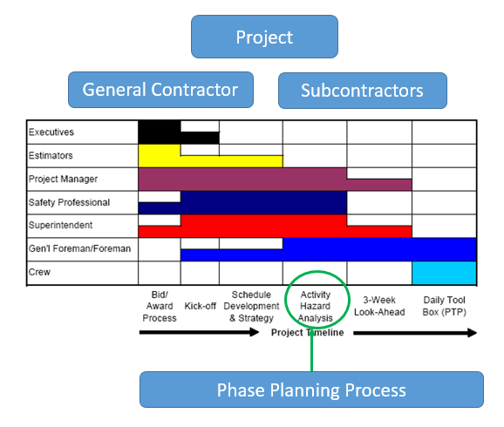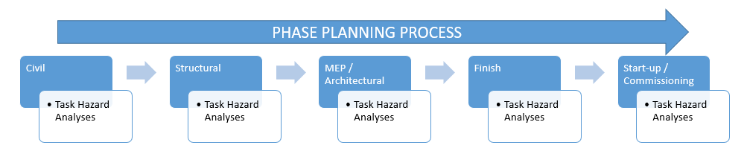

- % Adherence to the Lean Safety User’s Guide
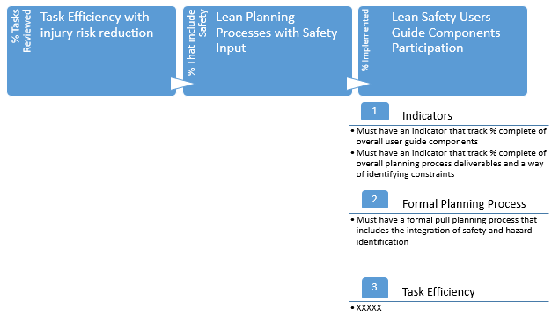

Lean Safety Training for Professional Contractors

A practical guide to working smarter, not harder, for professional construction workers.

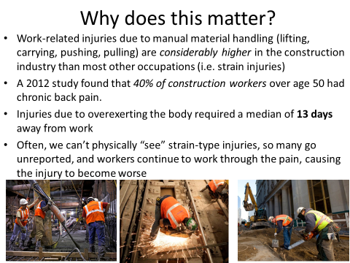

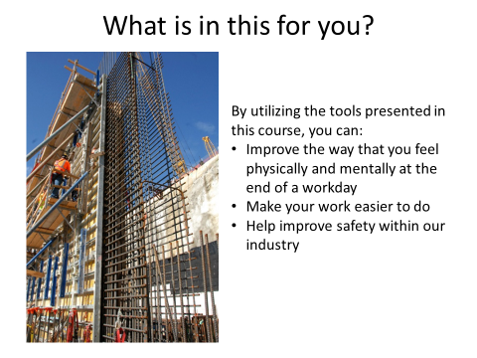

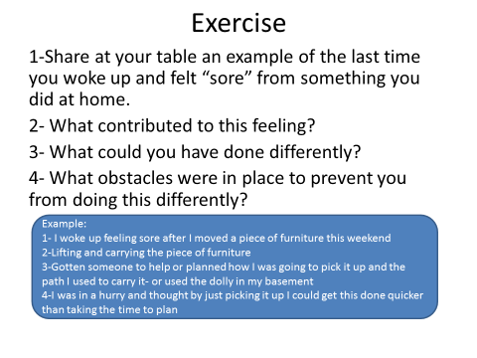

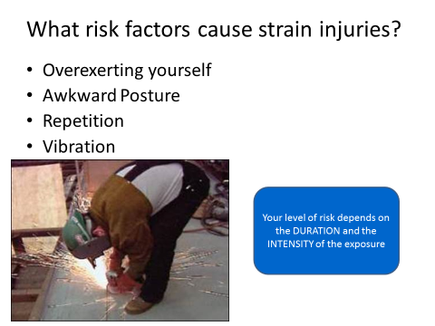

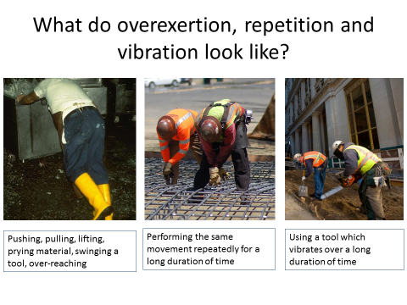

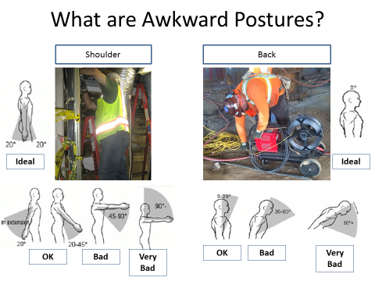

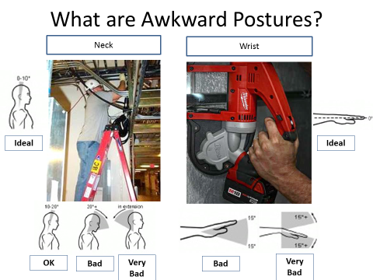

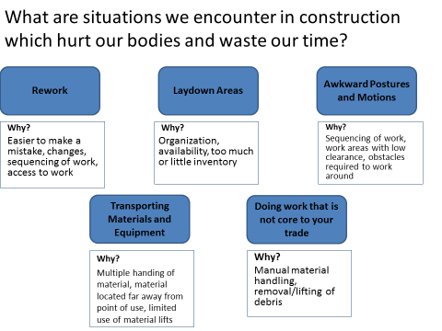

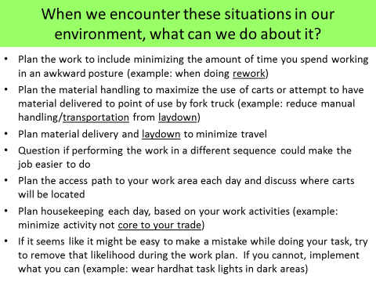

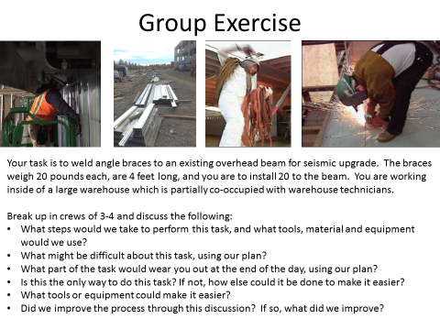

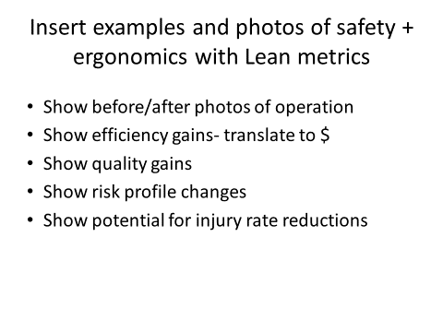

Lean Safety Training for Supervisors of Professional Contractors

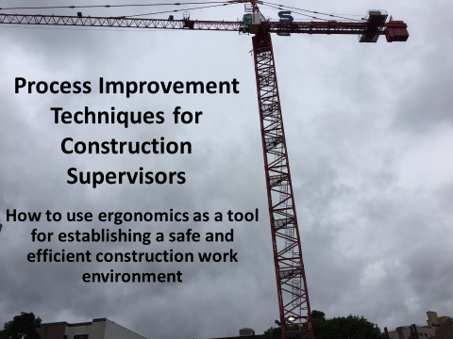

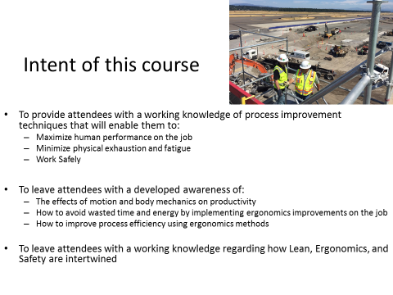

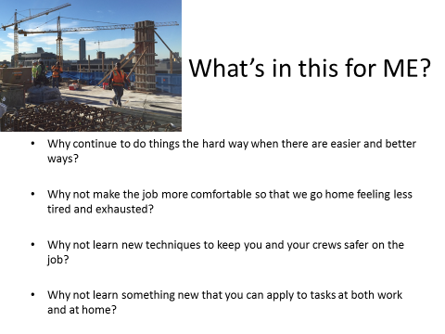

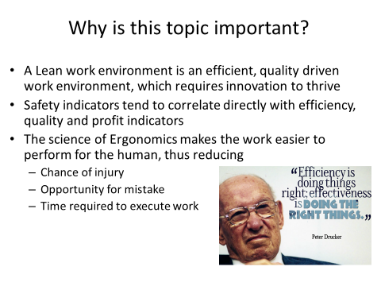

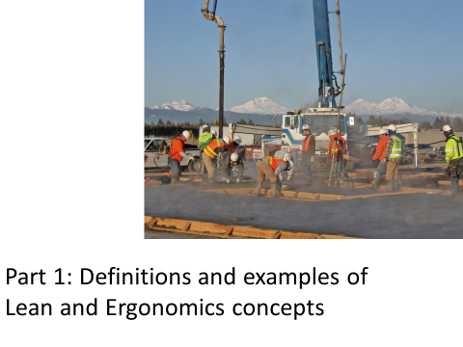

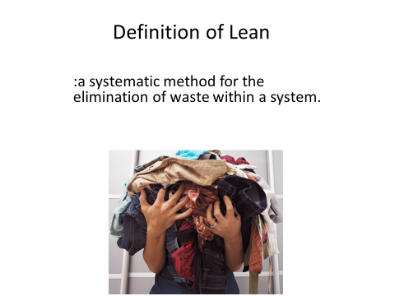

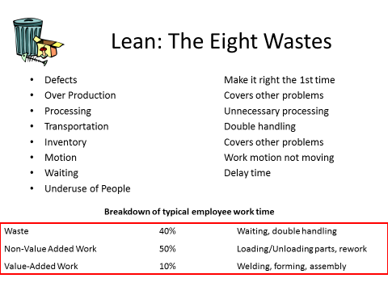

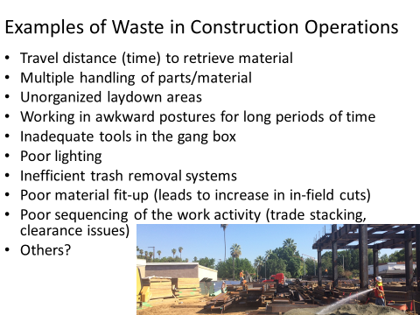

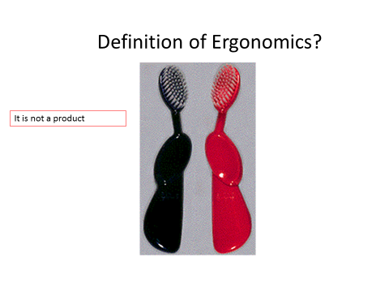

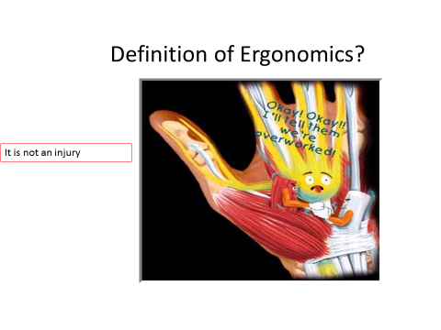

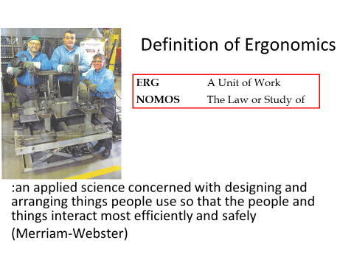

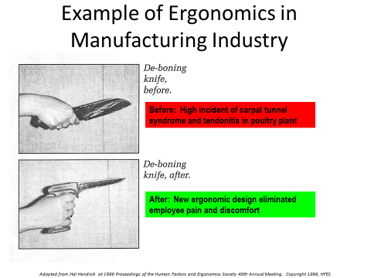

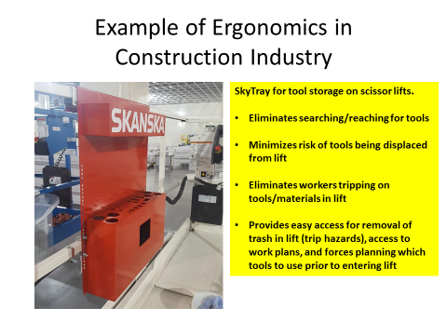

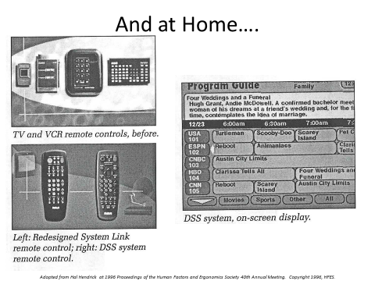

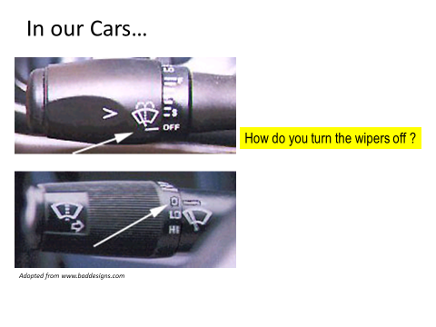

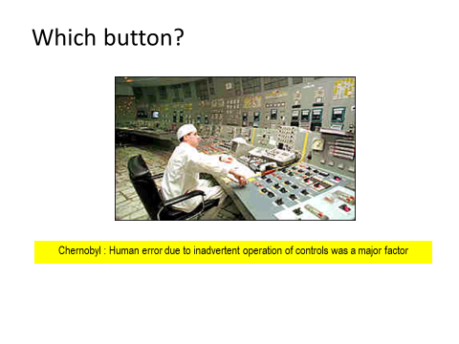

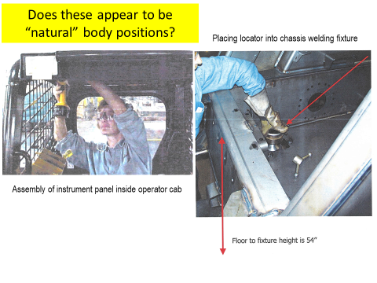

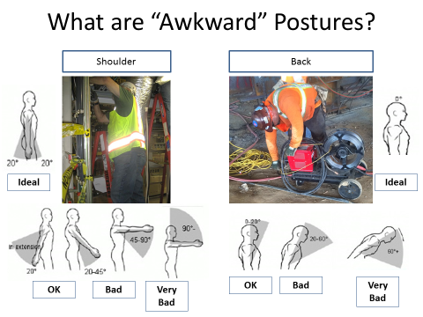

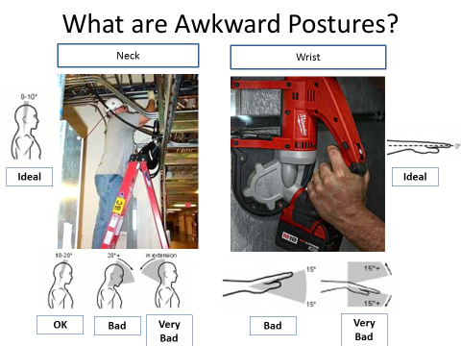

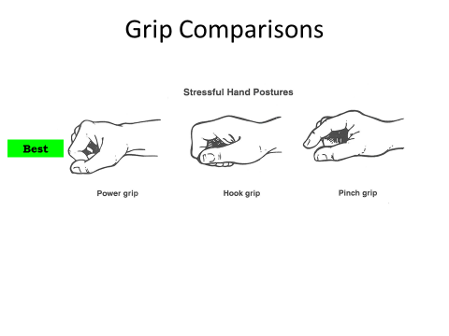

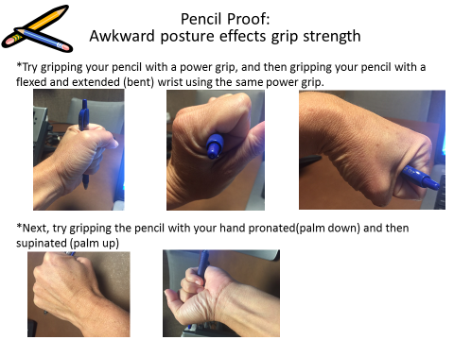

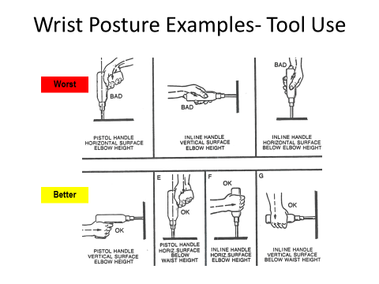

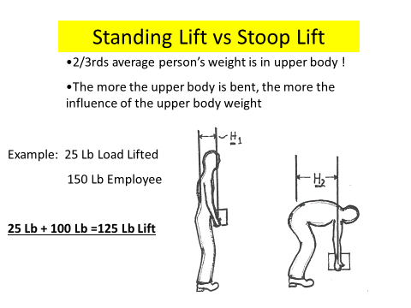

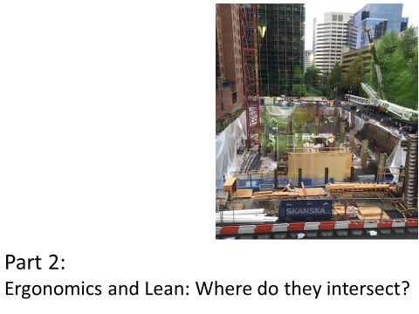

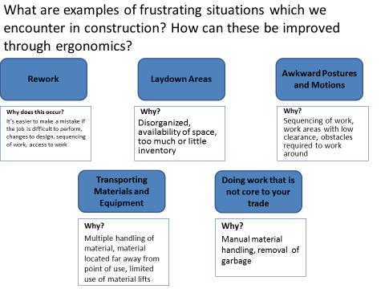

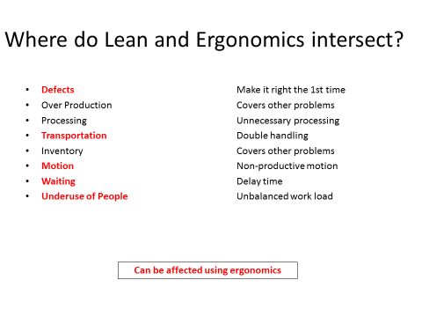

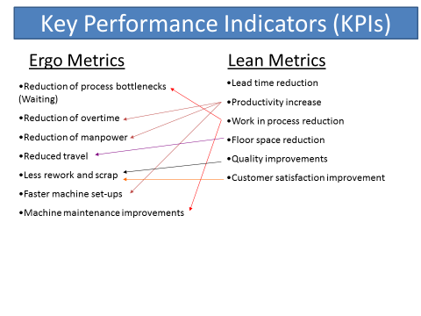

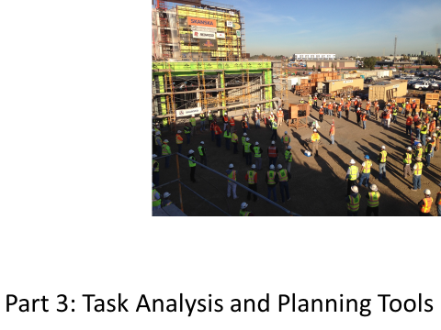

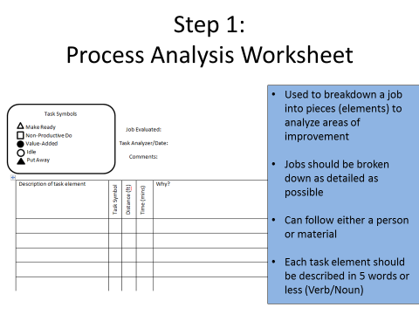

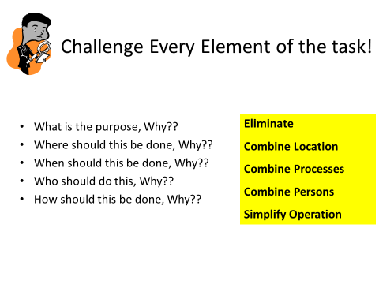

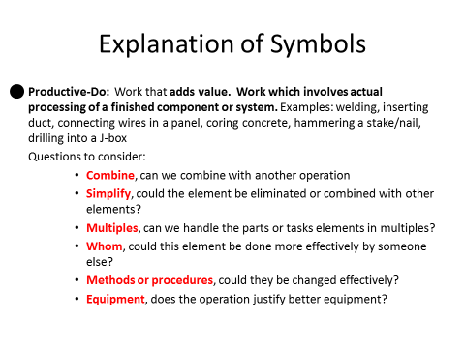

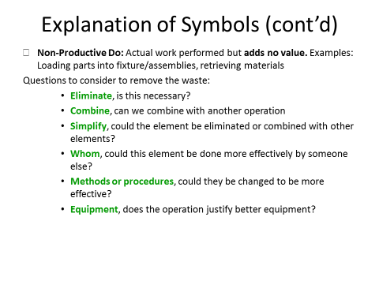

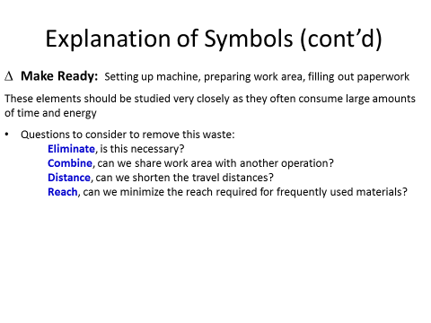

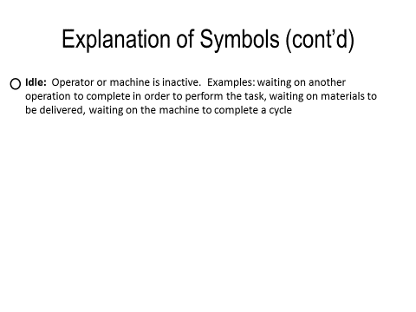

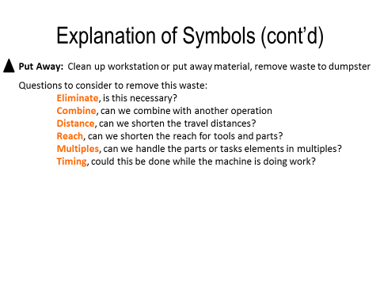

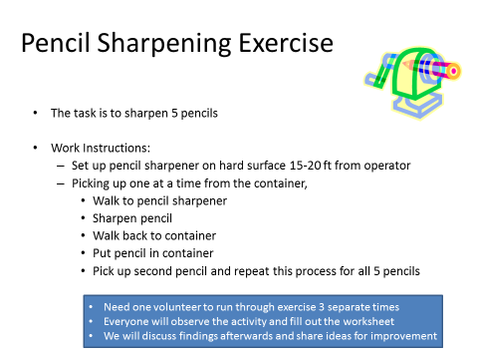

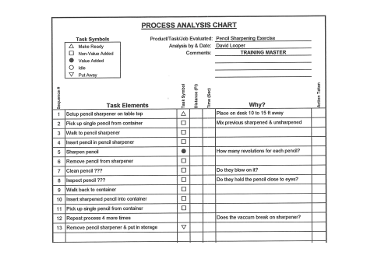

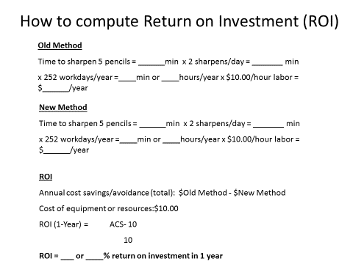

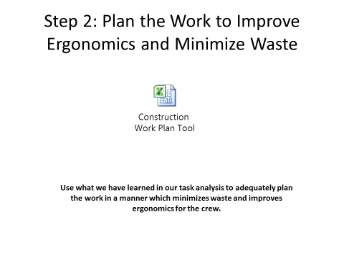

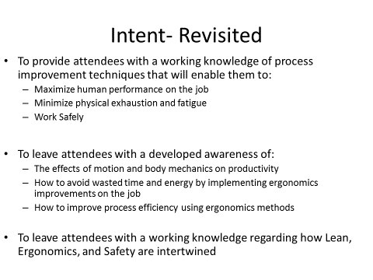

Lean Safety BKMs

The SafeBuild Alliance Lean Safety Subcommittee has a vision to create a partnered work environment that fosters collaboration, relationships and diverse ideas that provide the most efficient, effective and safest work environment for our people...
The committee has been working to develop a continuous improvement movement leveraging SafeBuild Alliance and the lean construction community using a unified understanding, means and methods and best known construction practices to achieve our vision.
One of the committee objectives is to create “A User’s Guide to a Lean Safety Culture” to help contractors implement key lean safety items that will ultimately lead their projects to be safer and more efficient. A component of the user guides includes Best Known Methods (BKMs) for tasks that we believe will help projects achieve this level of safety and efficiency.
SafeBuild Alliance was awarded an OSHA grant in December of 2016 that will help us to seek out and document these BKMs. These BKM’s will be posted on our website to share with the construction community. One BKM will be posted each month starting February 2017.
We will continue publishing and communicating to you our BKM efforts monthly. Please let us know if you have any questions, or if you know of BKMs today that we can share.
BKMs can be found at this URL.
http://SafeBuildalliance.com/interact/lean-safety
Resources:
Web Article: How Will Combining Safety and Lean in Process Improvement Efforts Save Money? By Tom Sammon, Project Manager, Georgia Manufacturing Extension Partnership (GaMEP) at Georgia Tech

