SAFE PATIENT HANDLING GUIDEBOOK
For
Facility Champions/Coordinators
TABLE OF CONTENTS
I. Peer Leader/Facility Coordinator Information 4
- Facility Peer Leaders & Facility Coordinator Contact Information 5
- Peer Leader Roles/Responsibilities 6
- Developing a Safe Patient Handling & Movement Action Plan 8
- Peer Leader Meetings notes/minutes 13
- ‘Safe Patient Handling Clinical /Area Binder’ Table of Contents…………………...…..14
- Communication Strategies
  - Communication Strategies Presentations...…………………………………...…16
  - Conference Call Agenda Template………………………………………...……17
.
II. EQUIPMENT Information 19
- Unit Equipment Log 20
- Contact information for vendors/manufacturers of unit patient handling equipment 20
- Bariatric Equipment Company contact information (See section V)
- Equipment/Slings Photos 24
- Sling Selection Chart 25
- Equipment instructions, brochures, competencies, or location of these 27
- Facility and/or manufacturer cleaning, infection control protocols/procedures 29
- Link to Patient Safety Center website for linking to equipment manufacture sites 30
- Generating Equipment Recommendations…………………………...………………….31
  - Unit-based Hazard Evaluation/Patient Care Ergonomic Presentation…………..32
  - Patient Care Ergonomic Evaluation Process Data Collection Tools/Templates/Sample Report………………………………………………..34
  - Patient Handling (Lifting) Equipment Coverage & Space Recommendations Table of Contents……………………………………………………………….44
- Equipment Selection (Background, Lessons Learned, Equipment Fairs, Equipment Trials/Survey Forms)………………………………………………………………...…..45
  - Survey Sample #1……………………………………………………………….51
  - Survey Sample #2……………………………………………………………….54

III. SPHM Program Elements 58
- Policy/Procedures 59
- Safety Huddle (AAR) 80
  - Brochure 81
  - Questions 83
  - Recommendations Template 84
  - Unit Recommendations Log 85
- Algorithms and other guidelines (or links) 86
- Safe Patient Handling Facility Committee …………………………………………….118
  - SPH Facility Task Force/Committee Members/Roles…………………………119
  - Facility Committee Charter………………………………………………...….120
  - Narrated PowerPoint Presentation on CD……………………………………..122

IV. Staff/Peer Leader Monitoring 123
- Peer Leader Activity Log Template 124
- Patient Handling Equipment Use Status - Walk-Thru Checklist 126
- Tool for Prioritizing High Risk Patient Handling Tasks 127
- Staff Competency Check Off 128
- Peer Leader Competency Check Off 131

V. Program Evaluation…………………………………………………………………………135
- Resources………………………………………………………………………………136
- Injury Data Collection Tool……………………………………………………………137

VI. Bariatric Patient Handling 143
- Bariatric Resource Staff Contact information 144
- Bariatric Equipment Acquisition 145
- Procedures for Acquiring Bariatric Equipment 145
  - Facility Contacts for Acquiring Bariatric Equipment 145
    - Normal duty hours facility contact 145
    - Off duty hours facility and/or vendor contact 145
  - Bariatric Equipment Vendors/Manufacturers 146
- Unit Admissions Process/Flowchart/Checklist 148
- Location of Bariatric Supplies/Equipment 149
- Safety check list w/ equipment dimensions, weight capacities, etc. 150
- Unit Transportation Plan 151

VII. Training Programs 152
- Peer Leader……………………………………………………………………………..153
- Direct Care Provider……………………………………………………………………154
  - Direct Provider Safe Patient Handling Training - Narrated PowerPoint Presentation on CD
  - New Employee Orientation to Safe Patient Handling – Narrated PowerPoint Presentation on CD………………………………………………
- Senior Leader Awareness - Narrated PowerPoint Presentation on CD………………..155
- Care Supervisors and Nurse Managers - Narrated PowerPoint Presentation on CD…..156
- Patient/Resident and Family Education………………………………………………..157
- Brochure
- DVD

VIII. Resources & Websites 161
- Patient Care Ergo Resource Guide 162
- Sling toolkit 162
- Bariatric Toolkit 162
- Technology Resource Guide 162
- Other SPHM Information 162

I. FACILITY PEER LEADERS & FACILITY COORDINATOR CONTACT INFORMATION
Peer Leader/Facility Coordinator
CONTACT INFORMATION

Name | Unit | Extension/  Pager | Nurse Manager | Extension/  Pager
 | Facility Coordinator
 | Bariatrics Resource Staff

PEER LEADER
ROLES & RESPONSIBILITIES

Act as SPHM Champion
- Act as unit expert and resource on patient care ergonomics, equipment use, and safe patient handling techniques for managers/supervisors, peers, patients, families
- Problem solve patient handing issues
- Motivate/coach peers – encourages co-workers in use of patient handling equipment and compliance with SPHM Program
- Bariatric SPHM resource/expert
- Assist in SPHM Program implementation

Train peers/mangers/patients/families
- Conduct staff in-services/training on SPHM issues, equipment, etc.
- On unit, orient new employees to SPHM & UPL role
- Facility-wide, participate in new employee orientation training
- Train, re-train co-workers on new & existing equipment
- Complete or assist in completion of equipment competency assessments
- Assist co-workers in patient/family training when needed

Facilitate SPHM Knowledge Transfer
- Maintain communication with other UPLs through
  - Face-to-face facility UPL meetings
  - UPL Email Group
  - Conference calls
- Share best practices learned during UPL meetings with co-workers/ management
- Communicate with Facility Champion
  - One-on-one as needed
  - UPL meetings
  - Ensure facility champion is aware of UPL personnel changes – resignation, transferring etc.
- Implement Safety Huddle (AAR) Program, Initially take lead in Safety Huddles
- Train staff on and ensure compliance with use of Algorithms

Monitor unit SPHM Program status/compliance
- Complete UPL Log to capture
  - UPL activity
  - SPHM Program status
  - SPHM Program acceptance
- Track equipment use
- Others

Equipment Super User

Equipment Use/Management
- Assist in conducting unit equipment needs evaluation
- Assist staff in selection of equipment through trials/equipment fairs
- Implement equipment introductions on unit
- Train staff on use of equipment (after initial manufacturer training)
- Track equipment locations, storage & ensure accessibility
- Track operational status and need for maintenance of equipment/batteries/slings
- Ensure annual/preventative maintenance is accomplished
- Track sling types, quantities, and condition
- Facilitate battery/sling/equipment orders when needed
- Notify appropriate staff when patient handling equipment problems/incidents arise
- Ensure facility & manufacturer infection control requirements are followed

Act as Unit liaison with
- Facility Champion/Coordinator
- equipment manufacturer/vendor
- purchasing
- Engineering/Facilities Management
- Infection control
- others

Conduct Ergonomic ongoing environmental/ergonomic evaluations, perform walk-throughs to assess equipment use and function

Maintain current knowledge of SPHM issues, technology, and best practices
- Attend facility UPL meetings, regional/national conference calls
- Participate in equipment manufacturer training
- Attend annual SPHM conferences

Follow unit injuries & close calls
- Assist in documentation and tracking of injuries and close calls
- Foster reporting of injuries, near misses, and safety concerns

Demonstrate Systems Thinking
- Participate in facility-wide SPHM initiatives and projects
- Foster supportive relationship with manager/supervisor
- Be knowledgeable of and provide input on facility policies/procedures

DEVELOPING A SAFE PATIENT HANDLING & MOVEMENT ACTION PLAN

A. What goals do you want to achieve for yourself, your co-workers, and your unit?

B. What specific Program Objectives do you want to attain?

C. Identify Social Marketing Target Group/s.
Who do you want to target? Why?

D. Identify potential barriers to implementation. Remember, these can be at staff, resident, and organization level.

 | Barriers | Strategies to Overcome Barriers

Staff

Resident
Organization
E. Identify facilitators to implementation. Remember, these can be at staff, resident, and organization level.

 | Facilitators | Strategies to Aid Facilitators

Staff

Resident
Organization

F. Social Marketing Plan – Identify what angle will be most convincing to each target group, related to changing practice to prevent musculoskeletal injuries in nursing staff. The chart below is only an example. Develop your own.
 | Cost Savings | Decrease Injuries | Decrease Injury Severity | Decrease Nursing Turnover | Employer of Choice | Decrease Light Duty | Increase Resident Safety | Other?
Nursing Staff who provide resident care
Nurse Managers
Administration

Staff Development/ Educators
Risk Management

Other?

Other?

G. Prioritize strategies you think will decrease the incidence/severity of nursing work-related injuries at your facility:
► Back Injury Resource Nurses ► Equipment (specify)
► Education/training
► Safety Huddles ► Providing feedback to staff
► Resident Handling & Movement Policy
► Assessment, Care Plan & Algorithms ► Ergonomic Assessments of Resident Care Areas ► Others
Strategy | Description | Target Audience | Plans and Target Dates

H. What strategies will you use to evaluate your success?

I. What strategies will you use to maintain the interventions over time?

J. Identify the first five tasks that you will undertake.
a.
b.
c.
d.
e. _______________ ___

PEER LEADER MEETING NOTES/MINUTES

SAFE PATIENT HANDLING CLINICAL UNIT/AREA BINDER
TABLE OF CONTENTS

‘Safe Patient Handling Clinical Unit/Area Binder’
Table of Contents

I. Peer Leader/Facility Coordinator Information 4
- Facility Peer Leaders & Facility Coordinator Contact Information 5
- Peer Leader Roles/Responsibilities 6
- Developing a Safe Patient Handling & Movement Action Plan 8
- Peer Leader Meetings notes/minutes 13

II. EQUIPMENT Information 14
- Equipment Log 15
- Contact information for vendors/manufacturers of unit patient handling equipment 17
- Bariatric Equipment Company contact information (See section V)
- Equipment/Slings Photos 19
- Sling Selection Chart 20
- Equipment instructions brochures or location of these 23
- Facility and/or manufacturer cleaning, infection control protocols/procedures 24
- Link to Patient Safety Center website for linking to equipment manufacture sites 25

III. SPHM Program Elements 26
- Policy/Procedures 27
- Safety Huddle (AAR) 48
  - Brochure 49
  - Questions 51
  - Recommendations Template 52
  - Unit Recommendations Log 53
- Algorithms and other guidelines (or links) 54

IV. Program/Staff Monitoring 86
- Peer Leader Activity Log Template 87
- Patient Handling Equipment Use Status - Walk-Thru Checklist 89
- Tool for Prioritizing High Risk Patient Handling Tasks 90
- Staff Competency Check Off 91
- Peer Leader Competency Check Off 94

V. Bariatric Patient Handling 99
- Bariatric Resource Staff Contact information 100
- Bariatric Equipment Acquisition 101
  - Procedures for Acquiring Bariatric Equipment 101
  - Facility Contacts for Acquiring Bariatric Equipment 101
    - Normal duty hours facility contact 101
    - Off duty hours facility and/or vendor contact 101
  - Bariatric Equipment Vendors/Manufacturers 102
- Unit Admissions Process/Flowchart/Checklist 104
- Location of Bariatric Supplies/Equipment 105
- Safety check list w/ equipment dimensions, weight capacities, etc. 106
- Unit Transportation Plan 107

VI. UPL Training Program 108
- Hard copy &/or CD 109
- How to access 109

VII. STAFF Training Program 110
- Hard copy &/or CD 111
- How to access on network hard drive 111

VIII. Resources & Websites 112
- Patient Care Ergo Resource Guide 113
- Sling toolkit 113
- Bariatric Toolkit 113
- Technology Resource Guide 113
- Other SPHM Information 113

COMMUNICATION STRATEGIES PRESENTATION

http://www.visn8.va.gov/patientsafetycenter/safePtHandling/default.asp

Meeting/Conference Call Agenda Template

- Welcome

- Roll Call (depending on size of group)

- Follow-up on previous issues

- New safe patient handling information to share (research findings, new equipment, conferences, training, etc.)

- Share Best Practices

- Share Issues of Concern

- Discuss Conference Call ‘Topic’ (decided upon previously)

- Determine if any follow-up needed for next call

- Selection of ‘Topic ‘for next call

- Reminder of date/time for next call

Meeting/Conference Call Agenda Template

Welcome

Roll Call (depending on size of group)

Follow-up on previous issues

Share new safe patient handling information (research findings, new equipment, conferences, training, etc.)

Share Best Practices
- Describe the Best Practice
- How can others benefit from this?
- How was it implemented?
- Who implemented it?
- What were some implementation facilitators?
- What were some implementation barriers?
- Discuss how others can implement the Best Practice

Share Issues of Concern
- Use the safety huddle format to discuss the issue
  - What happened or didn’t happen? What was the issue?
  - What was supposed to happen?
  - What accounts for the difference?
  - How could the same outcome be avoided the next time?
  - Develop a follow-up plan - What specific actions might other organizations institute as interventions for this issue in their own organization?
- Discuss how others can benefit from this information

Discuss Conference Call ‘Topic’ (decided upon previously)

Determine if any follow-up needed for next call

Selection of ‘Topic ‘for next call

Reminder of date/time for next call

II. EQUIPMENT INFORMATION
Date Completed:___________
PATIENT CARE EQUIPMENT | Manufacturer/Style/Name  (Ex: Arjo Maxi Move) | Inventory (Total # you have now) | In working order? | Use (% being used now) Comment: | # & Date of introduction of new equip

FULL BODY SLING LIFTS

Floor-based, Powered Lifts

Ex: Arjo Maxi Move

Floor-based, Non-Powered Lifts

Ex: Hoyer

Ceiling Mounted Lifts
Ex: BHM Voyager

Bathing Lifts

LATERAL TRANSFER AIDS
Mechanical Lateral Transfer Aids
Ex: Mobilizer, TotaLift II, On-3

Friction Reducing Lateral Sliding Aids
Ex: Sliding/Surf Boards, RTA, Phili slide

Air Assisted Lateral Transfer Aids

Ex: AirPal; Hovermat

UNIT PATIENT CARE EQUIPMENT INVENTORY Unit:__________
PATIENT CARE EQUIPMENT | Manufacturer/Style/Name  (Ex: Arjo Maxi Move) | Inventory  (Total # you have now) | In working order? | Use  (% being used now) Comment: | # & Date of introduction of new equip | # & Date of introduction of new equip

TRANSFER CHAIRS
Ex: Transitchair

POWERED STANDING ASSIST & REPOSITIONING LIFTS
Ex: Translift, Raisa Lift

STANDING ASSIST & REPOSITIONING AIDS (Non-Powered)

Ex: Super/Pivot Pole, Bed-Bar

ERGONOMIC SHOWER CHAIR
Ex: ARJO Carrendo

MOTORIZED BED/ WHEELCHAIR
BED OR WHEELCHAIR MOVERS

OTHERS

UNIT PATIENT HANDING EQUIPMENT VENDORS/MANUFACTURERS
CONTACT INFORMATION

Patient Handling Equipment: ___________________________________________________

Company/Manufacturer: ______________________________________________________

Website: ___________________________________________________________________

Facility representative: ________________________________________________________

Contact Information:
Cell Phone #: _______________________________________________________________

Office Phone #: _____________________________________________________________

Fax #: _______________________________________________________________

Other Information:

Patient Handling Equipment: ___________________________________________________

Company/Manufacturer: ______________________________________________________

Website: ___________________________________________________________________

Facility representative: ________________________________________________________

Contact Information:
Cell Phone #: _______________________________________________________________

Office Phone #: _____________________________________________________________

Fax #: _______________________________________________________________

Other Information

UNIT PATIENT HANDING EQUIPMENT VENDORS/MANUFACTURERS
CONTACT INFORMATION

Patient Handling Equipment: ___________________________________________________

Company/Manufacturer: ______________________________________________________

Website: ___________________________________________________________________

Facility representative: ________________________________________________________

Contact Information:
Cell Phone #: _______________________________________________________________

Office Phone #: _____________________________________________________________

Fax #: _______________________________________________________________

Other Information:

Patient Handling Equipment: ___________________________________________________

Company/Manufacturer: ______________________________________________________

Website: ___________________________________________________________________

Facility representative: ________________________________________________________

Contact Information:
Cell Phone #: _______________________________________________________________

Office Phone #: _____________________________________________________________

Fax #: _______________________________________________________________

Other Information
EQUIPMENT/SLINGS PHOTOS

SLING SELECTION CHART

Activity | Sling Choices | Criteria | Special Considerations
Vertical Transfers  (to/from bed/ wheelchair/  commode/ dependency chair/etc.) | SEATED | Patient can tolerate sitting position and has adequate hip & knee flexion | Consider presence of wounds for sling application and patient positioning.  Consider precautions of total hip replacement patients.
 | STANDING | Patient can grasp & hold handle with at least one hand, has at least partial weight bearing capability, has upper body strength, and is cooperative & can follow simple commands | Consider presence of wounds for sling application and patient positioning.
Lateral Transfers  (to/from bed/ stretcher/  Shower trolley/ gurney) | SUPINE | Patient cannot tolerate sitting position and has restricted hip & knee flexion. Patient can tolerate supine position. | Do NOT use if patient has respiratory compromise or if wounds present may affect transfers/positioning
Bathing | SUPINE | Patient cannot tolerate sitting position and has restricted hip & knee flexion. Patient can tolerate supine position. | Do NOT use if patient has respiratory compromise or if wounds present may affect transfers/positioning
Bathing | SEATED | Patient can tolerate sitting position and has adequate hip & knee flexion | Consider presence of wounds for sling application and patient positioning.  Consider precautions of total hip replacement patients.
Bathing | LIMB SUPPORT | Sustained holding of any extremity while bathing in bed | Consider wounds, comfort, circulation, neurovascular and joint conditions, if task is of long duration
Toileting | SEATED | Patient can tolerate sitting position and has adequate hip & knee flexion | Consider presence of wounds for sling application and patient positioning.  Consider precautions of total hip replacement patients.
Toileting | STANDING | Patient can grasp & hold handle with at least one hand, has at least partial weight bearing capability, has upper body strength, and is cooperative & can follow simple commands | Consider presence of wounds for sling application and patient positioning.
Activity | Sling Choices | Criteria | Special Considerations
Repositioning in Chair | SEATED | Patient can tolerate sitting position and has adequate hip & knee flexion | Consider presence of wounds for sling application and patient positioning.  Consider precautions of total hip replacement patients.
Repositioning UP in Bed | SUPINE | Patient cannot tolerate sitting position and has restricted hip & knee flexion. Patient can tolerate supine position. | Do NOT use if patient has respiratory compromise or if wounds present may affect transfers/positioning
Repositioning UP in Bed | SEATED | Patient can tolerate sitting position and has adequate hip & knee flexion | Consider presence of wounds for sling application and patient positioning.  Consider precautions of total hip replacement patients.
Repositioning UP in Bed | REPOSITIONING | Patient can tolerate supine position. | Do NOT use if patient has respiratory compromise or if wounds present may affect transfers/positioning
Turning a patient in bed | SUPINE | Patient cannot tolerate sitting position and has restricted hip & knee flexion. Patient can tolerate supine position. | Do NOT use if patient has respiratory compromise or if wounds present may affect transfers/positioning
Turning a patient in bed | REPOSITIONING | Patient can tolerate supine position. | Do NOT use if patient has respiratory compromise or if wounds present may affect transfers/positioning
Making an Occupied Bed | SUPINE | Patient cannot tolerate sitting position and has restricted hip & knee flexion. Patient can tolerate supine position. | Do NOT use if patient has respiratory compromise or if wounds present may affect transfers/positioning
Making an Occupied Bed | SEATED | Patient can tolerate sitting position and has adequate hip & knee flexion | Consider presence of wounds for sling application and patient positioning.  Consider precautions of total hip replacement patients.
Functional Sit-Stand training/support | STANDING | Patient can grasp & hold handle with at least one hand, has at least partial weight bearing capability, has upper body strength, and is cooperative & can follow simple commands | Consider presence of wounds for sling application and patient positioning.
Activity | Sling Choices | Criteria | Special Considerations
Dressing | STANDING | Patient can grasp & hold handle with at least one hand, has at least partial weight bearing capability, has upper body strength, is cooperative & can follow simple commands | Consider presence of wounds for sling application and patient positioning.
Dressing | LIMB SUPPORT | Sustained holding of any extremity while dressing in bed | Consider wounds, comfort, circulation, neurovascular and joints, if task is of long duration
Pericare | STANDING | Patient can grasp & hold handle with at least one hand, has at least partial weight bearing capability, has upper body strength, and is cooperative & can follow simple commands | Consider presence of wounds for sling application and patient positioning.
Ambulation training and support | WALKING | Partial weight bearing, level of cooperation, consult Dr. & therapist for readiness | Do NOT use if wounds present that affect transfers and positioning
Ambulation training and support | STANDING | Patient can grasp & hold handle with at least one hand, has at least partial weight bearing capability, has upper body strength, and is cooperative & can follow simple commands | Consider presence of wounds for sling application and patient positioning.
Wound Care/Dressing | LIMB SUPPORT | Sustained holding of any extremity while dressing/caring for wounds while patient in bed | Consider wounds, comfort, circulation, neurovascular and joints, if task is of long duration
Surgical Procedures | LIMB SUPPORT | Sustained holding of any extremity while performing surgical procedure in bed | Consider wounds, comfort, circulation, neurovascular and joints, if task is of long duration
Fall Rescue | SUPINE | Patient cannot tolerate sitting position and has restricted hip & knee flexion. Need for patient to remain flat. Patient can tolerate supine position. | Do NOT use if patient has respiratory compromise or if wounds present may affect transfers/positioning
Fall Rescue | SEATED | Patient can tolerate sitting position and has adequate hip & knee flexion | Consider presence of wounds for sling application and patient positioning.  Consider precautions of total hip replacement patients.

EQUIPMENT INSTRUCTIONS, BROCHURES, COMPETENCIES
OR LOCATION OF THESE

INSERT CLEAR PLASTIC SHEETS FOR INSERTING BROCHURES

FACILITY &/OR MANUFACTURER CLEANING, INFECTION CONTROL PROTOCOLS/PROCEDURES

Develop SOP with facility infection control practitioner for cleaning all patient handling equipment and slings.

LINK TO PATIENT SAFETY CENTER WEBSITE FOR
INFORMATION ON PATIENT HANDLING EQUIPMENT

Technology Resource Guide:

http://www.visn8.va.gov/patientsafetycenter/safePtHandling/default.asp

GENERATING EQUIPMENT RECOMMENDATIONS
Unit-based Hazard Evaluation/Patient Care Ergonomic Presentation (Matz)

http://www.visn8.va.gov/patientsafetycenter/safePtHandling/toolkitSlings.asp

Patient Care Ergonomic Evaluation Process Data Collection Tools/Templates/Sample Report

Unit Ergonomic Evaluation Data Collection Tool

Type of Unit: _____________________ Facility: ____________________________

Part I – SPACE/MAINTENANCE/STORAGE
a. Describe Unit, including # beds, room configurations (private, semi-private, 4-bed, etc.), and bathrooms:
# rooms w/ 2 beds:______ w/ 3 beds:_______ w/ 4 beds: _________ private:________

Bathrooms: In room?___ Community?___ Use Tub?___ Bathing Chair? ___Other?___

b. Describe current storage conditions and problems you have with storage. If new equipment were purchased, where would it be stored?

c. Identify anticipated changes in the physical layout of your unit, such as planned unit renovations in next 2 yrs.

d. Describe space constraints for patient care tasks & use of portable equipment; focus on patient rooms, bathrooms, shower/bathing areas. Are typical room doorways narrow or wide?? Is the threshold uneven?

e. Describe any routine equipment maintenance program or process for fixing broken equipment. What is the Reporting Mechanism/ procedure for identifying, marking, and getting broken equipment to shop for repair? Is equipment on a PM schedule?

- If potential for installation of overhead lifting equipment exists, describe any structural factors that may influence this installation, such as structural load limits, lighting fixtures, AC vents, presence of asbestos, etc.

Part II - STAFFING
a. Peak Lift Load Times (Think about the time of day that’s the busiest. What is the # of staff that would be lifting at same time):

b. Discuss projected plans or upcoming changes in staffing, patient population, or bed closures in next two years.

Part III - PATIENTS/RESIDENTS

a. Describe the average patients/residents on your unit. (hospice, Alzheimer, TBI,
etc.) and variability in this.

b. Discuss proposed changes in the average daily census over the next two years.

c. Identify typical distribution of patients by physical dependency level according to the definitions below. (Base on PHYSICAL LIMITATIONS not on clinical acuity)
Note: This is not the same as patient acuity. The total for the 5 categories should equal your average daily census.
____ Total Dependence – Cannot help at all with transfers, full staff assistance for activity during entire seven-day period. Requires total transfer at all times.
____ Extensive Assistance – Can perform part of activity, usually can follow simple directions, may require tactile cueing, can bear some weight, sit up with assistance, has some upper body strength, or may be able to pivot transfer. Over the last seven-day period, help provided three or more times for weight-bearing transfers or may have required a total transfer.
____ Limited Assistance – Highly involved in activity, able to pivot transfer and has considerable upper body strength and bears some weight on legs. Can sit up well, but may need some assistance. Guided maneuvering of limbs or other non-weight bearing assistance three or more times, or help provided one or two times during the last seven days.
____ Supervision – Oversight, encouragement, or cueing provided three or more times during the last seven days or physical assistance provided only one or two times during the last seven days.
____ Independent – Can ambulate normally without assistance in unusual situations may need some limited assistance. Help or oversight may have been provided only one or two times in the last seven days.
e. Have ALL staff complete & collate by UNIT & SHIFT: Tool for Prioritizing High-Risk Patient Handling Tasks
Part IV - PATIENT HANDLING INJURIES
Please have each UNIT Complete: Patient Care Incident/Injury Profile

Part V - EQUIPMENT
a. Provide inventory of all patient care equipment; describe working condition and how frequently equipment is used. Complete: Unit Patient Handling Equipment Inventory

b. What percent of high-risk tasks are completed using proper equipment? Why?

c. Perception of Problem Areas – what do you think are your problem areas?

d. What equipment do you think you need?

Person Completing Report:______________________________ Date: _______________
Title: _________________________ Contact #: ____________________
Tool for Prioritizing High-Risk Patient Handling Tasks

Directions: Assign a rank (from 1 to 10) to the tasks you consider to be the highest risk tasks contributing to musculoskeletal injuries for persons providing direct patient care. A “10” should represent the highest risk, “9” for the second highest, etc. For each task, consider the frequency of the task (high, moderate, low) and musculoskeletal stress (high, moderate, low) of each task when assigning a rank. Delete tasks not typically performed on your unit. You can have each nursing staff member complete the form and summarize the data, or you can have staff work together by shift to develop the rank by consensus.
Task Frequency  H= high  M= moderate  L= low | Stress of Task  H= high  M= moderate  L= low | Rank  10= high-risk  1= low risk | Patient Handling Tasks
 |  |  | Transferring patient from bathtub to chair
 |  |  | Transferring patient from wheelchair or shower/commode chair to bed
 |  |  | Transferring patient from wheelchair to toilet
 |  |  | Transferring a patient from bed to stretcher
 |  |  | Lifting a patient up from the floor
 |  |  | Weighing a patient
 |  |  | Bathing a patient in bed
 |  |  | Bathing a patient in a shower chair
 |  |  | Bathing a patient on a shower trolley or stretcher
 |  |  | Undressing/dressing a patient
 |  |  | Applying antiembolism stockings
 |  |  | Lifting patient to the head of the bed
 |  |  | Repositioning patient in bed from side to side
 |  |  | Repositioning patient in geriatric chair or wheelchair
 |  |  | Making an occupied bed
 |  |  | Feeding bed-ridden patient
 |  |  | Changing absorbent pad
 |  |  | Transporting patient off unit
 |  |  | Other Tasks:
Adapted from Owen, B.D. & Garg, A. (1991). AAOHN Journal, 39, (1).
PATIENT CARE INCIDENT/INJURY PROFILE

FACILITY: __________________________________________ UNIT: ___________________________________

DATES INCLUDED: __________________________________ DATE COMPLETED: ____________________
Patient Care Activity  (reposition, bathe, transfer, etc.) | Cause of Injury  (pull, push,reach, struck, etc.) | Type of Injury  (strain/sprain, contusion, struck, etc.) | Body Part/s  (upper/mid/lower back, legs, neck, etc.) | Location  (pt.room,hall, sun-room,etc.) | Lost Time  (# days) | Modified Duty  (# days)
Ex: Repositioning (side to side) | Reaching, pulling residents all night – shoulder hurting | S/S | Shoulder | Pt Room | No | 4 days

#1 Activity: _____________________ #1 Cause: ____________________ Modified Duty Trend? _____________________

#2 Activity ______________________ #2 Cause: ____________________ Lost Time Trend? _________________________

UNIT PATIENT CARE EQUIPMENT INVENTORY
Unit:______________________________ Facility:________________________________________________ Date Completed:___________
PATIENT CARE EQUIPMENT | Manufacturer/Style/Name  (Ex: Arjo Maxi Move) | Inventory (Total # you have now) | In working order? | Use (% being used now) Comment: | # Requested

FULL BODY SLING LIFTS

Floor-based, Powered Lifts

Ex: Arjo Maxi Move

Floor-based, Non-Powered Lifts

Ex: Hoyer

Ceiling Mounted Lifts
Ex: BHM Voyager

Bathing Lifts

LATERAL TRANSFER AIDS
Mechanical Lateral Transfer Aids
Ex: Mobilizer, TotaLift II, On-3

Friction Reducing Lateral Sliding Aids
Ex: Sliding/Surf Boards, RTA, Phili slide

Air Assisted Lateral Transfer Aids

Ex: AirPal; Hovermat

UNIT PATIENT CARE EQUIPMENT INVENTORY Unit:__________
PATIENT CARE EQUIPMENT | Manufacturer/Style/Name  (Ex: Arjo Maxi Move) | Inventory  (Total # you have now) | In working order? | Use  (% being used now) Comment: | # Requested

TRANSFER CHAIRS
Ex: Transitchair

DEPENDENCY CHAIRS
Ex: Broad, Geri-chair

POWERED STANDING ASSIST & REPOSITIONING LIFTS

Ex: Translift, Raisa Lift

STANDING ASSIST & REPOSITIONING AIDS (Non-Powered)
Ex: Super/Pivot Pole, Bed-Bar

GAIT BELTS

With Handles

OTHER

Equipment Recommendations Template #1
Patient Care Ergonomic Evaluation Data Collection Tool
Unit/Description: |  | Facility: | Date:
Patient Care Ergonomic Issues  Existing/Ordered Unit Equipment | Patient Handling Equipment/Sling Recommendations
Vertical Transfers/Lifts (dependent/extensive assistance pts)

Vertical Transfers/Lifts (partial assistance pts)

Ambulation Training

Transportation

Lateral transfers

Repositioning Side to Side

Pulling up to head of bed

Repositioning in Chair

Wound care

TED Hose Application

Toileting

Showering/Bathing

# beds: ____ Average Census:_____ % bariatric:_____ % total dependent/extensive assistance:_____ % total partial assistance:______

Room configurations: Storage: Notes:

Template #2
PATIENT CARE ERGONOMIC EVALUATION DATA COLLECTION TOOL

Unit: _________________________ Facility: ____________________________ Date:
Unit Description:________________________________________________________________

# Beds/Average Daily Census: _______Bariatric population: _________ Storage:____________
% Total Dependent/Extensive Assistance Pts: ________ % Partial Assistance Pts:__________

Room Configurations (# private etc.):_______________________________________________
High Risk Patient Handling Tasks | Existing/Ordered  Unit Equipment | Patient Handling Equipment/Sling Recommendations
Vertical Transfers (dependent/extensive assistance pts) | FBL | FBL
Vertical Transfers (dependent/extensive assistance pts) | CL | CL
Vertical Transfers (dependent/extensive assistance pts) | Other
Vertical Transfers (partial assistance pts) | SS | SS
Vertical Transfers (partial assistance pts) | TA | TA
Vertical Transfers (partial assistance pts) | Other
Ambulation Training | SS | SS
Ambulation Training | CL, | CL,
Ambulation Training | FBL | FBL
Lateral Transfers | FRD | FRD
Lateral Transfers | AA | AA
Lateral Transfers | MLD | MLD
Lateral Transfers | Other
Repositioning Up in Bed | FRD | FRD
Repositioning Up in Bed | RA | RA
Repositioning Up in Bed | CL | CL
Repositioning Up in Bed | FBL | FBL
Repositioning Up in Bed | Other
Repositioning Side to Side | CL | CL
Repositioning Side to Side | FBL | FBL
Repositioning Side to Side | RA | RA
Repositioning Side to Side | Other
Repositioning in Chair | FRD | FRD
Repositioning in Chair | FBL | FBL
Repositioning in Chair | CL | CL
Repositioning in Chair | Other
Wound care | CL | CL
Wound care | FBL | FBL
Wound care | Other
Transportation in Bed/Stretcher | Motorized Bed | Motorized Bed
Transportation in Bed/Stretcher | Bed Mover | Bed Mover
Transportation in Bed/Stretcher | Other
Transportation in W/C | Motorized W/C | Motorized W/C
Transportation in W/C | W/C Mover | W/C Mover
Transportation in W/C | Other
Bathing/Showering | Shower Chair | Ergonomic Shower Chair
Bathing/Showering | Shower Trolley | Shower Trolley

Notes:

Key:
AA-Air Assisted Lateral Transfer Device CL-Ceiling Lift FBL-Full Body Sling Lift
FRD-Friction Reducing Device SS-Sit to Stand Lift TA-Transfer Aid
MLD-Mechanical Lateral Transfer Device RA-Repositioning Aid
PATIENT HANDLING (LIFTING) EQUIPMENT
COVERAGE & SPACE RECOMMENDATIONS (Matz)
http://www.visn8.va.gov/patientsafetycenter/safePtHandling/toolkitSlings.asp
Table of Contents

INTRODUCTION……………………………………………………………………...3
CEILING-MOUNTED SLING LIFTS…………………………..……………………5
- Ceiling Lift Coverage Requirements by Unit/Area………………………5
  - Step 1. Determine ceiling lift system and track coverages needed in each unit/area…………….……………………………………..……5
  - Step 2. Calculate minimum # of Ceiling Lift Systems required for each unit/area…………..…………………………..…………………9
- Ceiling Lift System Weight Capacities……………………………………9
- Ceiling Lift Tracks………………………………………………………...10
  - Track Coverage……………………………………………………..10
  - Track Motorization………………………………………………….10
  - Track Design…………………………………………….………......10
  - Track Support/Fastening Options……………………………….…...13
4. Other Ceiling Lift Design Considerations………………………………....14
PORTABLE/FLOOR-BASED LIFTS……………………………………………..….16

- Portable/Floor-based Lift Coverage Requirements by Unit/Area……....16
- Step 1. Determine Number of Sit to Stand and Floor-based Sling Lifts required for each unit/area……………..………………….…………16
- Step 2. Calculate Space Requirements for Portable Lifting Equip…..19
- Portable/Floor-based Lift ‘Use’ Design Considerations……………….....20
- Door Widths…………………………………………..……………….…...20
- Thresholds……………………………………….………………..….20
- Flooring Materials…………………………………..……………..…20
STORAGE CONSIDERATIONS……………………………………………………..21
- Location of Unit Storage Areas for Patient Handling Equipment…...21
- Storage for Lift Slings, Hanger Bars & Other Patient Handing Equip21
- Storage for Infrequently Used Equipment…………….……………..22
OTHER DESIGN CONSIDERATIONS……………………………………………...22
- Elevators…………….…………………….…………………………22
- Emergency Evacuation of Bariatric Patients………….……….…….22
REFERENCES……………………………..…………………………………………...22

TABLES
Table 1. Ceiling Lift (CL) Coverage and Track Configuration Recommendations by
Clinical Unit/Area………………………………………………………………………..6
Table 2. Portable/Floor-Based Lift Minimal Coverage By Clinical Area/Unit…………17

EQUIPMENT SELECTION
Equipment Trials/Fairs/Survey Forms

Equipment Evaluation Process
Equipment evaluations are typically used to compare the usability of competitive equipment types for a specific application. As such, development of an equipment evaluation protocol is highly dependent on equipment type and application. The following details the process for ensuring equipment purchases are appropriate for the patient characteristics of a unit, easily used and safe for staff to operate, and cost-effective.

- Initial Review and Screening Process
The process should typically be initiated by identifying all products that could be used to perform the desired application in a reasonable and safe manner. It will be useful to develop criteria for the desired product type. Local contracting staff can assist with this process. Literature for each of these product types should then be requested from each identified product manufacturer.
Following an initial review of the product literature to eliminate those products that would not be suitable for the intended application, the evaluation team should approach each manufacturer requesting information on any previously performed or ongoing clinical and laboratory-based equipment evaluations. Be aware that if the product manufacturer has performed the equipment evaluation, not an outside research facility, then the findings of such evaluations might be biased or incomplete. A literature search, both peer review and newspaper/industry magazine, should be conducted to determine if other information is available for each product.
Local contracting staff should be involved early in the process and may assist with performance or cost of operation measures pertaining to both the equipment and vendor. Performance measures considered by contracting staff include:
- Special features of the product not offered by comparable products.
- Trade-in considerations.
- Probable life of the product compared to comparable products.
- Warranty considerations.
- Maintenance requirements and availability.
- Past-performance.
- Environmental and energy efficient considerations.

- Selection of Products for Clinical Evaluation
Before embarking upon a clinical evaluation, it will be necessary to reduce the number of products to be tested to ideally three and at most five competitive products. Often, due to the specialized nature of the equipment, this will be achieved by carrying out an effective initial review and screening process. If this preliminary process yields only one suitable product, and that product appears to reasonably satisfy the task requirements without imposing increased risk to either the patient or caregiver, then the evaluation is probably complete. If the preliminary process identifies more than three suitable products, it will be necessary to further select products for inclusion in a clinical assessment.
There is no set rule as to how to identify a select few products for further evaluation, but a good rule of thumb is to identify the:
- Best choice based upon the preliminary evaluation (initial review/screening).
- Most popular based on sales information.
- Upper and lower functionality extremes – e.g., most basic and most comprehensive products on the market.
- Any product which presents an innovative approach to the task.
- Feedback from Equipment Fairs
Oftentimes, one particular product will satisfy two or more of the above criteria, thereby reducing the overall number of products for further evaluation.

- Equipment Fairs
Equipment vendors might be invited to present their products on-site to the entire nursing staff and appropriate patient populations at an “Equipment Fair” exhibition. Product samples may be setup and demonstrated within the hospital auditorium or other large area. Staff, patients, biomedical engineering staff, housekeeping staff, and others should be encouraged to examine each product and to provide feedback via a structured evaluation questionnaire. Compilation of results from this rapid evaluation process can be useful in identifying the top three to five products for further evaluation.
To identify the key features across product types, ask each caregiver and patient to report their perceived findings on a structured scale. Key features might include: length, balance, texture, grip, aesthetics, safety, stability, durability, comfort and ease-of-use, etc. Response options for the rating scales may be formatted in a number of ways. The most common format is to provide a horizontal numerical scale, (1-5) often with anchor words to identify the meaning of the scale (Strongly Agree, Strongly Disagree, etc.). The subject circles the number that best represents their perception of acceptability of that feature. Another commonly used format referred to as visual analog scale provides a continuous line rather than a list of numbers where a mark is placed between the two end-points indicating perception of acceptability. While the latter method may be more sensitive to differences among products, it may be misunderstood by the respondent and is more difficult to score and therefore requires vigilance by the evaluation team or local Peer Leader.
Examples of Product Rating Forms for both caregiver and patient are attached. These can be developed or modified to suit individual needs that better reflect pertinent factors or indicators of interest.
.

- Criteria for Selection of Lifting and Transferring Devices
- The devices should be appropriate for the task that is to be accomplished.
- The device must be safe for both the patient and the caregiver. It must be stable, strong enough to secure and hold the patient. Use of the device should not subject the caregivers to excessive awkward postures or high exertion of forces when gripping or when operating equipment.
- The device must be comfortable for the patient. It should not produce or intensify pain, contribute to bruising of the skin, or tear the skin.
- The device should be understood and managed with relative ease.
- The device must be efficient in the use of time.
- Need for maintenance should be minimal.
- Storage requirements should be reasonable.
- The device must be maneuverable in a confined workspace.
- The device should be versatile.
- The device must be able to be kept clean easily and concur with infection control requirements. Refer to section on slings for further information on infection control regarding sling use.
- The device must be adequate in number so that it is accessible.
- Cost.
EQUIPMENT FAIR LESSONS LEARNED

The success of the VA Safe Patient Handling and Movement Research Project’s Equipment Fair was due to the collective efforts of many individuals. Preplanning and coordination of multiple facilities, vendors, and staff was required to orchestrate such an event. The following is an outline of the steps utilized to prepare and conduct such an endeavor:

- Selection of Equipment and Participating Vendors:

  - A panel of experts in the field of safe patient handling and movement selected equipment for inclusion based upon literature reviewed and familiarity of the product. Vendors selected were mandated to bring only the requested product(s).
  - Approximately 15 pieces of equipment were selected to participate in VISN 8’s equipment fair. Vendors were contacted individually, instructed as to what items to present, and given a point of contact for each facility. No participation fees were solicited from the vendors. Travel costs were at the expense of the vendor.

- Site Coordination

  - The event was held at seven sites within a two-week period. Dates were pre-determined, based on individual facility needs and were given to the vendors. All vendors chose to participate.
  - One individual was selected in each facility to coordinate the logistics. This included communication with the vendors as to their set-up needs and intra-facility coordination to provide space, address safety issues, and promote the event.

- Promotion of the Event

  - Various modes of communication were employed to promote the event. This included e-mail, promotional posters, discussion at nurse staff meetings, and educating key personnel.
  - Key personnel contacted included the nurse managers, safety personnel, occupational health, nurse educators, union representatives,
back injury resource nurses, engineering, and administration.
  - The event was promoted to all staff and emphasized in the high risk
patient care units. A high-risk unit is defined as an inpatient hospital unit with a high proportion of dependent patients with frequent moves in and out of bed and includes Long Term (nursing home) and Spinal Cord Care Units.
  - In an effort to entice participation, compensation time was offered to high risk nursing staff that did not work during the event hours. Nurse managers were encouraged to offer nursing staff time away from the unit to participate.
  - In most facilities, one hour of patient safety training was awarded to
participants and recorded in TEMPO. Education sign in sheets were made available at the site.

- The Event

  - The majority of the sites held the event between the hours of 7 am to 4 pm. This afforded all three nursing shifts the opportunity to participate.
  - VA police were notified of the activity in advance.
Vendor set-up time was pre-arranged with the site coordinator and averaged 1.5 hours. Five of the facilities held the event in a large auditorium. The other two facilities utilized vacant patient rooms
  - The facility Site Coordinator or a designee was responsible for the coordination of events throughout the day.
  - A member of the research project’s core team was present to facilitate the evaluation process and to ensure that the vendors did not distract from the process.

- Equipment Survey

  - Participants were requested to fill out an equipment rating survey for each individual piece of equipment. The survey, designed by the team members of the research project, sought to identify individual facility equipment preferences and needs through a rating system based on five questions related to patient care. A copy of the survey is attached.
  - All facility staff was allowed to complete the survey.
  - High-risk unit nursing staff members were directed to complete a color-coded survey packet and to place completed survey packet in a designated area.

6. Survey Results

a. Equipment-rating surveys were forwarded to the Patient Safety Center of
Inquiry for analysis by the Research Project staff.
b. Equipment purchasing decisions are to be based on the survey data, specific facility needs identified through recent onsite ergonomic analysis, and cost considerations.

EQUIPMENT RATING SURVEY
(Refers to Survey Sample #1 below..)

SITE COORDINATOR INSTRUCTIONS

The following simple questionnaire has been prepared to assist in decision-making with respect to safe patient handling technologies for your facility.

Please express to High-Risk Unit nurse managers and staff how important their cooperation is in completing these questionnaires. Purchasing decisions for your facility will be greatly influenced by staff preferences. Therefore, the more staff from the high-risk units who participate in the Equipment Day and complete these questionnaires, the more reliable will be the decision. Please encourage nurse managers from the high-risk units to offer comp time or allow their staff a thirty-minute break during the day to attend the equipment demonstrations.

These evaluation forms are for completion by staff members from the high-risk units ONLY. Other staff can be invited to the Equipment Day, but cannot complete a questionnaire.

Please ensure that there are adequate copies available for all staff on the high-risk units to evaluate each piece of equipment, probably15-20 products in all. Completed forms should be handed back to the site coordinator or designee before staff leave the equipment demonstration hall.

You’ll probably be asked about the outcome of the survey. The survey will be analyzed by Research Project staff and selection will also include cost factors, so please let them know that the Research Project staff will tabulate the ratings at a later time and will relay the results as soon as we can.

At the conclusion, all data collection forms should be returned for analysis to:

EQUIPMENT RATING SURVEY

High Risk Unit Nurse Managers:

The Safe Patient Handling & Movement Research Project Equipment Day will be here soon! In preparation for this, we have developed a simple questionnaire to assist in decision-making with respect to safe patient handling technologies for your facility. (Please review, discuss with staff, and post so they will be aware of what they will be asked to comment on.)

This questionnaire is for completion by staff members from high-risk units ONLY. So, please express to your staff how important their cooperation is in completing these questionnaires. Purchasing decisions for your facility will be greatly influenced by staff preferences. Therefore, the more staff from the high-risk units who participate in the Equipment Day and complete these questionnaires, the more reliable will be the decision. On Equipment Day, please offer comp time or allow a thirty-minute break during the day for your staff to attend the equipment demonstrations.

Completed forms should be handed back to the Safe Patient Handling and Movement Site Coordinator or designee before staff leave the equipment hall.

Sample #1
EQUIPMENT RATING SURVEY

Product Name: __________________ | Facility: __________ | Unit: __________

Examine the product very carefully and answer the following questions as they relate ONLY to this product.

Please answer each of the following questions on a scale from 0 to 10, by circling the number that matches your impression, where 0 indicates very poor and 10 indicates a very good.

We encourage you to express any comments you might have directly on this form and thank you for taking the time to help us make the right purchasing decisions for your facility.

- How would you rate your Overall Comfort during use of this product?
Very Poor
Very Good
Average

0 1 2 3 4 5 6 7 8 9 10

- What is your impression of this product’s Overall Ease-Of-Use?
Very Poor
Very Good
Average

0 1 2 3 4 5 6 7 8 9 10

- How EFFECTIVE do you think this product will be in reducing INJURIES?
Very Poor
Very Good
Average

0 1 2 3 4 5 6 7 8 9 10

- How EFFICIENT do you feel this product will be in use of your TIME?
Very Poor
Very Good
Average

0 1 2 3 4 5 6 7 8 9 10

- How SAFE do you feel this product would be for the PATIENT?
Very Poor
Very Good
Average

0 1 2 3 4 5 6 7 8 9 10
Sample #2 - includes patient/resident & caregivers
Product Feature Rating Survey (Caregiver)

Caregiver #: _________ | Product #: Ceiling lift with sling | Date: ________

Please examine the product very carefully and answer the following questions as they relate to this product ONLY. Please answer each question using a scale from 1 to 5, by circling the number that matches your impression, where 1 indicates a negative answer and 5 indicates a positive answer.

- What is your impression of this product’s OVERALL EASE-OF-USE?
Difficult |  |  |  | Easy
1 | 2 | 3 | 4 | 5

- How EFFECTIVE do you think this product will be in reducing CAREGIVER INJURIES?
Ineffective |  |  |  | Effective
1 | 2 | 3 | 4 | 5

- How EFFECTIVE do you think this product will be in reducing PATIENT INJURIES?
Ineffective |  |  |  | Effective
1 | 2 | 3 | 4 | 5

- How EFFICIENT do you feel this product will be in use of your TIME?
Inefficient |  |  |  | Efficient
1 | 2 | 3 | 4 | 5

- How SAFE do you feel this product would be for the PATIENT?
Unsafe |  |  |  | Safe
1 | 2 | 3 | 4 | 5

- How EFFECTIVE is this product in REPOSITIONING your patient UP in bed?

Ineffective |  |  |  | Effective
1 | 2 | 3 | 4 | 5

- How EFFECTIVE is this product in TURNING your patient to the side (if applicable)?
Ineffective |  |  |  | Effective
1 | 2 | 3 | 4 | 5

- How EFFECTIVE is using a DRAW SHEET to REPOSITION your patient UP in bed?
Ineffective |  |  |  | Effective
1 | 2 | 3 | 4 | 5

- How EFFECTIVE is a DRAW SHEET in TURNING your patient to the side?
Ineffective |  |  |  | Effective
1 | 2 | 3 | 4 | 5

- How EFFECTIVE is using a BED RAIL for your patient to TURN to the side in bed?
Ineffective |  |  |  | Effective
1 | 2 | 3 | 4 | 5

- How EFFECTIVE is using a BED RAIL for your patient to REPOSITION UP in BED?
Ineffective |  |  |  | Effective
1 | 2 | 3 | 4 | 5

Product Feature Rating Survey (Patient)

Patient #: _________ | Product #: Ceiling lift with sling | Date: ________

Please examine the product very carefully and answer the following questions as they relate to this product ONLY. Please answer each question using a scale from 1 to 5, by circling the number that matches your impression, where 1 indicates a negative answer and 5 indicates a positive answer.
- How would you rate your OVERALL COMFORT while using this product?
Uncomfortable |  |  |  | Comfortable
1 | 2 | 3 | 4 | 5

- How EFFECTIVE do you think this product will be in reducing STAFF INJURIES?
Difficult |  |  |  | Easy
1 | 2 | 3 | 4 | 5

- How EFFECTIVE do you think this product will be in reducing your (PATIENT) INJURIES?
Ineffective |  |  |  | Effective
1 | 2 | 3 | 4 | 5

- How SAFE did you feel when this product was used to RESPOSITION you to the head of the bed?
Insecure |  |  |  | Secure
1 | 2 | 3 | 4 | 5

- How EFFECTIVE is this product in REPOSITIONING you UP in bed?
Ineffective |  |  |  | Effective
1 | 2 | 3 | 4 | 5
- How EFFECTIVE is this product in helping you TURN to your side?
Ineffective |  |  |  | Effective
1 | 2 | 3 | 4 | 5

- How EFFECTIVE do you think a DRAW SHEET is in assisting you TURN to your side?
Ineffective |  |  |  | Effective
1 | 2 | 3 | 4 | 5

- How EFFECTIVE do you think a DRAW SHEET is in assisting you REPOSITION yourself to the head of the bed?
Ineffective |  |  |  | Effective
1 | 2 | 3 | 4 | 5

- How EFFECTIVE do you think a TRAPEZE BAR is in assisting you REPOSITION yourself to the head of the bed?
Ineffective |  |  |  | Effective
1 | 2 | 3 | 4 | 5

- How EFFECTIVE do you think a TRAPEZE BAR is in helping you TURN to your side?
Ineffective |  |  |  | Effective
1 | 2 | 3 | 4 | 5

- How EFFECTIVE do you think a BED RAIL is in REPOSITIONING you to the head of the bed?
Ineffective |  |  |  | Effective
1 | 2 | 3 | 4 | 5

- How EFFECTIVE do you think a BED RAIL is in helping you TURN to the head of the bed?
Ineffective |  |  |  | Effective
1 | 2 | 3 | 4 | 5

III. SPHM PROGRAM ELEMENTS

SPHM POLICY/PROCEDURES

FACILITY SAFE PATIENT HANDLING POLICY
(TEMPLATE)

1. PURPOSE: This SPH Policy provides procedures and responsibility for implementation and maintenance of a multi-faceted Safe Patient Handling (SPH) Program that integrates evidence-based practice and technology to minimize both the human and capital expenses associated with employee injuries caused by patient handling and movement within ___________________(facility name).

2. POLICY: ______________ (facility name) wants to ensure that its patients/residents are cared for safely, while maintaining a safe work environment for employees. To accomplish this, a Safe Patient Handling and Movement Program will be implemented in order to ensure required infrastructure is in place to comply with components of this safe patient handling and movement policy. This infrastructure includes patient handling and movement equipment, program elements to support use of equipment, employee training, and a “Culture of Safety” approach to safety in the work environment. Mechanical lifting equipment and/or other approved patient handling aids must be used to prevent the manual lifting and handling of patients/residents except when absolutely necessary, such as in a medical emergency. This policy is applicable in any location where patient handling occurs and where there is sufficient patient handling equipment in place for attainment of a ‘safe patient handling’ or ‘minimal manual lift’ work environment.

3. PROCEDURES:

A. Compliance: It is the duty of employees to take reasonable care of their own health and safety, as well as that of their co-workers and their patients/residents during patient handling activities. Non-compliance will indicate a need for retraining.

B. Safe Patient Handling and Movement Requirements:
1. Avoid hazardous manual patient handling and movement tasks whenever possible. If unavoidable, assess them carefully prior to completion.
2. Use patient handling equipment and other approved patient handling aids for high-risk patient handling and movement tasks except when absolutely necessary, such as in a medical emergency.
3. Use patient handling equipment and other approved patient handling aids in accordance with instructions and training.

C. Training:
1. Training will be provided by staff with training and expertise in Safe Patient Handling and Movement.
2. Training will be incorporated into the
a. current curriculum for new employees
b. unit based competencies
3. Mandatory annual training updates will be completed by all staff who move and handle patients

D. Patient Handling Equipment:
  - Patient handling equipment will be accessible to staff.
  - Patient handling equipment will be maintained regularly and kept in
proper working order.
  - Patient handling equipment shall be stored conveniently and safely.

E. Safe Patient Handling (SPH) Program Elements
- Patient Care Ergonomic Evaluations
- Patient Handling Equipment and Aids
- Safe Patient Handling Assessment, Algorithms, and Care Plan
- Unit Peer Leaders (UPL)
- Safety Huddle/After Action Review (AAR) Process

F. Reporting of Injuries/Incidents:
  - Nursing staff shall report all incidents/injuries resulting from patient
handling and movement.
  - Supervisors shall report patient handling injury information as required by
the facility. They may also collect supplemental patient handling injury statistics as required by the facility and the Safe Patient Handling Program.

4. DEFINITIONS:

- High Risk Patient Handling Tasks: Patient handling tasks that have a
high risk of musculoskeletal injury for staff performing the tasks. These include but are not limited to transferring tasks, lifting tasks, repositioning tasks, bathing patients in bed, making occupied beds, ambulating patients, dressing patients, turning patients in bed, tasks with long durations, standing for long periods of time, bariatric, and other patient handling tasks.
- High Risk Patient/Resident Care Areas: Inpatient hospital wards with a
high proportion of dependent patients, requiring full assistance with patient handling tasks and activities of daily living and who are frequently moved in and out of bed. Analysis of facility injury data and use of a tool for prioritization of high risk tasks may assist in designation of high risk areas. These units have the highest incidence and severity of injuries due to patient handling tasks and are priorities for patient handling equipment interventions.
- Manual Lifting: Lifting, transferring, repositioning, and moving patients
using a caregiver’s body strength without the use of lifting equipment/aids that reduce forces on the worker’s musculoskeletal structure.
D. Patient Handling Equipment and Aids – decrease the risk of injury from
patient handling activities and includes, but is not limited to the following.
- Lifting Equipment includes both ceiling-mounted and portable/floor-based designs and their accompanying slings that function to assist in lifting and transferring patients, ambulating patients, repositioning patients, and other patient handling tasks.
- Lateral Transfer Devices provide assistance in moving patients horizontally from one surface to another (e.g., transfers from bed to stretcher).
- Beds that provide assistance with patient handling tasks such as lateral rotation therapy, transportation, percussion, bringing patients to sitting positions, etc.
- Stretchers/Gurneys that are motorized provide assistance with transporting patients.
- Repositioning Aids provide assistance in turning patients and pulling patients up to the head of the bed and up in chairs.
- Equipment/bed/wheelchair transport assistive devices assist caregivers in pushing heavy equipment.
- Patient Handling Aids: Non-mechanical equipment used to assist in the lift or transfer process. Examples include stand assist aids, sliding boards, and surface friction-reducing devices.
E. Culture of Safety describes the collective attitude of employees taking shared responsibility for safety in a work environment and by doing so, providing a safe environment of care for themselves, co-workers, and patients/residents.
F. Safe Patient Handling Assessment, Algorithms, and Care Plan - Assists nurses in selecting the safest equipment, techniques, and number of staff required for completing high risk patient handling tasks based on specific patient. (www.visn8.va.gov/patientsafetycenter)
G. Patient Care Ergonomic Evaluations – As needed, these are conducted by trained staff in all clinical areas/units where patient/resident handling occurs. Includes risk identification, risk analysis, and generation of equipment, procedure, and policy recommendations.
H. Safety Huddle/After Action Review (AAR) Process – this is an optional but powerful program element. Use of Safety Huddles is an effective method of sharing knowledge between staff that incorporates staff into the problem-solving process. Safety Huddles are held as a result of an injury incident, near-miss/close-call incident, or a safety concern to decrease the chance of the recurrence.(See Attachment A)
I. Unit Peer Leaders (UPLs) – are staff members from clinical units/areas where patient handling occurs, including nursing, therapy, radiology, the morgue, and other diagnostic, treatment, and procedure areas. They act as the patient handling and movement unit/area champion and resource person. (Attachment B)
J. Facility Champions/Coordinators are nursing or therapy staff with expertise in patient handling and movement techniques and knowledge of patient handling equipment/aids and Safe Patient Handling Program elements. (Attachment C)
K. Facility Safe Patient Handling Team/Task Force consists of a multidisciplinary group of clinical staff, facilities management staff, infection control staff, union representative, safety, and others responsible for assisting in implementation of the SPH Program. (Attachment D)

5. DELEGATION OF AUTHORITY AND RESPONSIBLITY:

- FACILITY DIRECTOR shall:
1. Support the implementation of this policy and the associated Safe Patient Handling Program.
2. Support a “Culture of Safety” within this medical center.
3. Furnish sufficient patient handling equipment/aids to ensure safe patient handling and movement.
4. Furnish acceptable storage locations for patient handling equipment/aids.
5. Ensure patient handling equipment/aids are well maintained and repaired in a timely fashion when necessary.
6. Provide staffing levels sufficient to support safe patient handling and movement.

- NURSE MANAGERS shall:
- Support the implementation of this policy and the associated Safe Patient Handling Program.
- Ensure high-risk patient handling tasks are assessed prior to
completion and are completed safely, using patient handling equipment and other approved patient handling aids and appropriate techniques.
- Ensure patient handling equipment and other equipment/aids are
available, maintained regularly, in proper working order, and stored conveniently and safely.
- Ensure employees complete safe patient handling awareness training
on program elements and rationale for program. Ensure employees complete initial, annual, and additional equipment use training as required if employees show non-compliance with safe patient handling and movement or equipment use. Maintain training records for a period of three (3) years.
- Refer all staff reporting injuries due to patient handling tasks to
Occupational Health.
- Maintain Accident Reports and supplemental injury statistics as
required by the facility.
- Support a “Culture of Safety”.

C. EMPLOYEES shall:
1. Comply with all parameters of this policy.
- Use proper techniques, mechanical lifting devices, and other
approved equipment/aids during performance of high-risk patient handling tasks.
3. Notify supervisor of any injury sustained while performing patient
handling tasks.
4. Use appropriate procedures for reporting patient handling equipment in need of repair.
5. Notify supervisor of need for re-training in use of patient handling
equipment and aids and program elements.
6. Complete and document Safe Patient Handling and Movement training initially, annually, and as required to correct improper use/understanding of safe patient handling and movement.
7. Complete and document safe patient handling and movement equipment training initially and as required to correct improper use/understanding of safe patient handling and movement.
8. Support a “Culture of Safety”.

D. PEER LEADERS (UPLs) are responsible for the implementation and maintenance of the Safe Patient Handling Program in their unit/area, providing expertise in the safe patient handling and moving of patients and residents, assisting in Program monitoring & evaluation, training co-workers in Program elements, acting as staff resources, coaches, and team leaders, and sharing other applicable knowledge. (Attachment B.)

E. FACILITY CHAMPIONS/COORDINATORS are responsible for implementing and maintaining the facility Safe Patient Handling Program, providing leadership for the Unit Peer Leaders, and maintaining communication with administration and management regarding t he status of the Program. (Attachment C.)

F. FACILITY SAFE PATIENT HANDLING TEAM/TASK FORCE consists of a multidisciplinary group of clinical staff, facilities management staff, infection control staff, union representative, safety, and others responsible for assisting in implementation of the SPH Program. (Attachment D)

G. FACILITIES MANAGEMENT shall
1. Maintain patient care equipment in proper working order
2. Consult with equipment manufacturers in order to provide safe equipment installations.
3. Provide guidance, assistance, and support to the safe patient handling and movement team.

H. INFECTION CONTROL shall provide expertise in determining appropriate cleaning/disinfecting procedures for patient handling equipment ad aids.

I. SUPPLY/PROCESSING/DISTRIBUTION (SPD) shall assist in the purchase, maintenance, tracking, and provision of patient handling equipment and slings to units/areas where appropriate.

5. REFERENCES:

- Nelson, A. (1996). Identification of patient handling tasks that contribute to musculoskeletal injuries in SCI nursing practice. JAHVAH Study.
- Nelson, A., Gross, C., & Lloyd, J. (1997). Preventing musculoskeletal injuries in nurses: Directions for future research. SCI Journal, 14(2), 45-52.
- Royal Wolverhampton Hospitals NHS Trust. (1996). Health and safety: Manual handling. Policy ref: HS 11.
- United Kingdom Health and Safety Executive. (1992). Manual handling operations regulations.

Attachment A

Safety Huddle/AAR Brochure

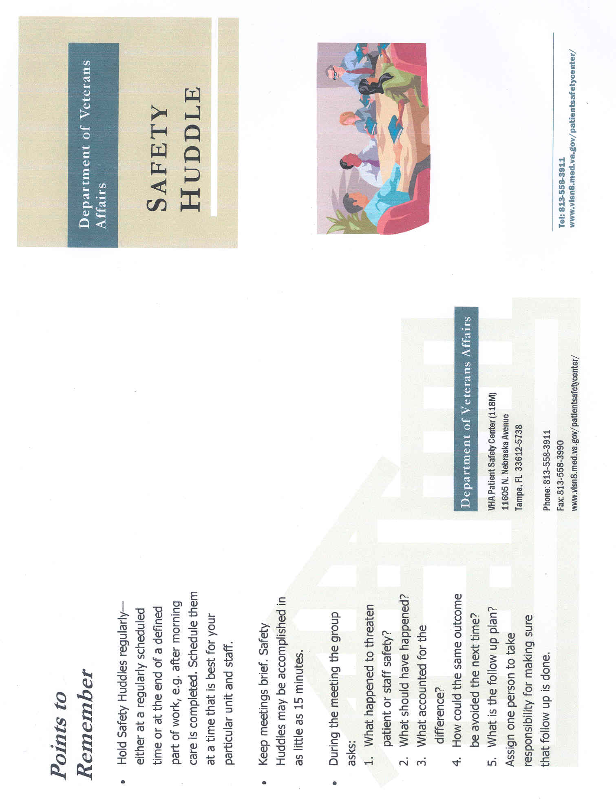
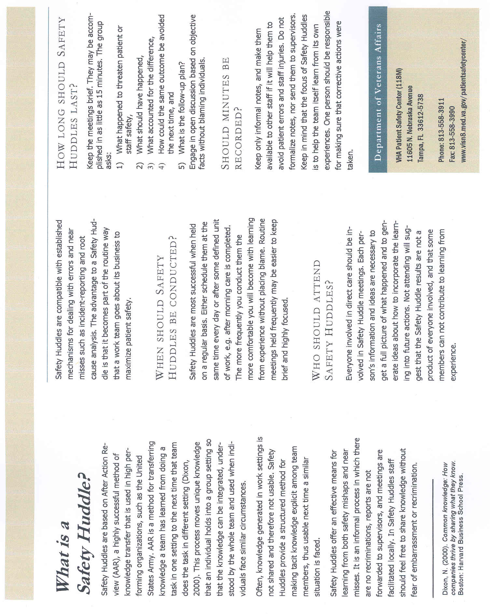

Attachment B

Peer Leaders
SELECTION
ROLES/RESPONSIBILITIES
SPH Peer Leaders
SUGGESTED Selection Criteria

Eligibility
- Any direct patient care staff (i.e., RN, LPN, CNA, PT, OT, diagnostic tech, etc.) with at least 6 months experience with handling patients
- Employed on unit for at least six months or a UPL in another area previously
- Anticipates working on unit at least one year or more

Qualities
- Satisfactory performance evaluation
- Respected by colleagues & management
- Responsible and reliable
- Flexible
- Takes initiative/proactive
- Good time management qualities
- Outgoing
- Resourceful
- Assertive (appropriately)
- Maintains good relationships w/ management

Skills
- Patient handling experience
- Effective oral/written communication skills
- Physically able to perform job duties
- Critical thinking skills (appropriate for duties)
- Ability to teach peers using established training programs
- Informal Leader – credible with & respected by peers
- Computer skills
- Ability to learn, apply, and transfer new knowledge

SPH Peer Leaders
SUGGESTED Roles/Responsibilities

Act as Unit SPH Champion
- Act as unit expert and resource on patient care ergonomics, equipment use, and safe patient handling techniques for managers/supervisors, peers, patients, families
- Problem solve patient handing issues
- Motivate/coach peers – encourages co-workers in use of patient handling equipment and compliance with SPH Program
- Bariatric SPH resource/expert
- Assist in SPH Program implementation

Train peers/mangers/patients/families
- Conduct staff in-services/training on SPH issues, equipment, etc.
- On unit, orient new employees to SPH & UPL role
- Facility-wide, participate in new employee orientation training
- Train, re-train co-workers on new & existing equipment
- Complete or assist in completion of equipment competency assessments
- Assist co-workers in patient/family training when needed

Facilitate SPH Knowledge Transfer
- Maintain communication with other UPLs through
  - Face-to-face facility UPL meetings
  - UPL Email Group
  - Conference calls
- Share best practices learned during UPL meetings with co-workers/ management
- Communicate with Facility Champion
  - One-on-one as needed
  - UPL meetings
  - Ensure facility champion is aware of UPL personnel changes – resignation, transferring etc.
- Implement After Action Review (AAR) Program, Initially take lead in AARs
- Train staff on and ensure compliance with use of Algorithms

Monitor unit SPH Program status/compliance
- Complete UPL Log to capture
  - UPL activity
  - SPH Program status
  - SPH Program acceptance
- Track equipment use
- Others

Equipment Super User

Equipment Use/Management
- Assist in conducting unit equipment needs evaluation
- Assist staff in selection of equipment through trials/equipment fairs
- Implement equipment introductions on unit
- Train staff on use of equipment (after initial manufacturer training)
- Track equipment locations, storage & ensure accessibility
- Track operational status and need for maintenance of equipment/batteries/slings
- Ensure annual/preventative maintenance is accomplished
- Track sling types, quantities, and condition
- Facilitate battery/sling/equipment orders when needed
- Notify appropriate staff when patient handling equipment problems/incidents arise
- Ensure facility & manufacturer infection control requirements are followed

Act as Unit liaison with
- Facility Champion/Coordinator
- equipment manufacturer/vendor
- purchasing
- Engineering/Facilities Management
- Infection control
- others

Conduct Ergonomic ongoing environmental/ergonomic evaluations, perform walk-throughs to assess equipment use and function

Maintain current knowledge of SPH issues, technology, and best practices
- Attend facility UPL meetings, regional/national conference calls
- Participate in equipment manufacturer training
- Attend annual SPH conferences

Follow unit injuries & close calls
- Assist in documentation and tracking of injuries and close calls
- Foster reporting of injuries, near misses, and safety concerns

Demonstrate Systems Thinking
- Participate in facility-wide SPH initiatives and projects
- Foster supportive relationship with manager/supervisor
- Be knowledgeable of and provide input on facility policies/procedures

Attachment C

Facility Safe Patient Handling Champion/Coordinator

SAMPLE FUNCTIONAL STATEMENT
Facility Safe Patient Handling Coordinator
Sample Functional Statement
DRAFT

Position Summary
The Safe Patient Handling Coordinator (SPH Coordinator) provides leadership and assumes continuing responsibility for the development, implementation, coordination, maintenance, and evaluation of the Safe Patient Handling program at the facility level. This includes integrated programs that cross service and/or discipline lines and influence organizational mission, vision, values, and strategic priorities.

Principle Duties and Responsibilities

The Safe Patient Handling Coordinator is responsible for:

- Implementation and maintenance of the facility’s Safe Patient Handling (SPH) Program
- Continuous evaluation of the facility’s Safe Patient Handling (SPH) Program; collection and submission of facility and national SPH performance measures and data call requests
- Development, leadership, coordination, expansion, and maintenance of the patient handling Unit Peer Leader (UPL) program
- UPL SPH education, training, and competency assessment in use of equipment and program elements
- Staff SPH education, training, and competency assessment in use of equipment and program elements
- Evaluation of compliance with JCAHO standards and planning and implementation of programs
- Identification, proposal, and oversight of equipment to meet current and future facility needs for safe patient handling
- Development and implementation of facility equipment and sling tracking programs
- Collaboration with facility infection control practitioners to develop and implement facility infection control program for patient handling equipment
- Communication of SPH goals and objectives and SPH Program status to facility administrators/Environment of Care Committee
- Leadership and coordination of facility multidisciplinary SPH committee
- Provision of expertise and oversight of SPH in all relevant clinical areas
- Provision of expertise and oversight of facility SPH bariatric issues
- Communication and coordination of equipment selection, installation, and maintenance with facility contracting, facilities management, and other applicable services
- Communication and coordination of remediation of equipment issues with manufacturers and facility contracting, facilities management, and other applicable service

FACTORS

Knowledge Required by the SPH Coordinator Position

Incumbent is a graduate of an accredited PT, OT, or RN program and holds a current and unrestricted license to practice their respective profession.

A Master’s Degree or Ph.D. (may be in a variety of related fields including Nursing, Ergonomics, Physical Therapy, Occupational Therapy, or other relevant areas) is desirable.

Proficiency in English is required.

At least three (3) years of exemplary clinical experience with demonstrated leadership skills is required.

The SPH Coordinator must possess solid interpersonal and collaboration skills. The SPH Coordinator must also demonstrate well honed communication abilities. As such the SPH Coordinator must be a team player that clearly illustrates how the Safe Patient Handling program segues with and complements existing programs.

Scope and Complexity

The Safe Patient Handling Coordinator must collaborate, elicit support, and network with interdisciplinary personnel, SPH experts/resources outside the facility and the VA Safety Center and equipment vendors.

Practice: Uses an analytical framework to create, develop and maintain the SPH program; as such the following practice components will be effectuated:
- Ongoing data collection and use of research to demonstrate progress/success of the SPH program
- Development of the peer leader program to facilitate facility-wide implementation of the SPH program. Education, supervision and support of the peer leaders
- Collaborate with managers to develop a strategy for dissemination of information, education, and justification of SPH program to nursing unit staff and other disciplines
- Develop and implement a plan to “sell” or market SPH program and educate interdisciplinary staff
- Collaborate with nursing and other related clinical professional management/staff in equipment selection and implementation.

Quality of Care: Provides leadership in improving and sustaining the quality and effectiveness of care in SPH program.

Performance: Implements standards of professional practice consistent with applicable accrediting bodies’ regulations.

Education/Career Development: Develops peer leaders for progression of responsibility. Anticipates new knowledge needs for changing practice environment/population groups. Plans, implements and evaluates strategies to meet those needs.

Collegiality: Contributes to the professional growth and development of colleagues and other health care providers at the local, regional, state, and national level including VA counterparts.

Ethics: Provides leadership in addressing ethical issues that impact the clients or staff involved with the SPH program.

Collaboration: Demonstrates leadership in developing productive working relationships with groups in other programs, services, academic settings and community settings.

Research: Collaborates with staff, other disciplines, faculty and peers in developing, conducting and evaluating SPH research activities and programs.

Resource Utilization: Designs, modifies, and implements systems compatible with professional standards and with the mission and the goals of the organization to improve cost-effective use of resources.

Guidelines

Guidelines consist of relevant clinical practice and administrative policies as they relate to Safe Patient Handling. This will require the SPH Coordinator to exercise considerable adaptation and interpretation for relevant SPH issues and applications. Existing precedents provide a basic outline of results desired, but do not go into sufficient detail as to the specific implementation of the SPH program. Within the context of broad regulatory guidelines the SPH Coordinator may refine or develop more specific guidelines such as implementing standards of practice and other related methods. Incumbent must have the ability to follow guidelines within the parameters of the overall SPH program.

Supervisory Controls

The Safe Patient Handling Coordinator is directly accountable to the Nurse Executive/ Associate Director for Patient Care Services for their professional practice and administrative performance.

The supervisor and SPH Coordinator will develop a mutually acceptable project plan which typically includes identification of the task to be accomplished, the scope of the project, and deadlines for its completion. Within the parameters of the SPH program, the incumbent is responsible for planning and organizing the work, estimating costs and requirements, coordinating with staff and line supervisors potentially controversial findings, issues, or problems with widespread impact. Completed projects, evaluations, reports, or recommendations are reviewed by the supervisor for compatibility with overall organizational goals, guidelines, and effectiveness in achieving intended objectives. Incumbent will work independently without daily close supervision; and as such will maintain SPH programs on an ongoing basis.

Personal Contacts

Personal contacts are extensive and include patients, clinical staff, facility leadership and others directly affected by the Safe Patient Handling program. Ongoing interaction will be maintained with respective program officials in VACO.

Purpose of Contacts

The purpose of the contacts outlined above, is to educate patients and related staff on the components of Safe Patient Handling and to fully implement/integrate the SPH program.

The SPH Coordinator also collects information from these contacts and provides ongoing qualitative analysis of the program’s effectiveness. This comprises a continuous quality improvement process for the SPH program.

Work Environment

Work is performed in a clinical setting within the medical center.

IT Security Statement

In the performance of their official duties, the SPH Coordinator has regular access to print and electronic files containing sensitive information which must be protected under the provision of the Privacy Act of 1974, HIPAA, and other applicable laws and regulations. The incumbent is responsible for (1) protecting all relevant information against unauthorized release or deletion and, (2) following applicable regulations and instructions regarding access to computerized files, release of access codes, etc., as set out in their computer access agreement which the employee signs for IT access.

Attachment D

Facility Safe Patient Handling Committee

Facility Safe Patient Handling Committee

Membership

- SPH Facility Champion
- Peer Leader Representative
- Nursing Administrator
- Nursing Staff (CNA, LPN, RN)
- Nursing Service Safety Rep
- Risk Manager
- Union
- Nurse Educator
- Therapy Staff (OT, PT, ST)
- Purchasing
- Engineering
- Employee Health/Safety
- Patient
- Others

Roles/Responsibilities

- Implements and maintains SPH Program
- Identifies SPH Program Goals and Objectives, utilizes them to drive Program
- Develops Policy and Procedures
- Reviews/trends Data
- Ensures incidents/injuries are investigated and remediated, if feasible
- Facilitates Equipment Purchases
- Others

SAFETY HUDDLE
After Action Review (AAR)

SAFETY HUDDLE QUESTIONS

(1) What happened?

(2) What was supposed to happen?

(3) What accounts for the difference?

(4) How could the same outcome be avoided the next time?

(5) What is the follow-up plan?

For More Information: Safe Patient Handling & Movement: A Practical Guide for Health Care Professionals, Ch. 7 (M. Matz, author; A. Nelson, editor)
SAFETY HUDDLE
RECOMMENDATIONS TEMPLATE

Date of Safety Huddle:____________________________

RECOMMENDATION #1:

STAFF RESPONSIBLE FOR FOLLOW-UP:

Contact Information:

FOLLOW-UP DATE/S:

RECOMMENDATION #2:

STAFF RESPONSIBLE FOR FOLLOW-UP:

Contact Information:

FOLLOW-UP DATE/S:

RECOMMENDATION #3:

STAFF RESPONSIBLE FOR FOLLOW-UP:

Contact Information:

FOLLOW-UP DATE/S:
SAFETY HUDDLE
UNIT RECOMMENDATIONS LOG

Date of initial Safety Huddle/AAR | Recommendation | Progress Notes | Follow-up Date/s | Recommendation  Completion Date | Date Staff Informed of Status

SAFE PATIENT HANDLING ASSESSMENT, ALGORITHMS, & CARE PLAN

Assessment Criteria and Care Plan for Safe Patient Handling and Movement

Assessment Criteria and Care Plan for Safe Patient Handling and Movement

I. Patient’s Level of Assistance:
_____ Independent— Patient performs task safely, with or without staff assistance, with or without assistive devices.
_____ Partial Assist—Patient requires no more help than stand-by, cueing, or coaxing, or caregiver is required to lift no more than 35 lbs. of
a patient’s weight.
_____ Dependent—Patient requires nurse to lift more than 35 lbs. of the patient’s weight, or is unpredictable in the amount of assistance
offered. In this case assistive devices should be used.

An assessment should be made prior to each task if the patient has varying level of ability to assist due to medical reasons, fatigue, medications, etc. When in doubt, assume the patient cannot assist with the transfer/repositioning.
II. Weight Bearing Capability III. Bi-Lateral Upper Extremity Strength
_____ Full _____ Yes
_____ Partial _____ No
_____ None

IV. Patient’s level of cooperation and comprehension:
_____ Cooperative — may need prompting; able to follow simple commands.
_____ Unpredictable or varies (patient whose behavior changes frequently should be considered as “unpredictable”), not cooperative, or
unable to follow simple commands.

V. Weight: _________ Height: ___________
Body Mass Index (BMI) [needed if patient’s weight is over 300]¹:___________
If BMI exceeds 50, institute Bariatric Algorithms

The presence of the following conditions are likely to affect the transfer/repositioning process and should be considered when identifying equipment and technique needed to move the patient.
VI. Check applicable conditions likely to affect transfer/repositioning techniques.
_____ Hip/Knee/Shoulder Replacements _____ Respiratory/Cardiac Compromise _____ Fractures
_____ History of Falls _____ Wounds Affecting Transfer/Positioning _____ Splints/Traction
_____ Paralysis/Paresis _____ Amputation _____ Severe Osteoporosis
_____ Unstable Spine _____ Urinary/Fecal Stoma _____ Severe Pain/Discomfort
_____ Severe Edema _____ Contractures/Spasms _____ Postural Hypotension
_____ Very Fragile Skin _____ Tubes (IV, Chest, etc.)

Comments:_____________________________________________________________________________________________________________________________________________________________________________________________________________________________________________________________________________________________________________________________________________________

VII. Appropriate Lift/Transfer Devices Needed:

Vertical Lift:

Horizontal Lift:

Other Patient Handling Devices Needed:

Sling Type: Seated_____ Seated (Head Support) ______ Seated (Amputee)_____ Hygiene_____ Supine_____ Ambulation_____ Limb Support_____

Sling Size: _____________

Signature: _______________________________________________ Date: _________________

___________________________________________________________
¹ For Online BMI table and calculator see: http://www.nhlbi.nih.gov/guidelines/obesity/bmi_tbl.htm

Algorithm 1: Transfer to and From: Bed to Chair, Chair to Toilet, Chair to Chair, or Car to Chair
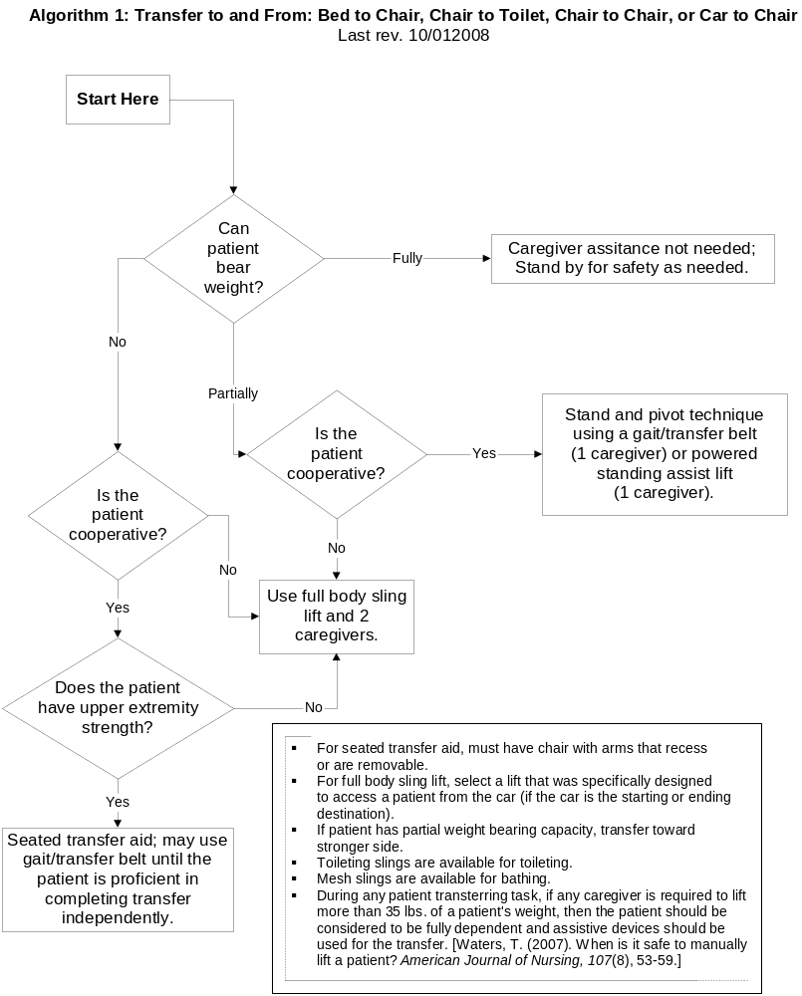

Algorithm 2: Lateral Transfer To and From: Bed to Stretcher, Trolley
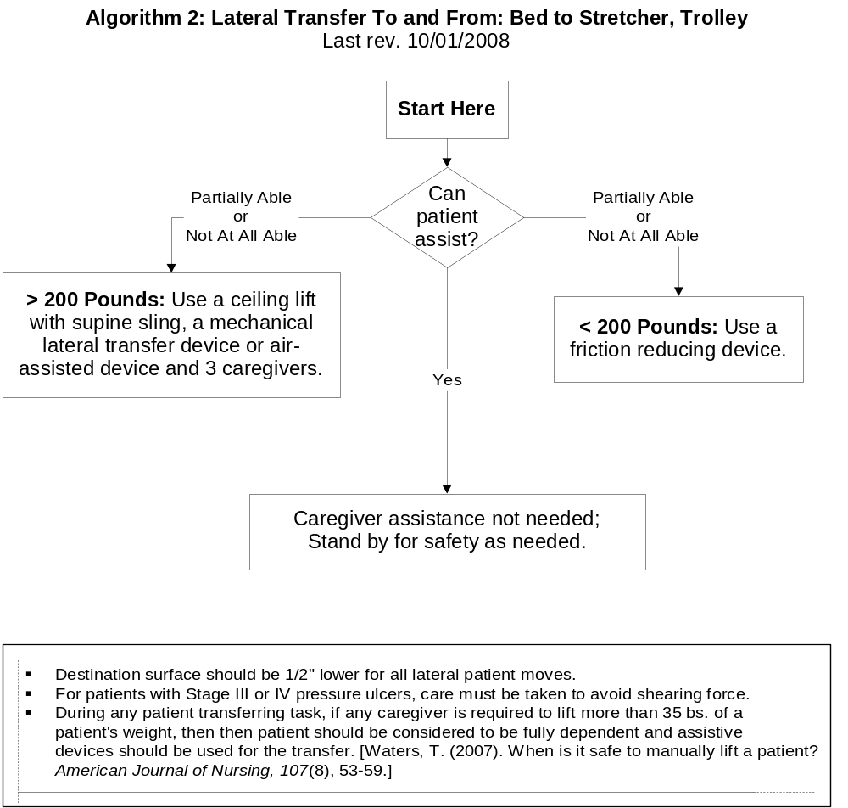

Algorithm 3: Transfer To and From: Chair to Stretcher or Chair to Exam Table
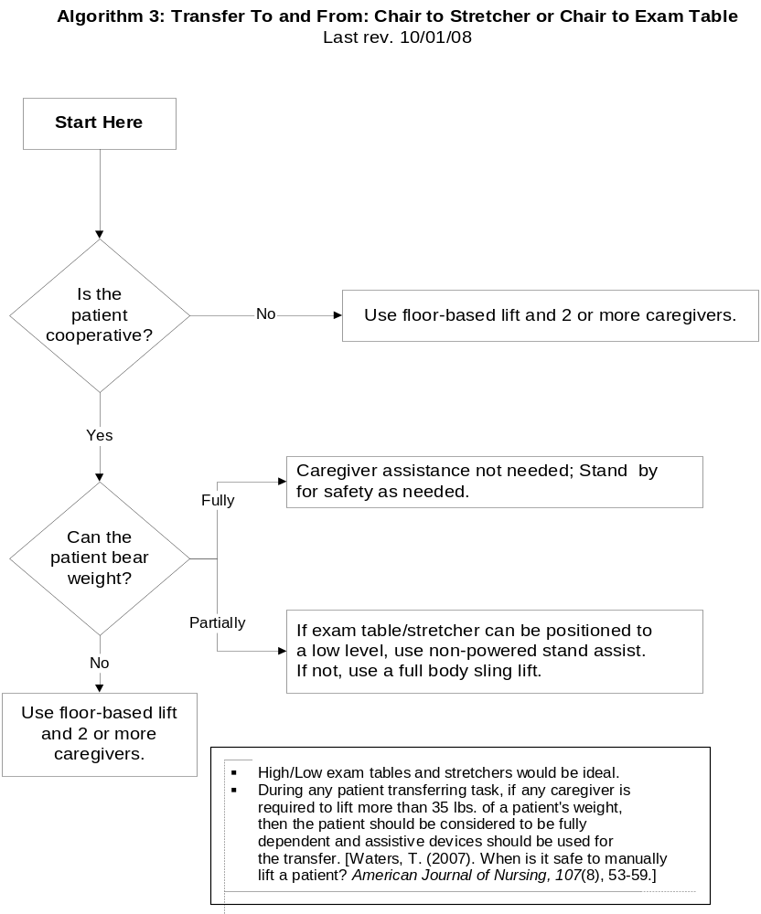

Algorithm 4: Reposition in Bed: Side-to-Side, Up in Bed
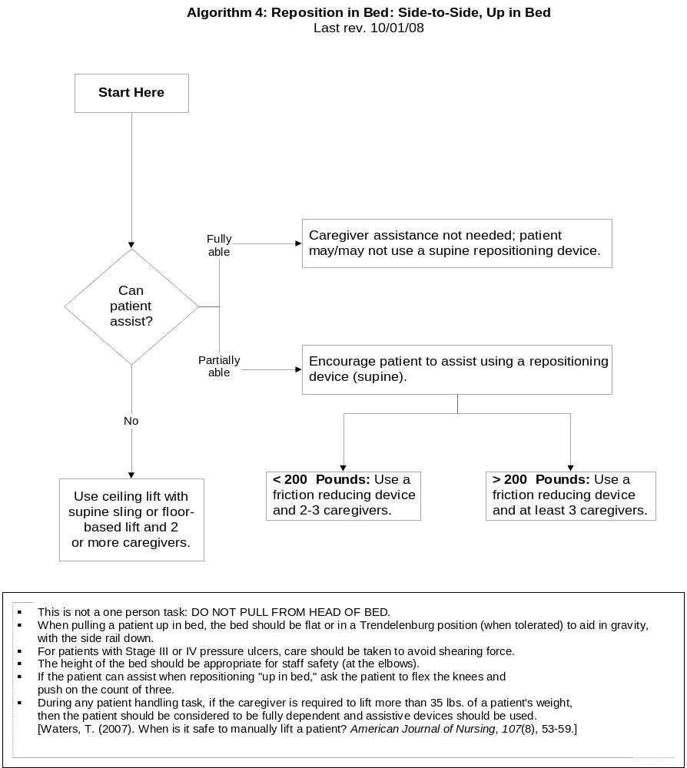

Algorithm 5: Reposition in Chair: Wheelchair and Dependency Chair
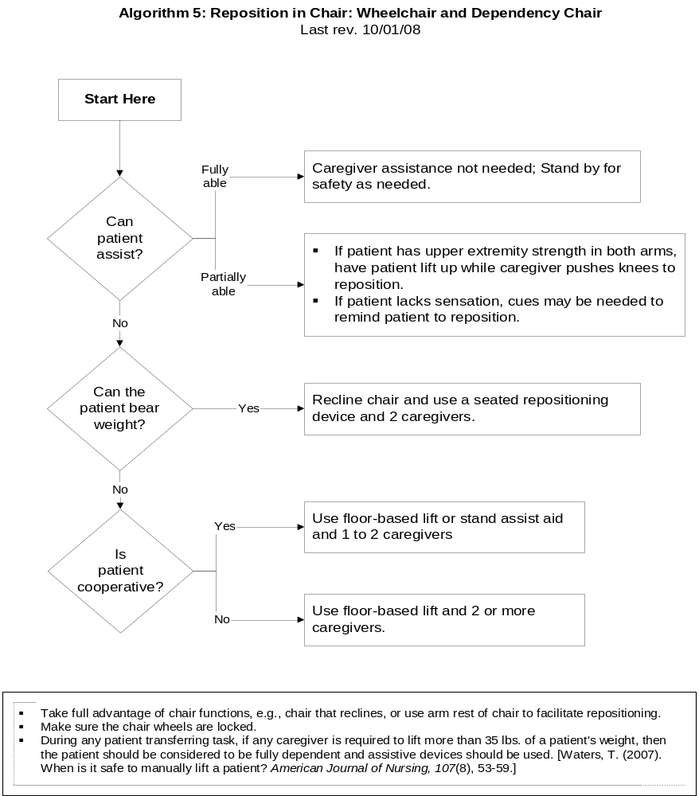

Algorithm 6: Transfer a Patient Up From the Floor
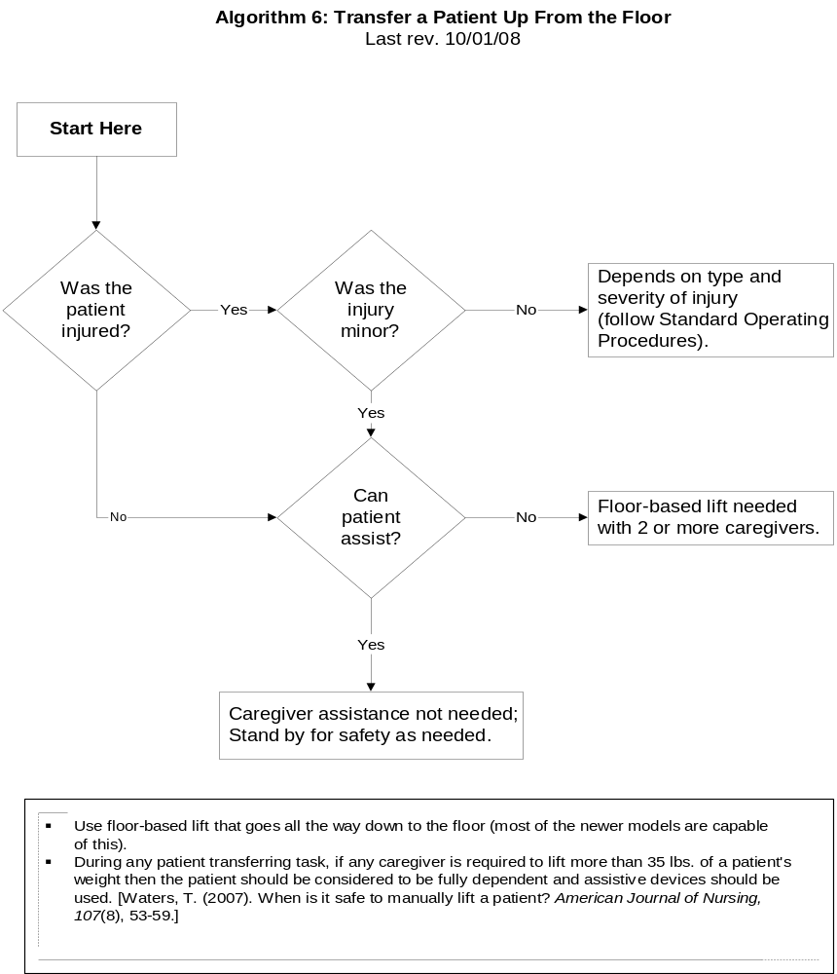

Bariatric Algorithm 1: Bariatric Transfer To and From: Bed/Chair, Chair/Toilet, or Chair/Chair
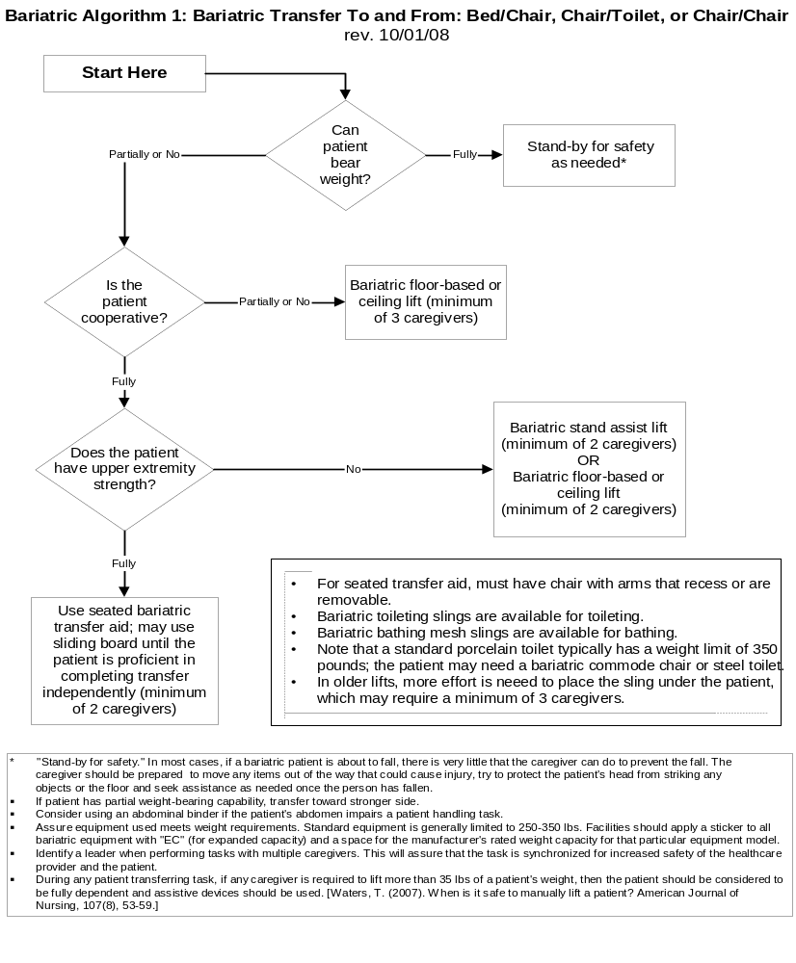

Bariatric Algorithm 2: Bariatric Lateral Transfer To and From: Bed/Stretcher/Trolley
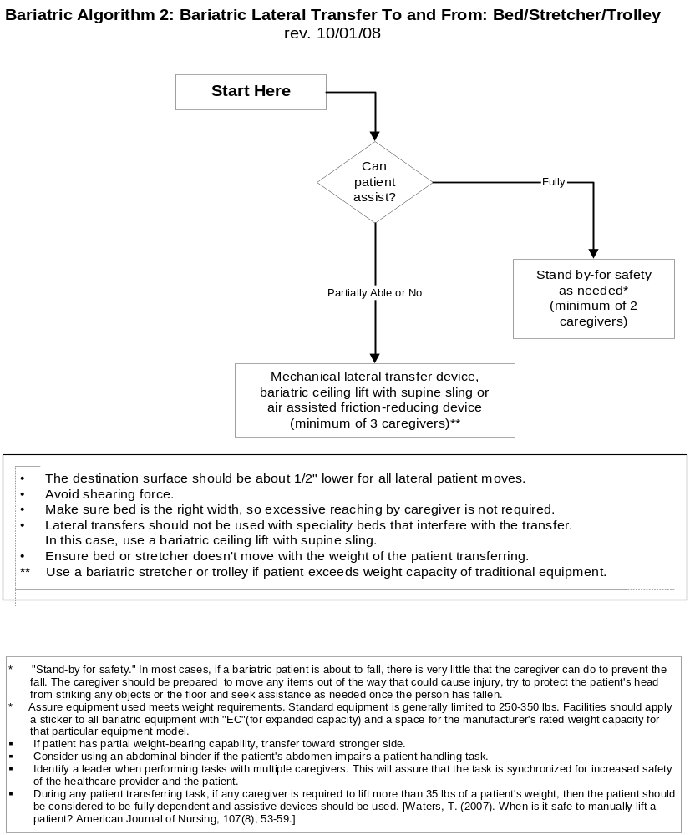

Bariatric Algorithm 3: Bariatric Reposition in Bed: Side-to-Side, Up in Bed
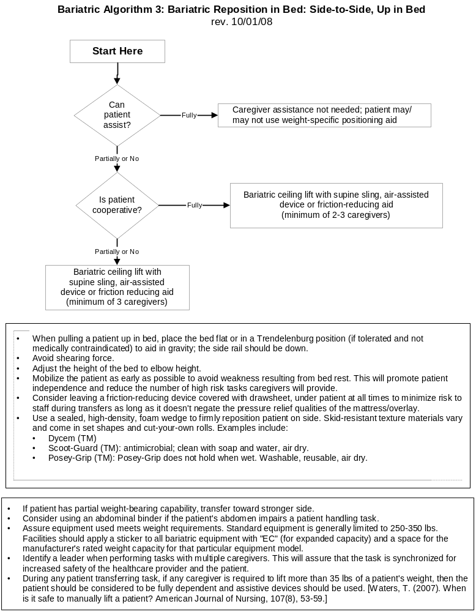

Bariatric Algorithm 4: Bariatric Reposition in Chair: Wheelchair, Chair, or Dependency Chair
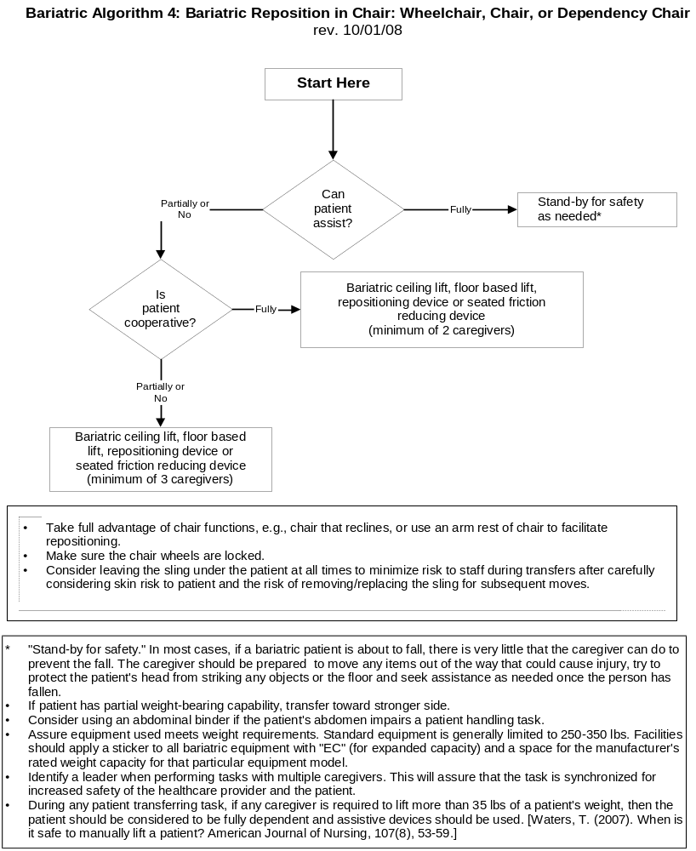

Bariatric Algorithm 5: Patient Handling Tasks Requiring Access to Body Parts (Limb, Abdominal Mass, Gluteal Area)
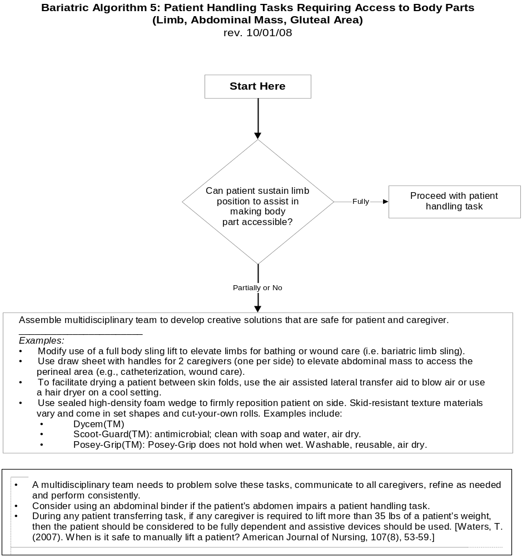

Bariatric Algorithm 6: Bariatric Transporting (Stretcher)
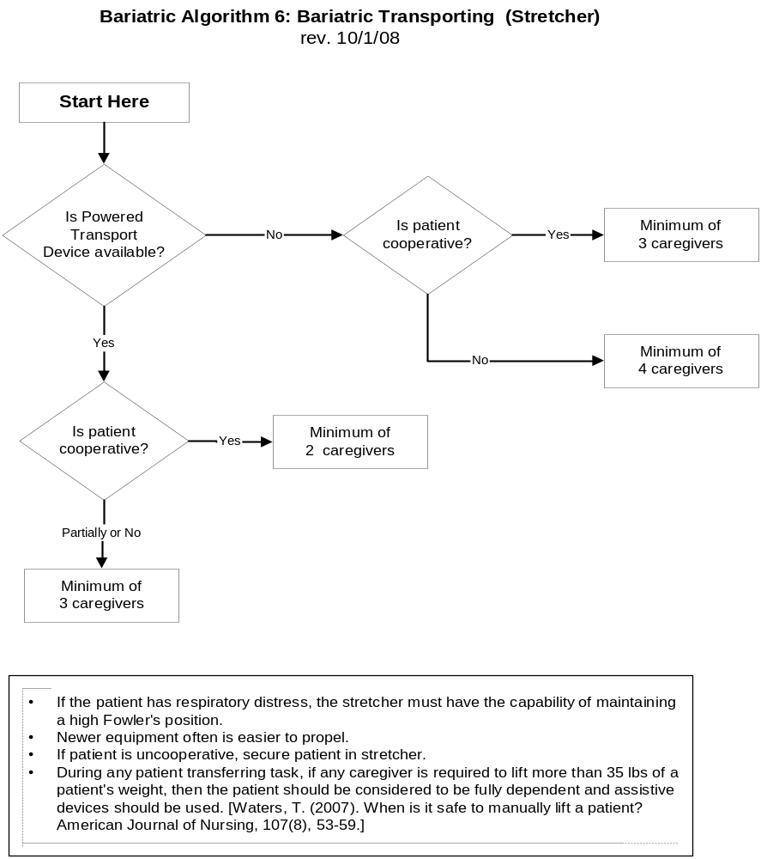

Bariatric Algorithm 7: Toileting Tasks for the Bariatric Patient

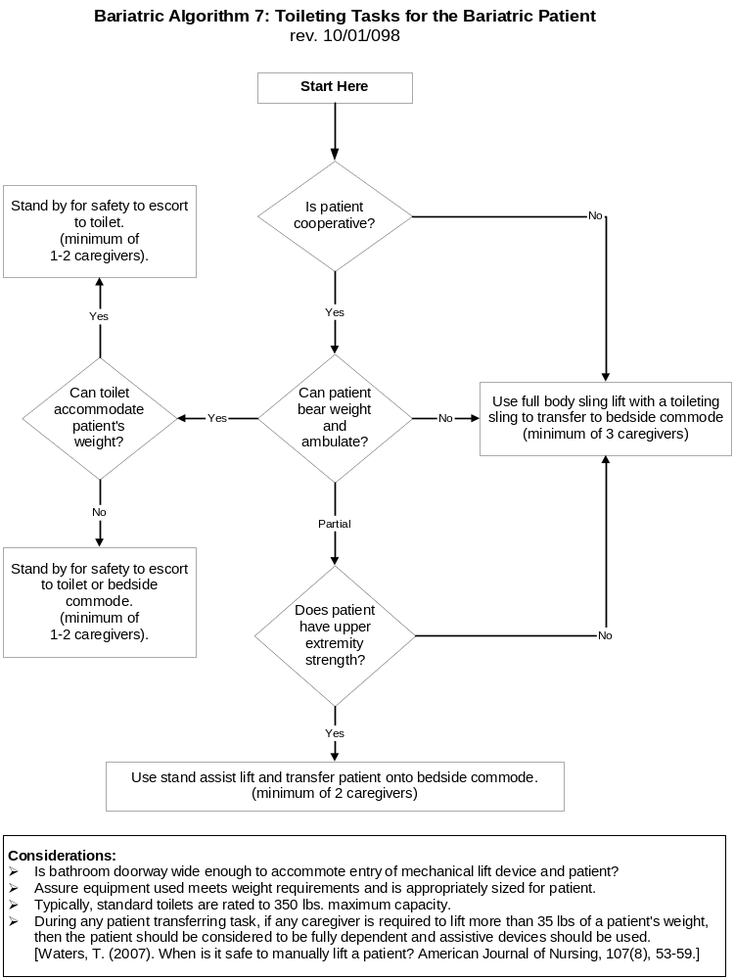

Bariatric Algorithm 8: Transfer a Bariatric Patient Up From the Floor
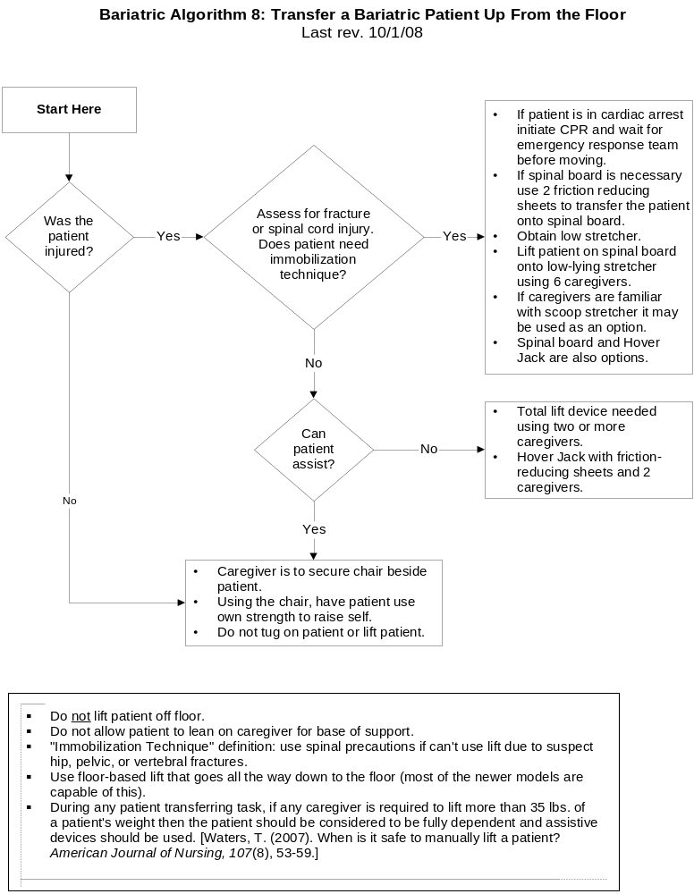

Orthopaedic Algorithm #1: Turning Patient in Bed (Side-to-Side) Patient with Orthopaedic Impairments
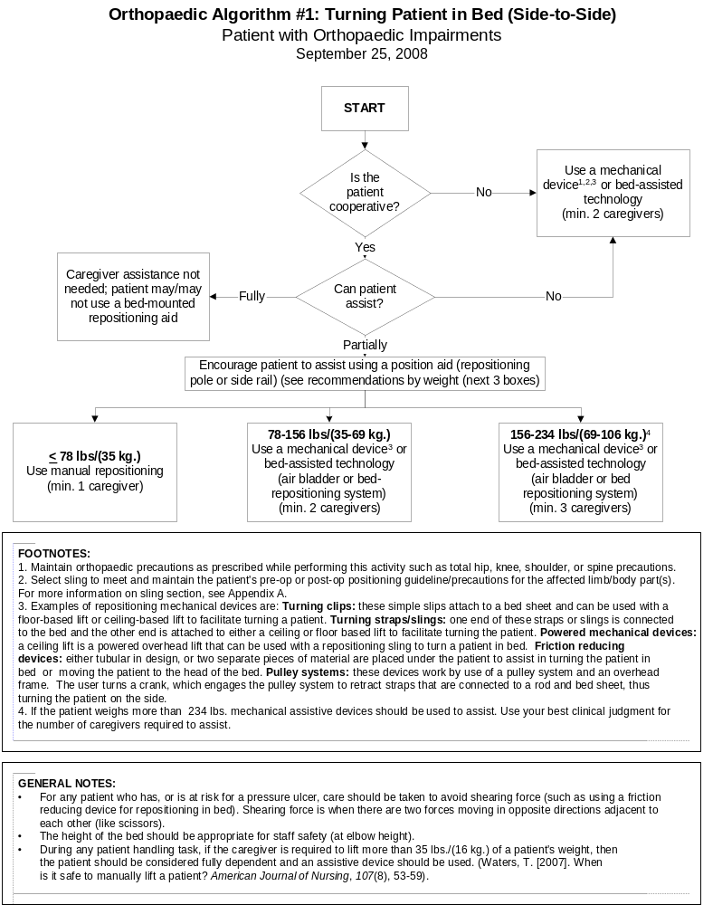
Orthopaedic Algorithm #2: Vertical Transfer of a Post-Operative Total Hip Replacement Patient (Bed to Chair, Chair to Toilet, Chair to Chair, or Car to Chair)
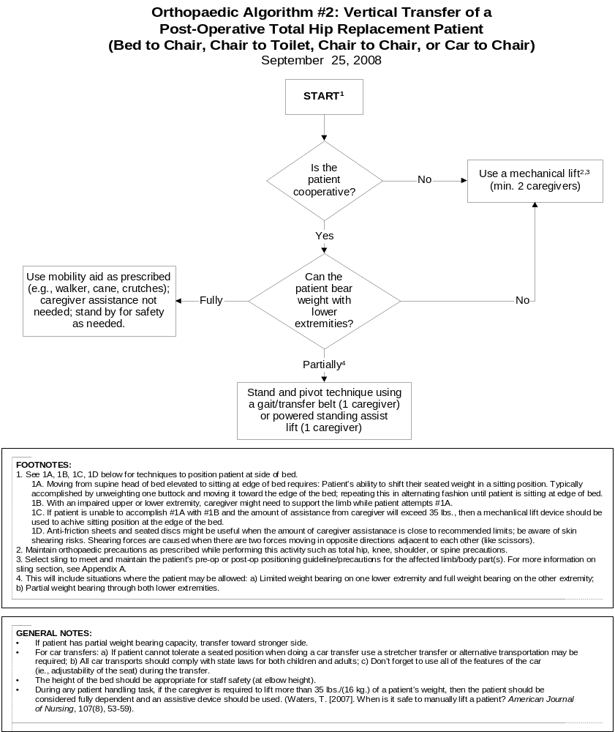
Orthopaedic Algorithm #3: Vertical Transfer of a Patient with an Extremity Cast/Splint
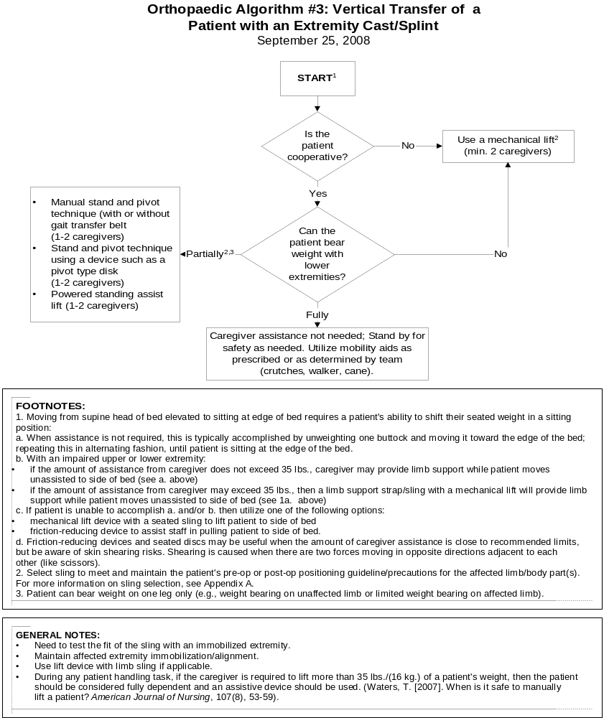

Orthopaedic Algorithm #4: Ambulation
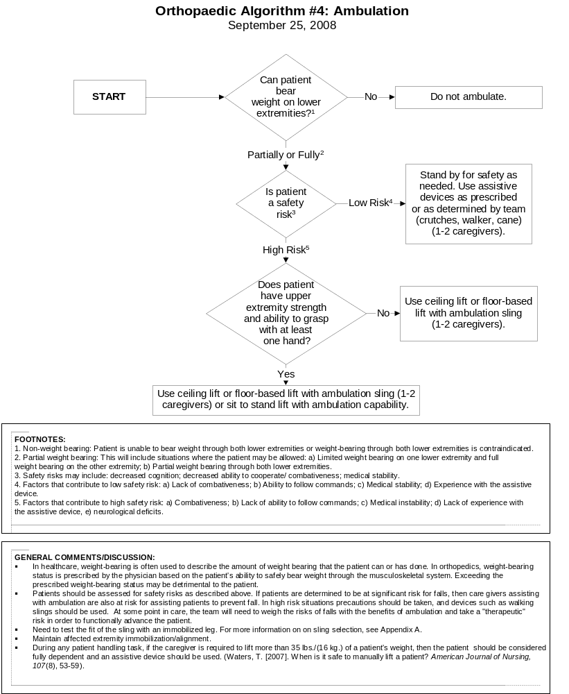

Orthopaedic Clinical Tool #1: Lifting and Holding Legs or Arms in an Orthopaedic Setting

Introduction
Often when orthopaedic care is being provided, the care giver must lift and/or hold a limb in place while some type of treatment is being provided, such as cast application. It is assumed that you are maintaining a neutral (upright) body posture (not fully flexed); adjust the height of the table. When a caregiver must lift a leg or arm, it is important to make sure that the weight of the limb being lifted does not exceed the strength capability of the caregiver. An ergonomic tool has been developed to assist caregivers in determining whether a specific lift and/or hold of a limb is acceptable and whether some type of lift or hold assist device is needed. For lifts of limbs with casts, an alternate method is presented for assessing whether the lift is acceptable or not as presented in Table #1.

This tool shows the calculation of the average weight for an adult patient’s leg and arm as a function of whole body mass, ranging from slim to morbidly obese body type. Weights are presented both in pounds (lbs.) and metric (kg.) units. Maximum lift and hold loads were calculated based on 75th percentile shoulder flexion strength and endurance capability for US adult females, where the maximum weight for a one-handed lift is 11.1 lbs. and a two-handed lift, 22.2lbs.

Table 1. Ergonomic Tool: Lifting and Holding Legs or Arms in an Orthopaedic Setting*

Patient Weight  lbs. (kg.) | Body  Part | Body Part  Weight  Lbs. (kg.) |  | Lift  1- hand | Lift  2- hand | Hold  2-hand  1 min. | Hold  2-hand  2 min. | Hold  2-hand  3 min.
<40 lbs. | Leg | <6.3 lbs. | (3 kg.)
(< 18 kg.) | Arm | <2.0 lbs. | (1 kg.)
40-90 lbs. | Leg | <14.1 lbs . | (6 kg.)
(18-41 kg.) | Arm | <4.6 lbs. | (2 kg.)
90-140 lbs. | Leg | <22.0 lbs. | (10 kg.)
(41-64 kg.) | Arm | <7.1 lbs. | (3 kg.)
140-190 lbs. | Leg | <29.8 lbs. | (14 kg.)
(64-86 kg.) | Arm | <9.7 lbs. | (4 kg.)
190-240 lbs. | Leg | <37.7 lbs. | (17 kg.)
(86-109 kg.) | Arm | <12.2 lbs. | (6 kg.)
240-290 lbs. | Leg | <45.5 lbs. | (21 kg.)
(109-132 kg.) | Arm | <14.8 lbs. | (7 kg.)
290-340 lbs. | Leg | <53.4 lbs. | (24 kg.)
(132-155 kg.) | Arm | <17.3 lbs. | (8 kg.)
340-390 lbs. | Leg | <61.2 lbs. | (28 kg.)
(155-177 kg.) | Arm | <19.9 lbs. | (9 kg.)
390-440 lbs. | Leg | <69.1 lbs. | (31 kg.)
(177-200 kg.) | Arm | <22.2 lbs. | (10 kg.)
> 440 lbs. | Leg | >69.1 lbs. | (31 kg.)
(>200 kg.) | Arm | >22.2 lbs. | (10 kg.)
* No shading: Lift and hold is appropriate but use clinical judgment and do not hold longer than noted.
Heavy shading: Do not lift alone; use assistive device or more than one caregiver.

The shaded areas of the table indicate whether it would be acceptable for one caregiver to lift the listed body parts with one or two hands or hold the respective body parts for 1, 2, or 3 minutes with two hands. Respecting these limits will minimize risk of muscle fatigue and the potential for musculoskeletal disorders. If the limb weight exceeds the values listed in the table it is recommended to use assistive technology, such as a ceiling lift or floor based lift with a limb support sling. Orthopaedic caregivers must use clinical judgment to assess the need for additional staff member assistance or assistive devices to lift and/or hold one of these body parts for a particular period of time.
Note: It is important to remember that the chart shows the acceptable weights for limbs without a cast in place. If the caregiver is lifting a limb with a cast, the additional weight of the cast should be added to the weight of the limb to determine whether the lift is acceptable. An alternate method is provided below for limbs with casts. These are guidelines for the average weight of the leg and arm, and are based upon the patient’s weight. The maximum weight for a 1-handed lift is 11.1 lbs. and a 2-handed lift, 22.2 lbs.

Patient weight is divided into weight categories (see Table 1), ranging from very light to morbidly obese. Normalized weight for each leg and each arm are calculated as a percentage of body weight where each complete arm weighs 5.1% of total body mass and each leg weighs 15.7% of total body mass (Chaffin, Anderson, & Martin, 1999). All weights are presented in both pounds and kilograms, rounded to the nearest whole unit.
To accommodate 75% of the US adult female working population, maximum load for a 1-handed lift is calculated to be 11.1 lbs. (5.0 kg.). This is determined by calculating the strength capabilities for 25th percentile US adult female maximum shoulder flexion movement (the mean equals 40 Newton meters, standard deviation equals 13 Nm) (Chaffin, Anderson, & Martin, 1999) and 75th percentile US adult female shoulder to grip length (the mean equals 610 mm, the standard deviation equals 30 mm) (Pheasant, 1992). Maximum loads for one person for a 2-handed lift (i.e., 22.2 lbs. /10.1 kg.) are calculated as twice that of a 1-handed lift. Muscle strength capabilities diminish as a function of time, therefore, maximum loads for 2-handed holding of body parts are presented for 1, 2, and 3 minute durations. After 1 minute, muscle endurance has decreased by 48%, decreased by 65% after 2 minutes, and, after 3 minutes of continuous holding, strength capability is only 29% of initial lifting strength (Rohmert, 1973, a, b). If the limits in ergonomic Table 1 are exceeded, additional staff members or assistive limb holders should be used.

References
Chaffin, D. B., Anderson, G.B.J., & Martin, B.J. (1999). Occupational biomechanics (3rd ed.). New York, NY: J. Wiley & Sons
Pheasant, S. (1992). Bodyspace. Taylor & Francis, Ltd: London.

Rohmert,W. (1973a). Problems of determination of rest allowances. Part 1: Use of modern methods to evaluate stress and strain in static muscular work. Applied Ergonomics, 4(2), 91-95.

Rohmert,W. (1973b) Problems of determination of rest allowances. Part 2: Determining rest allowances in different human tasks. Applied Ergonomics, 4(3), 158-162.
Waters, T. (2007). When is it safe to manually lift a patient? American Journal of Nursing, 107(8), 53–59.

Orthopaedic Clinical Tool #2: Alternate Method for Determining Safe Lifting and Holding of Limbs with Casts

Table 2.1. Predicted Weight for Different Types of Casts

Limb | Limb Weight Factor | 1-hand | 2-hands | 2-hands 1 min. | 2-hands  2 min. | 2-hands  3 min.
Leg | 0.157 | 11.1 lbs.  (5.1 kg.) | 22.2 lbs.  (10.2 kg.) | 11.6 lbs.  (5.3 kg.) | 7.8 lbs.  (3.5 kg.) | 6.4 lbs.  (2.9 kg.)
Arm | 0.051

Multiply the patients’ weight times the limb factor (0.157 for leg and 0.051 for arm) and add the weight of the cast. Compare the calculated weight to the value in the appropriate task box. If the total limb weight exceeds the weight in the appropriate box, then the caregiver should not manually lift the limb alone, but should use an assistive device or more than one caregiver to perform the lift. On the other hand, if the calculated weight is less than the value in the appropriate box, then it is acceptable to manually lift and hold the limb and the caregiver should use clinical judgment and not hold longer than noted.

For example if the patient weighs 200 lbs. and has an arm cast weighing 5 lbs., then the total arm weight would be 200 lbs. x 0.051 plus 5 lbs., or 15.2 lbs. In this case, the arm should not be lifted with one hand (i.e., 15.2 lbs. > 11.1 lbs.) but could be lifted with two hands (i.e., 15.2 lbs. < 22.2 lbs.), but not held in that position less than a few seconds (15.2 lbs. > 11.6 lbs.). Similarly, if the patient weighs 75 lbs. and has a 5 lb. leg cast, then the total limb weight would be 75 lbs. x 0.157 plus 5 lbs., or 16.8 lbs. In this case, it would not be acceptable to lift the limb with one hand (i.e., 16.8 lbs. > 11.1 lbs.), but it would be acceptable to lift it with two hands (i.e., 16.8 lbs. < 22.1 lbs.), but should not be held more than a few seconds (16.8 lbs. > 11.6 lbs.).

Table 2.2. Predicted Weights for a Fiberglass Cast
The following Table 2.2 provides some predicted weights for a fiberglass cast.
Short Arm Cast (adult) | Long Arm Cast (adult) | Short Leg Walking Cast (150 lbs. adult) | Long  Leg Cast  (150 lbs. adult) | Infant Body Spica  20-30 lbs. | Child Body Spica  3-5 yr old  30-50 lbs.
0.5 lbs. | 1 lbs. | 2 lbs. | 3.0 lbs. | 2 lbs. | 4lbs.
2 rolls 3” | 1 roll 2”  3 rolls 3” | 4 rolls 4” | 3 rolls 3”  3 rolls 4” | 2 rolls 2”  3 rolls 3” | 5 rolls 3”  5 rolls 4”
+ webril* | + webril* | + webril* | + webril* | + webril* | + webril*
*Weight of webril is 0.25 lb. per packet

Orthopaedic Appendix A: Helpful Hints on Slings

Selection of the appropriate sling accessory for movement / lift /transfer, must include the following considerations:
- Decision to transfer patient in sitting vs. supine position – choose correct functionality of the sling
- Select appropriate size
- Maintain alignment of the affected body part(s) according to pre-operative/post-operative guidelines
  - Consider the patient’s body size, shape and features (e.g. very large abdominal girth can limit degree of hip flexion )
  - Features of sling:
    - consider where material covers the patient
    - strap options for seated slings-the length of material for strap supports of the lower extremities can often be modified by selecting differing loop attachment points of the sling onto the hanger bar ( e.g. providing more material length will allow lower extremity to be in less flexed position)
    - seated slings back height can vary from supporting whole trunk and head to covering pelvis/waist only. When upper extremities are involved, consider height of the sling – high back slings will wrap around and enclose an upper extremity, while a low back sling will allow upper extremity to be free
- If alignment/positioning guidelines cannot be met with available sling accessory, transfer patient supine with sheet style sling or anti-friction methods, then sit upright.
- The “Patient Care Sling Selection and Usage Toolkit” is available for download at:
http://www.visn8.va.gov/patientsafetycenter/safePtHandling/toolkitSlings.asp

OR Algorithm 1: Lateral Transfer from Stretcher to and from the OR Bed

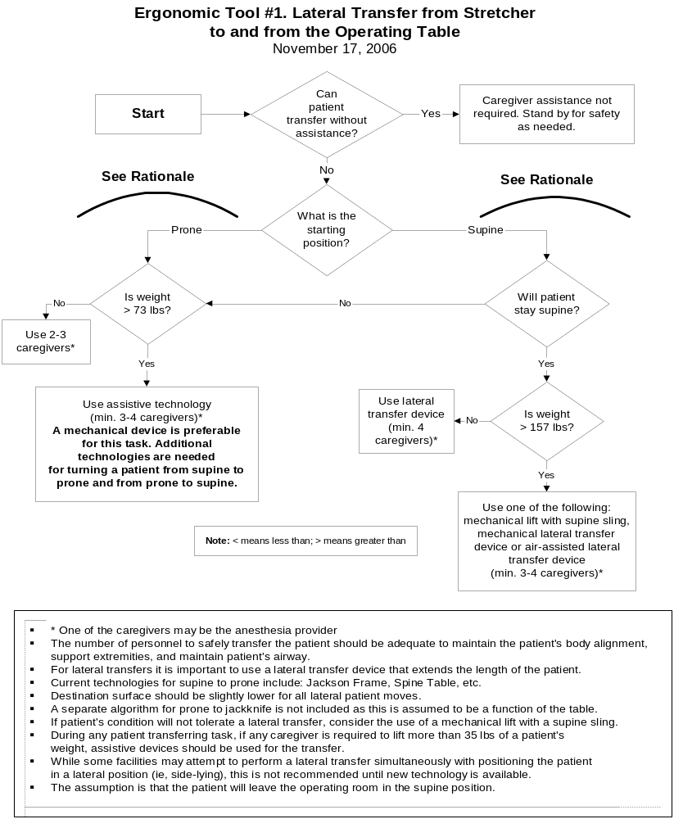
OR Algorithm 2: Positioning and Repositioning the Patient on the OR Bed to and from the Supine Position
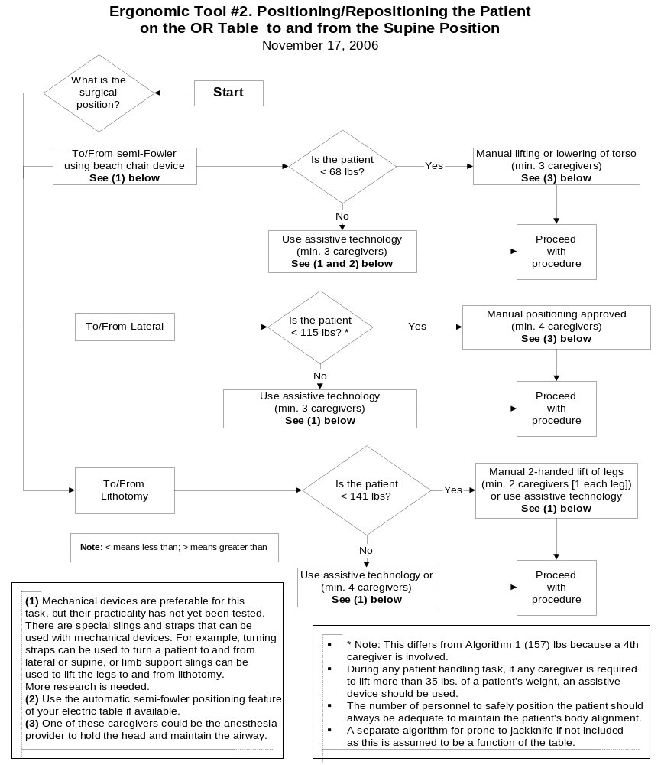
OR Algorithm 3: Prolonged Standing

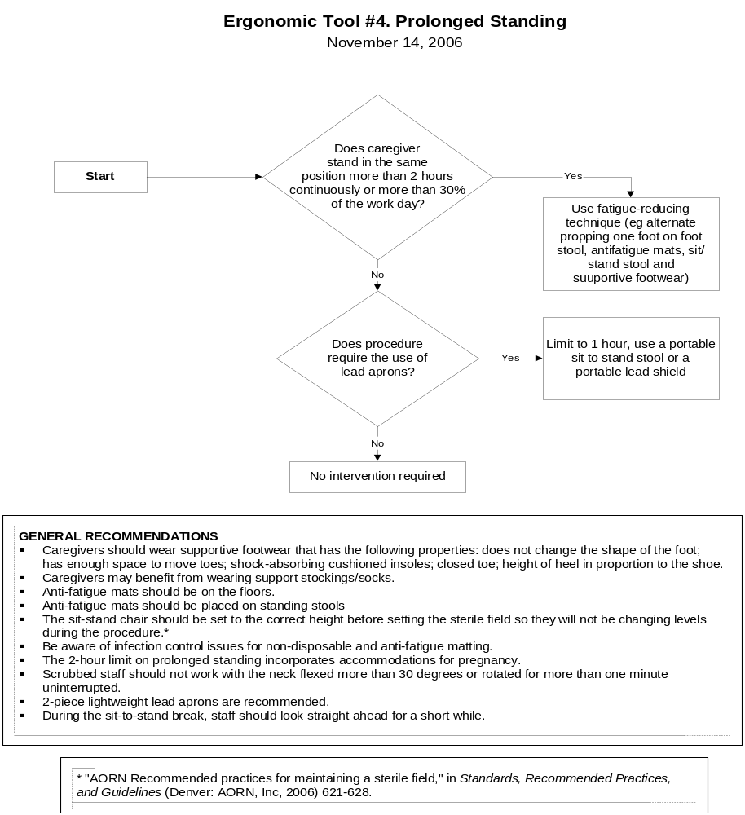

OR Algorithm 4: Retraction

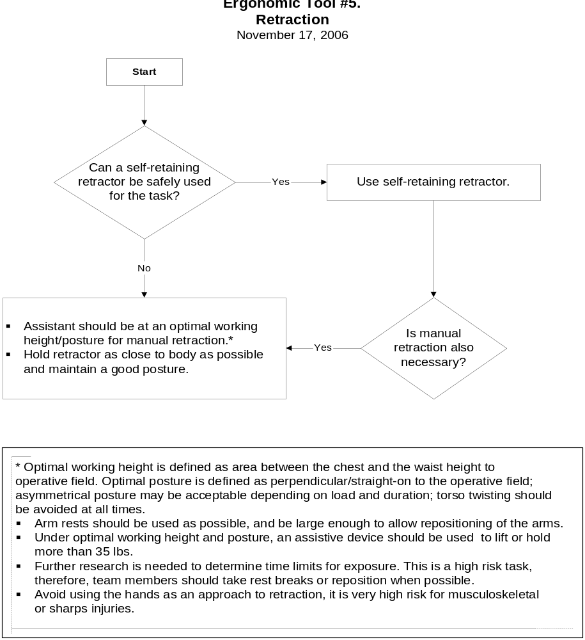
OR Clinical Tool 1: Lifting and Holding Legs, Arms, and Heads for Prepping in a Perioperative Setting

Key
No shading | OK to lift and hold, use clinical judgment, do not hold longer than noted
Heavy shading | Do not lift alone, use assistive device or more than one caregiver

Patient Weight lbs (kg) | Body | Body Part |  | Lift | Lift | Hold | Hold | Hold
Patient Weight lbs (kg) | Part | Weight |  | 1- hand | 2- hand | 2-hand | 2-hand | 2-hand
Patient Weight lbs (kg) |  | lbs (kg) |  |  |  | <1 min | <2 min | <3 min
<120 lbs | Leg | <19 lbs | (9 kg)
(< 54 kg) | Arm | <6 lbs | (3 kg)
 | Head | <10 lbs | (5 kg)
120-160 lbs | Leg | <25 lbs | (11 kg)
(54-73 kg) | Arm | <8 lbs | (4 kg)
 | Head | <13 lbs | (6 kg)
160-200 lbs | Leg | <31 lbs | (14 kg)
(73-91 kg) | Arm | <10 lbs | (5 kg)
 | Head | <17 lbs | (8 kg)
200-240 lbs | Leg | <38 lbs | (17 kg)
(91-109 kg) | Arm | <12 lbs | (6 kg)
 | Head | <20 lbs | (9 kg)
240-280 lbs | Leg | <44 lbs | (20 kg)
(109-127 kg) | Arm | <14 lbs | (6 kg)
 | Head | <24 lbs | (11 kg)
280-320 lbs | Leg | <50 lbs | (23 kg)
(127-145 kg) | Arm | <16 lbs | (7 kg)
 | Head | <27 lbs | (12 kg)
>360 lbs | Leg | >57 lbs | (26 kg)
(>163 kg) | Arm | >18 lbs | (8 kg)
 | Head | >30 lbs | (14 kg)

OR Clinical Tool 2: Lifting and Carrying Supplies and Equipment

Lifting Task | Lifting Index | Level of Risk
3,000 ml irrigation fluid | <0.2
Sand bags | 0.3
Linen bags | 0.4
Lead aprons | 0.4
Custom sterile packs (eg, heart or spine) | 0.5
Garbage bags (full) | 0.7
Positioning devices off shelf or rack (eg, stirrups) | 0.7
Positioning devices off shelf or rack (eg, gel pads) | 0.9
Hand table (49” x 28”)-largest hand table-used infrequently | 1.2
Fluoroscopy Board (49” x 21”) | 1.2
Stirrups (2- one in each hand) | 1.4
Wilson frame | 1.4
Irrigation containers for lithotripsy (12,000 ml) | 1.5
Instrument pans | 2.0

Key
No shading | Minimal risk – Safe to lift
Light shading | Potential risk – Use assistive technology, as available
Heavy shading | Considerable risk – one person should not perform alone or weight should be reduced.

OR Clinical Tool 3: Pushing, Pulling and Moving Equipment on Wheels

OR Equipment | Pushing Force  lbF (kgF) |  | Max Push Distance  ft / (m) |  | Ergonomic Recommendation
Electrosurgery unit | 8.4 lbF | (3.8 kgF) | >200ft | (60m) | Task is acceptable for 1 caregiver
Ultrasound | 12.4 lbF | (5.6 kgF) | >200ft | (60m) | Task is acceptable for 1 caregiver
X ray equipment portable | 12.9 lbF | (5.9 kgF) | >200ft | (60m) | Task is acceptable for 1 caregiver
Video towers | 14.1 lbF | (6.4 kgF) | >200ft | (60m) | Task is acceptable for 1 caregiver
Linen cart | 16.3 lbF | (7.4 kgF) | >200ft | (60m) | Task is acceptable for 1 caregiver
X ray equip – C-arm | 19.6 lbF | (8.9 kgF) | >200ft | (60m) | Task is acceptable for 1 caregiver
Case carts – empty | 24.2 lbF | (11.0 kgF) | >200ft | (60m) | Task is acceptable for 1 caregiver
OR stretcher unoccupied | 25.1 lbF | (11.4 kgF) | >200ft | (60m) | Task is acceptable for 1 caregiver
Case carts – full | 26.6 lbF | (12.1 kgF) | >200ft | (60m) | Task is acceptable for 1 caregiver
Microscopes | 27.5 lbF | (12.5 kgF) | >200ft | (60m) | Task is acceptable for 1 caregiver
Hospital bed – unoccupied | 29.8 lbF | (13.5 kgF) | >200ft | (60m) | Task is acceptable for 1 caregiver
Specialty equip carts | 39.3 lbF | (17.9 kgF) | >200ft | (60m) | Task is acceptable for 1 caregiver
OR stretcher - occupied 300 lbs | 43.8 lbF | (19.9 kgF) | >200ft | (60m) | Task is acceptable for 1 caregiver
Bed - occupied 300 lbs | 50.0 lbF | (22.7 kgF) | <200ft | (30m) | Min 2 caregivers required
Specialty OR beds unoccupied | 69.7 lbF | (31.7 kgF) | <100ft | (30m) | Min 2 caregivers required
OR bed unoccupied | 61.3 lbF | (27.9 kgF) | <25ft | (7.5m) | Recommend powered transport device
OR bed occupied 300 lbs | 112.4 lbF | (51.1 kgF) | <25ft | (7.5 m) | Recommend powered transport device
Specialty OR beds - occupied 300 lbs | 124.2 lbF | (56.5 kg) | <25ft | (7.5 m) | Recommend powered transport device

Key
No shading | Minimal risk - Task is acceptable for 1 caregiver
Light shading | Moderate risk – Minimum of 2 caregivers or powered device recommended
Heavy shading | Considerable risk - Recommend powered transport device

Safe Patient Handling Facility Committee/Task Force
Suggestions for SPH Facility Task Force/Committee

Members/Roles

MEMBERS
- Nursing Administrator
- Nursing Staff (CNA, LPN, RN)
- Nursing Service Safety Rep
- Peer Leader (BIRN)
- Risk Manager
- Patient
- Union
- Nurse Educator
- Therapy Staff (OT, PT, ST)
- Purchasing
- Engineering
- Employee Health/Safety
- Others…

ROLES
- Implements Program
- Writes Policy
- Reviews/Trends Data
- Ensures incidents/injuries are investigated
- Facilitates Equipment Purchases
- Uses Goals and Objectives to drive Program
- Others…

Facility Committee Charter Sample
(Acknowledgement & Appreciation: VA San Diego Healthcare System)

Safe Patient Handling and Movement Committee (SPH&M)
Charter

Overall Mission: To develop policies and procedures, evaluate outcomes related to safe patient handling and movement by VASDHS clinical staff and integrate OSHA and other current ergonomic standards into clinical practice.

- Specific Charge:
- Identify ergonomic risks of patient movement and lifting activities.
- Review, approve and oversee ergonomic modifications of clinical work areas associated with mechanical lifts, equipment and work area designed to reduce risks associated with patient movement, and lifting.
- Evaluate and recommend equipment purchases for patient movement and lifting.
- Develop training materials and a program for staff that integrates safe patient handling and movement principles and appropriate use of equipment into clinical practice.
- Monitor effectiveness of safe patient movement and lifting procedures and equipment. .
- Integrate safe patient handling and movement principles into Safety Committees and the Falls Prevention Program.
- Develop policies and procedures for storage, maintenance, cleaning and supply management of equipment used for safe patient movement.

- Committee Membership and Reporting.:
The SPH&M committee will be co-chaired by the Safety Program Coordinator, Nursing & PCS, and the Clinical Nurse Specialist, Spinal Cord Injury Center. Other team members will include a representative from the following Services/departments:
  - Each clinical nursing area (SCI, Medical-Surgical, Ambulatory Care, Critical Care/OR)
  - Employee Health
  - Facilities Management-Engineering
  - Sterile Processing and Delivery
  - Safety & Environmental Services
  - Rehabilitation Medicine
  - Radiology
  - Union/NAGE representative
  - Performance Improvement liaison.
  - Escort/Equipment Bank

The committee will report quarterly to the Environmental Health and Safety subcommittee of the Environment of Care Committee.

- Authority/Limitations
  - The Safe Patient Handling and Movement Committee is authorized to evaluate and recommend purchase of equipment or modification of work environments, but is not authorized to expend funds or approve plans. They are authorized to develop reports, meet with leadership and supervisory staff to make area specific action plans for employee patient movement and lifting injury prevention, and to collect data related to staff injuries.
  - All requests for funds will be submitted through Occupational Health sub-committee of the Environment of Care Council and then to Status of Funds.
  - It is expected that the committee will work closely with other committees and offices responsible for both patient and staff safety in the workplace.

- Processes:
- The SPH&M Committee will coordinate and accomplish activities through its members and task groups.
- The SPH& M Committee will meet at least every other month
- The SPH&M Committee will provide written reports to Occupational Health sub-committee of the Environment of Care Council at least twice annually.

- Evaluation:
The committee will develop measurable goals and time frames for all projects, will collect data for evaluation of success of outcomes, and make plans to overcome barriers to goal attainment. Annual goals and progress towards goals will be addressed in at least semi-annual reports.

- Desired Outcomes
- Reduction of the number of staff musculoskeletal injuries associated with patient handling and movement.
- Reduction of lost time claims rate and improved productivity.
- Reduction of associated direct and indirect costs of employee injuries.
- Improved patient comfort and physical access to care.
- Provide the opportunity for VASDHS to be the employer of choice congruent with the California Hospital Association strategic goals.

8/30/05

Facility Committee Narrated PowerPoint Presentation

(2009 SPH Conference Toolkit CD)

IV. Staff/UPL Monitoring
Type of Unit: _______________________________________

Dates Included in this Report: Sunday_____ through Saturday_____ Peer Leader ______________________

SAFE PATIENT HANDLING
PEER LEADER ACTIVITY & PROGRAM STATUS LOG

Part I: Being a Peer Leader for Your Clinical Unit
1. Indicate the number of times during the past week… | #
a. One of your coworkers asked you for your advice about patient handling & movement
b. You met in person with a nurse on a one-to-one basis about patient handling tasks
c. You met in person with staff in a group setting or meeting about patient handling tasks
d. You demonstrated the use of patient lifting equipment (Portable or Ceiling Mounted Sling lifts, Stand Assist lift, etc.)
e. You demonstrated the use of other patient handling or movement equipment (lateral transfer aids, stand assist aids, transfer/dependency chairs, transfer/gait belts, etc.)
f. You were asked to deal with a problem in the operation of a lifting device.

Part II: Other Activities Related to Being a Peer Leader
2. Indicate the number of times during the past week… | #
a. You demonstrated the use of the Algorithms for Safe Patient Handling & Movement or one of your co-workers asked you for your advice about their use.
b. You were asked to evaluate a potential ergonomic/safety hazard on your unit.
c. You performed an Ergonomic Hazard Evaluation on your unit.
d. You led an AAR.
e. You participated in an AAR led by another.
f. You attended activities related to being a peer leader, other than those above. (Meetings w/ NM, other peer leaders, Site Coordinator, or training, etc.)
g. You completed paperwork related to being a peer leader.
h. You asked your Nurse Manager for support/info/ help related to being a peer leader.

Patient Handling UPL Activity & Program Status Log - page 2

Part III: SUPPORT & INTEREST

3. During the past week… | YES | NO
a. My nurse manager was enthusiastic about the Back Injury Prevention Program and supported my efforts.
b. Nursing co-workers were enthusiastic about the Back Injury Prevention Program and supported my efforts.
c. Patients, Residents &/or families were enthusiastic about the changes taking place or supported what they knew of my/our efforts.

Part IV: PROGRAM EFFECTIVENESS

- How effective do you think these have been in preventing musculoskeletal incidents & injuries?

 | Not at All Effective | Somewhat  Ineffective | No effect | Somewhat  Effective | Extremely Effective | Unsure
Unit Peer Leader | ◻ | ◻ | ◻ | ◻ | ◻ | ◻
Safety Huddles | ◻ | ◻ | ◻ | ◻ | ◻ | ◻
Use of Lifting Equipment | ◻ | ◻ | ◻ | ◻ | ◻ | ◻
Ergonomic Hazard Analyses | ◻ | ◻ | ◻ | ◻ | ◻ | ◻
Safe Patient Handling & Movement Policy | ◻ | ◻ | ◻ | ◻ | ◻ | ◻
Algorithms for Safe Patient Handling & Movement | ◻ | ◻ | ◻ | ◻ | ◻ | ◻

PATIENT HANDLING EQUIPMENT USE STATUS WALK-THRU CHECKLIST

Please complete the following survey during unit safe patient handling walk-thru. These walk-thru checks should be randomly timed. When the walk-thru check is completed, fax this checklist to _________.

Date ______________ Time ______________ Unit _____________

For the transfers you observed (use a second page if necessary):
Transfer # | 1 | 2 | 3 | 4 | 5 | 6 | 7 | 8 | 9 | 10 | 11 | 12 | 13 | 14
Did the transfer require equipment (per patient handling algorithm)?
1 = Yes
2 = No
Was equipment used?
1 = Yes
2 = No
3 = Equipment not needed.
What equipment was used?
1 = Philly slide
2 = Hill Rom
3 = Other
4 = Equipment not needed.
Was the equipment
used properly?
1 = Yes
2 = No
3 = Equipment not needed.

Please give us your feedback:

1. Do you feel that the SPHM Program is currently being accepted and used on this unit? Yes No

2. Since the last walk-through, have staff identified any problems or made any recommendations regarding the program? Yes No

If Yes, what have they identified? ______________________________________________________________________________

3. Please offer any additional comments or concerns regarding the SPHM Program or the interventions in the space below.

TOOL FOR PRIORITIZING HIGH-RISK PATIENT HANDLING TASKS

Directions: Assign a rating (from 1 to 10) to the tasks that you consider to be high risk for contributing to musculoskeletal injuries. A “10” should represent highest risk and “1” for lowest risk. For each task, consider the frequency and duration of the task (high, moderate, low), and musculoskeletal stress (high, moderate, low). Delete tasks not typically performed on your unit. Add tasks you perceive as high risk but not included.

Have each nursing staff member on a unit complete the form. Summarize the data by unit and shift. An alternative is to have staff work together by shift to develop the ratings by consensus.

Task Frequency/  Duration  H= high  M= moderate  L= low | Stress of  Task  H= high  M= moderate  L= low | Rank  10= high-risk  1= low risk | Resident Handling Tasks
 |  |  | Transferring patient from bathtub to chair
 |  |  | Transferring patient from wheelchair or shower/ commode chair to bed
 |  |  | Transferring patient from wheelchair to toilet
 |  |  | Transferring a patient from bed to stretcher
 |  |  | Lifting a patient up from the floor
 |  |  | Weighing a patient
 |  |  | Bathing a patient in bed
 |  |  | Bathing a patient in a shower chair
 |  |  | Bathing a patient on a shower trolley or stretcher
 |  |  | Undressing/dressing a patient
 |  |  | Applying antiembolism stockings
 |  |  | Lifting patient to the head of the bed
 |  |  | Repositioning patient in bed from side to side
 |  |  | Repositioning patient in geriatric chair or wheelchair
 |  |  | Making an occupied bed
 |  |  | Feeding bed-ridden patient
 |  |  | Changing absorbent pad
 |  |  | Transporting patient off unit
 |  |  | Other Task:
 |  |  | Other Task:
 |  |  | Other Task:
Adapted from Owen, B.D. & Garg, A. (1991). AAOHN Journal, 39, (1).
CLINICAL STAFF
SPHM Skills/Competency Check-off

SKILL | BEHAVIORS | SELF ASSESSMENT |  | SKILL/  COMP  LEVEL |  |  | VALIDATION METHOD/ COMMENTS | TRAINER INITIALS/  DATE
SKILL | BEHAVIORS | I feel I have the knowledge & ability to perform these functions. | I request additional education &/or experience | C | NFP | N  A | VALIDATION METHOD/ COMMENTS | TRAINER INITIALS/  DATE
Demonstrates safe & efficient use of sit to stand lift | Selects appropriate sling taking into consideration patient size, shape, weight, task to be performed, medical conditions, skin integrity, pressure points, sling design, etc.
Demonstrates safe & efficient use of sit to stand lift | Inspects sling prior to insertion/use
Demonstrates safe & efficient use of sit to stand lift | Applies sling safely & properly
Demonstrates safe & efficient use of sit to stand lift | Uses lift effectively & safely, observing equal tension of sling straps, position of patient in sling, and signs of discomfort/distress.
Demonstrates safe & efficient use of sit to stand lift | Removes sling safely & properly
Demonstrates safe & efficient use of sit to stand lift | Knows location for sling storage
Demonstrates safe & efficient use of floor-based lift | Selects appropriate sling taking into consideration patient size, shape, weight, task to be performed, medical conditions, skin integrity, pressure points, sling design, etc.
Demonstrates safe & efficient use of floor-based lift | Inspects sling prior to insertion/use
Demonstrates safe & efficient use of floor-based lift | Applies sling safely & properly
Demonstrates safe & efficient use of floor-based lift | Uses lift effectively & safely, observing equal tension of sling straps, position of patient in sling, and signs of discomfort/distress.
Demonstrates safe & efficient use of floor-based lift | Removes sling safely & properly
Demonstrates safe & efficient use of floor-based lift | Knows location/s for sling and lift storage
Demonstrates safe & efficient use of ceiling lift | Selects appropriate sling taking into consideration patient size, shape, weight, task to be performed, medical conditions, skin integrity, pressure points, sling design, etc.
Demonstrates safe & efficient use of ceiling lift | Inspects sling prior to insertion/use
Demonstrates safe & efficient use of ceiling lift | Applies sling safely & properly
Demonstrates safe & efficient use of ceiling lift | Uses lift effectively & safely, observing equal tension of sling straps, position of patient in sling, and signs of discomfort/distress.
Demonstrates safe & efficient use of ceiling lift | Removes sling safely & properly
Demonstrates safe & efficient use of ceiling lift | Knows location for sling and lift storage
Demonstrates safe & efficient use of FRD (air assisted lateral transfer device) | Selects appropriate friction reducing device taking into consideration patient size, shape, weight, task to be performed, medical conditions, skin integrity, pressure points, FRD design, etc.
 | Inspects FRD prior to insertion/use
 | Inserts safely & properly
 | Uses FRD effectively & safely, observing position of patient and signs of discomfort/distress.
 | Removes FRD safely & properly
 | Knows location for FRD storage
Completes  /uses Safe Patient Handling Documentati-on Appropriately | Licensed Nurse: Completes Care Plan using information from the patient assessment & facilities algorithms to determine patient’s SPHM needs
 | ALL Uses information from Care Plans along with algorithms to identify appropriate equipment & # of staff needed to safely perform patient handling tasks
 | ALL Demonstrates how to use the facilities algorithms in a changing situation ie patient fall, post surgery etc.
Is able to demonstrate knowledge of the correct procedure for cleaning the SPH equipment | States when and with what the equipment should be cleaned  Is able to state the process for laundering the slings  Demonstrates awareness of when it is appropriate to use disposable slings/Hovermats/Hovermat covers etc.  Demonstrates knowledge of who to contact if unsure of any infection control issues related to SPH equipment

C = Competent
NFP = Needs Further Practice
NA = Not in use in area of practice
August 23rd 2008
PEER LEADER (UPL)
SPHM Skills/Competency Check-off

SKILL | BEHAVIORS | SELF ASSESSMENT |  | SKILL/  COMP  LEVEL |  |  | VALIDATION METHOD/ COMMENTS | TRAINER INITIALS/  DATE
SKILL | BEHAVIORS | I feel I have the knowledge & ability to perform these functions. | I request additional education &/or experience | C | NFP | NA | VALIDATION METHOD/ COMMENTS | TRAINER INITIALS/  DATE
Demonstrates safe & efficient use of sit to stand lift | Selects appropriate sling taking into consideration patient size, shape, weight, task to be performed, medical conditions, skin integrity, pressure points, sling design, etc.
Demonstrates safe & efficient use of sit to stand lift | Inspects sling prior to insertion/use
Demonstrates safe & efficient use of sit to stand lift | Applies sling safely & properly
Demonstrates safe & efficient use of sit to stand lift | Uses lift effectively & safely, observing equal tension of sling straps, position of patient in sling, and signs of discomfort/distress.
Demonstrates safe & efficient use of sit to stand lift | Removes sling safely & properly
Demonstrates safe & efficient use of sit to stand lift | Knows location/s for sling storage and lift storage
Demonstrates safe & efficient use of floor-based lift | Selects appropriate sling taking into consideration patient size, shape, weight, task to be performed, medical conditions, skin integrity, pressure points, sling design, etc.
Demonstrates safe & efficient use of floor-based lift | Inspects sling prior to insertion/use
Demonstrates safe & efficient use of floor-based lift | Applies sling safely & properly
Demonstrates safe & efficient use of floor-based lift | Uses lift effectively & safely, observing equal tension of sling straps, position of patient in sling, and signs of discomfort/distress.
Demonstrates safe & efficient use of floor-based lift | Removes sling safely & properly
Demonstrates safe & efficient use of floor-based lift | Knows location for sling and lift storage
Demonstrates safe & efficient use of ceiling lift | Selects appropriate sling taking into consideration patient size, shape, weight, task to be performed, medical conditions, skin integrity, pressure points, sling design, etc.
Demonstrates safe & efficient use of ceiling lift | Inspects sling prior to insertion/use
Demonstrates safe & efficient use of ceiling lift | Applies sling safely & properly
Demonstrates safe & efficient use of ceiling lift | Uses lift effectively & safely, observing equal tension of sling straps, position of patient in sling, and signs of discomfort/distress.
Demonstrates safe & efficient use of ceiling lift | Removes sling safely & properly
Demonstrates safe & efficient use of ceiling lift | Knows location for sling storage
Demonstrates safe & efficient use of FRD (air assisted lateral transfer device) | Selects appropriate friction reducing device taking into consideration patient size, shape, weight, task to be performed, medical conditions, skin integrity, pressure points, FRD design, etc.
 | Inspects FRD prior to insertion/use
 | Inserts safely & properly
 | Uses FRD effectively & safely, observing position of patient and signs of discomfort/distress.
 | Removes FRD safely & properly
 | Knows location for FRD storage
Completes Safe Patient Handling Documentati-on appropriately | Accurately assesses patients for their patient handling needs.
Completes Safe Patient Handling Documentati-on appropriately | Uses information from assessment along with algorithms to identify appropriate equipment & # of staff needed to safely perform patient handling tasks
Completes Safe Patient Handling Documentati-on appropriately | If appropriate, completes Care Plan using information from assessment & algorithms
Uses Problem Solving Skills in Safe Patient Handling Challenges  (Safety Huddles) | Understands rationale for use of Safety Huddles
 | Lists situations/conditions that would warrant Safety Huddles
 | Gives examples of use of Safety Huddle questions
 | Relates understanding of need for sensitivity and respect of others views
Uses Appropriate Resources for the Specific Needs of the Bariatric Patient | Identifies the criteria for determining a patient has specific Bariatric needs (policy, weight etc)  Demonstrates knowledge of the specific equipment available at the James A. Hayley VAMC for bariatric patients and how it may be obtained.  Has knowledge of location and route of access to bariatric patient supplies such as gowns etc.  Knows where to find Unit Bariatric Binder
Uses Problem Solving Skills in Safe Patient Handling Challenges (Phase 2) | Attends a program on the principles of teaching and coaching in the clinical areas.  Demonstrates the principles of adult learning through the delivery of a SPHM training program in their local area.  Demonstrates knowledge of effective communication through reflecting on a ‘Crucial Conversation’ they have had with a colleague.  Gives 2 examples of how effective coaching skills have improved SPHM practice with a colleague.
Is able to demonstrate knowledge of the correct procedure for cleaning the SPH equipment. | States when and with what the equipment should be cleaned  Is able to state the process for laundering the slings  Demonstrates awareness of when it is appropriate to use disposable slings/ Hovermats/ Hovermat covers etc.  Demonstrates knowledge of who to contact if unsure of any infection control issues related to SPHM equipment

C = Competent
NFP = Needs Further Practice
NA = Not in use in area of practice

August 23rd 2008

V. PROGRAM EVALUATION
Program Evaluation Tools/Outcome Measures/Evaluation Tools

The following is a very limited list of tools for measuring outcomes.

Musculoskeletal Discomfort:
Nordic Musculoskeletal Questionnaire
Cornell Pain Tool

Nursing Satisfaction
Index of Worker Satisfaction (IWS) Nursing Staff Satisfaction Survey

Patient Handling Injuries – p. 130

VA Patient Care Ergonomics Resource Guide - Ch. 11
http://www.visn8.va.gov/PatientSafetyCenter/safePtHandling/
- Incidence/severity of MS injuries (p.131 & 133)
- Intensity/duration/frequency of MS discomfort
- Job Satisfaction (p. 139)
- Adherence to/Acceptance of Program (p.97 & 145)
- Equipment Use (p.147)
- Competency (p. 119)
- Cost & Cost Savings (p.129)
- Performance Measures

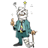
Name ______________________________________________Date Submitted_____________

INJURY DATA COLLECTION LOG

Please complete for EACH RECORDABLE injury. (Write in information and/or Circle/highlight your selection)

Variable Name Description of what it means Your Reply
Position | Position of the nurse | RN  LPN  NA  Nurse Manager  CNS  Nurse Practitioner  Student  Health Care Tech
Hrs/Week | Hrs NORMALLY worked per week
Date | Date of injury
Time | Time of the injury in non-military time
Unit | Unit where injury occurred
Staffing Variance | Staffing Variance
Location | Location of injury | Patient Room  Bathroom  Hall  Dayroom  Other location on unit  Lab  Procedure Room  Public Area (ex: waiting room)  Elevator  Grounds  Elsewhere in hospital (off the unit)  Other
Type of Injury | Medical type of injury | Abrasions  Contusion/Bruise  Cumulative Trauma  Dislocation  Exhaustion/Overexertion  Fracture  General Muscle Pain  Hernia  Joint Pain  Laceration/cut  Puncture wound  Tingling/Numbness  Slipped Disk  Subluxation/Dislocation  Other:_______________ | 919.0  924.9*  924.9  831.00  780.79  829.0*  729.1  553.9  719.40  879.8  879.8  782.0  839.8* | Sprain/Strain  Neck  Shoulder/Arm  Thoracic  Upper Back  Mid Back  Low Back  Leg  Knee  Ankle | 847.0  840.8  847.1  847.9  847.2  847.9  844.9  845.00  847.1
Patient Care Activity | Activity being performed when injured | Pulling Patient up to Head of Bed  Repositioning Patient in Bed (side-to-side)  Pulling Patient up in Chair/WC/Geri, etc  Repositioning Patient in Chair/WC/Geri, etc.  Transferring Patient to & from Chair to Chair/Geri chair  Transferring Patient to & from Chair to Car  Transferring Patient to & from Chair to Toilet  Transferring Patient to & from Chair to Bed  Transferring Patient to & from Bed to Stretcher/Trolley/Surgi-lift/Exam table  Bathing Patient in Bed  Bathing Patient in Bathroom  Feeding Patient  Dressing Patient in Bed  Dressing Patient other than in bed  Diapering Patient  Making Occupied Bed  Making Unoccupied Bed  Applying TED hose  Picking Patient Up from Floor  Managing Aggressive Behavior  Moving Patient Care Equipment – No patient  Transporting Patient in Wheelchair  Transporting Patient by stretcher, trolley, etc.  Other

Primary Cause of Injury | The primary cause of the injury | Lifted/moved patient vertically  Pushed/Pulled Patient/Object  Twisted while moving/lifting patient  Twisted while moving/lifting load other than patient  Twisted with no patient/load  Bent/stooped while holding patient (leg, arm, body)  Bent/stooped holding load other than patient  Bent/stooped with no load  Reached while holding patient (leg arm, body)  Reached while holding load other than patient  Reached with no load  Patient Slipped/Tripped/Fell  Patient made sudden Movement  Used Lifting equipment (full body sling lift, stand assist lift, etc.)  Used other patient care aids (wheelchair, stretcher, lateral transfer aids, etc.)  Attached/Detached sling to lifting equipment  Positioned sling under patient  Positioned object under patient (sheet, lateral transfer aid, clothes, diaper, etc.)  Physical overexertion  Struck by object  Struck by patient  Struck against  Slipped/Tripped performing patient care  Caught in/on/between/under something  Punctured/cut by something  Other
Secondary cause of Injury | The secondary cause of the injury – use same list as for primary cause

#1 Body Part | The single body part most affected by the injury | Whole Body  Head/skull/face  Neck  Shoulders  Left arm (upper or lower)  Right arm (upper or lower)  Left wrist  Right wrist  Left Hand/fingers  Right Hand/fingers  Chest  Abdomen  Hips/pelvis  Back-lower  Back-middle  Back-upper  Buttocks  Knees  Right leg (upper or lower) Left leg (upper or lower)  Right ankle Left Ankle  Right Foot/toes Left Foot/toes
#2 Body Part | The #2 body part most affected – use same list as for #1 Body Part
Restricted Days | How many TOTAL restricted days resulted from injury | INITIAL SUBMISSION | FOLLOW-UP SUBMISSIONS
Restricted Days | How many TOTAL restricted days resulted from injury | Total # _____  Date _______ | Total #____  Date _____ | Total # ____  Date: _____ |  | Total # _____  Date: ______ |  | Total # _____  Date: ______
Lost days | How many TOTAL lost days resulted from injury. (Count lost days the day AFTER the injury occurred. (Ex. If injured at 9 AM Tues, & are sent home till Friday, 1st lost day is Wed, not Tues.) | INITIAL SUBMISSION | FOLLOW-UP SUBMISSIONS
Lost days |  | Total # ________  Date _________ | Total #_____  Date ______ |  | Total # ____  Date: _____ |  | Total # ____  Date: _____ |  | Total # ____  Date: _____
Full Duty Status | If on Lost Time or Restricted Duty, has injured employee returned to Full Duty Status? | YES NO | YES NO |  | YES NO |  | YES NO |  | YES NO
Sick/Annual days taken | How many TOTAL sick OR annual days were taken due to the injury | INITIAL SUBMISSION  Total # ________  Date _________ | FOLLOW-UP SUBMISSIONS  Total # ________ Total # ________ Total # ________  Date _________Date _________ Date _________

Name ______________________________________________Date Submitted_____________

VI. BARIATRIC PATIENT HANDLING

FACILITY BARIATRIC CONTACT/RESOURCE STAFF

Name: ____________________________________________________________________

Service/Unit: ______________________________________________________________

Cell Phone #: _______________________________________________________________

Office Phone #: _____________________________________________________________

Fax #: _______________________________________________________________
BARIATRIC EQUIPMENT ACQUISITION

PROCEDURE FOR ACQUIRING BARIATRIC EQUIPMENT

FACILITY CONTACTS FOR ACQUISITION OF BARIATRIC EQUIPMENT

Purchasing/Leasing Contact during Normal Duty Hours

Name: ____________________________________________________________________

Cell Phone #: _______________________________________________________________

Office Phone #: _____________________________________________________________

Fax #: _______________________________________________________________

Purchasing/Leasing Contact during Off Duty Hours

Name: ____________________________________________________________________

Cell Phone #: _______________________________________________________________

Office Phone #: _____________________________________________________________

Fax #: _______________________________________________________________

BARIATRIC EQUIPMENT VENDORS/MANUFACTURERS

Patient Handling Equipment: ___________________________________________________

Company/Manufacturer: ______________________________________________________

Website: ___________________________________________________________________

Facility representative: ________________________________________________________

Contact Information:
Cell Phone #: _______________________________________________________________

Office Phone #: _____________________________________________________________

Fax #: _______________________________________________________________

Other Information:

Patient Handling Equipment: ___________________________________________________

Company/Manufacturer: ______________________________________________________

Website: ___________________________________________________________________

Facility representative: ________________________________________________________

Contact Information:
Cell Phone #: _______________________________________________________________

Office Phone #: _____________________________________________________________

Fax #: _______________________________________________________________

Other Information
BARIATRIC EQUIPMENT VENDORS/MANUFACTURERS

Patient Handling Equipment: ___________________________________________________

Company/Manufacturer: ______________________________________________________

Website: ___________________________________________________________________

Facility representative: ________________________________________________________

Contact Information:
Cell Phone #: _______________________________________________________________

Office Phone #: _____________________________________________________________

Fax #: _______________________________________________________________

Other Information:

Patient Handling Equipment: ___________________________________________________

Company/Manufacturer: ______________________________________________________

Website: ___________________________________________________________________

Facility representative: ________________________________________________________

Contact Information:
Cell Phone #: _______________________________________________________________

Office Phone #: _____________________________________________________________

Fax #: _______________________________________________________________

Other Information
UNIT ADMISSIONS PROCESS/FLOWCHART/CHECKLIST

Insert plan for admission or treatment of bariatric patients to your unit /area.

LOCATION OF BARIATRIC SUPPLIES/EQUIPMENT

Bariatric Items | Location
Gowns
Slippers
Robes
Blood Pressure Cuffs
ID Wristbands
Bed Pans
Abdominal Binders
CPAP
Scale
OR Equipment/Case Cart
Gurney
Treatment Tables
Exam Tables
Patient/Visitor Chairs
Lifts
Air Assisted Lateral Transfer Device
Bed Mover
Wheelchair Mover
Other patient handling equipment

Bariatric
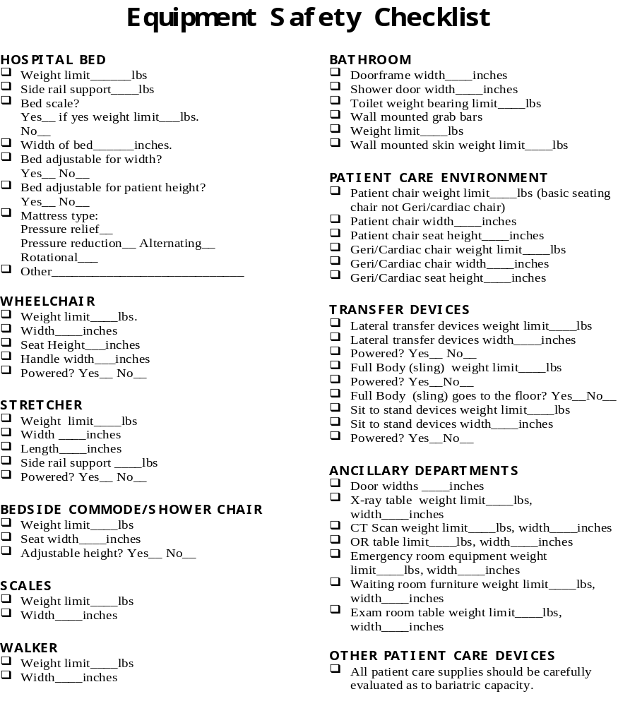

UNIT TRANSPORTATION PLAN FOR BARIATRIC PATIENTS

Map out the safest and most feasible route for transporting your bariatric patients off your unit to treatment, diagnostic, and other areas. Use measurements of wheelchairs, beds, gurneys, etc. as well as door widths, elevator widths, etc. to develop these pathways.

VII. TRAINING PROGRAMS

Peer Leader

- Insert Hard copy here
- include plastic holder for CD

(2009 SPH Conference Toolkit CD)

Direct Care Provider

Direct Care Provider Safe Patient Handling Training Narrated PowerPoint (2009 SPH Conference Toolkit CD)

New Employee Orientation to Safe Patient Handling Narrated PowerPoint (2009 SPH Conference Toolkit CD)

- Insert Hard copy here
- include plastic holder for CD

Senior Leader

Senior Leader Awareness Training Narrated PowerPoint (2009 SPH Conference Toolkit CD)

- Insert Hard copy here
- include plastic holder for CD
Care Supervisors & Nurse Managers

Care Supervisors & Nurse Managers Awareness Training Narrated PowerPoint (2009 SPH Conference Toolkit CD)

- Insert Hard copy here
- include plastic holder for CD

Patient/Resident & Family

Patient/Resident & Family Brochure
(Acknowledgement & Appreciation to James A. Quillen VAMC)

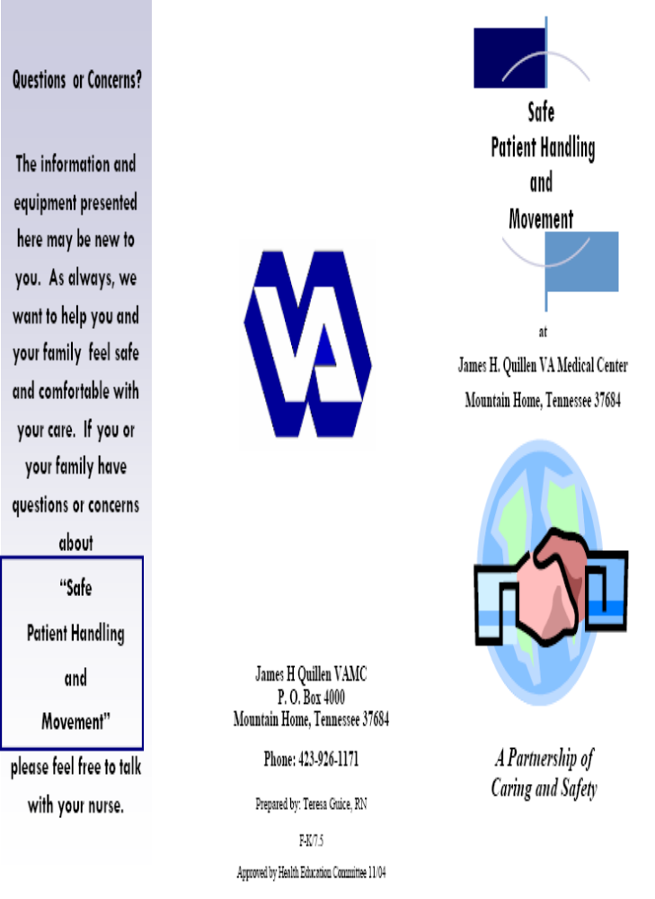
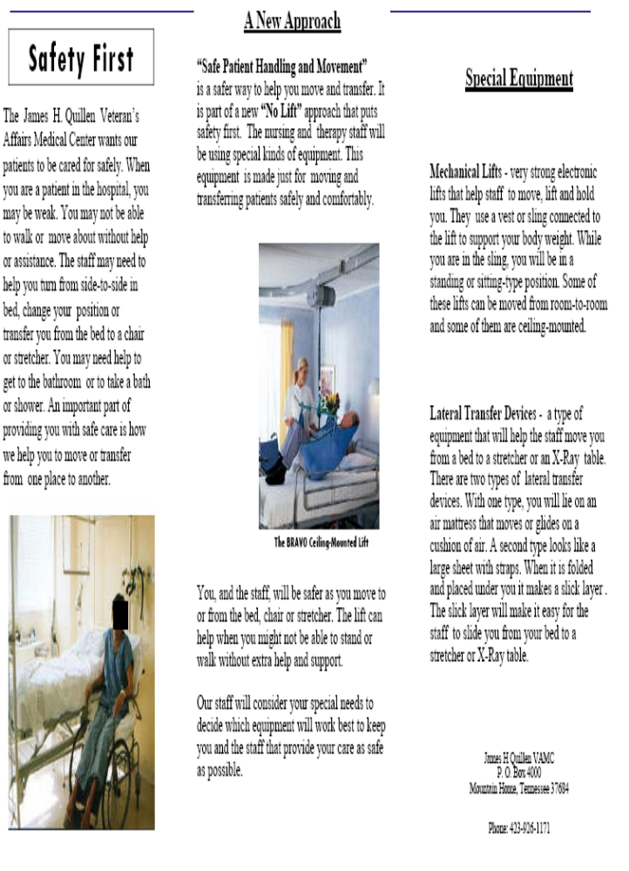
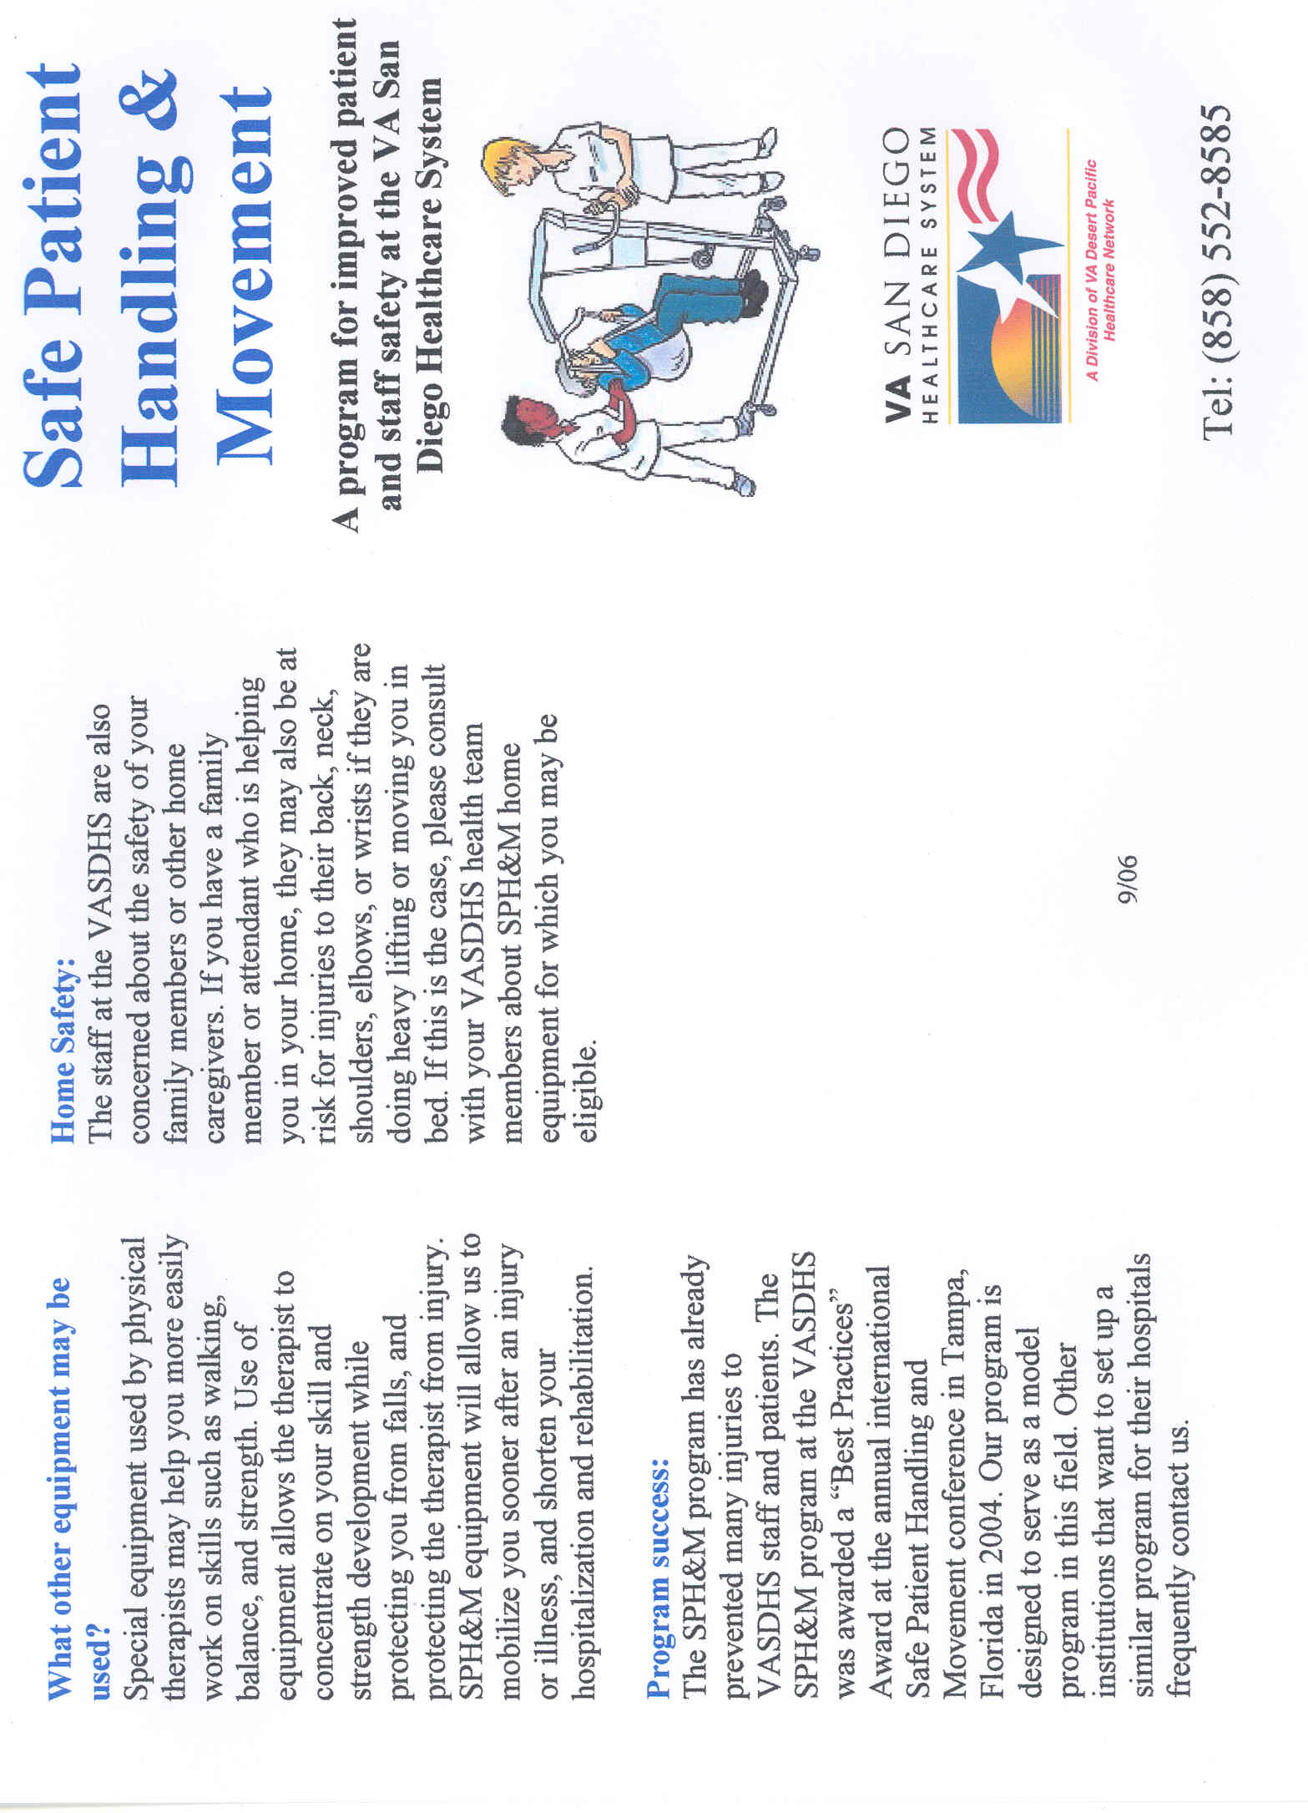
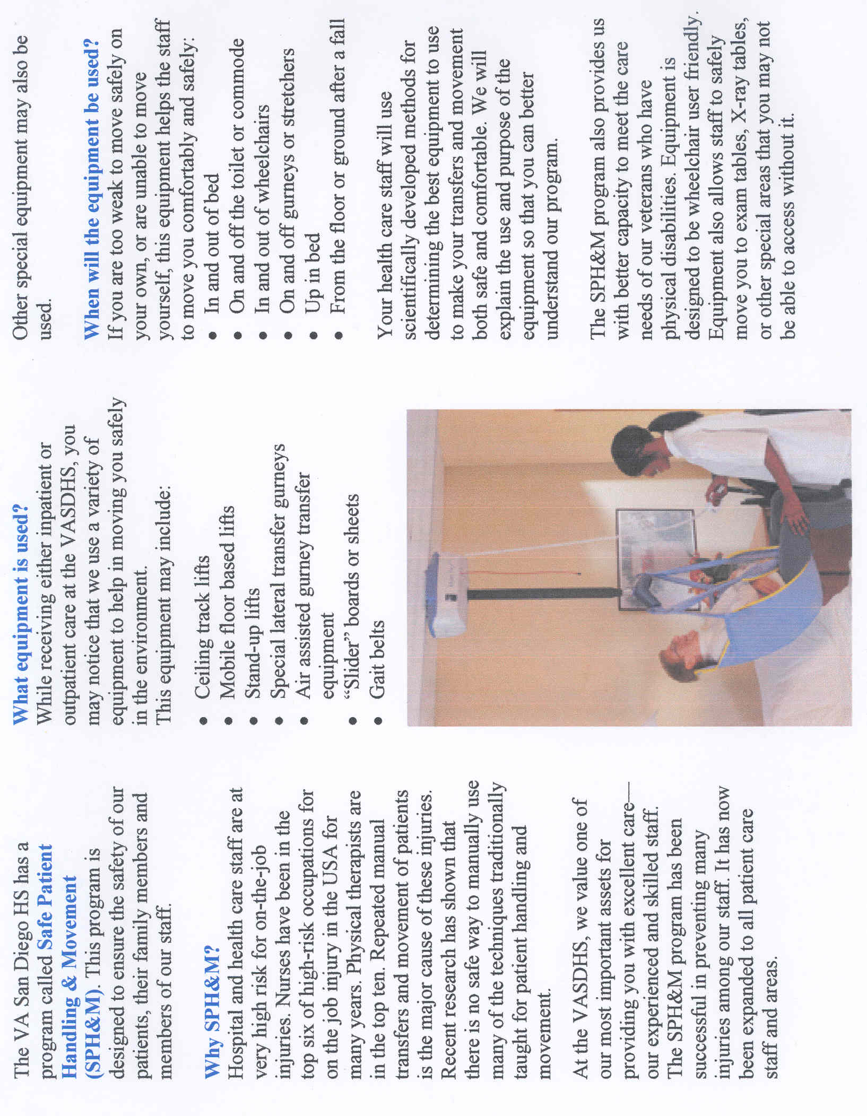
Patient/Resident & Family

Patient/Resident & Family Video Presentation (2009 SPH Conference Toolkit DVD)

- include plastic holder for DVD

VIII. RESOURCES & WEBSITES

PATIENT SAFETY CENTER & OTHER RESOURCES

Website: http://www.visn8.va.gov/patientsafetycenter/safePtHandling/default.asp

- Patient Care Ergonomic Resource Guide

- Sling Toolkit

- Bariatric Toolkit

- Technology Resource Guide

- Bariatric Technology Resource Guide

- Peer Leader Safe Patient Handling UNIT Binder

Website: http://vaww1.va.gov/nursing/page.cfm?pg=125#dir (Find 2/3 down on right side)

- Bariatric Surgery Nursing Guidelines

Website: http://www.washingtonsafepatienthandling.org/additionalresources.html

- Safe Patient Handling in Washington State

Website: www.osha.gov/ergonomics/guidelines/nursinghome/index.html

- OSHA 2003 Ergonomic Guidelines for Nursing Homes

