Oregon Administrative Rules

Chapter 437

Division 2
General Occupational Safety and Health
Walking-Working Surfaces | Subdivision
 | D
 | AO 2-2017

The Oregon Department of Consumer and Business Services adopted these rules pursuant to ORS 654.025(2).
The Secretary of State designated OAR Chapter 437 as the “Oregon Occupational Safety and Health Code.” Six general subject areas within this code are designated as “Divisions.”
• Division 1 General Administrative Rules
• Division 2 General Occupational Safety and Health Rules
• Division 3 Construction
• Division 4 Agriculture
• Division 5 Maritime Activities
• Division 7 Forest Activities
• Oregon Revised Statutes (ORS) 654 The Oregon Safe Employment Act (OSEAct)
Oregon-initiated rules in this division of the Oregon Occupational Safety and Health Code are numbered in a uniform system developed by the Secretary of State. This system does not number the rules in sequence (001, 002, 003, etc.). Omitted numbers may be assigned to new rules at the time of their adoption.
Oregon-initiated rules are arranged in the following Basic Codification Structure adopted by the Secretary of State for Oregon Administrative Rules (OAR):
Chapter Division Rule Section Subsection Paragraphs
437 002 0322 (1) (a) (A)(i)(I)
The majority of Oregon OSHA rules are adopted by reference from the Code of Federal Regulations (CFR), and are arranged in the following basic federal numbering system:
Chapter Division Part Subpart Section Paragraphs
(Subdivision)
437 002 1910 G .303 (a)
The terms “subdivision” and “subpart” are synonymous within OAR 437, Oregon Occupational Safety and Health Code.

To obtain an order form or copies of these codes, address:
Department of Consumer & Business Services
Oregon Occupational Safety & Health Division (Oregon OSHA)
350 Winter St. NE, 3rd Floor
Salem, OR 97301-3882
Or call the Oregon OSHA Resource Library at 503-378-3272
The rules referenced in this division are available for viewing in the Office of the Secretary of State, Oregon State Archives Building, Salem, Oregon, or the Central Office, Oregon Occupational Safety and Health Division of the Department of Consumer and Business Services, 350 Winter St. NE, Salem, Oregon, and on our web site at osha.oregon.gov.

Table of contents

437-002-0020 Adoption by Reference 1
1910.21 Scope and definitions 2
437-002-2021 Additional Oregon Definitions 7
1910.22 General requirements 8
437-002-0022 Additional Oregon General Requirements 9
437-002-0032 Ramps and Runways 10
437-002-0033 Piers and Wharves 10
1910.23 Ladders 11
437-002-0026 Portable Ladders 20
1910.24 Step bolts and manhole steps 22
1910.25 Stairways 25
1910.26 Dockboards 30
1910.27 Scaffolds and rope descent systems 30
437-002-2027 Rope Descent & Rope Access Systems 31
1910.28 Duty to have fall protection and falling object protection 39
1910.29 Fall protection systems and falling object protection – criteria and practices 49
1910.30 Training requirements 59
437-002-2031 Delayed Effective Dates for Walking-Working Surfaces 60
Historical Notes for Subdivision D 63
List of Figures for Subdivision D 66
List of Tables for Subdivision D 66

437-002-0020 Adoption by Reference
In addition to, and not in lieu of, any other safety and health codes contained in OAR Chapter 437, the Department adopts by reference the following federal regulations printed as part of the Code of Federal Regulations, 29 CFR 1910, in the Federal Register:
(1) 29 CFR 1910.21 Scope and definitions, published 11/18/16, Federal Register, vol. 81, no. 223, p. 82494.
(2) 29 CFR 1910.22 General Requirements, published 11/18/16, Federal Register, vol. 81, no. 223, p. 82494.
(3) 29 CFR 1910.23 Ladders, published 11/18/16, Federal Register, vol. 81, no. 223, p. 82494.
(4) 29 CFR 1910.24 Step bolts and manhole steps, published 11/18/16, Federal Register, vol. 81, no. 223, p. 82494.
(5) 29 CFR 1910.25 Stairways, published 11/18/16, Federal Register, vol. 81, no. 223, p. 82494.
(6) 29 CFR 1910.26 Dockboards, published 11/18/16, Federal Register, vol. 81, no. 223, p. 82494.
(7) 29 CFR 1910.27 Scaffolds and rope descent systems, published 11/18/16, Federal Register, vol. 81, no. 223, p. 82494.
(8) 29 CFR 1910.28 Duty to have fall protection and falling object protection, published 11/18/16, Federal Register, vol. 81, no. 223, p. 82494.
(9) 29 CFR 1910.29 Fall protection systems and falling object protection – criteria and practices, published 11/18/16, Federal Register, vol. 81, no. 223, p. 82494.
(10) 29 CFR 1910.30 Training requirements, published 11/18/16, Federal Register, vol. 81, no. 223, p. 82494.
These standards are available at the Oregon Occupational Safety and Health Division, Oregon Department of Consumer and Business Services, and the United States Government Printing Office.

Stat. Auth.: ORS 654.025(2) and 656.726(4).
Stats. Implemented: ORS 654.001 to 654.295.
Hist: OR-OSHA Admin. Order 4-1990, f. 1/23/90, ef. 1/23/90.
OR-OSHA Admin. Order 2-1991, f. 2/4/91, ef. 4/1/91.
OR-OSHA Admin. Order 4-1997, f. 4/2/97, ef. 4/2/97.
OR-OSHA Admin. Order 10-1999, f. 9/10/99, ef. 9/10/99.
OR-OSHA Admin. Order 2-2013, f. 2/15/13, ef. 4/1/13.
OR-OSHA Admin. Order 2-2017, f. 5/16/17, ef. 11/1/17.

1910.21 Scope and definitions
(a) Scope. This subdivision applies to all general industry workplaces. It covers all walking-working surfaces unless specifically excluded by an individual section of this subdivision.
(b) Definitions. The following definitions apply in this subdivision:
Alternating tread-type stair means a type of stairway consisting of a series of treads that usually are attached to a center support in an alternating manner such that an employee typically does not have both feet on the same level while using the stairway.
Anchorage means a secure point of attachment for equipment such as lifelines, lanyards, deceleration devices, and rope descent systems.
Authorized means an employee who the employer assigns to perform a specific type of duty, or allows in a specific location or area.
Cage means an enclosure mounted on the side rails of a fixed ladder or fastened to a structure behind the fixed ladder that is designed to surround the climbing space of the ladder. A cage also is called a ‘‘cage guard’’ or ‘‘basket guard.’’
Carrier means the track of a ladder safety system that consists of a flexible cable or rigid rail attached to the fixed ladder or immediately adjacent to it.
Combination ladder means a portable ladder that can be used as a stepladder, extension ladder, trestle ladder, or stairway ladder. The components of a combination ladder also may be used separately as a single ladder.
Dangerous equipment means equipment, such as vats, tanks, electrical equipment, machinery, equipment or machinery with protruding parts, or other similar units, that, because of their function or form, may harm an employee who falls into or onto the equipment.
Designated area means a distinct portion of a walking-working surface delineated by a warning line in which employees may perform work without additional fall protection.
Dockboard means a portable or fixed device that spans a gap or compensates for a difference in elevation between a loading platform and a transport vehicle. Dockboards include, but are not limited to, bridge plates, dock plates, and dock levelers.
Equivalent means alternative designs, equipment, materials, or methods, that the employer can demonstrate will provide an equal or greater degree of safety for employees compared to the designs, equipment, materials, or methods specified in this subpart.
Extension ladder means a non-self supporting portable ladder that is adjustable in length.
Failure means a load refusal, breakage, or separation of component parts. A load refusal is the point at which the ultimate strength of a component or object is exceeded.
Fall hazard means any condition on a walking-working surface that exposes an employee to a risk of harm from a fall on the same level or to a lower level.
Fall protection means any equipment, device, or system that prevents an employee from falling from an elevation or mitigates the effect of such a fall.

Fixed ladder means a ladder with rails or individual rungs that is permanently attached to a structure, building, or equipment. Fixed ladders include individual-rung ladders, but not ship stairs, step bolts, or manhole steps.
Grab bar means an individual horizontal or vertical handhold installed to provide access above the height of the ladder.
Guardrail system means a barrier erected along an unprotected or exposed side, edge, or other area of a walking-working surface to prevent employees from falling to a lower level.
Handrail means a rail used to provide employees with a handhold for support.
Hoist area means any elevated access opening to a walking-working surface through which equipment or materials are loaded or received.
Hole means a gap or open space in a floor, roof, horizontal walking-working surface, or similar surface that is at least 2 inches (5 cm) in its least dimension.
Individual-rung ladder means a ladder that has rungs individually attached to a building or structure. An individual-rung ladder does not include manhole steps.
Ladder means a device with rungs, steps, or cleats used to gain access to a different elevation.
Ladder safety system means a system designed to eliminate or reduce the possibility of falling from a ladder. A ladder safety system usually consists of a carrier, safety sleeve, lanyard, connectors, and body harness. Cages and wells are not ladder safety systems.
Note: Oregon OSHA did not adopt the federal OSHA definition of Low-slope roof. Instead, see the definition of Low-slope roof in OAR 437-002-2021(2) Additional Oregon Definitions.
Lower level means a surface or area to which an employee could fall. Such surfaces or areas include, but are not limited to, ground levels, floors, roofs, ramps, runways, excavations, pits, tanks, materials, water, equipment, and similar surfaces and structures, or portions thereof.
Manhole steps means steps that are individually attached to, or set into, the wall of a manhole structure.
Maximum intended load means the total load (weight and force) of all employees, equipment, vehicles, tools, materials, and other loads the employer reasonably anticipates to be applied to a walking-working surface at any one time.
Mobile means manually propelled or moveable.
Mobile ladder stand (ladder stand) means a mobile, fixed-height, self-supporting ladder that usually consists of wheels or casters on a rigid base and steps leading to a top step. A mobile ladder stand also may have handrails and is designed for use by one employee at a time.
Mobile ladder stand platform means a mobile, fixed-height, self-supporting unit having one or more standing platforms that are provided with means of access or egress.
Open riser means the gap or space between treads of stairways that do not have upright or inclined members (risers).
Opening means a gap or open space in a wall, partition, vertical walking-working surface, or similar surface that is at least 30 inches (76 cm) high and at least 18 inches (46 cm) wide, through which an employee can fall to a lower level.
Personal fall arrest system means a system used to arrest an employee in a fall from a walking-working surface. It consists of a body harness, anchorage, and connector. The means of connection may include a lanyard, deceleration device, lifeline, or a suitable combination of these.
Personal fall protection system means a system (including all components) an employer uses to provide protection from falling or to safely arrest an employee’s fall if one occurs. Examples of personal fall protection systems include personal fall arrest systems, positioning systems, and travel restraint systems.
Platform means a walking-working surface that is elevated above the surrounding area.
Portable ladder means a ladder that can readily be moved or carried, and usually consists of side rails joined at intervals by steps, rungs, or cleats.
Positioning system (work-positioning system) means a system of equipment and connectors that, when used with a body harness or body belt, allows an employee to be supported on an elevated vertical surface, such as a wall or window sill, and work with both hands free. Positioning systems also are called ‘‘positioning system devices’’ and ‘‘work-positioning equipment.’’
Qualified describes a person who, by possession of a recognized degree, certificate, or professional standing, or who by extensive knowledge, training, and experience has successfully demonstrated the ability to solve or resolve problems relating to the subject matter, the work, or the project.
Ramp means an inclined walking-working surface used to access another level.
Riser means the upright (vertical) or inclined member of a stair that is located at the back of a stair tread or platform and connects close to the front edge of the next higher tread, platform, or landing.
Rope descent system means a suspension system that allows an employee to descend in a controlled manner and, as needed, stop at any point during the descent. A rope descent system usually consists of a roof anchorage, support rope, a descent device, carabiner(s) or shackle(s), and a chair (seatboard). A rope descent system also is called controlled descent equipment or apparatus. Rope descent systems do not include industrial rope access systems.
Rung, step, or cleat means the crosspiece of a ladder on which an employee steps to climb up and down.
Runway means an elevated walking-working surface, such as a catwalk, a foot walk along shafting, or an elevated walkway between buildings.
Scaffold means any temporary elevated or suspended platform and its supporting structure, including anchorage points, used to support employees, equipment, materials, and other items. For purposes of this subpart, a scaffold does not include a crane-suspended or derrick-suspended personnel platform or a rope descent system.
Ship stair (ship ladder) means a stairway that is equipped with treads, stair rails, and open risers, and has a slope that is between 50 and 70 degrees from the horizontal.
Side-step ladder means a type of fixed ladder that requires an employee to step sideways from it in order to reach a walking-working surface, such as a landing.
Spiral stairs means a series of treads attached to a vertical pole in a winding fashion, usually within a cylindrical space.
Stair rail or stair rail system means a barrier erected along the exposed or open side of stairways to prevent employees from falling to a lower level.
Stairway (stairs) means risers and treads that connect one level with another, and includes any landings and platforms in between those levels. Stairways include standard, spiral, alternating tread-type, and ship stairs.
Standard stairs means a fixed or permanently installed stairway. Ship, spiral, and alternating tread-type stairs are not considered standard stairs.
Step bolt (pole step) means a bolt or rung attached at intervals along a structural member used for foot placement and as a handhold when climbing or standing.
Stepladder means a self-supporting, portable ladder that has a fixed height, flat steps, and a hinged back.

Stepstool means a self-supporting, portable ladder that has flat steps and side rails. For purposes of the final rule, stepstool includes only those ladders that have a fixed height, do not have a pail shelf, and do not exceed 32 inches (81 cm) in overall height to the top cap, although side rails may extend above the top cap. A stepstool is designed so an employee can climb and stand on all of the steps and the top cap.
Through ladder means a type of fixed ladder that allows the employee to step through the side rails at the top of the ladder to reach a walking-working surface, such as a landing.
Tieback means an attachment between an anchorage (e.g., structural member) and a supporting device (e.g., parapet clamp or cornice hook).
Toeboard means a low protective barrier that is designed to prevent materials, tools, and equipment from falling to a lower level, and protect employees from falling.
Travel restraint system means a combination of an anchorage, anchorage connector, lanyard (or other means of connection), and body support that an employer uses to eliminate the possibility of an employee going over the edge of a walking-working surface.
Tread means a horizontal member of a stair or stairway, but does not include landings or platforms.
Unprotected sides and edges mean any side or edge of a walking-working surface (except at entrances and other points of access) where there is no wall, guardrail system, or stair rail system to protect an employee from falling to a lower level.
Walking-working surface means any horizontal or vertical surface on or through which an employee walks, works, or gains access to a work area or workplace location.
Warning line means a barrier erected to warn employees that they are approaching an unprotected side or edge, and which designates an area in which work may take place without the use of other means of fall protection.
Well means a permanent, complete enclosure around a fixed ladder.
Stat. Auth.: ORS 654.025(2) and 656.726(4).
Stats. Implemented: ORS 654.001 through 654.295.
Hist: OR-OSHA Admin. Order 2-2017, f. 5/16/17, ef. 11/1/17.

437-002-2021 Additional Oregon Definitions
(1) Scope and application. These definitions apply to Subdivision 2/D. Additional terms in 1910.21(b) also apply to Subdivision 2/D.
(2) Definitions.
Low-slope roof means a roof that has a slope less than or equal to a ratio of 2 in 12 (vertical to horizontal).
Stat. Auth.: ORS 654.025(2) and 656.726(4).
Stats. Implemented: ORS 654.001 through 654.295.
Hist: OR-OSHA Admin. Order 2-2017, f. 5/16/17, ef. 11/1/17.

1910.22 General requirements
(a) Surface conditions. The employer must ensure:
(1) All places of employment, passageways, storerooms, service rooms, and walking-working surfaces are kept in a clean, orderly, and sanitary condition.
(2) The floor of each workroom is maintained in a clean and, to the extent feasible, in a dry condition. When wet processes are used, drainage must be maintained and, to the extent feasible, dry standing places, such as false floors, platforms, and mats must be provided.
(3) Walking-working surfaces are maintained free of hazards such as sharp or protruding objects, loose boards, corrosion, leaks, spills, snow, and ice.
(b) Loads. The employer must ensure that each walking-working surface can support the maximum intended load for that surface.
(c) Access and egress. The employer must provide, and ensure each employee uses, a safe means of access and egress to and from walking-working surfaces.
(d) Inspection, maintenance, and repair. The employer must ensure:
(1) Walking-working surfaces are inspected, regularly and as necessary, and maintained in a safe condition;
(2) Hazardous conditions on walking-working surfaces are corrected or repaired before an employee uses the walking-working surface again. If the correction or repair cannot be made immediately, the hazard must be guarded to prevent employees from using the walking-working surface until the hazard is corrected or repaired; and
(3) When any correction or repair involves the structural integrity of the walking-working surface, a qualified person performs or supervises the correction or repair.

Stat. Auth.: ORS 654.025(2) and 656.726(4).
Stats. Implemented: ORS 654.001 through 654.295.
Hist: OR-OSHA Admin. Order 2-2017, f. 5/16/17, ef. 11/1/17.

437-002-0022 Additional Oregon General Requirements
(1) Scope and application. This rule applies in addition to those in Division 2/D Walking-Working Surfaces.
(2) Barriers. The employer must ensure:
(a) Protective barriers or suitable guards are erected when covers over openings are removed or excavations made in places accessible to vehicular or pedestrian traffic. Warning lights or flares shall be displayed if work is being done at night. These protective measures shall be maintained until permanent or adequate covers or barricades are in place or the hazard removed.
(b) A watchperson is stationed where temporary conditions do not permit safeguarding of employees through the use of warning signs, lights, protective barriers, or covers.
(3) Plant Arrangement. The employer must ensure:
(a) Provisions for safety (such as adequate work and storage space for the full needs of raw, in-process, and finished materials, and for machinery, equipment and operations) are included in plant design, layout, and operation.
(b) A vertical clearance of not less than 6 1/2 feet is provided over work areas. Where it is otherwise impractical to secure adequate head room, overhead obstructions may be padded or may be indicated by means of contrasting paint, telltales, or similar means, if such means will furnish adequate protection.
(c) Work platforms provided shall be of sufficient width to provide a safe working space.
(4) Aisles, Passageways, Walkways, Inclines. The employer must ensure:
(a) Aisles, passageways, and walkways are of adequate width for their intended or actual use, and in no event shall they be less than 22 inches wide.
(b) Fixed inclined walkways are not less than 22 inches wide, inclined at no greater angle than 24 degrees, and are securely fastened at the top and bottom.
(c) Moveable inclined walkways which extend to floats or floating equipment (except to vessels under Federal jurisdiction) are not less than 20 inches wide, and are secured at the upper end only with clear space provided for the lower end to adjust automatically with the heights of water.
(d) An adequate antislip surface is applied to inclined walkways whenever the gradient so warrants. Adequate cleats secured at uniform intervals not to exceed 18 inches, and extending the full width of the walkway when practical, may be used for this purpose.
(e) Inclines extending from floor to floor which are used instead of stairways have standard railings in accordance with the requirements in 1910.29(b).
(f) In addition to the surface conditions in 1910.22(a)(3), aisles, passageways, walkways, and inclines are maintained free of holes, unevenness, or any unnecessary obstructions or debris that may create a hazard.

Stat. Auth.: ORS 654.025(2) and 656.726(4).
Stats. Implemented: ORS 654.001 to 654.295.
Hist: WCB No. 1-1967, f. 1/12/67, ef. 1/15/67.
OR-OSHA Admin. Order 4-1990, f. 1/23/90, ef. 1/23/90.
OR-OSHA Admin. Order 6-1994, f. 9/30/94, ef. 9/30/94.
OR-OSHA Admin. Order 2-2017, f. 5/16/17, ef. 11/1/17.

437-002-0032 Ramps and Runways
(1) Scope and application. This rule applies to the safe use of ramps and runways for vehicles in addition to the rules in Division 2/D.
(2) The employer must ensure ramps and runways for vehicles:
(a) Have adequate width and evenness for safe operation of equipment.
(b) Are provided with timber guards of not less than nominal 6-inch by 6-inch material set on nominal 3-inch blocks, or the equivalent, placed parallel to and secured to the sides of the ramp or runway.
Stat. Auth.: ORS 654.025(2) and 656.726(4).
Stats. Implemented: ORS 654.001 through 654.295.
Hist: OR-OSHA Admin. Order 4-1990, f. 1/23/90, ef. 1/23/90.
OR-OSHA Admin. Order 2-2017, f. 5/16/17, ef. 11/1/17.

437-002-0033 Piers and Wharves
(1) Scope and application. This rule applies to piers and wharves in addition to the rules in Division 2/D.
(2) The employer must ensure piers and wharves:
(a) With open sides of piers and wharves, more than 4 feet above the ground or water level, have a shear or guard timber (bull rail) of not less than 6-inch by 6-inch wood material set on nominal 3-inch blocking, or material of equal strength and minimum height securely attached.
(b) Except for areas where vessels’ mooring lines are handled, the open sides, more than 4 feet above the ground or water level, not used for loading or unloading purposes, shall be provided with standard guardrails in accordance with 1910.29(b) in addition to shear timbers in accordance with paragraph (2)(a) of this section.
(c) Ladders or other means of access reaching from low water mark to the dock floor shall be provided for each 400 feet or portion thereof of the water side of all wharves and piers. Where portable ladders are used, a secure method of fastening them shall be provided.
Stat. Auth.: ORS 654.025(2) and 656.726(4).
Stats. Implemented: ORS 654.001 through 654.295.
Hist: OR-OSHA Admin. Order 4-1990, f. 1/23/90, ef. 1/23/90.
OR-OSHA Admin. Order 2-2017, f. 5/16/17, ef. 11/1/17.

1910.23 Ladders
(a) Application. The employer must ensure that each ladder used meets the requirements of this section. This section covers all ladders, except when the ladder is:
(1) Used in emergency operations such as firefighting, rescue, and tactical law enforcement operations, or training for these operations; or
(2) Designed into or is an integral part of machines or equipment.
(b) General requirements for all ladders. The employer must ensure:
(1) Ladder rungs, steps, and cleats are parallel, level, and uniformly spaced when the ladder is in position for use;
(2) Ladder rungs, steps, and cleats are spaced not less than 10 inches (25 cm) and not more than 14 inches (36 cm) apart, as measured between the centerlines of the rungs, cleats, and steps, except that:
(i) Ladder rungs and steps in elevator shafts must be spaced not less than 6 inches (15 cm) apart and not more than 16.5 inches (42 cm) apart, as measured along the ladder side rails; and
(ii) Fixed ladder rungs and steps on telecommunication towers must be spaced not more than 18 inches (46 cm) apart, measured between the centerlines of the rungs or steps;
(3) Steps on stepstools are spaced not less than 8 inches (20 cm) apart and not more than 12 inches (30 cm) apart, as measured between the centerlines of the steps;
(4) Ladder rungs, steps, and cleats have a minimum clear width of 11.5 inches (29 cm) on portable ladders and 16 inches (41 cm) (measured before installation of ladder safety systems) for fixed ladders, except that:
(i) The minimum clear width does not apply to ladders with narrow rungs that are not designed to be stepped on, such as those located on the tapered end of orchard ladders and similar ladders;
(ii) Rungs and steps of manhole entry ladders that are supported by the manhole opening must have a minimum clear width of 9 inches (23 cm);

(iii) Rungs and steps on rolling ladders used in telecommunication centers must have a minimum clear width of 8 inches (20 cm); and
(iv) Stepstools have a minimum clear width of 10.5 inches (26.7 cm);
(5) Wooden ladders are not coated with any material that may obscure structural defects;
(6) Metal ladders are made with corrosion-resistant material or protected against corrosion;
(7) Ladder surfaces are free of puncture and laceration hazards;
(8) Ladders are used only for the purposes for which they were designed;
(9) Ladders are inspected before initial use in each work shift, and more frequently as necessary, to identify any visible defects that could cause employee injury;
(10) Any ladder with structural or other defects is immediately tagged ‘‘Dangerous: Do Not Use’’ or with similar language in accordance with § 1910.145 and removed from service until repaired in accordance with § 1910.22(d), or replaced;
(11) Each employee faces the ladder when climbing up or down it;
(12) Each employee uses at least one hand to grasp the ladder when climbing up and down it; and
(13) No employee carries any object or load that could cause the employee to lose balance and fall while climbing up or down the ladder.
(c) Portable ladders. The employer must ensure:
(1) Rungs and steps of portable metal ladders are corrugated, knurled, dimpled, coated with skid-resistant material, or otherwise treated to minimize the possibility of slipping;
Note: Oregon OSHA did not adopt 1910.23(c)(2). Instead, see OAR 437-002-0026(4)(a).
(3) Ladders are not loaded beyond the maximum intended load;
Note to paragraph (c)(3): The maximum intended load, as defined in § 1910.21(b), includes the total load (weight and force) of the employee and all tools, equipment, and materials being carried.
(4) Ladders are used only on stable and level surfaces unless they are secured or stabilized to prevent accidental displacement;
(5) No portable single rail ladders are used;
(6) No ladder is moved, shifted, or extended while an employee is on it;
(7) Ladders placed in locations such as passageways, doorways, or driveways where they can be displaced by other activities or traffic:
(i) Are secured to prevent accidental displacement; or
(ii) Are guarded by a temporary barricade, such as a row of traffic cones or caution tape, to keep the activities or traffic away from the ladder;
(8) The cap (if equipped) and top step of a stepladder are not used as steps;
(9) Portable ladders used on slippery surfaces are secured and stabilized;
(10) The top of a non-self-supporting ladder is placed so that both side rails are supported, unless the ladder is equipped with a single support attachment;
(11) Portable ladders used to gain access to an upper landing surface have side rails that extend at least 3 feet (0.9 m) above the upper landing surface (see Figure D–1 of this section);
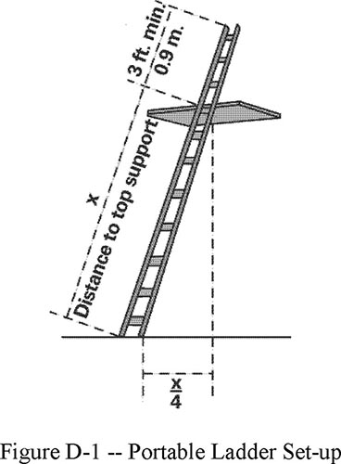
Figure D-1 - Portable Ladder Set-up
(12) Ladders and ladder sections are not tied or fastened together to provide added length unless they are specifically designed for such use;

(13) Ladders are not placed on boxes, barrels, or other unstable bases to obtain additional height.
(d) Fixed ladders. The employer must ensure:
(1) Fixed ladders are capable of supporting their maximum intended load;
(2) The minimum perpendicular distance from the centerline of the steps or rungs, or grab bars, or both, to the nearest permanent object in back of the ladder is 7 inches (18 cm), except for elevator pit ladders, which have a minimum perpendicular distance of 4.5 inches (11 cm);
(3) Grab bars do not protrude on the climbing side beyond the rungs of the ladder that they serve;
(4) The side rails of through or sidestep ladders extend 42 inches (1.1 m) above the top of the access level or landing platform served by the ladder. For parapet ladders, the access level is:
(i) The roof, if the parapet is cut to permit passage through the parapet; or
(ii) The top of the parapet, if the parapet is continuous;
(5) For through ladders, the steps or rungs are omitted from the extensions, and the side rails are flared to provide not less than 24 inches (61cm) and not more than 30 inches (76 cm) of clearance. When a ladder safety system is provided, the maximum clearance between side rails of the extension must not exceed 36 inches (91 cm);
(6) For side-step ladders, the side rails, rungs, and steps must be continuous in the extension (see Figure D–2 of this section);
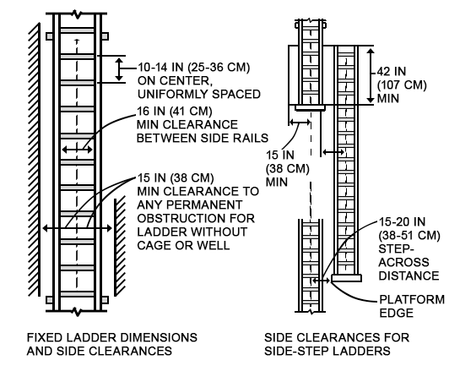
Figure D-2 - Side-Step Fixed Ladder Sections
(7) Grab bars extend 42 inches (1.1 m) above the access level or landing platforms served by the ladder;
(8) The minimum size (cross-section) of grab bars is the same size as the rungs of the ladder.
(9) When a fixed ladder terminates at a hatch (see Figure D–3 of this section), the hatch cover:
(i) Opens with sufficient clearance to provide easy access to or from the ladder; and
(ii) Opens at least 70 degrees from horizontal if the hatch is counterbalanced;

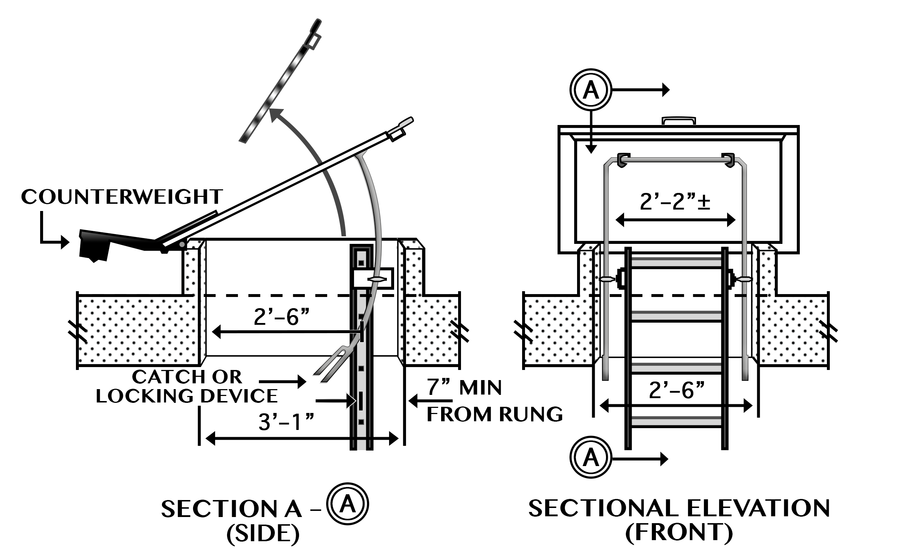
Figure D-3 - Example of Counterbalanced Hatch Cover at Roof
(10) Individual-rung ladders are constructed to prevent the employee’s feet from sliding off the ends of the rungs (see Figure D–4 of this section);
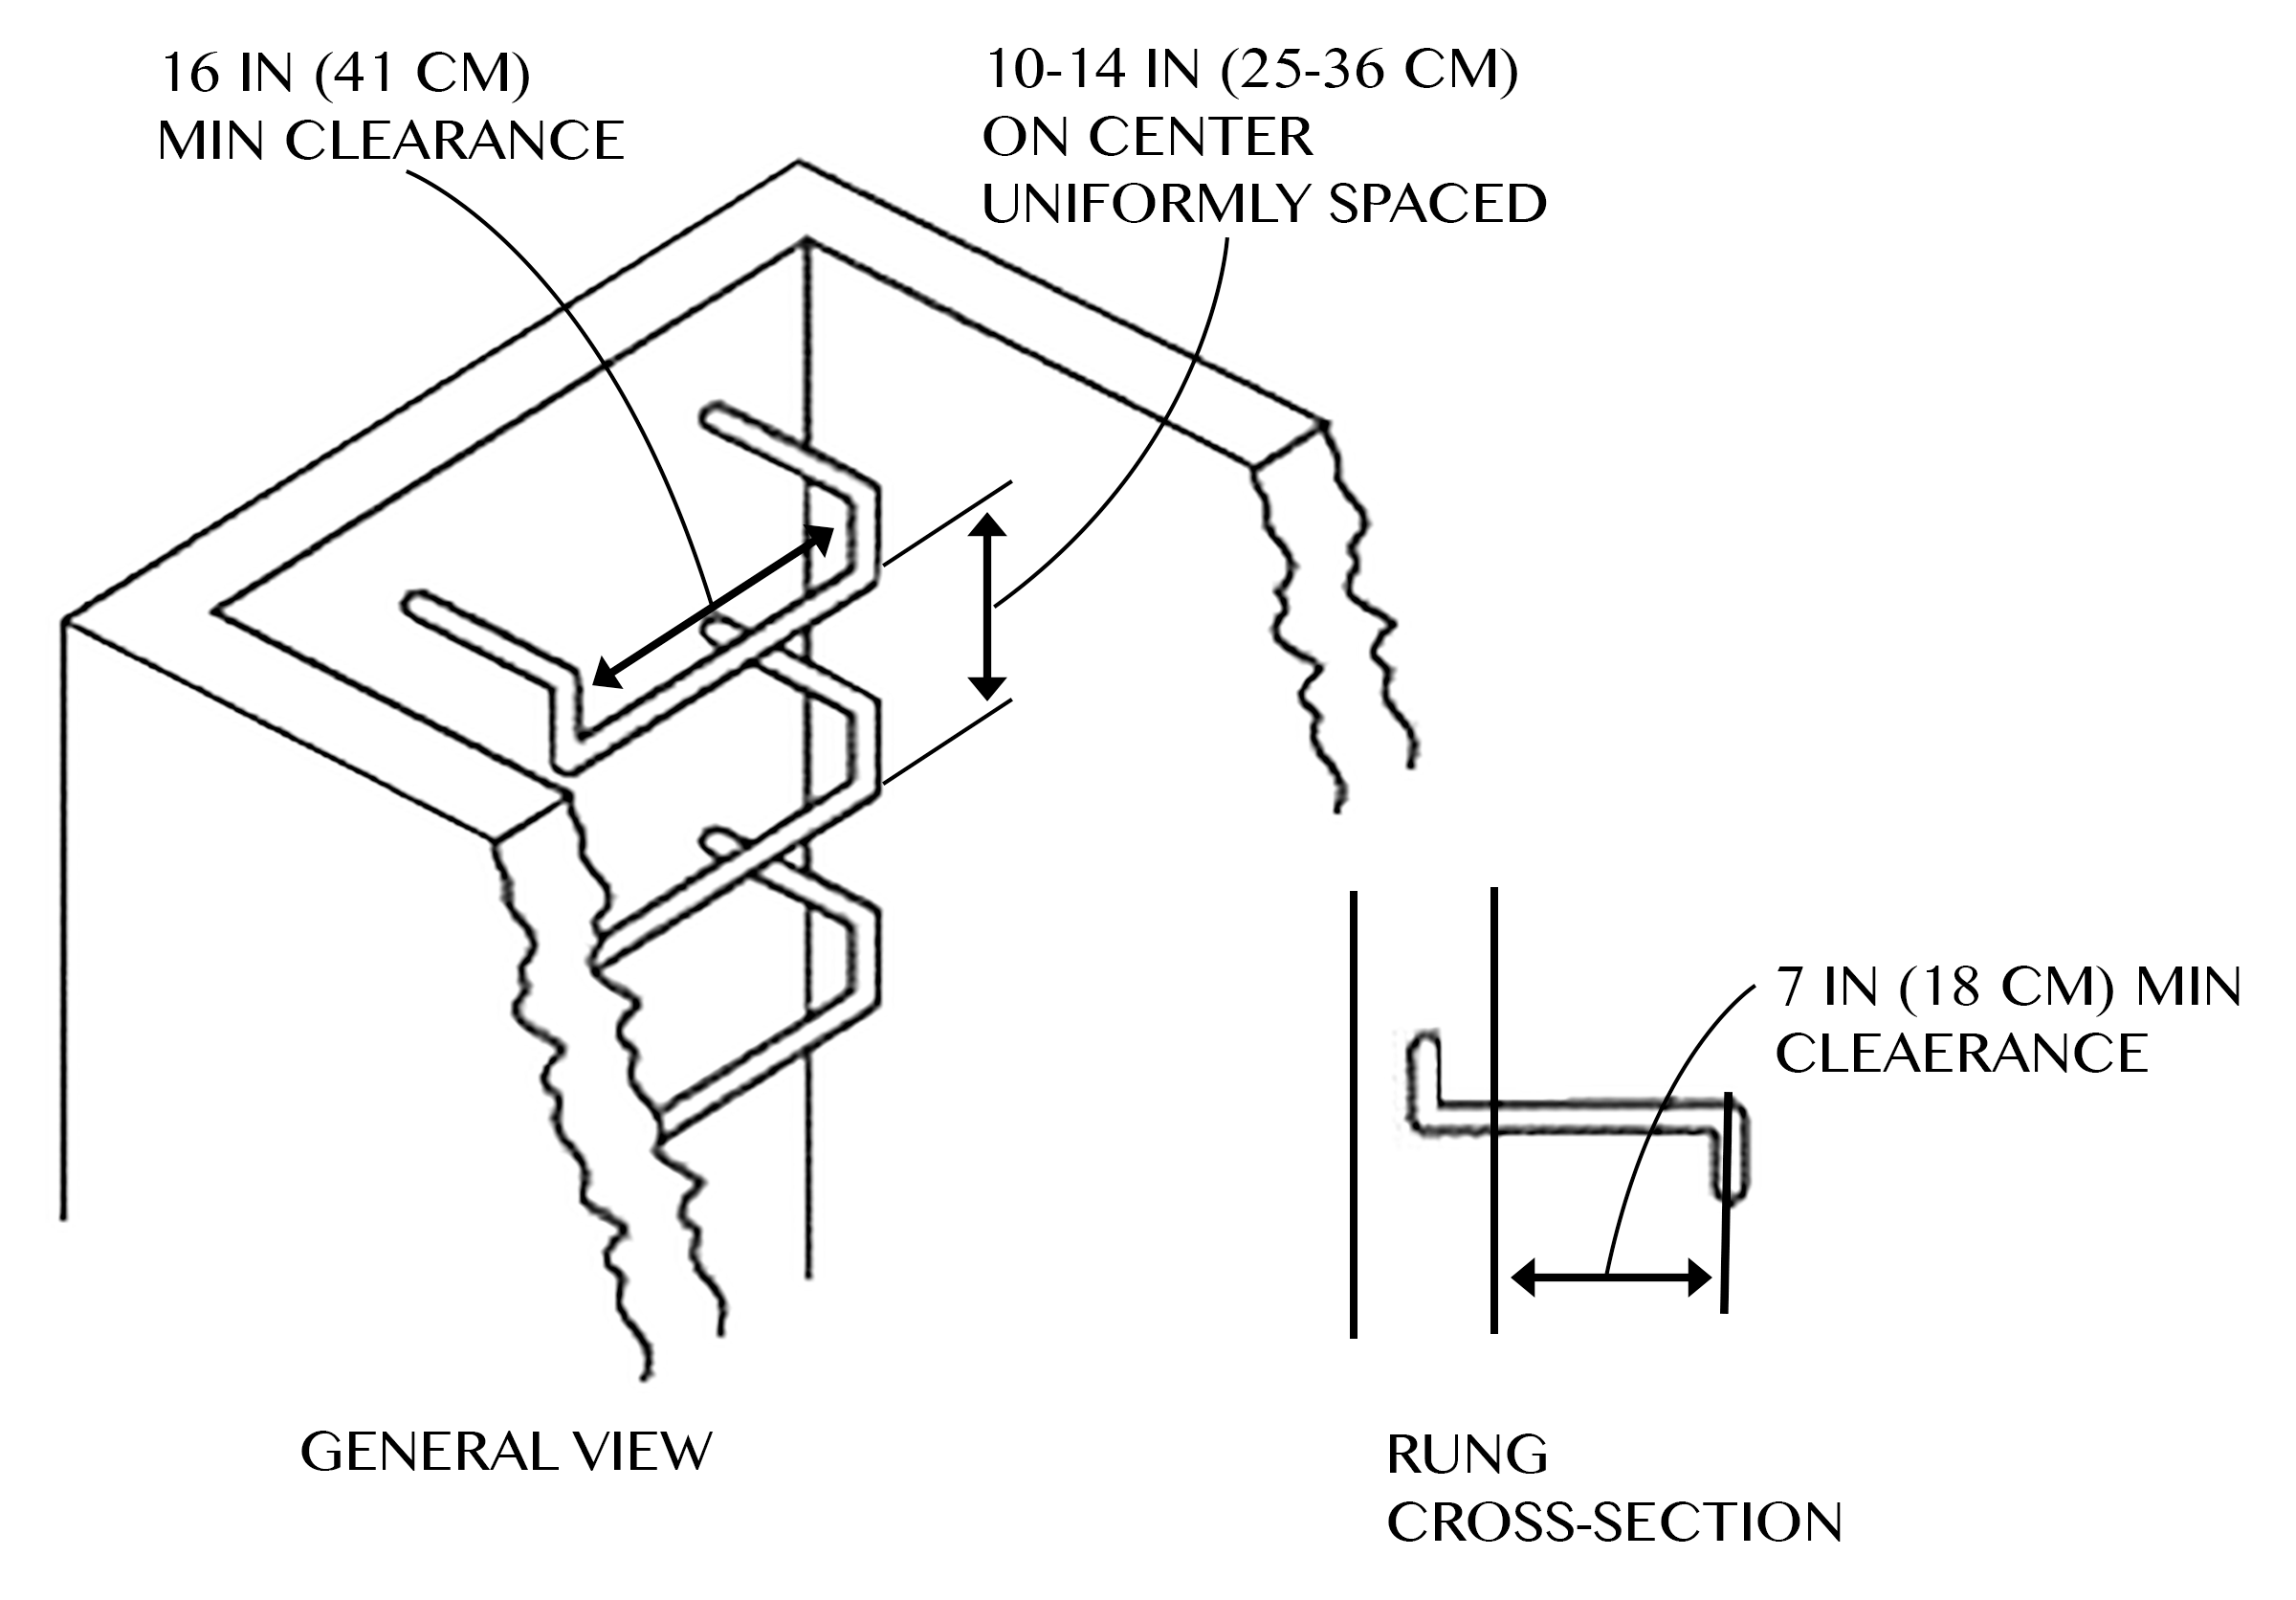
Figure D-4 - Individual Rung Ladder
(11) Fixed ladders having a pitch greater than 90 degrees from the horizontal are not used;
(12) The step-across distance from the centerline of the rungs or steps is:
(i) For through ladders, not less than 7 inches (18 cm) and not more than 12 inches (30 cm) to the nearest edge of the structure, building, or equipment accessed from the ladders;
(ii) For side-step ladders, not less than 15 inches (38 cm) and not more than 20 inches (51 cm) to the access points of the platform edge;
(13) Fixed ladders that do not have cages or wells have:
(i) A clear width of at least 15 inches (38 cm) on each side of the ladder centerline to the nearest permanent object; and
(ii) A minimum perpendicular distance of 30 inches (76 cm) from the centerline of the steps or rungs to the nearest object on the climbing side. When unavoidable obstructions are encountered, the minimum clearance at the obstruction may be reduced to 24 inches (61 cm), provided deflector plates are installed (see Figure D–5 of this section).
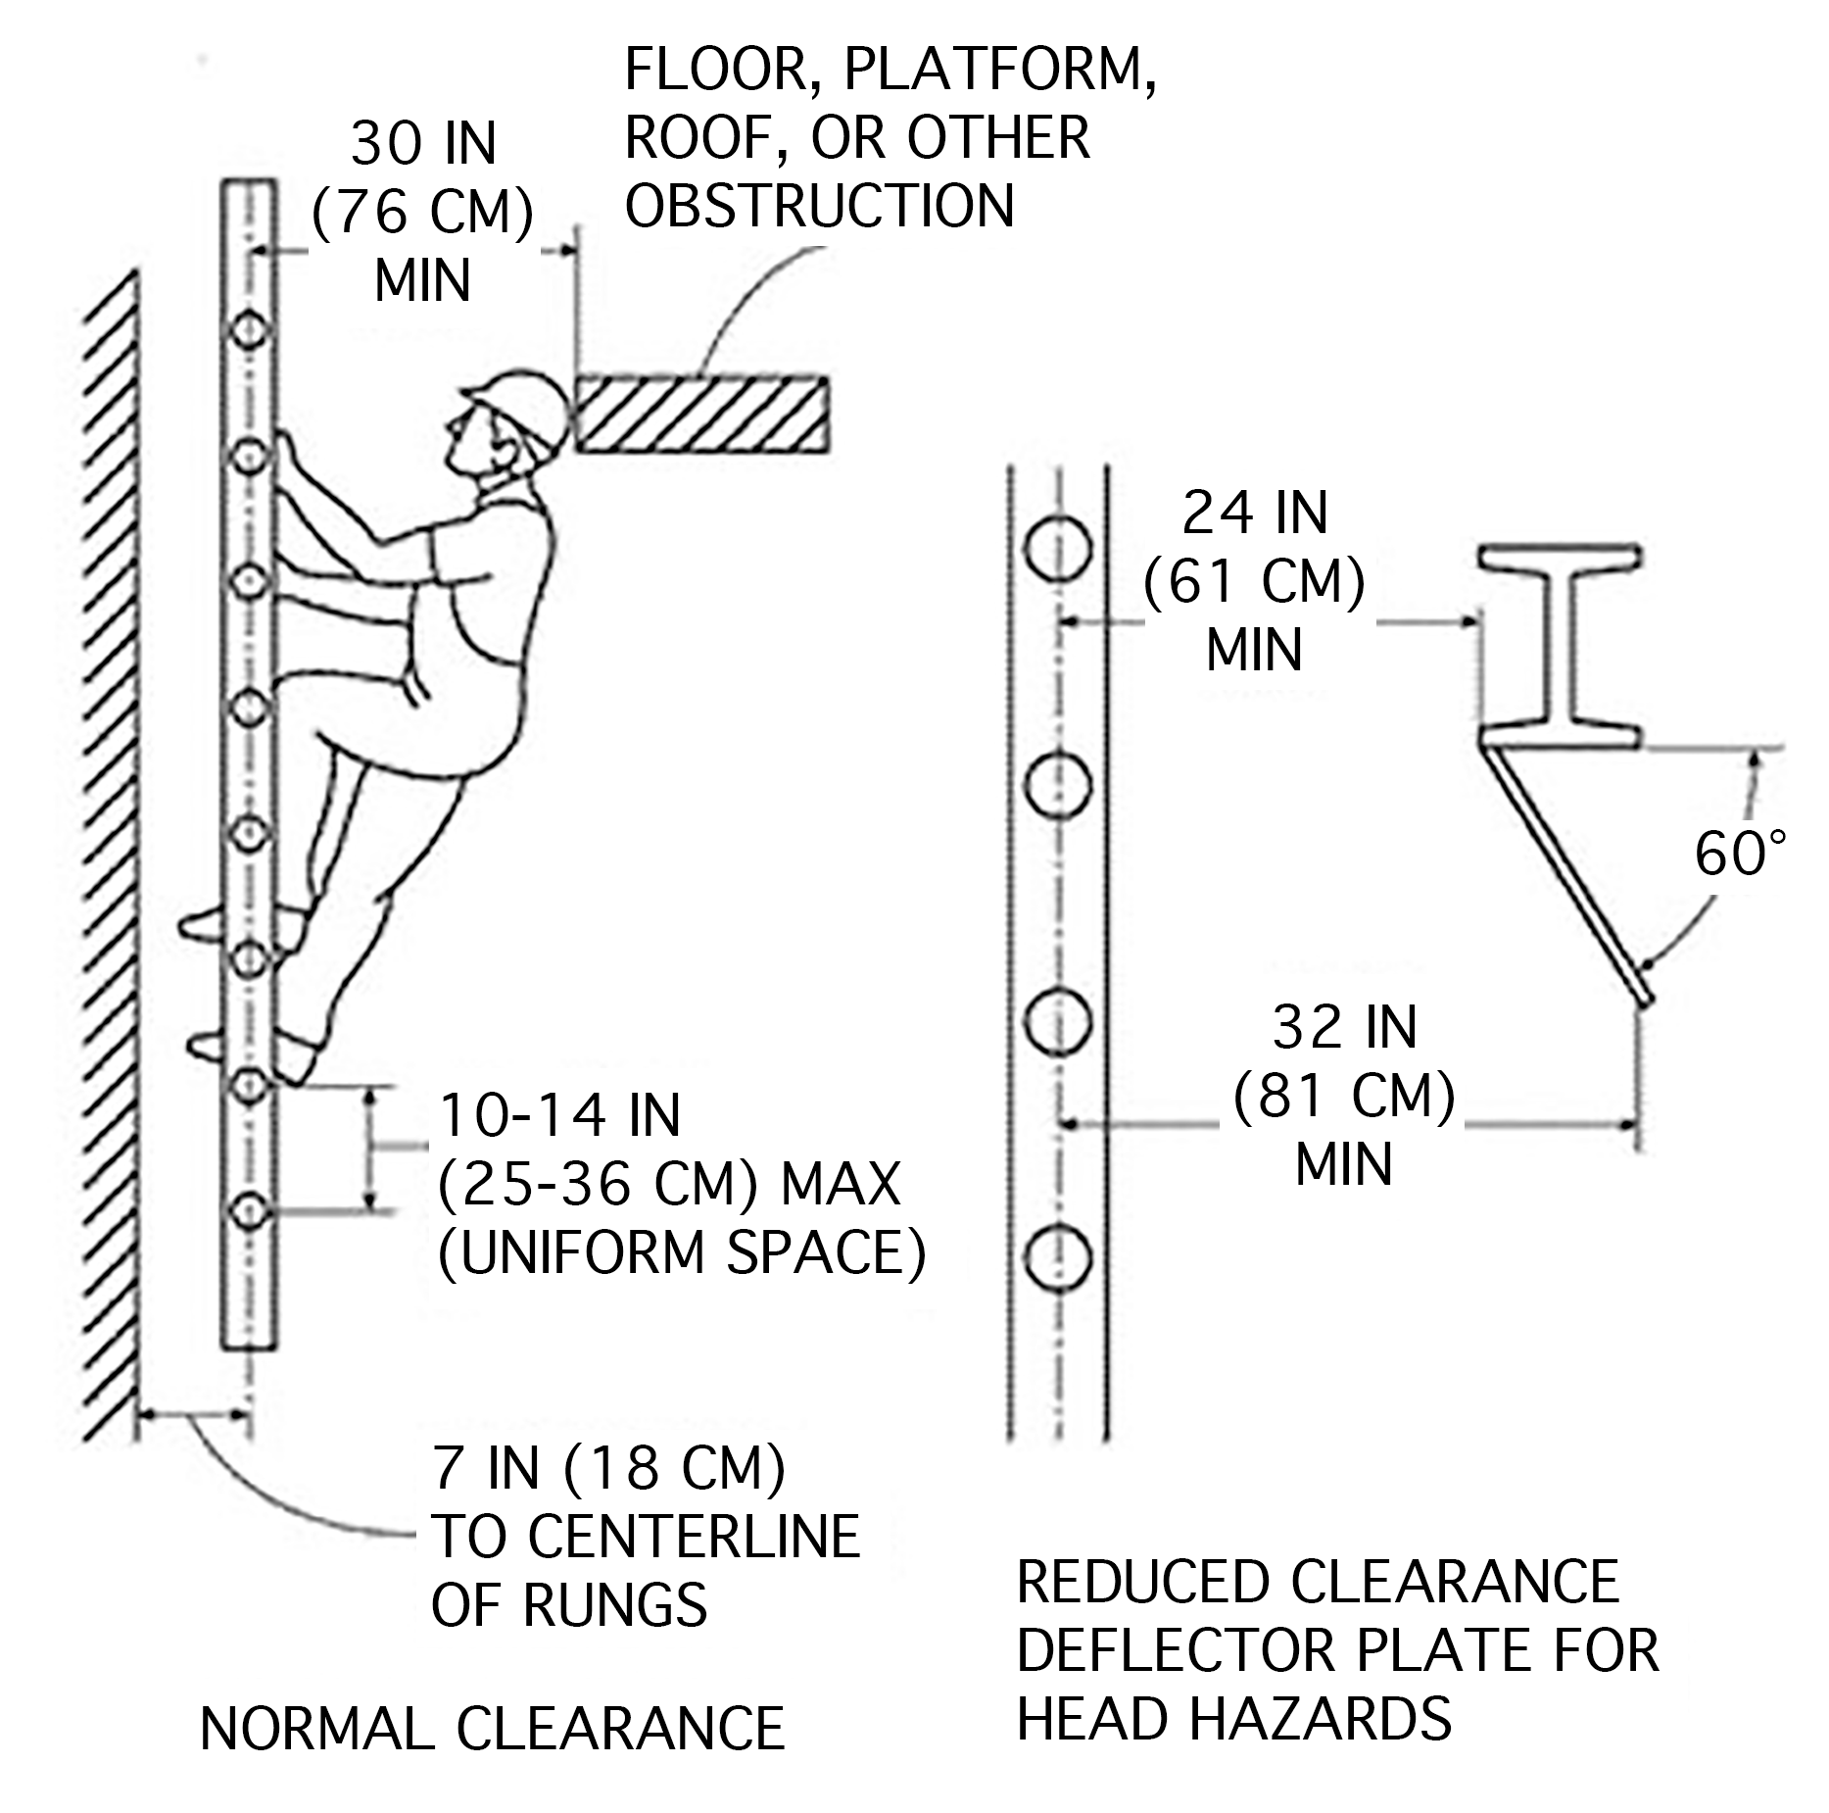
Figure D-5 - Fixed Ladder Clearances
Note to paragraph (d): Section 1910.28 establishes the employer’s duty to provide fall protection for employees on fixed ladders, and § 1910.29 specifies the criteria for fall protection systems for fixed ladders.

(e) Mobile ladder stands and mobile ladder stand platforms
(1) General requirements. The employer must ensure:
(i) Mobile ladder stands and platforms have a step width of at least 16 inches (41 cm);
(ii) The steps and platforms of mobile ladder stands and platforms are slip resistant. Slip-resistant surfaces must be either an integral part of the design and construction of the mobile ladder stand and platform, or provided as a secondary process or operation, such as dimpling, knurling, shotblasting, coating, spraying, or applying durable slip-resistant tapes;
(iii) Mobile ladder stands and platforms are capable of supporting at least four times their maximum intended load;
(iv) Wheels or casters under load are capable of supporting their proportional share of four times the maximum intended load, plus their proportional share of the unit’s weight;
(v) Unless otherwise specified in this section, mobile ladder stands and platforms with a top step height of 4 feet (1.2 m) or above have handrails with a vertical height of 29.5 inches (75 cm) to 37 inches (94 cm), measured from the front edge of a step. Removable gates or non-rigid members, such as chains, may be used instead of handrails in special use applications;
(vi) The maximum work-surface height of mobile ladder stands and platforms does not exceed four times the shortest base dimension, without additional support. For greater heights, outriggers, counterweights, or comparable means that stabilize the mobile ladder stands and platforms and prevent overturning must be used;
(vii) Mobile ladder stands and platforms that have wheels or casters are equipped with a system to impede horizontal movement when an employee is on the stand or platform; and
(viii) No mobile ladder stand or platform moves when an employee is on it.
(2) Design requirements for mobile ladder stands. The employer must ensure:
(i) Steps are uniformly spaced and arranged, with a rise of not more than 10 inches (25 cm) and a depth of not less than 7 inches (18 cm). The slope of the step stringer to which the steps are attached must not be more than 60 degrees, measured from the horizontal;
(ii) Mobile ladder stands with a top step height above 10 feet (3 m) have the top step protected on three sides by a handrail with a vertical height of at least 36 inches (91 cm); and top steps that are 20 inches (51 cm) or more, front to back, have a midrail and toeboard. Removable gates or non-rigid members, such as chains, may be used instead of handrails in special-use applications; and
(iii) The standing area of mobile ladder stands is within the base frame.
(3) Design requirements for mobile ladder stand platforms. The employer must ensure:
(i) Steps of mobile ladder stand platforms meet the requirements of paragraph (e)(2)(i) of this section. When the employer demonstrates that the requirement is not feasible, steeper slopes or vertical rung ladders may be used, provided the units are stabilized to prevent overturning;
(ii) Mobile ladder stand platforms with a platform height of 4 to 10 feet (1.2 m to 3 m) have, in the platform area, handrails with a vertical height of at least 36 inches (91 cm) and midrails; and
(iii) All ladder stand platforms with a platform height above 10 feet (3 m) have guardrails and toeboards on the exposed sides and ends of the platform.
(iv) Removable gates or non-rigid members, such as chains, may be used on mobile ladder stand platforms instead of handrails and guardrails in special-use applications.

Stat. Auth.: ORS 654.025(2) and 656.726(4).
Stats. Implemented: ORS 654.001 through 654.295.
Hist: OR-OSHA Admin. Order 2-2017, f. 5/16/17, ef. 11/1/17.

437-002-0026 Portable Ladders
(1) Scope and application. This rule applies to the use of portable ladders, including job-made ladders, in addition to the rules in 1910.23 Ladders.
(2) Definitions. These definitions apply to portable ladder terms in this rule. Additional terms in 1910.21(b) apply to portable ladders within 1910.23 and this rule.
Job-made ladder. A non-commercially manufactured portable ladder constructed on the worksite for temporary use.
Non-self-supporting ladder. A class of portable ladders that, by design, must be placed against a structure independent of itself, such as a wall, to remain standing for use. Single ladders, extension ladders, sectional ladders, and articulating ladders set up in a straight ladder mode are examples of non-self-supporting ladders.
Self-supporting ladder. A class of portable ladders that, by design, stand on their own when erected for use without assistance from external structures. Stepladders, double front ladders, platform ladders, trestle ladders, and articulating ladders set up in a stepladder mode are examples of self-supporting ladders.
(3) Ladder selection. The employer must ensure:
(a) Wood ladders comply with American National Standard ANSI/ASC A14.1-2007.
(b) Portable metal ladders comply with American National Standard ANSI/ASC A14.2-2007.
(c) Portable reinforced plastic (fiberglass) ladders comply with American National Standard ANSI/ASC A14.5-2007.
Note to 437-002-0026(3): Unaltered and properly maintained ladders that meet the ANSI standard in effect at the time of their manufacture comply with this standard. This includes job-made ladders designed and built according to American National Standard A14.4-1979 and portable ladders that comply with newer versions of the particular ANSI standard.
(4) Use – all portable ladders. The employer must ensure:
(a) Each self-supporting ladder or combination ladder used in a self-supporting ladder mode is equipped with a metal spreader or locking device that securely holds the front and back sections in a fully open position while the ladder is in use.
(b) Each non-self-supporting ladder is erected to the angle represented in Figure D-1 of 1910.23(c)(11) unless otherwise instructed in writing by the ladder manufacture.
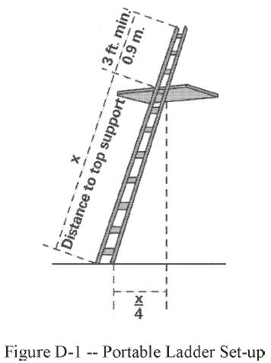
Figure D-1 - Portable Ladder Set-up
(c) No employee steps, jumps or otherwise moves from one erected ladder to another.
(d) Ladders are not used as planks or bridges between walking-working surfaces or in other horizontal applications.
(e) Ladders are not used to gain additional height from elevated surfaces such as scaffolds, truck beds, vehicle bodies, tractor scoops or boom truck buckets.
(f) Ladders are not used as supports for working platforms or scaffolding planks unless approved for such purposes by the ladder manufacturer.
Note to 437-002-0026(4): When working on or near electric circuits or energized lines, comply with 1910.333(c) in Division 2/S.

Stat. Auth.: ORS 654.025(2) and 656.726(4).
Stats. Implemented: ORS 654.001 through 654.295.
Hist: OR-OSHA Admin. Order 10-1999, f. 9/10/99, ef. 9/10/99.
OR-OSHA Admin. Order 2-2017, f. 5/16/17, ef. 11/1/17.

1910.24 Step bolts and manhole steps
(a) Step bolts. The employer must ensure.
(1) Each step bolt installed on or after January 17, 2017 in an environment where corrosion may occur is constructed of, or coated with, material that protects against corrosion;
Note to 1910.24(a)(1): The above referenced date does not apply in Oregon. Instead, in accordance with OAR 437-002-2031(2)(a), the Oregon delayed effective date is January 1, 2018.
(2) Each step bolt is designed, constructed, and maintained to prevent the employee’s foot from slipping off the end of the step bolt;
(3) Step bolts are uniformly spaced at a vertical distance of not less than 12 inches (30 cm) and not more than 18 inches (46 cm) apart, measured center to center (see Figure D–6 of this section). The spacing from the entry and exit surface to the first step bolt may differ from the spacing between the other step bolts;
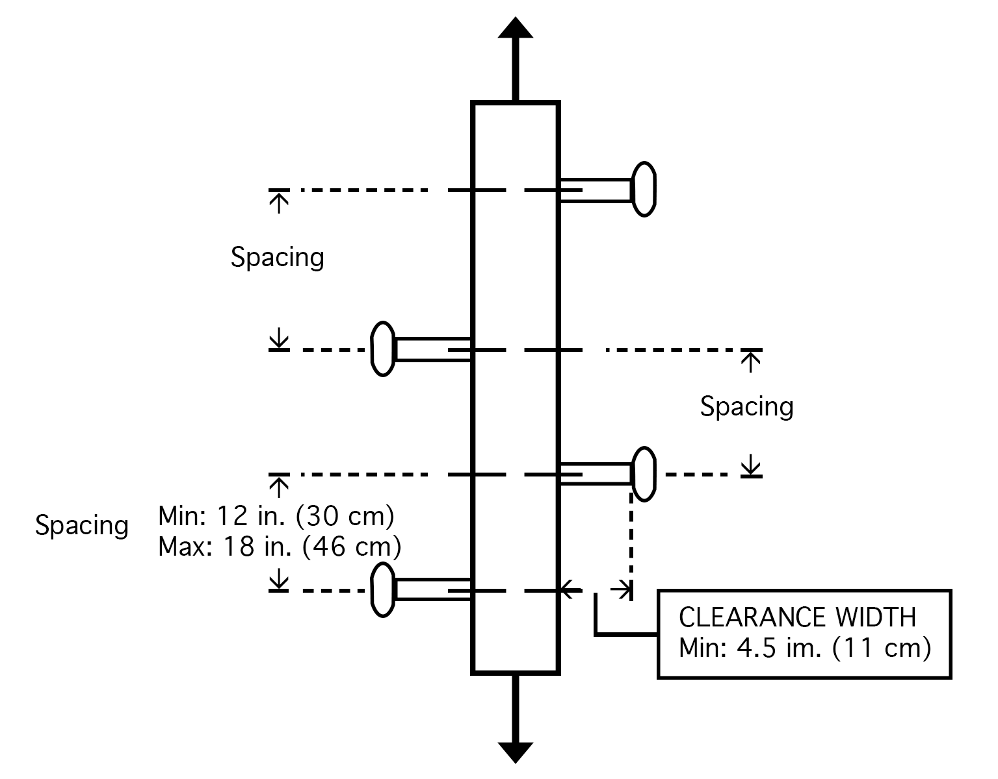
Figure D-6 - Step Bolt Spacing
(4) Each step bolt has a minimum clear width of 4.5 inches (11 cm);
(5) The minimum perpendicular distance between the centerline of each step bolt to the nearest permanent object in back of the step bolt is 7 inches (18 cm). When the employer demonstrates that an obstruction cannot be avoided, the distance must be at least 4.5 inches (11 cm);
(6) Each step bolt installed before January 17, 2017 is capable of supporting its maximum intended load;
Note to 1910.24(a)(6): The above referenced date does not apply in Oregon. Instead, in accordance with OAR 437-002-2031(2)(b), the Oregon delayed effective date is January 1, 2018.
(7) Each step bolt installed on or after January 17, 2017 is capable of supporting at least four times its maximum intended load;
Note to 1910.24(a)(7): The above referenced date does not apply in Oregon. Instead, in accordance with OAR 437-002-2031(2)(c), the Oregon delayed effective date is January 1, 2018.
(8) Each step bolt is inspected at the start of the workshift and maintained in accordance with § 1910.22; and
(9) Any step bolt that is bent more than 15 degrees from the perpendicular in any direction is removed and replaced with a step bolt that meets the requirements of this section before an employee uses it.
(b) Manhole steps.
(1) The employer must ensure that each manhole step is capable of supporting its maximum intended load.
(2) The employer must ensure that each manhole step installed on or after January 17, 2017:
Note to 1910.24(b)(2): The above referenced date does not apply in Oregon. Instead, in accordance with OAR 437-002-2031(2)(d), the Oregon delayed effective date is January 1, 2018.
(i) Has a corrugated, knurled, dimpled, or other surface that minimizes the possibility of an employee slipping;
(ii) Is constructed of, or coated with, material that protects against corrosion if the manhole step is located in an environment where corrosion may occur;
(iii) Has a minimum clear step width of 10 inches (25 cm);
(iv) Is uniformly spaced at a vertical distance not more than 16 inches (41cm) apart, measured center to center between steps. The spacing from the entry and exit surface to the first manhole step may differ from the spacing between the other steps.
(v) Has a minimum perpendicular distance between the centerline of the manhole step to the nearest permanent object in back of the step of at least 4.5 inches (11 cm); and
(vi) Is designed, constructed, and maintained to prevent the employee’s foot from slipping or sliding off the end.
(3) The employer must ensure that each manhole step is inspected at the start of the work shift and maintained in accordance with § 1910.22.

Stat. Auth.: ORS 654.025(2) and 656.726(4).
Stats. Implemented: ORS 654.001 through 654.295.
Hist: OR-OSHA Admin. Order 2-2017, f. 5/16/17, ef. 11/1/17.

1910.25 Stairways
(a) Application. This section covers all stairways (including standard, spiral, ship, and alternating tread-type stairs), except for stairs serving floating roof tanks, stairs on scaffolds, stairs designed into machines or equipment, and stairs on self-propelled motorized equipment.
(b) General requirements. The employer must ensure:
(1) Handrails, stair rail systems, and guardrail systems are provided in accordance with § 1910.28;
(2) Vertical clearance above any stair tread to any overhead obstruction is at least 6 feet, 8 inches (203 cm), as measured from the leading edge of the tread. Spiral stairs must meet the vertical clearance requirements in paragraph (d)(3) of this section.
(3) Stairs have uniform riser heights and tread depths between landings;
(4) Stairway landings and platforms are at least the width of the stair and at least 30 inches (76 cm) in depth, as measured in the direction of travel;
(5) When a door or a gate opens directly on a stairway, a platform is provided, and the swing of the door or gate does not reduce the platform’s effective usable depth to:
(i) Less than 20 inches (51 cm) for platforms installed before January 17, 2017; and
Note to 1910.25(b)(5)(i): The above referenced date does not apply in Oregon. Instead, in accordance with OAR 437-002-2031(3)(a), the Oregon delayed effective date is January 1, 2018.
(ii) Less than 22 inches (56 cm) for platforms installed on or after January 17, 2017 (see Figure D–7 of this section);
Note to 1910.25(b)(5)(ii): The above referenced date does not apply in Oregon. Instead, in accordance with OAR 437-002-2031(3)(b), the Oregon delayed effective date is January 1, 2018.
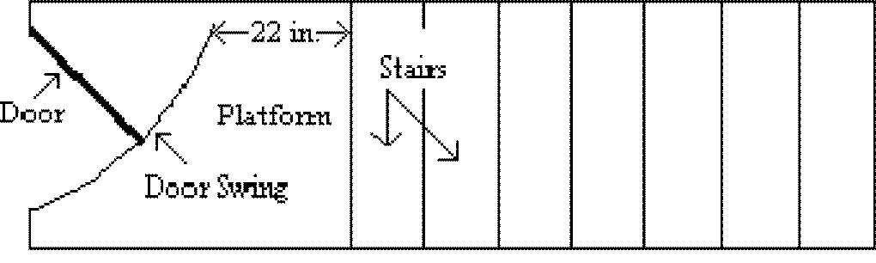
Figure D-7 - Door or Gate Opening on Stairway
(6) Each stair can support at least five times the normal anticipated live load, but never less than a concentrated load of 1,000 pounds (454 kg) applied at any point;

(7) Standard stairs are used to provide access from one walking-working surface to another when operations necessitate regular and routine travel between levels, including access to operating platforms for equipment. Winding stairways may be used on tanks and similar round structures when the diameter of the tank or structure is at least 5 feet (1.5 m).
(8) Spiral, ship, or alternating tread-type stairs are used only when the employer can demonstrate that it is not feasible to provide standard stairs.
(9) When paragraph (b)(8) of this section allows the use of spiral, ship, or alternating tread-type stairs, they are installed, used, and maintained in accordance with manufacturer’s instructions.
(c) Standard stairs. In addition to paragraph (b) of this section, the employer must ensure standard stairs:
(1) Are installed at angles between 30 to 50 degrees from the horizontal;
(2) Have a maximum riser height of 9.5 inches (24 cm);
(3) Have a minimum tread depth of 9.5 inches (24 cm); and
(4) Have a minimum width of 22 inches (56 cm) between vertical barriers (see Figure D–8 of this section).
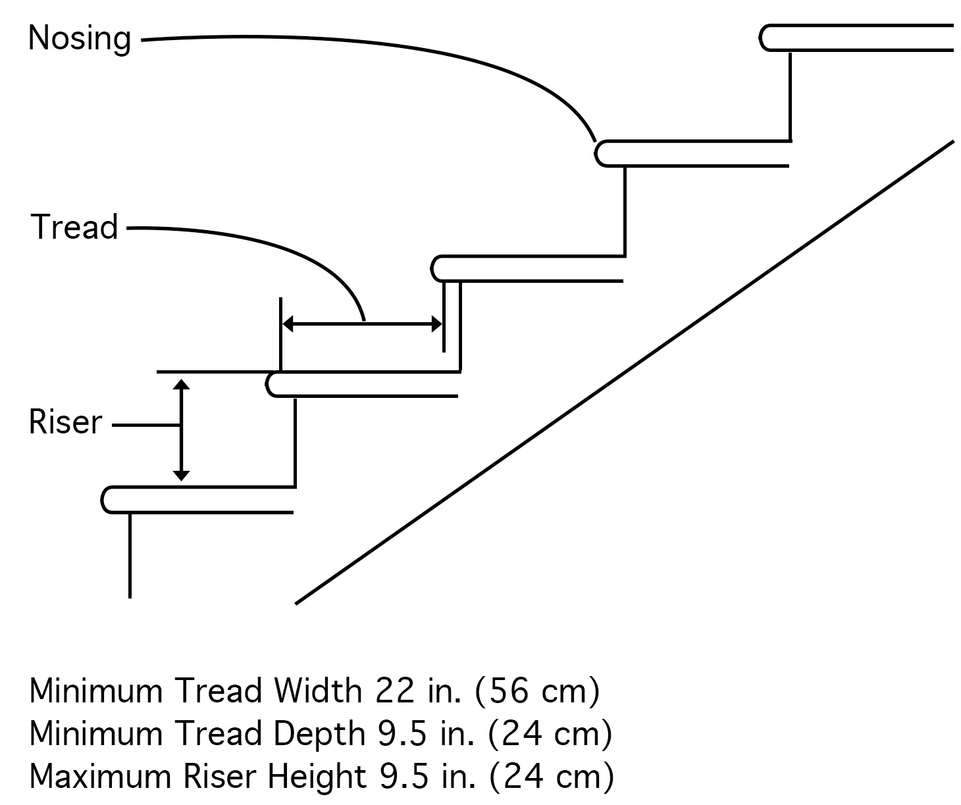
Figure D-8 - Dimensions of Standard Stairs
(5) Exception to paragraphs (c)(2) and (3) of this section. The requirements of paragraphs (c)(2) and (3) do not apply to standard stairs installed prior to January 17, 2017. OSHA will deem those stairs in compliance if they meet the dimension requirements specified in Table D–1 of this section or they use a combination that achieves the angle requirements of paragraph (c)(1) of this section.
Note to 1910.25(c)(5): The above referenced date does not apply in Oregon. Instead, in accordance with OAR 437-002-2031(3)(c), the Oregon delayed effective date is January 1, 2018.
Table D-1 - Stairway Rise and Tread Dimensions
Angle to horizontal | Rise (in inches) | Tread run (in inches)
30 deg. 35' | 6 1/2 | 11
32 deg. 08' | 6 3/4 | 10 3/4
33 deg. 41' | 7 | 10 1/2
35 deg. 16' | 7 1/4 | 10 1/4
36 deg. 52' | 7 1/2 | 10
38 deg. 29' | 7 3/4 | 9 3/4
40 deg. 08' | 8 | 9 1/2
41 deg. 44' | 8 1/4 | 9 1/4
43 deg. 22' | 8 1/2 | 9
45 deg. 00' | 8 3/4 | 8 3/4
46 deg. 38' | 9 | 8 1/2
48 deg. 16' | 9 1/4 | 8 1/4
49 deg. 54' | 9 1/2 | 8
(d) Spiral stairs. In addition to paragraph (b) of this section, the employer must ensure spiral stairs:
(1) Have a minimum clear width of 26 inches (66 cm);
(2) Have a maximum riser height of 9.5 inches (24 cm);
(3) Have a minimum headroom above spiral stair treads of at least 6 feet, 6 inches (2 m), measured from the leading edge of the tread;
(4) Have a minimum tread depth of 7.5 inches (19 cm), measured at a point 12 inches (30 cm) from the narrower edge;
(5) Have a uniform tread size;

(e) Ship stairs. In addition to paragraph (b) of this section, the employer must ensure ship stairs (see Figure D–9 of this section):
(1) Are installed at a slope of 50 to 70 degrees from the horizontal;
(2) Have open risers with a vertical rise between tread surfaces of 6.5 to 12 inches (17 to 30 cm);
(3) Have minimum tread depth of 4 inches (10 cm); and
(4) Have a minimum tread width of 18 inches (46 cm).
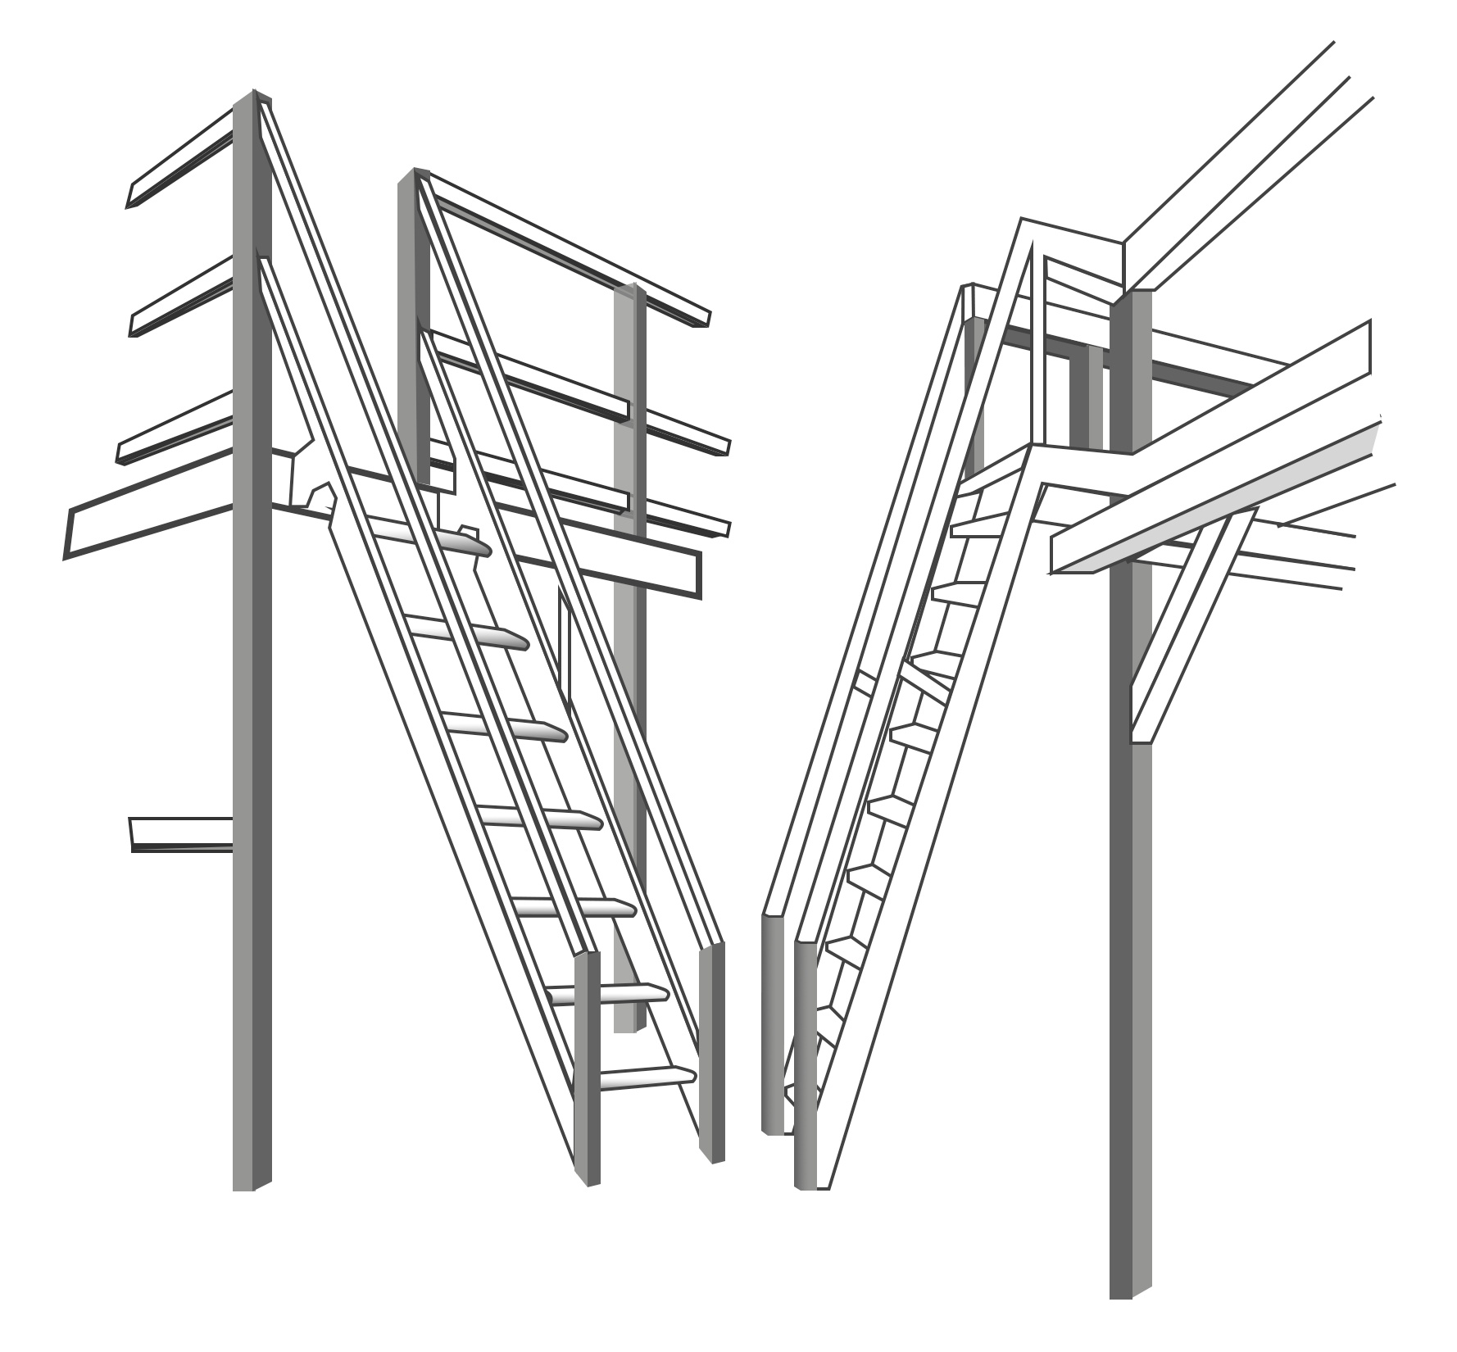
Figure D-9 - Ship Stairs
(f) Alternating tread-type stairs. In addition to paragraph (b) of this section, the employer must ensure alternating tread-type stairs:
(1) Have a series of treads installed at a slope of 50 to 70 degrees from the horizontal;
(2) Have a distance between handrails of 17 to 24 inches (51 to 61 cm);
(3) Have a minimum tread depth of 8.5 inches (22 cm); and
(4) Have open risers if the tread depth is less than 9.5 inches (24 cm);
(5) Have a minimum tread width of 7 inches (18 cm), measured at the leading edge of the tread (i.e., nosing).
Stat. Auth.: ORS 654.025(2) and 656.726(4).
Stats. Implemented: ORS 654.001 through 654.295.
Hist: OR-OSHA Admin. Order 2-2017, f. 5/16/17, ef. 11/1/17.

1910.26 Dockboards
The employer must ensure that each dockboard used meets the requirements of this section. The employer must ensure:
(a) Dockboards are capable of supporting the maximum intended load in accordance with § 1910.22(b);
(b)
(1) Dockboards put into initial service on or after January 17, 2017 are designed, constructed, and maintained to prevent transfer vehicles from running off the dockboard edge;
Note to 1910.26(b)(1): The above referenced date does not apply in Oregon. Instead, in accordance with OAR 437-002-2031(4), the Oregon delayed effective date is January 1, 2018.
(2) Exception to paragraph (b)(1) of this section. When the employer demonstrates there is no hazard of transfer vehicles running off the dockboard edge, the employer may use dockboards that do not have run-off protection.
(c) Portable dockboards are secured by anchoring them in place or using equipment or devices that prevent the dockboard from moving out of a safe position. When the employer demonstrates that securing the dockboard is not feasible, the employer must ensure there is sufficient contact between the dockboard and the surface to prevent the dockboard from moving out of a safe position;
(d) Measures, such as wheel chocks or sand shoes, are used to prevent the transport vehicle (e.g. a truck, semitrailer, trailer, or rail car) on which a dockboard is placed, from moving while employees are on the dockboard; and
(e) Portable dockboards are equipped with handholds or other means to permit safe handling of dockboards.

Stat. Auth.: ORS 654.025(2) and 656.726(4).
Stats. Implemented: ORS 654.001 through 654.295.
Hist: OR-OSHA Admin. Order 2-2017, f. 5/16/17, ef. 11/1/17.

1910.27 Scaffolds and rope descent systems
(a) Scaffolds. Scaffolds used in general industry must meet the requirements in 29 CFR part 1926, subpart L (Scaffolds).
Note 1: The regulations for scaffolds used in general industry are located in Division 3/L.
Note 2: The following rules were repealed on 11/1/2017 with AO 2-2017:
- OAR 437-002-0072 Manually propelled elevation aerial platforms.
- OAR 437-002-0074 Scissor lifts – self-propelled elevating work platforms.
- OAR 437-002-0076 Boom supported elevating work.
These requirements were previously located in Division 2/F.
The regulations for these three devices used in general industry are now located in Division 3/L and are identified as:
- OAR 437-003-0071 Manually propelled elevation aerial platforms.
- OAR 437-003-0074 Scissor lifts – self-propelled elevating work platforms.
- OAR 437-003-0073 Boom supported elevating work.
Note: 1910.27(b) was not adopted. See OAR 437-002-2027 Rope descent & rope access systems.
Stat. Auth.: ORS 654.025(2) and 656.726(4).
Stats. Implemented: ORS 654.001 through 654.295.
Hist: OR-OSHA Admin. Order 2-2017, f. 5/16/17, ef. 11/1/17.

437-002-2027 Rope Descent & Rope Access Systems
(1) Scope and application. This rule establishes safety requirements for rope descent and rope access. Rope descent and rope access systems can provide a safe way for employees to reach hard-to-reach locations, either natural or man-made. The requirements of this rule include, but are not limited to, the cleaning of buildings or structures, the inspection of dams and spillways, access to interior or exterior structural and architectural components of buildings, highway/bridge inspection and maintenance, powerplant penstocks and other difficult access areas.
(2) Definitions. For the purposes of this rule the following definitions apply:
Access is the means of reaching a workspace of a work area.
Rope access means the use of rope access equipment where two ropes are used; one as the primary means of support and a second for fall arrest protection. The employee accesses the work area by ascending, descending, or traversing along both ropes by alternating connections and weight between the two ropes. Rope access may also be called industrial rope access but is not limited to industrial applications.
Rope descent system means a suspension system that allows an employee to descend in a controlled manner and, as needed, stop at any point during the descent. A rope descent system usually consists of a roof anchorage, support rope, a descent device, carabiner(s) or shackle(s), and a chair (seatboard). A rope descent system also is called controlled descent equipment or apparatus. Rope descent systems do not include industrial rope access systems.
(3) Personal Protective Equipment. The employer must ensure personal protective equipment is in accordance with Division 2/I when rope descent systems or rope access methods are used.
(4) Anchorages for Rope Descent and Rope Access Systems.
(a) Permanent Anchorages on Buildings.
(A) Before any rope descent or rope access system is used, the building owner must inform the employer, in writing that the building owner has identified, tested, certified, and maintained each permanent anchorage so it is capable of supporting at least 5,000 pounds (22.24kN), in any direction, for each employee attached. The information must be based on an annual inspection by a qualified person and certification of each anchorage by a qualified person, as necessary, and at least every 10 years.
(B) The employer must ensure that no employee uses any permanent anchorage before the employer has obtained written information from the building owner that each anchorage meets the requirements of 437-002-2027(4)(a)(A). The employer must keep the information for the duration of the job.
(C) The requirements of 437-002-2027(4)(a)(A) and (B) must be implemented no later than December 1, 2018.
(b) Temporary Anchorages. Anchorages for rope descent or rope access systems on structure or natural surroundings other than buildings must be independent from each other (primary support rope and secondary fall arrest system) and must be:

(A) Capable of supporting at least 5000 pounds (22.24 kN) for each employee attached: or
(B) Designed, installed, and used, under the supervision of a qualified person, as part of a complete system that maintains a safety factor of at least two.
(5) Rope descent systems. The employer must ensure:
(a) No rope descent system is used for heights greater than 300 feet (91 m) above grade unless the employer demonstrates that it is not feasible to access such heights by any other means or that those means pose a greater hazard than using a rope descent system;
(b) The rope descent system is used in accordance with instructions, warnings, and design limitations set by the manufacturer or under the direction of a qualified person;
(c) Each employee who uses the rope descent system is trained in accordance with 1910.30;
(d) The rope descent system is inspected at the start of each workshift that it is to be used. The employer must ensure damaged or defective equipment is removed from service immediately and replaced;
(e) The rope descent system has proper rigging, including anchorages and tiebacks, with particular emphasis on providing tiebacks when counterweights, cornice hooks, or similar non-permanent anchorages are used;
(f) Each employee uses a separate, independent personal fall arrest system that meets the requirements of 1910.140 in Division 2, Subdivision I;
(g) All components of each rope descent system, except seat boards, are capable of sustaining a minimum rated load of 5,000 pounds (22.2 kN). Seat boards must be capable of supporting a live load of 300 pounds (136 kg);
Note to 437-002-2027(5)(g): Oregon OSHA based this rule on federal OSHA’s 1910.27(b)(2)(vii). Federal OSHA’s discussion on final rule 1910.27(b)(2)(vii), as published on page 82577 of the Federal Register on November 18, 2016, states the following: “OSHA notes that the final rule does not preclude the use of lines or ropes that have knots, swage, or eye splice, which could reduce the tensile strength of a rope or line. However, under final paragraph (b)(2)(vii), even if an employer uses a line or rope that has a knot, swage, or eye split, the rope or line still must be capable of supporting a minimum rated load of 5,000 pounds.”
(h) Prompt rescue of each employee is provided in the event of a fall, equipment malfunction or entanglement;
(i) The ropes of each rope descent system are effectively padded or otherwise protected, where they can contact edges of the building, anchorage, obstructions, or other surfaces, to prevent them from being cut or weakened;
(j) Stabilization is provided at the specific work location when descents are greater than 130 feet (39.6 m);
(k) No employee uses a rope descent system when hazardous weather conditions, such as storms or gusty or excessive wind, are present;
(l) Equipment, such as tools, squeegees, or buckets, is secured by a tool lanyard or similar method to prevent it from falling;
(m) The ropes of each rope descent system are protected from exposure to open flames, hot work, corrosive chemicals, and other destructive conditions;
(n) The ropes of each rope descent system are made from industrial synthetic fibers and classified as life-safety rope. Ropes made from natural fibers and polypropylene cannot be used for rope descent;
(o) Descent control devices include automatic locks that will engage and prevent an uncontrolled descent in case the employee lets go or loses control of the device;
(p) Anchorages for rope descent systems meet the requirements of 437-002-2027(4) of this rule; and
(q) A pre-work briefing is conducted with each employee involved in rope descent to include, but is not limited to:
(A) The objective(s) of the work to be performed.
(B) Site-specific hazards.
(C) Environmental conditions that could affect the safety of the employee using the system.
(D) Emergency procedures to be followed (e.g., employee rescue).
(6) Rope access systems.

(a) Exceptions. 437-002-2027(6) does not apply to:
(A) Emergency search and rescue operations.
(B) Entertainment performances and rehearsals. This exception does not apply to the set up, dismantling or operation of; stages, sound systems, lighting systems, pyrotechnics, associated supporting structures or props.
(C) Tree and shrub service activities covered by Division 2, Subdivision R.
(b) Written Rope Access Program. The employer must develop, implement and maintain a written Rope Access Program that includes, but not be limited to the following elements:
(A) Identification of a program administrator responsible for the overall rope access program.
(B) Methods of access and anchorage used by the employer.
(C) Listing of specific rope skills (i.e. ascending, descending, traversing, aid climbing, etc.) necessary to complete the work.
(D) Employee selection criteria.
(E) Equipment selection and inspection criteria.
(F) Roles and responsibilities of rope access team members.
(G) Communication systems.
(H) Employee training program.
(I) Rescue and emergency protocol.
(J) Identification of any unique site hazards that may affect the safety of employees using rope access equipment and methods.
(K) Pre-work briefings.
(c) Program Administration. The employer must ensure that the rope access program is administered by a program administrator knowledgeable in the elements of the written rope access program as required by subsection (6)(b) of this rule.
(d) Training and Evaluation. The employer must conduct training according to the requirements of 1910.30, and ensure:
(A) Employees who use rope access equipment and/or are engaged in rope access activities are trained and evaluated by persons with the qualifications and experience necessary to effectively instruct the employee in the proper fundamentals of rope access, equipment, and techniques described in subsection (6)(b) of this rule;
(B) Employees, prior to engaging in rope access activities, are trained in accordance with the written Rope Access Program, including applicable equipment, skills and rescue methods required of the work;
(C) Employees, prior to engaging in rope access activities, are evaluated by a hands-on demonstration by the employee of his/her skills;
(D) Employees, at a minimum, who perform rope access activities receive annual refresher training in accordance with 1910.30 and the written Rope Access Program;
(E) Employees, at a minimum, who perform rope access activities are annually re-evaluated (e.g., hands-on demonstration) of their ability to perform work in accordance with the written Rope Access Program;
(F) Employees who perform rope access are re-trained and re-evaluated before further engaging in rope access activities when the employer has reason to believe the employee does not have the understanding or skills required by 1910.30 and the written Rope Access Program. Additionally, when the employer has reason to believe the employee has violated a condition of the written Rope Access Program, the employee must be re-trained and re-evaluated. Re-training and re-evaluation under this subsection may be limited to the specific topics, concepts or skills which the employer believes, or the employee has demonstrated, are deficient;
(G) All training, re-training, evaluation and re-evaluation events are documented, and retained for three years; and
(H) Documentation of employee training, re-training, evaluation and re-evaluation include the following:

(i) Name of the employee;
(ii) Skills included in the training or evaluation;
(iii) Date(s) of the training or re-training;
(iv) Date(s) of the evaluation or re-evaluation;
(v) Identity of the person(s) performing the training or evaluation.
(e) Rope Access Use. When rope access is used, the employer must ensure:
(A)There are at least two rope access trained employees present at the physical location where rope access is being performed;
(B) No employee uses a rope access system when hazardous weather conditions, such as storms or excessive wind, are present;
(C) Anchorages for rope access systems meet the requirements of 437-002-2027(4) of this rule;
(D) Each employee using a rope access system 4 feet (1.2 m) or more above a lower level is protected from falling by a personal fall arrest system in compliance with 1910.140 in 2/I with the following exceptions to 1910.140:
(i) 1910.140(c)(1) does not apply when aluminum carabiners meet the strength requirements of 1910.140(c)(8).
(ii) 1910.140(c)(10)(i) does not apply when carabiners are connected directly to rope meeting the requirements of 437-002-2027(6)(e)(E)(i) and (ii).
(iii) 1910.140(c)(10)(ii) does not apply during temporary rope transfer operations when carabiners are connected to each other lasting only long enough to complete the transfer and not as a part of the rigging for normal use.
(iv) 1910.140(c)(10)(iii) does not apply during temporary rope transfer operations when multiple carabiners are connected to a single D-ring lasting only long enough to complete the transfer and not as a part of the rigging for normal use.
(E) Components used for rope access support, positioning, transfer and back-up (fall protection) must meet the following minimum requirements:
(i) Primary support ropes and secondary fall arrest ropes are made from industrial synthetic fibers and classified as life-safety rope. Ropes made from natural fibers or polypropylene cannot be used for rope access.
(ii) Primary support ropes and secondary fall arrest ropes have a minimum rated breaking strength before being knotted, swaged or eye-spliced of 6,000 pounds (26.69 kN) as established by the rope manufacturer.
(iii) Combination harnesses (designed and manufactured for rope access positioning and employee fall protection) are capable of sustaining a minimum rated load of 3,600 pounds (16.01 kN).
(iv) Seat boards must be capable of supporting a live load of 300 pounds (136 kg).
(v) Connectors must have an automatic locking feature and are capable of sustaining a minimum rated load of 5,000 pounds (22.24 kN).
(vi) Descent control devices include automatic locks that will engage and prevent an uncontrolled descent in case the employee lets go or loses control of the device and are capable of sustaining a minimum rated load of 3,000 pounds (13.35 kN).
(vii) Manufactured lanyards (cowstails) are capable of sustaining a minimum rated load of 5,000 pounds (22.24 kN) as established by the manufacturer.
(viii) Job-made lanyards (cowstails), when constructed of rope, meet the requirements of 437-002-2027(6)(e)(E)(i) and (ii).
(ix) Back-up devices (fall arrest) must be capable of sustaining a minimum rated load of 3,600 pounds (16.01 kN).
(x) Auxiliary equipment designed to allow an employee to move along a line (rope) such as rope clamps, rope grabs, chest ascenders, foot ascender and hand ascenders must be capable of sustaining a minimum rated load of 1,000 pounds (4.49 kN).

(F) Rope access system components are used in accordance with instructions, warnings, and design limitations set by the manufacturer or under the direction of a qualified person;
(G) Rope access system components are inspected at the start of each workshift that it is to be used. The employer must ensure damaged or defective equipment is removed from service immediately and replaced;
(H) Prompt rescue of each employee is provided in the event of a fall, equipment malfunction or entanglement, or assure employees are able to rescue themselves;
(I) The ropes of each rope access system are effectively padded or otherwise protected, where they can contact edges of the building, anchorage, obstructions, structure, or other surfaces, to prevent them from being cut or weakened;
(J) The ropes of each rope access system are protected from exposure to open flames, hot work, corrosive chemicals, and other destructive conditions;
(K) Equipment, such as tools are secured by a tool lanyard or similar method to prevent it from falling where employees below are exposed to falling objects;
(L) A pre-work briefing is conducted with each employee involved in rope access to include, but is not limited to:
(i) The objective(s) of the work to be performed.
(ii) Site-specific hazards.
(iii) Environmental conditions that could affect the safety of the employee using the system.
(iv) Emergency procedures to be followed (e.g., employee rescue).
Stat. Auth.: ORS 654.025(2) and 656.726(4).
Stats. Implemented: ORS 654.001 through 654.295.
Hist: OR-OSHA Admin. Order 2-2017, f. 5/16/17, ef. 11/1/17.

1910.28 Duty to have fall protection and falling object protection
(a) General.
(1) This section requires employers to provide protection for each employee exposed to fall and falling object hazards. Unless stated otherwise, the employer must ensure that all fall protection and falling object protection required by this section meet the criteria in § 1910.29, except that personal fall protection systems required by this section meet the criteria of § 1910.140.
(2) This section does not apply:
(i) To portable ladders;
(ii) When employers are inspecting, investigating, or assessing workplace conditions or work to be performed prior to the start of work or after all work has been completed. This exemption does not apply when fall protection systems or equipment meeting the requirements of § 1910.29 have been installed and are available for workers to use for pre-work and post-work inspections, investigations, or assessments;
(iii) To fall hazards presented by the exposed perimeters of entertainment stages and the exposed perimeters of rail-station platforms;
(iv) To powered platforms covered by § 1910.66(j);
(v) To aerial lifts covered by § 1910.67(c)(2)(v);
(vi) To telecommunications work covered by § 1910.268(n)(7) and (8); and
(vii) To electric power generation, transmission, and distribution work covered by OAR 437-002-2306(2) within Subdivision 2/RR.
(b) Protection from fall hazards.
(1) Unprotected sides and edges.
(i) Except as provided elsewhere in this section, the employer must ensure that each employee on a walking-working surface with an unprotected side or edge that is 4 feet (1.2 m) or more above a lower level is protected from falling by one or more of the following:
(A) Guardrail systems;
(B) Safety net systems; or
(C) Personal fall protection systems, such as personal fall arrest, travel restraint, or positioning systems.
Note: Oregon OSHA did not adopt paragraph 1910.28(b)(1)(ii) or the corresponding note to paragraph (b)(1)(ii) of this section.
(iii) When the employer can demonstrate that the use of fall protection systems is not feasible on the working side of a platform used at a loading rack, loading dock, or teeming platform, the work may be done without a fall protection system, provided:
(A) The work operation for which fall protection is infeasible is in process;
(B) Access to the platform is limited to authorized employees; and,
(C) The authorized employees are trained in accordance with § 1910.30.

(2) Hoist areas. The employer must ensure:
(i) Each employee in a hoist area is protected from falling 4 feet (1.2 m) or more to a lower level by:
(A) A guardrail system;
(B) A personal fall arrest system; or
(C) A travel restraint system.
(ii) When any portion of a guardrail system, gate, or chains is removed, and an employee must lean through or over the edge of the access opening to facilitate hoisting, the employee is protected from falling by a personal fall arrest system.
(iii) If grab handles are installed at hoist areas, they meet the requirements of § 1910.29(l).
(3) Holes. The employer must ensure:
(i) Each employee is protected from falling through any hole (including skylights) that is 4 feet (1.2 m) or more above a lower level by one or more of the following:
(A) Covers;
(B) Guardrail systems;
(C) Travel restraint systems; or
(D) Personal fall arrest systems.
(ii) Each employee is protected from tripping into or stepping into or through any hole that is less than 4 feet (1.2 m) above a lower level by covers or guardrail systems.
(iii) Each employee is protected from falling into a stairway floor hole by a fixed guardrail system on all exposed sides, except at the stairway entrance. However, for any stairway used less than once per day where traffic across the stairway floor hole prevents the use of a fixed guardrail system (e.g., holes located in aisle spaces), the employer may protect employees from falling into the hole by using a hinged floor hole cover that meets the criteria in § 1910.29 and a removable guardrail system on all exposed sides, except at the entrance to the stairway.
(iv) Each employee is protected from falling into a ladderway floor hole or ladderway platform hole by a guardrail system and toeboards erected on all exposed sides, except at the entrance to the hole, where a self-closing gate or an offset must be used.
(v) Each employee is protected from falling through a hatchway and chute floor hole by:
(A) A hinged floor-hole cover that meets the criteria in § 1910.29 and a fixed guardrail system that leaves only one exposed side. When the hole is not in use, the employer must ensure the cover is closed or a removable guardrail system is provided on the exposed sides;
(B) A removable guardrail system and toeboards on not more than two sides of the hole and a fixed guardrail system on all other exposed sides. The employer must ensure the removable guardrail system is kept in place when the hole is not in use; or
(C) A guardrail system or a travel restraint system when a work operation necessitates passing material through a hatchway or chute floor hole.
(4) Dockboards.
(i) The employer must ensure that each employee on a dockboard is protected from falling 4 feet (1.2 m) or more to a lower level by a guardrail system or handrails.
(ii) A guardrail system or handrails are not required when:
(A) Dockboards are being used solely for materials-handling operations using motorized equipment;
(B) Employees engaged in these operations are not exposed to fall hazards greater than 10 feet (3 m); and
(C) Those employees have been trained in accordance with § 1910.30.
(5) Runways and similar walkways.

(i) The employer must ensure each employee on a runway or similar walkway is protected from falling 4 feet (1.2 m) or more to a lower level by a guardrail system.
(ii) When the employer can demonstrate that it is not feasible to have guardrails on both sides of a runway used exclusively for a special purpose, the employer may omit the guardrail on one side of the runway, provided the employer ensures:
(A) The runway is at least 18 inches (46 cm) wide; and
(B) Each employee is provided with and uses a personal fall arrest system or travel restraint system.
(6) Dangerous equipment. The employer must ensure:
(i) Each employee less than 4 feet (1.2 m) above dangerous equipment is protected from falling into or onto the dangerous equipment by a guardrail system or a travel restraint system, unless the equipment is covered or guarded to eliminate the hazard.
(ii) Each employee 4 feet (1.2 m) or more above dangerous equipment must be protected from falling by:
(A) Guardrail systems;
(B) Safety net systems;
(C) Travel restraint systems; or
(D) Personal fall arrest systems.
(7) Openings. The employer must ensure that each employee on a walking-working surface near an opening, including one with a chute attached, where the inside bottom edge of the opening is less than 39 inches (99 cm) above that walking-working surface and the outside bottom edge of the opening is 4 feet (1.2 m) or more above a lower level is protected from falling by the use of:
(i) Guardrail systems;
(ii) Safety net systems;
(iii) Travel restraint systems; or,
(iv) Personal fall arrest systems.
(8) Repair pits, service pits, and assembly pits less than 10 feet in depth. The use of a fall protection system is not required for a repair pit, service pit, or assembly pit that is less than 10 feet (3 m) deep, provided the employer:
(i) Limits access within 6 feet (1.8 m) of the edge of the pit to authorized employees trained in accordance with § 1910.30;
(ii) Applies floor markings at least 6 feet (1.8 m) from the edge of the pit in colors that contrast with the surrounding area; or places a warning line at least 6 feet (1.8 m) from the edge of the pit as well as stanchions that are capable of resisting, without tipping over, a force of at least 16 pounds (71 N) applied horizontally against the stanchion at a height of 30 inches (76 cm); or places a combination of floor markings and warning lines at least 6 feet (1.8 m) from the edge of the pit. When two or more pits in a common area are not more than 15 feet (4.5m) apart, the employer may comply by placing contrasting floor markings at least 6 feet (1.8 m) from the pit edge around the entire area of the pits; and
(iii) Posts readily visible caution signs that meet the requirements of § 1910.145 and state ‘‘Caution—Open Pit.’’
(9) Fixed ladders (that extend more than 24 feet (7.3 m) above a lower level).
(i) For fixed ladders that extend more than 24 feet (7.3 m) above a lower level, the employer must ensure:
(A) Existing fixed ladders. Each fixed ladder installed before November 19, 2018 is equipped with a personal fall arrest system, ladder safety system, cage, or well;
Note to 1910.28(b)(9)(i)(A): The above referenced date does not apply in Oregon. Instead, in accordance with OAR 437-002-2031(5)(a), the Oregon delayed effective date is November 1, 2019.

(B) New fixed ladders. Each fixed ladder installed on and after November 19, 2018, is equipped with a personal fall arrest system or a ladder safety system;
Note to 1910.28(b)(9)(i)(B): The above referenced date does not apply in Oregon. Instead, in accordance with OAR 437-002-2031(5)(b), the Oregon delayed effective date is November 1, 2019.
(C) Replacement. When a fixed ladder, cage, or well, or any portion of a section thereof, is replaced, a personal fall arrest system or ladder safety system is installed in at least that section of the fixed ladder, cage, or well where the replacement is located; and
(D) Final deadline. On and after November 18, 2036, all fixed ladders are equipped with a personal fall arrest system or a ladder safety system.
Note to 1910.28(b)(9)(i)(D): The above referenced date does not apply in Oregon. Instead, in accordance with OAR 437-002-2031(5)(c), the Oregon delayed effective date is December 1, 2036.
(ii) When a one-section fixed ladder is equipped with a personal fall protection or a ladder safety system or a fixed ladder is equipped with a personal fall arrest or ladder safety system on more than one section, the employer must ensure:
(A) The personal fall arrest system or ladder safety system provides protection throughout the entire vertical distance of the ladder, including all ladder sections; and
(B) The ladder has rest platforms provided at maximum intervals of 150 feet (45.7 m).
(iii) The employer must ensure ladder sections having a cage or well:
(A) Are offset from adjacent sections; and
(B) Have landing platforms provided at maximum intervals of 50 feet (15.2 m).
(iv) The employer may use a cage or well in combination with a personal fall arrest system or ladder safety system provided that the cage or well does not interfere with the operation of the system.
(10) Outdoor advertising (billboards).
(i) The requirements in paragraph (b)(9) of this section, and other requirements in subparts D and I of this part, apply to fixed ladders used in outdoor advertising activities.
(ii) When an employee engaged in outdoor advertising climbs a fixed ladder before November 19, 2018 that is not equipped with a cage, well, personal fall arrest system, or a ladder safety system the employer must ensure the employee:
Note to 1910.28(b)(10)(ii): The above referenced date does not apply in Oregon. Instead, in accordance with OAR 437-002-2031(5)(d), the Oregon delayed effective date is November 1, 2019.
(A) Receives training and demonstrates the physical capability to perform the necessary climbs in accordance with § 1910.29(h);
(B) Wears a body harness equipped with an 18-inch (46 cm) rest lanyard;
(C) Keeps both hands free of tools or material when climbing on the ladder; and
(D) Is protected by a fall protection system upon reaching the work position.
(11) Stairways. The employer must ensure:
(i) Each employee exposed to an unprotected side or edge of a stairway landing that is 4 feet (1.2 m) or more above a lower level is protected by a guardrail or stair rail system;
(ii) Each flight of stairs having at least 3 treads and at least 4 risers is equipped with stair rail systems and handrails as follows:
Table D-2 - Stairway Handrail Requirements
Stair width | Enclosed | One open side | Two open sides | With earth built up on both sides
Less than  44 inches  (1.1 m) | At least one handrail. | One stair rail system with handrail on open side. | One stair rail system each open side.
44 inches  (1.1 m) to  88 inches  (2.2 m) | One handrail on each enclosed side. | One stair rail system with handrail on open side and one handrail on enclosed side. | One stair rail system with handrail on each open side.
Greater than  88 inches  (2.2 m) | One handrail on each enclosed side and one intermediate handrail located in the middle of the stair. | One stair rail system with handrail on open side, one handrail on enclosed side, and one intermediate handrail located in the middle of the stair. | One stair rail system with handrail on each open side and one intermediate handrail located in the middle of the stair.
Exterior stairs  less than  44 inches  (1.1 m) |  |  |  | One handrail on at least one side.
Note to table: The width of the stair must be clear of all obstructions except handrails.

(iii) Each ship stairs and alternating tread type stairs is equipped with handrails on both sides.
(12) Scaffolds and rope descent systems. The employer must ensure:
(i) Each employee on a scaffold is protected from falling in accordance 29 CFR part 1926, subpart L; and
(ii) Each employee using a rope descent system 4 feet (1.2 m) or more above a lower level is protected from falling by a personal fall arrest system.
(13) Work on low-slope roofs.
(i) When work is performed less than 6 feet (1.6 m) from the roof edge, the employer must ensure each employee is protected from falling by a guardrail system, safety net system, travel restraint system, or personal fall arrest system.
(ii) When work is performed at least 6 feet (1.6 m) but less than 15 feet (4.6 m) from the roof edge, the employer must ensure each employee is protected from falling by using a guardrail system, safety net system, travel restraint system, or personal fall arrest system. The employer may use a designated area when performing work that is both infrequent and temporary.
(iii) When work is performed 15 feet (4.6 m) or more from the roof edge, the employer must:
(A) Protect each employee from falling by a guardrail system, safety net system, travel restraint system, or personal fall arrest system or a designated area. The employer is not required to provide any fall protection, provided the work is both infrequent and temporary; and
(B) Implement and enforce a work rule prohibiting employees from going within 15 feet (4.6 m) of the roof edge without using fall protection in accordance with paragraphs (b)(13)(i) and (ii) of this section.
(14) Slaughtering facility platforms.
(i) The employer must protect each employee on the unprotected working side of a slaughtering facility platform that is 4 feet (1.2 m) or more above a lower level from falling by using:
(A) Guardrail systems; or
(B) Travel restraint systems.
(ii) When the employer can demonstrate the use of a guardrail or travel restraint system is not feasible, the work may be done without those systems provided:
(A) The work operation for which fall protection is infeasible is in process;
(B) Access to the platform is limited to authorized employees; and
(C) The authorized employees are trained in accordance with § 1910.30.
(15) Walking-working surfaces not otherwise addressed. Except as provided elsewhere in this section or by other subparts of this part, the employer must ensure each employee on a walking-working surface 4 feet (1.2 m) or more above a lower level is protected from falling by:
(i) Guardrail systems;
(ii) Safety net systems; or
(iii) Personal fall protection systems, such as personal fall arrest, travel restraint, or positioning systems.
(c) Protection from falling objects. When an employee is exposed to falling objects, the employer must ensure that each employee wears head protection that meets the requirements of subpart I of this part. In addition, the employer must protect employees from falling objects by implementing one or more of the following:
(1) Erecting toeboards, screens, or guardrail systems to prevent objects from falling to a lower level;
(2) Erecting canopy structures and keeping potential falling objects far enough from an edge, hole, or opening to prevent them from falling to a lower level; or
(3) Barricading the area into which objects could fall, prohibiting employees from entering the barricaded area, and keeping objects far enough from an edge or opening to prevent them from falling to a lower level.

Stat. Auth.: ORS 654.025(2) and 656.726(4).
Stats. Implemented: ORS 654.001 through 654.295.
Hist: OR-OSHA Admin. Order 2-2017, f. 5/16/17, ef. 11/1/17.

1910.29 Fall protection systems and falling object protection – criteria and practices
(a) General requirements. The employer must:
(1) Ensure each fall protection system and falling object protection, other than personal fall protection systems, that this part requires meets the requirements in this section. The employer must ensure each personal fall protection system meets the requirements in subpart I of this part; and
(2) Provide and install all fall protection systems and falling object protection this subpart requires, and comply with the other requirements in this subpart before any employee begins work that necessitates fall or falling object protection.
(b) Guardrail systems. The employer must ensure guardrail systems meet the following requirements:
(1) The top edge height of top rails, or equivalent guardrail system members, are 42 inches (107 cm), plus or minus 3 inches (8 cm), above the walking-working surface. The top edge height may exceed 45 inches (114 cm), provided the guardrail system meets all other criteria of paragraph (b) of this section (see Figure D–11 of this section).
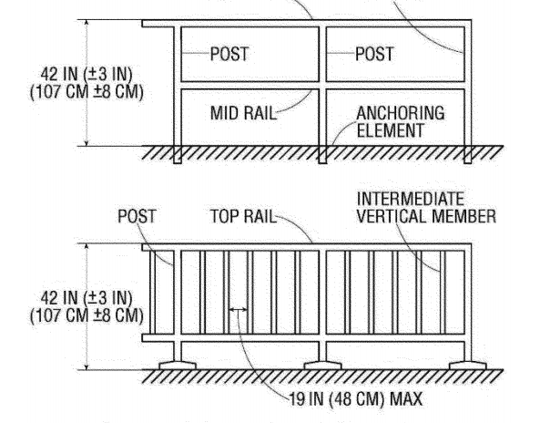
Figure D-11 - Guard Rail Systems
(2) Midrails, screens, mesh, intermediate vertical members, solid panels, or equivalent intermediate members are installed between the walking-working surface and the top edge of the guardrail system as follows when there is not a wall or parapet that is at least 21 inches (53 cm) high:
(i) Midrails are installed at a height midway between the top edge of the guardrail system and the walking-working surface;
(ii) Screens and mesh extend from the walking-working surface to the top rail and along the entire opening between top rail supports;
(iii) Intermediate vertical members (such as balusters) are installed no more than 19 inches (48 cm) apart; and
(iv) Other equivalent intermediate members (such as additional midrails and architectural panels) are installed so that the openings are not more than 19 inches (48 cm) wide.
(3) Guardrail systems are capable of withstanding, without failure, a force of at least 200 pounds (890 N) applied in a downward or outward direction within 2 inches (5 cm) of the top edge, at any point along the top rail.
(4) When the 200-pound (890–N) test load is applied in a downward direction, the top rail of the guardrail system must not deflect to a height of less than 39 inches (99 cm) above the walking-working surface.
(5) Midrails, screens, mesh, intermediate vertical members, solid panels, and other equivalent intermediate members are capable of withstanding, without failure, a force of at least 150 pounds (667 N) applied in any downward or outward direction at any point along the intermediate member.

(6) Guardrail systems are smooth-surfaced to protect employees from injury, such as punctures or lacerations, and to prevent catching or snagging of clothing.
(7) The ends of top rails and midrails do not overhang the terminal posts, except where the overhang does not pose a projection hazard for employees.
(8) Steel banding and plastic banding are not used for top rails or midrails.
(9) Top rails and midrails are at least 0.25-inches (0.6 cm) in diameter or in thickness.
(10) When guardrail systems are used at hoist areas, a removable guardrail section, consisting of a top rail and midrail, are placed across the access opening between guardrail sections when employees are not performing hoisting operations. The employer may use chains or gates instead of a removable guardrail section at hoist areas if the employer demonstrates the chains or gates provide a level of safety equivalent to guardrails.
(11) When guardrail systems are used around holes, they are installed on all unprotected sides or edges of the hole.
(12) For guardrail systems used around holes through which materials may be passed:
(i) When materials are being passed through the hole, not more than two sides of the guardrail system are removed; and
(ii) When materials are not being passed through the hole, the hole must be guarded by a guardrail system along all unprotected sides or edges or closed over with a cover.
(13) When guardrail systems are used around holes that serve as points of access (such as ladderways), the guardrail system opening:
(i) Has a self-closing gate that slides or swings away from the hole, and is equipped with a top rail and midrail or equivalent intermediate member that meets the requirements in paragraph (b) of this section; or
(ii) Is offset to prevent an employee from walking or falling into the hole;
(14) Guardrail systems on ramps and runways are installed along each unprotected side or edge.
(15) Manila or synthetic rope used for top rails or midrails are inspected as necessary to ensure that the rope continues to meet the strength requirements in paragraphs (b)(3) and (5) of this section.
Note to paragraph (b) of this section: The criteria and practices requirements for guardrail systems on scaffolds are contained in 29 CFR part 1926, subpart L.
(c) Safety net systems. The employer must ensure each safety net system meets the requirements in 29 CFR part 1926, subpart M.
(d) Designated areas.
(1) When the employer uses a designated area, the employer must ensure:
(i) Employees remain within the designated area while work operations are underway; and
(ii) The perimeter of the designated area is delineated with a warning line consisting of a rope, wire, tape, or chain that meets the requirements of paragraphs (d)(2) and (3) of this section.
(2) The employer must ensure each warning line:
(i) Has a minimum breaking strength of 200 pounds (0.89 kN);
(ii) Is installed so its lowest point, including sag, is not less than 34 inches (86 cm) and not more than 39 inches (99 cm) above the walking-working surface;
(iii) Is supported in such a manner that pulling on one section of the line will not result in slack being taken up in adjacent sections causing the line to fall below the limits specified in paragraph (d)(2)(ii) of this section;
(iv) Is clearly visible from a distance of 25 feet (7.6 m) away, and anywhere within the designated area;
(v) Is erected as close to the work area as the task permits; and
(vi) Is erected not less than 6 feet (1.8 m) from the roof edge for work that is both temporary and infrequent, or not less than 15 feet (4.6 m) for other work.

(3) When mobile mechanical equipment is used to perform work that is both temporary and infrequent in a designated area, the employer must ensure the warning line is erected not less than 6 feet (1.8 m) from the unprotected side or edge that is parallel to the direction in which the mechanical equipment is operated, and not less than 10 feet (3 m) from the unprotected side or edge that is perpendicular to the direction in which the mechanical equipment is operated.
(e) Covers. The employer must ensure each cover for a hole in a walking-working surface:
(1) Is capable of supporting without failure, at least twice the maximum intended load that may be imposed on the cover at any one time; and
(2) Is secured to prevent accidental displacement.
(f) Handrails and stair rail systems. The employer must ensure:
(1) Height criteria.
(i) Handrails are not less than 30 inches (76 cm) and not more than 38 inches (97 cm), as measured from the leading edge of the stair tread to the top surface of the handrail (see Figure D–12 of this section).
(ii) The height of stair rail systems meets the following:
(A) The height of stair rail systems installed before January 17, 2017 is not less than 30 inches (76 cm) from the leading edge of the stair tread to the top surface of the top rail; and
Note to 1910.29(f)(1)(ii)(A): The above referenced date does not apply in Oregon. Instead, in accordance with OAR 437-002-2031(6)(a), the Oregon delayed effective date is January 1, 2018.
(B) The height of stair rail systems installed on or after January 17, 2017 is not less than 42 inches (107 cm) from the leading edge of the stair tread to the top surface of the top rail.
Note to 1910.29(f)(1)(ii)(B): The above referenced date does not apply in Oregon. Instead, in accordance with OAR 437-002-2031(6)(b), the Oregon delayed effective date is January 1, 2018.
(iii) The top rail of a stair rail system may serve as a handrail only when:
(A) The height of the stair rail system is not less than 36 inches (91 cm) and not more than 38 inches (97 cm) as measured at the leading edge of the stair tread to the top surface of the top rail (see Figure D–13 of this section); and
(B) The top rail of the stair rail system meets the other handrail requirements in paragraph (f) of this section.
(2) Finger clearance. The minimum clearance between handrails and any other object is 2.25 inches (5.7 cm).
(3) Surfaces. Handrails and stair rail systems are smooth-surfaced to protect employees from injury, such as punctures or lacerations, and to prevent catching or snagging of clothing.
(4) Openings in stair rails. No opening in a stair rail system exceeds 19 inches (48 cm) at its least dimension.
(5) Handhold. Handrails have the shape and dimension necessary so that employees can grasp the handrail firmly.
(6) Projection hazards. The ends of handrails and stair rail systems do not present any projection hazards.
(7) Strength criteria. Handrails and the top rails of stair rail systems are capable of withstanding, without failure, a force of at least 200 pounds (890 N) applied in any downward or outward direction within 2 inches (5 cm) of any point along the top edge of the rail.
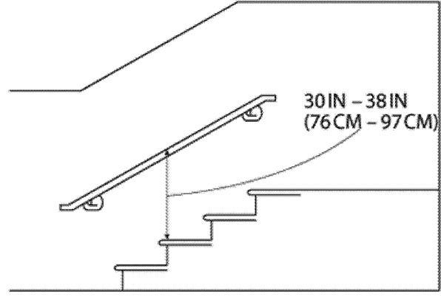
Figure D-12 - Handrail Measurement
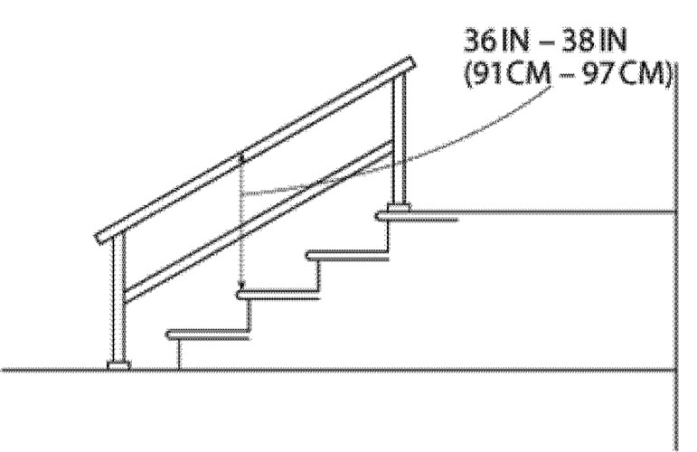
Figure D-13 - Combination Handrail and Stair Rail

(g) Cages, wells, and platforms used with fixed ladders. The employer must ensure:
(1) Cages and wells installed on fixed ladders are designed, constructed, and maintained to permit easy access to, and egress from, the ladder that they enclose (see Figures D–14 and D–15 of this section);
(2) Cages and wells are continuous throughout the length of the fixed ladder, except for access, egress, and other transfer points;
(3) Cages and wells are designed, constructed, and maintained to contain employees in the event of a fall, and to direct them to a lower landing; and
(4) Platforms used with fixed ladders provide a horizontal surface of at least 24 inches by 30 inches (61 cm by 76 cm).
Note to paragraph (g): Section 1910.28 establishes the requirements that employers must follow on the use of cages and wells as a means of fall protection.
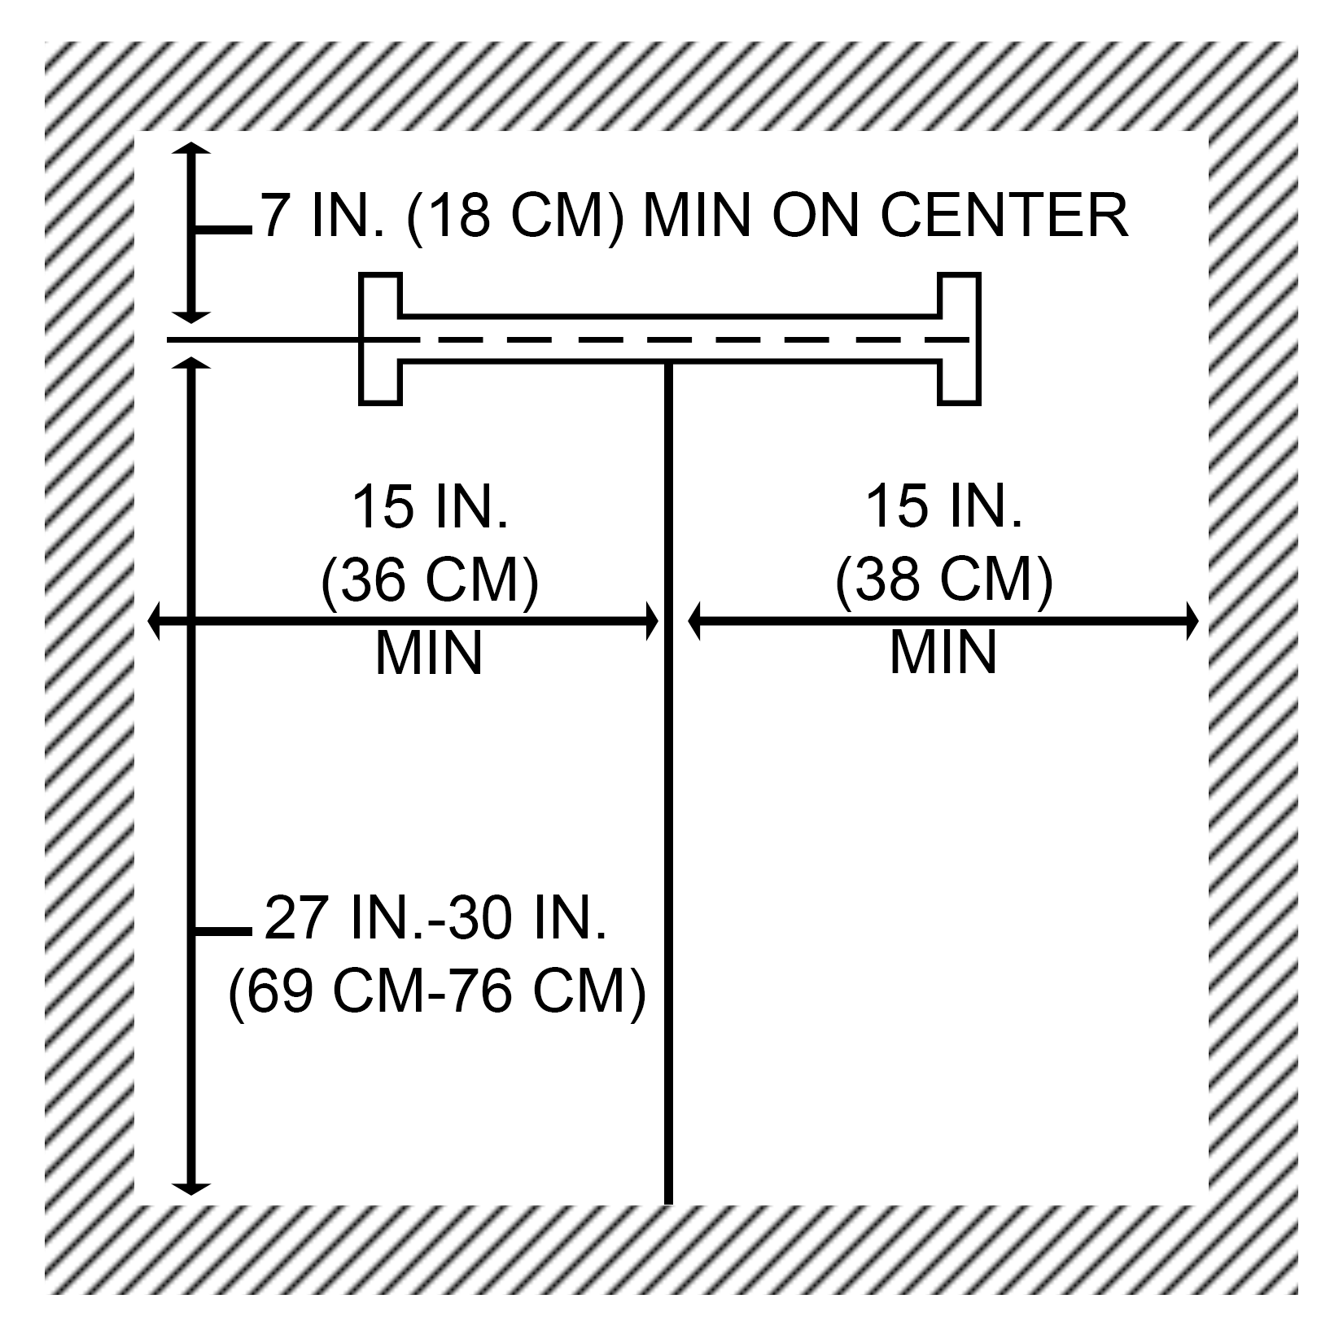
Figure D-14 - Clearances for Fixed Ladders in Wells
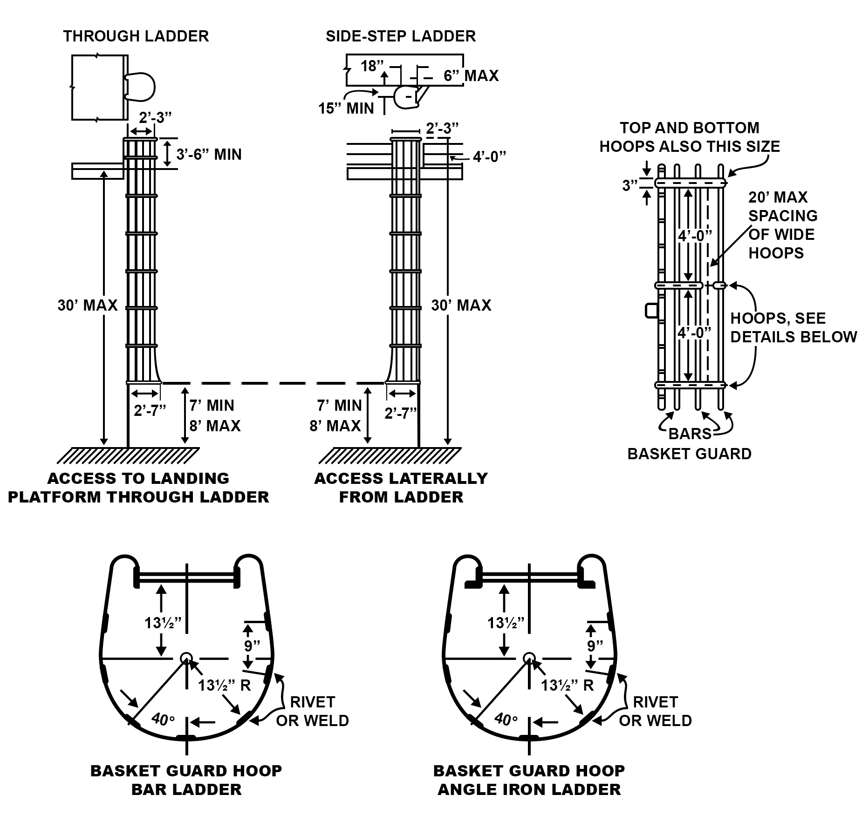
Figure D-15 - Example of General Construction of Cages

(h) Outdoor advertising. This paragraph (h) applies only to employers engaged in outdoor advertising operations (see § 1910.28(b)(10)). Employers must ensure that each employee who climbs a fixed ladder without fall protection:
(1) Is physically capable, as demonstrated through observations of actual climbing activities or by a physical examination, to perform the duties that may be assigned, including climbing fixed ladders without fall protection;
(2) Has successfully completed a training or apprenticeship program that includes hands-on training on the safe climbing of ladders and is retrained as necessary to maintain the necessary skills;
(3) Has the skill to climb ladders safely, as demonstrated through formal classroom training or on-the-job training, and performance observation; and
(4) Performs climbing duties as a part of routine work activity.
(i) Ladder safety systems. The employer must ensure:
(1) Each ladder safety system allows the employee to climb up and down using both hands and does not require that the employee continuously hold, push, or pull any part of the system while climbing;
(2) The connection between the carrier or lifeline and the point of attachment to the body harness or belt does not exceed 9 inches (23 cm);
(3) Mountings for rigid carriers are attached at each end of the carrier, with intermediate mountings spaced, as necessary, along the entire length of the carrier so the system has the strength to stop employee falls;
(4) Mountings for flexible carriers are attached at each end of the carrier and cable guides for flexible carriers are installed at least 25 feet (7.6 m) apart but not more than 40 feet (12.2 m) apart along the entire length of the carrier;
(5) The design and installation of mountings and cable guides does not reduce the design strength of the ladder; and
(6) Ladder safety systems and their support systems are capable of withstanding, without failure, a drop test consisting of an 18-inch (41-cm) drop of a 500-pound (227-kg) weight.
(j) Personal fall protection systems. Body belts, harnesses, and other components used in personal fall arrest systems, work positioning systems, and travel restraint systems must meet the requirements of §1910.140.
(k) Protection from falling objects.
(1) The employers must ensure toeboards used for falling object protection:
(i) Are erected along the exposed edge of the overhead walking-working surface for a length that is sufficient to protect employees below.
(ii) Have a minimum vertical height of 3.5 inches (9 cm) as measured from the top edge of the toeboard to the level of the walking-working surface.
(iii) Do not have more than a 0.25- inch (0.5-cm) clearance or opening above the walking-working surface.
(iv) Are solid or do not have any opening that exceeds 1 inch (3 cm) at its greatest dimension.
(v) Have a minimum height of 2.5 inches (6 cm) when used around vehicle repair, service, or assembly pits. Toeboards may be omitted around vehicle repair, service, or assembly pits when the employer can demonstrate that a toeboard would prevent access to a vehicle that is over the pit.
(vi) Are capable of withstanding, without failure, a force of at least 50 pounds (222 N) applied in any downward or outward direction at any point along the toeboard.
(2) The employer must ensure:

(i) Where tools, equipment, or materials are piled higher than the top of the toeboard, paneling or screening is installed from the toeboard to the midrail of the guardrail system and for a length that is sufficient to protect employees below. If the items are piled higher than the midrail, the employer also must install paneling or screening to the top rail and for a length that is sufficient to protect employees below; and
(ii) All openings in guardrail systems are small enough to prevent objects from falling through the opening.
(3) The employer must ensure canopies used for falling object protection are strong enough to prevent collapse and to prevent penetration by falling objects.
(l) Grab handles. The employer must ensure each grab handle:
(1) Is not less than 12 inches (30 cm) long;
(2) Is mounted to provide at least 3 inches (8 cm) of clearance from the framing or opening; and
(3) Is capable of withstanding a maximum horizontal pull-out force equal to two times the maximum intended load or 200 pounds (890 N), whichever is greater.
Stat. Auth.: ORS 654.025(2) and 656.726(4).
Stats. Implemented: ORS 654.001 through 654.295.
Hist: OR-OSHA Admin. Order 2-2017, f. 5/16/17, ef. 11/1/17.

1910.30 Training requirements
(a) Fall hazards.
(1) Before any employee is exposed to a fall hazard, the employer must provide training for each employee who uses personal fall protection systems or who is required to be trained as specified elsewhere in this subpart. Employers must ensure employees are trained in the requirements of this paragraph on or before May 17, 2017.
Note to 1910.30(a)(1): The above referenced date does not apply in Oregon. Instead, in accordance with OAR 437-002-2031(7)(a), the Oregon delayed effective date is May 1, 2018.
(2) The employer must ensure that each employee is trained by a qualified person.
(3) The employer must train each employee in at least the following topics:
(i) The nature of the fall hazards in the work area and how to recognize them;
(ii) The procedures to be followed to minimize those hazards;
(iii) The correct procedures for installing, inspecting, operating, maintaining, and disassembling the personal fall protection systems that the employee uses; and
(iv) The correct use of personal fall protection systems and equipment specified in paragraph (a)(1) of this section, including, but not limited to, proper hook-up, anchoring, and tie-off techniques, and methods of equipment inspection and storage, as specified by the manufacturer.
(b) Equipment hazards.
(1) The employer must train each employee on or before May 17, 2017 in the proper care, inspection, storage, and use of equipment covered by this subpart before an employee uses the equipment.
Note to 1910.30(b)(1): The above referenced date does not apply in Oregon. Instead, in accordance with OAR 437-002-2031(7)(b), the Oregon delayed effective date is May 1, 2018.
(2) The employer must train each employee who uses a dockboard to properly place and secure it to prevent unintentional movement.
(3) The employer must train each employee who uses a rope descent system in proper rigging and use of the equipment in accordance with § 1910.27.
Note: Oregon OSHA did not adopt 1910.27. Instead, see OAR 437-002-2027 Rope descent and rope access systems.
(4) The employer must train each employee who uses a designated area in the proper set-up and use of the area.
(c) Retraining. The employer must retrain an employee when the employer has reason to believe the employee does not have the understanding and skill required by paragraphs (a) and (b) of this section. Situations requiring retraining include, but are not limited to, the following:
(1) When changes in the workplace render previous training obsolete or inadequate;
(2) When changes in the types of fall protection systems or equipment to be used render previous training obsolete or inadequate; or
(3) When inadequacies in an affected employee’s knowledge or use of fall protection systems or equipment indicate that the employee no longer has the requisite understanding or skill necessary to use equipment or perform the job safely.
(d) Training must be understandable. The employer must provide information and training to each employee in a manner that the employee understands.

Stat. Auth.: ORS 654.025(2) and 656.726(4).
Stats. Implemented: ORS 654.001 through 654.295.
Hist: OR-OSHA Admin. Order 2-2017, f. 5/16/17, ef. 11/1/17.

437-002-2031 Delayed Effective Dates for Walking-Working Surfaces
(1) Scope and application. The delayed effective dates in this rule apply in Oregon to 1910.24, 1910.25, 1910.26, 1910.28, 1910.29 and 1910.30 within Subdivision 2/D.
(2) Step bolts and manhole steps (1910.24). The delayed federal effective dates referenced in 1910.24 do not apply in Oregon. In Oregon, the following delayed effective dates apply:
(a) 1910.24(a)(1): Replace January 17, 2017 with January 1, 2018.
(b) 1910.24(a)(6): Replace January 17, 2017 with January 1, 2018.
(c) 1910.24(a)(7): Replace January 17, 2017 with January 1, 2018.
(d) 1910.24(b)(2): Replace January 17, 2017 with January 1, 2018.
(3) Stairways (1910.25). The delayed federal effective dates referenced in 1910.25 do not apply in Oregon. In Oregon, the following delayed effective dates apply:
(a) 1910.25(b)(5)(i): Replace January 17, 2017 with January 1, 2018.
(b) 1910.25(b)(5)(ii): Replace January 17, 2017 with January 1, 2018.
(c) 1910.25(c)(5): Replace January 17, 2017 with January 1, 2018.
(4) Dockboards (1910.26). The delayed federal effective date referenced in 1910.26(b)(1) does not apply in Oregon. In Oregon, replace January 17, 2017 with January 1, 2018.
(5) Duty to have fall protection and falling object protection (1910.28). The delayed federal effective dates referenced in 1910.28 do not apply in Oregon. In Oregon, the following delayed effective dates apply:
(a) 1910.28(b)(9)(i)(A): Replace November 19, 2018 with November 1, 2019.
(b) 1910.28(b)(9)(i)(B): Replace November 19, 2018 with November 1, 2019.
(c) 1910.28(b)(9)(i)(D): Replace November 18, 2036 with December 1, 2036.
(d) 1910.28(b)(10)(ii): Replace November 19, 2018 with November 1, 2019.
(6) Fall protection systems and falling object protection – criteria and practices (1910.29). The delayed federal effective dates referenced in 1910.29 do not apply in Oregon. In Oregon, the following delayed effective dates apply:
(a) 1910.29(f)(1)(ii)(A): Replace January 17, 2017 with January 1, 2018.
(b) 1910.29(f)(1)(ii)(B): Replace January 17, 2017 with January 1, 2018.
(7) Training requirements (1910.30). The delayed federal effective dates referenced in 1910.30 do not apply in Oregon. In Oregon, the following delayed effective dates apply:
(a) 1910.30(a)(1): Replace May 17, 2017 with May 1, 2018.
(b) 1910.30(b)(1): Replace May 17, 2017 with May 1, 2018.
Stat. Auth.: ORS 654.025(2) and 656.726(4).
Stats. Implemented: ORS 654.001 through 654.295.
Hist: OR-OSHA Admin. Order 2-2017, f. 5/16/17, ef. 11/1/17.

Notes

Historical Notes for Subdivision D
Note: The following rules were adopted by OR-OSHA Admin. Order 4-1990, filed 1/23/90, EFFECTIVE 1/23/90: Subdivision D, Walking-Working Surfaces (29 CFR 1910.21 through 1910.32), Subdivision E, Means of Egress (29 CFR 1910.35 through 1910.40), and Subdivision F, Powered Platforms, Manlifts, and Vehicle-Mounted Work Platforms (29 CFR 1910.66 through 1910.70). These rules superseded OAR 437, Division 41, Buildings, Structures and Workplaces, Division 88, Ladders and Scaffolds, and specific rules in Division 56, Vehicles (OAR 437-56-005(4) through (12), and 437-56-200 through 437-56-260).
Amendments were made to Subdivisions D and F by OR-OSHA Admin. Order 2-1991, filed 2/4/91, effective 4/1/91.
Amendments were made to Subdivision D by OR-OSHA Admin. Order 6-1994, filed 9/30/94, effective 9/30/94.
Amendments were made to Subdivisions D, E and F by OR-OSHA Admin. Order 4-1997, filed 4/2/97, effective 4/2/97.

Note: Amendments were made to Subdivisions D by OR-OSHA Admin. Order 10-1999, filed 9/10/99, effective 9/10/99. Oregon OSHA repealed: OAR 437-002-1910.25, Portable Wood Ladders; 1910.26, Portable Metal Ladders; 1910.27, Fixed Ladders; portions of 1910.21, Definitions; and OAR 437-002-0025, Extension Ladders. In their place, two new rules are added to Division 2/D (general industry/walking-working surfaces): OAR 437-002-0026, Portable Ladders; and, 437-002-0027, Fixed Ladders.
These changes are necessary to update the existing standards, re-organize them into a more understandable sequence, make them compliant with ORS 183.025 that requires us to write standards in “clear language,” and to add language covering plastic (reinforced fiberglass) ladders.
We deleted old language that went into great detail about the design and construction of ladders. In its place we added a simple requirement that each type of ladder meet its respective ANSI standard.
Basic use and care requirements are grouped by type of ladder rather than the material from which it is made.
Fixed ladder requirements will change to meet the newest edition of ANSI A-14.3 which changes requirements for landing platforms, cages and climbing safety devices.

Note: Personal Protective Equipment in Construction:
Oregon OSHA is revising the personal protective equipment (PPE) sections of its construction standards regarding requirements for eye and face protective devices, head protection, foot protection, extremities and torso to include protective clothing, respiratory devices, and protective shields and barriers.
Oregon OSHA updated the Division 2, Subdivision I, Personal Protective Equipment references in its regulations on December 8, 2011.The update referenced more recent editions of applicable national consensus standards and removed requirements that employers prepare and maintain written training certification records. Oregon OSHA repealed all of Division 2/I rules with some exceptions and replaced them with a new Oregon initiated rule, 437-002-0134 Personal Protective Equipment, that includes sections covering the scope/application, hazard assessment, equipment, training, payment, fall protection, clothing, high visibility garments, and eye, head, foot, leg, hand and skin protection.
The change was mostly a format change that simplified the existing text while making little change to the overall rule requirements with a few exceptions. Oregon OSHA modified the hazard assessment requirement to clarify that employers must identify hazards to the entire body, including the torso and extremities, when performing the assessment. The assessment previously was limited to head, hands, eyes and face and foot protection.
We are removing the current PPE requirements in various locations of the construction standard and replacing them with the same requirements that are in General Industry standards of Division 2, Subdivision I. These requirements (with the exception of a written assessment certification) will be substantially similar allowing for greater consistency in construction and general Industry.
The design requirements for eye and face-protective devices, head protection, and foot protection are currently the same in Division 2 General Industry, Shipyard Employment, Marine Terminals, Longshoring, and Division 3 Construction. These revisions are a continuation of Oregon OSHA’s effort to update consensus and industry standards.
Personal Protective Equipment in General Industry:
Oregon OSHA is also amending the general industry PPE rule 437-002-0134, to include ANSI Z89.1-2009, American National Standard for Industrial Head Protection, as another option of compliance, as published in the June 22, 2012 Federal Register. http://www.osha.gov/FedReg_osha_pdf/FED20120622A.pdf
Hole Openings (including skylights) in General Industry:
Oregon OSHA is also changing the hole covering requirements for holes in floors, roofs, and other walking/working surfaces (to include skylights and skylight screens). Currently employers in construction and general industry have different hole cover strength criteria. To eliminate the confusion and inconsistency, Oregon OSHA is changing the general industry requirements to be the same as the construction requirements as referenced in the Federal OSHA proposal for walking working surfaces and personal protective equipment (fall protection) found in the May 24. 2010 Federal Register http://www.osha.gov/FedReg_osha_pdf/FED20100524.pdf .
This is Oregon OSHA Administrative Order 2-2013, adopted February 15, 2013, and effective April 1, 2013.

Note: On February 24, 2017 Oregon OSHA proposed to revise the existing walking-working surface and personal protective equipment rules for general industry. This proposal was required to harmonize Oregon OSHA’s existing Division 2 regulations with the new Federal OSHA’s rule titled: “Walking-Working Surfaces and Personal Protective Equipment (Fall Protection Systems)” as published in the Federal Register on November 18, 2016. Federal OSHA’s general industry final rule revised the previous walking-working surfaces standards within 29 CFR part 1910, subpart D and created a new standard and two new non-mandatory appendixes for fall protection systems within 29 CFR part 1910, subpart I. In addition to the significant changes made to Subparts D and I, federal OSHA also amended standards in 29 CFR part 1910, subparts F, N, and R to create uniformity across all of the affected subparts where walking-working surfaces and personal fall protection systems are addressed. Oregon OSHA’s proposal made significant revisions to Subdivision 2/D (Walking-Working Surfaces) and Subdivision 2/I (Personal Protective Equipment) of Chapter 437, Division 2 including a proposal for rope access systems. Subsequently, since many existing Oregon OSHA regulations are based on those within 2/D and 2/I, the following Division 2 subdivisions also were amended in the February 24th proposal: 2/A, 2/F, 2/L, 2/N, 2/R, and 2/RR.
Four public hearings were held during March and April of 2017. Oregon OSHA received oral testimony at three of the public hearings in addition to written comments. Several comments received supported the overall rule making. Several comments opposed specific sections of the overall rulemaking. Major topics Oregon OSHA received comment on were; impacts of limiting acceptable standard guardrail heights to 42 inches +/- 3 inches, use of body belts in travel restraint systems, inspection of permanent mount lifeline systems, fall protection for fixed ladders and the associated inspections, duty to have fall protection when exposed to unprotected sides and edges, duty to have fall protection while exposed to walking-working surfaces not otherwise addressed by proposed 1910.28(b), and rope descent/access systems.
Oregon OSHA considered all comments received. Oregon OSHA, based on comments received, made adjustments to proposed 437-002-2027 Rope Descent & Rope Access Systems. Changes include separating the rules for rope descent from those for rope access with the exception of anchorages which both systems share in the final rule. Furthermore, the rope descent portion of the rule is no longer the foundation for the rope access portion. The proposed “assessment of need” for rope access work was removed, a rope access program administrator was added, a section listing minimum capacity requirements for rope access specific equipment was added, and a section establishing exceptions to 1910.140 Fall Protection was added when rope access work is conducted. Finally, Oregon OSHA added language to Division 2/I (Personal Protective Equipment) to permit general industry employers to use anchorages for travel restraint systems that meet the same capacity requirements previous afforded to construction employers in the construction regulations (Division 3/M).
This is OR-OSHA Administrative Order 2-2017, adopted May 16, 2017 and effective November 1, 2017.

List of Figures for Subdivision D
Figure D-1 - Portable Ladder Set-up 14
Figure D-2 - Side-Step Fixed Ladder Sections 15
Figure D-3 - Example of Counterbalanced Hatch Cover at Roof 16
Figure D-4 - Individual Rung Ladder 17
Figure D-5 - Fixed Ladder Clearances 18
Figure D-6 - Step Bolt Spacing 23
Figure D-7 - Door or Gate Opening on Stairway 26
Figure D-8 - Dimensions of Standard Stairs 27
Figure D-9 - Ship Stairs 29
Figure D-11 - Guard Rail Systems 49
Figure D-12 - Handrail Measurement 54
Figure D-13 - Combination Handrail and Stair Rail 54
Figure D-14 - Clearances for Fixed Ladders in Wells 55
Figure D-15 - Example of General Construction of Cages 56

List of Tables for Subdivision D
Table D-1 - Stairway Rise and Tread Dimensions 28
Table D-2 - Stairway Handrail Requirements 46

