OREGON OCCUPATIONAL

SAFETY AND HEALTH STANDARDS

Oregon Administrative Rules, Chapter 437

DIVISION 3 (29 CFR 1926)
CONSTRUCTION

CONSTRUCTION

Subdivision L
Scaffolding

Oregon Occupational Safety and Health Division (Oregon OSHA)
Department of Consumer and Business Services
Salem, Oregon 97301-3882

AO 1-2011
The Oregon Department of Consumer and Business Services adopted these rules pursuant to ORS
654.025(2).

The Secretary of State Designated OAR Chapter 437 as the “Oregon Occupational Safety and Health Code.”
Six general subject areas within this code are designated as “Divisions.”

- Division 1 General Administrative Rules
- Division 2 General Occupational Safety and Health Rules
- Division 3 Construction
- Division 4 Agriculture
- Division 5 Maritime Activities
- Division 7 Forest Activities
- Oregon Revised Statutes (ORS) 654 The Oregon Safe Employment Act (OSEAct)
Oregon-initiated rules in this division of the Oregon Occupational Safety and Health Code are numbered in a uniform system developed by the Secretary of State. This system does not number the rules in sequence (001, 002, 003, etc.). Omitted numbers may be assigned to new rules at the time of their adoption.

Oregon-initiated rules are arranged in the following Basic Codification Structure adopted by the Secretary of
State for Oregon Administrative Rules (OAR):

Chapter Division Rule Section Subsection Paragraphs
437 003 1760 (1) (a) (A)(i)(I)

The majority of Oregon OSHA codes are adopted by reference from the Code of Federal Regulations (CFR),
and are arranged in the following basic federal numbering system:

Chapter Division Part Subpart Section Paragraphs
(Subdivision)
437 003 1926 M .502 (a)

The terms “subdivision” and “subpart” are synonymous within OAR 437, Oregon Occupational Safety and
Health Code.

To obtain an order form or copies of these codes, address:

Department of Consumer & Business Services
Oregon Occupational Safety & Health Division (Oregon OSHA)
350 Winter St. NE, Room 430
Salem, OR 97301-3882

Or call the Oregon OSHA Resource Library at 503-378-3272

The rules referenced in this division are available for viewing in the Office of the Secretary of State, Administrative Rules and Office Document Section, Oregon State Archives Building, Salem, Oregon 97310,
or the Central Office, Oregon Occupational Safety and Health Division of the Department of Consumer and Business Services, Room 430, 350 Winter St. NE Salem, OR 97301-3882. Please visit our web site at: www.orosha.org
TABLE OF CONTENTS

1926.450 Scope, application and definitions applicable to this subpart L-1
1926.451 General requirements L-9
1926.452 Additional requirements applicable to specific types of scaffolds L-27
1926.453 Aerial lifts L-39
437-003-0071 Manually propelled elevating aerial platforms L-41
437-003-0073 Boom supported elevating work platforms L-42
437-003-0074 Scissor lifts – self-propelled elevating work platforms L-42
1926.454 Training requirements L-43
Non-Mandatory Appendix A to Subpart L – Scaffold specifications L-45
Non-Mandatory Appendix B to Subpart L – Criteria for determining the feasibility of providing safe access and fall protection for scaffold erectors and dismantlers (Reserved) L-57
Non-Mandatory Appendix C to Subpart L – List of National Consensus Standards L-57
Non-Mandatory Appendix D to Subpart L – List of training topics for scaffold erectors and dismantlers L-59
Non-Mandatory Appendix E to Subpart L – Drawings and illustrations L-61

OAR 437, DIVISION 3

CONSTRUCTION

SUBDIVISION L – SCAFFOLDING

437-003-0001 Adoption by Reference. In addition to, and not in lieu of, any other safety and health codes contained in OAR Chapter 437, the Department adopts by reference the following federal regulations printed as part of the Code of Federal Regulations, in the Federal Register:

(12 Subdivision L – Scaffolding.
(a) 29 CFR 1926.450 Scope, application and definitions applicable to this subpart, published 8/9/10, FR vol. 75, no. 152, pp. 47906-48177.
(b) 29 CFR 1926.451 General requirements, published 11/25/96, FR vol. 61, no. 228, p. 59831.
(c) 29 CFR 1926.452 Additional requirements applicable to specific types of scaffolds, published 8/30/96, FR vol. 61, no. 170, p. 46113.
(d) 29 CFR 1926.453 Aerial lifts, published 11/25/96, FR vol. 61, no. 228, p. 59832.
(e) 29 CFR 1926.454 Training, published 8/30/96, FR vol. 61, no. 170, p. 46117.
(f) Appendix A to Subpart L Scaffold Specifications, published 8/30/96, FR vol. 61, no. 170, p. 46117.
(g) Appendix B to Subpart L Criteria for determining the feasibility of providing safe access and fall protection for scaffold erectors and dismantlers (Reserved), published 8/30/96, FR vol. 61, no. 170, p. 46122.
(h) Appendix C to Subpart L List of National Consensus Standards, published 8/30/96, FR vol. 61, no. 170, p. 46122.
(i) Appendix D to Subpart L List of training topics for scaffold erectors and dismantlers, published 8/30/96, FR vol. 61, no. 170, p. 46122.
(j) Appendix E to Subpart L Drawing and illustrations, published 11/25/96, FR vol. 61, no. 228, p. 59832.

These standards are available at the Oregon Occupational Safety and Health Division, Oregon Department of Consumer and Business Services, and the United States Government Printing Office.

Stat. Auth.: ORS 654.025(2) and 656.726(4).
Stats. Implemented: ORS 654.001 through 654.295.
Hist: APD Admin. Order 5-1989, f. 3/31/89, ef. 5/1/89 (temp).
APD Admin. Order 8-1989, f. 7/7/89, ef. 7/7/89 (perm).
APD Admin. Order 14-1989, f. 7/20/89, ef. 8/1/89 (temp).
APD Admin. Order 15-1989, f. 9/13/89, ef. 9/13/89 (perm).
APD Admin. Order 16-1989 (temp), f. 9/13/89, ef. 9/13/89.
OR-OSHA Admin. Order 2-1989, f. 10/17/89, ef. 10/17/89.
OR-OSHA Admin. Order 3-1990, f. 1/19/90, ef. 1/19/90 (temp).
OR-OSHA Admin. Order 7-1990, f. 3/2/90, ef. 3/2/90 (perm).
OR-OSHA Admin. Order 8-1990, f. 3/30/90, ef. 3/30/90.
OR-OSHA Admin. Order 13-1990, f. 6/28/90, ef. 8/1/90 (temp).
OR-OSHA Admin. Order 19-1990, f. 8/31/90, ef. 8/31/90 (perm).
OR-OSHA Admin. Order 27-1990, f. 12/12/90, ef. 2/1/91.
OR-OSHA Admin. Order 6-1991, f. 3/18/91, ef. 4/15/91.
OR-OSHA Admin. Order 7-1991, f. 4/25/91, ef. 4/25/91.
OR-OSHA Admin. Order 15-1991, f. 12/13/91, ef. 12/13/91.
OR-OSHA Admin. Order 16-1991, f. 12/16/91, ef. 1/1/92.
OR-OSHA Admin. Order 6-1992, f. 5/18/92, ef. 5/18/92.
OR-OSHA Admin. Order 11-1992, f. 10/9/92, ef. 10/9/92.
OR-OSHA Admin. Order 1-1993, f. 1/22/93, ef. 1/22/93.
OR-OSHA Admin. Order 16-1993, f. 11/1/93, ef. 11/1/93 (Lead).
OR-OSHA Admin. Order 1-1994, f. 4/27/94, ef. 4/27/94.
OR-OSHA Admin. Order 4-1994, f. 8/4/94, ef. 8/4/94 (HazCom).
OR-OSHA Admin. Order 6-1994, f. 9/30/94, ef. 9/30/94.
OR-OSHA Admin. Order 1-1995, f. 1/19/95, ef. 1/19/95 (DOT markings, placards & labels).
OR-OSHA Admin. Order 3-1995, f. 2/22/95, ef. 2/22/95 (Haz Waste).
OR-OSHA Admin. Order 4-1995, f. 3/29/95, ef. 3/29/95 (Asbestos).
OR-OSHA Admin. Order 5-1995, f. 4/6/95, ef. 4/6/95 (HazCom).
OR-OSHA Admin. Order 6-1995, f. 4/18/95, ef. 6/1/95 (Fall Protection).
OR-OSHA Admin. Order 8-1995, f. 8/25/95, ef. 8/25/95 (Asbestos).
OR-OSHA Admin. Order 5-1996, f. 11/29/96, ef. 11/29/96.
OR-OSHA Admin. Order 6-1996, f. 11/29/96, ef. 11/29/96.
OR-OSHA Admin. Order 2-1997, f. 3/12/97, ef. 3/12/97.
OR-OSHA Admin. Order 4-1997, f. 4/2/97, ef. 4/2/97.
OR-OSHA Admin. Order 6-1997, f. 5/2/97, ef. 5/2/97.
OR-OSHA Admin. Order 7-1997, f. 9/15/97, ef. 9/15/97 (Fall Protection).
OR-OSHA Admin. Order 8-1997, f. 11/14/97, e. 11/14/97 (Methylene Chloride).
OR-OSHA Admin. Order 1-1998, f. 2/13/98, e. 2/13/98 (Methylene Chloride).
OR-OSHA Admin. Order 3-1998, f. 7/7/98, ef. 7/7/98 (Respiratory Protection).
OR-OSHA Admin. Order 6-1998, f. 10/15/98, ef. 10/15/98 (Slings 3/H).
OR-OSHA Admin. Order 7-1998, f. 12/28/98, ef. 12/28/98 (Asbestos).
OR-OSHA Admin. Order 1-1999, f. 3/22/99, e. 3/22/99 (Methylene Chloride).
OR-OSHA Admin. Order 4-1999, f. 4/30/99, ef. 4/30/99.
OR-OSHA Admin. Order 6-1999, f. 5/26/99, ef. 5/26/99.
OR-OSHA Admin. Order 3-2000, f. 2/8/00, ef. 2/8/00.
OR-OSHA Admin. Order 3-2001, f. 2/5/01, ef. 2/5/01 (Fall Protection/Oregon Exceptions).
OR-OSHA Admin. Order 3-2002, f. 4/15/02, ef. 4/18/02 (Steel Erection).
OR-OSHA Admin. Order 5-2002, f. 6/28/02, ef. 10/1/03 (GFCI 3/K).
OR-OSHA Admin. Order 6-2002, f. 7/19/02, ef. 7/19/02 (Fall Protection/Steel Erection).
OR-OSHA Admin. Order 1-2003, f. 1/30/03, ef. 4/30/03 (3/Q Masonry Wall Bracing).
OR-OSHA Admin. Order 2-2003, f. 1/30/03, ef. 1/30/03 (3/G).
OR-OSHA Admin. Order 7-2003, f. 12/5/03, ef. 12/5/03 (3/O).
OR-OSHA Admin. Order 8-2003, f. 12/30/03, ef. 1/1/04 (3/R).
OR-OSHA Admin. Order 1-2005, f. 4/12/05, ef. 4/12/05 (3/D and 3/Z).
OR-OSHA Admin. Order 2-2006, f. 4/28/06, ef. 4/28/06 (3/R).
OR-OSHA Admin. Order 4-2006, f. 7/24/06, ef. 7/24/06.
OR-OSHA Admin. Order 5-2006, f. 8/7/06, ef. 1/1/07.
OR-OSHA Admin. Order 6-2006, f. 8/30/06, ef. 8/30/06.
OR-OSHA Admin. Order 10-2006, f. 11/30/06, ef. 11/30/06.
OR-OSHA Admin. Order 6-2007, f. 9/26/07, ef. 9/26/07 (3/O).
OR-OSHA Admin. Order 5-2008, f. 5/1/08, ef. 5/15/08 (PPE).
OR-OSHA Admin. Order 5-2009, f. 5/29/09, ef. 5/29/09.
OR-OSHA Admin. Order 3-2010, f. 6/10/10, ef. 6/15/10.
OR-OSHA Admin. Order 1-2011, f. 2/9/11, ef. 2/9/11.
OR-OSHA Admin. Order 4-2011, f. 12/8/11, ef. 12/8/11.
OR-OSHA Admin. Order 5-2011, f. 12/8/11, ef. 7/1/12.
OR-OSHA Admin. Order 1-2012, f. 4/10/12, ef. 4/10/12.
OR-OSHA Admin. Order 5-2012, f. 9/25/12, ef. 9/25/12.
OR-OSHA Admin. Order 1-2013, f. 2/14/13, ef. 2/14/13.
OR-OSHA Admin. Order 2-2013, f. 2/15/13, ef. 4/1/13.
OR-OSHA Admin. Order 4-2013, f. 7/19/13, ef. 7/19/13.
OR-OSHA Admin. Order 5-2013, f. 9/13/13, ef. 9/13/13.
OR-OSHA Admin. Order 6-2013, f. 10/9/13, ef. 10/9/13.
OR-OSHA Admin. Order 7-2013, f. 12/12/13, ef. 12/12/13.
OR-OSHA Admin. Order 6-2014, f. 10/28/14, ef. 5/1/15.
OR-OSHA Admin. Order 7-2014, f. 11/7/14, ef. 11/9/14.

SUBDIVISION L

SCAFFOLDING

Authority: Sec. 107, Contract Work Hours and Safety Standards Act (Construction Safety Act) (40 U.S.C. 333); Sections 4, 6, 8, Occupational Safety and Health Act of 1970 (29 U.S.C. 653, 655, 657); Secretary of Labor’s Order No. 1-90 (55 FR 9033) and 5-2007 (72 FR 31159) and 29 CFR part 1911.

§1926.450 Scope, Application and Definitions Applicable to this Subpart.

(a) Scope and application. This subpart applies to all scaffolds used in workplaces covered by this part. It does not apply to crane or derrick suspended personnel platforms. The criteria for aerial lifts are set out exclusively in §1926.453.
(b) Definitions.
Adjustable suspension scaffold means a suspension scaffold equipped with a hoist(s) that can be operated by an employee(s) on the scaffold.
Bearer (putlog) means a horizontal transverse scaffold member (which may be supported by ledgers or runners) upon which the scaffold platform rests and which joins scaffold uprights, posts, poles, and similar members.
Boatswains’ chair means a single-point adjustable suspension scaffold consisting of a seat or sling designed to support one employee in a sitting position.
Body belt (safety belt) means a strap with means both for securing it about the waist and for attaching it to a lanyard, lifeline, or deceleration device.
Body harness means a design of straps which may be secured about the employee in a manner to distribute the fall arrest forces over at least the thighs, pelvis, waist, chest and shoulders, with means for attaching it to other components of a personal fall arrest system.
Brace means a rigid connection that holds one scaffold member in a fixed position with respect to another member, or to a building or structure.
Bricklayers’ square scaffold means a supported scaffold composed of framed squares which support a platform.
Carpenters’ bracket scaffold means a supported scaffold consisting of a platform supported by brackets attached to building or structural walls.
Catenary scaffold means a suspension scaffold consisting of a platform supported by two essentially horizontal and parallel ropes attached to structural members of a building or other structure. Additional support may be provided by vertical pickups.
Chimney hoist means a multi-point adjustable suspension scaffold used to provide access to work inside chimneys. (See “Multi-point adjustable suspension scaffold”.)
Cleat means a structural block used at the end of a platform to prevent the platform from slipping off its supports. Cleats are also used to provide footing on sloped surfaces such as crawling boards.
Competent person means one who is capable of identifying existing and predictable hazards in the surroundings or working conditions which are unsanitary, hazardous, or dangerous to employees, and who has authorization to take prompt corrective measures to eliminate them.
Continuous run scaffold (Run scaffold) means a two-point or multi-point adjustable suspension scaffold constructed using a series of interconnected braced scaffold members or supporting structures erected to form a continuous scaffold.
Coupler means a device for locking together the tubes of a tube and coupler scaffold.
Crawling board (chicken ladder) means a supported scaffold consisting of a plank with cleats spaced and secured to provide footing, for use on sloped surfaces such as roofs.
Deceleration device means any mechanism, such as a rope grab, rip-stitch lanyard, specially-oven lanyard, tearing or deforming lanyard, or automatic self-retracting lifeline lanyard, which dissipates a substantial amount of energy during a fall arrest or limits the energy imposed on an employee during fall arrest.
Double pole (independent pole) scaffold means a supported scaffold consisting of a platform(s) resting on cross beams (bearers) supported by ledgers and a double row of uprights independent of support (except ties, guys, braces) from any structure.
Equivalent means alternative designs, materials or methods to protect against a hazard which the employer can demonstrate will provide an equal or greater degree of safety for employees than the methods, materials or designs specified in the standard.
Exposed power lines means electrical power lines which are accessible to employees and which are not shielded from contact. Such lines do not include extension cords or power tool cords.
Eye or Eye splice means a loop with or without a thimble at the end of a wire rope.
Fabricated decking and planking means manufactured platforms made of wood (including laminated wood, and solid sawn wood planks), metal or other materials.
Fabricated frame scaffold (tubular welded frame scaffold) means a scaffold consisting of a platform(s) supported on fabricated end frames with integral posts, horizontal bearers, and intermediate members.
Failure means load refusal, breakage, or separation of component parts. Load refusal is the point where the ultimate strength is exceeded.
Float (ship) scaffold means a suspension scaffold consisting of a braced platform resting on two parallel bearers and hung from overhead supports by ropes of fixed length.
Form scaffold means a supported scaffold consisting of a platform supported by brackets attached to formwork.
Guardrail system means a vertical barrier, consisting of, but not limited to, toprails, midrails, and posts, erected to prevent employees from falling off a scaffold platform or walkway to lower levels.
Hoist means a manual or power-operated mechanical device to raise or lower a suspended scaffold.
Horse scaffold means a supported scaffold consisting of a platform supported by construction horses (saw horses). Horse scaffolds constructed of metal are sometimes known as trestle scaffolds.
Independent pole scaffold (see “Double pole scaffold”).
Interior hung scaffold means a suspension scaffold consisting of a platform suspended from the ceiling or roof structure by fixed length supports.
Ladder jack scaffold means a supported scaffold consisting of a platform resting on brackets attached to ladders.
Ladder stand means a mobile, fixed-size, self-supporting ladder consisting of a wide flat tread ladder in the form of stairs.
Landing means a platform at the end of a flight of stairs.
Large area scaffold means a pole scaffold, tube and coupler scaffold, systems scaffold, or fabricated frame scaffold erected over substantially the entire work area. For example: a scaffold erected over the entire floor area of a room.
Lean-to scaffold means a supported scaffold which is kept erect by tilting it toward and resting it against a building or structure.
Lifeline means a component consisting of a flexible line that connects to an anchorage at one end to hang vertically (vertical lifeline), or that connects to anchorages at both ends to stretch horizontally (horizontal lifeline), and which serves as a means for connecting other components of a personal fall arrest system to the anchorage.
Lower levels means areas below the level where the employee is located and to which an employee can fall. Such areas include, but are not limited to, ground levels, floors, roofs, ramps, runways, excavations, pits, tanks, materials, water, and equipment.
Masons’ adjustable supported scaffold (see “Self-contained adjustable scaffold”).
Masons’ multi-point adjustable suspension scaffold means a continuous run suspension scaffold designed and used for masonry operations.
Maximum intended load means the total load of all persons, equipment, tools, materials, transmitted loads, and other loads reasonably anticipated to be applied to a scaffold or scaffold component at any one time.
Mobile scaffold means a powered or unpowered, portable, caster or wheel-mounted supported scaffold.
Multi-level suspended scaffold means a two-point or multi-point adjustable suspension scaffold with a series of platforms at various levels resting on common stirrups.
Multi-point adjustable suspension scaffold means a suspension scaffold consisting of a platform(s) which is suspended by more than two ropes from overhead supports and equipped with means to raise and lower the platform to desired work levels. Such scaffolds include chimney hoists.
Needle beam scaffold means a platform suspended from needle beams.
Open sides and ends means the edges of a platform that are more than 14 inches (36 cm) away horizontally from a sturdy, continuous, vertical surface (such as a building wall) or a sturdy, continuous horizontal surface (such as a floor), or a point of access. Exception: For plastering and lathing operations the horizontal threshold distance is 18 inches (46 cm).
Outrigger means the structural member of a supported scaffold used to increase the base width of a scaffold in order to provide support for and increased stability of the scaffold.
Outrigger beam (Thrustout) means the structural member of a suspension scaffold or outrigger scaffold which provides support for the scaffold by extending the scaffold point of attachment to a point out and away from the structure or building.
Outrigger scaffold means a supported scaffold consisting of a platform resting on outrigger beams (thrustouts) projecting beyond the wall or face of the building or structure, the inboard ends of which are secured inside the building or structure.
Overhand bricklaying means the process of laying bricks and masonry units such that the surface of the wall to be jointed is on the opposite side of the wall from the mason, requiring the mason to lean over the wall to complete the work. It includes mason tending and electrical installation incorporated into the brick wall during the overhand bricklaying process.
Personal fall arrest system means a system used to arrest an employee’s fall. It consists of an anchorage, connectors, a body belt or body harness and may include a lanyard, deceleration device, lifeline, or combinations of these.
Platform means a work surface elevated above lower levels. Platforms can be constructed using individual wood planks, fabricated planks, fabricated decks, and fabricated platforms.
Pole scaffold (see definitions for “Single-pole scaffold” and “Double (independent) pole scaffold”).
Power operated hoist means a hoist which is powered by other than human energy.
Pump jack scaffold means a supported scaffold consisting of a platform supported by vertical poles and movable support brackets.
Qualified means one who, by possession of a recognized degree, certificate, or professional standing, or who by extensive knowledge, training, and experience, has successfully demonstrated his/her ability to solve or resolve problems related to the subject matter, the work, or the project.
Rated load means the manufacturer’s specified maximum load to be lifted by a hoist or to be applied to a scaffold or scaffold component.
Repair bracket scaffold means a supported scaffold consisting of a platform supported by brackets which are secured in place around the circumference or perimeter of a chimney, stack, tank or other supporting structure by one or more wire ropes placed around the supporting structure.
Roof bracket scaffold means a rooftop supported scaffold consisting of a platform resting on angular-shaped supports.
Runner (ledger or ribbon) means the lengthwise horizontal spacing or bracing member which may support the bearers.
Scaffold means any temporary elevated platform (supported or suspended) and its supporting structure (including points of anchorage), used for supporting employees or materials or both.
Self-contained adjustable scaffold means a combination supported and suspension scaffold consisting of an adjustable platform(s) mounted on an independent supporting frame(s) not a part of the object being worked on, and which is equipped with a means to permit the raising and lowering of the platform(s). Such systems include rolling roof rigs, rolling outrigger systems, and some masons’ adjustable supported scaffolds.
Shore scaffold means a supported scaffold which is placed against a building or structure and held in place with props.
Single-point adjustable suspension scaffold means a suspension scaffold consisting of a platform suspended by one rope from an overhead support and equipped with means to permit the movement of the platform to desired work levels.
Single-pole scaffold means a supported scaffold consisting of a platform(s) resting on bearers, the outside ends of which are supported on runners secured to a single row of posts or uprights, and the inner ends of which are supported on or in a structure or building wall.
Stair tower (Scaffold stairway/tower) means a tower comprised of scaffold components and which contains internal stairway units and rest platforms. These towers are used to provide access to scaffold platforms and other elevated points such as floors and roofs.
Stall load means the load at which the prime-mover of a power-operated hoist stalls or the power to the prime-mover is automatically disconnected.
Step, platform, and trestle ladder scaffold means a platform resting directly on the rungs of step ladders or trestle ladders.
Stilts means a pair of poles or similar supports with raised footrests, used to permit walking above the ground or working surface.
Stonesetters’ multi-point adjustable suspension scaffold means a continuous run suspension scaffold designed and used for stonesetters' operations.
Supported scaffold means one or more platforms supported by outrigger beams, brackets, poles, legs, uprights, posts, frames, or similar rigid support.
Suspension scaffold means one or more platforms suspended by ropes or other non-rigid means from an overhead structure(s).
System scaffold means a scaffold consisting of posts with fixed connection points that accept runners, bearers, and diagonals that can be interconnected at predetermined levels.
Tank builders’ scaffold means a supported scaffold consisting of a platform resting on brackets that are either directly attached to a cylindrical tank or attached to devices that are attached to such a tank.
Top plate bracket scaffold means a scaffold supported by brackets that hook over or are attached to the top of a wall. This type of scaffold is similar to carpenters’ bracket scaffolds and form scaffolds and is used in residential construction for setting trusses.
Tube and coupler scaffold means a supported or suspended scaffold consisting of a platform(s) supported by tubing, erected with coupling devices connecting uprights, braces, bearers, and runners.
Tubular welded frame scaffold (see “Fabricated frame scaffold”).
Two-point suspension scaffold (swing stage) means a suspension scaffold consisting of a platform supported by hangers (stirrups) suspended by two ropes from overhead supports and equipped with means to permit the raising and lowering of the platform to desired work levels.
Unstable objects means items whose strength, configuration, or lack of stability may allow them to become dislocated and shift and therefore may not properly support the loads imposed on them. Unstable objects do not constitute a safe base support for scaffolds, platforms, or employees. Examples include, but are not limited to, barrels, boxes, loose brick, and concrete blocks.
Vertical pickup means a rope used to support the horizontal rope in catenary scaffolds.
Walkway means a portion of a scaffold platform used only for access and not as a work level.
Window jack scaffold means a platform resting on a bracket or jack which projects through a window opening.
Stat. Auth.: ORS 654.025(2) and 656.726(4).
Stats. Implemented: ORS 654.001 to 654.295.
Hist: OR-OSHA Admin. Order 2-1997, f. 3/12/97, ef. 3/12/97.
OR-OSHA Admin. Order 1-2011, f. 2/9/11, ef. 2/9/11.

§1926.451 General Requirements.

This section does not apply to aerial lifts, the criteria for which are set out exclusively in §1926.453.

- Capacity.
  - Except as provided in paragraphs (a)(2), (a)(3), (a)(4), (a)(5) and (g) of this section, each scaffold and scaffold component shall be capable of supporting, without failure, its own weight and at least 4 times the maximum intended load applied or transmitted to it.
  - Direct connections to roofs and floors, and counterweights used to balance adjustable suspension scaffolds, shall be capable of resisting at least 4 times the tipping moment imposed by the scaffold operating at the rated load of the hoist, or 1.5 (minimum) times the tipping moment imposed by the scaffold operating at the stall load of the hoist, whichever is greater.
  - Each suspension rope, including connecting hardware, used on non-adjustable suspension scaffolds shall be capable of supporting, without failure, at least 6 times the maximum intended load applied or transmitted to that rope.
  - Each suspension rope, including connecting hardware, used on adjustable suspension scaffolds shall be capable of supporting, without failure, at least 6 times the maximum intended load applied or transmitted to that rope with the scaffold operating at either the rated load of the hoist, or 2 (minimum) times the stall load of the hoist, whichever is greater.
  - The stall load of any scaffold hoist shall not exceed 3 times its rated load.
  - Scaffolds shall be designed by a qualified person and shall be constructed and loaded in accordance with that design. Non-mandatory Appendix A to this subpart contains examples of criteria that will enable an employer to comply with paragraph (a) of this section.
- Scaffold platform construction.
  - Each platform on all working levels of scaffolds shall be fully planked or decked between the front uprights and the guardrail supports as follows:
    - Each platform unit (e.g., scaffold plank, fabricated plank, fabricated deck, or fabricated platform) shall be installed so that the space between adjacent units and the space between the platform and the uprights is no more than 1 inch (2.5 cm) wide, except where the employer can demonstrate that a wider space is necessary (for example, to fit around uprights when side brackets are used to extend the width of the platform).
    - Where the employer makes the demonstration provided for in paragraph (b)(1)(i) of this section, the platform shall be planked or decked as fully as possible and the remaining open space between the platform and the uprights shall not exceed 9 1/2 inches (24.1 cm).
Exception to paragraph (b)(1): The requirement in paragraph (b)(1) to provide full planking or decking does not apply to platforms used solely as walkways or solely by employees performing scaffold erection or dismantling. In these situations, only the planking that the employer establishes is necessary to provide safe working conditions is required.
  - Except as provided in paragraphs (b)(2)(i) and (b)(2)(ii) of this section, each scaffold platform and walkway shall be at least 18 inches (46 cm) wide.
    - Each ladder jack scaffold, top plate bracket scaffold, roof bracket scaffold, and pump jack scaffold shall be at least 12 inches (30 cm) wide. There is no minimum width requirement for boatswains' chairs.
Note to paragraph (b)(2)(i): pursuant to an administrative stay effective November 29, 1996 and published in the Federal Register on November 25, 1996, the requirement in paragraph (b)(2)(i) that roof bracket scaffolds be at least 12 inches wide is stayed until November 25, 1997 or until rulemaking regarding the minimum width of roof bracket scaffolds has been completed, whichever is later.
    - Where scaffolds must be used in areas that the employer can demonstrate are so narrow that platforms and walkways cannot be at least 18 inches (46 cm) wide, such platforms and walkways shall be as wide as feasible, and employees on those platforms and walkways shall be protected from fall hazards by the use of guardrails and/or personal fall arrest systems.
  - Except as provided in paragraphs (b)(3)(i) and (ii) of this section, the front edge of all platforms shall not be more than 14 inches (36 cm) from the face of the work, unless guardrail systems are erected along the front edge and/or personal fall arrest systems are used in accordance with paragraph (g) of this section to protect employees from falling.
    - The maximum distance from the face for outrigger scaffolds shall be 3 inches (8 cm);
    - The maximum distance from the face for plastering and lathing operations shall be 18 inches (46 cm).
  - Each end of a platform, unless cleated or otherwise restrained by hooks or equivalent means, shall extend over the centerline of its support at least 6 inches (15 cm).

    - Each end of a platform 10 feet or less in length shall not extend over its support more than 12 inches (30 cm) unless the platform is designed and installed so that the cantilevered portion of the platform is able to support employees and/or materials without tipping, or has guardrails which block employee access to the cantilevered end.
    - Each platform greater than 10 feet in length shall not extend over its support more than 18 inches (46 cm), unless it is designed and installed so that the cantilevered portion of the platform is able to support employees without tipping, or has guardrails which block employee access to the cantilevered end.
  - On scaffolds where scaffold planks are abutted to create a long platform, each abutted end shall rest on a separate support surface. This provision does not preclude the use of common support members, such as “T” sections, to support abutting planks, or hook on platforms designed to rest on common supports.
  - On scaffolds where platforms are overlapped to create a long platform, the overlap shall occur only over supports, and shall not be less than 12 inches (30 cm) unless the platforms are nailed together or otherwise restrained to prevent movement.
  - At all points of a scaffold where the platform changes direction, such as turning a corner, any platform that rests on a bearer at an angle other than a right angle shall be laid first, and platforms which rest at right angles over the same bearer shall be laid second, on top of the first platform.
  - Wood platforms shall not be covered with opaque finishes, except that platform edges may be covered or marked for identification. Platforms may be coated periodically with wood preservatives, fire-retardant finishes, and slip-resistant finishes; however, the coating may not obscure the top or bottom wood surfaces.
  - Scaffold components manufactured by different manufacturers shall not be intermixed unless the components fit together without force and the scaffold’s structural integrity is maintained by the user. Scaffold components manufactured by different manufacturers shall not be modified in order to intermix them unless a competent person determines the resulting scaffold is structurally sound.
  - Scaffold components made of dissimilar metals shall not be used together unless a competent person has determined that galvanic action will not reduce the strength of any component to a level below that required by paragraph (a)(1) of this section.
- Criteria for supported scaffolds.
  - Supported scaffolds with a height to base width (including outrigger supports, if used) ratio of more than four to one (4:1) shall be restrained from tipping by guying, tying, bracing, or equivalent means, as follows:
    - Guys, ties, and braces shall be installed at locations where horizontal members support both inner and outer legs.
    - Guys, ties, and braces shall be installed according to the scaffold manufacturer’s recommendations or at the closest horizontal member to the 4:1 height and be repeated vertically at locations of horizontal members every 20 feet (6.1 m) or less thereafter for scaffolds 3 feet (0.91 m) wide or less, and every 26 feet (7.9 m) or less thereafter for scaffolds greater than 3 feet (0.91 m) wide.
The top guy, tie or brace of completed scaffolds shall be placed no further than the 4:1 height from the top. Such guys, ties and braces shall be installed at each end of the scaffold and at horizontal intervals not to exceed 30 feet (9.1 m) (measured from one end [not both] towards the other).
    - Ties, guys, braces, or outriggers shall be used to prevent the tipping of supported scaffolds in all circumstances where an eccentric load, such as a cantilevered work platform, is applied or is transmitted to the scaffold.
  - Supported scaffold poles, legs, posts, frames, and uprights shall bear on base plates and mud sills or other adequate firm foundation.
    - Footings shall be level, sound, rigid, and capable of supporting the loaded scaffold without settling or displacement.
    - Unstable objects shall not be used to support scaffolds or platform units.
    - Unstable objects shall not be used as working platforms.
    - Front-end loaders and similar pieces of equipment shall not be used to support scaffold platforms unless they have been specifically designed by the manufacturer for such use.
    - Forklifts shall not be used to support scaffold platforms unless the entire platform is attached to the fork and the forklift is not moved horizontally while the platform is occupied.
  - Supported scaffold poles, legs, posts, frames, and uprights shall be plumb and braced to prevent swaying and displacement.
- Criteria for suspension scaffolds.
  - All suspension scaffold support devices, such as outrigger beams, cornice hooks, parapet clamps, and similar devices, shall rest on surfaces capable of supporting at least 4 times the load imposed on them by the scaffold operating at the rated load of the hoist (or at least 1.5 times the load imposed on them by the scaffold at the stall capacity of the hoist, whichever is greater).
  - Suspension scaffold outrigger beams, when used, shall be made of structural metal or equivalent strength material, and shall be restrained to prevent movement.
  - The inboard ends of suspension scaffold outrigger beams shall be stabilized by bolts or other direct connections to the floor or roof deck, or they shall have their inboard ends stabilized by counterweights, except masons’ multi-point adjustable suspension scaffold outrigger beams shall not be stabilized by counterweights.
    - Before the scaffold is used, direct connections shall be evaluated by a competent person who shall confirm, based on the evaluation, that the supporting surfaces are capable of supporting the loads to be imposed. In addition, masons’ multi-point adjustable suspension scaffold connections shall be designed by an engineer experienced in such scaffold design.
    - Counterweights shall be made of non-flowable material. Sand, gravel and similar materials that can be easily dislocated shall not be used as counterweights.
    - Only those items specifically designed as counterweights shall be used to counterweight scaffold systems. Construction materials such as, but not limited to, masonry units and rolls of roofing felt, shall not be used as counterweights.
    - Counterweights shall be secured by mechanical means to the outrigger beams to prevent accidental displacement.
    - Counterweights shall not be removed from an outrigger beam until the scaffold is disassembled.
    - Outrigger beams which are not stabilized by bolts or other direct connections to the floor or roof deck shall be secured by tiebacks.
    - Tiebacks shall be equivalent in strength to the suspension ropes.
    - Outrigger beams shall be placed perpendicular to its bearing support (usually the face of the building or structure). However, where the employer can demonstrate that it is not possible to place an outrigger beam perpendicular to the face of the building or structure because of obstructions that cannot be moved, the outrigger beam may be placed at some other angle, provided opposing angle tiebacks are used.
    - Tiebacks shall be secured to a structurally sound anchorage on the building or structure. Sound anchorages include structural members, but do not include standpipes, vents, other piping systems, or electrical conduit.
    - Tiebacks shall be installed perpendicular to the face of the building or structure, or opposing angle tiebacks shall be installed. Single tiebacks installed at an angle are prohibited.
  - Suspension scaffold outrigger beams shall be:
    - Provided with stop bolts or shackles at both ends;
    - Securely fastened together with the flanges turned out when channel iron beams are used in place of I-beams;
    - Installed with all bearing supports perpendicular to the beam center line;
    - Set and maintained with the web in a vertical position; and
    - When an outrigger beam is used, the shackle or clevis with which the rope is attached to the outrigger beam shall be placed directly over the center line of the stirrup.
  - Suspension scaffold support devices such as cornice hooks, roof hooks, roof irons, parapet clamps, or similar devices shall be:
    - Made of steel, wrought iron, or materials of equivalent strength;
    - Supported by bearing blocks; and
    - Secured against movement by tiebacks installed at right angles to the face of the building or structure, or opposing angle tiebacks shall be installed and secured to a structurally sound point of anchorage on the building or structure. Sound points of anchorage include structural members, but do not include standpipes, vents, other piping systems, or electrical conduit.
    - Tiebacks shall be equivalent in strength to the hoisting rope.
  - When winding drum hoists are used on a suspension scaffold, they shall contain not less than four wraps of the suspension rope at the lowest point of scaffold travel. When other types of hoists are used, the suspension ropes shall be long enough to allow the scaffold to be lowered to the level below without the rope end passing through the hoist, or the rope end shall be configured or provided with means to prevent the end from passing through the hoist.
  - The use of repaired wire rope as suspension rope is prohibited.
  - Wire suspension ropes shall not be joined together except through the use of eye splice thimbles connected with shackles or coverplates and bolts.
  - The load end of wire suspension ropes shall be equipped with proper size thimbles and secured by eyesplicing or equivalent means.
  - Ropes shall be inspected for defects by a competent person prior to each workshift and after every occurrence which could affect a rope’s integrity. Ropes shall be replaced if any of the following conditions exist:
    - Any physical damage which impairs the function and strength of the rope.
    - Kinks that might impair the tracking or wrapping of rope around the drum(s) or sheave(s).
    - Six randomly distributed broken wires in one rope lay or three broken wires in one strand in one rope lay.
    - Abrasion, corrosion, scrubbing, flattening or peening causing loss of more than one-third of the original diameter of the outside wires.
    - Heat damage caused by a torch or any damage caused by contact with electrical wires.
    - Evidence that the secondary brake has been activated during an overspeed condition and has engaged the suspension rope.
  - Swaged attachments or spliced eyes on wire suspension ropes shall not be used unless they are made by the wire rope manufacturer or a qualified person.
  - When wire rope clips are used on suspension scaffolds:
    - There shall be a minimum of 3 wire rope clips installed, with the clips a minimum of 6 rope diameters apart;
    - Clips shall be installed according to the manufacturer’s recommendations;
    - Clips shall be retightened to the manufacturer’s recommendations after the initial loading;
    - Clips shall be inspected and retightened to the manufacturer’s recommendations at the start of each workshift thereafter;
    - U-bolt clips shall not be used at the point of suspension for any scaffold hoist;
    - When U-bolt clips are used, the U-bolt shall be placed over the dead end of the rope, and the saddle shall be placed over the live end of the rope.
  - Suspension scaffold power-operated hoists and manual hoists shall be tested by a qualified testing laboratory.
  - Gasoline-powered equipment and hoists shall not be used on suspension scaffolds.
  - Gears and brakes of power-operated hoists used on suspension scaffolds shall be enclosed.
  - In addition to the normal operating brake, suspension scaffold power-operated hoists and manually operated hoists shall have a braking device or locking pawl which engages automatically when a hoist makes either of the following uncontrolled movements: an instantaneous change in momentum or an accelerated overspeed.
  - Manually operated hoists shall require a positive crank force to descend.
  - Two-point and multi-point suspension scaffolds shall be tied or otherwise secured to prevent them from swaying, as determined to be necessary based on an evaluation by a competent person. Window cleaners' anchors shall not be used for this purpose.
  - Devices whose sole function is to provide emergency escape and rescue shall not be used as working platforms. This provision does not preclude the use of systems which are designed to function both as suspension scaffolds and emergency systems.
- Access. This paragraph applies to scaffold access for all employees. Access requirements for employees erecting or dismantling supported scaffolds are specifically addressed in paragraph (e)(9) of this section.
  - When scaffold platforms are more than 2 feet (0.6 m) above or below a point of access, portable ladders, hook-on ladders, attachable ladders, stair towers (scaffold stairways/towers), stairway-type ladders (such as ladder stands), ramps, walkways, integral prefabricated scaffold access, or direct access from another scaffold, structure, personnel hoist, or similar surface shall be used. Cross-braces shall not be used as a means of access.
  - Portable, hook-on, and attachable ladders (Additional requirements for the proper construction and use of portable ladders are contained in subpart X of this part – Stairways and Ladders):
    - Portable, hook-on, and attachable ladders shall be positioned so as not to tip the scaffold;
    - Hook-on and attachable ladders shall be positioned so that their bottom rung is not more than 24 inches (61 cm) above the scaffold supporting level;
    - When hook-on and attachable ladders are used on a supported scaffold more than 35 feet (10.7 m) high, they shall have rest platforms at 35-foot (10.7 m) maximum vertical intervals.
    - Hook-on and attachable ladders shall be specifically designed for use with the type of scaffold used;
    - Hook-on and attachable ladders shall have a minimum rung length of 11 1/2 inches (29 cm); and
    - Hook-on and attachable ladders shall have uniformly spaced rungs with a maximum spacing between rungs of 16 3/4 inches.
  - Stairway-type ladders shall:
    - Be positioned such that their bottom step is not more than 24 inches (61 cm) above the scaffold supporting level;
    - Be provided with rest platforms at 12 foot (3.7 m) maximum vertical intervals;
    - Have a minimum step width of 16 inches (41 cm), except that mobile scaffold stairway-type ladders shall have a minimum step width of 11 1/2 inches (30 cm); and
    - Have slip-resistant treads on all steps and landings.
  - Stairtowers (scaffold stairway/towers) shall be positioned such that their bottom step is not more than 24 inches (61 cm.) above the scaffold supporting level.
    - A stairrail consisting of a toprail and a midrail shall be provided on each side of each scaffold stairway.
    - The toprail of each stairrail system shall also be capable of serving as a handrail, unless a separate handrail is provided.
    - Handrails, and toprails that serve as handrails, shall provide an adequate handhold for employees grasping them to avoid falling.
    - Stairrail systems and handrails shall be surfaced to prevent injury to employees from punctures or lacerations, and to prevent snagging of clothing.
    - The ends of stairrail systems and handrails shall be constructed so that they do not constitute a projection hazard.
    - Handrails, and toprails that are used as handrails, shall be at least 3 inches (7.6 cm) from other objects.
    - Stairrails shall be not less than 28 inches (71 cm) nor more than 37 inches (94 cm) from the upper surface of the stairrail to the surface of the tread, in line with the face of the riser at the forward edge of the tread.
    - A landing platform at least 18 inches (45.7 cm) wide by at least 18 inches (45.7 cm) long shall be provided at each level.
    - Each scaffold stairway shall be at least 18 inches (45.7 cm) wide between stairrails.
    - Treads and landings shall have slip-resistant surfaces.
    - Stairways shall be installed between 40 degrees and 60 degrees from the horizontal.
    - Guardrails meeting the requirements of paragraph (g)(4) of this section shall be provided on the open sides and ends of each landing.
    - Riser height shall be uniform, within 1/4 inch (0.6 cm), for each flight of stairs. Greater variations in riser height are allowed for the top and bottom steps of the entire system, not for each flight of stairs.
    - Tread depth shall be uniform, within 1/4 inch, for each flight of stairs.
  - Ramps and walkways.
    - Ramps and walkways 6 feet (1.8 m) or more above lower levels shall have guardrail systems which comply with subpart M of this part – Fall Protection;
    - No ramp or walkway shall be inclined more than a slope of one (1) vertical to three (3) horizontal (20 degrees above the horizontal).
    - If the slope of a ramp or a walkway is steeper than one (1) vertical in eight (8) horizontal (Clarification note: 7 degrees above the horizontal), the ramp or walkway shall have cleats not more than fourteen (14) inches (35 cm) apart which are securely fastened to the planks to provide footing.
  - Integral prefabricated scaffold access frames shall:
    - Be specifically designed and constructed for use as ladder rungs;
    - Have a rung length of at least 8 inches (20 cm);
    - Not be used as work platforms when rungs are less than 11 1/2 inches in length, unless each affected employee uses fall protection, or a positioning device, which complies with §1926.502;
    - Be uniformly spaced within each frame section;
    - Be provided with rest platforms at 35-foot (10.7 m) maximum vertical intervals on all supported scaffolds more than 35 feet (10.7 m) high; and
    - Have a maximum spacing between rungs of 16 3/4 inches (43 cm). Non-uniform rung spacing caused by joining end frames together is allowed, provided the resulting spacing does not exceed 16 3/4 inches (43 cm).
  - Steps and rungs of ladder and stairway type access shall line up vertically with each other between rest platforms.
  - Direct access to or from another surface shall be used only when the scaffold is not more than 14 inches (36 cm) horizontally and not more than 24 inches (61 cm) vertically from the other surface.
  - Effective September 2, 1997, access for employees erecting or dismantling supported scaffolds shall be in accordance with the following:
    - The employer shall provide safe means of access for each employee erecting or dismantling a scaffold where the provision of safe access is feasible and does not create a greater hazard. The employer shall have a competent person determine whether it is feasible or would pose a greater hazard to provide, and have employees use a safe means of access. This determination shall be based on site conditions and the type of scaffold being erected or dismantled.
    - Hook-on or attachable ladders shall be installed as soon as scaffold erection has progressed to a point that permits safe installation and use.
    - When erecting or dismantling tubular welded frame scaffolds, (end) frames, with horizontal members that are parallel, level and are not more than 22 inches apart vertically may be used as climbing devices for access, provided they are erected in a manner that creates a usable ladder and provides good hand hold and foot space.
    - Cross braces on tubular welded frame scaffolds shall not be used as a means of access or egress.
- Use.
  - Scaffolds and scaffold components shall not be loaded in excess of their maximum intended loads or rated capacities, whichever is less.
  - The use of shore or lean-to scaffolds is prohibited.
  - Scaffolds and scaffold components shall be inspected for visible defects by a competent person before each work shift, and after any occurrence which could affect a scaffold’s structural integrity.
  - Any part of a scaffold damaged or weakened such that its strength is less than that required by paragraph (a) of this section shall be immediately repaired or replaced, braced to meet those provisions, or removed from service until repaired.
  - Scaffolds shall not be moved horizontally while employees are on them, unless they have been designed by a registered professional engineer specifically for such movement or, for mobile scaffolds, where the provisions of §1926.452(w) are followed.
  - The clearance between scaffolds and power lines shall be as follows: Scaffolds shall not be erected, used, dismantled, altered, or moved such that they or any conductive material handled on them might come closer to exposed and energized power lines than as follows:
Insulated Lines
Voltage | Minimum distance | Alternatives
Less than 300 volts  300 volts to 50 kv  More than 50 kv | 3 feet (0.9 m)  10 feet (3.1 m)  10 feet (3.1 m) plus 0.4 inches (1.0 cm) for each 1 kv over 50 kv. | 2 times the length of the line insulator, but never less than 10 feet (3.1 m).
Uninsulated Lines
Voltage | Minimum distance | Alternatives
Less than 50 kv  More than 50 kv | 10 feet (3.1 m)  10 feet (3.1 m) plus 0.4 inches (1.0 cm) for each 1 kv over 50 kv. | 2 times the length of the line insulator, but never less than 10 feet (3.1 m).

Exception to paragraph (f)(6): Scaffolds and materials may be closer to power lines than specified above where such clearance is necessary for performance of work, and only after the utility company, or electrical system operator, has been notified of the need to work closer and the utility company, or electrical system operator, has deenergized the lines, relocated the lines, or installed protective coverings to prevent accidental contact with the lines.
  - Scaffolds shall be erected, moved, dismantled, or altered only under the supervision and direction of a competent person qualified in scaffold erection, moving, dismantling or alteration. Such activities shall be performed only by experienced and trained employees selected for such work by the competent person.
  - Employees shall be prohibited from working on scaffolds covered with snow, ice, or other slippery material except as necessary for removal of such materials.
  - Where swinging loads are being hoisted onto or near scaffolds such that the loads might contact the scaffold, tag lines or equivalent measures to control the loads shall be used.
  - Suspension ropes supporting adjustable suspension scaffolds shall be of a diameter large enough to provide sufficient surface area for the functioning of brake and hoist mechanisms.
  - Suspension ropes shall be shielded from heat-producing processes. When acids or other corrosive substances are used on a scaffold, the ropes shall be shielded, treated to protect against the corrosive substances, or shall be of a material that will not be damaged by the substance being used.
  - Work on or from scaffolds is prohibited during storms or high winds unless a competent person has determined that it is safe for employees to be on the scaffold and those employees are protected by a personal fall arrest system or wind screens. Wind screens shall not be used unless the scaffold is secured against the anticipated wind forces imposed.
  - Debris shall not be allowed to accumulate on platforms.
  - Makeshift devices, such as but not limited to boxes and barrels, shall not be used on top of scaffold platforms to increase the working level height of employees.
  - Ladders shall not be used on scaffolds to increase the working level height of employees, except on large area scaffolds where employers have satisfied the following criteria:
    - When the ladder is placed against a structure which is not a part of the scaffold, the scaffold shall be secured against the sideways thrust exerted by the ladder;
    - The platform units shall be secured to the scaffold to prevent their movement;
    - The ladder legs shall be on the same platform or other means shall be provided to stabilize the ladder against unequal platform deflection, and
    - The ladder legs shall be secured to prevent them from slipping or being pushed off the platform.
  - Platforms shall not deflect more than 1/60 of the span when loaded.
  - To reduce the possibility of welding current arcing through the suspension wire rope when performing welding from suspended scaffolds, the following precautions shall be taken, as applicable:
    - An insulated thimble shall be used to attach each suspension wire rope to its hanging support (such as cornice hook or outrigger). Excess suspension wire rope and any additional independent lines from grounding shall be insulated;
    - The suspension wire rope shall be covered with insulating material extending at least 4 feet (1.2 m) above the hoist. If there is a tail line below the hoist, it shall be insulated to prevent contact with the platform. The portion of the tail line that hangs free below the scaffold shall be guided or retained, or both, so that it does not become grounded;
    - Each hoist shall be covered with insulated protective covers;
    - In addition to a work lead attachment required by the welding process, a grounding conductor shall be connected from the scaffold to the structure. The size of this conductor shall be at least the size of the welding process work lead, and this conductor shall not be in series with the welding process or the work piece;
    - If the scaffold grounding lead is disconnected at any time, the welding machine shall be shut off; and
    - An active welding rod or uninsulated welding lead shall not be allowed to contact the scaffold or its suspension system.
- Fall protection.
  - Each employee on a scaffold more than 10 feet (3.1 m) above a lower level shall be protected from falling to that lower level. Paragraphs (g)(1)(i) through (vii) of this section establish the types of fall protection to be provided to the employees on each type of scaffold. Paragraph (g)(2) of this section addresses fall protection for scaffold erectors and dismantlers.
Note to paragraph (g)(1): The fall protection requirements for employees installing suspension scaffold support systems on floors, roofs, and other elevated surfaces are set forth in subpart M of this part.
    - Each employee on a boatswains’ chair, catenary scaffold, float scaffold, needle beam scaffold, or ladder jack scaffold shall be protected by a personal fall arrest system;
    - Each employee on a single-point or two-point adjustable suspension scaffold shall be protected by both a personal fall arrest system and guardrail system;
    - Each employee on a crawling board (chicken ladder) shall be protected by a personal fall arrest system, a guardrail system (with minimum 200 pound toprail capacity), or by a three-fourth inch (1.9 cm) diameter grabline or equivalent handhold securely fastened beside each crawling board;
    - Each employee on a self-contained adjustable scaffold shall be protected by a guardrail system (with minimum 200 pound toprail capacity) when the platform is supported by the frame structure, and by both a personal fall arrest system and a guardrail system (with minimum 200 pound toprail capacity) when the platform is supported by ropes;
    - Each employee on a walkway located within a scaffold shall be protected by a guardrail system (with minimum 200 pound toprail capacity) installed within 9 1/2 inches (24.1 cm) of and along at least one side of the walkway.
    - Each employee performing overhand bricklaying operations from a supported scaffold shall be protected from falling from all open sides and ends of the scaffold (except at the side next to the wall being laid) by the use of a personal fall arrest system or guardrail system (with minimum 200 pound toprail capacity).
    - For all scaffolds not otherwise specified in paragraphs (g)(1)(i) through (g)(1)(vi) of this section, each employee shall be protected by the use of personal fall arrest systems or guardrail systems meeting the requirements of paragraph (g)(4) of this section.
  - Effective September 2, 1997, the employer shall have a competent person determine the feasibility and safety of providing fall protection for employees erecting or dismantling supported scaffolds. Employers are required to provide fall protection for employees erecting or dismantling supported scaffolds where the installation and use of such protection is feasible and does not create a greater hazard.
  - In addition to meeting the requirements of §1926.502(d), personal fall arrest systems used on scaffolds shall be attached by lanyard to a vertical lifeline, horizontal lifeline, or scaffold structural member. Vertical lifelines shall not be used when overhead components, such as overhead protection or additional platform levels, are part of a single-point or two-point adjustable suspension scaffold.
    - When vertical lifelines are used, they shall be fastened to a fixed safe point of anchorage, shall be independent of the scaffold, and shall be protected from sharp edges and abrasion. Safe points of anchorage include structural members of buildings, but do not include standpipes, vents, other piping systems, electrical conduit, outrigger beams, or counterweights.
    - When horizontal lifelines are used, they shall be secured to two or more structural members of the scaffold, or they may be looped around both suspension and independent suspension lines (on scaffolds so equipped) above the hoist and brake attached to the end of the scaffold. Horizontal lifelines shall not be attached only to the suspension ropes.
    - When lanyards are connected to horizontal lifelines or structural members on a single-point or two-point adjustable suspension scaffold, the scaffold shall be equipped with additional independent support lines and automatic locking devices capable of stopping the fall of the scaffold in the event one or both of the suspension ropes fail. The independent support lines shall be equal in number and strength to the suspension ropes.
    - Vertical lifelines, independent support lines, and suspension ropes shall not be attached to each other, nor shall they be attached to or use the same point of anchorage, nor shall they be attached to the same point on the scaffold or personal fall arrest system.
  - Guardrail systems installed to meet the requirements of this section shall comply with the following provisions (guardrail systems built in accordance with Appendix A to this subpart will be deemed to meet the requirements of paragraphs (g)(4)(vii), (viii), and (ix) of this section):
    - Guardrail systems shall be installed along all open sides and ends of platforms. Guardrail systems shall be installed before the scaffold is released for use by employees other than erection/dismantling crews.
    - The top edge height of toprails or equivalent member on supported scaffolds manufactured or placed in service after January 1, 2000 shall be installed between 38 inches (0.97 m) and 45 inches (1.2 m) above the platform surface. The top edge height on supported scaffolds manufactured and placed in service before January 1, 2000, and on all suspended scaffolds where both a guardrail and a personal fall arrest system are required shall be between 36 inches (0.9 m) and 45 inches (1.2 m). When conditions warrant, the height of the top edge may exceed the 45-inch height, provided the guardrail system meets all other criteria of paragraph (g)(4).
    - When midrails, screens, mesh, intermediate vertical members, solid panels, or equivalent structural members are used, they shall be installed between the top edge of the guardrail system and the scaffold platform.
    - When midrails are used, they shall be installed at a height approximately midway between the top edge of the guardrail system and the platform surface.
    - When screens and mesh are used, they shall extend from the top edge of the guardrail system to the scaffold platform, and along the entire opening between the supports.
    - When intermediate members (such as balusters or additional rails) are used, they shall not be more than 19 inches (48 cm) apart.
    - Each toprail or equivalent member of a guardrail system shall be capable of withstanding, without failure, a force applied in any downward or horizontal direction at any point along its top edge of at least 100 pounds (445 n) for guardrail systems installed on single-point adjustable suspension scaffolds or two-point adjustable suspension scaffolds, and at least 200 pounds (890 n) for guardrail systems installed on all other scaffolds.
    - When the loads specified in paragraph (g)(4)(vii) of this section are applied in a downward direction, the top edge shall not drop below the height above the platform surface that is prescribed in paragraph (g)(4)(ii) of this section.
    - Midrails, screens, mesh, intermediate vertical members, solid panels, and equivalent structural members of a guardrail system shall be capable of withstanding, without failure, a force applied in any downward or horizontal direction at any point along the midrail or other member of at least 75 pounds (333 n) for guardrail systems with a minimum 100 pound toprail capacity, and at least 150 pounds (666 n) for guardrail systems with a minimum 200 pound toprail capacity.
    - Suspension scaffold hoists and non-walkthrough stirrups may be used as end guardrails, if the space between the hoist or stirrup and the side guardrail or structure does not allow passage of an employee to the end of the scaffold.
    - Guardrails shall be surfaced to prevent injury to an employee from punctures or lacerations, and to prevent snagging of clothing.
    - The ends of all rails shall not overhang the terminal posts except when such overhang does not constitute a projection hazard to employees.
    - Steel or plastic banding shall not be used as a toprail or midrail.
    - Manila or plastic (or other synthetic) rope being used for toprails or midrails shall be inspected by a competent person as frequently as necessary to ensure that it continues to meet the strength requirements of paragraph (g) of this section.
    - Crossbracing is acceptable in place of a midrail when the crossing point of two braces is between 20 inches (0.5 m) and 30 inches (0.8 m) above the work platform or as a toprail when the crossing point of two braces is between 38 inches (0.97 m) and 48 inches (1.3 m) above the work platform. The end points at each upright shall be no more than 48 inches (1.3 m) apart.
- Falling object protection.
  - In addition to wearing hardhats each employee on a scaffold shall be provided with additional protection from falling hand tools, debris, and other small objects through the installation of toeboards, screens, or guardrail systems, or through the erection of debris nets, catch platforms, or canopy structures that contain or deflect the falling objects. When the falling objects are too large, heavy or massive to be contained or deflected by any of the above-listed measures, the employer shall place such potential falling objects away from the edge of the surface from which they could fall and shall secure those materials as necessary to prevent their falling.
NOTE: This paragraph does not require all employees on scaffolding to wear hardhats. It simply details additional responsibilities when hardhats are required. Requirements for hardhats are found in OAR 437-003-1926.100.
  - Where there is a danger of tools, materials, or equipment falling from a scaffold and striking employees below, the following provisions apply:
    - The area below the scaffold to which objects can fall shall be barricaded, and employees shall not be permitted to enter the hazard area; or
    - A toeboard shall be erected along the edge of platforms more than 10 feet (3.1 m) above lower levels for a distance sufficient to protect employees below, except on float (ship) scaffolds where an edging of 3/4 X 1 1/2 inch (2 X 4 cm) wood or equivalent may be used in lieu of toeboards;
    - Where tools, materials, or equipment are piled to a height higher than the top edge of the toeboard, paneling or screening extending from the toeboard or platform to the top of the guardrail shall be erected for a distance sufficient to protect employees below; or
    - A guardrail system shall be installed with openings small enough to prevent passage of potential falling objects; or
    - A canopy structure, debris net, or catch platform strong enough to withstand the impact forces of the potential falling objects shall be erected over the employees below.
  - Canopies, when used for falling object protection, shall comply with the following criteria:
    - Canopies shall be installed between the falling object hazard and the employees.
    - When canopies are used on suspension scaffolds for falling object protection, the scaffold shall be equipped with additional independent support lines equal in number to the number of points supported, and equivalent in strength to the strength of the suspension ropes.
    - Independent support lines and suspension ropes shall not be attached to the same points of anchorage.
  - Where used, toeboards shall be:
    - Capable of withstanding, without failure, a force of at least 50 pounds (222 n) applied in any downward or horizontal direction at any point along the toeboard (toeboards built in accordance with Appendix A to this subpart will be deemed to meet this requirement); and
    - At least three and one-half inches (9 cm) high from the top edge of the toeboard to the level of the walking/working surface. Toeboards shall be securely fastened in place at the outermost edge of the platform and have not more than 1/4 inch (0.7 cm) clearance above the walking/working surface. Toeboards shall be solid or with openings not over one inch (2.5 cm) in the greatest dimension.
[61 FR 59831, November 25, 1996]

Stat. Auth.: ORS 654.025(2) and 656.726(3).
Stats. Implemented: ORS 654.001 to 654.295.
Hist: OR-OSHA Admin. Order 2-1997, f. 3/12/97, ef. 3/12/97.

§1926.452 Additional Requirements Applicable to Specific Types of Scaffolds.

In addition to the applicable requirements of §1926.451, the following requirements apply to the specific types of scaffolds indicated. Scaffolds not specifically addressed by §1926.452, such as but not limited to systems scaffolds, must meet the requirements of §1926.451.

- Pole scaffolds.
  - When platforms are being moved to the next level, the existing platform shall be left undisturbed until the new bearers have been set in place and braced, prior to receiving the new platforms.
  - Crossbracing shall be installed between the inner and outer sets of poles on double pole scaffolds.
  - Diagonal bracing in both directions shall be installed across the entire inside face of double-pole scaffolds used to support loads equivalent to a uniformly distributed load of 50 pounds (222 kg) or more per square foot (929 square cm).
  - Diagonal bracing in both directions shall be installed across the entire outside face of all double- and single-pole scaffolds.
  - Runners and bearers shall be installed on edge.
  - Bearers shall extend a minimum of 3 inches (7.6 cm) over the outside edges of runners.
  - Runners shall extend over a minimum of two poles, and shall be supported by bearing blocks securely attached to the poles.
  - Braces, bearers, and runners shall not be spliced between poles.
  - Where wooden poles are spliced, the ends shall be squared and the upper section shall rest squarely on the lower section. Wood splice plates shall be provided on at least two adjacent sides, and shall extend at least 2 feet (0.6 m) on either side of the splice, overlap the abutted ends equally, and have at least the same cross-sectional areas as the pole. Splice plates of other materials of equivalent strength may be used.
  - Pole scaffolds over 60 feet in height shall be designed by a registered professional engineer, and shall be constructed and loaded in accordance with that design. Non-mandatory Appendix A to this subpart contains examples of criteria that will enable an employer to comply with design and loading requirements for pole scaffolds under 60 feet in height.
- Tube and coupler scaffolds.
  - When platforms are being moved to the next level, the existing platform shall be left undisturbed until the new bearers have been set in place and braced prior to receiving the new platforms.
  - Transverse bracing forming an “X” across the width of the scaffold shall be installed at the scaffold ends and at least at every third set of posts horizontally (measured from only one end) and every fourth runner vertically. Bracing shall extend diagonally from the inner or outer posts or runners upward to the next outer or inner posts or runners. Building ties shall be installed at the bearer levels between the transverse bracing and shall conform to the requirements of §1926.451(c)(1).
  - On straight run scaffolds, longitudinal bracing across the inner and outer rows of posts shall be installed diagonally in both directions, and shall extend from the base of the end posts upward to the top of the scaffold at approximately a 45 degree angle. On scaffolds whose length is greater than their height, such bracing shall be repeated beginning at least at every fifth post. On scaffolds whose length is less than their height, such bracing shall be installed from the base of the end posts upward to the opposite end posts, and then in alternating directions until reaching the top of the scaffold. Bracing shall be installed as close as possible to the intersection of the bearer and post or runner and post.
  - Where conditions preclude the attachment of bracing to posts, bracing shall be attached to the runners as close to the post as possible.
  - Bearers shall be installed transversely between posts, and when coupled to the posts, shall have the inboard coupler bear directly on the runner coupler. When the bearers are coupled to the runners, the couplers shall be as close to the posts as possible.
  - Bearers shall extend beyond the posts and runners, and shall provide full contact with the coupler.
  - Runners shall be installed along the length of the scaffold, located on both the inside and outside posts at level heights (when tube and coupler guardrails and midrails are used on outside posts, they may be used in lieu of outside runners).
  - Runners shall be interlocked on straight runs to form continuous lengths, and shall be coupled to each post. The bottom runners and bearers shall be located as close to the base as possible.
  - Couplers shall be of a structural metal, such as drop-forged steel, malleable iron, or structural grade aluminum. The use of gray cast iron is prohibited.
  - Tube and coupler scaffolds over 125 feet in height shall be designed by a registered professional engineer, and shall be constructed and loaded in accordance with such design. Non-mandatory Appendix A to this subpart contains examples of criteria that will enable an employer to comply with design and loading requirements for tube and coupler scaffolds under 125 feet in height.
- Fabricated frame scaffolds (tubular welded frame scaffolds).
  - When moving platforms to the next level, the existing platform shall be left undisturbed until the new end frames have been set in place and braced prior to receiving the new platforms.
  - Frames and panels shall be braced by cross, horizontal, or diagonal braces, or combination thereof, which secure vertical members together laterally. The cross braces shall be of such length as will automatically square and align vertical members so that the erected scaffold is always plumb, level, and square. All brace connections shall be secured.
  - Frames and panels shall be joined together vertically by coupling or stacking pins or equivalent means.
  - Where uplift can occur which would displace scaffold end frames or panels, the frames or panels shall be locked together vertically by pins or equivalent means.
  - Brackets used to support cantilevered loads shall:
    - Be seated with side-brackets parallel to the frames and end-brackets at 90 degrees to the frames;
    - Not be bent or twisted from these positions; and
    - Be used only to support personnel, unless the scaffold has been designed for other loads by a qualified engineer and built to withstand the tipping forces caused by those other loads being placed on the bracket-supported section of the scaffold.
  - Scaffolds over 125 feet (38.0 m) in height above their base plates shall be designed by a registered professional engineer, and shall be constructed and loaded in accordance with such design.
- Plasterers’, decorators’, and large area scaffolds. Scaffolds shall be constructed in accordance with paragraphs (a), (b), or (c) of this section, as appropriate.
- Bricklayers’ square scaffolds (squares).
  - Scaffolds made of wood shall be reinforced with gussets on both sides of each corner.
  - Diagonal braces shall be installed on all sides of each square.
  - Diagonal braces shall be installed between squares on the rear and front sides of the scaffold, and shall extend from the bottom of each square to the top of the next square.
  - Scaffolds shall not exceed three tiers in height, and shall be so constructed and arranged that one square rests directly above the other. The upper tiers shall stand on a continuous row of planks laid across the next lower tier, and shall be nailed down or otherwise secured to prevent displacement.
- Horse scaffolds.
  - Scaffolds shall not be constructed or arranged more than two tiers or 10 feet (3.0 m) in height, whichever is less.
  - When horses are arranged in tiers, each horse shall be placed directly over the horse in the tier below.
  - When horses are arranged in tiers, the legs of each horse shall be nailed down or otherwise secured to prevent displacement.
  - When horses are arranged in tiers, each tier shall be crossbraced.
- Form scaffolds and carpenters’ bracket scaffolds.
  - Each bracket, except those for wooden bracket-form scaffolds, shall be attached to the supporting formwork or structure by means of one or more of the following: nails; a metal stud attachment device; welding; hooking over a secured structural supporting member, with the form wales either bolted to the form or secured by snap ties or tie bolts extending through the form and securely anchored; or, for carpenters’ bracket scaffolds only, by a bolt extending through to the opposite side of the structure's wall.
  - Wooden bracket-form scaffolds shall be an integral part of the form panel.
  - Folding type metal brackets, when extended for use, shall be either bolted or secured with a locking-type pin.
- Roof bracket scaffolds.
  - Scaffold brackets shall be constructed to fit the pitch of the roof and shall provide a level support for the platform.
  - Brackets (including those provided with pointed metal projections) shall be anchored in place by nails unless it is impractical to use nails. When nails are not used, brackets shall be secured in place with first-grade manila rope of at least three-fourth inch (1.9 cm) diameter, or equivalent.
- Outrigger scaffolds.
  - The inboard end of outrigger beams, measured from the fulcrum point to the extreme point of anchorage, shall be not less than one and one-half times the outboard end in length.
  - Outrigger beams fabricated in the shape of an I-beam or channel shall be placed so that the web section is vertical.
  - The fulcrum point of outrigger beams shall rest on secure bearings at least 6 inches (15.2 cm) in each horizontal dimension.
  - Outrigger beams shall be secured in place against movement, and shall be securely braced at the fulcrum point against tipping.
  - The inboard ends of outrigger beams shall be securely anchored either by means of braced struts bearing against sills in contact with the overhead beams or ceiling, or by means of tension members secured to the floor joists underfoot, or by both.
  - The entire supporting structure shall be securely braced to prevent any horizontal movement.
  - To prevent their displacement, platform units shall be nailed, bolted, or otherwise secured to outriggers.
  - Scaffolds and scaffold components shall be designed by a registered professional engineer and shall be constructed and loaded in accordance with such design.
- Pump jack scaffolds.
  - Pump jack brackets, braces, and accessories shall be fabricated from metal plates and angles. Each pump jack bracket shall have two positive gripping mechanisms to prevent any failure or slippage.
  - Poles shall be secured to the structure by rigid triangular bracing or equivalent at the bottom, top, and other points as necessary. When the pump jack has to pass bracing already installed, an additional brace shall be installed approximately 4 feet (1.2 m) above the brace to be passed, and shall be left in place until the pump jack has been moved and the original brace reinstalled.
  - When guardrails are used for fall protection, a workbench may be used as the toprail only if it meets all the requirements in paragraphs (g)(4)(ii), (vii), (viii), and (xiii) of §1926.451.
  - Work benches shall not be used as scaffold platforms.
  - When poles are made of wood, the pole lumber shall be straight-grained, free of shakes, large loose or dead knots, and other defects which might impair strength.
  - When wood poles are constructed of two continuous lengths, they shall be joined together with the seam parallel to the bracket.
  - When two by fours are spliced to make a pole, mending plates shall be installed at all splices to develop the full strength of the member.
- Ladder jack scaffolds.
  - Platforms shall not exceed a height of 20 feet (6.1 m).
  - All ladders used to support ladder jack scaffolds shall meet the requirements of subpart X of this part – Stairways and Ladders, except that job-made ladders shall not be used to support ladder jack scaffolds.
  - The ladder jack shall be so designed and constructed that it will bear on the side rails and ladder rungs or on the ladder rungs alone. If bearing on rungs only, the bearing area shall include a length of at least 10 inches (25.4 cm) on each rung.
  - Ladders used to support ladder jacks shall be placed, fastened, or equipped with devices to prevent slipping.
  - Scaffold platforms shall not be bridged one to another.
- Window jack scaffolds.
  - Scaffolds shall be securely attached to the window opening.
  - Scaffolds shall be used only for the purpose of working at the window opening through which the jack is placed.
  - Window jacks shall not be used to support planks placed between one window jack and another, or for other elements of scaffolding.
- Crawling boards (chicken ladders).
  - Crawling boards shall extend from the roof peak to the eaves when used in connection with roof construction, repair, or maintenance.
  - Crawling boards shall be secured to the roof by ridge hooks or by means that meet equivalent criteria (e.g., strength and durability).
- Step, platform, and trestle ladder scaffolds.
  - Scaffold platforms shall not be placed any higher than the second highest rung or step of the ladder supporting the platform.
  - All ladders used in conjunction with step, platform and trestle ladder scaffolds shall meet the pertinent requirements of subpart X of this part – Stairways and Ladders, except that job-made ladders shall not be used to support such scaffolds.
  - Ladders used to support step, platform, and trestle ladder scaffolds shall be placed, fastened, or equipped with devices to prevent slipping.
  - Scaffolds shall not be bridged one to another.
- Single-point adjustable suspension scaffolds.
  - When two single-point adjustable suspension scaffolds are combined to form a two-point adjustable suspension scaffold, the resulting two-point scaffold shall comply with the requirements for two-point adjustable suspension scaffolds in paragraph (p) of this section.
  - The supporting rope between the scaffold and the suspension device shall be kept vertical unless all of the following conditions are met:
    - The rigging has been designed by a qualified person, and
    - The scaffold is accessible to rescuers, and
    - The supporting rope is protected to ensure that it will not chafe at any point where a change in direction occurs, and
    - The scaffold is positioned so that swinging cannot bring the scaffold into contact with another surface.
  - Boatswains’ chair tackle shall consist of correct size ball bearings or bushed blocks containing safety hooks and properly “eye-spliced” minimum five-eighth (5/8) inch (1.6 cm) diameter first-grade manila rope, or other rope which will satisfy the criteria (e.g., strength and durability) of manila rope.
  - Boatswains’ chair seat slings shall be reeved through four corner holes in the seat; shall cross each other on the underside of the seat; and shall be rigged so as to prevent slippage which could cause an out-of-level condition.
  - Boatswains’ chair seat slings shall be a minimum of five-eighth (5/8) inch (1.6 cm) diameter fiber, synthetic, or other rope which will satisfy the criteria (e.g., strength, slip resistance, durability, etc.) of first grade manila rope.
  - When a heat-producing process such as gas or arc welding is being conducted, boatswains’ chair seat slings shall be a minimum of three-eighth (3/8) inch (1.0 cm) wire rope.
  - Non-cross-laminated wood boatswains’ chairs shall be reinforced on their underside by cleats securely fastened to prevent the board from splitting.
- Two-point adjustable suspension scaffolds (swing stages). The following requirements do not apply to two-point adjustable suspension scaffolds used as masons’ or stonesetters’ scaffolds. Such scaffolds are covered by paragraph (q) of this section.
  - Platforms shall not be more than 36 inches (0.9 m) wide unless designed by a qualified person to prevent unstable conditions.
  - The platform shall be securely fastened to hangers (stirrups) by U-bolts or by other means which satisfy the requirements of §1926.451(a).
  - The blocks for fiber or synthetic ropes shall consist of at least one double and one single block. The sheaves of all blocks shall fit the size of the rope used.
  - Platforms shall be of the ladder-type, plank-type, beam-type, or light-metal type. Light metal-type platforms having a rated capacity of 750 pounds or less and platforms 40 feet (12.2 m) or less in length shall be tested and listed by a nationally recognized testing laboratory.
  - Two-point scaffolds shall not be bridged or otherwise connected one to another during raising and lowering operations unless the bridge connections are articulated (attached), and the hoists properly sized.
  - Passage may be made from one platform to another only when the platforms are at the same height, are abutting, and walk-through stirrups specifically designed for this purpose are used.
- Multi-point adjustable suspension scaffolds, stonesetters’ multi-point adjustable suspension scaffolds, and masons’ multi-point adjustable suspension scaffolds.
  - When two or more scaffolds are used they shall not be bridged one to another unless they are designed to be bridged, the bridge connections are articulated, and the hoists are properly sized.
  - If bridges are not used, passage may be made from one platform to another only when the platforms are at the same height and are abutting.
  - Scaffolds shall be suspended from metal outriggers, brackets, wire rope slings, hooks, or means that meet equivalent criteria (e.g., strength, durability).
- Catenary scaffolds.
  - No more than one platform shall be placed between consecutive vertical pickups, and no more than two platforms shall be used on a catenary scaffold.
  - Platforms supported by wire ropes shall have hook-shaped stops on each end of the platforms to prevent them from slipping off the wire ropes. These hooks shall be so placed that they will prevent the platform from falling if one of the horizontal wire ropes breaks.
  - Wire ropes shall not be tightened to the extent that the application of a scaffold load will overstress them.
  - Wire ropes shall be continuous and without splices between anchors.
- Float (ship) scaffolds.
  - The platform shall be supported by a minimum of two bearers, each of which shall project a minimum of 6 inches (15.2 cm) beyond the platform on both sides. Each bearer shall be securely fastened to the platform.
  - Rope connections shall be such that the platform cannot shift or slip.
  - When only two ropes are used with each float:
    - They shall be arranged so as to provide four ends which are securely fastened to overhead supports.
    - Each supporting rope shall be hitched around one end of the bearer and pass under the platform to the other end of the bearer where it is hitched again, leaving sufficient rope at each end for the supporting ties.
- Interior hung scaffolds.
  - Scaffolds shall be suspended only from the roof structure or other structural member such as ceiling beams.
  - Overhead supporting members (roof structure, ceiling beams, or other structural members) shall be inspected and checked for strength before the scaffold is erected.
  - Suspension ropes and cables shall be connected to the overhead supporting members by shackles, clips, thimbles, or other means that meet equivalent criteria (e.g., strength, durability).
- Needle beam scaffolds.
  - Scaffold support beams shall be installed on edge.
  - Ropes or hangers shall be used for supports, except that one end of a needle beam scaffold may be supported by a permanent structural member.
  - The ropes shall be securely attached to the needle beams.
  - The support connection shall be arranged so as to prevent the needle beam from rolling or becoming displaced.
  - Platform units shall be securely attached to the needle beams by bolts or equivalent means. Cleats and overhang are not considered to be adequate means of attachment.
- Multi-level suspended scaffolds.
  - Scaffolds shall be equipped with additional independent support lines, equal in number to the number of points supported, and of equivalent strength to the suspension ropes, and rigged to support the scaffold in the event the suspension rope(s) fail.
  - Independent support lines and suspension ropes shall not be attached to the same points of anchorage.
  - Supports for platforms shall be attached directly to the support stirrup and not to any other platform.
- Mobile scaffolds.
  - Scaffolds shall be braced by cross, horizontal, or diagonal braces, or combination thereof, to prevent racking or collapse of the scaffold and to secure vertical members together laterally so as to automatically square and align the vertical members. Scaffolds shall be plumb, level, and squared. All brace connections shall be secured.
    - Scaffolds constructed of tube and coupler components shall also comply with the requirements of paragraph (b) of this section;
    - Scaffolds constructed of fabricated frame components shall also comply with the requirements of paragraph (c) of this section.
  - Scaffold casters and wheels shall be locked with positive wheel and/or wheel and swivel locks, or equivalent means, to prevent movement of the scaffold while the scaffold is used in a stationary manner.
  - Manual force used to move the scaffold shall be applied as close to the base as practicable, but not more than 5 feet (1.5 m) above the supporting surface.
  - Power systems used to propel mobile scaffolds shall be designed for such use. Forklifts, trucks, similar motor vehicles or add-on motors shall not be used to propel scaffolds unless the scaffold is designed for such propulsion systems.
  - Scaffolds shall be stabilized to prevent tipping during movement.
  - Employees shall not be allowed to ride on scaffolds unless the following conditions exist:
    - The surface on which the scaffold is being moved is within 3 degrees of level, and free of pits, holes, and obstructions;
    - The height to base width ratio of the scaffold during movement is two to one or less, unless the scaffold is designed and constructed to meet or exceed nationally recognized stability test requirements such as those listed in paragraph (x) of Appendix A to this subpart (ANSI/SIA A92.5 and A92.6);
    - Outrigger frames, when used, are installed on both sides of the scaffold;
    - When power systems are used, the propelling force is applied directly to the wheels, and does not produce a speed in excess of 1 foot per second (.3 mps); and
    - No employee is on any part of the scaffold which extends outward beyond the wheels, casters, or other supports.
  - Platforms shall not extend outward beyond the base supports of the scaffold unless outrigger frames or equivalent devices are used to ensure stability.
  - Where leveling of the scaffold is necessary, screw jacks or equivalent means shall be used.
  - Caster stems and wheel stems shall be pinned or otherwise secured in scaffold legs or adjustment screws.
  - Before a scaffold is moved, each employee on the scaffold shall be made aware of the move.
- Repair bracket scaffolds.
  - Brackets shall be secured in place by at least one wire rope at least 1/2 inch (1.27 cm) in diameter.
  - Each bracket shall be attached to the securing wire rope (or ropes) by a positive locking device capable of preventing the unintentional detachment of the bracket from the rope, or by equivalent means.
  - Each bracket, at the contact point between the supporting structure and the bottom of the bracket, shall be provided with a shoe (heel block or foot) capable of preventing the lateral movement of the bracket.
  - Platforms shall be secured to the brackets in a manner that will prevent the separation of the platforms from the brackets and the movement of the platforms or the brackets on a completed scaffold.
  - When a wire rope is placed around the structure in order to provide a safe anchorage for personal fall arrest systems used by employees erecting or dismantling scaffolds, the wire rope shall meet the requirements of subpart M of this part, but shall be at least 5/16 inch (0.8 cm) in diameter.
  - Each wire rope used for securing brackets in place or as an anchorage for personal fall arrest systems shall be protected from damage due to contact with edges, corners, protrusions, or other discontinuities of the supporting structure or scaffold components.
  - Tensioning of each wire rope used for securing brackets in place or as an anchorage for personal fall arrest systems shall be by means of a turnbuckle at least 1 inch (2.54 cm) in diameter, or by equivalent means.
  - Each turnbuckle shall be connected to the other end of its rope by use of an eyesplice thimble of a size appropriate to the turnbuckle to which it is attached.
  - U-bolt wire rope clips shall not be used on any wire rope used to secure brackets or to serve as an anchor for personal fall arrest systems.
  - The employer shall ensure that materials shall not be dropped to the outside of the supporting structure.
  - Scaffold erection shall progress in only one direction around any structure.
- Stilts. Stilts, when used, shall be used in accordance with the following requirements:
  - An employee may wear stilts on a scaffold only if it is a large area scaffold.
  - When an employee is using stilts on a large area scaffold where a guardrail system is used to provide fall protection, the guardrail system shall be increased in height by an amount equal to the height of the stilts being used by the employee.
  - Surfaces on which stilts are used shall be flat and free of pits, holes and obstructions, such as debris, as well as other tripping and falling hazards.
  - Stilts shall be properly maintained. Any alteration of the original equipment shall be approved by the manufacturer.
Stat. Auth.: ORS 654.025(2) and 656.726(3).
Stats. Implemented: ORS 654.001 to 654.295.
Hist: OR-OSHA Admin. Order 2-1997, f. 3/12/97, ef. 3/12/97.
§1926.453 Aerial Lifts.

- General requirements.
  - Unless otherwise provided in this section, aerial lifts acquired for use on or after January 22, 1973 shall be designed and constructed in conformance with the applicable requirements of the American National Standards for “Vehicle Mounted Elevating and Rotating Work Platforms,” ANSI A92.2-1969, including appendix. Aerial lifts acquired before January 22, 1973 which do not meet the requirements of ANSI A92.2-1969, may not be used after January 1, 1976, unless they shall have been modified so as to conform with the applicable design and construction requirements of ANSI A92.2-1969. Aerial lifts include the following types of vehicle-mounted aerial devices used to elevate personnel to job-sites above ground:
    - Extensible boom platforms;
    - Aerial ladders;
    - Articulating boom platforms;
    - Vertical towers; and
    - A combination of any such devices. Aerial equipment may be made of metal, wood, fiberglass reinforced plastic (FRP), or other material; may be powered or manually operated; and are deemed to be aerial lifts whether or not they are capable of rotating about a substantially vertical axis.
  - Aerial lifts may be “field modified” for uses other than those intended by the manufacturer provided the modification has been certified in writing by the manufacturer or by any other equivalent entity, such as a nationally recognized testing laboratory, to be in conformity with all applicable provisions of ANSI A92.2-1969 and this section and to be at least as safe as the equipment was before modification.
- Specific requirements.
  - Ladder trucks and tower trucks. Aerial ladders shall be secured in the lower traveling position by the locking device on top of the truck cab, and the manually operated device at the base of the ladder before the truck is moved for highway travel.
  - Extensible and articulating boom platforms.
    - Lift controls shall be tested each day prior to use to determine that such controls are in safe working condition.
    - Only authorized persons shall operate an aerial lift.
    - Belting off to an adjacent pole, structure, or equipment while working from an aerial lift shall not be permitted.
    - Employees shall always stand firmly on the floor of the basket, and shall not sit or climb on the edge of the basket or use planks, ladders, or other devices for a work position.
    - A body belt shall be worn and a lanyard attached to the boom or basket when working from an aerial lift.
Note to paragraph (b)(2)(v): As of January 1, 1998, subpart M of this part (§1926.502(d)) provides that body belts are not acceptable as part of a personal fall arrest system. The use of a body belt in a tethering system or in a restraint system is acceptable and is regulated under §1926.502(e).
    - Boom and basket load limits specified by the manufacturer shall not be exceeded.
    - The brakes shall be set and when outriggers are used, they shall be positioned on pads or a solid surface. Wheel chocks shall be installed before using an aerial lift on an incline, provided they can be safely installed.
    - An aerial lift truck shall not be moved when the boom is elevated in a working position with men in the basket, except for equipment which is specifically designed for this type of operation in accordance with the provisions of paragraphs (a)(1) and (2) of this section.
    - Articulating boom and extensible boom platforms, primarily designed as personnel carriers, shall have both platform (upper) and lower controls. Upper controls shall be in or beside the platform within easy reach of the operator. Lower controls shall provide for overriding the upper controls. Controls shall be plainly marked as to their function. Lower level controls shall not be operated unless permission has been obtained from the employee in the lift, except in case of emergency.
    - Climbers shall not be worn while performing work from an aerial lift.
    - The insulated portion of an aerial lift shall not be altered in any manner that might reduce its insulating value.
    - Before moving an aerial lift for travel, the boom(s) shall be inspected to see that it is properly cradled and outriggers are in stowed position except as provided in paragraph (b)(2)(viii) of this section.
  - Electrical tests. All electrical tests shall conform to the requirements of ANSI A92.2-1969 section 5. However equivalent d.c.; voltage tests may be used in lieu of the a.c. voltage specified in A92.2-1969; d.c. voltage tests which are approved by the equipment manufacturer or equivalent entity shall be considered an equivalent test for the purpose of this paragraph (b)(3).
  - Bursting safety factor. The provisions of the American National Standards Institute standard ANSI A92.2-1969, section 4.9 Bursting Safety Factor shall apply to all critical hydraulic and pneumatic components. Critical components are those in which a failure would result in a free fall or free rotation of the boom. All noncritical components shall have a bursting safety factor of at least 2 to 1.
  - Welding standards. All welding shall conform to the following standards as applicable:
    - Standard Qualification Procedure, AWS B3.0-41.
    - Recommended Practices for Automotive Welding Design, AWS D8.4-61.
    - Standard Qualification of Welding Procedures and Welders for Piping and Tubing, AWS D10.9-69.
    - Specifications for Welding Highway and Railway Bridges, AWS D2.0-69.
Note to §1926.453: Non-mandatory Appendix C to this subpart lists examples of national consensus standards that are considered to provide employee protection equivalent to that provided through the application of ANSI A92.2-1969, where appropriate. This incorporation by reference was approved by the Director of the Federal Register in accordance with 5 U.S.C. 552(a) and 1 CFR part 51. Copies may be obtained from the American National Standards Institute. Copies may be inspected at the Docket Office, Occupational Safety and Health Administration, U.S. Department of Labor, 200 Constitution Avenue NW, room N2634, Washington, DC, or at the Office of the Federal Register, 800 North Capitol Street NW, suite 700, Washington, DC.
[61 FR 59831, November 25, 1996]

Stat. Auth.: ORS 654.025(2) and 656.726(3).
Stats. Implemented: ORS 654.001 to 654.295.
Hist: OR-OSHA Admin. Order 2-1997, f. 3/12/97, ef. 3/12/97.

437-003-0071 Manually Propelled Elevating Aerial Platforms.

- When using manually propelled elevating aerial platforms as covered by ANSI/SIA A92.3-1990, the manufacturer’s operating manual must be with the equipment. You must follow all operating and maintenance instructions and recommendations of the manufacturer.
Stat. Auth.: ORS 654.025(2) and 656.726(3).
Stats. Implemented: ORS 654.001 to 654.295.
Hist: OR-OSHA Admin. Order 2-1997, f. 3/12/97, ef. 3/12/97.

437-003-0073 Boom Supported Elevating Work Platforms.

- When using boom supported elevating work platforms as covered by ANSI/SIA A92.5-1992, the manufacturer’s operating manual must be with the equipment. You must follow all operating and maintenance instructions and recommendations of the manufacturer.
- Workers must use personal fall protection that complies with subdivision M of this division, when working in these devices.
Stat. Auth.: ORS 654.025(2) and 656.726(3).
Stats. Implemented: ORS 654.001 to 654.295.
Hist: OR-OSHA Admin. Order 2-1997, f. 3/12/97, ef. 3/12/97.

437-003-0074 Scissor Lifts – Self-Propelled Elevating Work Platforms.

- When using self-propelled elevating aerial platforms, scissor lifts, as covered by ANSI/SIA A92.6-1990, the manufacturer’s operating manual must be with the equipment. You must follow all operating and maintenance instructions and recommendations of the manufacturer.
Stat. Auth.: ORS 654.025(2) and 656.726(3).
Stats. Implemented: ORS 654.001 to 654.295.
Hist: OR-OSHA Admin. Order 2-1997, f. 3/12/97, ef. 3/12/97.
§1926.454 Training Requirements.

This section supplements and clarifies the requirements of §1926.21(b)(2) as these relate to the hazards of work on scaffolds.

- The employer shall have each employee who performs work while on a scaffold trained by a person qualified in the subject matter to recognize the hazards associated with the type of scaffold being used and to understand the procedures to control or minimize those hazards. The training shall include the following areas, as applicable:
  - The nature of any electrical hazards, fall hazards and falling object hazards in the work area;
  - The correct procedures for dealing with electrical hazards and for erecting, maintaining, and disassembling the fall protection systems and falling object protection systems being used;
  - The proper use of the scaffold, and the proper handling of materials on the scaffold;
  - The maximum intended load and the load-carrying capacities of the scaffolds used; and
  - Any other pertinent requirements of this subpart.
- The employer shall have each employee who is involved in erecting, disassembling, moving, operating, repairing, maintaining, or inspecting a scaffold trained by a competent person to recognize any hazards associated with the work in question. The training shall include the following topics, as applicable:
  - The nature of scaffold hazards;
  - The correct procedures for erecting, disassembling, moving, operating, repairing, inspecting, and maintaining the type of scaffold in question;
  - The design criteria, maximum intended load-carrying capacity and intended use of the scaffold;
  - Any other pertinent requirements of this subpart.
- When the employer has reason to believe that an employee lacks the skill or under- standing needed for safe work involving the erection, use or dismantling of scaffolds, the employer shall retrain each such employee so that the requisite proficiency is regained. Retraining is required in at least the following situations:
  - Where changes at the worksite present a hazard about which an employee has not been previously trained; or
  - Where changes in the types of scaffolds, fall protection, falling object protection, or other equipment present a hazard about which an employee has not been previously trained; or
  - Where inadequacies in an affected employee’s work involving scaffolds indicate that the employee has not retained the requisite proficiency.
Stat. Auth.: ORS 654.025(2) and 656.726(3).
Stats. Implemented: ORS 654.001 to 654.295.
Hist: OR-OSHA Admin. Order 2-1997, f. 3/12/97, ef. 3/12/97.

Non-Mandatory Appendix A to Subpart L – Scaffold Specifications

This Appendix provides non-mandatory guidelines to assist employers in complying with the requirements of subpart L of this part. An employer may use these guidelines and tables as a starting point for designing scaffold systems. However, the guidelines do not provide all the information necessary to build a complete system, and the employer is still responsible for designing and assembling these components in such a way that the completed system will meet the requirements of §1926.451(a). Scaffold components which are not selected and loaded in accordance with this Appendix, and components for which no specific guidelines or tables are given in this Appendix (e.g., joints, ties, components for wood pole scaffolds more than 60 feet in height, components for heavy-duty horse scaffolds, components made with other materials, and components with other dimensions, etc.) must be designed and constructed in accordance with the capacity requirements of §1926.451(a), and loaded in accordance with §1926.451(d)(1).

Index to Appendix A for Subpart L

1. General guidelines and tables.
2. Specific guidelines and tables.
(a) Pole scaffolds:
Single-pole wood pole scaffolds.
Independent wood pole scaffolds.
(b) Tube and coupler scaffolds.
(c) Fabricated frame scaffolds.
(d) Plasterers’, decorators’ and large area scaffolds.
(e) Bricklayers’ square scaffolds.
(f) Horse scaffolds.
(g) Form scaffolds and carpenters’ bracket scaffolds.
(h) Roof bracket scaffolds.
(i) Outrigger scaffolds (one level).
(j) Pump jack scaffolds.
(k) Ladder jack scaffolds.
(l) Window jack scaffolds.
(m) Crawling boards (chicken ladders).
(n) Step, platform and trestle ladder scaffolds.
(o) Single-point adjustable suspension scaffolds.
(p) Two-point adjustable suspension scaffolds.
(q)
(1) Stonesetters’ multi-point adjustable suspension scaffolds.
(2) Masons’ multi-point adjustable suspension scaffolds.
(r) Catenary scaffolds.
(s) Float (ship) scaffolds.
(t) Interior hung scaffolds.
(u) Needle beam scaffolds.
(v) Multi-level suspension scaffolds.
(w) Mobile scaffolds.
(x) Repair bracket scaffolds.
(y) Stilts.
(z) Tank builders’ scaffolds.

1. General Guidelines and Tables
(a) The following tables, and the tables in Part 2 – Specific guidelines and tables, assume that all load-carrying timber members (except planks) of the scaffold are a minimum of 1,500 lb-f/in² (stress grade) construction grade lumber. All dimensions are nominal sizes as provided in the American Softwood Lumber Standards, dated January 1970, except that, where rough sizes are noted, only rough or undressed lumber of the size specified will satisfy minimum requirements.
(b) Solid sawn wood used as scaffold planks shall be selected for such use following the grading rules established by a recognized lumber grading association or by an independent lumber grading inspection agency. Such planks shall be identified by the grade stamp of such association or agency. The association or agency and the grading rules under which the wood is graded shall be certified by the Board of Review, American Lumber Standard Committee, as set forth in the American Softwood Lumber Standard of the U.S. Department of Commerce.
(i) Allowable spans shall be determined in compliance with the National Design Specification for Wood Construction published by the National Forest Products Association; paragraph 5 of ANSI A10.8-1988 Scaffolding – Safety Requirements published by the American National Standards Institute; or for 2 X 10 inch (nominal) or 2 X 9 inch (rough) solid sawn wood planks, as shown in the following table:
Maximum intended  nominal load (lb/ft ²) | Maximum permissible span using  full thickness undressed lumber (ft) | Maximum permissible span using  nominal thickness lumber (ft)
25 ..............................  50 ..............................  75 .............................. | 10  8  6 | 8  6

(ii) The maximum permissible span for 1 1/4 X 9-inch or wider wood plank of full thickness with a maximum intended load of 50 lb/ft.² shall be 4 feet.
(c) Fabricated planks and platforms may be used in lieu of solid sawn wood planks. Maximum spans for such units shall be as recommended by the manufacturer based on the maximum intended load being calculated as follows:
Rated load  capacity | Intended load
Light-duty  Medium-duty  Heavy-duty  One-person  Two-person  Three-person | 25 pounds per square foot applied uniformly over the entire span area.  50 pounds per square foot applied uniformly over the entire span area.  75 pounds per square foot applied uniformly over the entire span area.  250 pounds placed at the center of the span (total 250 pounds).  250 pounds placed 18 inches to the left and right of the center of the span (total 500 pounds).  250 pounds placed at the center of the span and 250 pounds placed 18 inches to the left and right of the center of the span (total 750 pounds).

Note: Platform units used to make scaffold platforms intended for light-duty use shall be capable of supporting at least 25 pounds per square foot applied uniformly over the entire unit-span area, or a 250-pound point load placed on the unit at the center of the span, whichever load produces the greater shear force.
(d) Guardrails shall be as follows:
(i) Toprails shall be equivalent in strength to 2 inch by 4 inch lumber; or
1 1/4 inch X 1/8 inch structural angle iron; or
1 inch X .070 inch wall steel tubing; or 1.990 inch X .058 inch wall aluminum tubing.

(ii) Midrails shall be equivalent in strength to 1 inch by 6 inch lumber; or
1 1/4 inch X 1 1/4 inch X 1/8 inch structural angle iron; or
1 inch X .070 inch wall steel tubing; or
1.990 inch X .058 inch wall aluminum tubing.

(iii) Toeboards shall be equivalent in strength to 1 inch by 4 inch lumber; or
1 1/4 inch X 1 1/4 inch structural angle iron; or
1 inch X .070 inch wall steel tubing; or
1.990 inch X .058 inch wall aluminum tubing.

(iv) Posts shall be equivalent in strength to 2 inch by 4 inch lumber; or
1 1/4 inch X 1 1/4 inch X 1/8 inch structural angle iron; or
1 inch X .070 inch wall steel tubing; or
1.990 inch X .058 inch wall aluminum tubing.

(v) Distance between posts shall not exceed 8 feet.
(e) Overhead protection shall consist of 2 inch nominal planking laid tight, or 3/4-inch plywood.
(f) Screen installed between toeboards and midrails or toprails shall consist of No. 18 gauge U.S. Standard wire one inch mesh.

2. Specific guidelines and tables.
(a) Pole Scaffolds.

Single Pole Wood Pole Scaffolds
 | Light duty up to  20 feet high | Light duty up to  60 feet high | Medium duty up  to 60 feet high | Heavy duty up  to 60 feet high
Maximum intended load (lbs/ft²)  Poles or uprights  Maximum pole spacing (longitudinal)  Maximum pole spacing (transverse)  Runners  Bearers and maximum spacing of bearers:  3 feet  5 feet  6 feet  8 feet  Planking  Maximum vertical spacing of horizontal members  Bracing horizontal  Bracing diagonal  Tie-ins | 25  2 X 4 in  6 feet  5 feet  1 X 4 in  2 X 4 in  2 X 6 in or 3 X 4 in  ...........  ...........  1¼ X 9 in  7 feet  1 X 4 in  1 X 4 in  1 X 4 in | 25  4 X 4 in  10 feet  5 feet  1¼ X 9 in  2 X 4 in  2 X 6 in or 3 X 4 in (rough)  ....  ....  2 X 10 in  9 feet  1 X 4 in  1 X 4 in  1 X 4 in | 50  4 X 4 in  8 feet  5 feet  2 X 10 in  2 X 10 in or 3 X 4 in  2 X 10 in or 3 X 4 in  2 X 10 in or 3 X 4 in  2 X 10 in or 3 X 4 in  2 X 10 in  7 feet  1 X 6 in. or 1¼ X 4 in  1 X 4 in  1 X 4 in | 75  4 X 6 in  6 feet  5 feet  2 X 10 in.  2 X 10 in or 3 X 5 in  2 X 10 in or 3 X 5 in  2 X 10 in or 3 X 5 in  2 X 10 in.  6 ft. 6 in.  2 X 4 in.  2 X 4 in.  1 X 4 in.
Note: All members except planking are used on edge. All wood bearers shall be reinforced with 3/16 X 2 inch steel strip, or the equivalent, secured to the lower edges for the entire length of the bearer.

Independent Wood Pole Scaffolds
 | Light duty up to  20 feet high | Light duty up to  60 feet high | Medium duty up  to 60 feet high | Heavy duty up  to 60 feet high
Maximum intended load  Poles or uprights  Maximum pole spacing (longitudinal)  Maximum (transverse)  Runners  Bearers and maximum spacing of bearers:  3 feet  6 feet  8 feet  10 feet  Planking  Maximum vertical spacing of horizontal members  Bracing horizontal  Bracing diagonal  Tie-ins | 25 lbs/ft²  2 X 4 in  6 feet  6 feet  1¼ X 4 in  2 X 4 in  2 X 6 in or 3 X 4 in  2 X 6 in or 3 X 4 in  2 X 6 in or 3 X 4 in  1¼ X 9 in  7 feet  1 X 4 in  1 X 4 in  1 X 4 in | 25 lbs/ft²  4 X 4 in  10 feet  10 feet  1¼ X 9 in  2 X 4 in  2 X 10 in (rough) or 3 X 8 in.  2 X 10 in (rough) or 3 X 8 in.  2 X 10 in (rough) or 3 X 3 in.  2 X 10 in  7 feet  1 X 4 in  1 X 4 in  1 X 4 in | 50 lbs/ft²  4 X 4 in  8 feet  8 feet  2 X 10 in  2 X 10 in  2 X 10 in  2 X 10 in  .............  2 X 10 in  6 feet  1 X 6 in. or 1¼ X 4 in  1 X 4 in  1 X 4 in | 75 lbs/ft²  4 X 4 in  6 feet  8 feet  2 X 10 in.  2 X 10 in (rough)  2 X 10 in (rough)  2 X 10 in  6 feet  2 X 4 in.  2 X 4 in.  1 X 4 in.
Note: All members except planking are used on edge. All wood bearers shall be reinforced with 3/16 X 2 inch steel strip, or the equivalent, secured to the lower edges for the entire length of the bearer.

(b) Tube and coupler scaffolds.
Minimum Size of Members
 | Light duty | Medium duty | Heavy duty
Maximum intended load ................. | 25 lbs/ft² .................................. | 50 lbs/ft² .................................. | 75 lbs/ft²
Posts, runners and braces ............. | Nominal 2 in. (1.90 inches)  OD steel tube or pipe. | Nominal 2 in. (1.90 inches)  OD steel tube or pipe. | Nominal 2 in. (1.90 inches)  OD steel tube or pipe.
Bearers ................ | Nominal 2 in. (1.90 inches)  OD steel tube or pipe and a maximum post spacing of 4 ft. X 10 ft. | Nominal 2 in. (1.90 inches)  OD steel tube or pipe and a maximum post spacing of 4 ft. X 7 ft. or  Nominal 2½ in. (2.375 inches)  OD steel tube or pipe and a maximum post spacing of 6 ft. X 8 ft. * | Nominal 2½ in. (2.375 inches)  OD steel tube or pipe and a maximum post spacing of 6 ft. X 6 ft.
Maximum runner spacing vertically | 6 ft. 6 in. .................................. | 6 ft. 6 in. .................................. | 6 ft. 6 in.
* Bearers shall be installed in the direction of the shorter dimension.

Note: Longitudinal diagonal bracing shall be installed at an angle of 45º (±5º).

Maximum Number of Planked Levels
 | Maximum number of additional  planked levels |  |  | Maximum height  of scaffold (in feet)
 | Light duty | Medium duty | Heavy duty | Maximum height  of scaffold (in feet)
Number of Working Levels:  1 ..........................................  2 ..........................................  3 ..........................................  4 .......................................... | 16  11  6  1 | 11  1  0  0 | 6  0  0  0 | 125  125  125  125

(c) Fabricated frame scaffolds. Because of their prefabricated nature, no additional guidelines or tables for these scaffolds are being adopted in this Appendix.
(d) Plasterers’, decorators’, and large area scaffolds. The guidelines for pole scaffolds or tube and coupler scaffolds (Appendix A (a) and (b)) may be applied.
(e) Bricklayers’ square scaffolds.
Maximum intended load: 50 lb/ft.² *
Maximum width: 5 ft.
Maximum height: 5 ft.
Gussets: 1 X 6 in.
Braces: 1 X 8 in.
Legs: 2 X 6 in.
Bearers (horizontal members): 2 X 6 in.

(f) Horse scaffolds.
Maximum intended load (light duty): 25 lb/ft.2 **
Maximum intended load (medium duty): 50 lb/ft.2 **
Horizontal members or bearers:
Light duty: 2 X 4 in.
Medium duty: 3 X 4 in.
Legs: 2 X 4 in.
Longitudinal brace between legs: 1 X 6 in.
Gusset brace at top of legs: 1 X 8 in.
Half diagonal braces: 2 X 4 in.

(g) Form scaffolds and carpenters’ bracket scaffolds.
(1) Brackets shall consist of a triangular-shaped frame made of wood with a cross-section not less than 2 inches by 3 inches, or of 1 1/4 inch X 1 1/4 inch X 1/8 inch structural angle iron.

* The squares shall be set not more than 8 feet apart for light duty scaffolds and not more than 5 feet apart for medium duty scaffolds.

** Horses shall be spaced not more than 8 feet apart for light duty loads, and not more than 5 feet apart for medium duty loads.

(2) Bolts used to attach brackets to structures shall not be less than 5/8 inches in diameter.
(3) Maximum bracket spacing shall be 8 feet on centers.
(4) No more than two employees shall occupy any given 8 feet of a bracket or form scaffold at any one time. Tools and materials shall not exceed 75 pounds in addition to the occupancy.
(5) Wooden figure-four scaffolds:
Maximum intended load: 25 lb/ft.²
Uprights: 2 X 4 in. or 2 X 6 in.
Bearers (two): 1 X 6 in.
Braces: 1 X 6 in.
Maximum length of bearers (unsupported): 3 ft. 6 in.

(i) Outrigger bearers shall consist of two pieces of 1 X 6 inch lumber nailed on opposite sides of the vertical support.
(ii) Bearers for wood figure-four brackets shall project not more than 3 feet 6 inches from the outside of the form support, and shall be braced and secured to prevent tipping or turning. The knee or angle brace shall intersect the bearer at least 3 feet from the form at an angle of approximately 45 degrees, and the lower end shall be nailed to a vertical support.
(6) Metal bracket scaffolds:
Maximum intended load: 25 lb/ft.2
Uprights: 2 X 4 inch
Bearers: As designed.
Braces: As designed.

(7) Wood bracket scaffolds:
Maximum intended load: 25 lb/ft.2
Uprights: 2 X 4 in or 2 X 6 in
Bearers: 2 X 6 in
Maximum scaffold width: 3 ft 6 in
Braces: 1 X 6 in

(h) Roof bracket scaffolds. No specific guidelines or tables are given.
(i) Outrigger scaffolds (single level). No specific guidelines or tables are given.
(j) Pump jack scaffolds. Wood poles shall not exceed 30 feet in height. Maximum intended load – 500 lbs between poles; applied at the center of the span. Not more than two employees shall be on a pump jack scaffold at one time between any two supports. When 2 X 4’s are spliced together to make a 4 X 4 inch wood pole, they shall be spliced with “10 penny” common nails no more than 12 inches center to center, staggered uniformly from the opposite outside edges.
(k) Ladder jack scaffolds. Maximum intended load – 25 lb/ft². However, not more than two employees shall occupy any platform at any one time. Maximum span between supports shall be 8 feet.
(l) Window jack scaffolds. Not more than one employee shall occupy a window jack scaffold at any one time.
(m) Crawling boards (chicken ladders). Crawling boards shall be not less than 10 inches wide and 1 inch thick, with cleats having a minimum 1 X 1 1/2 inch cross-sectional area. The cleats shall be equal in length to the width of the board and spaced at equal intervals not to exceed 24 inches.
(n) Step, platform, and trestle ladder scaffolds. No additional guidelines or tables are given.
(o) Single-point adjustable suspension scaffolds. Maximum intended load – 250 lbs. Wood seats for boatswains’ chairs shall be not less than 1 inch thick if made of non-laminated wood, or 5/8 inches thick if made of marine quality plywood.
(p) Two-point adjustable suspension scaffolds.
(1) In addition to direct connections to buildings (except window cleaners’ anchors) acceptable ways to prevent scaffold sway include angulated roping and static lines. Angulated roping is a system of platform suspension in which the upper wire rope sheaves or suspension points are closer to the plane of the building face than the corresponding attachment points on the platform, thus causing the platform to press against the face of the building. Static lines are separate ropes secured at their top and bottom ends closer to the plane of the building face than the outer- most edge of the platform. By drawing the static line taut, the platform is drawn against the face of the building.
(2) On suspension scaffolds designed for a working load of 500 pounds, no more than two employees shall be permitted on the scaffold at one time. On suspension scaffolds with a working load of 750 pounds, no more than three employees shall be permitted on the scaffold at one time.
(3) Ladder-type platforms. The side stringer shall be of clear straight-grained spruce. The rungs shall be of straight-grained oak, ash, or hickory, at least 1 1/8 inches in diameter, with 7/8 inch tenons mortised into the side stringers at least 7/8 inch. The stringers shall be tied together with tie rods not less than 1/4 inch in diameter, passing through the stringers and riveted up tight against washers on both ends. The flooring strips shall be spaced not more than 5/8 inch apart, except at the side rails where the space may be 1 inch. Ladder-type platforms shall be constructed in accordance with the following table:

Schedule for Ladder-Type Platforms
Length of Platform | 12 feet | 14 & 16 feet | 18 & 20 feet | 22 & 24 feet | 28 & 30 feet
Side stringers, minimum cross section (finished sizes):  At ends ......................  At middle ................... | 1¾ X 2¾ in.  1¾ X 3¾ in. | 1¾ X 2¾ in.  1¾ X 3¾ in. | 1¾ X 3 in.  1¾ X 4 in. | 1¾ X 3 in.  1¾ X 4¼ in. | 1¾ X 3½ in.  1¾ X 5 in.
Reinforcing strip (minimum) ....................... | A 1/8 X 7/8 inch steel reinforcing strip shall be attached to the side or underside, full length.
Rungs .............................. | Rungs shall be 1-1/8 inch minimum diameter with at least 7/8 inch in diameter tenons, and the maximum spacing shall be 12 inches to center.
Tie rods:  Number (minimum) ...  Diameter (minimum) | 3  ¼ inch | 4  ¼ inch | 4  ¼ inch | 5  ¼ inch | 6  ¼ inch
Flooring, minimum finished size .................... | ½ X 2¾ in. | ½ X 2¾ in. | ½ X 2¾ in. | ½ X 2¾ in. | ½ X 2¾ in.

(4) Plank-Type Platforms. Plank-type platforms shall be composed of not less than nominal 2 X 8 inch unspliced planks, connected together on the underside with cleats at intervals not exceeding 4 feet, starting 6 inches from each end. A bar or other effective means shall be securely fastened to the platform at each end to prevent the platform from slipping off the hanger. The span between hangers for plank-type platforms shall not exceed 10 feet.
(5) Beam-Type Platforms. Beam platforms shall have side stringers of lumber not less than 2 X 6 inches set on edge. The span between hangers shall not exceed 12 feet when beam platforms are used. The flooring shall be supported on 2 X 6 inch cross beams, laid flat and set into the upper edge of the stringers with a snug fit, at intervals of not more than 4 feet, securely nailed to the cross beams. Floorboards shall not be spaced more than 1/2 inch apart.
(q)
(1) Multi-point adjustable suspension scaffolds and stonesetters’ multi-point adjustable suspension scaffolds. No specific guidelines or tables are given for these scaffolds.
(2) Masons’ multi-point adjustable suspension scaffolds. Maximum intended load – 50 lb/ft². Each outrigger beam shall be at least a standard 7 inch, 15.3 pound steel I-beam, at least 15 feet long. Such beams shall not project more than 6 feet 6 inches beyond the bearing point. Where the overhang exceeds 6 feet 6 inches, outrigger beams shall be composed of stronger beams or multiple beams.
(r) Catenary scaffolds.
(1) Maximum intended load – 500 lbs.
(2) Not more than two employees shall be permitted on the scaffold at one time.
(3) Maximum capacity of come-along shall be 2,000 lbs.
(4) Vertical pickups shall be spaced not more than 50 feet apart.
(5) Ropes shall be equivalent in strength to at least 1/2 inch (1.3 cm) diameter improved plow steel wire rope.
(s) Float (ship) scaffolds.
(1) Maximum intended load – 750 lbs.
(2) Platforms shall be made of 3/4 inch plywood, equivalent in rating to American Plywood Association Grade B-B, Group I, Exterior.
(3) Bearers shall be made from 2 X 4 inch, or 1 X 10 inch rough lumber. They shall be free of knots and other flaws.
(4) Ropes shall be equivalent in strength to at least 1 inch (2.5 cm) diameter first grade manila rope.
(t) Interior hung scaffolds.
Bearers (use on edge): 2 X 10 in.
Maximum intended load: Maximum span
25 lb/ft.²: 10 ft.
50 lb/ft.²: 10 ft.
75 lb/ft.²: 7 ft.

(u) Needle beam scaffolds.
Maximum intended load: 25 lb/ft.2
Beams: 4 X 6 in.
Maximum platform span: 8 ft.
Maximum beam span: 10 ft.

(1) Ropes shall be attached to the needle beams by a scaffold hitch or an eye splice. The loose end of the rope shall be tied by a bowline knot or by a round turn and a half hitch.
(2) Ropes shall be equivalent in strength to at least 1 inch (2.5 cm) diameter first grade manila rope.
(v) Multi-level suspension scaffolds. No additional guidelines or tables are being given for these scaffolds.
(w) Mobile Scaffolds. Stability test as described in the ANSI A92 series documents, as appropriate for the type of scaffold, can be used to establish stability for the purpose of §1926.452(w)(6).
(x) Repair bracket scaffolds. No additional guidelines or tables are being given for these scaffolds.
(y) Stilts. No specific guidelines or tables are given.
(z) Tank builder’s scaffold.
(1) The maximum distance between brackets to which scaffolding and guardrail supports are attached shall be no more than 10 feet 6 inches.
(2) Not more than three employees shall occupy a 10 feet 6 inch span of scaffold planking at any time.
(3) A taut wire or synthetic rope supported on the scaffold brackets shall be installed at the scaffold plank level between the innermost edge of the scaffold platform and the curved plate structure of the tank shell to serve as a safety line in lieu of an inner guardrail assembly where the space between the scaffold platform and the tank exceeds 12 inches (30.48 cm). In the event the open space on either side of the rope exceeds 12 inches (30.48 cm), a second wire or synthetic rope appropriately placed, or guardrails in accordance with §1926.451(e)(4), shall be installed in order to reduce that open space to less than 12 inches (30.48 cm).
(4) Scaffold planks of rough full-dimensioned 2-inch (5.1 cm) X 12-inch (30.5 cm) Douglas Fir or Southern Yellow Pine of Select Structural Grade shall be used. Douglas Fir planks shall have a fiber stress of at least 1900 lb/in² (130,929 n/cm ²) and a modulus of elasticity of at least 1,900,000 lb/in² (130,929,000 n/cm²), while Yellow Pine planks shall have a fiber stress of at least 2500 lb/in ² (172,275 n/cm ²) and a modulus of elasticity of at least 2,000,000 lb/in ² (137,820,000 n/cm ²).
(5) Guardrails shall be constructed of a taut wire or synthetic rope, and shall be supported by angle irons attached to brackets welded to the steel plates. These guardrails shall comply with §1926.451(e)(4). Guardrail supports shall be located at no greater than 10 feet 6 inch intervals.
Stat. Auth.: ORS 654.025(2) and 656.726(3).
Hist: APD Admin. Order 4-1989, f. 3/31/89, ef. 5/1/89 (temp).
APD Admin. Order 8-1989, f. 7/7/89, ef. 7/7/89 (perm).

Non-Mandatory Appendix B to Subpart L – Criteria for Determining the Feasibility of Providing Safe Access and Fall Protection for Scaffold Erectors and Dismantlers (Reserved)

Non-Mandatory Appendix C to Subpart L – List of National Consensus Standards

ANSI/SIA A92.2-1990 Vehicle-Mounted Elevating and Rotating Aerial Devices
ANSI/SIA A92.3-1990 Manually Propelled Elevating Aerial Platforms
ANSI/SIA A92.5-1990 Boom Supported Elevating Work Platforms
ANSI/SIA A92.6-1990 Self-Propelled Elevating Work Platforms
ANSI/SIA A92.7-1990 Airline Ground Support Vehicle-Mounted Vertical Lift Devices
ANSI/SIA A92.8-1993 Vehicle-Mounted Bridge Inspection and Maintenance Devices
ANSI/SIA A92.9-1993 Mast-Climbing Work Platforms

Stat. Auth.: ORS 654.025(2) and 656.726(3).
Hist: APD Admin. Order 4-1989, f. 3/31/89, ef. 5/1/89 (temp).
APD Admin. Order 8-1989, f. 7/7/89, ef. 7/7/89 (perm).

Non-Mandatory Appendix D to Subpart L – List of Training Topics for Scaffold Erectors and Dismantlers

This Appendix D is provided to serve as a guide to assist employers when evaluating the training needs of employees erecting or dismantling supported scaffolds.

The Agency believes that employees erecting or dismantling scaffolds should be trained in the following topics:

- General Overview of Scaffolding
- regulations and standards
- erection/dismantling planning
- PPE and proper procedures
- fall protection
- materials handling
- access
- working platforms
- foundations
- guys, ties and braces

- Tubular Welded Frame Scaffolds
- specific regulations and standards
- components
- parts inspection
- erection/dismantling planning
- guys, ties and braces
- fall protection
- general safety
- access and platforms
- erection/dismantling procedures
- rolling scaffold assembly
- putlogs

- Tube and Clamp Scaffolds
- specific regulations and standards
- components
- parts inspection
- erection/dismantling planning
- guys, ties and braces
- fall protection
- general safety
- access and platforms
- erection/dismantling procedures
- buttresses, cantilevers, & bridges

- System Scaffolds
- specific regulations and standards
- components
- parts inspection
- erection/dismantling planning
- guys, ties and braces
- fall protection
- general safety
- access and platforms
- erection/dismantling procedures
- buttresses, cantilevers, & bridges

Scaffold erectors and dismantlers should all receive the general overview, and, in addition, specific training for the type of supported scaffold being erected or dismantled.

Stat. Auth.: ORS 654.025(2) and 656.726(3).
Hist: APD Admin. Order 4-1989, f. 3/31/89, ef. 5/1/89 (temp).
APD Admin. Order 8-1989, f. 7/7/89, ef. 7/7/89 (perm).
Non-Mandatory Appendix E to Subpart L – Drawings and Illustrations

This Appendix provides drawings of particular types of scaffolds and scaffold components, and graphic illustrations of bracing patterns and tie spacing patterns.

This Appendix is intended to provide visual guidance to assist the user in complying with the requirements of subpart L, part 1926.

[61 FR 46026, August 30, 1996]

Bracing – Tube & Coupler Scaffolds
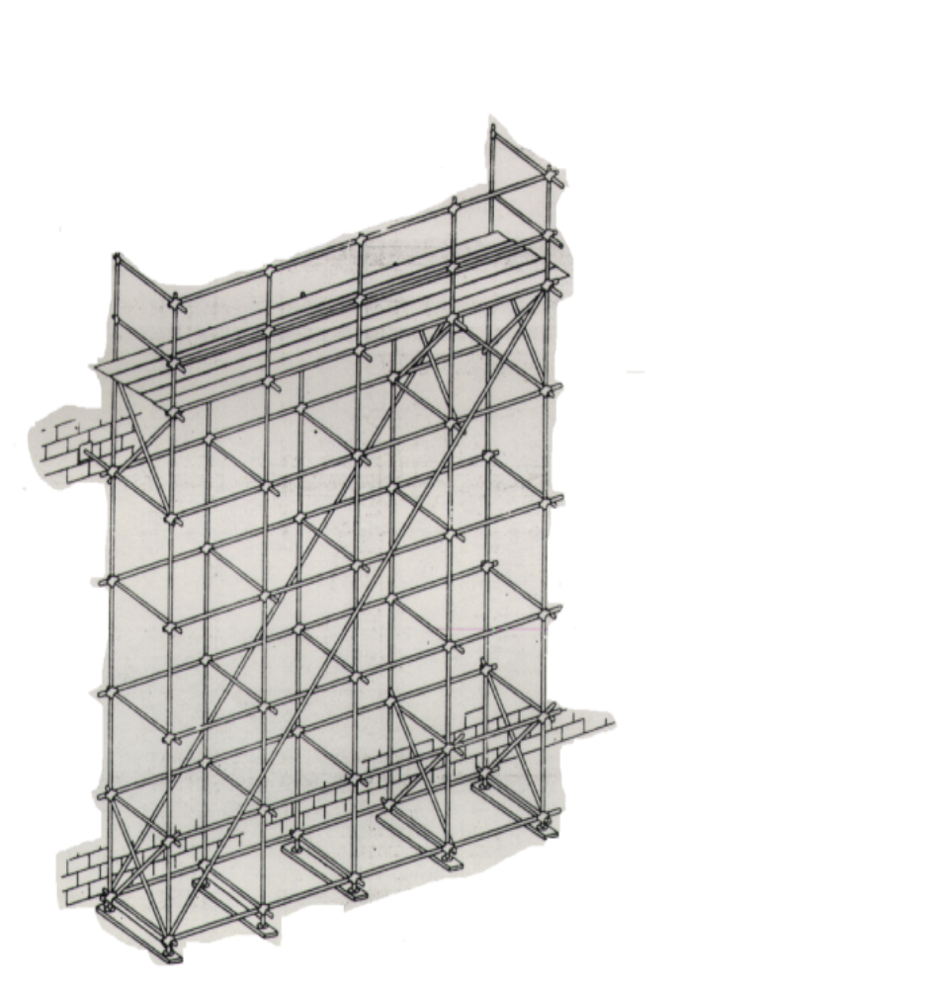

Suspended Scaffold Platform Welding Precautions
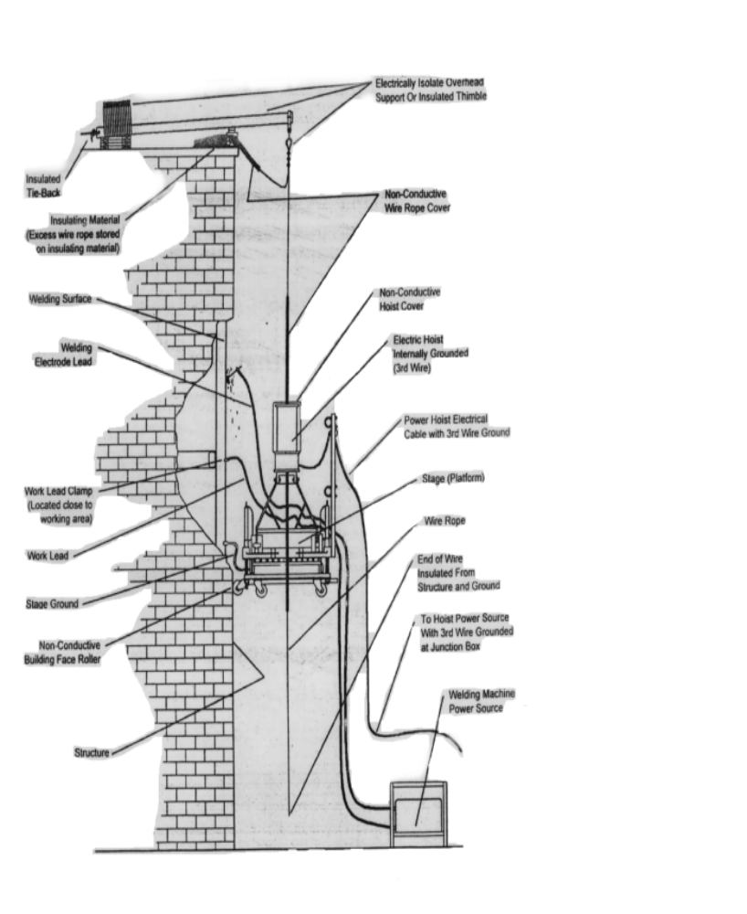
Hoists must be electronically isolated from scaffold

Maximum Vertical Tie Spacing Wider than 3’-0” Bases
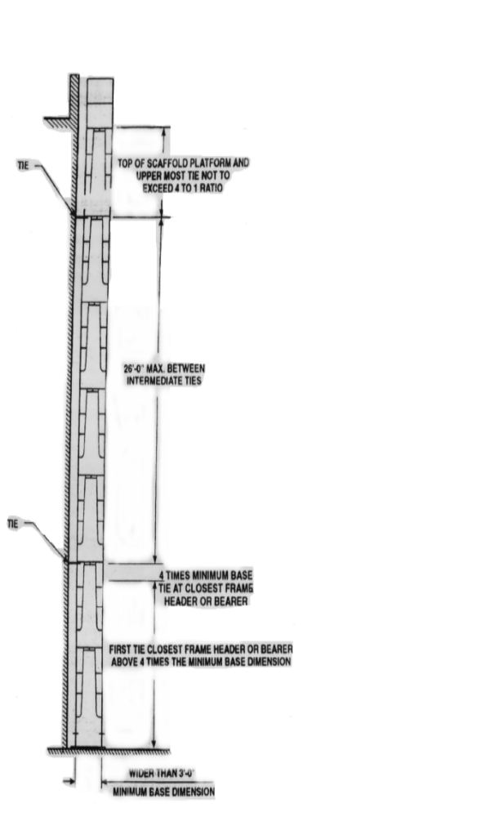

Maximum Vertical Tie Spacing 3’-0” and Narrower Bases

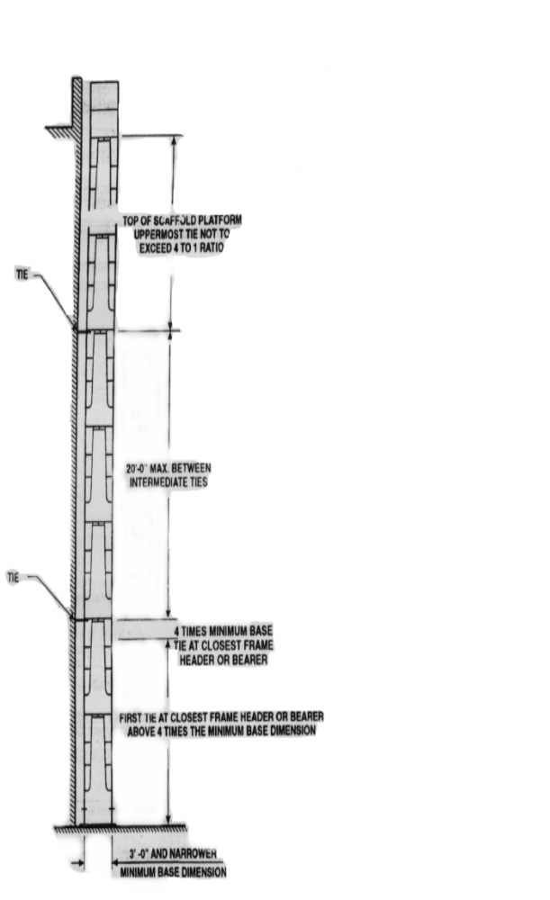
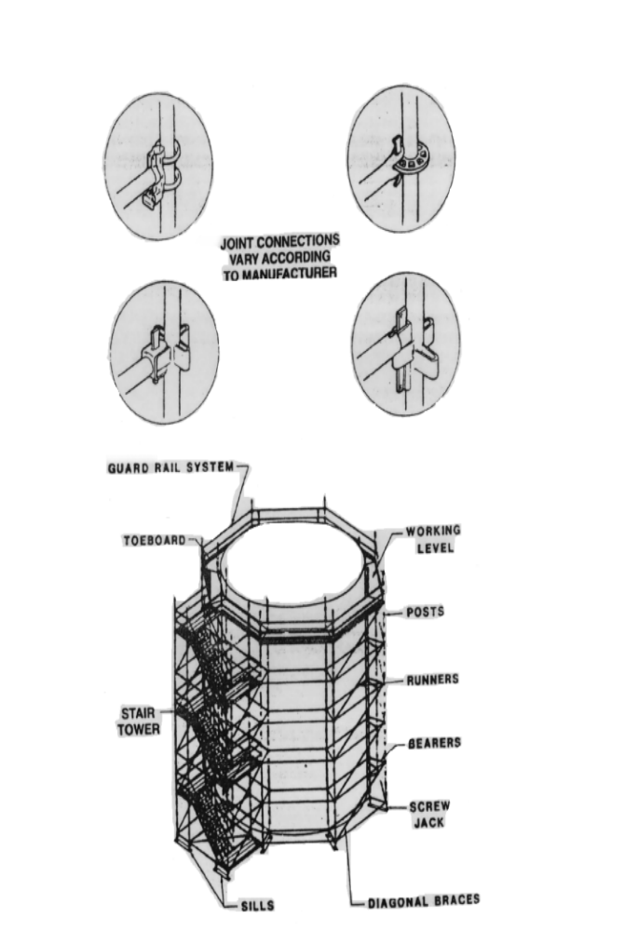System Scaffold

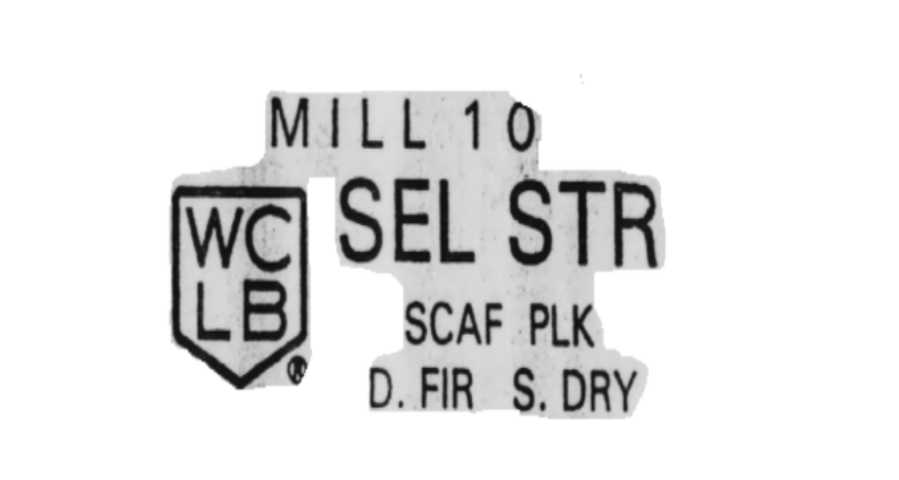Grade stamp courtesy of Southern Pine Inspection Bureau

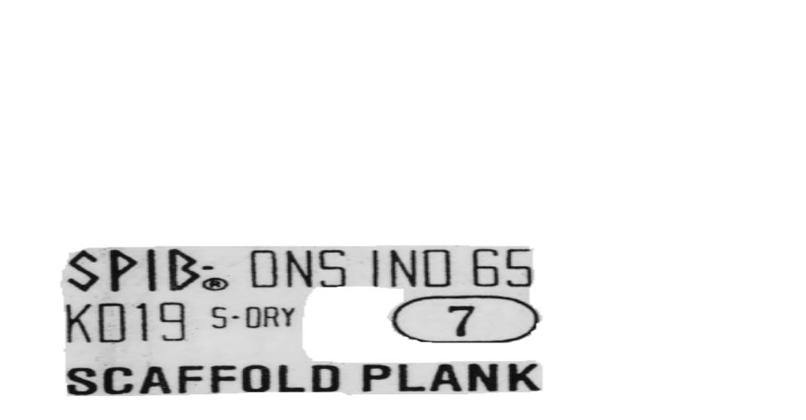

Grade stamp courtesy of West Coast Lumber Inspection Bureau

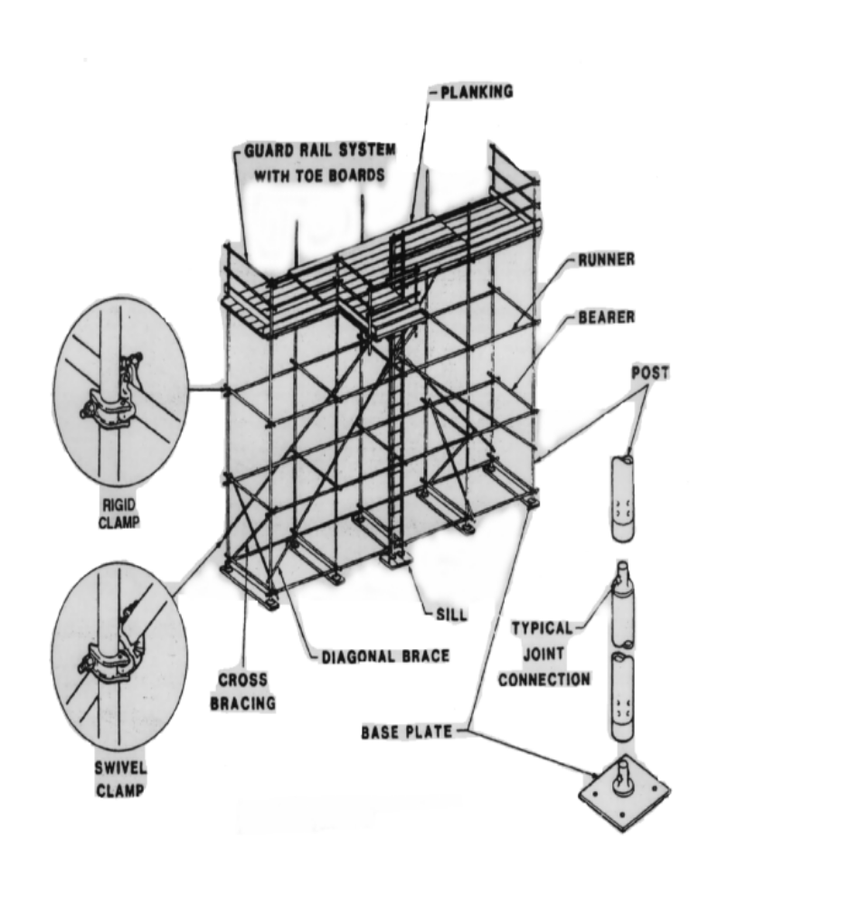Tube and Coupler Scaffold

Note: All ties should be located at clamp locations.

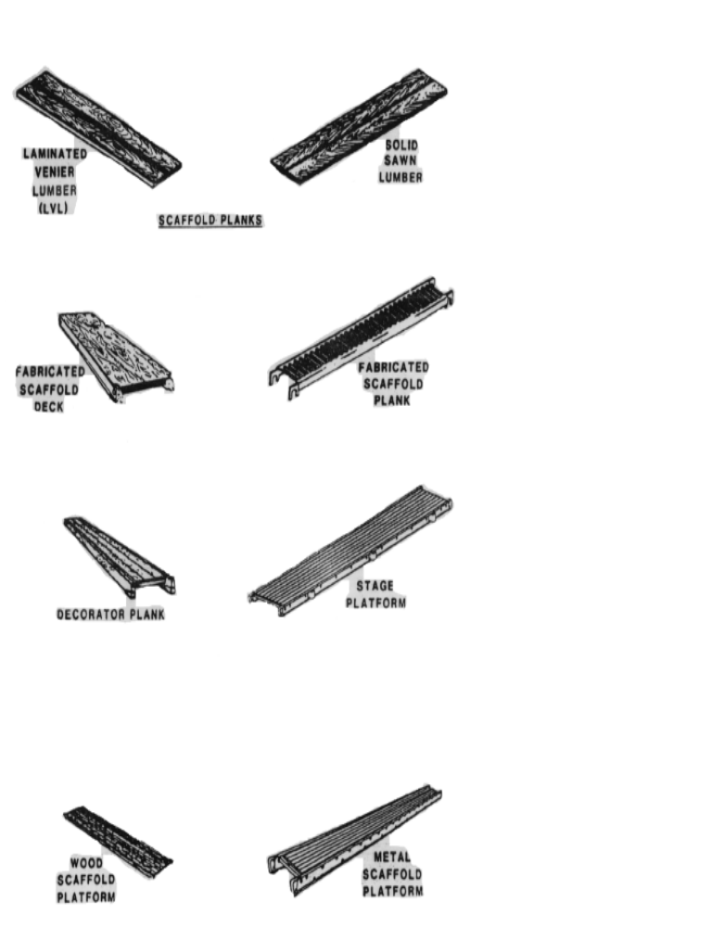Scaffolding Work Surfaces

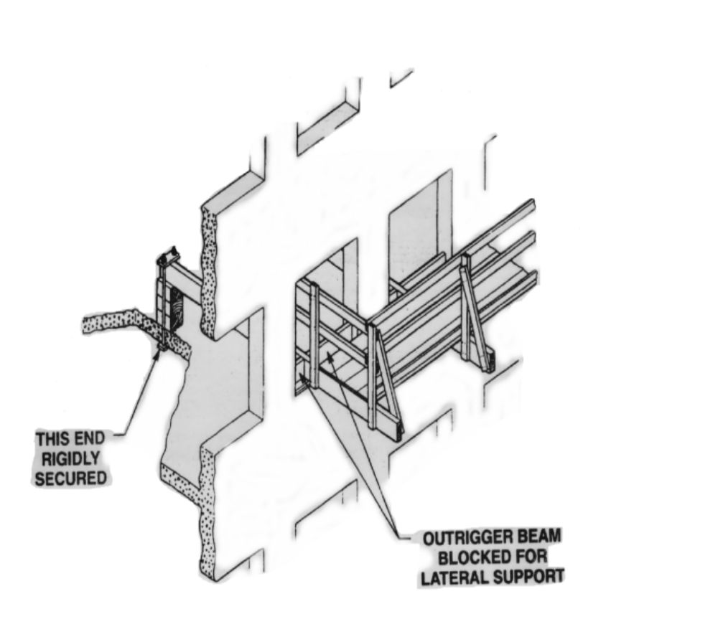Outrigger Scaffold

[FR Doc. 96-21289 Filed 8-29-96; 8:45 am]

BILLING CODE 4510-26-P

Stat. Auth.: ORS 654.025(2) and 656.726(3).
Hist: APD Admin. Order 4-1989, f. 3/31/89, ef. 5/1/89 (temp).
APD Admin. Order 8-1989, f. 7/7/89, ef. 7/7/89 (perm).

