OREGON OCCUPATIONAL

SAFETY AND HEALTH STANDARDS

Oregon Administrative Rules, Chapter 437

DIVISION 3 (29 CFR 1926)
CONSTRUCTION

CONSTRUCTION

Subdivision R
Steel Erection

Oregon Occupational Safety and Health Division (Oregon OSHA)
Department of Consumer and Business Services
Salem, Oregon 97301-3882

AO 1-2011
The Oregon Department of Consumer and Business Services adopted these rules pursuant to ORS
654.025(2).

The Secretary of State Designated OAR Chapter 437 as the “Oregon Occupational Safety and Health Code.”
Six general subject areas within this code are designated as “Divisions.”

- Division 1 General Administrative Rules
- Division 2 General Occupational Safety and Health Rules
- Division 3 Construction
- Division 4 Agriculture
- Division 5 Maritime Activities
- Division 7 Forest Activities
- Oregon Revised Statutes (ORS) 654 The Oregon Safe Employment Act (OSEAct)
Oregon-initiated rules in this division of the Oregon Occupational Safety and Health Code are numbered in a uniform system developed by the Secretary of State. This system does not number the rules in sequence (001, 002, 003, etc.). Omitted numbers may be assigned to new rules at the time of their adoption.

Oregon-initiated rules are arranged in the following Basic Codification Structure adopted by the Secretary of
State for Oregon Administrative Rules (OAR):

Chapter Division Rule Section Subsection Paragraphs
437 003 1760 (1) (a) (A)(i)(I)

The majority of Oregon OSHA codes are adopted by reference from the Code of Federal Regulations (CFR),
and are arranged in the following basic federal numbering system:

Chapter Division Part Subpart Section Paragraphs
(Subdivision)
437 003 1926 M .502 (a)

The terms “subdivision” and “subpart” are synonymous within OAR 437, Oregon Occupational Safety and
Health Code.

To obtain an order form or copies of these codes, address:

Department of Consumer & Business Services
Oregon Occupational Safety & Health Division (Oregon OSHA)
350 Winter St. NE, Room 430
Salem, OR 97301-3882

Or call the Oregon OSHA Resource Library at 503-378-3272

The rules referenced in this division are available for viewing in the Office of the Secretary of State, Administrative Rules and Office Document Section, Oregon State Archives Building, Salem, Oregon 97310,
or the Central Office, Oregon Occupational Safety and Health Division of the Department of Consumer and Business Services, Room 430, 350 Winter St. NE Salem, OR 97301-3882. Please visit our web site at: www.orosha.org
TABLE OF CONTENTS

1926.750 Scope R-1
1926.751 Definitions R-3
437-003-0045 Additional definitions R-3
1926.752 Site layout, site-specific erection plan and construction sequence R-9
437-003-1752 Written notifications R-9
437-003-0752 Site-specific erection plan R-10
1926.753 Hoisting and rigging R-11
437-003-0753 Tag lines R-11
1926.754 Structural steel assembly R-15
437-003-1754 Roof and floor holes and openings R-16
1926.755 Column anchorage R-18
1926.756 Beams and columns R-19
1926.757 Open web steel joists R-20
1926.758 Systems-engineered metal buildings R-26
1926.759 Falling object protection R-27
1926.760 Fall protection R-27
1926.761 Training R-29
437-003-0761 Additional training requirements R-30
Appendix A to Subpart R – Guidelines for Establishing the Components of a Site-specific Erection Plan: Nonmandatory guidelines for complying with §1926.752(e) R-31
Appendix B to Subpart R – [Reserved] R-32
Appendix C to Subpart R – Illustrations of Bridging Terminus Points: Nonmandatory guidelines for complying with §§1926.757(a)(10) and 1926.757(c)(5) R-33
Appendix D to Subpart R – Illustration of the Use of Control Lines to Demarcate Controlled Decking Zones (CDZs): Nonmandatory guidelines for complying with §1926.760(c)(3) R-39
Appendix E to Subpart R – Training: Nonmandatory guidelines for complying with §1926.761 R-41
Appendix F to Subpart R – Perimeter Columns: Nonmandatory guidelines for complying with §1926.756(e) to protect the unprotected side or edge of a walking/ working surface R-41
Appendix G to Subpart R §1926.502(b)-(e) Fall Protection Systems Criteria and Practices R-43
Appendix H to Subpart R - Double Connections: Illustration of a Clipped End Connection and a Staggered Connection: Nonmandatory guidelines for complying with §1926.756(c)(1) R-51

OAR 437, DIVISION 3

CONSTRUCTION

SUBDIVISION R – STEEL ERECTION

437-003-0001 Adoption by Reference. In addition to, and not in lieu of, any other safety and health codes contained in OAR Chapter 437, the Department adopts by reference the following federal regulations printed as part of the Code of Federal Regulations, in the Federal Register:

(18) Subdivision R – Steel Erection.
(a) 29 CFR 1926.750 Scope, published 7/17/01, FR vol. 66, no. 137, p. 37137.
(b) 29 CFR 1926.751 Definitions, published 7/17/01, FR vol. 66, no. 137, p. 37137; amended with AO 6-2002, f. and ef. 7/19/02; amended with AO 8-2003, f. 12/30/03, ef. 1/1/04.
(c) 29 CFR 1926.752 Site layout, site-specific erection plan and construction sequence, published 7/17/01, FR vol. 66, no. 137, p. 37137.
(d) 29 CFR 1926.753 Hoisting and rigging, published 8/9/10, FR vol. 75, no. 152, pp. 47906-48177.
(e) 29 CFR 1926.754 Structural steel assembly, published 4/3/06, FR vol. 71, no. 63, p. 16669.
(f) 29 CFR 1926.755 Column anchorage, published 7/17/01, FR vol. 66, no. 137, p. 37137.
(g) 29 CFR 1926.756 Beams and columns, published 7/17/01, FR vol. 66, no. 137, p. 37137.
(h) 29 CFR 1926.757 Open web steel joists, published 7/17/01, FR vol. 66, no. 137, p. 37137; amended with AO 8-2003, f. 12/30/03, ef. 1/1/04.
(i) 29 CFR 1926.758 Systems-engineered metal buildings, published 7/17/01, FR vol. 66, no. 137, p. 37137.
(j) 29 CFR 1926.759 Falling object protection, published 7/17/01, FR vol. 66, no. 137, p. 37137.
(k) 29 CFR 1926.760 Fall protection, published 7/17/01, FR vol. 66, no. 137, p. 37137; amended with AO 8-2003, f. 12/30/03, ef. 1/1/04.
(l) 29 CFR 1926.761 Training, published 12/12/08, FR vol. 73, no. 240, pp. 75568-75589.
(m) Appendix A to Subpart R Guidelines for establishing the components of a site-specific erection plan: Nonmandatory Guidelines for Complying with §1926.752(e), published 7/17/01, FR vol. 66, no. 137, p. 37137.
(n) Appendix B to Subpart R Reserved.
(o) Appendix C to Subpart R Illustrations of bridging terminus points: Nonmandatory Guidelines for Complying with §1926.757(a)(10) and §1926.757(c)(5), published 7/17/01, FR vol. 66, no. 137, p. 37137.
(p) Appendix D to Subpart R Illustration of the use of control lines to demarcate controlled decking zones (CDZs): Nonmandatory Guidelines for Complying with §1926.760(c)(3), REPEALED with AO 6-2002, f. and ef. 7/19/02; amended with AO 8-2003, f. 12/30/03, ef. 1/1/04.
(q) Appendix E to Subpart R Training: Nonmandatory Guidelines for Complying with §1926.761, published 7/17/01, FR vol. 66, no. 137, p. 37137.
(r) Appendix F to Subpart R Perimeter columns: Nonmandatory Guidelines for Complying with §1926.756(e) to Protect the Unprotected Side or Edge of a Walking/Working Surface, published 7/17/01, FR vol. 66, no. 137, p. 37137.
(s) Appendix G to Subpart R Fall protection systems criteria and practices from §1926.502: Nonmandatory Guidelines for Complying with Complying with §1926.760(d), REPEALED with AO 6-2002, f. and ef. 7/19/02; amended with AO 8-2003, f. 12/30/03, ef. 1/1/04.
(t) Appendix H to Subpart R Double connections: Illustration of a clipped end connection and a staggered connection: Non-Mandatory Guidelines for Complying with Complying with §1926.756(c)(1), published 7/17/01, FR vol. 66, no. 137, p. 37137.

These standards are available at the Oregon Occupational Safety and Health Division, Oregon Department of Consumer and Business Services, and the United States Government Printing Office.

Stat. Auth.: ORS 654.025(2) and 656.726(4).
Stats. Implemented: ORS 654.001 through 654.295.
Hist: APD Admin. Order 5-1989, f. 3/31/89, ef. 5/1/89 (temp).
APD Admin. Order 8-1989, f. 7/7/89, ef. 7/7/89 (perm).
APD Admin. Order 14-1989, f. 7/20/89, ef. 8/1/89 (temp).
APD Admin. Order 15-1989, f. 9/13/89, ef. 9/13/89 (perm).
APD Admin. Order 16-1989 (temp), f. 9/13/89, ef. 9/13/89.
OR-OSHA Admin. Order 2-1989, f. 10/17/89, ef. 10/17/89.
OR-OSHA Admin. Order 3-1990, f. 1/19/90, ef. 1/19/90 (temp).
OR-OSHA Admin. Order 7-1990, f. 3/2/90, ef. 3/2/90 (perm).
OR-OSHA Admin. Order 8-1990, f. 3/30/90, ef. 3/30/90.
OR-OSHA Admin. Order 13-1990, f. 6/28/90, ef. 8/1/90 (temp).
OR-OSHA Admin. Order 19-1990, f. 8/31/90, ef. 8/31/90 (perm).
OR-OSHA Admin. Order 27-1990, f. 12/12/90, ef. 2/1/91.
OR-OSHA Admin. Order 6-1991, f. 3/18/91, ef. 4/15/91.
OR-OSHA Admin. Order 7-1991, f. 4/25/91, ef. 4/25/91.
OR-OSHA Admin. Order 15-1991, f. 12/13/91, ef. 12/13/91.
OR-OSHA Admin. Order 16-1991, f. 12/16/91, ef. 1/1/92.
OR-OSHA Admin. Order 6-1992, f. 5/18/92, ef. 5/18/92.
OR-OSHA Admin. Order 11-1992, f. 10/9/92, ef. 10/9/92.
OR-OSHA Admin. Order 1-1993, f. 1/22/93, ef. 1/22/93.
OR-OSHA Admin. Order 16-1993, f. 11/1/93, ef. 11/1/93 (Lead).
OR-OSHA Admin. Order 1-1994, f. 4/27/94, ef. 4/27/94.
OR-OSHA Admin. Order 4-1994, f. 8/4/94, ef. 8/4/94 (HazCom).
OR-OSHA Admin. Order 6-1994, f. 9/30/94, ef. 9/30/94.
OR-OSHA Admin. Order 1-1995, f. 1/19/95, ef. 1/19/95 (DOT markings, placards & labels).
OR-OSHA Admin. Order 3-1995, f. 2/22/95, ef. 2/22/95 (Haz Waste).
OR-OSHA Admin. Order 4-1995, f. 3/29/95, ef. 3/29/95 (Asbestos).
OR-OSHA Admin. Order 5-1995, f. 4/6/95, ef. 4/6/95 (HazCom).
OR-OSHA Admin. Order 6-1995, f. 4/18/95, ef. 6/1/95 (Fall Protection).
OR-OSHA Admin. Order 8-1995, f. 8/25/95, ef. 8/25/95 (Asbestos).
OR-OSHA Admin. Order 5-1996, f. 11/29/96, ef. 11/29/96.
OR-OSHA Admin. Order 6-1996, f. 11/29/96, ef. 11/29/96.
OR-OSHA Admin. Order 2-1997, f. 3/12/97, ef. 3/12/97.
OR-OSHA Admin. Order 4-1997, f. 4/2/97, ef. 4/2/97.
OR-OSHA Admin. Order 6-1997, f. 5/2/97, ef. 5/2/97.
OR-OSHA Admin. Order 7-1997, f. 9/15/97, ef. 9/15/97 (Fall Protection).
OR-OSHA Admin. Order 8-1997, f. 11/14/97, e. 11/14/97 (Methylene Chloride).
OR-OSHA Admin. Order 1-1998, f. 2/13/98, e. 2/13/98 (Methylene Chloride).
OR-OSHA Admin. Order 3-1998, f. 7/7/98, ef. 7/7/98 (Respiratory Protection).
OR-OSHA Admin. Order 6-1998, f. 10/15/98, ef. 10/15/98 (Slings 3/H).
OR-OSHA Admin. Order 7-1998, f. 12/28/98, ef. 12/28/98 (Asbestos).
OR-OSHA Admin. Order 1-1999, f. 3/22/99, e. 3/22/99 (Methylene Chloride).
OR-OSHA Admin. Order 4-1999, f. 4/30/99, ef. 4/30/99.
OR-OSHA Admin. Order 6-1999, f. 5/26/99, ef. 5/26/99.
OR-OSHA Admin. Order 3-2000, f. 2/8/00, ef. 2/8/00.
OR-OSHA Admin. Order 3-2001, f. 2/5/01, ef. 2/5/01 (Fall Protection/Oregon Exceptions).
OR-OSHA Admin. Order 3-2002, f. 4/15/02, ef. 4/18/02 (Steel Erection).
OR-OSHA Admin. Order 5-2002, f. 6/28/02, ef. 10/1/03 (GFCI 3/K).
OR-OSHA Admin. Order 6-2002, f. 7/19/02, ef. 7/19/02 (Fall Protection/Steel Erection).
OR-OSHA Admin. Order 1-2003, f. 1/30/03, ef. 4/30/03 (3/Q Masonry Wall Bracing).
OR-OSHA Admin. Order 2-2003, f. 1/30/03, ef. 1/30/03 (3/G).
OR-OSHA Admin. Order 7-2003, f. 12/5/03, ef. 12/5/03 (3/O).
OR-OSHA Admin. Order 8-2003, f. 12/30/03, ef. 1/1/04 (3/R).
OR-OSHA Admin. Order 1-2005, f. 4/12/05, ef. 4/12/05 (3/D and 3/Z).
OR-OSHA Admin. Order 2-2006, f. 4/28/06, ef. 4/28/06 (3/R).
OR-OSHA Admin. Order 4-2006, f. 7/24/06, ef. 7/24/06.
OR-OSHA Admin. Order 5-2006, f. 8/7/06, ef. 1/1/07.
OR-OSHA Admin. Order 6-2006, f. 8/30/06, ef. 8/30/06.
OR-OSHA Admin. Order 10-2006, f. 11/30/06, ef. 11/30/06.
OR-OSHA Admin. Order 6-2007, f. 9/26/07, ef. 9/26/07 (3/O).
OR-OSHA Admin. Order 5-2008, f. 5/1/08, ef. 5/15/08 (PPE).
OR-OSHA Admin. Order 5-2009, f. 5/29/09, ef. 5/29/09.
OR-OSHA Admin. Order 3-2010, f. 6/10/10, ef. 6/15/10.
OR-OSHA Admin. Order 1-2011, f. 2/9/11, ef. 2/9/11.
OR-OSHA Admin. Order 4-2011, f. 12/8/11, ef. 12/8/11.
OR-OSHA Admin. Order 5-2011, f. 12/8/11, ef. 7/1/12.
OR-OSHA Admin. Order 1-2012, f. 4/10/12, ef. 4/10/12.
OR-OSHA Admin. Order 5-2012, f. 9/25/12, ef. 9/25/12.
OR-OSHA Admin. Order 1-2013, f. 2/14/13, ef. 2/14/13.
OR-OSHA Admin. Order 2-2013, f. 2/15/13, ef. 4/1/13.
OR-OSHA Admin. Order 4-2013, f. 7/19/13, ef. 7/19/13.
OR-OSHA Admin. Order 5-2013, f. 9/13/13, ef. 9/13/13.
OR-OSHA Admin. Order 6-2013, f. 10/9/13, ef. 10/9/13.
OR-OSHA Admin. Order 7-2013, f. 12/12/13, ef. 12/12/13.
OR-OSHA Admin. Order 6-2014, f. 10/28/14, ef. 5/1/15.
OR-OSHA Admin. Order 7-2014, f. 11/7/14, ef. 11/9/14.

SUBDIVISION R

STEEL ERECTION

Authority: Section 3704 of the Contract Work Hours and Safety Standards Act (40 U.S.C. 3701); Sections 4, 6, and 8 of the Occupational Safety and Health Act of 1970 (29 U.S.C. 653, 655, 657); Secretary of Labor’s Order Nos. 3-2000 (65 FR 50017), 5-2002 (67 FR 65008), and 5-2007 (72 FR 31159); and 29 CFR part 1911.

§1926.750 Scope.

- This subpart sets forth requirements to protect employees from the hazards associated with steel erection activities involved in the construction, alteration, and/or repair of single and multi-story buildings, bridges, and other structures where steel erection occurs. The requirements of this subpart apply to employers engaged in steel erection unless otherwise specified. This subpart does not cover electrical transmission towers, communication and broadcast towers, or tanks.
Note to paragraph (a): Examples of structures where steel erection may occur include but are not limited to the following: Single and multi-story buildings; systems-engineered metal buildings; lift slab/tilt-up structures; energy exploration structures; energy production, transfer and storage structures and facilities; auditoriums; malls; amphitheaters; stadiums; power plants; mills; chemical process structures; bridges; trestles; overpasses; underpasses; viaducts; aqueducts; aerospace facilities and structures; radar and communication structures; light towers; signage; billboards; scoreboards; conveyor systems; conveyor supports and related framing; stairways; stair towers; fire escapes; draft curtains; fire containment structures; monorails; aerialways; catwalks; curtain walls; window walls; store fronts; elevator fronts; entrances; skylights; metal roofs; industrial structures; hi-bay structures; rail, marine and other transportation structures; sound barriers; water process and water containment structures; air and cable supported structures; space frames; geodesic domes; canopies; racks and rack support structures and frames; platforms; walkways; balconies; atriums; penthouses; car dumpers; stackers/reclaimers; cranes and craneways; bins; hoppers; ovens; furnaces; stacks; amusement park structures and rides; and artistic and monumental structures.

  - Steel erection activities include hoisting, laying out, placing, connecting, welding, burning, guying, bracing, bolting, plumbing and rigging structural steel, steel joists and metal buildings; installing metal decking, curtain walls, window walls, siding systems, miscellaneous metals, ornamental iron and similar materials; and moving point-to-point while performing these activities.
  - The following activities are covered by this subpart when they occur during and are a part of steel erection activities: rigging, hoisting, laying out, placing, connecting, guying, bracing, dismantling, burning, welding, bolting, grinding, sealing, caulking, and all related activities for construction, alteration and/or repair of materials and assemblies such as structural steel; ferrous metals and alloys; non-ferrous metals and alloys; glass; plastics and synthetic composite materials; structural metal framing and related bracing and assemblies; anchoring devices; structural cabling; cable stays; permanent and temporary bents and towers; falsework for temporary supports of permanent steel members; stone and other non-precast concrete architectural materials mounted on steel frames; safety systems for steel erection; steel and metal joists; metal decking and raceway systems and accessories; metal roofing and accessories; metal siding; bridge flooring; cold formed steel framing; elevator beams; grillage; shelf racks; multi-purpose supports; crane rails and accessories; miscellaneous, architectural and ornamental metals and metal work; ladders; railings; handrails; fences and gates; gratings; trench covers; floor plates; castings; sheet metal fabrications; metal panels and panel wall systems; louvers; column covers; enclosures and pockets; stairs; perforated metals; ornamental iron work, expansion control including bridge expansion joint assemblies; slide bearings; hydraulic structures; fascias; soffit panels; penthouse enclosures; skylights; joint fillers; gaskets; sealants and seals; doors; windows; hardware; detention/security equipment and doors, windows and hardware; conveying systems; building specialties; building equipment; machinery and plant equipment, furnishings and special construction.
- The duties of controlling contractors under this subpart include, but are not limited to, the duties specified in §§1926.752(a) and (c), 1926.755(b)(2), 1926.759(b), and 1926.760(e).
Stat. Auth.: ORS 654.025(2) and 656.726(4).
Stats. Implemented: ORS 654.001 through 654.295.
Hist: OR-OSHA Admin. Order 3-2002, f. 4/15/02, ef. 4/18/02.

§1926.751 Definitions.

Anchored bridging means that the steel joist bridging is connected to a bridging terminus point.
Bolted diagonal bridging means diagonal bridging that is bolted to a steel joist or joists.
Bridging clip means a device that is attached to the steel joist to allow the bolting of the bridging to the steel joist.
Bridging terminus point means a wall, a beam, tandem joists (with all bridging installed and a horizontal truss in the plane of the top chord) or other element at an end or intermediate point(s) of a line of bridging that provides an anchor point for the steel joist bridging.

437-003-0045 Additional Definitions. The following definitions are in addition to those found in 1926.751:

- Certification required by this section means “in writing”.

Choker means a wire rope or synthetic fiber rigging assembly that is used to attach a load to a hoisting device.
Cold forming means the process of using press brakes, rolls, or other methods to shape steel into desired cross sections at room temperature.
Column means a load-carrying vertical member that is part of the primary skeletal framing system. Columns do not include posts.
Competent person (also defined in §1926.32) means one who is capable of identifying existing and predictable hazards in the surroundings or working conditions which are unsanitary, hazardous, or dangerous to employees, and who has authorization to take prompt corrective measures to eliminate them.
NOTE: In Oregon, a competent person is considered to be someone with equivalent skills as a qualified person in identifying existing and potential hazards in the workplace, while also being authorized by the employer or employer’s representative to take immediate corrective action to control or eliminate hazards.
Connector means an employee who, working with hoisting equipment, is placing and connecting structural members and/or components.
Constructibility means the ability to erect structural steel members in accordance with subpart R without having to alter the overall structural design.
Construction load (for joist erection) means any load other than the weight of the employee(s), the joists and the bridging bundle.
Controlled Decking Zone (CDZ) means an area in which certain work (for example, initial installation and placement of metal decking) may take place without the use of guardrail systems, personal fall arrest systems, fall restraint systems, or safety net systems and where access to the zone is controlled.
Controlled load lowering means lowering a load by means of a mechanical hoist drum device that allows a hoisted load to be lowered with maximum control using the gear train or hydraulic components of the hoist mechanism. Controlled load lowering requires the use of the hoist drive motor, rather than the load hoist brake, to lower the load.
Controlling contractor means a prime contractor, general contractor, construction manager or any other legal entity which has the overall responsibility for the construction of the project – its planning, quality and completion.
Critical lift means a lift that (1) exceeds 75 percent of the rated capacity of the crane or derrick, or (2) requires the use of more than one crane or derrick.

437-003-0045(2) Dangerous equipment – Equipment such as pickling or galvanizing tanks, degreasing units, machinery, electrical equipment, and other units which, as a result of form or function, may be hazardous to employees who fall onto or into such equipment.

Decking hole means a gap or void more than 2 inches (5.1 cm) in its least dimension and less than 12 inches (30.5 cm) in its greatest dimension in a floor, roof or other walking/ working surface. Pre-engineered holes in cellular decking (for wires, cables, etc.) are not included in this definition.
Derrick floor means an elevated floor of a building or structure that has been designated to receive hoisted pieces of steel prior to final placement.
Double connection means an attachment method where the connection point is intended for two pieces of steel which share common bolts on either side of a central piece.
Double connection seat means a structural attachment that, during the installation of a double connection, supports the first member while the second member is connected.
Erection bridging means the bolted diagonal bridging that is required to be installed prior to releasing the hoisting cables from the steel joists.
Fall restraint system means a fall protection system that prevents the user from falling any distance. The system is comprised of either a body belt or body harness, along with an anchorage, connectors and other necessary equipment. The other components typically include a lanyard, and may also include a lifeline and other devices.
Final interior perimeter means the perimeter of a large permanent open space within a building such as an atrium or courtyard. This does not include openings for stairways, elevator shafts, etc.
Girt (in systems-engineered metal buildings) means a “Z” or “C” shaped member formed from sheet steel spanning between primary framing and supporting wall material.
Headache ball means a weighted hook that is used to attach loads to the hoist load line of the crane.
Hoisting equipment means commercially manufactured lifting equipment designed to lift and position a load of known weight to a location at some known elevation and horizontal distance from the equipment’s center of rotation. “Hoisting equipment” includes but is not limited to cranes, derricks, tower cranes, barge-mounted derricks or cranes, gin poles and gantry hoist systems. A “come-a-long” (a mechanical device, usually consisting of a chain or cable attached at each end, that is used to facilitate movement of materials through leverage) is not considered “hoisting equipment.”
Leading edge means the unprotected side and edge of a floor, roof, or formwork for a floor or other walking/working surface (such as deck) which changes location as additional floor, roof, decking or formwork sections are placed, formed or constructed.

437-003-0045(3) Lower levels – Those areas or surfaces to which an employee can fall. Such areas or surfaces include, but are not limited to, ground levels, floors, platforms, ramps, runways, excavations, pits, tanks, material, water, equipment, structures.

Metal decking means a commercially manufactured, structural grade, cold rolled metal panel formed into a series of parallel ribs; for this subpart, this includes metal floor and roof decks, standing seam metal roofs, other metal roof systems and other products such as bar gratings, checker plate, expanded metal panels, and similar products. After installation and proper fastening, these decking materials serve a combination of functions including, but not limited to: a structural element designed in combination with the structure to resist, distribute and transfer loads, stiffen the structure and provide a diaphragm action; a walking/ working surface; a form for concrete slabs; a support for roofing systems; and a finished floor or roof.
Multiple lift rigging means a rigging assembly manufactured by wire rope rigging suppliers that facilitates the attachment of up to five independent loads to the hoist rigging of a crane.

Note: Oregon OSHA did not adopt the federal OSHA definition of ‘Opening’. In Oregon, OAR 437-003-0045(4) applies.
437-003-0045(4) Opening means a gap or void 12 inches (30.5 cm) or more in any dimension in a floor, roof or other walking/working surface. For the purposes of this subpart, skylight and smoke domes that do not meet the strength requirements of 1926.754(e)(3) shall be regarded as openings.

Permanent floor means a structurally completed floor at any level or elevation (including slab on grade).
Personal fall arrest system means a system used to arrest an employee in a fall from a working level. A personal fall arrest system consists of an anchorage, connectors, a body harness and may include a lanyard, deceleration device, lifeline, or suitable combination of these. The use of a body belt for fall arrest is prohibited.
Positioning device system means a body belt or body harness rigged to allow an employee to be supported on an elevated, vertical surface, such as a wall or column and work with both hands free while leaning.
Post means a structural member with a longitudinal axis that is essentially vertical, that: (1) weighs 300 pounds or less and is axially loaded (a load presses down on the top end), or (2) is not axially loaded, but is laterally restrained by the above member. Posts typically support stair landings, wall framing, mezzanines and other substructures.
Project structural engineer of record means the registered, licensed professional responsible for the design of structural steel framing and whose seal appears on the structural contract documents.
Purlin (in systems-engineered metal buildings) means a “Z” or “C” shaped member formed from sheet steel spanning between primary framing and supporting roof material.
Qualified person (also defined in §1926.32) means one who, by possession of a recognized degree, certificate, or professional standing, or who by extensive knowledge, training, and experience, has successfully demonstrated the ability to solve or resolve problems relating to the subject matter, the work, or the project.
Safety deck attachment means an initial attachment that is used to secure an initially placed sheet of decking to keep proper alignment and bearing with structural support members.
Shear connector means headed steel studs, steel bars, steel lugs, and similar devices which are attached to a structural member for the purpose of achieving composite action with concrete.
Steel erection means the construction, alteration or repair of steel buildings, bridges and other structures, including the installation of metal decking and all planking used during the process of erection.
Steel joist means an open web, secondary load-carrying member of 144 feet (43.9 m) or less, designed by the manufacturer, used for the support of floors and roofs. This does not include structural steel trusses or cold-formed joists.
Steel joist girder means an open web, primary load-carrying member, designed by the manufacturer, used for the support of floors and roofs. This does not include structural steel trusses.
Steel truss means an open web member designed of structural steel components by the project structural engineer of record. For the purposes of this subpart, a steel truss is considered equivalent to a solid web structural member.
Structural steel means a steel member, or a member made of a substitute material (such as, but not limited to, fiberglass, aluminum or composite members). These members include, but are not limited to, steel joists, joist girders, purlins, columns, beams, trusses, splices, seats, metal decking, girts, and all bridging, and cold formed metal framing which is integrated with the structural steel framing of a building.
Systems-engineered metal building means a metal, field-assembled building system consisting of framing, roof and wall coverings. Typically, many of these components are cold-formed shapes. These individual parts are fabricated in one or more manufacturing facilities and shipped to the job site for assembly into the final structure. The engineering design of the system is normally the responsibility of the systems-engineered metal building manufacturer.
Tank means a container for holding gases, liquids or solids.
Unprotected sides and edges means any side or edge (except at entrances to points of access) of a walking/working surface, for example a, floor, roof, ramp or runway, where there is no wall or guardrail system at least 39 inches (1.0 m) high.
Stat. Auth.: ORS 654.025(2) and 656.726(4).
Stats. Implemented: ORS 654.001 through 654.295.
Hist: OR-OSHA Admin. Order 3-2002, f. 4/15/02, ef. 4/18/02.
OR-OSHA Admin. Order 6-2002, f. 7/19/02, ef. 7/19/02.
OR-OSHA Admin. Order 8-2003, f. 12/30/03, ef. 1/1/04.

437-003-0045(5) Walking/working surface means any surface, whether horizontal or vertical on which an employee walks or works, including, but not limited to, floors, roofs, ramps, bridges, runways, formwork, beams, columns, trusses and concrete reinforcing steel but not ladders, vehicles, or trailers, on which employees must be located in order to perform their job duties.

Stat. Auth.: ORS 654.025(2) and 656.726(4).
Stats. Implemented: ORS 654.001 through 654.295.
Hist: APD Admin. Order 8-1989, f. 7/7/89, ef. 7/7/89.
OR-OSHA Admin. Order 3-2002, f. 4/15/02, ef. 4/18/02.
OR-OSHA Admin. Order 6-2002, f. 7/19/02, ef. 7/19/02.

§1926.752 Site Layout, Site-specific Erection Plan and Construction Sequence.

- Approval to begin steel erection. Before authorizing the commencement of steel erection, the controlling contractor shall ensure that the steel erector is provided with the following written notifications:
  - The concrete in the footings, piers and walls and the mortar in the masonry piers and walls has attained, on the basis of an appropriate ASTM standard test method of field-cured samples, either 75 percent of the intended minimum compressive design strength or sufficient strength to support the loads imposed during steel erection.
  - Any repairs, replacements and modifications to the anchor bolts were conducted in accordance with §1926.755(b).
- Commencement of steel erection. A steel erection contractor shall not erect steel unless it has received written notification that the concrete in the footings, piers and walls or the mortar in the masonry piers and walls has attained, on the basis of an appropriate ASTM standard test method of field-cured samples, either 75 percent of the intended minimum compressive design strength or sufficient strength to support the loads imposed during steel erection.

437-003-1752 Written notifications. A copy of the written notification(s) required by this section must be maintained on the site by the controlling contractor for review until completion of the project.

Stat. Auth.: ORS 654.025(2) and 656.726(4).
Stats. Implemented: ORS 654.001 through 654.295.
Hist: OR-OSHA Admin. Order 6-2002, f. 7/19/02, ef. 7/19/02.

- Site layout. The controlling contractor shall ensure that the following is provided and maintained:
  - Adequate access roads into and through the site for the safe delivery and movement of derricks, cranes, trucks, other necessary equipment, and the material to be erected and means and methods for pedestrian and vehicular control. Exception: this requirement does not apply to roads outside of the construction site.
  - A firm, properly graded, drained area, readily accessible to the work with adequate space for the safe storage of materials and the safe operation of the erector’s equipment.
- Pre-planning of overhead hoisting operations. All hoisting operations in steel erection shall be pre-planned to ensure that the requirements of §1926.753(d) are met.
- Site-specific erection plan. Where employers elect, due to conditions specific to the site, to develop alternate means and methods that provide employee protection in accordance with §1926.753(c)(5), §1926.757(a)(4) or §1926.757(e)(4), a site-specific erection plan shall be developed by a qualified person and be available at the work site. Guidelines for establishing a site-specific erection plan are contained in Appendix A to this subpart.
Stat. Auth.: ORS 654.025(2) and 656.726(4).
Stats. Implemented: ORS 654.001 through 654.295.
Hist: OR-OSHA Admin. Order 3-2002, f. 4/15/02, ef. 4/18/02.

437-003-0752 Site-Specific Erection Plan. In addition to and not in lieu of the provisions of 29 CFR 1926.752(e), the steel erection contractor must develop and implement a written site-specific erection plan.

- The site-specific erection plan must:
  - Be developed by a qualified person;
  - Identify the site;
  - Be available at the work site; and
  - Be signed by the qualified person responsible for its development and any modification(s).
NOTE: The site-specific erection plan does not have to be developed by an engineer, or resemble an engineering report.
- The site-specific erection plan must contain the following:
  - A description of the procedures that will be used to comply with 1926.754(a). Consider the dead weight of the structure, the weight and working reactions of all static and dynamic loads placed on it, and all external forces that may be applied such as wind and reactions by erection equipment.
NOTE: There is a presumption that some form of temporary guying or bracing is necessary to provide lateral stability to the structural steel framing as it is being erected. Accordingly, the employer has the burden of establishing that the structural steel framing is inherently stable during erection and/or the sequence of erection, plumbing, bolting and decking is such that structural stability is maintained at all times and no temporary guying or bracing is needed. Such determination must be documented in the site-specific erection plan.
  - A description of the procedures and work practices that will be used to protect employees from falls and other hazards where it is necessary to walk/work on suspended loads. Employee(s) are allowed on suspended loads only when a competent person has determined that it is the safest way to accomplish a specific task or there is no other way to do the work.
Stat. Auth.: ORS 654.025(2) and 656.726(4).
Stats. Implemented: ORS 654.001 through 654.295.
Hist: OR-OSHA Admin. Order 3-2002, f. 4/15/02, ef. 4/18/02.
§1926.753 Hoisting and Rigging.

- All the provisions of Subpart CC apply to hoisting and rigging with the exception of §1926.1431(a).

437-003-0753 Tag lines. Tag lines shall be used to control loads except when it is determined, by a qualified rigger, that they create a hazard.

Stat. Auth.: ORS 654.025(2) and 656.726(4).
Stats. Implemented: ORS 654.001 through 654.295.
Hist: OR-OSHA Admin. Order 6-2002, f. 7/19/02, ef. 7/19/02.

- In addition, paragraphs (c) through (e) of this section apply regarding the hazards associated with hoisting and rigging.
- General.
  - Pre-shift visual inspection of cranes.
    - Cranes being used in steel erection activities shall be visually inspected prior to each shift by a competent person; the inspection shall include observation for deficiencies during operation. At a minimum this inspection shall include the following:
      - All control mechanisms for maladjustments;
      - Control and drive mechanism for excessive wear of components and contamination by lubricants, water or other foreign matter;
      - Safety devices, including but not limited to boom angle indicators, boom stops, boom kick out devices, anti-two block devices, and load moment indicators where required;
      - Air, hydraulic, and other pressurized lines for deterioration or leakage, particularly those which flex in normal operation;
      - Hooks and latches for deformation, chemical damage, cracks, or wear;
      - Wire rope reeving for compliance with hoisting equipment manufacturer’s specifications;
      - Electrical apparatus for malfunctioning, signs of excessive deterioration, dirt, or moisture accumulation;
      - Hydraulic system for proper fluid level;
      - Tires for proper inflation and condition;
      - Ground conditions around the hoisting equipment for proper support, including ground settling under and around outriggers, ground water accumulation, or similar conditions;
      - The hoisting equipment for level position; and
      - The hoisting equipment for level position after each move and setup.
    - If any deficiency is identified, an immediate determination shall be made by the competent person as to whether the deficiency constitutes a hazard.
    - If the deficiency is determined to constitute a hazard, the hoisting equipment shall be removed from service until the deficiency has been corrected.
    - The operator shall be responsible for those operations under the operator’s direct control. Whenever there is any doubt as to safety, the operator shall have the authority to stop and refuse to handle loads until safety has been assured.
  - A qualified rigger (a rigger who is also a qualified person) shall inspect the rigging prior to each shift in accordance with §1926.251.
  - The headache ball, hook or load shall not be used to transport personnel except as provided in paragraph (c)(4) of this section.
  - Cranes or derricks may be used to hoist employees on a personnel platform when work under this subpart is being conducted, provided that all provisions of §1926.1431 (except for §1926.1431(a)) are met.
  - Safety latches on hooks shall not be deactivated or made inoperable except:
    - When a qualified rigger has determined that the hoisting and placing of purlins and single joists can be performed more safely by doing so; or
    - When equivalent protection is provided in a site-specific erection plan.
- Working under loads.
  - Routes for suspended loads shall be pre-planned to ensure that no employee is required to work directly below a suspended load except for:
    - Employees engaged in the initial connection of the steel; or
    - Employees necessary for the hooking or unhooking of the load.
  - When working under suspended loads, the following criteria shall be met:
    - Materials being hoisted shall be rigged to prevent unintentional displacement;
    - Hooks with self-closing safety latches or their equivalent shall be used to prevent components from slipping out of the hook; and
    - All loads shall be rigged by a qualified rigger.
- Multiple lift rigging procedure.
  - A multiple lift shall only be performed if the following criteria are met:
    - A multiple lift rigging assembly is used;
    - A maximum of five members are hoisted per lift;
    - Only beams and similar structural members are lifted; and
    - All employees engaged in the multiple lift have been trained in these procedures in accordance with §1926.761(c)(1).
    - No crane is permitted to be used for a multiple lift where such use is contrary to the manufacturer’s specifications and limitations.
  - Components of the multiple lift rigging assembly shall be specifically designed and assembled with a maximum capacity for total assembly and for each individual attachment point. This capacity, certified by the manufacturer or a qualified rigger, shall be based on the manufacturer’s specifications with a 5 to 1 safety factor for all components.
  - The total load shall not exceed:
    - The rated capacity of the hoisting equipment specified in the hoisting equipment load charts;
    - The rigging capacity specified in the rigging rating chart.
  - The multiple lift rigging assembly shall be rigged with members:
    - Attached at their center of gravity and maintained reasonably level;
    - Rigged from top down; and
    - Rigged at least 7 feet (2.1 m) apart.
  - The members on the multiple lift rigging assembly shall be set from the bottom up.
  - Controlled load lowering shall be used whenever the load is over the connectors.
Stat. Auth.: ORS 654.025(2) and 656.726(4).
Stats. Implemented: ORS 654.001 through 654.295.
Hist: OR-OSHA Admin. Order 3-2002, f. 4/15/02, ef. 4/18/02.
OR-OSHA Admin. Order 1-2011, f. 2/9/11, ef. 2/9/11.

§1926.754 Structural Steel Assembly.

- Structural stability shall be maintained at all times during the erection process.
NOTE to paragraph (a): Federal Highway Administration (FHWA) regulations incorporate by reference a number of standards, policies, and standard specifications published by the American Association of State Highway and Transportation Officials (AASHTO) and other organizations. (see 23 CFR 625.4). Many of these incorporated provisions may be relevant to maintaining structural stability during the erection process. For instance, as of May 17, 2010, in many cases FHWA requires a Registered Engineer to prepare and seal working drawings for falsework used in highway bridge construction. (See AASHTO Specifications for Highway Bridges, Div. II, §3.2.1, 15th edition, 1992, which FHWA incorporates by reference in 23 CFR 625.4). FHWA also encourages compliance with AASHTO Specifications that the FHWA regulations do not currently incorporate by reference. (See http://www.fhwa.dot.gov/bridge/lrfd/index.htm.)
NOTE: OAR 437-003-0752 requires use of a site-specific erection plan.
- The following additional requirements shall apply for multi-story structures:
  - The permanent floors shall be installed as the erection of structural members progresses, and there shall be not more than eight stories between the erection floor and the upper-most permanent floor, except where the structural integrity is maintained as a result of the design.
  - At no time shall there be more than four floors or 48 feet (14.6 m), whichever is less, of unfinished bolting or welding above the foundation or uppermost permanently secured floor, except where the structural integrity is maintained as a result of the design.
  - A fully planked or decked floor or nets shall be maintained within two stories or 30 feet (9.1 m), whichever is less, directly under any erection work being performed.
- Walking/working surfaces – shear connectors and other similar devices.
  - Tripping hazards. Shear connectors (such as headed steel studs, steel bars or steel lugs), reinforcing bars, deformed anchors or threaded studs shall not be attached to the top flanges of beams, joists or beam attachments so that they project vertically from or horizontally across the top flange of the member until after the metal decking, or other walking/working surface, has been installed.
  - Installation of shear connectors on composite floors, roofs and bridge decks. When shear connectors are used in construction of composite floors, roofs and bridge decks, employees shall lay out and install the shear connectors after the metal decking has been installed, using the metal decking as a working platform. Shear connectors shall not be installed from within a controlled decking zone (CDZ), as specified in §1926.760(c)(8).
- Plumbing-up.
  - When deemed necessary by a competent person, plumbing-up equipment shall be installed in conjunction with the steel erection process to ensure the stability of the structure.
  - When used, plumbing-up equipment shall be in place and properly installed before the structure is loaded with construction material such as loads of joists, bundles of decking or bundles of bridging.
  - Plumbing-up equipment shall be removed only with the approval of a competent person.
- Metal decking.
  - Hoisting, landing and placing of metal decking bundles.
    - Bundle packaging and strapping shall not be used for hoisting unless specifically designed for that purpose.
    - If loose items such as dunnage, flashing, or other materials are placed on the top of metal decking bundles to be hoisted, such items shall be secured to the bundles.
    - Bundles of metal decking on joists shall be landed in accordance with §1926.757(e)(4).
    - Metal decking bundles shall be landed on framing members so that enough support is provided to allow the bundles to be unbanded without dislodging the bundles from the supports.
    - At the end of the shift or when environmental or jobsite conditions require, metal decking shall be secured against displacement.
  - Roof and floor holes and openings. Metal decking at roof and floor holes and openings shall be installed as follows:
    - Framed metal deck openings shall have structural members turned down to allow continuous deck installation except where not allowed by structural design constraints or constructibility.

Note: Oregon-initiated rule 437-003-1754 replaces 1926.754(e)(2)(ii):
437-003-1754 Roof and floor holes and openings. Roof and floor holes and openings shall be decked over. Where large size configuration or other structural design does not allow openings to be decked over (such as elevator shafts, stairwells, etc.) employees shall be protected by covers or guardrail systems erected around such openings as soon as the openings are created.

Stat. Auth.: ORS 654.025(2) and 656.726(4).
Stats. Implemented: ORS 654.001 through 654.295.
Hist: OR-OSHA Admin. Order 8-2003, f. 12/30/03, ef. 1/1/04.

    - Metal decking holes and openings shall not be cut until immediately prior to being permanently filled with the equipment or structure needed or intended to fulfill its specific use and which meets the strength requirements of paragraph (e)(3) of this section, or shall be immediately covered.
  - Covering roof and floor openings.
    - Covers for roof and floor openings shall be capable of supporting, without failure, twice the weight of the employees, equipment and materials that may be imposed on the cover at any one time.
    - All covers shall be secured when installed to prevent accidental displacement by the wind, equipment or employees.
    - All covers shall be painted with high-visibility paint or shall be marked with the word “HOLE” or “COVER” to provide warning of the hazard.
    - Smoke dome or skylight fixtures that have been installed, are not considered covers for the purpose of this section unless they meet the strength requirements of paragraph (e)(3)(i) of this section.
  - Decking gaps around columns. Wire mesh, exterior plywood, or equivalent, shall be installed around columns where planks or metal decking do not fit tightly. The materials used must be of sufficient strength to provide fall protection for personnel and prevent objects from falling through.
  - Installation of metal decking.
    - Except as provided in 1926.760(c), metal decking shall be laid tightly and immediately secured upon placement to prevent accidental movement or displacement.
    - During initial placement, metal decking panels shall be placed to ensure full support by structural members.
  - Derrick floors.
    - A derrick floor shall be fully decked and/or planked and the steel member connections completed to support the intended floor loading.
    - Temporary loads placed on a derrick floor shall be distributed over the underlying support members so as to prevent local overloading of the deck material.
Stat. Auth.: ORS 654.025(2) and 656.726(4).
Stats. Implemented: ORS 654.001 through 654.295.
Hist: OR-OSHA Admin. Order 3-2002, f. 4/15/02, ef. 4/18/02.
OR-OSHA Admin. Order 6-2002, f. 7/19/02, ef. 7/19/02.
OR-OSHA Admin. Order 8-2003, f. 12/30/03, ef. 1/1/04.
OR-OSHA Admin. Order 2-2006, f. 4/28/06, ef. 4/28/06.
OR-OSHA Admin. Order 4-2006, f. 7/24/06, ef. 7/24/06.

§1926.755 Column Anchorage.

- General requirements for erection stability.
  - All columns shall be anchored by a minimum of 4 anchor rods (anchor bolts).
  - Each column anchor rod (anchor bolt) assembly, including the column-to-base plate weld and the column foundation, shall be designed to resist a minimum eccentric gravity load of 300 pounds (136.2 kg) located 18 inches (.46m) from the extreme outer face of the column in each direction at the top of the column shaft.
  - Columns shall be set on level finished floors, pre-grouted leveling plates, leveling nuts, or shim packs which are adequate to transfer the construction loads.
  - All columns shall be evaluated by a competent person to determine whether guying or bracing is needed; if guying or bracing is needed, it shall be installed.
- Repair, replacement or field modification of anchor rods (anchor bolts).
  - Anchor rods (anchor bolts) shall not be repaired, replaced or field-modified without the approval of the project structural engineer of record.
  - Prior to the erection of a column, the controlling contractor shall provide written notification to the steel erector if there has been any repair, replacement or modification of the anchor rods (anchor bolts) of that column.
Stat. Auth.: ORS 654.025(2) and 656.726(4).
Stats. Implemented: ORS 654.001 through 654.295.
Hist: OR-OSHA Admin. Order 3-2002, f. 4/15/02, ef. 4/18/02.

§1926.756 Beams and Columns.

- General.
  - During the final placing of solid web structural members, the load shall not be released from the hoisting line until the members are secured with at least two bolts per connection, of the same size and strength as shown in the erection drawings, drawn up wrench-tight or the equivalent as specified by the project structural engineer of record, except as specified in paragraph (b) of this section.
  - A competent person shall determine if more than two bolts are necessary to ensure the stability of cantilevered members; if additional bolts are needed, they shall be installed.
- Diagonal bracing. Solid web structural members used as diagonal bracing shall be secured by at least one bolt per connection drawn up wrench-tight or the equivalent as specified by the project structural engineer of record.

  - Double connections at columns and/or at beam webs over a column. When two structural members on opposite sides of a column web, or a beam web over a column, are connected sharing common connection holes, at least one bolt with its wrench-tight nut shall remain connected to the first member unless a shop-attached or field-attached seat or equivalent connection device is supplied with the member to secure the first member and prevent the column from being displaced (See Appendix H to this subpart for examples of equivalent connection devices).
  - If a seat or equivalent device is used, the seat (or device) shall be designed to support the load during the double connection process. It shall be adequately bolted or welded to both a supporting member and the first member before the nuts on the shared bolts are removed to make the double connection.
- Column splices. Each column splice shall be designed to resist a minimum eccentric gravity load of 300 pounds (136.2 kg) located 18 inches (.46 m) from the extreme outer face of the column in each direction at the top of the column shaft.
- Perimeter columns. Perimeter columns shall not be erected unless:
  - The perimeter columns extend a minimum of 48 inches (1.2 m) above the finished floor to permit installation of perimeter safety cables prior to erection of the next tier, except where constructibility does not allow (see Appendix F to this subpart);
  - The perimeter columns have holes or other devices in or attached to perimeter columns at 42-45 inches (107-114 cm) above the finished floor and the midpoint between the finished floor and the top cable to permit installation of perimeter safety cables required by §1926.760(a)(2), except where constructibility does not allow. (See Appendix F to this subpart.)
Stat. Auth.: ORS 654.025(2) and 656.726(4).
Stats. Implemented: ORS 654.001 through 654.295.
Hist: OR-OSHA Admin. Order 3-2002, f. 4/15/02, ef. 4/18/02.

§1926.757 Open Web Steel Joists.

- General.
  - Except as provided in paragraph (a)(2) of this section, where steel joists are used and columns are not framed in at least two directions with solid web structural steel members, a steel joist shall be field-bolted at the column to provide lateral stability to the column during erection. For the installation of this joist:
    - A vertical stabilizer plate shall be provided on each column for steel joists. The plate shall be a minimum of 6 inch by 6 inch (152 mm by 152 mm) and shall extend at least 3 inches (76 mm) below the bottom chord of the joist with a 13/16 inch (21 mm) hole to provide an attachment point for guying or plumbing cables.
    - The bottom chords of steel joists at columns shall be stabilized to prevent rotation during erection.
    - Hoisting cables shall not be released until the seat at each end of the steel joist is field-bolted, and each end of the bottom chord is restrained by the column stabilizer plate.
  - Where constructibility does not allow a steel joist to be installed at the column:
    - an alternate means of stabilizing joists shall be installed on both sides near the column and shall:
      - provide stability equivalent to paragraph (a)(1) of this section;
      - be designed by a qualified person;
      - be shop installed; and
      - be included in the erection drawings.
    - hoisting cables shall not be released until the seat at each end of the steel joist is field-bolted and the joist is stabilized.
  - Where steel joists at or near columns span 60 feet (18.3 m) or less, the joist shall be designed with sufficient strength to allow one employee to release the hoisting cable without the need for erection bridging.
  - Where steel joists at or near columns span more than 60 feet (18.3 m), the joists shall be set in tandem with all bridging installed unless an alternative method of erection, which provides equivalent stability to the steel joist, is designed by a qualified person and is included in the site-specific erection plan.
  - A steel joist or steel joist girder shall not be placed on any support structure unless such structure is stabilized.
  - When steel joist(s) are landed on a structure, they shall be secured to prevent unintentional displacement prior to installation.
  - No modification that affects the strength of a steel joist or steel joist girder shall be made without the approval of the project structural engineer of record.
  - Field-bolted joists.
    - Except for steel joists that have been pre-assembled into panels, connections of individual steel joists to steel structures in bays of 40 feet (12.2 m) or more shall be fabricated to allow for field bolting during erection.
    - These connections shall be field-bolted unless constructibility does not allow.
  - Steel joists and steel joist girders shall not be used as anchorage points for a fall arrest system unless written approval to do so is obtained from a qualified person.
  - A bridging terminus point shall be established before bridging is installed. (See Appendix C to this subpart.)
- Attachment of steel joists and steel joist girders.
  - Each end of “K” series steel joists shall be attached to the support structure with a minimum of two 1/8-inch (3 mm) fillet welds 1 inch (25 mm) long or with two 1/2-inch (13 mm) bolts, or the equivalent.
  - Each end of “LH” and “DLH” series steel joists and steel joist girders shall be attached to the support structure with a minimum of two 1/4-inch (6 mm) fillet welds 2 inches (51 mm) long, or with two 3/4-inch (19 mm) bolts, or the equivalent.
  - Except as provided in paragraph (b)(4) of this section, each steel joist shall be attached to the support structure, at least at one end on both sides of the seat, immediately upon placement in the final erection position and before additional joists are placed.
  - Panels that have been pre-assembled from steel joists with bridging shall be attached to the structure at each corner before the hoisting cables are released.
- Erection of steel joists.
  - Both sides of the seat of one end of each steel joist that requires bridging under Tables A and B shall be attached to the support structure before hoisting cables are released.
  - For joists over 60 feet, both ends of the joist shall be attached as specified in paragraph (b) of this section and the provisions of paragraph (d) of this section met before the hoisting cables are released.
  - On steel joists that do not require erection bridging under Tables A and B, only one employee shall be allowed on the joist until all bridging is installed and anchored.

Table A – Erection Bridging for Short Span Joists
Joist | Span | Joist | Span | Joist | Span | Joist | Span
8K1  10K1  12K1  12K3  12K5  14K1  14K3  14K4  14K6  16K2  16K3  16K4  16K5  16K6  16K7  16K9  18K3  18K4  18K5  18K6  18K7  18K9  18K10  20K3  20K4  20K5 | NM  NM  23-0  NM  NM  27-0  NM  NM  NM  29-0  30-0  32-0  32-0  NM  NM  NM  31-0  32-0  33-0  35-0  NM  NM  NM  32-0  34-0  34-0 | 20K6  20K7  20K9  20K10  22K4  22K5  22K6  22K7  22K9  22K10  22K11  24K4  24K5  24K6  24K7  24K8  24K9  24K10  24K12  26K5  26K6  26K7  26K8  26K9  26K10  26K12 | 36-0  39-0  39-0  NM  34-0  35-0  36-0  40-0  40-0  NM  NM  36-0  38-0  39-0  43-0  43-0  44-0  NM  NM  38-0  39-0  43-0  44-0  44-0  49-0  NM | 28K6  28K7  28K8  28K9  28K10  28K12  30K7  30K8  30K9  30K10  30K11  30K12  10KCS1  10KCS2  10KCS3  12KCS1  12KCS2  12KCS3  14KCS1  14KCS2  14KCS3  16KCS2  16KCS3  16KCS4  16KCS5  18KCS2 | 40-0  43-0  44-0  45-0  49-0  53-0  44-0  45-0  45-0  50-0  52-0  54-0  NM  NM  NM  NM  NM  NM  NM  NM  NM  NM  NM  NM  NM  35-0 | 18KCS3  18KCS4  18KCS5  20KCS2  20KCS3  20KCS4  20KCS5  22KCS2  22KCS3  22KCS4  22KCS5  24KCS2  24KCS3  24KCS4  24KCS5  26KCS2  26KCS3  26KCS4  26KCS5  28KCS2  28KCS3  28KCS4  28KCS5  30KCS3  30KCS4  30KCS5 | NM  NM  NM  36-0  39-0  NM  NM  36-0  40-0  NM  NM  39-0  44-0  NM  NM  39-0  44-0  NM  NM  40-0  45-0  53-0  53-0  45-0  54-0  54-0
NM = diagonal bolted bridging not mandatory.

Table B – Erection Bridging for Long Span Joists
Joist | Span | Joist | Span | Joist | Span
18LH02  18LH03  18LH04  18LH05  18LH06  18LH07  18LH08  18LH09  20LH02  20LH03  20LH04  20LH05  20LH06  20LH07  20LH08  20LH09  20LH10  24LH03 | 33-0  NM  NM  NM  NM  NM  NM  NM  33-0  38-0  NM  NM  NM  NM  NM  NM  NM  35-0 | 24LH04  24LH05  24LH06  24LH07  24LH08  24LH09  24LH10  24LH11  28LH05  28LH06  28LH07  28LH08  28LH09  28LH10  28LH11  28LH12  28LH13  32LH06 | 39-0  40-0  45-0  NM  NM  NM  NM  NM  42-0  46-0  54-0  54-0  NM  NM  NM  NM  NM  47-0 through 60-0 | 32LH07  32LH08  32LH09  32LH10  32LH11  32LH12  32LH13  32LH14  32LH15  36LH07  36LH08  36LH09  36LH10  36LH11  36LH12  36LH13  36LH14  36LH15 | 47-0 through 60-0  55-0 through 60-0  NM through 60-0  NM through 60-0  NM through 60-0  NM through 60-0  NM through 60-0  NM through 60-0  NM through 60-0  47-0 through 60-0  47-0 through 60-0  57-0 through 60-0  NM through 60-0  NM through 60-0  NM through 60-0  NM through 60-0  NM through 60-0  NM through 60-0
NM = diagonal bolted bridging not mandatory.

  - Employees shall not be allowed on steel joists where the span of the steel joist is equal to or greater than the span shown in Tables A and B except in accordance with §1926.757(d).
  - When permanent bridging terminus points cannot be used during erection, additional temporary bridging terminus points are required to provide stability. (See appendix C of this subpart.)
- Erection bridging.
  - Where the span of the steel joist is equal to or greater than the span shown in Tables A and B, the following shall apply:
    - A row of bolted diagonal erection bridging shall be installed near the midspan of the steel joist;
    - Hoisting cables shall not be released until this bolted diagonal erection bridging is installed and anchored; and
    - No more than one employee shall be allowed on these spans until all other bridging is installed and anchored.
  - Where the span of the steel joist is over 60 feet (18.3 m) through 100 feet (30.5 m), the following shall apply:
    - All rows of bridging shall be bolted diagonal bridging;
    - Two rows of bolted diagonal erection bridging shall be installed near the third points of the steel joist;
    - Hoisting cables shall not be released until this bolted diagonal erection bridging is installed and anchored; and
    - No more than two employees shall be allowed on these spans until all other bridging is installed and anchored.
  - Where the span of the steel joist is over 100 feet (30.5 m) through 144 feet (43.9 m), the following shall apply:
    - All rows of bridging shall be bolted diagonal bridging;
    - Hoisting cables shall not be released until all bridging is installed and anchored; and
    - No more than two employees shall be allowed on these spans until all bridging is installed and anchored.
  - For steel members spanning over 144 feet (43.9 m), the erection methods used shall be in accordance with §1926.756.
  - Where any steel joist specified in paragraphs (c)(2) and (d)(1), (d)(2), and (d)(3) of this section is a bottom chord bearing joist, a row of bolted diagonal bridging shall be provided near the support(s). This bridging shall be installed and anchored before the hoisting cable(s) is released.
  - When bolted diagonal erection bridging is required by this section, the following shall apply:
    - The bridging shall be indicated on the erection drawing;
    - The erection drawing shall be the exclusive indicator of the proper placement of this bridging;
    - Shop-installed bridging clips, or functional equivalents, shall be used where the bridging bolts to the steel joists;
    - When two pieces of bridging are attached to the steel joist by a common bolt, the nut that secures the first piece of bridging shall not be removed from the bolt for the attachment of the second; and
    - Bridging attachments shall not protrude above the top chord of the steel joist.
- Landing and placing loads.
  - During the construction period, the employer placing a load on steel joists shall ensure that the load is distributed so as not to exceed the carrying capacity of any steel joist.
  - Except for paragraph (e)(4) of this section, no construction loads are allowed on the steel joists until all bridging is installed and anchored and all joist-bearing ends are attached.
  - The weight of a bundle of joist bridging shall not exceed a total of 1,000 pounds (454 kg). A bundle of joist bridging shall be placed on a minimum of three steel joists that are secured at one end. The edge of the bridging bundle shall be positioned within 1 foot (.30 m) of the secured end.
  - No bundle of decking may be placed on steel joists until all bridging has been installed and anchored and all joist bearing ends attached, unless all of the following conditions are met:
    - The employer has first determined from a qualified person and documented in a site-specific erection plan that the structure or portion of the structure is capable of supporting the load;
    - The bundle of decking is placed on a minimum of three steel joists;
    - The joists supporting the bundle of decking are attached at both ends;
    - At least one row of bridging is installed and anchored;
    - The total weight of the bundle of decking does not exceed 4,000 pounds (1816 kg); and
    - Placement of the bundle of decking shall be in accordance with paragraph (e)(5) of this section.
  - The edge of the construction load shall be placed within 1 foot (.30 m) of the bearing surface of the joist end.
Stat. Auth.: ORS 654.025(2) and 656.726(4).
Stats. Implemented: ORS 654.001 through 654.295.
Hist: OR-OSHA Admin. Order 3-2002, f. 4/15/02, ef. 4/18/02.
OR-OSHA Admin. Order 8-2003, f. 12/30/03, ef. 1/1/04.
§1926.758 Systems-Engineered Metal Buildings.

- All of the requirements of this subpart apply to the erection of systems-engineered metal buildings except §§1926.755 (column anchorage) and 1926.757 (open web steel joists).
- Each structural column shall be anchored by a minimum of four anchor rods (anchor bolts).
- Rigid frames shall have 50 percent of their bolts or the number of bolts specified by the manufacturer (whichever is greater) installed and tightened on both sides of the web adjacent to each flange before the hoisting equipment is released.
- Construction loads shall not be placed on any structural steel framework unless such framework is safely bolted, welded or otherwise adequately secured.
- In girt and eave strut-to-frame connections, when girts or eave struts share common connection holes, at least one bolt with its wrench-tight nut shall remain connected to the first member unless a manufacturer-supplied, field-attached seat or similar connection device is present to secure the first member so that the girt or eave strut is always secured against displacement.
- Both ends of all steel joists or cold-formed joists shall be fully bolted and/or welded to the support structure before:
  - Releasing the hoisting cables;
  - Allowing an employee on the joists; or
  - Allowing any construction loads on the joists.
- Purlins and girts shall not be used as an anchorage point for a fall arrest system unless written approval is obtained from a qualified person.
- Purlins may only be used as a walking/working surface when installing safety systems, after all permanent bridging has been installed and fall protection is provided.
- Construction loads may be placed only within a zone that is within 8 feet (2.5 m) of the center-line of the primary support member.
Stat. Auth.: ORS 654.025(2) and 656.726(4).
Stats. Implemented: ORS 654.001 through 654.295.
Hist: OR-OSHA Admin. Order 3-2002, f. 4/15/02, ef. 4/18/02.

§1926.759 Falling Object Protection.

- Securing loose items aloft. All materials, equipment, and tools, which are not in use while aloft, shall be secured against accidental displacement.
- Protection from falling objects other than materials being hoisted. The controlling contractor shall bar other construction processes below steel erection unless overhead protection for the employees below is provided.
Stat. Auth.: ORS 654.025(2) and 656.726(4).
Stats. Implemented: ORS 654.001 through 654.295.
Hist: OR-OSHA Admin. Order 3-2002, f. 4/15/02, ef. 4/18/02.

§1926.760 Fall Protection.

- General requirements.
  - Except as provided by paragraph (a)(3) of this section, each employee engaged in a steel erection activity who is on a walking/working surface with an unprotected side or edge more than 15 feet (4.6 m) above a lower level shall be protected from fall hazards by guardrail systems, safety net systems, personal fall arrest systems, positioning device systems or fall restraint systems.
  - Perimeter safety cables. On multi-story structures, perimeter safety cables shall be installed at the final interior and exterior perimeters of the floors as soon as the metal decking has been installed.
  - Connectors and employees working in controlled decking zones shall be protected from fall hazards as provided in paragraphs (b) and (c) of this section, respectively.
- Connectors. Each connector shall:
  - Be protected in accordance with paragraph (a)(1) of this section from fall hazards of more than two stories or 30 feet (9.1 m) above a lower level, whichever is less;
  - Have completed connector training in accordance with §1926.761; and
  - Be provided, at heights over 15 and up to 30 feet above a lower level, with a personal fall arrest system, positioning device system or fall restraint system and wear the equipment necessary to be able to be tied off; or be provided with other means of protection from fall hazards in accordance with paragraph (a)(1) of this section.
- Controlled Decking Zone (CDZ). A controlled decking zone may be established in that area of the structure over 15 and up to 30 feet above a lower level where metal decking is initially being installed and forms the leading edge of a work area. In each CDZ, the following shall apply:
  - Each employee working at the leading edge in a CDZ shall be protected from fall hazards of more than two stories or 30 feet (9.1 m), whichever is less.
  - Access to a CDZ shall be limited to only those employees engaged in leading edge work.
  - The boundaries of a CDZ shall be designated and clearly marked. The CDZ shall not be more than 90 feet (27.4 m) wide and 90 (27.4 m) feet deep from any leading edge. The CDZ shall be marked by the use of control lines or the equivalent. Examples of acceptable procedures for demarcating CDZ’s can be found in Appendix D to this subpart.
  - Each employee working in a CDZ shall have completed CDZ training in accordance with §1926.761.
  - Unsecured decking in a CDZ shall not exceed 3,000 square feet (914.4 m²).
  - Safety deck attachments shall be performed in the CDZ from the leading edge back to the control line and shall have at least two attachments for each metal decking panel.
  - Final deck attachments and installation of shear connectors shall not be performed in the CDZ.
- Criteria for fall protection equipment.
Note to paragraphs (d)(1), (2) and (3): In Oregon, please refer to Subdivision 3/M, Fall Protection.
  - Guardrail systems, safety net systems, personal fall arrest systems, positioning device systems and their components shall conform to the criteria in §1926.502 (see Appendix G to this subpart).
  - Fall arrest system components shall be used in fall restraint systems and shall conform to the criteria in §1926.502 (see Appendix G). Either body belts or body harnesses shall be used in fall restraint systems.
  - Perimeter safety cables shall meet the criteria for guardrail systems in §1926.502 (see Appendix G).
- Custody of fall protection. Fall protection provided by the steel erector shall remain in the area where steel erection activity has been completed, to be used by other trades, only if the controlling contractor or its authorized representative:
  - Has directed the steel erector to leave the fall protection in place; and
  - Has inspected and accepted control and responsibility of the fall protection prior to authorizing persons other than steel erectors to work in the area.
Stat. Auth.: ORS 654.025(2) and 656.726(4).
Stats. Implemented: ORS 654.001 through 654.295.
Hist: OR-OSHA Admin. Order 3-2002, f. 4/15/02, ef. 4/18/02.
OR-OSHA Admin. Order 6-2002, f. 7/19/02, ef. 7/19/02.
OR-OSHA Admin. Order 8-2003, f. 12/30/03, ef. 1/1/04.

§1926.761 Training.

The following provisions supplement the requirements of §1926.21 regarding the hazards addressed in this subpart.

- Training personnel. Training required by this section shall be provided by a qualified person(s).
- Fall hazard training. The employer shall train each employee exposed to a fall hazard in accordance with the requirements of this section. The employer shall institute a training program and ensure employee participation in the program.
  - The recognition and identification of fall hazards in the work area;
  - The use and operation of guardrail systems (including perimeter safety cable systems), personal fall arrest systems, positioning device systems, fall restraint systems, safety net systems, and other protection to be used;
  - The correct procedures for erecting, maintaining, disassembling, and inspecting the fall protection systems to be used;
  - The procedures to be followed to prevent falls to lower levels and through or into holes and openings in walking/working surfaces and walls; and
  - The fall protection requirements of this subpart.
- Special training programs. In addition to the training required in paragraphs (a) and (b) of this section, the employer shall provide special training to employees engaged in the following activities.
  - Multiple lift rigging procedure. The employer shall ensure that each employee who performs multiple lift rigging has been provided training in the following areas:
    - The nature of the hazards associated with multiple lifts; and
    - The proper procedures and equipment to perform multiple lifts required by §1926.753(e).
  - Connector procedures. The employer shall ensure that each connector has been provided training in the following areas:
    - The nature of the hazards associated with connecting; and
    - The establishment, access, proper connecting techniques and work practices required by §1926.756(c) and §1926.760(b).
  - Controlled Decking Zone Procedures. Where CDZs are being used, the employer shall assure that each employee has been provided training in the following areas:
    - The nature of the hazards associated with work within a controlled decking zone; and
    - The establishment, access, proper installation techniques and work practices required by §1926.760(c) and §1926.754(e).
Stat. Auth.: ORS 654.025(2) and 656.726(4).
Stats. Implemented: ORS 654.001 through 654.295.
Hist: OR-OSHA Admin. Order 3-2002, f. 4/15/02, ef. 4/18/02.
OR-OSHA Admin. Order 6-2002, f. 7/19/02, ef. 7/19/02.
OR-OSHA Admin. Order 8-2003, f. 12/30/03, ef. 1/1/04.
OR-OSHA Admin. Order 5-2009, f. 5/29/09, ef. 5/29/09.

437-003-0761 Additional training requirements.

- Certification of training.
  - The employer shall verify compliance with this section by preparing a written certification record. The written certification record shall contain the name or other identity of the employee trained, the date(s) of the training, and the signature of the person who conducted the training or the signature of the employer. If the employer relies on training conducted by another employer or completed prior to the effective date of this section, the certification record shall indicate the date the employer determined the prior training was adequate rather than the date of actual training.
  - The latest training certification shall be maintained.
- Retraining. When the employer has reason to believe that any affected employee who has already been trained does not have the understanding and skill required by this section, the employer shall retain each such employee. Circumstances where retaining is required include, but are not limited to, situations where:
  - Changes in the workplace render previous training obsolete; or
  - Changes in the types of fall protection systems or equipment to be used render previous training obsolete; or
  - Inadequacies in an affected employee’s knowledge or use of fall protection systems or equipment indicate that the employee has not retained the requisite understanding or skill.
Stat. Auth.: ORS 654.025(2) and 656.726(4).
Stats. Implemented: ORS 654.001 through 654.295.
Hist: OR-OSHA Admin. Order 6-2002, f. 7/19/02, ef. 7/19/02.

Appendix A to Subpart R – Guidelines for Establishing the Components of a Site-specific Erection Plan: Nonmandatory Guidelines for Comply- ing with §1926.752(e)

(a) General. This appendix serves as a guideline to assist employers who elect to develop a site-specific erection plan in accordance with §1926.752(e) with alternate means and methods to provide employee protection in accordance with §1926.752(e), §1926.753(c)(5), §1926.757(a)(4) and §1926.757(e)(4).
(b) Development of a site-specific erection plan. Pre-construction conference(s) and site inspection(s) are held between the erector and the controlling contractor, and others such as the project engineer and fabricator before the start of steel erection. The purpose of such conference(s) is to develop and review the site-specific erection plan that will meet the requirements of this section.
(c) Components of a site-specific erection plan. In developing a site-specific erection plan, a steel erector considers the following elements:
(1) The sequence of erection activity, developed in coordination with the controlling contractor, that includes the following:
(i) Material deliveries:
(ii) Material staging and storage; and
(iii) Coordination with other trades and construction activities.
(2) A description of the crane and derrick selection and placement procedures, including the following:
(i) Site preparation;
(ii) Path for overhead loads; and
(iii) Critical lifts, including rigging supplies and equipment.
(3) A description of steel erection activities and procedures, including the following:
(i) Stability considerations requiring temporary bracing and guying;
(ii) Erection bridging terminus point;
(iii) Anchor rod (anchor bolt) notifications regarding repair, replacement and modifications;
(iv) Columns and beams (including joists and purlins);
(v) Connections;
(vi) Decking; and
(vii) Ornamental and miscellaneous iron.
(4) A description of the fall protection procedures that will be used to comply with §1926.760.
(5) A description of the procedures that will be used to comply with §1926.759.
(6) A description of the special procedures required for hazardous non-routine tasks.
(7) A certification for each employee who has received training for performing steel erection operations as required by §1926.761.
(8) A list of the qualified and competent persons.
(9) A description of the procedures that will be utilized in the event of rescue or emergency response.
(d) Other plan information. The plan:
(1) Includes the identification of the site and project; and
(2) Is signed and dated by the qualified person(s) responsible for its preparation and modification.
Stat. Auth.: ORS 654.025(2) and 656.726(4).
Stats. Implemented: ORS 654.001 through 654.295.
Hist: OR-OSHA Admin. Order 3-2002, f. 4/15/02, ef. 4/18/02.

Appendix B to Subpart R – [Reserved]

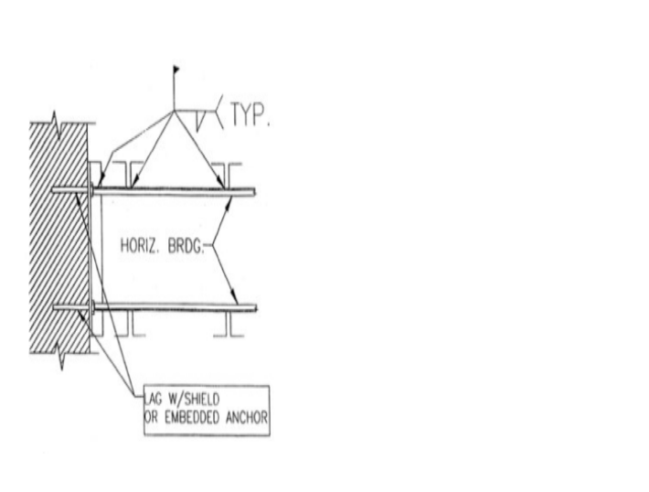Appendix C to Subpart R – Illustrations of Bridging Terminus Points: Nonmandatory Guidelines for Complying With §§1926.757(a)(10) and 1926.757(c)(5)

Horizontal Bridging Terminus at Wall

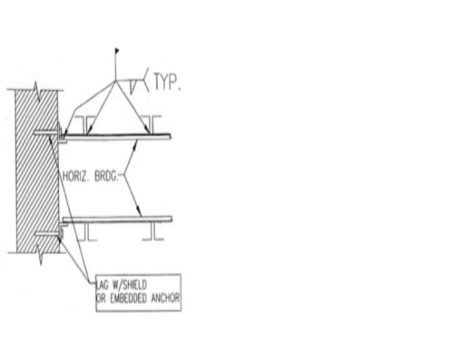

Horizontal Bridging Terminus at Wall

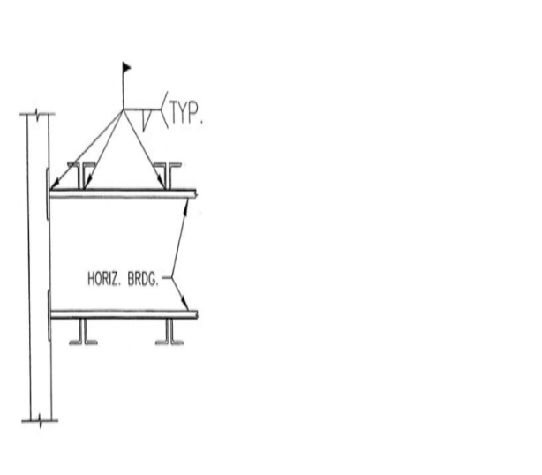Horizontal Bridging Terminus at Panel Wall

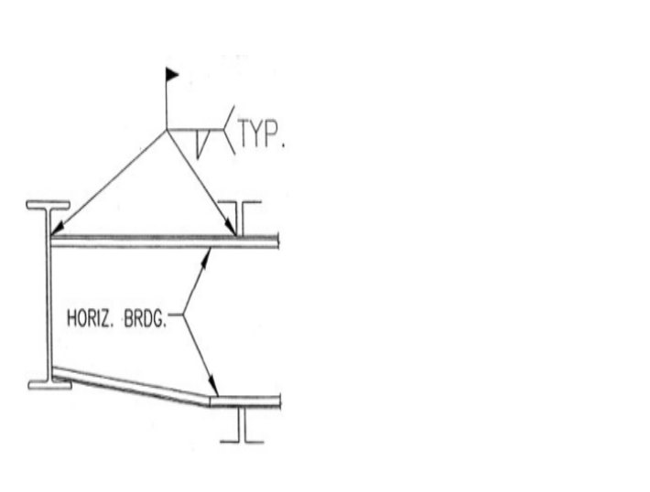
Horizontal Bridging Terminus at Structural Shape

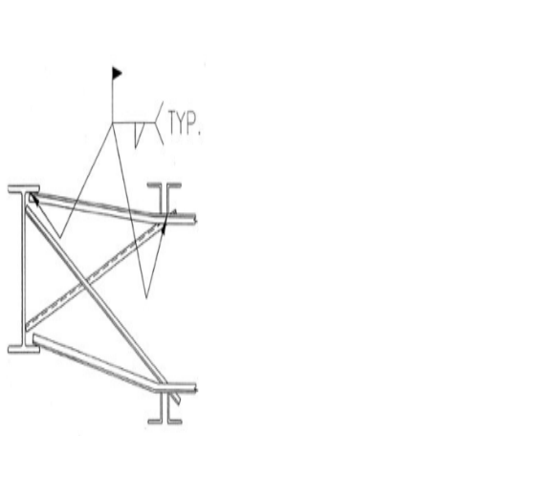Horizontal Bridging Terminus at Structural Shape with Optional “X-Bridging”

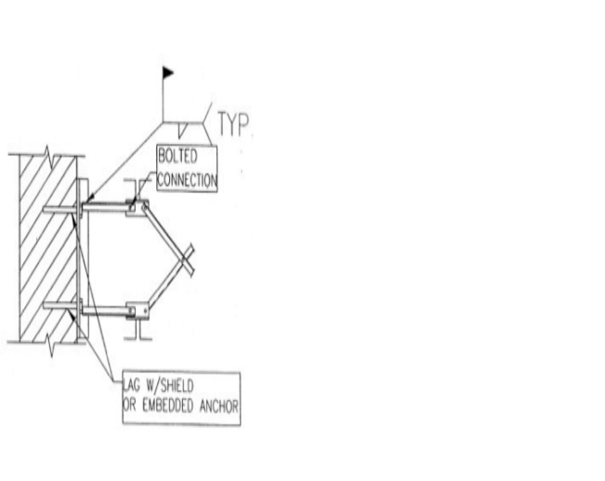
Bolted Diagonal Bridging Terminus at Wall

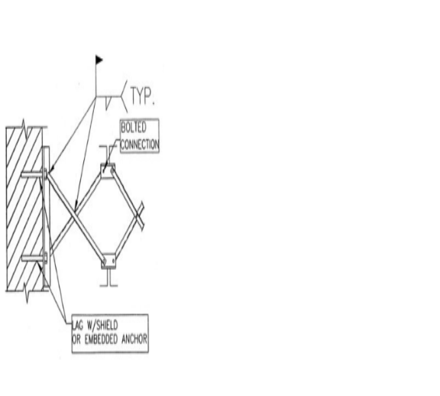Bolted Diagonal Bridging Terminus at Wall

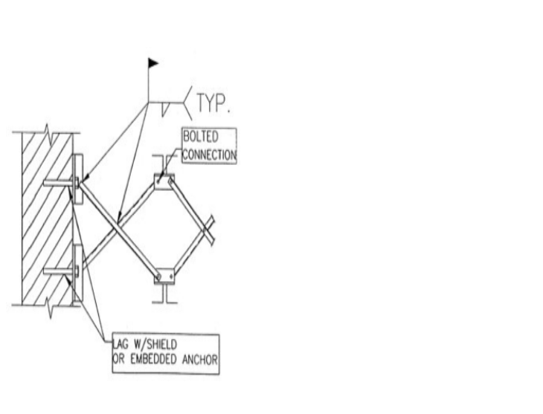

Bolted Diagonal Bridging Terminus at Wall

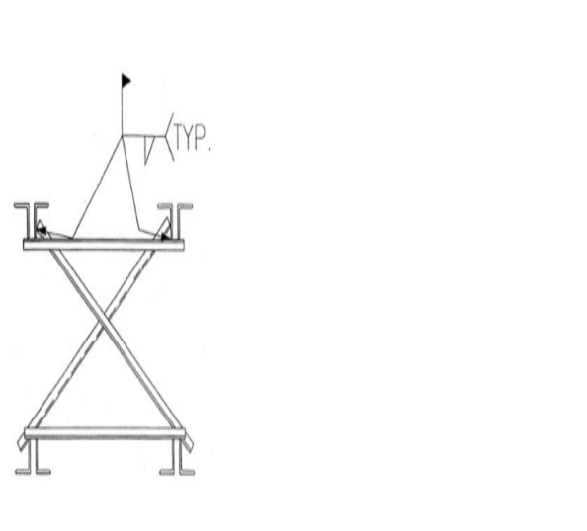Joists Pair Bridging Terminus Point

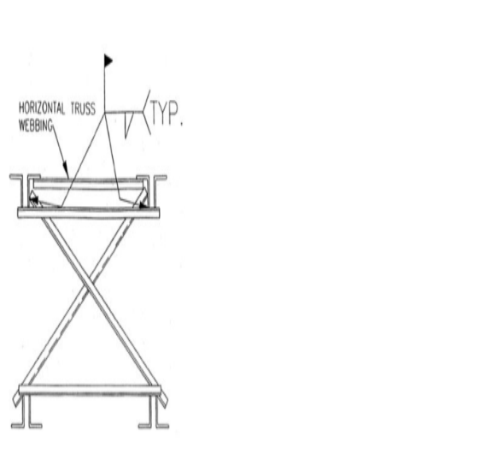Joists Pair Bridging Terminus Point with Horizontal Truss

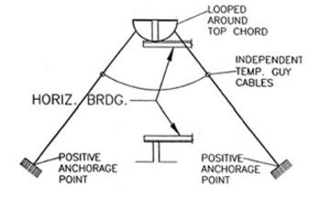
Horizontal Bridging Terminus Point Secured By Temporary Guy Cables

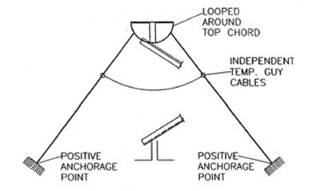
Diagonal Bridging Terminus Point Secured By Temporary Guy Cables

BILLING CODE 4510-26-C

Stat. Auth.: ORS 654.025(2) and 656.726(4).
Stats. Implemented: ORS 654.001 through 654.295.
Hist: OR-OSHA Admin. Order 3-2002, f. 4/15/02, ef. 4/18/02.
Appendix D to Subpart R – Illustration of the Use of Control Lines to Demarcate Controlled Decking Zones (CDZs): Nonmandatory Guidelines for Complying with §1926.760(c)(3)

(1) When used to control access to areas where leading edge and initial securement of metal deck and other operations connected with leading edge work are taking place, the controlled decking zone (CDZ) is defined by a control line or by any other means that restricts access.
(i) A control line for a CDZ is erected not less than 6 feet (1.8 m) nor more than 90 feet (27.4 m) from the leading edge.
(ii) Control lines extend along the entire length of the unprotected or leading edge and are approximately parallel to the unprotected or leading edge.
(iii) Control lines are connected on each side to a guardrail system, wall, stanchion or other suitable anchorage.
(2) Control lines consist of ropes, wires, tapes, or equivalent materials, and supporting stanchions as follows:
(i) Each line is rigged and supported in such a way that its lowest point (including sag) is not less than 39 inches (1.0 m) from the walking/working surface and its highest point is not more than 45 inches (1.3 m) from the walking/working surface.
(ii) Each line has a minimum breaking strength of 200 pounds (90.8 kg).

[66 FR 5277, Jan. 18, 2001]

Stat. Auth.: ORS 654.025(2) and 656.726(4).
Stats. Implemented: ORS 654.001 through 654.295.
Hist: OR-OSHA Admin. Order 8-2003, f. 12/30/03, ef. 1/1/04.

Appendix E to Subpart R – Training: Nonmandatory Guidelines for Complying with §1926.761

The training requirements of §1926.761 will be deemed to have been met if employees have completed a training course on steel erection, including instruction in the provisions of this standard, that has been approved by the U.S. Department of Labor Bureau of Apprenticeship.

Stat. Auth.: ORS 654.025(2) and 656.726(4).
Stats. Implemented: ORS 654.001 through 654.295.
Hist: OR-OSHA Admin. Order 3-2002, f. 4/15/02, ef. 4/18/02.

Appendix F to Subpart R – Perimeter Columns: Nonmandatory Guidelines for Complying with §1926.756(e) to Protect the Unprotected Side or Edge of a Walking/Working Surface

In multi-story structures, when holes in the column web are used for perimeter safety cables, the column splice must be placed sufficiently high so as not to interfere with any attachments to the column necessary for the column splice. Column splices are recommended to be placed at every other or fourth levels as design allows. Column splices at third levels are detrimental to the erection process and should be avoided if possible.

Stat. Auth.: ORS 654.025(2) and 656.726(4).
Stats. Implemented: ORS 654.001 through 654.295.
Hist: OR-OSHA Admin. Order 3-2002, f. 4/15/02, ef. 4/18/02.

Appendix G to Subpart R – §1926.502(b)-(e) Fall Protection Systems Criteria and Practices

(b) “Guardrail systems.” Guardrail systems and their use shall comply with the following provisions:
(1) Top edge height of top rails, or equivalent guardrail system members, shall be 42 inches (1.1 m) plus or minus 3 inches (8 cm) above the walking/working level. When conditions warrant, the height of the top edge may exceed the 45-inch height, provided the guardrail system meets all other criteria of this paragraph (§1926.502(b)).
Note: When employees are using stilts, the top edge height of the top rail, or equivalent member, shall be increased an amount equal to the height of the stilts.
(2) Midrails, screens, mesh, intermediate vertical members, or equivalent intermediate structural members shall be installed between the top edge of the guardrail system and the walking/working surface when there is no wall or parapet wall at least 21 inches (53 cm) high.
(i) Midrails, when used, shall be installed at a height midway between the top edge of the guardrail system and the walking/working level.
(ii) Screens and mesh, when used, shall extend from the top rail to the walking/ working level and along the entire opening between top rail supports.
(iii) Intermediate members (such as balusters), when used between posts, shall be not more than 19 inches (48 cm) apart.
(iv) Other structural members (such as additional midrails and architectural panels) shall be installed such that there are no openings in the guardrail system that are more than 19 inches (.5 m) wide.
(3) Guardrail systems shall be capable of withstanding, without failure, a force of at least 200 pounds (890 N) applied within 2 inches (5.1 cm) of the top edge, in any outward or downward direction, at any point along the top edge.
(4) When the 200 pound (890 N) test load specified in paragraph (b)(3) of this section (§1926.502) is applied in a downward direction, the top edge of the guardrail shall not deflect to a height less than 39 inches (1.0 m) above the walking/working level. Guardrail system components selected and constructed in accordance with the appendix B to subpart M of this part will be deemed to meet this requirement.
(5) Midrails, screens, mesh, intermediate vertical members, solid panels, and equivalent structural members shall be capable of withstanding, without failure, a force of at least 150 pounds (666 N) applied in any downward or outward direction at any point along the midrail or other member.
(6) Guardrail systems shall be so surfaced as to prevent injury to an employee from punctures or lacerations, and to prevent snagging of clothing.
(7) The ends of all top rails and midrails shall not overhang the terminal posts, except where such overhang does not constitute a projection hazard.
(8) Steel banding and plastic banding shall not be used as top rails or midrails.
(9) Top rails and midrails shall be at least one-quarter inch (0.6 cm) nominal diameter or thickness to prevent cuts and lacerations. If wire rope is used for top rails, it shall be flagged at not more than 6-foot intervals with high-visibility material.
(10) When guardrail systems are used at hoisting areas, a chain, gate or removable guardrail section shall be placed across the access opening between guardrail sections when hoisting operations are not taking place.
(11) When guardrail systems are used at holes, they shall be erected on all unprotected sides or edges of the hole.
(12) When guardrail systems are used around holes used for the passage of materials, the hole shall have not more than two sides provided with removable guardrail sections to allow the passage of materials. When the hole is not in use, it shall be closed over with a cover, or a guardrail system shall be provided along all unprotected sides or edges.
(13) When guardrail systems are used around holes which are used as points of access (such as ladderways), they shall be provided with a gate, or be so offset that a person cannot walk directly into the hole.
(14) Guardrail systems used on ramps and runways shall be erected along each unprotected side or edge.
(15) Manila, plastic or synthetic rope being used for top rails or midrails shall be inspected as frequently as necessary to ensure that it continues to meet the strength requirements of paragraph (b)(3) of this section (§1926.502).
(c) Safety net systems. Safety net systems and their use shall comply with the following provisions:
(1) Safety nets shall be installed as close as practicable under the walking/working surface on which employees are working, but in no case more than 30 feet (9.1 m) below such level. When nets are used on bridges, the potential fall area from the walking/working surface to the net shall be unobstructed.
(2) Safety nets shall extend outward from the outermost projection of the work surface as follows:

Vertical distance from working  level to horizontal plane of net | Minimum required horizontal distance of outer  edge of net from the edge of the working surface
Up to 5 feet  More than 5 feet up to 10 feet  More than 10 feet | 8 feet  10 feet  13 feet

(3) Safety nets shall be installed with sufficient clearance under them to prevent contact with the surface or structures below when subjected to an impact force equal to the drop test specified in paragraph (4) of this section [§1926.502].
(4) Safety nets and their installations shall be capable of absorbing an impact force equal to that produced by the drop test specified in paragraph (c)(4)(i) of this section [§1926.502].
(i) Except as provided in paragraph (c)(4)(ii) of this section (§1926.502), safety nets and safety net installations shall be drop-tested at the jobsite after initial installation and before being used as a fall protection system, whenever relocated, after major repair, and at 6-month intervals if left in one place. The drop-test shall consist of a 400 pound (180 kg) bag of sand 30+ or -2 inches (76+ or -5 cm) in diameter dropped into the net from the highest walking/working surface at which employees are exposed to fall hazards, but not from less than 42 inches (1.1 m) above that level.
(ii) When the employer can demonstrate that it is unreasonable to perform the drop-test required by paragraph (c)(4)(i) of this section (§1926.502), the employer (or a designated competent person) shall certify that the net and net installation is in compliance with the provisions of paragraphs (c)(3) and (c)(4)(i) of this section (§1926.502) by preparing a certification record prior to the net being used as a fall protection system. The certification record must include an identification of the net and net installation for which the certification record is being prepared; the date that it was determined that the identified net and net installation were in compliance with paragraph (c)(3) of this section (§1926.502) and the signature of the person making the determination and certification. The most recent certification record for each net and net installation shall be available at the jobsite for inspection.
(5) Defective nets shall not be used. Safety nets shall be inspected at least once a week for wear, damage, and other deterioration. Defective components shall be removed from service. Safety nets shall also be inspected after any occurrence which could affect the integrity of the safety net system.
(6) Materials, scrap pieces, equipment, and tools which have fallen into the safety net shall be removed as soon as possible from the net and at least before the next work shift.
(7) The maximum size of each safety net mesh opening shall not exceed 36 square inches (230 cm) nor be longer than 6 inches (15 cm) on any side, and the opening, measured center-to-center of mesh ropes or webbing, shall not be longer than 6 inches (15 cm). All mesh crossings shall be secured to prevent enlargement of the mesh opening.
(8) Each safety net (or section of it) shall have a border rope for webbing with a minimum breaking strength of 5,000 pounds (22.2 kN).
(9) Connections between safety net panels shall be as strong as integral net components and shall be spaced not more than 6 inches (15 cm) apart.
(d) “Personal fall arrest systems.” Personal fall arrest systems and their use shall comply with the provisions set forth below. Effective January 1, 1998, body belts are not acceptable as part of a personal fall arrest system.
Note: The use of a body belt in a positioning device system is acceptable and is regulated under paragraph (e) of this section (§1926.502).
(1) Connectors shall be drop forged, pressed or formed steel, or made of equivalent materials.
(2) Connectors shall have a corrosion-resistant finish, and all surfaces and edges shall be smooth to prevent damage to interfacing parts of the system.
(3) Dee-rings and snaphooks shall have a minimum tensile strength of 5,000 pounds (22.2 kN).
(4) Dee-rings and snaphooks shall be proof-tested to a minimum tensile load of 3,600 pounds (16 kN) without cracking, breaking, or taking permanent deformation.
(5) Snaphooks shall be sized to be compatible with the member to which they are connected to prevent unintentional disengagement of the snaphook by depression of the snaphook keeper by the connected member, or shall be a locking type snaphook designed and used to prevent disengagement of the snaphook by the contact of the snaphook keeper by the connected member. Effective January 1, 1998, only locking type snaphooks shall be used.
(6) Unless the snaphook is a locking type and designed for the following connections, snaphooks shall not be engaged:
(i) directly to webbing, rope or wire rope;
(ii) to each other;
(iii) to a dee-ring to which another snaphook or other connector is attached;
(iv) to a horizontal lifeline; or
(v) to any object which is incompatibly shaped or dimensioned in relation to the snaphook such that unintentional disengagement could occur by the connected object being able to depress the snaphook keeper and release itself.
(7) On suspended scaffolds or similar work platforms with horizontal lifelines which may become vertical lifelines, the devices used to connect to a horizontal lifeline shall be capable of locking in both directions on the lifeline.
(8) Horizontal lifelines shall be designed, installed, and used, under the supervision of a qualified person, as part of a complete personal fall arrest system, which maintains a safety factor of at least two.
(9) Lanyards and vertical lifelines shall have a minimum breaking strength of 5,000 pounds (22.2 kN).
(10)
(i) Except as provided in paragraph (d)(10)(ii) of this section [§1926.502], when vertical lifelines are used, each employee shall be attached to a separate lifeline.
(ii) During the construction of elevator shafts, two employees may be attached to the same lifeline in the hoistway, provided both employees are working atop a false car that is equipped with guardrails; the strength of the lifeline is 10,000 pounds [5,000 pounds per employee attached] (44.4 kN); and all other criteria specified in this paragraph for lifelines have been met.
(11) Lifelines shall be protected against being cut or abraded.
(12) Self-retracting lifelines and lanyards which automatically limit free fall distance to 2 feet (0.61 m) or less shall be capable of sustaining a minimum tensile load of 3,000 pounds (13.3 kN) applied to the device with the lifeline or lanyard in the fully extended position.
(13) Self-retracting lifelines and lanyards which do not limit free fall distance to 2 feet (0.61 m) or less, ripstitch lanyards, and tearing and deforming lanyards shall be capable of sustaining a minimum tensile load of 5,000 pounds (22.2 kN) applied to the device with the lifeline or lanyard in the fully extended position.
(14) Ropes and straps (webbing) used in lanyards, lifelines, and strength components of body belts and body harnesses shall be made from synthetic fibers.
(15) Anchorages used for attachment of personal fall arrest equipment shall be independent of any anchorage being used to support or suspend platforms and capable of supporting at least 5,000 pounds (22.2 kN) per employee attached, or shall be designed, installed, and used as follows:
(i) as part of a complete personal fall arrest system which maintains a safety factor of at least two; and
(ii) under the supervision of a qualified person.
(16) Personal fall arrest systems, when stopping a fall, shall:
(i) limit maximum arresting force on an employee to 900 pounds (4 kN) when used with a body belt;
(ii) limit maximum arresting force on an employee to 1,800 pounds (8 kN) when used with a body harness;
(iii) be rigged such that an employee can neither free fall more than 6 feet (1.8 m), nor contact any lower level;
(iv) bring an employee to a complete stop and limit maximum deceleration distance an employee travels to 3.5 feet (1.07 m); and,
(v) have sufficient strength to withstand twice the potential impact energy of an employee free falling a distance of 6 feet (1.8 m), or the free fall distance permitted by the system, whichever is less.
Note: If the personal fall arrest system meets the criteria and protocols contained in Appendix C to subpart M, and if the system is being used by an employee having a combined person and tool weight of less than 310 pounds (140 kg), the system will be considered to be in compliance with the provisions of paragraph (d)(16) of this section [§1926.502]. If the system is used by an employee having a combined tool and body weight of 310 pounds (140 kg) or more, then the employer must appropriately modify the criteria and protocols of the Appendix to provide proper protection for such heavier weights, or the system will not be deemed to be in compliance with the requirements of paragraph (d)(16) of this section (§1926.502).
(17) The attachment point of the body belt shall be located in the center of the wearer’s back. The attachment point of the body harness shall be located in the center of the wearer’s back near shoulder level, or above the wearer’s head.
(18) Body belts, harnesses, and components shall be used only for employee protection (as part of a personal fall arrest system or positioning device system) and not to hoist materials.
(19) Personal fall arrest systems and components subjected to impact loading shall be immediately removed from service and shall not be used again for employee protection until inspected and determined by a competent person to be undamaged and suitable for reuse.
(20) The employer shall provide for prompt rescue of employees in the event of a fall or shall assure that employees are able to rescue themselves.
(21) Personal fall arrest systems shall be inspected prior to each use for wear, damage and other deterioration, and defective components shall be removed from service.
(22) Body belts shall be at least one and five-eighths (1 5/8) inches (4.1 cm) wide.
(23) Personal fall arrest systems shall not be attached to guardrail systems, nor shall they be attached to hoists except as specified in other subparts of this Part.
(24) When a personal fall arrest system is used at hoist areas, it shall be rigged to allow the movement of the employee only as far as the edge of the walking/working surface.
(e) Positioning device systems. Positioning device systems and their use shall conform to the following provisions:
(1) Positioning devices shall be rigged such that an employee cannot free fall more than 2 feet (.9 m).
(2) Positioning devices shall be secured to an anchorage capable of supporting at least twice the potential impact load of an employee’s fall or 3,000 pounds (13.3 kN), whichever is greater.
(3) Connectors shall be drop forged, pressed or formed steel, or made of equivalent materials.
(4) Connectors shall have a corrosion-resistant finish, and all surfaces and edges shall be smooth to prevent damage to interfacing parts of this system.
(5) Connecting assemblies shall have a minimum tensile strength of 5,000 pounds (22.2 kN).
(6) Dee-rings and snaphooks shall be proof-tested to a minimum tensile load of 3,600 pounds (16 kN) without cracking, breaking, or taking permanent deformation.
(7) Snaphooks shall be sized to be compatible with the member to which they are connected to prevent unintentional disengagement of the snaphook by depression of the snaphook keeper by the connected member, or shall be a locking type snaphook designed and used to prevent disengagement of the snaphook by the contact of the snaphook keeper by the connected member. As of January 1, 1998, only locking type snaphooks shall be used.
(8) Unless the snaphook is a locking type and designed for the following connections, snaphooks shall not be engaged:
(i) directly to webbing, rope or wire rope;
(ii) to each other;
(iii) to a dee-ring to which another snaphook or other connector is attached;
(iv) to a horizontal lifeline; or to depress the snaphook keeper and release itself.
(v) to any object which is incompatibly shaped or dimensioned in relation to the snaphook such that unintentional disengagement could occur by the connected object being able to depress the snaphook keeper and release itself.
(9) Positioning device systems shall be inspected prior to each use for wear, damage, and other deterioration, and defective components shall be removed from service.
(10) Body belts, harnesses, and components shall be used only for employee protection (as part of a personal fall arrest system or positioning device system) and not to hoist materials.
[66 FR 5277, Jan. 18, 2001]

Stat. Auth.: ORS 654.025(2) and 656.726(4).
Stats. Implemented: ORS 654.001 through 654.295.
Hist: OR-OSHA Admin. Order 8-2003, f. 12/30/03, ef. 1/1/04.
Appendix H to Subpart R - Double Connections: Illustration of a Clipped End Connection and a Staggered Connection: Nonmandatory Guidelines for Complying with §1926.756(c)(1)

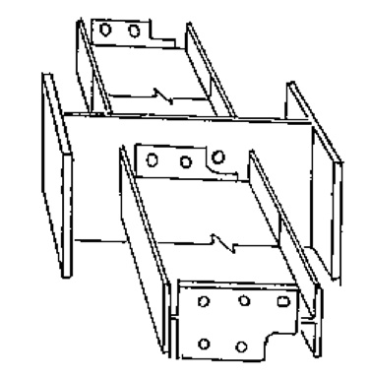

Clipped end connections are connection material on the end of a structural member which has a notch at the bottom and/or top to allow the bolt(s) of the first member placed on the opposite side of the central member to remain in place. The notch(es) fits around the nut or bolt head of the opposing member to allow the second member to be bolted up without removing the bolt(s) holding the first member.

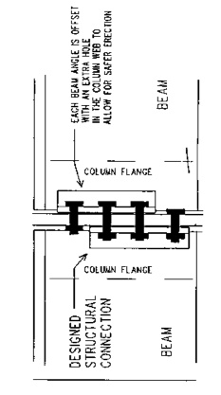

Staggered connections are connection material on a structural member in which all of the bolt holes in the common member web are not shared by the two incoming members in the final connection. The extra hole in the column web allows the erector to maintain at least a one bolt connection at all times while making the double connection.

[FR Doc. 01-979 Filed 1-17-01; 8:45 am]

BILLING CODE 4510-26-P

Stat. Auth.: ORS 654.025(2) and 656.726(4).
Stats. Implemented: ORS 654.001 through 654.295.
Hist: OR-OSHA Admin. Order 3-2002, f. 4/15/02, ef. 4/18/02.

