Section V
(previously Section IV of Oregon OSHA’s Technical Manual)

CONSTRUCTION OPERATIONS

CHAPTER 1: DEMOLITION

CHAPTER 2: EXCAVATIONS: HAZARD RECOGNITION IN TRENCHING AND SHORING

CHAPTER 3: CONTROLLING LEAD EXPOSURE IN THE CONSTRUCTION INDUSTRY: ENGINEERING AND WORK PRACTICE CONTROLS

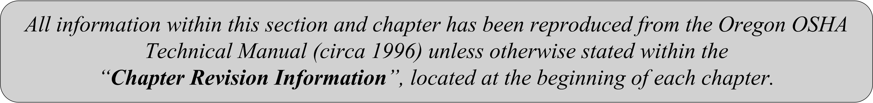

SECTION V: CHAPTER 3
CONTROLLING LEAD EXPOSURES IN THE CONSTRUCTION INDUSTRY:
ENGINEERING AND WORK PRACTICE CONTROLS

Chapter Revision Information:

- This chapter was previously identified as Section IV, Chapter 3 in Oregon OSHA’s circa 1996 Technical Manual. The section number was modified from Section IV to Section V in March 2014 to provide uniformity with federal OSHA’s Technical Manual (OTM).

- In March 2014, the chapter’s multilevel listing format was modified from an alphanumeric system to a roman numeral system.

- In March 2014, all references to “Material Safety Data Sheets (MSDS)” were replaced with references to “Safety Data Sheets (SDS).”

SECTION V: CHAPTER 3
CONTROLLING LEAD EXPOSURES IN THE CONSTRUCTION INDUSTRY:
ENGINEERING AND WORK PRACTICE CONTROLS

TABLE OF CONTENTS
I. | INTRODUCTION . . . . . . . . . . . . . . . . . . . . . . . . . . . . . . . . . . . . . . . . . . . |  |  | 5
II. | ENGINEERING AND WORK PRACTICE CONTROLS. . . . . . . . . . |  |  | 6
 | A. | Engineering Controls . . . . . . . . . . . . . . . . . . . . . . . . . . . . . . . . . . . . . . |  | 6
 | B. | Work Practice Controls . . . . . . . . . . . . . . . . . . . . . . . . . . . . . . . . . . . . |  | 7
III. | OPERATIONS . . . . . . . . . . . . . . . . . . . . . . . . . . . . . . . . . . . . . . . . . . . . . |  |  | 11
 | A. | Open Abrasive Blast Cleaning . . . . . . . . . . . . . . . . . . . . . . . . . . . . . . |  | 11
 | B. | Vacuum Blast Cleaning . . . . . . . . . . . . . . . . . . . . . . . . . . . . . . . . . . . . |  | 14
 | C. | Wet Abrasive Blast Cleaning. . . . . . . . . . . . . . . . . . . . . . . . . . . . . . . . |  | 14
 | D. | High-Pressure Water Jetting . . . . . . . . . . . . . . . . . . . . . . . . . . . . . . . . |  | 15
 | E. | High-Pressure with Abrasive Injection. . . . . . . . . . . . . . . . . . . . . . . . . |  | 16
 | F. | Ultrahigh-Pressure Water Jetting . . . . . . . . . . . . . . . . . . . . . . . . . . . . . |  | 16
 | G. | Sponge Jetting . . . . . . . . . . . . . . . . . . . . . . . . . . . . . . . . . . . . . . . . . . . |  | 16
 | H. | Carbon-Dioxide (Dry-Ice) Blasting . . . . . . . . . . . . . . . . . . . . . . . . . . . |  | 16
 | I. | Welding, Burning, and Torch Cutting . . . . . . . . . . . . . . . . . . . . . . . . . |  | 17
 | J. | Spray Painting with Lead-Based Paint. . . . . . . . . . . . . . . . . . . . . . . . . |  | 19
 | K. | Manual Scraping and Sanding of Lead-Based Paints. . . . . . . . . . . . . . |  | 19
 | L. | Manual Demolition and/or Removal of Plaster Walls or Building Components . . . . . . . . . . . . . . . . . . . . . . . . . . . . . . . . . . . . . . . . . . . . . |  | 20
 | M. | Heat-Gun Removal of Lead-Based Paint. . . . . . . . . . . . . . . . . . . . . . . |  | 20
 | N. | Chemical Stripping of Lead-Based Paint . . . . . . . . . . . . . . . . . . . . . . |  | 21
 | O. | Encapsulation of Lead-Based Paint . . . . . . . . . . . . . . . . . . . . . . . . . . . |  | 22
 | P. | Power Tool Cleaning . . . . . . . . . . . . . . . . . . . . . . . . . . . . . . . . . . . . . . |  | 22
 | Q. | Use of Lead Pots . . . . . . . . . . . . . . . . . . . . . . . . . . . . . . . . . . . . . . . . . |  | 23
 | R. | Soldering and Brazing . . . . . . . . . . . . . . . . . . . . . . . . . . . . . . . . . . . . . |  | 25
 | S. | Use of Lead-Containing Mortar in Chemical (Acid) Storage and Process Tanks . . . . . . . . . . . . . . . . . . . . . . . . . . . . . . . . . . . . . . . . . . . |  | 25
TABLE OF CONTENTS (CONTINUED)
 | T. | Handling Lead Shot, Bricks, or Sheets, and Lead-Foil Panels . . . . . . |  | 26
 | U. | Reinsulation Over Existing Mineral Wool . . . . . . . . . . . . . . . . . . . . . |  | 26
 | V. | Removal and Repair of Stained-Glass Windows . . . . . . . . . . . . . . . . |  | 27
 | W. | Industrial Vacuuming . . . . . . . . . . . . . . . . . . . . . . . . . . . . . . . . . . . . . |  | 27
 | X. | Miscellaneous Activities . . . . . . . . . . . . . . . . . . . . . . . . . . . . . . . . . . . |  | 27
 | Y. | Lead Abatement Activities (Commercial/Industrial and Residential) |  | 29
IV. | BIBLIOGRAPHY. . . . . . . . . . . . . . . . . . . . . . . . . . . . . . |  |  | 29
LIST OF APPDENENDICES
 | APPENDIX: 3-1 |  | Lead-Related Construction Tasks and Their Presumed 8-Hour TWA Exposure Levels . . . . . . . . . | 31

I. Introduction
This chapter provides OR- OSHA compliance officers and safety and health professionals with general information on the types of construction activities involving worker exposure to lead and the feasible engineering and work practice controls to reduce these exposures. The construction activities identified range from those such as abrasive blasting and welding, cutting, and burning, where exposures to lead are often high, to encapsulating lead-based paint or using lead pots, where exposures are generally low.

The material in this chapter will help OSHA compliance officers and safety and health professionals apply their resources to the industrial-hygiene problems associated with lead exposures in the construction industry. General engineering and work practice controls that can be applied to almost any construction activity are addressed in Section B, below.

This chapter also describes those lead-related tasks and operations that give rise to lead exposures among construction workers. Recommended/feasible engineering controls (e.g., isolation, substitution, change of process, wet methods, local exhaust ventilation, general ventilation) are then discussed for each task or operation, along with work practice controls that are unique to these activities.

The current OSHA standard (29 CFR 1926.62) for lead exposure in construction has a permissible exposure limit (PEL) of 50 micrograms per cubic meter of air (50 µg/m³), measured as an 8-hour time-weighted average (TWA). As with all OSHA health standards, when the PEL is exceeded, the hierarchy of controls requires employers to institute feasible engineering and work practice controls as the primary means to reduce and maintain employee exposures to levels at or below the PEL.

When all feasible engineering and work practice controls have been implemented but have proven inadequate to meet the PEL, employers must nonetheless implement these controls and must supplement them with appropriate respiratory protection. The employer also must ensure that employees wear the respiratory protection provided when it is required.

Certain lead-related construction tasks commonly produce exposures above the PEL and often orders of magnitude above the PEL. The OSHA lead standard for construction is unique in that it groups tasks (Appendix V:3-1) that are presumed to be associated with employee exposures above the PEL into three lead-exposure ranges. The exposure ranges assigned to the different categories of tasks are based on data collected by OSHA and other sources including two advisory groups.

Until an employer performs an employee-exposure assessment and determines the magnitude of the exposures actually occurring during the lead-related activity, the employer must assume that employees performing that task are exposed to the lead concentrations indicated in Appendix
V:3-1. For all three groups of tasks, employers are required to provide respiratory protection appropriate to the task's presumed exposure level, protective work clothing and equipment, change areas, hand-washing facilities, training, and the initial medical surveillance prescribed by paragraph (d)(2)(v) of the standard (29 CFR 1926.62). The only difference in the provisions applying to the three categories of tasks is the degree of respiratory protection required.

II. Engineering and Work Practice Controls

A. Engineering Controls

Engineering controls, such as ventilation, and good work practices are the preferred methods of minimizing exposures to airborne lead at the worksite. The engineering control methods that can be used to reduce or eliminate lead exposures can be grouped into three main categories: (1)
substitution, (2) isolation, and (3) ventilation. Engineering controls are the first line of defense in protecting workers from hazardous exposures.

SUBSTITUTION

Substitution includes using a material that is less hazardous than lead, changing from one type of process equipment to another, or even, in some cases, changing the process itself to reduce the potential exposure to lead. In other words, material, equipment, or an entire process can be substituted to provide effective control of a lead hazard. However, in choosing alternative methods, a hazard evaluation should be conducted to identify inherent hazards of the method and equipment.

Examples of substitution include:

- Use of a less hazardous material: applying a nonleaded paint rather than a coating that contains lead.

- Change in process equipment: using less dusty methods such as vacuum blast cleaning, wet abrasive blast cleaning, shrouded power tool cleaning, or chemical stripping to substitute for open abrasive blast cleaning to reduce exposure to respirable airborne particulates containing lead.

- Change in process: performing demolition work using mobile hydraulic shears instead of a cutting torch to reduce exposure to lead fumes generated by heating lead compounds.

Any material that is being considered as a substitute for a lead-based paint should be evaluated to ensure that it does not contain equally or more toxic components (e.g., cadmium or chromates). Because substitute materials can also be hazardous, employers must obtain a Safety Data Sheet (SDS) before a material is used in the workplace. If the SDS identifies the material as hazardous, as defined by OSHA's hazard communication standard (29 CFR 1926.59), an SDS must be maintained at the job site and proper protective measures must be implemented prior to usage of the material.

ISOLATION

Isolation is a method of limiting lead exposure to those employees who are working directly with it. A method which isolates lead contamination and thus protects both nonessential workers, bystanders, and the environment is to erect a sealed containment structure around open abrasive blasting operations. However, this method may substantially increase the lead exposures of the workers doing the blasting inside the structure. The containment structure must therefore be provided with negative-pressure exhaust ventilation to reduce workers' exposure to lead, improve visibility, and reduce emissions from the enclosure.

VENTILATION

Ventilation, either local or dilution (general), is probably the most important engineering control available to the safety and health professional to maintain airborne concentrations of lead at acceptable levels. Local exhaust ventilation, which includes both portable ventilation systems and shrouded tools supplied with ventilation, is generally the preferred method. If a local exhaust system is properly designed, it will capture and control lead particles at or near the source of generation and transport these particles to a collection system before they can be dispersed into the work environment.

Dilution ventilation, on the other hand, allows lead particles generated by work activities to spread throughout the work area and then dilutes the concentration of particles by circulating large quantities of air into and out from the work area. For work operations where the sources of lead dust generation are numerous and widely distributed (e.g., open abrasive blasting conducted in containment structures), dilution ventilation may be the best control .

Examples of ventilation controls include:

- Power tools that are equipped with dust collection shrouds or other attachments for dust removal and are exhausted through a High-Efficiency Particulate Air (HEPA) vacuum system;

- Vacuum blast nozzles (vacuum blasting is a variation on open abrasive blasting). In this type of blasting, the blast nozzle has local containment (a shroud) at its end, and containment is usually accomplished through brush-lined attachments at the outer periphery and a vacuum inlet between the blast nozzle and the outer brushes.

- Containment structures that are provided with negative-pressure dilution ventilation systems to reduce airborne lead concentrations within the enclosure, increase visibility, and control emissions of particulate matter to the environment.

B. Work Practice Controls

Work practices involve the way a task is performed. OSHA has found that appropriate work practices can be a vital aid in lowering worker exposures to hazardous substances and in achieving compliance with the PEL. Some fundamental and easily implemented work practices are:
(1) good housekeeping,
(2) use of appropriate personal hygiene practices,
(3) periodic inspection and maintenance of process and control equipment,
(4) use of proper procedures to perform a task,
(5) provision of supervision to ensure that the proper procedures are followed, and
(6) use of administrative controls.

HOUSEKEEPING

A rigorous housekeeping program is necessary in many jobs to keep airborne lead levels at or below permissible exposure limits. Good housekeeping involves a regular schedule of housekeeping activities to remove accumulations of lead dust and lead-containing debris. The schedule should be adapted to exposure conditions at a particular worksite.

All workplace surfaces must be maintained as free as practicable of accumulations of lead dust. Lead dust on overhead ledges, equipment, floors, and other surfaces must be removed to prevent traffic, vibration, or random air currents from re-entraining the lead-laden dust and making it
airborne again. Regularly scheduled clean-ups are important because they minimize the re-entrainment of lead dust into the air, which otherwise serves as an additional source of exposure that engineering controls are generally not designed to control.

Vacuuming is considered the most reliable method of cleaning dusty surfaces, but any effective method that minimizes the likelihood of re-entrainment may be used (for example, a wet floor scrubber). When vacuuming equipment is used, the vacuums must be equipped with high-efficiency particulate air (HEPA) filters(1926.62(h)(4)). Blowing with compressed air is generally prohibited as a cleaning method, unless the compressed air is used in conjunction with a ventilation system that is designed to capture the airborne dust created by the compressed air (e.g., dust "blowdown" inside a negative-pressure containment structure). In addition, all persons doing the cleanup should be provided with suitable respiratory protection and personal protective
clothing to prevent contact with lead.

Where feasible, lead-containing debris and contaminated items accumulated for disposal should be wet-misted before handling. Such materials must be collected and put into sealed impermeable bags or other closed impermeable containers. Bags and containers must be labeled to indicate that they contain lead-containing waste.

PERSONAL HYGIENE PRACTICES

Personal hygiene is also an important element in any program to protect workers from exposure to lead dust. When employee exposure is above the PEL, the lead standard requires the employer to provide, and ensure that workers use, adequate shower facilities (where feasible), hand-washing facilities, clean change areas, and separate noncontaminated eating areas. Employees must also wash their hands and faces prior to eating, drinking, using tobacco products, or applying cosmetics, and they must not eat, drink, use tobacco products, or apply cosmetics in any work area where the PEL is exceeded. In addition, employees must not enter lunchroom facilities or eating areas while wearing protective work clothing or equipment unless surface lead dust has first been removed from the clothing or equipment by vacuuming or another cleaning method that limits dispersion of lead dust.

Workers who do not shower and change into clean clothing before leaving the worksite may contaminate their homes and vehicles with lead dust. Other members of the household may then be exposed to harmful amounts of lead. A recent NIOSH publication (NIOSH 1992 see section D in the bibliography) points out the dangers of "take-home" lead contamination. For the same reason, vehicles driven to the worksite should be parked where they will not be contaminated with lead.

The personal hygiene measures described above will reduce worker exposure to lead and decrease the likelihood of lead absorption caused by ingestion or inhalation of lead particles.
In addition, these measures will minimize employee exposure to lead after the work shift ends, significantly reduce the movement of lead from the worksite, and provide added protection to employees and their families.

CHANGE AREAS

When employee airborne exposures to lead are above the PEL, the employer must provide employees with a clean change area that is equipped with storage facilities for street clothes and a separate area with facilities for the removal and storage of lead-contaminated protective work clothing and equipment. Separate clean and dirty change areas are essential in preventing cross-contamination of the employees' street and work clothing.

Clean change areas are used to remove street clothes, to suit up in clean work clothes (protective clothing), and to don respirators prior to beginning work, and to dress in street clothes after work. No lead-contaminated items are permitted to enter the clean change area.

Work clothing should be worn only on the job site. Under no circumstances should lead-contaminated work clothes be laundered at home or taken from the worksite, except to be laundered professionally or properly disposed of following applicable Federal, State, and local regulations.

SHOWERS

When employee exposures exceed the PEL, the employer must provide employees with suitable shower facilities, where feasible, so that exposed employees can remove accumulated lead dust from their skin and hair prior to leaving the worksite. Where shower facilities are available, employees must shower at the end of the work shift before changing into their street clothes and leaving the worksite. Showers must be equipped with hot and cold water.

WASHING FACILITIES

Washing facilities must be provided to employees in accordance with the requirements of 29 CFR 1926.51(f). Water, soap, and clean towels are to be provided for this purpose. Where showers are not provided, the employer must ensure that employees wash their hands and faces at the end of the work shift.

EATING FACILITIES

The employer must provide employees who are exposed to lead at levels exceeding the PEL with eating facilities or designated areas that are readily accessible to employees and must ensure that the eating area is free from lead contamination. To further minimize the possibility of food
contamination and reduce the likelihood of additional lead absorption from contaminated food, beverages, tobacco, and cosmetic products, the employer must prohibit the storage, use, or consumption of these products in any area where lead dust or fumes may be present.

PERIODIC INSPECTION AND MAINTENANCE

Periodic inspection and maintenance of process equipment and control equipment, such as ventilation systems, is another important work practice control. At worksites where full containment is used as an environmental control, the failure of the ventilation system for the containment area can result in hazardous exposures to workers within the enclosure. Equipment that is near failure or in disrepair will not perform as intended. Regular inspections can detect abnormal conditions so that timely maintenance can be performed. If process and control equipment is routinely inspected, maintained, and repaired, or is replaced before failure occurs, there is less chance that hazardous employee exposures will occur.

PERFORMANCE OF TASK

In addition to the work practice controls previously described in Section B, the employer must provide training and information to employees as required by OSHA's lead in construction (29CFR 1926.62), hazard communication (29 CFR 1926.59), and safety training and education (29 CFR 1926.21) standards. One important element of this program is training workers to follow the proper work practices and procedures for their jobs. Workers must know the proper way to perform job tasks to minimize their exposure to lead and to maximize the effectiveness of engineering controls. For example, if a worker performs a task away from (rather than close to) an exhaust hood, the control measure will be unable to capture the particulates generated by the task and will thus be ineffective.

In certain applications such as abatement in buildings, wet methods can significantly reduce the generation of lead-containing dust in the work area. Wetting of surfaces with water mist prior to sanding, scraping, or sawing, and wetting lead-containing building components prior to removal will minimize airborne dust generation during these activities. Failure to operate engineering controls properly may also contaminate the work area. Workers can be informed of safe operating procedures through fact sheets, discussions at safety meetings, and other educational means.

SUPERVISION

Good supervision is another important work practice. It provides needed support for ensuring that proper work practices are followed by workers. By directing a worker to position the exhaust hood properly or to improve work practice, such as standing to the side or upwind of the cutting torch to avoid the smoke plume, a supervisor can do much to minimize unnecessary employee exposure to airborne contaminants.

The OSHA construction standard for lead also requires that a competent person perform frequent and regular inspections of job sites, materials, and equipment. A competent person is defined by the standard as one who is capable of identifying existing and predictable lead hazards and who has authorization to take prompt corrective measures to eliminate them.

ADMINISTRATIVE CONTROLS

Administrative controls are another form of work practice controls that can be used to influence the way a task is performed. Controls of this type generally involve scheduling of the work or the worker. For example, employee exposure can be controlled by scheduling construction activities or workers' tasks in ways that minimize employee exposure levels. One method the employer can use is to schedule the most dust- or fume-producing operations for a time when the fewest employees will be present.

Another method is worker rotation which involves rotating employees into and out of contaminated areas in the course of a shift, thereby reducing the full-shift exposure of any given
employee. When a worker is rotated out of the job that involves lead exposure, he or she is assigned to an area of the worksite that does not involve lead exposure. If this method is used to control worker exposure to lead, the lead standard requires that the employer implement a job rotation schedule that (1) identifies each affected worker, (2) lists the duration and exposure levels at each job or work station where each affected employee is located, and (3) lists any other
information that may be useful in assessing the reliability of administrative controls to reduce exposure to lead.

III. Operations
This section describes the job operations that take place in construction worksites and involve worker exposures to lead. Although this list of operations is extensive, it is not necessarily inclusive (i.e., other construction activities not mentioned here may also involve lead exposure). OSHA's lead standard for construction applies to any construction activity that potentially exposes workers to airborne concentrations of lead.

A. Open Abrasive Blast Cleaning

The most common method of removing lead-based paints is open abrasive blast cleaning. The abrasive medium, generally steel shot/grit, sand, or slag, is propelled through a hose by compressed air. The abrasive material abrades the surface of the structure, exposing the steel substrate underneath. The abrasive also conditions the substrate, forming a "profile" of the metal, which improves the adherence of the new paint. Work is generally organized so that blasting proceeds for approximately one-half day, followed by compressed air cleaning of the steel and application of the prime coat of paint. Prime coat painting must follow blasting immediately to prevent surface rust from forming. Intermediate or finish coats of paint are applied later.

Structures that are typically cleaned by open abrasive blasting are bridges, tanks and towers, locks and dams, pipe racks, pressure vessels and process equipment, supporting steel, and metal buildings. Until recently, abrasive blasting work was conducted in unobstructed air. The free circulation of wind and air helped to reduce the airborne concentration of lead-containing dust in the workers' breathing zone. Tarpaulins were generally used only to protect neighboring homes and automobiles from a damaging blast of abrasive or to reduce residents' complaints about overspray, dust, and dirt.

Currently, some State and local regulations require the use of enclosures or containment structures to prevent the uncontrolled dispersal of lead dust and debris into the environment. Although containment structures are designed to reduce the dispersion of lead into the environment, they usually increase worker exposure to airborne lead, reduce visibility, and increase the risk of slip and fall injuries due to waste material build-up on the footing surface of the enclosure.

Containment structures vary in their design and in their effectiveness in containing debris. Some containment structures consist of tarpaulins made of open mesh fabrics (screens) that are loosely fitted around the blasting area; some use rigid materials such as wood, metal, or plastic to enclose the blasting area; and some use a combination of flexible and rigid materials. Large air-moving devices may be connected to the enclosed containment structure to exhaust dust-laden
air and create a negative pressure with respect to the ambient atmosphere.

Containment or enclosure structures can be broadly classified as either partial or full. Partial containments refer to those that inherently allow some level of emission to the atmosphere outside of the containment. An example of a partial containment is a structure with loosely hung
permeable tarps and partially sealed joints and entryways. Full containment refers to a relatively tight enclosure (with tarps that are generally impermeable and fully sealed joints and entryways) where minimal or no fugitive emissions are expected to reach the outside environment. Partial or full containments can be used to contain entire structures or portions thereof.

Examples of the kinds of engineering controls and work practices that can be implemented to protect blasting workers are presented below.

ENGINEERING CONTROLS

- Containment/ventilation systems should be designed and operated so as to create a negative pressure within the structure, which reduces the dispersion of lead into the environment . The containment/ventilation system should be designed to optimize the flow of ventilation air past the worker(s), thereby reducing the airborne concentration of lead and increasing visibility. This can be accomplished by employing either a downdraft or crossdraft ventilation system that is properly balanced by a make-up air supply. Designs for the containment structure and ventilation systems should be specific to each task, because conditions can vary substantially from one worksite to another. The dust-laden air must be filtered prior to its release into the atmosphere.

- Mini-enclosures, which have smaller cross-sectional areas than conventional enclosures, can be erected. Mini-enclosures have advantages over larger conventional enclosures because the same size fan and dust collector can achieve much higher velocities past the helmets of the workers. Mini-enclosure containment structures are usually light-weight, low wind-loading structures that isolate that area where blasting and surface priming is taking place on a given day.

- The risk of silicosis is high among workers exposed to abrasive blasting with silica-containing media, and this hazard is difficult to control. The National Institute for Occupational Safety and Health (NIOSH) has therefore recommended since 1974 that silica sand (or other substances containing more than 1% crystalline silica) be prohibited as abrasive blasting material. A variety of materials such as slags and steel grit are available as alternative blasting media. Because some substitute materials may have their own unique hazards, the MSDS for the substitute material should be consulted before it is used.

- Blast cleaning with recyclable abrasive such as steel grit or aluminum oxide requires specialized equipment for vacuuming or collecting the abrasive for reuse, separating the lead dust and fines from the reusable abrasive, and, in the case of steel grit, maintaining clean, dry air to avoid rusting of the abrasive. In addition, the abrasive classifier must be extremely efficient in removing lead dust, to prevent it from being reintroduced into the containment and combining with the paint to increase worker exposures. Recycling equipment must be well maintained and regularly monitored to ensure it is removing lead effectively.

- When site conditions warrant, less dusty methods should be used in place of open abrasive blast cleaning. These include:

- Vacuum-blast cleaning,
- Wet abrasive blast cleaning,
- High-pressure water jetting,
- High-pressure water jetting with abrasive injection,
- Ultrahigh-pressure water jetting,
- Sponge jetting,
- Carbon-dioxide (dry-ice) blasting,
- Chemical stripping, and
- Power-tool cleaning.

WORK PRACTICE CONTROLS

Construction employers engaged in open abrasive blast cleaning operations should implement the following control measures:

- Develop and implement a good respiratory protection program in accordance with OSHA requirements in 29 CFR 1926.103 and OAR 437-003-037.

- Provide workers with Type CE abrasive-blast respirators; these are the only respirators suitable for use in abrasive-blasting operations. Currently there are only three models of Type CE abrasive blast respirators certified by MSHA/ NIOSH:

- A continuous-flow respirator with a loose-fitting hood that has a protection factor of 25,

- A continuous-flow respirator with a tight-fitting face-piece that has a protection factor of 50, and

- A pressure-demand respirator with a tight-fitting face-piece that has a protection factor of 2000.

The first two models (i.e., the continuous-flow respirators) should be used only for abrasive blast operations where the abrasive materials do not include silica sand and the level of contaminant in the ambient air does not exceed 25 or 50 times the recommended exposure limit, respectively. The third model, which is a pressure-demand respirator, must be worn whenever silica sand is used as an abrasive material (NIOSH 1993).

- Ensure to the extent possible that workers are upstream from the blasting operation to reduce their exposure to lead dust entrained in the ventilation air.

B. Vacuum Blast Cleaning

Vacuum blasting is a variation of open abrasive blasting. In this configuration, the blast nozzle has local containment (a shroud) at its end and containment is usually accomplished by brush-lined attachments at the outer periphery and a vacuum inlet between the blast nozzle and the outer brushes (Waagbo and McPhee 1991). The brushes prevent dispersion of the abrasive and debris as they rebound from the steel surface. These particles are removed from the work area by the built-in vacuum system. The abrasive itself can either be disposed of or cleaned and recycled.

If used properly, vacuum blast cleaning can achieve cleaning of good quality with minimal dust generation except in areas where access is difficult because of configuration (such as between back-to-back angles). A variety of heads are available to achieve a tight seal for inside corners, outside corners, and flat surfaces. The advantages of vacuum blasting are that most of the waste material and abrasive is collected at the site of generation and is therefore not transported to the
breathing zone of the worker, and that there may be little or no need for containment.

Vacuum blasting has several disadvantages (Knoy 1990). It is more time-consuming than conventional open abrasive blasting because the abrasive blast nozzle must be smaller to capture the ricocheting abrasive and dust. This restricts the dispersion of the abrasive and thus the size of the area that can be cleaned. Abrasive also may escape the vacuum head if the brush attachments do not seal completely around the substrate; poor seals may be caused by operator fatigue, poor
work practices or irregular surfaces and edges. Small areas and areas with gross irregularities cannot be effectively sealed by the shroud. The vacuum system and brushes obscure the blast surface, and some areas may therefore need to be blasted repeatedly because they are missed on the first or second pass. In addition, some vacuum heads are so heavy that mechanical suspension systems are needed to support them, and even then, the blasters may need to take frequent breaks.

C. Wet Abrasive Blast Cleaning

Wet abrasive blast cleaning is a modification of traditional open abrasive blast cleaning. This system uses compressed air to propel the abrasive medium to the surface being cleaned; however, water (which reduces dusting) is injected into the abrasive stream either before or after the abrasive exits the nozzle (Figure V:3-1).

The disadvantages of using water are that inhibitors may be necessary to avoid flash rusting, the containment must be designed to capture the water and debris generated by the cleaning process, wet abrasive/paint debris is more difficult to handle and transport than dry debris, and, unless the water can be filtered, it may add to the volume of debris generated. Because many corrosion inhibitors (e.g., nitrates, nitrites, and amines) raise industrial hygiene concerns, their use must be considered carefully.

Figure V:3-1. Wet Abrasive Blasting Cleaning

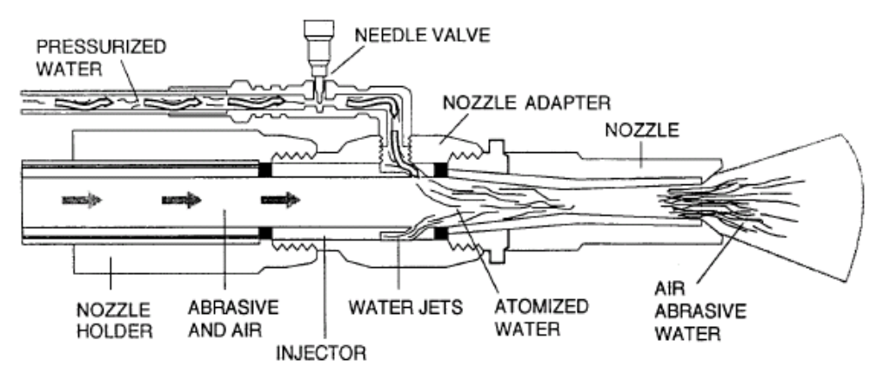

D. High-Pressure Water Jetting

High-pressure water jetting (6,000 to 25,000 psi) utilizes a pressure pump, a large volume of water, a specialized lance and nozzle assembly and, in some cases, a supply of inhibitor to prevent flash rusting. High-pressure water can remove loose paint and rust, but will not efficiently remove tight paint or tight rust, or mill scale. This technique does not create a profile (mechanically induced toothing pattern to enhance the adhesion of high-performance coatings) on its own, but if the original surface was blast cleaned, high-pressure water jetting can be used to remove the old paint and restore the original profile.

Because of the water, this kind of jetting generates little dust. The containment must be constructed to collect water rather than to control dust emissions. The debris generated is comprised of the removed paint and rust, along with the water. If the lead debris can be adequately filtered from the water, the volume of debris is low. If not, the volume of debris can be high. Typically, 5 to 10 gallons of water per minute are used.

Productivity can be high with this method if the objective is to remove only loose, flaky paint. If the objective is to remove tight paint, productivity may be low. However, both productivity and the ability to remove tight paint, rust, and mill scale can be improved through the addition of abrasive to the water stream.

E. High-Pressure Water Jetting with Abrasive Injection

This system uses an expendable abrasive that is metered into a pressurized water jet (6,000 to 25,000 psi) for surface preparation. Although airborne lead exposures are virtually eliminated with this approach, wet abrasive is more difficult to handle and move than dry abrasive, and the volume of debris also increases. Because the abrasive exposes the bare substrate, inhibitors such as sodium nitrate or amines are often added to the water to prevent flash rusting.

Abrasives used for injection include sand and slag materials, as well as soluble abrasives such as sodium bicarbonate. The sodium bicarbonate will not remove paint, rust, and mill scale
as efficiently as sand or slag abrasives. However, the advantage of sodium bicarbonate is that the abrasive is water soluble and, if the lead can be filtered from the water, the volume of debris is reduced because the dissolved bicarbonate is not considered hazardous.

F. Ultrahigh-Pressure Water Jetting

Ultrahigh-pressure water jetting utilizes pressurized water at pressures in excess of 25,000 psi. Ultrahigh-pressure water jetting is similar to high pressure water jetting except that the ultrahigh variant uses even higher pressures. This means that it cleans more efficiently and removes tight paint and rust more effectively. In addition, the volume of water required is reduced, with less than 5 gallons per minute typically used.

Because of the water, little dust is generated. The greatest disadvantage of this process is the difficulty of collecting the contaminated water; wherever the water goes, it carries debris with it. Dust generation, debris generation, and the type of containment necessary in ultrahigh-pressure water jetting are comparable to those in high-pressure water jetting. Inhibitors are also often required to avoid flash rusting. Mill scale is not removed; however, if the surface was previously blast cleaned, the profile of the original substrate can be restored.

G. Sponge Jetting

Sponge jetting involves the use of specialized blasting equipment that propels a combination of an abrasive material (e.g., steel, garnet) encased in a soft sponge (foam) medium. The high-density foam cleaning medium is absorptive and can be used either wet or dry. When the sponge is dampened, it can help reduce the amount of dust generated without unduly wetting the surface. The medium provides the impact needed to break the paint coating up into larger particles, and particle rebound is low because of the energy absorbed by the foam. The relatively small volume of dust generated by this method can help to reduce containment requirements, although some screens and tarping are necessary to isolate the work area and to allow the sponge and debris to be collected. Productivity is lower than for open abrasive blasting using more traditional abrasives, according to contractors who have used this product (CONSAD 1993).

H. Carbon-Dioxide (Dry-Ice) Blasting

Cryogenic cleaning by blasting with dry-ice pellets is one of the least-tried methods of surface preparation (Figure V:3-2). A stream of pellets cooled to about -100EF (-79EC) moves at high velocity through a blast hose and nozzle. The pellets impinge on the surface and then sublime, leaving only paint debris to be cleaned up. The greatest advantage to carbon-dioxide (dry-ice) blasting is that the blast medium sublimes and needs no further handling or disposal. However, when used in confined spaces, the potential for creating an oxygen-deficient environment is significant and must always be guarded against.

The cost of cryogenic cleaning, however, is still often prohibitive. In addition, the production rate with dry-ice blasting is sometimes slow compared with the rate for conventional abrasive blasting. Finally, because only the paint is removed, the surface may need to be "brush-off"
blasted with an abrasive to produce a rough surface to facilitate adhesion of the new coating.

Figure V:3-2. Dry-Ice Blast Cleaning
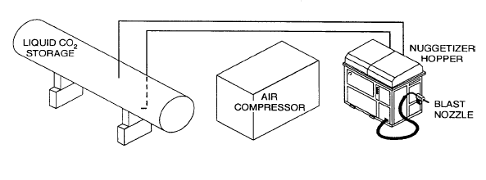

I. Welding, Burning, and Torching

Welding and cutting activities that potentially involve exposure to lead can occur as part of a number of construction projects such as highway/railroad bridge rehabilitation (including elevated mass-transit lines), demolition, and indoor and outdoor industrial facility maintenance and renovation. Lead exposures are generated when a piece of lead-based painted steel is heated to its melting point either by an oxyacetylene torch or an arc welder. In this situation, lead becomes airborne as a volatilized component of the coating.

The amount of time a worker may spend actually welding or cutting can vary from only a few minutes up to a full shift. In addition, the coating being worked on may consist of several layers of lead-based paint, each of which could contain as much as 50% lead. Taken together, these factors suggest that a worker's exposure to airborne lead during welding or cutting activities can vary widely and may be exceedingly high.

Lead burning, a process by which virgin or alloyed lead is melted with a torch or otherwise fused to another lead object, is typically performed in maintenance operations on electrostatic precipitators or during the installation of lead shot, bricks, or sheets in the walls or floors of health-care x-ray units or industrial sites. Lead health hazards in this operation, as in welding and torch cutting, are from lead that is superheated and released into the worker's breathing zone in the form of a fume.

ENGINEERING CONTROLS

The controls that can be used, depending on feasibility, are:

- Local exhaust ventilation (LEV) that has a flanged hood and is equipped with HEPA filtration may be appropriate where the use of LEV does not create safety hazards. Use of a flexible duct system requires that the welder be instructed to keep the duct close to the emission source and to ensure the duct is not twisted or bent.

- A fume-extractor gun that removes fumes from the point of generation (Figure V:3-3) is an alternative to an exhaust hood for gas-shielded arc-welding processes. Such extraction systems can reduce breathing zone concentrations by 70% or more (Hughes and Amendola 1982). These systems require that the gun and shielding gas flow rates be carefully balanced to maintain weld quality and still provide good exhaust flow.

- A longer cutting torch can be used in some situations to increase the distance from the lead source to the worker's breathing zone.

- Hydraulic shears can sometimes be used to mechanically cut steel that is coated with lead based-paint. The use of this method is limited by the ability of the shears to reach the cutting area.

- Whenever possible, pneumatic air tools should be used to remove rivets in lieu of burning and torch cutting.

Figure V:3-3. Fume-Extractor Gun
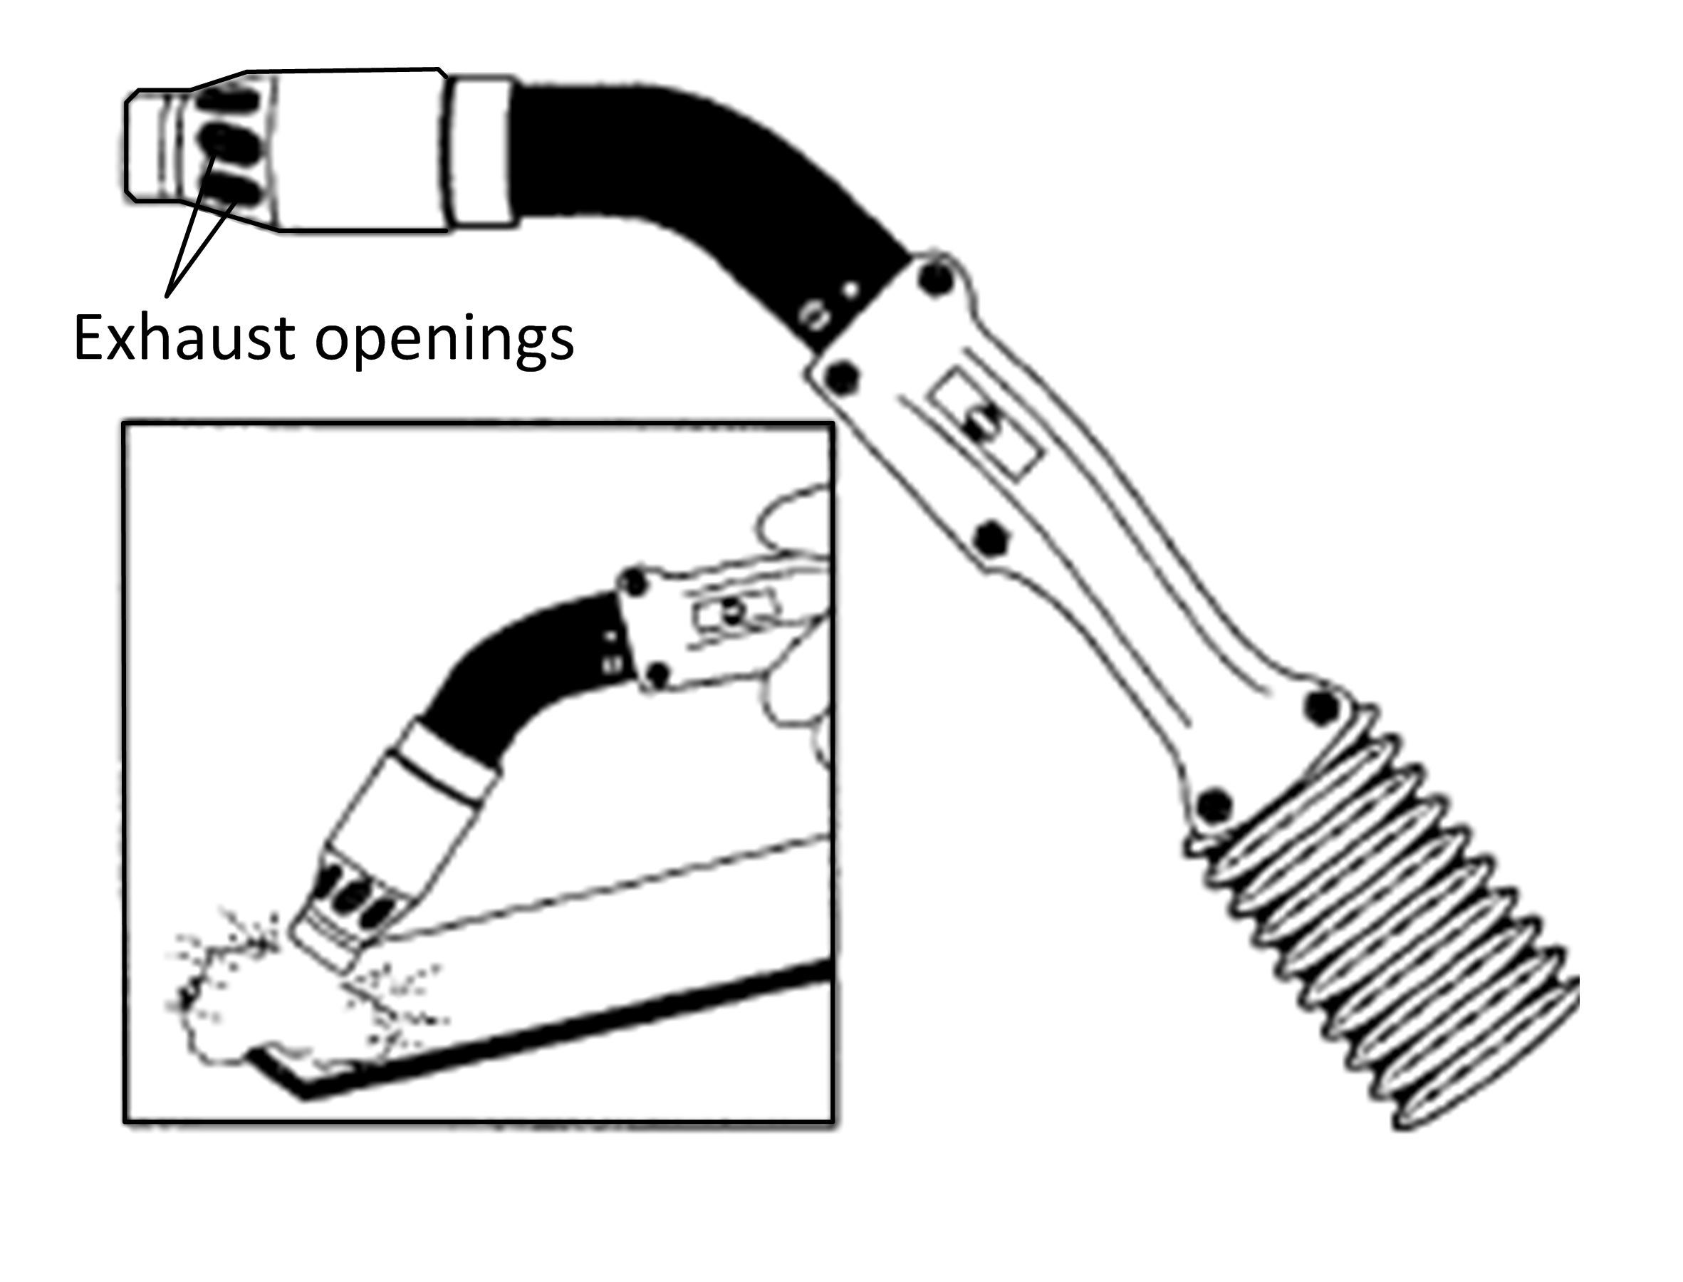
WORK PRACTICE CONTROLS

The following work practice controls will help to reduce worker exposures to lead during welding, burning, and torch cutting:

- Strip back all lead-based paint for a distance of at least 4 inches in all directions from the area of heat application. Chemical stripping, vacuum-shrouded hand tools, vacuum blasting, or other suitable method may be used. However, in enclosed spaces, strip back or protect the workers with air-line respirators in accordance with the requirements of 29CFR 1926.354(c) and Program Directive A-9.

- Ensure that workers avoid the smoke plume by standing to the side or upwind of the cutting torch whenever the configuration of the job permits.

- Prohibit burning to remove lead-based paint. Paint should be removed using other methods, such as chemical stripping, power tools (e.g., needle guns) with vacuum attachments, etc.

J. Spray Painting with Lead-Based Paint

In the construction field, the primary source of lead exposure in painting is red lead primers, although many finish coatings continue to contain a small percentage of lead. For most interior or exterior construction painting projects, workers employ conventional compressed-air spray equipment.

Overspray and rebound of the paint spray off the structure being painted increases the inhalation hazards to workers using lead-based paint. The magnitude of the painter's particulate exposure to lead is dependent on the product used, its lead content, and the quantity of paint applied.

ENGINEERING CONTROLS

The following engineering controls will reduce or eliminate worker exposures to lead during painting:

- Applying non-lead containing paints and primers.

- To the extent possible, replacing lead chromate with zinc.

- Hand-applying lead-based paint by brush or roller coating methods rather than spray methods.

- Using local exhaust ventilation with proper filtration. (The ability to use LEV may be limited by location of the painting operation.)

K. Manual Scraping and Sanding of Lead-Based Paints

Hand scraping of lead-based paints involves the use of a hand-held scraping tool to remove paint from coated surfaces. The health hazards in this activity are caused by the lead dust and paint chips produced in the scraping process. Hand sanding can also produce excessive dust. These activities are typically performed during residential and commercial/institutional lead abatement projects.

ENGINEERING AND WORK PRACTICE CONTROLS

The controls that employers can implement to protect workers performing scraping and sanding of lead-based paints are:

- Use of wet-sanding and wet-scraping methods in conjunction with HEPA vacuuming or HEPA mechanical ventilation. Wet methods include misting of peeling paint with water before scraping, and sanding and misting of debris prior to sweeping or vacuuming.

- Use of shrouded power tools with HEPA vacuum attachments. The shroud must be kept flush with the surface.

- Use of techniques with known low exposure potential, such as encapsulation and removal or replacement instead of hand-scraping and hand-sanding.

L. Manual Demolition and/or Removal of Plaster Walls or Building Components

The demolition of lead-painted plaster walls or building components is usually performed by striking a wall with a sledge hammer or similar tool. This results in an uncontrolled release of dust. High levels of airborne total dust and lead dust can be generated by breaking lead-painted plaster into small pieces.

Removal and replacement is the process of removing components (such as windows, doors, kitchen cabinets, and trim) that have lead-painted surfaces and installing new components that are free of lead-containing paint. Exposures may result from the release of dust and paint-chip particles when these items are removed with a prybar or cut with a saw. Unless the component is seriously deteriorated occupational exposures during this operation are minimal.

ENGINEERING AND WORK PRACTICE CONTROLS

The engineering controls and work practices used to reduce lead exposures during demolition/removal of architectural components are:

- Install partitions or other temporary barriers to allow for partial containment of dust to minimize exposures to other workers and building occupants.

- Keep surfaces and debris moist when disturbing them.

- Remove wallboard by cutting it into large pieces/sections with a carpet knife or shrouded saw with HEPA vacuum attachment.

M. Heat-Gun Removal of Lead-Based Paint

In this activity, the worker uses a heat gun, a tool similar in design to a hand-held hair dryer. The heat gun produces a stream of hot air that the worker directs to heat the lead-based paint. This heat separates the substrate, which is subsequently scraped off with a putty knife or similar tool.
The health hazards encountered are generated by lead fumes released into the air during the heating process and lead particulates created during the scraping process.

ENGINEERING AND WORK PRACTICE CONTROLS

The controls used to reduce lead exposure during heat gun operations are:

- Provide thermostatic control for heat guns to restrict operating temperatures to the lowest temperature that will allow for the effective removal of lead-based paint. [Note: HUD places a 700°F limit on the use of heat guns. However, NIOSH (1990) reports that the 700°F restriction for heat-gun nozzle airstream temperatures appears to limit the effectiveness of the guns in removing paint. To compensate for the airstream temperature limitation, workers often hold the gun nozzle close to the surfaces (less than one inch). This reduces the surface area heated and potentially increases the time required for paint removal and prolongs the duration of exposure. On the other hand, commercial heat guns operating at airstream temperatures of 1000°F can generate and disperse high levels of airborne lead.]

- Use techniques with known low exposure potential such as encapsulation and removal/replacement instead of hand scraping with a heat gun.

N. Chemical Stripping of Lead-Based Paint

Chemical stripping of old paint coatings is performed by applying solvent- or caustic-based strippers to the surface, either by hand or spray gun. The product remains on the surface for a period ranging from 5 minutes to 48 hours, depending on the thickness and composition of the paint being removed. Mechanical scrapers, a vacuum system, or pressurized water are then used to remove the product and the stripped paint. Finally, a wet-vac system is used to clean the
surface, although hard-to-reach areas may not be accessible to the vacuum. This system may employ vibrating brushes to help release the paint from the surface.

Some chemical stripping products are toxic (e.g., methylene chloride) when inhaled or absorbed through the skin, and many are skin irritants or skin corrosives. Consequently, appropriate controls must be implemented when using chemical strippers. Although OSHA does not prohibit the use of methylene chloride-based stripping products, some local, State, and other Federal authorities may prohibit its use in residential units.

In the industrial arena, some disadvantages of chemical stripping are that containment and collection of the waste materials may be difficult and productivity may be low compared with the rate for conventional abrasive blasting. Because chemical stripping removes only the paint, a final abrasive blast must often be performed to remove rust and mill scale and to provide the metal profile required for adhesion of the new paint. Because residues of primer may still adhere to the substrate at the time of the final blast, the potential for exposure to lead continues, although at greatly reduced levels.

O. Encapsulation of Lead-Based Paint

Encapsulation refers to processes that makes lead paint inaccessible by covering or sealing the lead-painted surfaces. This may be achieved by installing sheet-rock walls on top of the paint, covering surfaces with fiberglass, or recoating housing components with a nonlead-based paint.
Encapsulation is the best strategy if it provides relatively long term protection and does not require routine maintenance to ensure the integrity of the encapsulant. Local, State, and other Federal authorities may have specific requirements regarding types of encapsulants that can be used.

If surfaces are peeling or deteriorating and scraping is necessary prior to encapsulation, this method will produce lead dust and paint chips. If encapsulation is used over a surface covered with intact paint, little dust is generated and cleanup and waste disposal problems are therefore minimized.

Encapsulation may be a temporary measure because the lead-based paint that remains under the encapsulant may have to be disturbed at a future time and create a new potential for lead exposure. Encapsulation is particularly attractive as a control method when large surfaces such as walls, ceilings, and floors are involved because encapsulation requires little containment or clean-up and does not threaten the environment. Documentation of encapsulation is important
because of the potential for exposures to underlying lead-based paint during maintenance, future renovation, and eventual demolition.

ENGINEERING CONTROLS

- During encapsulation operations, engineering controls may not be necessary to protect workers from lead exposures. Results from HUD air sampling (NIOSH 990) indicate that 8-hour TWA exposures are well below 50mg/m3 for this activity.

P. Power-Tool Cleaning

Power-tool cleaning involves the use of power-operated impact, grinding, or brushing tools. Power tools available for paint removal include needle guns, disc sanders, grinders, power wire brushes, rotary hammers, rotary peeners, and scarifiers. Each can be used with or without a local exhaust ventilation control. Health hazards in this operation come from lead dust and paint chips created during tool use.

ENGINEERING AND WORK PRACTICE CONTROLS

The following controls are recommended to reduce worker exposures to lead during power-tool cleaning of lead-painted surfaces.

- Use shrouded tools wherever feasible (shrouding can restrict accessibility to the work area) with vacuum attachment to collect dust and debris at the point of generation (Figure V:3-4). Exhaust ventilation must be equipped with an appropriate HEPA filtration/collection system.

- Keep shroud flush with the surface during cleaning. Dust generation is minimal, but dust can escape when cleaning areas are of difficult configuration because it may not be possible to maintain a seal between the tool and the surface in these areas.

Figure V:3-4. Example of a Shrouded Tool

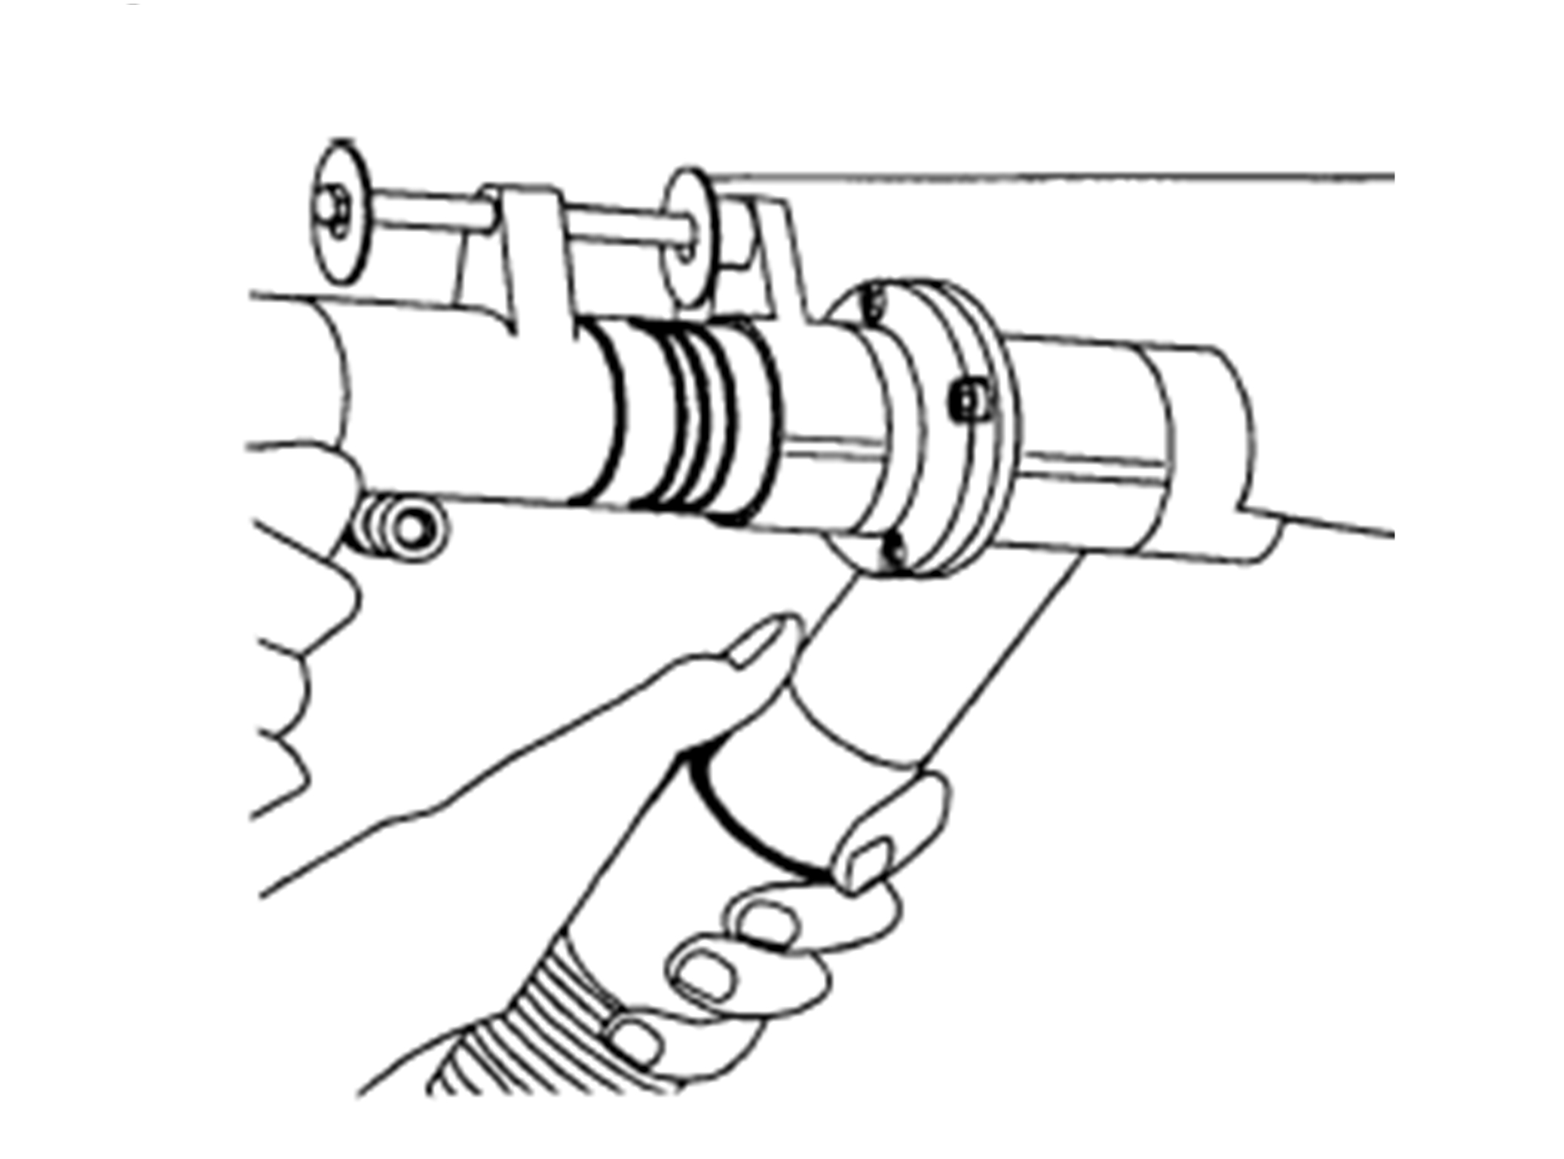

Q. Use of Lead Pots

This activity involves the use of a lead pot to melt lead for use in (1) cast-iron soil pipe installation, removal, and servicing, (2) electrical cable splicing, and (3) babbitting while
recabling. The health hazard in these operations arises from lead fumes becoming airborne. These operations are discussed below.

CAST-IRON SOIL PIPE INSTALLATION AND REMOVAL

Lead caulking is used in commercial construction building applications, most commonly in the joining or sealing of cast iron soil pipes. The lead used for this purpose must be liquefied.

The process of heating the lead and applying it as a liquid presents an opportunity for exposure to lead-oxide fumes. The primary exposure to fumes occurs while dipping the ladle into the lead pot, carrying the ladle by hand to the solder area, and pouring solder into the pipe joint. Pot dressing is another source of lead fumes. Additional exposures to lead fumes can occur during repair and maintenance operations in which pipe joints are heated to melt the lead caulking and are then pulled apart.

Engineering Controls

The controls used with lead pots include a portable local exhaust ventilation system mounted directly on or near the pot to control lead fumes, or a thermostatic control device installed on the lead pot to prevent overheating to reduce the amount of lead fumes generated.

Work Practice Controls

During the repair and removal of cast iron pipes, workers can disconnect the pipe by cutting it (above and below the leaded joints) without creating a lead exposure problem.

ELECTRICAL CABLE SPLICING

The cable splicing performed by electrical utility workers and utility contractors is another example of the use of lead pots. In this operation, the lead is typically melted above ground and then lowered by the assistant to the splicer, who is located in the manhole or underground vault. The splicer pours the lead from one ladle over the copper joint and catches the excess in another ladle held below. This process is repeated several times until the metal is too cold to pour. If needed, the process is repeated. A lead metal sheath is then slipped over the connection and the ends are sealed with molten lead.

Engineering Controls

During cable splicing, the following controls are used: (1) a portable local exhaust ventilation system is mounted directly on or near the lead pot; (2) a thermostatic control device can be installed on the lead pot to prevent overheating and reduce the amount of lead fumes; and (3) rubber or plastic connectors can be used instead of molten lead as the sealing method (NIOSH 1993b).

BABBITTING WHILE RECABLING

Elevators receive new wire ropes (i.e., cables) every 10 to 15 years on average. When recabling elevator ropes, it is necessary to secure the ends of the wire ropes in the baskets of thimble rods (sockets) at each end of the cable to keep the multistrand cable from unwinding. This is accomplished by pouring a tin-based babbitt material into the sockets to keep all of the strands in place within the socket.

Engineering Controls

The tin-based babbitt material is usually melted in a thermostatically controlled pot that keeps the lead at a temperature below that at which it fumes.

This job is done within the confines of the hoist way, which normally has an updraft that will draw lead fumes up through the hoist way and away from the worker and release the fumes over the roof of the building.

Where legally permitted, some elevator companies have switched the wire ropes on older elevators from sockets that utilize poured babbitt metal to wedge clamps or to sockets utilizing a thermoplastic/epoxy mixture (Personal communication, E. Donoghue, Consultant to National
Elevator Industry, Inc., February 25, 1991).

R. Soldering and Brazing

Soldering and brazing are techniques that are used to join metal pieces or parts. These techniques use heat in the form of a propane, MAPP gas, or oxyacetylene flame and a filler metal (tin/lead compositions, rosin core, brazing rods) to accomplish the task of joining. This activity is usually
performed by workers in the plumbing trades. The potential exposure source is the filler metal that contains lead.

Soldering and brazing operations present similar health hazards (airborne lead fumes) but to a different degree. Most soldering operations occur at temperatures that are less than 800°F. The melting point of the filler metals is usually quite low (<600°F) and the activity does not generate significant concentrations of metal fumes. Brazing operations usually occur at temperatures in excess of 800°F. The temperature of the operation is of major importance because temperature
determines the vapor pressure of the metals that are heated and therefore the potential concentration of metal fumes to which the employee may be exposed.

Because most field soldering and brazing work is conducted with a torch, it is difficult to regulate operating temperatures to within recommended limits to reduce the amount of metal
fumes generated. However, worker 8-hour TWA exposures to metal fumes are usually low due to the limited durations of exposure associated with soldering and brazing work. Electricians soldering electrical connections, plumbers soldering nonpotable water lines, or roofers repairing tin flashing could all experience these short-term and intermittent lead exposures.

ENGINEERING CONTROLS

- In confined areas, portable local exhaust ventilation can be used to remove metal fumes and gases associated with this type of work.

S. Use of Lead-Containing Mortar in Chemical (Acid) Storage and Process Tanks

High-pressure acid tanks used in the mining industry (especially during gold refining), as well as tanks (called "accumulators") found in some older paper mills and perhaps in other industries, are often lined with a specialized tile or lead brick. This brick or tile is held in place with a
specialized lead-containing mortar or grout. Every three to five years the linings of these tanks must be repointed (i.e., the grout between the tiles/brick must be restored), repaired, or relined with an entirely new lining (either tile or lead brick). Specialty contractors are hired to do this work.

After inspection of the lining, the damaged pointing (i.e., mortar between the tiles/brick) must be removed. This is done by a crew of workers simultaneously chipping away the old mortar by hand. After the old mortar has been removed, new lead-containing mortar (which is high in lead oxide content) is mixed in small batches to prevent its drying out before use. This mortar is then used as pointing between the tiles or bricks.

Lead must be included in the grout to ensure the structural integrity of the tank, i.e., lead is one of the few materials that can withstand the corrosive effects of the acids in use. The health hazards in these operations arise from lead dust and particulates, with a potential for high airborne levels in the mortar mixing area.

ENGINEERING CONTROLS

- Portable local exhaust ventilation should be used to remove lead dust and particulates from localized areas.

- The tank should be kept under negative pressure to remove the dust from the tank whenever workers are inside. All exhaust systems and vacuum equipment must be equipped with HEPA filters.

T. Handling Lead Shot, Bricks, or Sheets, and Lead-Foil Panels

Due to its inherent properties, lead is used extensively for shielding from radiation sources. The three principal projects involving the handling of lead shot, bricks, or sheets and lead-foil panels include the construction of linear accelerator suites, radiology (x-ray) suites, and industrial processing tanks. Installation and cutting of solid lead sheets, lead foil panels, and lead brick as well as the pouring of lead shot into cavities produce lead dust in varying quantities (Personal
Communication, G. Hyde, Baltimore Lead Burning Corporation, March 5, 1991). Additional exposures to lead can occur when lead sheets and bricks are fused with a welding torch or cut with a power saw when they are made into shielding containers.

ENGINEERING CONTROLS

- Portable local exhaust ventilation should be used for lead burning (melting/fusing) and sawing operations involving lead sheets and lead bricks, where exposures can easily exceed the PEL. Engineering controls may not be necessary to protect workers from lead exposure when pouring lead shot into cavities or when cutting lead-foil sheets.

U. Reinsulation Over Existing Mineral Wool

Mineral wool insulation manufactured before about 1970 has been found to have lead particles. According to industry sources, lead slag is no longer used in the manufacture of mineral wool, although lead can be present as a trace impurity (CONSAD 1993).

Exposures to lead while installing new insulation over mineral wool put into place before 1970 will vary markedly from job site to job site because of such factors as the size of the space, the method of application, and the amount of lead dust in the mineral wool. Workers perform this work in relatively confined areas (such as an attic) or in an open bay structure. Moreover, the worker can install insulation manually (e.g., when installing rigid preformed insulation around pipes) or mechanically using, for example, a pneumatic blower (e.g., when blowing fiberglass or mineral wool into place over existing mineral-wool insulation). Exposures are likely to be highest when insulation is blown into place in a confined space. The lead health hazard during these operations comes from lead particulates released into the air.

ENGINEERING CONTROLS

- No feasible controls are known to exist for this operation.

V. Removal and Repair of Stained-Glass Windows

The removal and repair of stained-glass windows includes several distinct activities:

- Removing the glass from the building, Tracing the location of the pieces of glass,

- Disassembling the lead strips ("came") and removing the lead putty seals,

- Cleaning or replacing of the individual pieces of glass, and

- Reassembling and soldering the "came."

Only the first activity, removal, takes place at the construction site. Health hazards arise from lead dust released into the air during glass removal. The other activities typically take place in a workshop and are therefore covered under the general industry lead standard (29 CFR 1910.1025).

ENGINEERING AND WORK PRACTICE CONTROLS

- Precleaning the stained-glass window with HEPA vacuums or damp wiping to remove loose dust before removal could lower exposures during removal. Whenever feasible, use portable local exhaust ventilation.

W. Industrial Vacuuming

Industrial vacuuming involves the use of vehicle-mounted vacuum systems to clean various areas of industrial facilities. The companies providing this industrial cleaning service are hired to clean such areas as catwalks, structural beams, and floors to reduce worker exposure to accumulated dust and debris that results from normal operations. The kinds of facilities where vacuuming could result in lead exposure include nonferrous metal plants (excluding aluminum) or steel plants melting lead-containing scrap in an electric-arc furnace.

ENGINEERING AND WORK PRACTICE CONTROLS

- Conventional cartridge dust collection systems capable of meeting the EPA ambient air quality requirements of 1.5 mg/m3 for discharge air should be used.

X. Miscellaneous Activities

The workers included in this group are those that are secondarily involved with other activities described above. These workers are not directly involved in the lead-generating activity but may nonetheless be exposed to lead in the course of their work. The lead exposure of this group of workers can be caused either by the activities of their co-workers or their own work-related activities.

Three separate miscellaneous activities representative of the jobs performed by this group of workers are discussed below. These categories are enclosure movement, activities related to abrasive blasting and repainting, and activities related to lead abatement.

ENCLOSURE MOVEMENT

Moving containment enclosures involves the setting up, tearing down, and handling of flexible nylon, plastic, and cotton tarpaulins as well as framing members which together form the sides of the enclosure. Projects such as the abrasive blasting of bridges, elevated highways, water towers, and storage tanks are likely to involve some type of containment structure.

Generally, the sequence of events in setting up, tearing down, and moving of a containment structure on a bridge project is as follows. First, a section of the bridge is blast-cleaned and primed within the enclosure. After completion, the sides of the containment (tarpaulins and framing) are dismantled so that the structure can be moved forward to the next section of the bridge to be worked on. After relocating the containment structure, the framing and plastic nylon coverings for the sides are reinstalled before blasting and repainting operations begin. As the enclosures are torn down and moved, the workers involved are exposed to lead dust generated by the movement of the containment components.

Engineering and Work Practice Controls

The inside of the containment should be cleaned prior to tear-down and movement to remove the lead-contaminated dust that accumulates on the walls and ledges. If compressed air is used to clean, the ventilation system of the containment structure must be operating and workers must wear appropriate respirators.

ABRASIVE BLASTING AND REPAINTING ACTIVITIES

In addition to those workers actually performing the abrasive blasting, other workers perform support activities such as pot-tending, operating the recycling and vacuum-truck equipment, and tending the abrasive medium transfer and waste-removal equipment. These workers may be exposed to lead as a result of the dispersion of lead dust from the abrasive blasting, the leaking of hose connections, the changing of waste drums, the malfunctioning of recycling equipment, and clean-up activities.

Engineering Controls

Full containment enclosures provided with exhaust ventilation and conventional cartridge filtration units should be used to reduce lead-dust emissions from the abrasive blasting area and prevent environmental contamination.

Small HEPA-filtered vacuum systems should be used to clean lead dust from work clothing and to clean up small spills.

Work Practice Controls

Regular inspections and timely maintenance of process equipment and control equipment help to eliminate dust leaks and prevent equipment malfunction or failure.

Y. Lead Abatement Activities (Commercial/Institutional and Residential)

These miscellaneous activities occur in conjunction with lead abatement or in-place management activities that have been previously addressed (i.e., dry hand-scraping, removal, and replacement of building components, heat-gun removal, chemical stripping of lead-based paint, and encapsulation).

These ancillary activities include washing, HEPA vacuuming, enclosure set-up and tear-down, and waste disposal.

Engineering Controls

Exposure levels are generally below the PEL during the performance of these activities, and engineering controls are therefore not likely to be necessary.

Work Practice Controls

Surfaces and debris should be kept moist when they are being disturbed. Before sweeping or vacuuming, dust and debris should be misted with water to reduce airborne dust. Plastic
sheeting should also be misted with water before handling to reduce dust.

All retained liquid waste should be poured through a filter cloth to remove paint chips and other debris prior to disposal. Filtered materials as well as other waste and debris should be placed in appropriately labeled, 6-mil plastic bags or sealed containers suitable for the transport of lead waste, and stored in a secure area pending disposal in accordance with State and/or local requirements.

IV. Bibliography
CONSAD Research Corporation. 1993. Economic Analysis of OSHA's Interim Final Standard for Lead in Construction. Performed under contract to the Office of Regulatory Analysis, OSHA. Contract No. J-9-F-1-0011.

Hughes, R. T., and Amendola, A. A. 1982. Recirculating Exhaust Air. Plant Engineering, March issue.

Knoy, T. 1990. Vacuum Blasting of an Elevated Water Storage Tank. Steel Structures Painting Council, Lead Paint Removal From Industrial Structures: Meeting the Challenge, SSPC 90-01-:95-99.

NIOSH. 1993a. Notice to All Users of Type CE, Abrasive-Blast Supplied-Air Respirators. NIOSH Division of Safety Research.

NIOSH. 1993b. Health Hazard Evaluation Report. Boston Edison Company. DHHS NIOSH Publication HETA 90-075.

NIOSH. 1992. NIOSH Alert: Request for Assistance in Preventing Lead Poisoning in Construction Workers. DHHS, April 1992.

NIOSH. 1990. Health Hazard Evaluation Report. HUD Lead-Based Paint Abatement Demonstration Project. DHHS NIOSH Publication HETA 90-070-2181.

Waagbo, S. and McPhee, W. 1991. Vacuum Blasting Lead-Based Paint Structures. Steel Structures Painting Council, Lead Paint Removal: Meeting the Challenge, SSPC 91-05:117-130.

APPENDIX V:3-1
Lead Related Construction Tasks and Their Presumed 8-Hour TWA Exposure Levels
> 50 to 500 µg/m³ | > 500 µg/m³ to 2,500 µg/m³ | > 2,500 µg/m³
Manual demolition | Using lead-containing mortar | Abrasive blasting
Dry manual scraping | Lead burning | Welding
Dry manual sanding | Rivet busting | Torch cutting
Heat gun use | Power tool cleaning without dust collection systems | Torch burning
Power tool cleaning with dust collection systems | Cleanup of dry expendable abrasive blasting jobs
Spray painting with lead paint | Abrasive blasting enclosure movement and removal

The current OSHA lead standard for construction (29 CFR 1926.62) is unique in that it groups tasks presumed to create employee exposures above the PEL of 50µg/m3 as an 8-hour
TWA. Until the employer performs an employee exposure assessment and determines actual employee exposure, the employer must assume that employees performing one of these tasks are exposed to the levels of lead indicated for that task in this Appendix. For all three groups of tasks, employers are required to provide respiratory protection appropriate to the task's presumed exposure level, protective work clothing and equipment, change areas, hand-washing facilities, training, and initial medical surveillance as prescribed by paragraph (d)(2)(v) of the standard. The only difference in the provisions applying to these groups is in the degree of respiratory protection required.

