Section V
(previously Section IV of Oregon OSHA’s Technical Manual)

CONSTRUCTION OPERATIONS

CHAPTER 1: DEMOLITION

CHAPTER 2: EXCAVATIONS: HAZARD RECOGNITION IN TRENCHING AND SHORING

CHAPTER 3: CONTROLLING LEAD EXPOSURE IN THE CONSTRUCTION INDUSTRY: ENGINEERING AND WORK PRACTICE CONTROLS

CHAPTER 4: FALL PROTECTION IN CONSTRUCTION



SECTION V: CHAPTER 4
FALL PROTECTION IN CONSTRUCTION
Chapter Revision Information:

This chapter is based on federal OSHA’s Technical Manual (OTM) Section V: Chapter 4, Fall Protection in Construction which was released in April, 2016 and Oregon OSHA regulations as of 10-2016.
- References to “OSHA Technical Manual (OTM)” were modified to “Oregon OSHA Technical Manual (TM)”.

- References to “Subpart”, where appropriate, were modified to “Subdivision”.

- References to “29 CFR 1926”, where appropriate, were modified to “Division 3” with the addition of the appropriate Subdivision.

- References to “29 CFR 1926”, where appropriate, were modified to “OAR 437-003”.

- References to “1926.501(b) were modified to “OAR 437-003-1501”.

- References to “1926.502(g) & (h) were modified to “OAR 437-003-2501”.

- References to “1926.502(k) were modified to “OAR 437-003-1501”.

- References to “1926.503 were modified to “OAR 437-003-0503”.

- References to “1926.954(b)(3)(iii)(A)” were modified to “2/RR, 437-002-2306(2)(d)(I)(i)..

- In Section I.A.3.ii, reference to federal OSHA’s “Stairway and Ladder” publication 3124-12R was removed.

- In Section I.B.2.II, reference to “SLTC” was removed.

- In Section I.C.3.i, Controlled Access Zones (CAZ) are not permitted in Oregon.

- In Section I.D, information about restraint systems was added.

- In Section II.B.4, references to “It’s A Snap” were removed.

- In Section II.B.6, OAR 437-003-0502(2) permits body belts in a personal fall restraint system.

- Figures II.B.4, 11a, 11c, 11d, 11e, 16b and 19 were added.

- Appendix A, B & E: modified to reflect Oregon regulations.

- Appendix C & D: reformatted for easier reading. Content unchanged.

SECTION V: CHAPTER 4
FALL PROTECTION IN CONSTRUCTION
TABLE OF CONTENTS
 | INTRODUCTION . . . . . . . . . . . . . . . . . . . . . . . . . . . . . . . . . . . . . . . . . . |  |  |  | 5
I. | FALL PROTECTION . . . . . . . . . . . . . . . . . . . . . . . . . . . . . . . . . . . . . . . |  |  |  | 6
 | A. | Guardrail Systems . . . . . . . . . . . . . . . . . . . . . . . . . . . . . . . . . . . . . . . . |  |  | 6
 |  | 1. | Temporary Guardrails . . . . . . . . . . . . . . . . . . . . . . . . . . . . . . . . |  | 8
 |  | 2. | Guardrails for Scaffolds, Aerial Lifts, and Scissor Lifts . . . . . . . |  | 8
 |  | 3. | Stairrails and Handrails . . . . . . . . . . . . . . . . . . . . . . . . . . . . . . . . |  | 9
 | B. | Hole Covers . . . . . . . . . . . . . . . . . . . . . . . . . . . . . . . . . . . . . . . . . . . . |  |  | 9
 |  | 1. | Effective Hole Covers . . . . . . . . . . . . . . . . . . . . . . . . . . . . . . . . |  | 10
 |  | 2. | Plywood Hole Covers . . . . . . . . . . . . . . . . . . . . . . . . . . . . . . . . . |  | 11
 | C. | Warning or Marking Systems . . . . . . . . . . . . . . . . . . . . . . . . . . . . . . . |  |  | 12
 |  | 1. | Warning Line System . . . . . . . . . . . . . . . . . . . . . . . . . . . . . . . . |  | 12
 |  | 2. | Safety Monitoring System . . . . . . . . . . . . . . . . . . . . . . . . . . . . . |  | 13
 |  | 3. | Access Zoning . . . . . . . . . . . . . . . . . . . . . . . . . . . . . . . . . . . . . . |  | 14
 | D. | Fall Restraint System and Positioning Devices . . . . . . . . . . . . . . . . . . |  |  | 15
 |  | 1. | Personal Fall Restraint System . . . . . . . . . . . . . . . . . . . . . . . . . |  | 15
 |  | 2. | Positioning Devices . . . . . . . . . . . . . . . . . . . . . . . . . . . . . . . . . . |  | 15
II. | FALL ARREST SYSTEMS . . . . . . . . . . . . . . . . . . . . . . . . . . . . . . . . . . . |  |  |  | 16
 | A. | Safety Net Systems . . . . . . . . . . . . . . . . . . . . . . . . . . . . . . . . . . . . . . . |  |  | 16
 | B. | Personal Fall Protection Equipment for Personal Fall Arrest Systems |  |  | 16
 |  | 1. | Component Compatibility . . . . . . . . . . . . . . . . . . . . . . . . . . . . . . |  | 18
 |  | 2. | Anchorage . . . . . . . . . . . . . . . . . . . . . . . . . . . . . . . . . . . . . . . . . |  | 19
 |  | 3. | Lanyards and Deceleration Devices . . . . . . . . . . . . . . . . . . . . . . |  | 19
 |  | 4. | Vertical and Horizontal Lifelines . . . . . . . . . . . . . . . . . . . . . . . . |  | 20
 |  | 5. | Full-Body Harnesses . . . . . . . . . . . . . . . . . . . . . . . . . . . . . . . . . . |  | 22
 |  | 6. | Body Belts . . . . . . . . . . . . . . . . . . . . . . . . . . . . . . . . . . . . . . . . . . |  | 22
 |  | 7. | Ladder Safety Devices . . . . . . . . . . . . . . . . . . . . . . . . . . . . . . . . . |  | 22
 | C. | Fallen Worker Rescue . . . . . . . . . . . . . . . . . . . . . . . . . . . . . . . . . . . . . |  |  | 24
 |  | 1. | Aided Rescue . . . . . . . . . . . . . . . . . . . . . . . . . . . . . . . . . . . . . . . |  | 24
 |  | 2. | Self-Rescue . . . . . . . . . . . . . . . . . . . . . . . . . . . . . . . . . . . . . . . . . |  | 24
TABLE OF CONTENTS (CONTINUED)

III. | MEASUREMENTS FOR ASSESSING FALL HAZARDS AND CONTROLS. . . . . . . . . . . . . . . . . . . . . . . . . . . . . . . . . . . . . . . . . . . . . . . . |  |  |  | 25
 | A. | Total Fall Clearance Distance for PFAS . . . . . . . . . . . . . . . . . . . . . . |  |  | 25
 |  | 1. | Calculating Total Fall Clearance Distance for Fall Arrest Systems with a Shock-absorbing Lanyard . . . . . . . . . . . . . . . . . |  | 26
 |  | 2. | Calculating Free Fall Distance . . . . . . . . . . . . . . . . . . . . . . . . . . |  | 27
 |  | 3. | Examples . . . . . . . . . . . . . . . . . . . . . . . . . . . . . . . . . . . . . . . . . . . |  | 28
 | B. | How to Evaluate the Swing Fall Hazard . . . . . . . . . . . . . . . . . . . . . . . |  |  | 31
LIST OF APPDENENDICES
 | APPENDIX A |  |  | FALL PROTECTION FOR SPECIFIC SCAFFOLODS AND RELATED EQUIPMENT . . . . . | 32
 | APPENDIX B |  |  | OSHA STANDARDS RELATED TO FALL PROTECTION . . . . . . . . . . . . . . . . . . . . . . . . . . . . . . . | 33
 | APPENDIX C |  |  | EXAMPLES: Fall Protection Anchors by Type . . . . . . . | 34
 | APPENDIX D |  |  | EXAMPLES: Lanyards, Deceleration Devices, Harnesses, and Body Belts . . . . . . . . . . . . . . . . . . . . . . . | 44
 | APPENDIX E |  |  | REFERENCES AND RESOURCES . . . . . . . . . . . . . . | 48

Introduction
This chapter provides technical information about fall hazards and protection methods. The information is intended to help prepare Oregon OSHA compliance officers to conduct inspections and investigations. For convenience, links are provided to applicable Oregon OSHA standards throughout this chapter. This chapter does not cover all Oregon OSHA, nor federal OSHA, requirements for fall prevention/protection methods, and is not intended to serve as a comprehensive guide for developing compliant fall protection programs.

Although fall hazards are common at construction worksites, fall-related injuries and fatalities are preventable. Fall hazards can be addressed in two main ways:

Fall prevention: preventing workers from falling by using engineering controls (e.g., guardrails and hole covers) or personal protective equipment (e.g., restraint systems).

Fall arrest/rescue: preventing injury during and after a fall by using personal fall arrest systems (PFAS) or safety nets, and having an effective rescue plan in place.

Recognizing fall hazards and planning to control them before work begins is critical for determining the best methods and equipment for protecting workers during construction activities at heights.

Emergency response planning will identify necessary emergency response training and critical resources (e.g., trained on-site fall arrest rescue team and rescue equipment).

A number of Oregon OSHA standards contain provisions for protecting workers from falls. In the construction industry, applicable standards include:
- Division 3, Subdivision M (3/M): Fall Protection;
- Division 3, Subdivision R (3/R), 1926.760: Steel Erection;
- Division 3, Subdivision V = See Division 2, Subdivision RR (2/RR): Electric Power Generation, Transmission and Distribution; and
- Division 3, Subdivision CC (3/CC), 1926.1423 and 437-003-1423: Cranes and Derricks.

Refer to Appendix B for a more complete list of Oregon OSHA standards on fall protection.

I. Fall Prevention
I.A. Guardrail Systems

A guardrail system can be used as a barrier to prevent workers from falling off a work surface edge to a lower level. Guardrail systems can be used on many work surfaces, including rooftops, platforms, mezzanines, balconies, scaffolds, incomplete decked floors, catwalks, observation platforms, mobile work surfaces and ladderway points of access. Figure 1 shows a temporary guardrail system for a walkway (see Div 3/M, 1926.500; Div 3/M, 1926.502(b)).
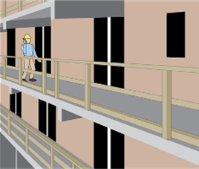
Figure 1. Guardrail system

Guardrails can also be used to keep workers from falling into holes or openings in decking or floors (see Div 3/M, 437-003-1501; Div 3/M, 1926.502(b); Figure 2).
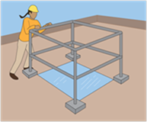
Figure 2. Guardrail used around
an opening
Guardrails are typically constructed using:
- Upright supports attached to the working surface;
- A horizontal top rail connected to the supports;
- One or more midrails running parallel to the top rail; and
- Toeboards when necessary to protect workers below from falling objects.

(See Div 3/M, 1926.501(c)(1); Div 3/M, 1926.502(b); Div 3/M, 1926.502(j).)

Effective guardrail systems will have at a minimum:
- A surface that is smooth and free from burrs to prevent punctures and lacerations and to prevent snagging of clothing (see Div 3/M, 1926.502(b)(6)).
- Toprails and midrails that are at least ¼ inch in diameter (see Div 3/M, 1926.502(b)(9)).
- Strength to withstand at least 200 pounds applied within 2 inches of the top edge in any outward or downward direction (see Div 3/M, 1926.502(b)(3)) .
- A toprail between 39 and 45 inches from the working level, raised as necessary to account for workers using stilts or otherwise working in an elevated location above the work surface (see Div 3/M, 1926.502(b)(1)).
- Midrails (or equivalent structural members) that withstand at least 150 pounds of force in the downward or outward direction (see Div 3/M, 1926.502(b)(5)).
- A midrail, mesh, screen, or equivalent intermediate structural members installed between the guardrail system top edge and the walking/working surface when there is no wall or parapet wall at least 21 inches high (see Div 3/M, 1926.502(b)(2)).
- Intermediate members (such as balusters), when used between posts, that are not more than 19 inches apart (see Div 3/M, 1926.502(b)(2)(iii)).
- Flags made of high visibility material every 6 feet if wire rope is used for top rails (see Div 3/M, 1926.502(b)(9)).

Effective guardrail systems will not have:
- Guardrails that deflect to lower than 39 inches above the working surface when 200 pounds of pressure are applied in a downward direction (see Div 3/M, 1926.502(b)(4)).
- Toprails and midrails that overhang terminal posts to constitute a projection hazard (see Div 3/M, 1926.502(b)(7)).

Basic guardrail components come in a variety of materials and configuration options. It is common for employers to use material available or produced at the worksite. Upright supports may be made from wood, formed metal, pipe, or composites. Wire rope is sometimes used for the top rails and midrails.

Table 1 provides guidelines as a starting point for designing guardrail systems. However, the guidelines do not provide all the information necessary to build a complete system. The components of a guardrail system must still be designed and assembled in such a way that the completed system meets all applicable requirements.

Workers installing or removing guardrails must be protected using other forms of fall protection whenever the guardrail systems are not attached securely to a stable structure.

Table 1 – Guardrail Component Strength Indicators

Material | Strength  (minimum criteria) | Posts  (minimum criteria) | Top Rail  (minimum criteria) | Intermediate Rail  (minimum criteria)
Wood guardrails | 1,500 lb-ft/in2 fiber (stress grade) construction lumber | 2 inch × 4 inch (nominal) lumber | 2 inch × 4 inch (nominal) lumber | 1 inch × 6 inch (nominal) lumber
Pipe guardrails | N/A | 1.5 inch diameter (schedule 40 pipe) | 1.5 inch diameter (schedule 40 pipe) | 1.5 inch diameter (schedule 40 pipe)
Structural steel guardrails | N/A | 2 inch × 2 inch × 3/8 inch | 2 inch × 2 inch × 3/8 inch | 2 inch × 2 inch × 3/8 inch
Spacing | N/A | All material: no more than 8 feet apart (on centers) | N/A | N/A
N/A = not applicable.
lb-ft/in2 = pound-foot per square inch. Adapted from 29 CFR 1926 Subpart M, Appendix B.
I.A.1. Temporary Guardrails

Premade or job-made guardrails can be used as temporary guardrails while more permanent structures are being installed or when the work is transient or in a space not intended as a permanent work area. For example, temporary guardrails can be used while constructing a wall, completing floor decking, or replacing a roof (see Figure 4). These guardrails are often constructed from reusable materials or premade guardrail system components as shown in Figure 3 and Figure 4 (see Div 3/M, 1926.502(b)).
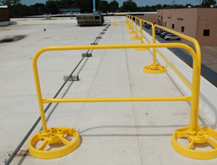
Figure 3. Temporary guardrails

Premade guardrails are particularly susceptible to damage if not handled properly when disassembled and stored. Specific handling instructions are typically included in the manufacturer’s recommended procedures for disassembling and storing the guardrail components. If railing components are bent, broken, or missing, the guardrail may not be effective. Damage is more likely to occur if the components are dropped when disassembled, transported in vehicles, or stored in areas not protected from conditions that could cause corrosion or distortion.
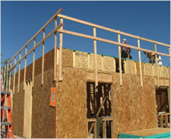
Figure 4. Temporary guardrails

I.A.2. Guardrails for Scaffolds, Aerial Lifts, and Scissor Lifts

Scaffolds, aerial lifts, and scissor lifts can pose similar fall hazards. Guardrails, possibly in combination with additional types of fall protection systems (e.g., PFAS or restraint system), may be used to address these hazards. (see Div 3/L, 1926.451(g)(1); Div 3/L, 1926.453(b)(2)(v); Div 2/RR, 437-002-2306(2)(d)(I)(i)).

For additional information on fall protection for scaffolds and lifts see:
- Appendix A (chart describing fall protection for various types of scaffolds and related equipment)
- Federal OSHA Scaffolding eTool: https://www.osha.gov/SLTC/etools/scaffolding/index.html

I.A.3. Stairrails and Handrails

I.A.3.i. Stairrails

A stairrail system is a vertical barrier that runs along the unprotected side edge of a stairway to prevent workers from falling to lower levels (see Figures 5 and 6). The top surface of the stair rail system may be used as the handrail (see Div 3/X, 1926.1050(b); Div 3/X, 1926.1052(c)(7)).

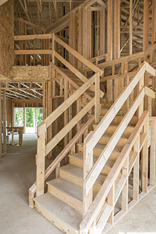
Figure 5. Stairail System
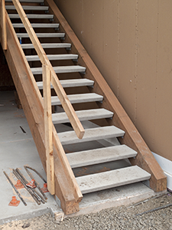
Figure 6. Stairail System with handrail

I.A.3.ii. Handrails

Effective handrails provide an adequate handhold for workers to grasp to prevent them from falling (see Figure 6 and Div 3/X, 1926.1052(c)(1), (c)(9)).

Effective handrails are 30 to 37 inches high and meet the guardrail strength requirements (i.e., able to withstand 200 pounds of weight applied within two inches of the top edge in any downward or outward direction at any point along the top edge) (see Div 3/X, 1926.1052(c)(5), (c)(6)).

Effective temporary handrails have a minimum clearance of 3 inches between the handrail and walls, stairrail systems, and other objects (see Div 3/X, 1926.1052(c)(11)).

I.B. Hole Covers

A hole is a gap or void 2 inches or more in its least dimension in a floor, roof, deck, or other walking/working surface (see Div 3/M, 1926.500(b); Div 3/M, 437-003-1501(1); Div 3/R, 1926.751; Div 3/R, 437-003-1754) that is hazardous because:
• workers can fall through the hole (see Div 3/M, 437-003-1501(1)(a));
• the hole’s design can create a trip hazard (see Div 3/M, 437-003-1501(1)(b)); and
• objects can fall through the hole and injure workers below (see Div 3/M, 437-003-1501(1)(c)).

Workers are protected from the hazards associated with holes by the use of covers, personal fall protection or guardrail systems (see Div 3/M, 437-003-1501).

The following types of holes are commonly found at construction worksites:
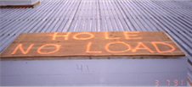
Figure 7. Hole cover
• Holes cut (or constructed) in floors to receive equipment or ducts and for future access points (e.g., openings for stairs that will be installed later);
• Holes cut in roofs in preparation for installing skylights, ventilation units, and other features or equipment;
• Excavations for pits, wells, or shafts (e.g., caissons);
• Excavations or cuts in roadways.

I.B.1. Effective Hole Covers

Covers are strong protective surfaces used on walking/working surfaces or roadways to prevent workers from falling through a hole (see Figure 7).

Covers for permanent holes are typically built for a specific purpose (e.g., permanent access points, manhole covers, and trap doors) and are only effective when they are properly designed and secured in place.

Covers for temporary holes are often constructed on work sites with reusable materials, most commonly using plywood and steel plates. For example, to cover large holes in a road, hinged steel plate covers can be used. Other options for covers include grates designed to support weight, custom boxes to cover a hole with an elevated lip or partially installed equipment, and temporary trapdoors.

Effective hole covers are:
• Large enough to provide appropriate overlap to prevent workers from falling through.
• Strong enough to support at least twice the anticipated weight imposed by the heaviest load (see Div 3/M, 1926.502(i)(1), (i)(2)).
• Left in place over the hole until access is needed.
• Inspected periodically to identify deterioration.
• Secured (see Div 3/M, 1926.502(i)(3)) and do not create trip hazards.
• Clearly marked as hole covers (see Div 3/M, 1926.502(i)(4)).

The following materials lack the strength necessary to prevent a worker from falling through a hole (see Div 3/M, 1926.502(i)(1), (i)(2)):
• Cardboard;
• Tarps;
• Materials not intended to bear the anticipated load (e.g., plastic or glass);
• Loose materials that could separate (e.g., unsecured two-by-four planks);
• Damaged materials (e.g., deteriorating wood, a bent metal plate);
• Drywall or particle board; and
• Chicken wire or other fencing material.

I.B.2. Plywood Hole Covers

Heavy plywood is a common choice for covering temporary holes in floors and roofs (see Figure 9), but plywood strength and durability can vary. Some materials, including plywood scraps from shipping crates or similar scrap products, do not have structural value or span ratings, making it hard to know if they are strong enough. In addition, strength information on the plywood is occasionally covered with paint.

Figure 9. Plywood hole cover

I.B.2.i. Plywood Strength

Several factors determine and measure plywood strength. In the United States, two groups provide the most commonly used plywood rating systems: APA–The Engineered Wood Association (formerly the American Plywood Association and Douglas Fir Plywood Association) and the Timber Engineering Company (TECO). CSHOs should refer to these organizations for detailed information.

The hole size and the expected load weight are considered when determining if the plywood is effective for use as a hole cover (see Div 3/M, 437-003-1501(1); Div 3/M, 1926.502(i)(1), (i)(2)).

I.B.2.ii. Plywood Durability

Plywood is susceptible to damage over time from exposure to water, traffic, and heavy loads that may reduce its strength. Some indicators of reduced-strength plywood may include cracks, chips, a warped appearance, a worn surface, de-lamination, and water stains. Expected damage after exposure to water depends on whether the plywood is exterior-grade or interior-grade. The binding agents (i.e., adhesive) used to adhere interior-grade plywood layers degrade more rapidly in a moist environment than do the binders used in exterior-grade plywood.

When workers are using hauling equipment, the weight of the equipment and its load is concentrated into the smaller area that contacts the ground (e.g., the load in a wheelbarrow will concentrate where the wheel hits the ground – an area of just a few inches in size). Commonly used routes for hauling these loads will experience additional wear and tear to the flooring. Adding a protective layer to the floor along these routes is one way to prevent damage to the flooring from concentrated loads. Typical protective layers may include liquid latex compounds, penetrating oils, sheet plastics, and interlocking membranes.

I.B.2.iii. Plywood Cover Size and Orientation

The plywood cover’s size and orientation can affect the cover’s overall effectiveness. Plywood covers rest on the hole edges that are supported through the joists. The following are indications that a plywood cover’s size and orientation will generally keep workers from falling through a hole:
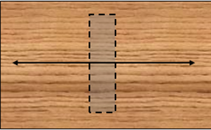
Figure 10. Plywood orientation relative to hole orientation and strength axis

• The plywood piece is larger than the hole size so that it is possible to cover the hole with the shortest panel side overlaying the longest unsupported hole dimension.
• The panel overlaps the supporting surfaces around the hole far enough for needed support.
• The panel is positioned with the strength axis (grain direction) running along the shortest unsupported hole dimension (Figure 10 above).

I.C. Warning or Marking Systems

I.C.1. Warning Line Systems

A warning line system is a barrier erected on a flat or low-sloped roof (2-in-12 or less) to warn workers engaged in roofing work that they are approaching an unprotected roof side or edge (see Div 3/M, 1926.500(b)); Figure 11a; Figure 11b). A warning line system includes a line (rope, wire, or chain) and supporting stanchions (see Div 3/M, 1926.502(f)(2)). Warning lines are not engineered to physically prevent or arrest falls, and may not be used in all situations.

I.C.1.i. Warning Line Systems for Roofers

On flat or low-sloped roofs (2-in-12 or less), roofers inside the warning line system can use the warning lines as fall protection. Employees performing roofing work between the roof edge and the warning line must be protected by a personal fall arrest system, personal fall restraint system, guardrail system, safety net system, or safety monitoring system. No employee is allowed in the area between a roof edge and a warning line unless the employee is performing roofing work in that area. (see 3/M, 1926.502(f)(3)).

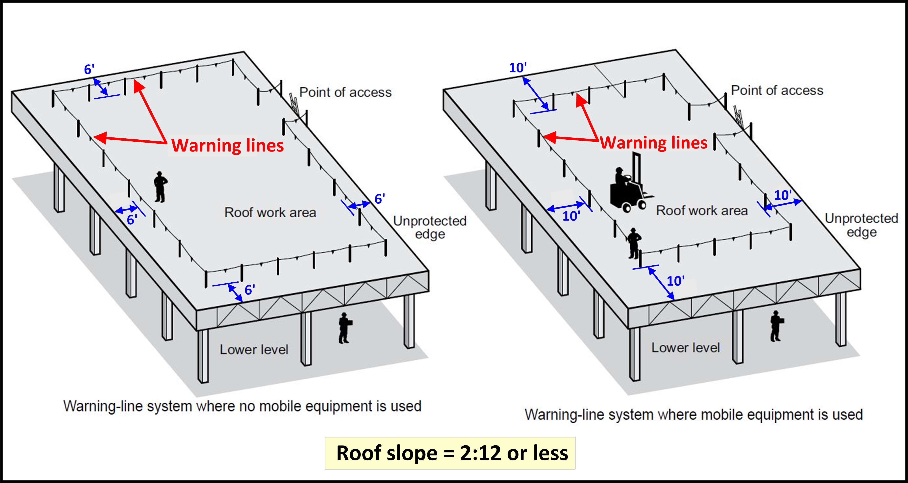
Figure 11a. Examples of warning line systems for roofing work

I.C.1.ii. Warning Lines used as Awareness Barriers for non-Roofers

Trades, other than roofers, cannot use warning lines as a fall protection system. Warning lines can be used by trades (other than roofers) only as an awareness barrier when there is no exposure to a fall hazard (see Oregon OSHA Fact Sheet FS-26: http://osha.oregon.gov/OSHAPubs/factsheets/fs26.pdf .)
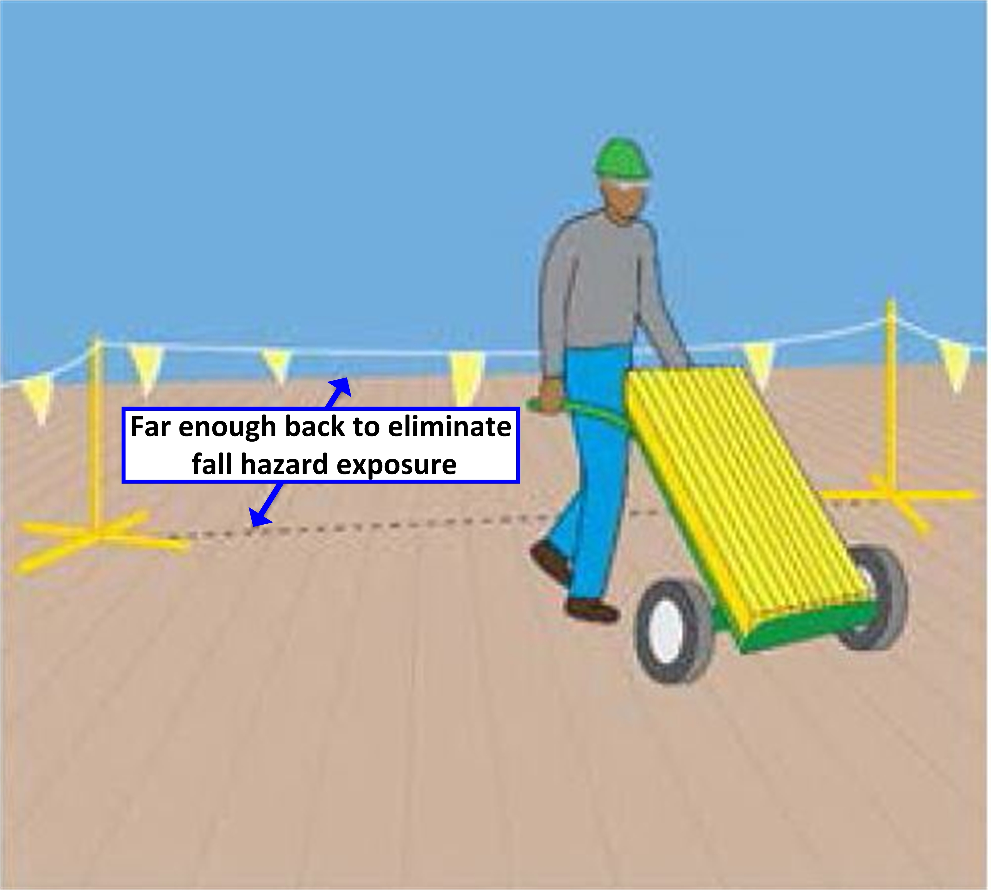
Figure 11b. Warning line (awareness barrier) for non-roofers

Additionally, non-roofers cannot work between the edge and the warning line (awareness barrier) when protected by a safety monitoring system (See Div 3/M, 1926.500(b) and 3/M, 437-003-01502).

I.C.2. Safety-Monitoring Systems

In Oregon, 1926.502(h) was not adopted. In Oregon, Div 3/M, 437-003-2502 (Safety monitoring systems) applies.

Safety monitoring systems must not be used as a fall protection system for any work other than roofing work. Safety monitoring systems are limited to use on roofs with slopes of 2-in-12 or less (see Div 3/M, 437-003-2502; Figure 11c). The use of a safety monitoring system alone (without a warning line system) is not allowed on roofs more than 50 feet in width.

A safety-monitoring system uses a competent person as a safety monitor who can recognize and warn workers of fall hazards (see Div 3/M, 1926.500(b)).
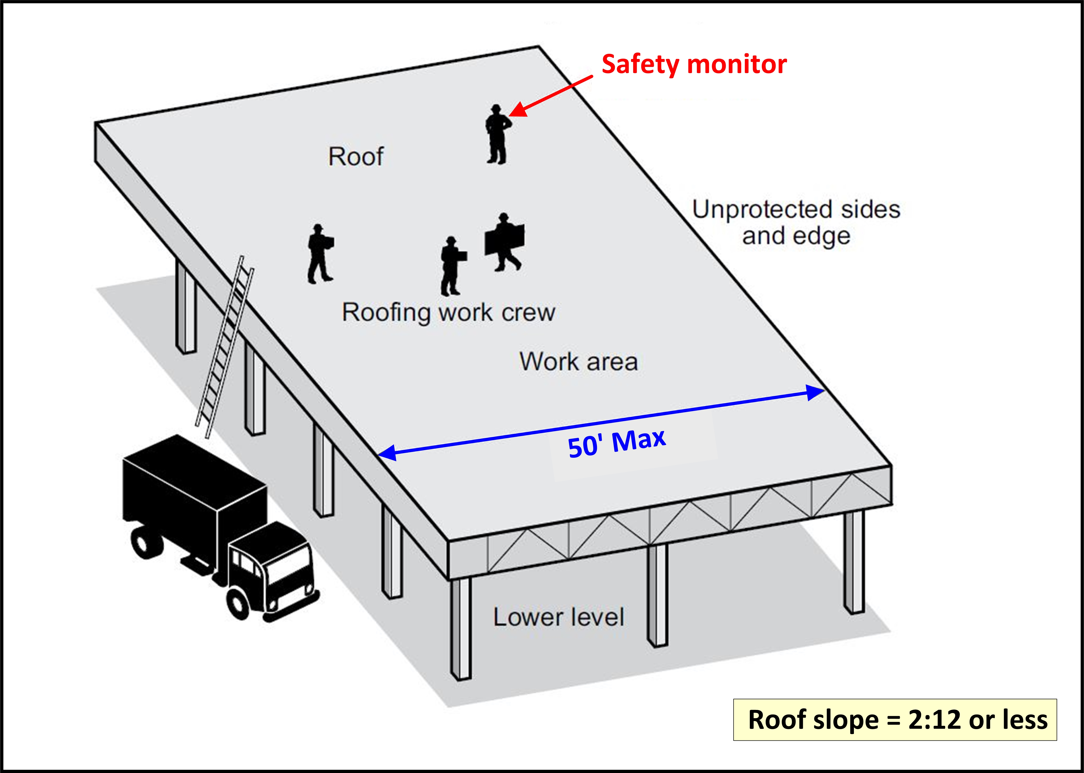
Figure 11c. Examples of a safety monitoring system on a roof less than 50 feet wide

I.C.3. Access Zoning

I.C.3.i. Controlled Access Zones (CAZs)

Federal OSHA allows the use of controlled access zones in 29 CFR 1926.502(g). In Oregon, 1926.502(g) was not adopted. The use of controlled access zones for fall protection in Oregon is not permitted. Federal OSHA allows the following situations to use controlled access zones as fall protection; however, Oregon OSHA does not:
- Overhand bricklaying and related work
- Leading edge work
- Residential construction
- Precast concrete erection

I.C.3.ii. Controlled Decking Zones (CDZs)

A controlled decking zone is a clearly marked work area used during steel erection while workers are initially installing decking at the leading edge of the work area (see 3/R, 1926.751; 3/R, 1926.760(c); 3/R, 1926 Subpart R Appendix D).

I.D. Fall Restraint Systems and Positioning Devices

I.D.1 Personal Fall Restraint Systems

Fall restraint systems (identified in rule as Personal Fall Restraint) prevent the user from falling any distance. To determine the force needed to restrain a worker, consideration is given to the force that would be generated by the worker walking, leaning, or sliding down the working surface. Personal fall restraint systems must have the capacity to withstand at least 3,000 pounds of force or twice the maximum expected force that is needed to restrain the worker from exposure to the fall hazard. Additionally, fall restraint systems must use fall arrest system components that conform to the criteria in Div 3/M, 1926.502 except a body belt may be used in fall restraint systems and the attachment point to the body belt or full body harness may be at the back, front or side D-rings. (see Div 3/M, 437-003-0502; Figure 11d).
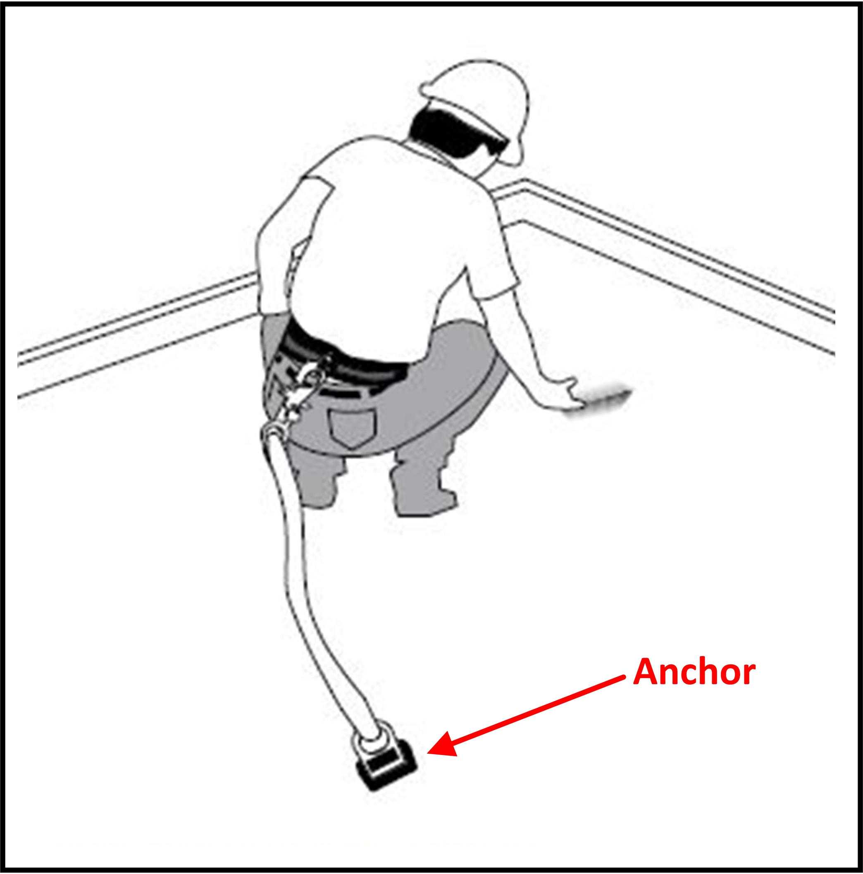
Figure 11d. Example of a body belt used with a personal fall restraint system

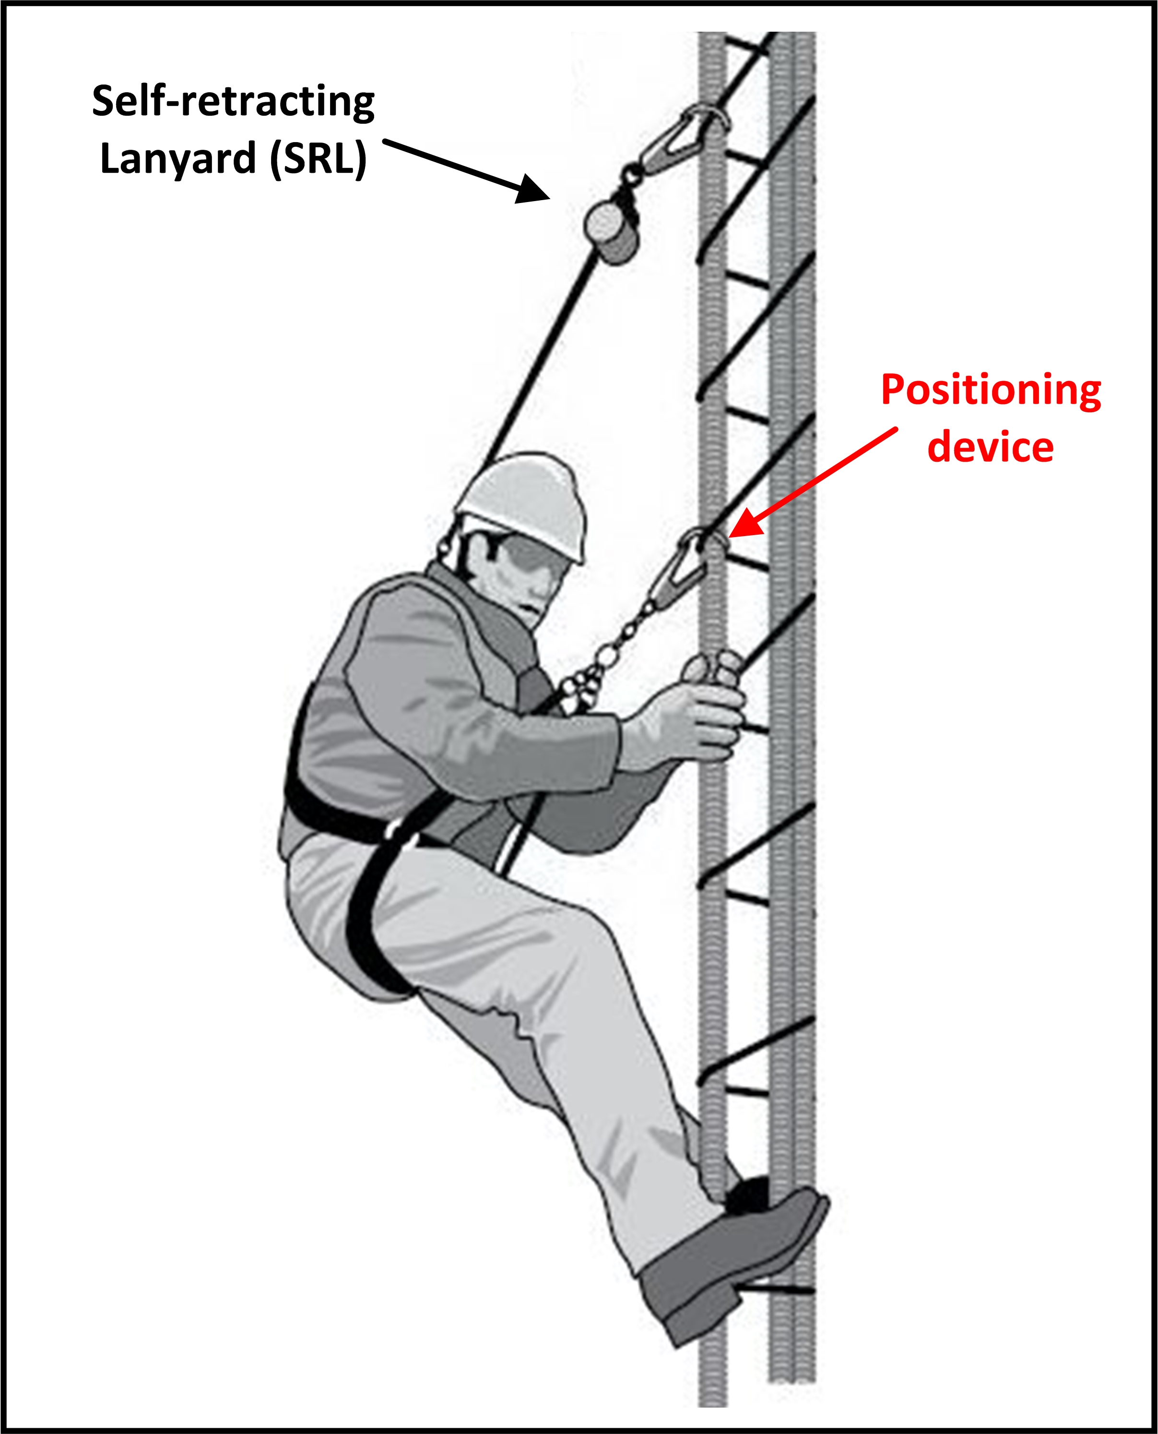
Figure 11e. Example of a positioning device system used with a SRL

I.D.2 Positioning Devices

Positioning devices are specialized systems that hold workers in place on an elevated vertical surface (such as a wall) allowing them to keep both hands free to work while leaning into the system (see Div 3/M, 1926.500(b)).

When the worker leans back, the system is activated (supporting the worker’s body weight). Positioning devices must be rigged to limit free falls to 2 feet or less (see Div 3/M, 1926.502(e)(1); Figure 11e).

II. Fall Arrest Systems

Fall arrest systems are designed to prevent or reduce injuries when a worker falls from an elevated height.

II.A. Safety Net Systems

Safety net systems (see Figures 12 and 13) are an option when workers are working at elevated heights with hazardous vertical drops (see Table 2). Safety net systems are commonly used during work on bridges and large structures. The nets are available in various sizes and materials, including materials resistant to ultraviolet deterioration.

Table 2. Safety Net System Dimensions

Vertical Distance from Working Level to Horizontal Plane of Net | Minimum Required Horizontal Distance of Outer Edge of Net from Edge of Working Surface
Up to 5 feet | 8 feet
More than 5 feet, up to 10 feet | 10 feet
More than 10 feet, up to 30 feet | 13 feet
More than 30 feet | Safety net not permitted as fall protection
See Div 3/M,1926.502(c)(1), (c)(2)

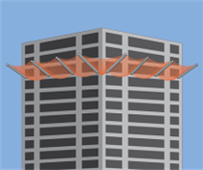
Figure 12. Safety net system
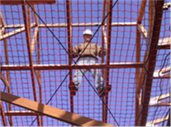
Figure 13. Safety net system

II.B. Personal Fall Protection Equipment for Personal Fall Arrest Systems

A Personal Fall Arrest System (PFAS) is a system with components that work together to protect workers when they fall from elevated heights. PFAS components include an anchorage, connectors, and a full-body harness, and may include a shock-absorbing lanyard, a retractable lifeline, and/or a deceleration device (see Div 3/M, 1926.500(b)).

PFAS components will be marked by the manufacturer with pertinent information specific to the equipment, such as warnings, serial/model number, capacity, and the materials used to make the component (see Figure 14). Information (e.g., proper use, maintenance, inspection) about fall protection components is typically provided in equipment manuals.

Although some components may look the same, they may not be interchangeable if they are from different manufacturers or from different equipment series made by the same manufacturer.

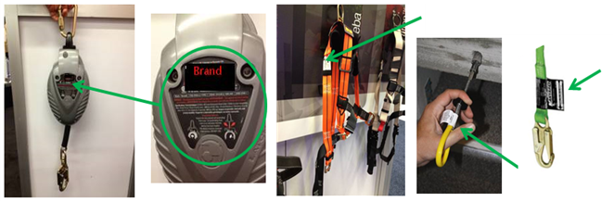
Figure 14. Examples of manufacturers’ labels for various types of fall protection equipment

II.B.1. Component Compatibility

Personal fall protection system effectiveness relies on component compatibility. Often, components are supplied together as a set. Using non-compatible fittings can lead to damage and system failure (see Div 3/M, 1926.502(d)(5)).

A compatibility assessment should be performed when using fittings from different manufacturers or different product lines from the same manufacturer. This includes assessing the way fittings connect to each other and confirming with the manufacturer(s) that the fittings can be used together safely.

For additional information see:

- Compatibility of Personal Fall Protection System Components, federal OSHA Safety and Health Information Bulletin, www.osha.gov/dts/shib/shib092203.html

Many factors can contribute to a worker’s risk of falling from an elevated work area. Examples include precarious work positions, excessive leaning or reaching, improper work practices, unstable structures, trip hazards, slippery surfaces, and distractions.

When guardrails are not an option, personal fall protection equipment is helpful in some situations, but only when properly selected, worn, and attached to an adequate anchor point.

A personal fall arrest system was not a good choice in this case. In the illustration below, the trusses were not fully installed, braced and sheathed, so they did not form a sufficiently strong anchor point. The structure collapsed when it received the sudden force of the falling worker.

The fall hazard could have been eliminated by pre-assembling the truss sections (groups of several trusses) on the ground or using special devices that serve as temporary bracing for fall arrest equipment.

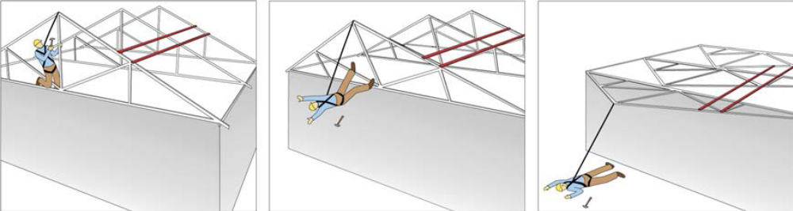

II.B.2. Anchorage

Anchorage systems normally include, at a minimum, a building structure and an anchorage device to which the worker will tie-off (see Appendix C).

Anchors are fixed to a strong structural member. Anchors are not effective if they are attached to weak materials. Certain structural members may not be strong enough to hold the sudden weight imposed by a falling worker. The anchorage manufacturer should provide instructions on anchor installation (see Div 3/M, 1926.502(d)(15); Div 3/CC, 1926.1423(g)).

Many anchors are removed when they are no longer needed. Other anchors are designed to be left in place for future use (e.g., repeated servicing), or are covered over during the job (e.g., with roofing shingles), or are cut flush with the surrounding surface (e.g., concrete bolt-style anchor protruding from a wall). Appendix C provides fall protection anchor examples. (See Division 3/M, Appendix C(II)(h), Tie-off considerations)

II.B.3. Lanyards

A lanyard is a flexible rope, wire rope, or strap which generally has a connector at each end for connecting the body belt or body harness to a deceleration device, lifeline, or anchorage point (see Div 3/M, 1926.500(b)). Some manufacturers offer adjustable length lanyards. Effective lanyards are maintained in a clean, intact condition, and inspected prior to each use for wear, tear, and any obvious distortion or signs that the fall arrest (energy-absorbing) system has been activated (see Div 3/M, 1926.502(d)(21)).

Inspecting a lanyard involves beginning at one end and continuing to the opposite end. During an inspection, the lanyard is slowly rotated so that its entire circumference is checked. Spliced ends require particular attention.

Lanyards used for personal fall protection are not to be used for hoisting materials. Equipment used for hoisting is not suitable for use in a fall protection system (see Div 3/M, 1926.502(d)(18)).

II.B.3.i. Deceleration Device

A deceleration device is a mechanism (e.g., tearing or deforming lanyards) that serves to dissipate energy during a fall to limit the energy and stress imposed on a worker during a fall. Deceleration occurs over a maximum distance of 3.5 feet (see Div 3/M, 1926.502(d)(16)(iv)). Deceleration devices vary widely. Examples include:

- Self-retracting lanyard. A self-retracting lanyard/lifeline contains a drum-wound line which can be slowly extracted or retracted. The lanyard extends as necessary to allow the worker to move about the work area, but retracts as necessary to maintain slight tension, preventing the line from becoming slack. The drum is under slight tension during normal worker movement and automatically locks the drum when the line is extracted too rapidly (see Div 3/M, 1926.500(b)).

Self-retracting lanyards and lifelines that limit free fall to 2 feet or less need to sustain, at a minimum, 3,000 pounds applied to the device with the lanyard in the fully extended position (see Div 3/M, 1926.502(d)(12)).

Self-retracting lanyards that do not limit free fall to 2 feet or less need to sustain, at a minimum, 5,000 pounds applied to the device with the lanyard in the fully extended position (see Div 3/M, 1926.502(d)(13)).

Some retractable lifelines provide a deceleration (energy-absorbing) function. These lifelines can include a feature that slows the fall over a distance of up to 3.5 feet (see Div 3/M, 1926.502(d)(16)(iv)).

- Rip-stitch lanyards. A rip-stitch lanyard has extra webbing incorporated into the lanyard. The extra webbing is stitched into place and folded lengthwise along the lanyard. During a fall, the weaker stitching allows the folded webbing to pull away at a controlled speed, slowing the fall.

- Shock-absorbing lanyards. The webbing in a shock-absorbing lanyard is designed to stretch as it receives the worker’s falling weight. The stretching action breaks the fall in a controlled manner.

- This is not an all-inclusive list of lanyards. Oregon OSHA expects that emerging lanyard technology will continue to improve safety in the workplace.

II.B.4. Vertical and Horizontal Lifelines

A lifeline is a component consisting of a flexible line for connection to an anchorage at one end to hang vertically (vertical lifeline) or for connection to anchorages at both ends to stretch horizontally (horizontal lifeline), and which serves as a means for connecting other components of a PFAS to the anchorage (see Div 3/M, 1926.500(b)).

Vertical and Horizontal Lifelines

Lifelines function as an extension of an anchorage system, allowing an employee to move up and down (vertical lifeline) or back and forth (horizontal lifeline) across a work area. A sliding fitting (rope grab or shuttle) connects to the line and a lanyard connects the worker’s harness to that sliding fitting.

Vertical lifelines require active participation by the worker, who must often reposition the rope grab when moving to a new position.

Vertical lifelines remain connected to a set anchorage point while the lanyard moves with the worker. If the worker falls, the clip locks (cable grab) to the lifeline and stops the worker from falling further. When vertical lifelines are used each worker generally needs to be attached to a separate lifeline (see Div 3/M, 1926.502(d)(10)).

Horizontal lifelines require special attention during design and installation to: (1) limit the distance the worker can fall (a greater sag in the line can mean a farther fall); and (2) minimize the forces on the connectors at the anchorage (a greater sag in the line can mean lower forces on the anchorage connectors at either end). A qualified person must supervise the horizontal lifeline’s design, installation, and use (see Div 3/M, 1926.502(d)(8)).

Depending on their geometry and sag angle, horizontal lifelines may be subjected to greater loads than the impact load imposed by an attached component. When the horizontal lifeline’s sag is less than 30 degrees, the impact force applied to the lifeline by an attached lanyard is greatly amplified. For reference:
- 15-degree sag angle amplifies the force approximately 2:1
- 5-degree sag angle amplifies the force approximately 6:1.

See Div 3/M, Appendix C for more information.

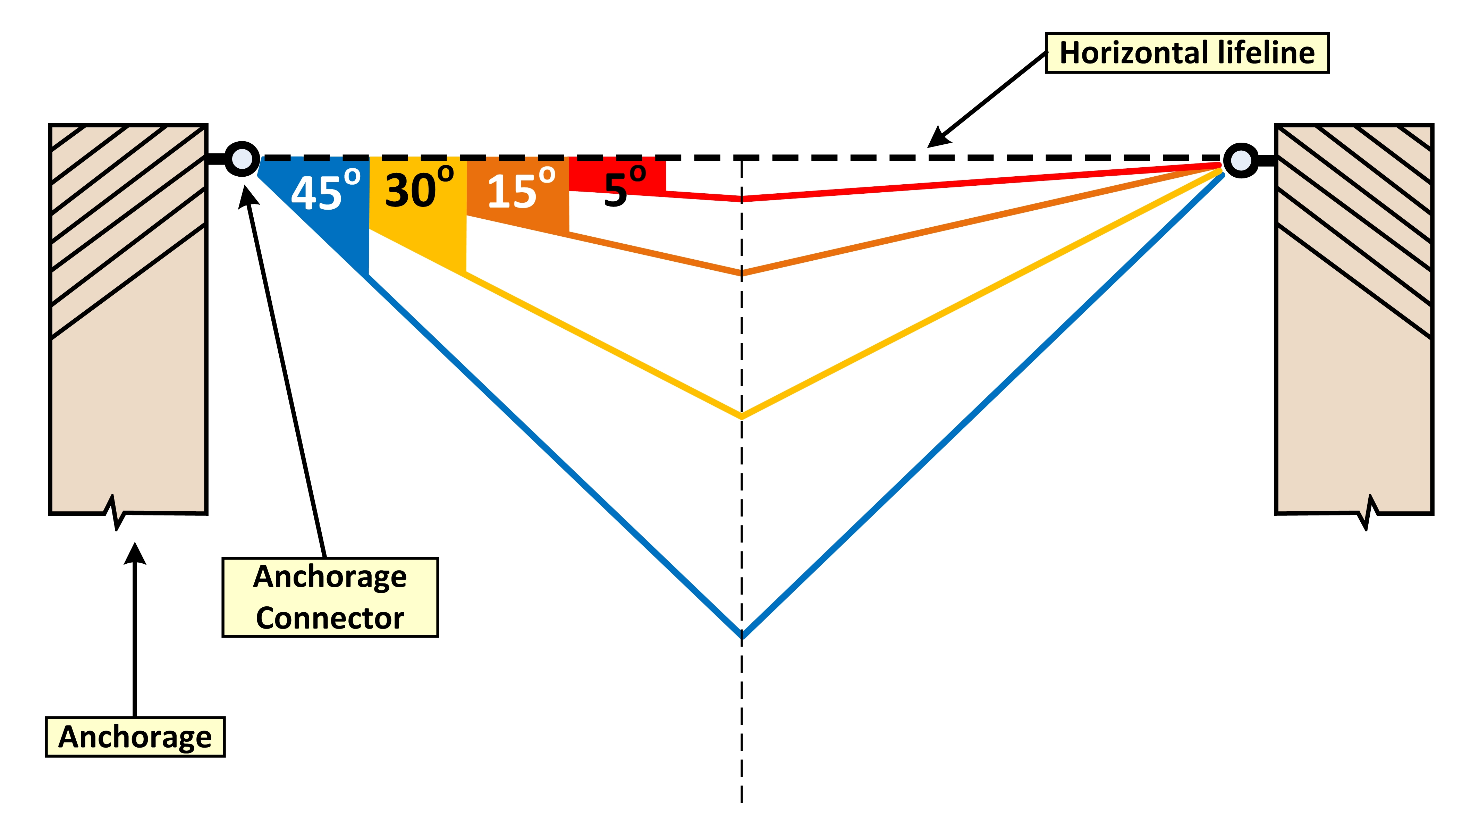
Figure II.B.4.: Measuring approximate horizontal lifeline sag angles

When a horizontal lifeline is used for multiple tie-offs, if one worker falls, the lifeline’s movement may cause other workers to fall.

Oregon OSHA is aware of emerging fall protection technology, such as pre-manufactured horizontal lifelines, that will continue to improve workplace safety.

II.B.5. Full-Body Harnesses

Harnesses include shoulder straps and leg straps, a sub-pelvic assembly, adjustable buckles or fasteners, and one or more D-rings to connect to a lanyard.

The dorsal D-ring (between the worker’s shoulder blades) is used with a fall arrest system. D-rings in other positions are sometimes included for use with ladder safety devices. For this reason, some harnesses come with D-rings on the front, sides, and lower back.

A safe and effective harness will fit (i.e., be the correct size) and is adjusted so that all straps are snug (see Figure 15). Dangling leg straps or arm straps are signs that the harness is not being worn correctly. The sub-pelvic assembly transfers the forces during a fall or suspension to the worker’s sub-pelvic region. Although adjustable, some models come in different sizes and may be gender specific.

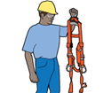 | 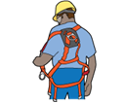 | 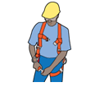 | 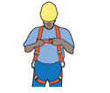 | 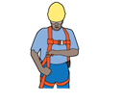
Inspect | Position back D-ring between shoulder blades | Buckle up legs | Buckle up front | Adjust so the harness fits snuggly and D-ring remains in the correct position
Figure 15. Simple steps to fitting a full body harness

II.B.6. Body Belts

A body belt is a wide band that buckles around the hips with means both for securing it about the waist and for attaching it to a lanyard, lifeline, or deceleration device. Body belts serve as positioning devices or fall restraint devices that position a worker so the person can perform a job safely in a vertical work position. Body belts are designed to hold a worker in place and reduce the possibility of a fall (see Div 3/M, 1926.502(e); Div 3/M, Appendix D; Div 3/M, 437-003-0502(2)).

II.B.7. Ladder Safety Devices

Ladder safety devices or systems are used to climb fixed ladders. The system includes a body harness, carabiner, carrier rail, and safety sleeve. Ladder safety devices are available as a cable (i.e., vertical lifeline) or fixed rail system (see Figure 16a and Div 3/X, 1926.1053(a)(18), (a)(22), (a)(23)).

The worker wears a body harness attached to the system by a carabiner. The system uses a cable/safety sleeve, shuttle, or cable grab specifically designed to attach the climber to the vertical line or rail. The cable grab or shuttle freely travels up or down the lifeline/rail as the worker ascends or descends the ladder, allowing the worker to maintain full contact with the ladder. If the worker falls, a locking cam or friction brake in the cable grab or shuttle locks onto the cable or rail and arrests the fall.

Typically, cable and fixed rail systems are permanently attached to the ladder or supporting structure. The cable (flexible carrier) or rail (rigid carrier) is attached by mountings at the top and bottom of the fixed ladder, with intermediate mountings or cable guides for added strength. Existing ladders may be retrofitted with commercially available ladder climbing systems.

A ladder climbing system should not be confused with a “climb assist” system, which consists of motorized equipment that ascends the ladder and partially bears the worker’s weight. Some, but not all, climb assist systems incorporate fall protection features.
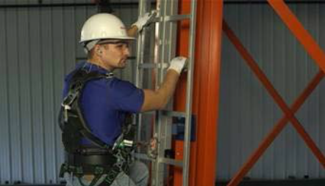 | 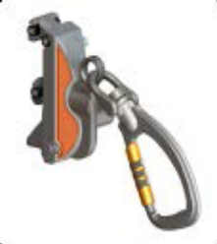 | 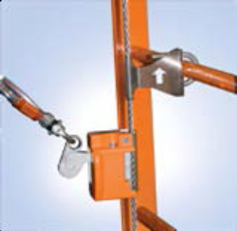
Figure 16a. Ladder safety device

In certain situations, protection from fall hazards can also be achieved while using portable ladders (see Figure 16b). The use of a prepositioned vertical lifeline system equipped with a personal energy absorber and a fall arrestor such as a rope grab can provide fall protection. Self-retracting lanyards (SRL) are also an option for providing protection while working from a portable ladder. Special care needs to be taken to avoid swing fall hazards.
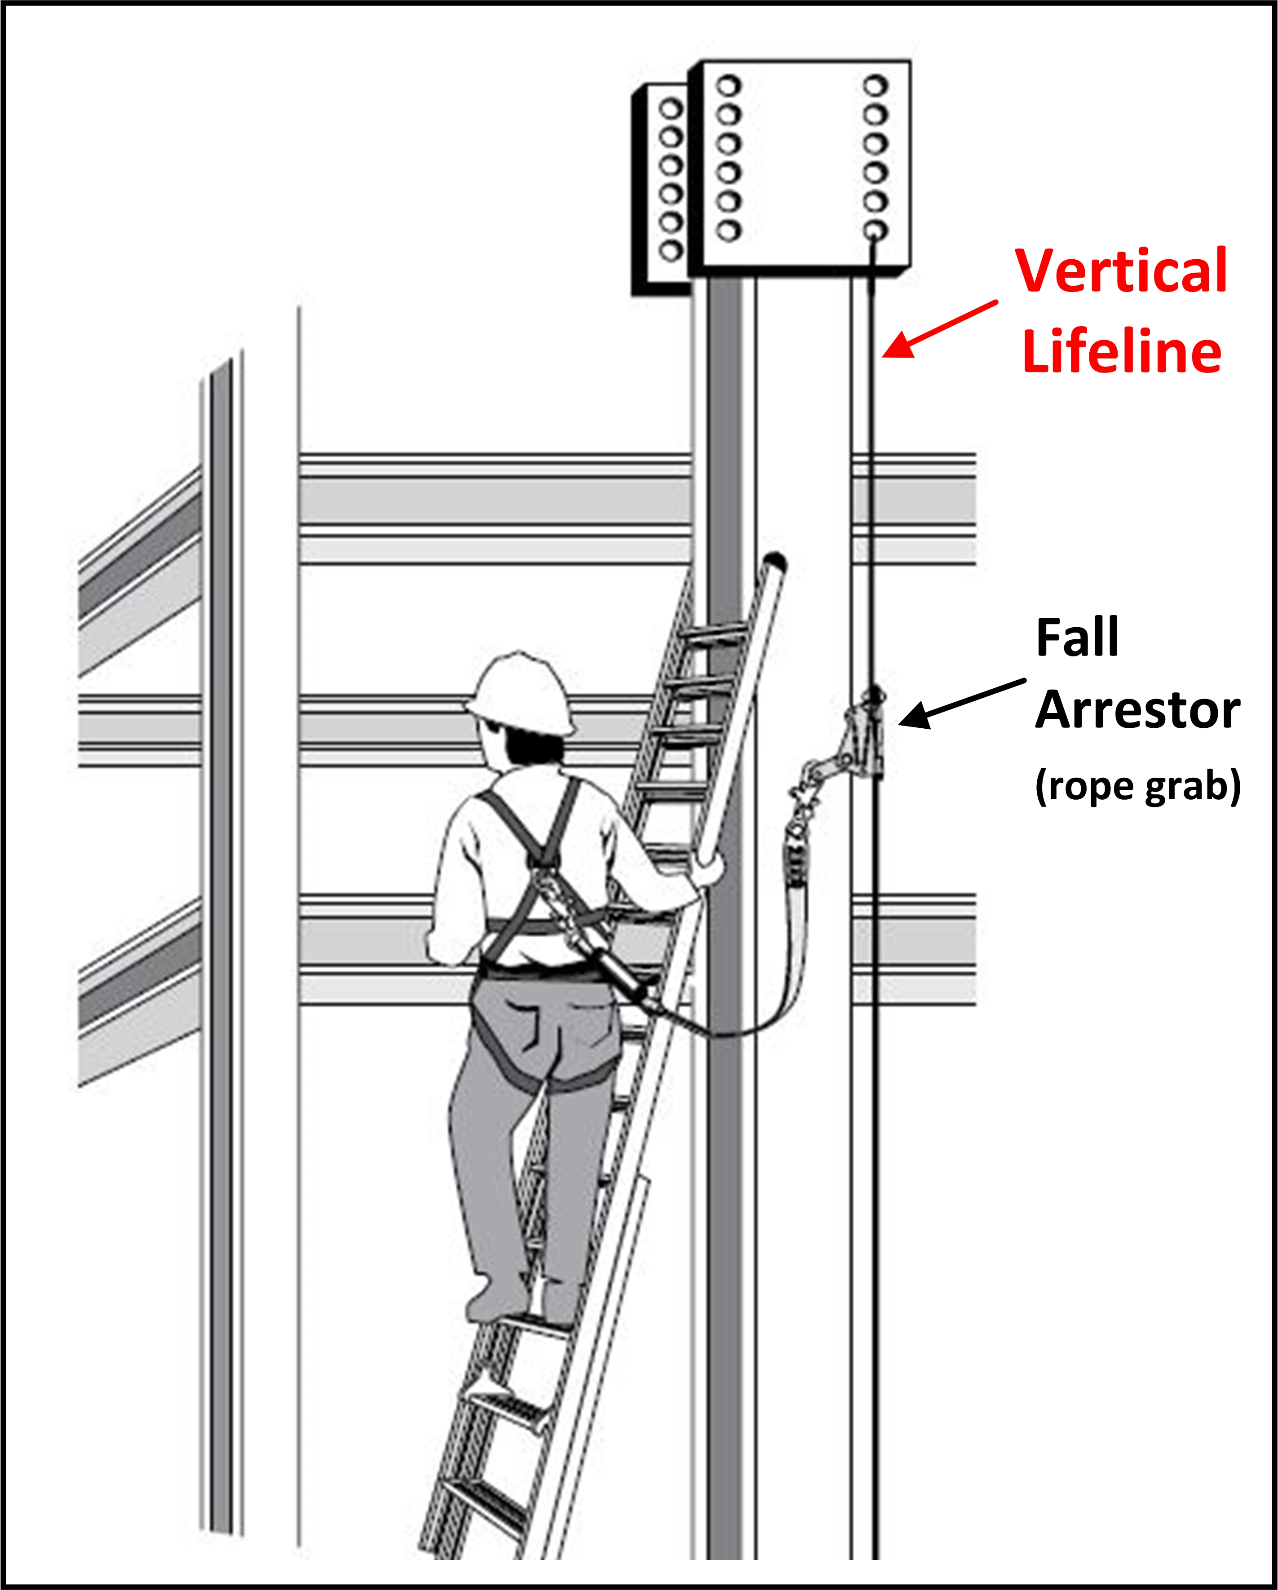
Figure 16b. Example of a worker on a portable ladder protected by a vertical lifeline.

II.C. Fallen Worker Rescue

An effective fallen worker rescue plan addresses the procedures, equipment, and personnel needed to ensure that a rescue proceeds quickly and efficiently when a fall occurs.
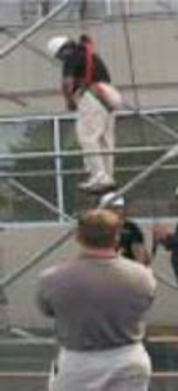
Figure 17. Worker suspended in harness prior to rescue

Even when a PFAS works properly, the fallen worker is still in danger. The worker’s body weight places pressure on the harness straps, which can compress the veins, and cause blood to pool, in the lower extremities and reduce blood return to the worker’s heart (see Figure 17). This condition is called suspension trauma, also known as harness hang syndrome. In medical terms, this results in orthostatic intolerance. If the pressure is not reduced promptly, the worker can lose consciousness within minutes.

(See federal OSHA’s Safety and Health Bulletin (SHIB) - Suspension Trauma/Orthostatic Intolerance www.osha.gov/dts/shib/shib032404.html)

Examples of self-rescue methods are discussed in Washington Industrial Safety & Health Division’s Fall Protection Responding to Emergencies: http://www.lni.wa.gov/safety/topics/atoz/fallprotect/FallProtectionEmergencies.pdf

Self-rescue and aided rescue are two techniques for rescuing a suspended worker. Rescuing the worker promptly (i.e., aided rescue) or ensuring the worker can self-rescue is imperative to preventing injury or a fatality (see Div 3/M, 1926.502(d)(20)).

II.C.1. Aided Rescue

A worker who is suspended from a lifeline and cannot perform a self-rescue will need help from trained rescuers using appropriate equipment, including appropriate fall protection. Off-site emergency response personnel may rescue suspended workers, although most 911 responders are not trained in how to do so.

II.C.2. Self-Rescue

With proper personal fall protection equipment, training and practice, a fallen worker can take steps to minimize suspension trauma. Self-rescue devices and methods allow a fallen worker to temporarily relieve pressure on the legs or in some cases to even lower himself or herself to a lower level.

III. Measurements for Assessing Fall Hazards and Controls

A few basic measurements and equations can aid in evaluating if a PFAS will be sufficient to prevent workers from contacting a lower level. This section provides information on evaluating:

- The necessary total fall clearance distance for PFASs;
- Swing fall hazards for PFASs.

III.A. Total Fall Clearance Distance for PFAS

The total fall clearance distance is the minimum vertical distance between the worker and the lower level that is necessary to ensure the worker does not contact a lower level during a fall. The total fall clearance distance is calculated before a decision is made to use a PFAS. If the available distance is not greater than the total fall clearance distance, it is inappropriate to use the PFAS and a fall restraint system might be used instead. Total fall clearance distance calculations are simple to perform based on several factors, including:

- Lanyard length;
- The height at which the lanyard is anchored relative to where the other end attaches to the worker’s harness;
- The distance the worker will travel as the deceleration device absorbs the energy from the fall (i.e., slows it down);
- The worker’s height;
- D-ring shift; and
- A safety factor.

The following variables are necessary to calculate the total fall clearance distance:

- Free fall distance: This is the distance the worker falls before the PFAS begins to slow the fall. When using a PFAS, this distance must be 6 feet or less and also prevent the worker from contacting a lower level (see Div 3/M, 1926.502(d)(16)(iii)).
- Free fall distance varies depending on the lanyard’s length and where the anchor is set relative to the back D-ring on the harness.
- Deceleration distance: This is the distance the lanyard stretches in order to arrest the fall. Deceleration distance must be no greater than 3.5 feet (see Div 3/M, 1926.502(d)(16)(iv)).
- D-ring shift: This is the distance the D-ring moves and the harness shifts when they support the worker’s full weight. As the line tugs upwards, the harness can shift so the D-ring location is higher on the worker than it was before the fall. This shift is often assumed to be one foot, but it can vary, depending on the equipment design and the manufacturer. (See International Safety Equipment Association (ISEA), ISEA. 2015. Personal Fall Protection Equipment. Use and Selection Guide).
- Back D-ring height: The D-ring height is measured as the distance between the D-ring and the worker’s shoe sole while the worker is wearing the harness. This height is often standardized as five feet for six-foot-tall workers (shorter workers may also be protected using this default distance). It is necessary to adjust the back D-ring height for workers taller than six feet. (See International Safety Equipment Association (ISEA), ISEA. 2015. Personal Fall Protection Equipment. Use and Selection Guide).
- Safety factor: A safety factor is an additional distance added to the total fall clearance distance to ensure there is enough clearance between the worker and the lower level after a fall. This distance is typically 2 feet.

The total fall clearance distance is calculated by adding these values together.

III.A.1. Calculating Total Fall Clearance Distance for Fall Arrest Systems with a Shock-absorbing Lanyard

Common assumptions:

- Deceleration distance: 3.5 feet (the maximum per Oregon OSHA requirements (see Div 3/M, 1926.502(d)(16)(iv)).
- D-ring shift: 1 foot.
- D-ring height (shoe sole to point between shoulder blades): 5 feet.
- Safety factor: typically 2 feet.

The equation below shows how to add the various values in order to calculate total fall clearance distance. A fall arrest system will not protect a falling worker if the calculated clearance distance is greater than the actual distance available below the elevated work area (measured as the distance between the point at which a worker would be anchored and any lower surface).

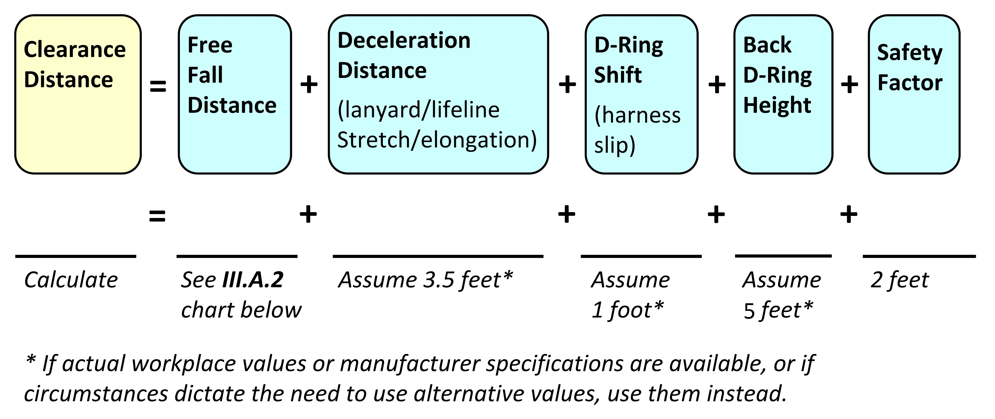

III.A.2. Calculating Free Fall Distance

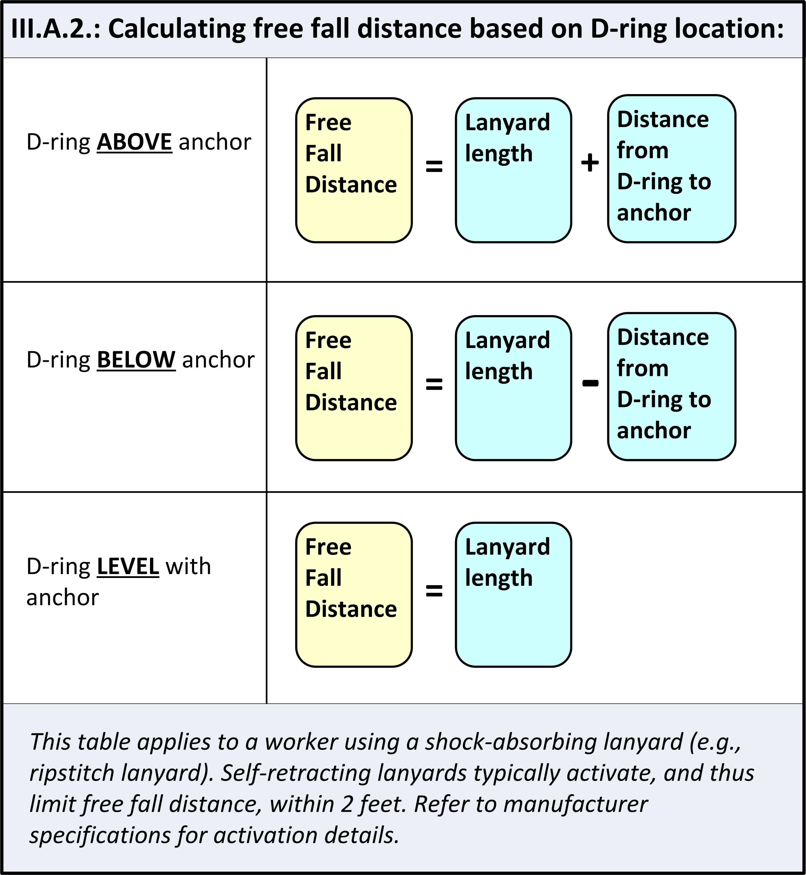

III.A.3. Examples

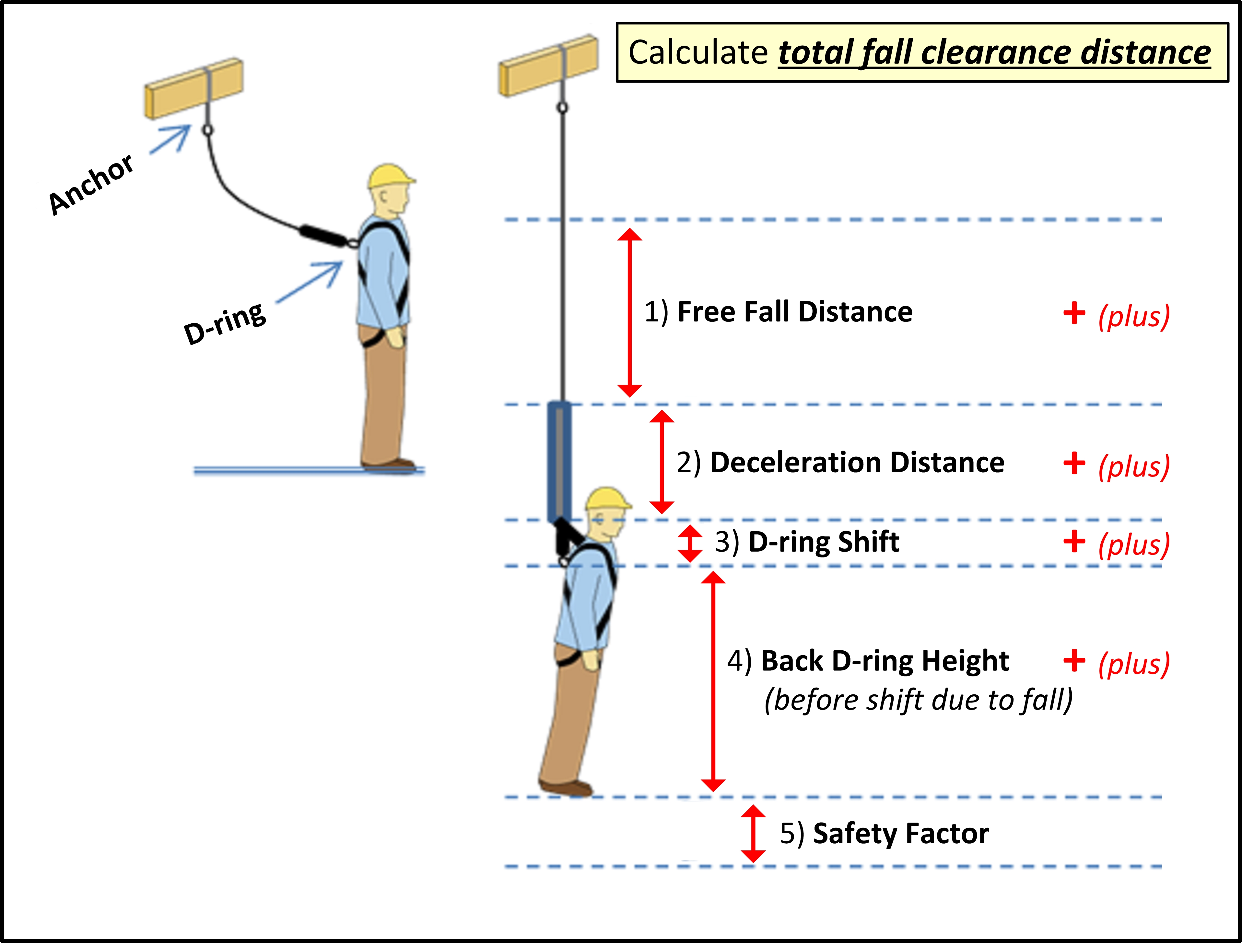
Figure 18. Total fall clearance distance – Example with D-ring below anchor

- Example 1a

A worker is framing an attic. The worker will wear a PFAS with a 6-foot rip-stitch lanyard tied off to an anchor attached to a truss’ bottom chord. He will also be standing on the same bottom chord (so the anchor will be at foot level). Calculate his total fall clearance distance.

- Free fall distance = 6-foot lanyard + 5 feet between the anchor and D-ring = 11 feet.

Answer: The free fall distance (11 feet) is greater than the 6-foot maximum free fall permitted (see Div 3/M, 1926.502(d)(16)(iii)).

No further calculations are necessary. The free fall distance can be reduced by moving the anchor above the D-ring. For example, if a section of truss has been stabilized and sheathed, the anchorage point might be moved above the worker’s head.

- Example 1b

A competent person sees that the trusses in the adjacent section have been installed, fastened in place, and sheathed, and are stable enough to serve as an anchorage. An anchor is installed 2 feet above the back D-ring on the worker’s harness. What is the total fall clearance distance?

- Free fall distance = 6-foot lanyard – 2 feet between the anchor and D-ring = 4 feet
- Deceleration distance = 3.5 feet
- D-ring shift = 1 foot
- Back D-ring height = 5 feet
- Safety factor = 2 feet

Answer: total necessary fall clearance distance = 4 + 3.5 + 1 + 5 + 2 = 15.5 feet. This value can then be compared to the vertical clearance actually available at the work location.

- Example 2

A worker on a concrete wall is wearing a PFAS tied off to a concrete anchor strap, that is 1-foot below his D-ring. His shock-absorbing lanyard is 2 feet long. What is the total fall clearance distance?

- Free fall distance = 2-foot lanyard + 1 foot between the anchor and D-ring = 3 feet
- Deceleration distance = 3.5 feet
- D-ring shift = 1 foot
- Back D-ring height = 5 feet
- Safety factor = 2 feet

Answer: total fall clearance distance = 3 + 3.5 + 1 + 5 + 2 = 14.5 feet. This value can then be compared to the vertical clearance actually available at the work location.

This example demonstrates that, even with a relatively short lanyard (2 feet), a fall arrest system can require considerable clearance below the elevated work area. In this case the free fall distance is 3 feet (less than OSHA’s 6-foot maximum); however, the total fall distance is 14.5 feet (more than the typical space between levels in a building under construction). A falling concrete worker could come in contact with (and be injured by) any object within the space 14.5 feet below the worker’s original position.

If fall protection in this configuration is used, there needs to be at least 14.5 feet of clear space below the worker. The fall protection equipment requires this much vertical distance to stop a fall and prevent the worker from falling on an object and sustaining an injury.

Where guardrails cannot be used, fall restraint is a better option than fall arrest for a work area with limited clearance below.

- Example 3

A worker welding in a warehouse is using a PFAS. The system includes a 4-foot shock-absorbing lanyard that is anchored to an I-beam clamp, level with the D-ring on her upper back. What is her total fall clearance distance?

- Free fall distance = 4-foot lanyard
- Deceleration distance = 3.5 feet
- D-ring shift = 1 foot
- Back D-ring height = 5 feet
- Safety factor = 2 feet

Answer: total fall clearance distance = 4 + 3.5 + 1 + 5 + 2 = 15.5 feet. This value can then be compared to the available vertical clearance actually available at the work location.

- Example 4

A construction worker is wearing a PFAS including a 6-foot rip-stitch lanyard. He uses a strap anchor to tie off around a steel ceiling joist 4 feet above the D-ring on his back. What is the total fall clearance distance?

- Free fall distance = 6-foot lanyard – 4 feet between the D-ring and the anchor = 2 feet
- Deceleration distance = 3.5 feet
- D-ring shift = 1 foot
- Back D-ring height = 5 feet
- Safety factor = 2 feet

Answer: total fall clearance distance = 2 + 3.5 + 1 + 5 + 2 = 13.5 feet. This value can then be compared to the vertical clearance actually available at the work location.

- Example 5

The same construction worker is now using a self-retracting lanyard that activates (locks) within 2 feet if he falls. This new lanyard is connected to the same steel ceiling joist 4 feet above the D-ring on his back. What is the total fall clearance distance?

- Free fall distance = 2 feet
- This self-retracting lanyard automatically limits free fall distance to 2 feet as stated in the Example 5 problem statement (see Div 3/M, 1926.502(d)(12)).
- Deceleration distance = 3.5 feet
- D-ring shift = 1 foot
- Back D-ring height = 5 feet
- Safety factor = 2 feet

Answer: total fall clearance distance = 2 + 3.5 + 1 + 5 + 2 = 13.5 feet. This value can then be compared to the vertical clearance actually available at the work location.

III.B. How to Evaluate the Swing Fall Hazard

The swing fall hazard is created by the pendulum effect, which can swing a fallen worker into a nearby surface, such as a wall or protruding beam. It is important to evaluate the swing fall hazard at any edges where a worker might fall. A worker who falls while connected to an anchor (unless it is directly overhead) will swing back and forth like a pendulum. Workers can be seriously injured if they strike objects during a swing fall. Installing the anchorage point directly above the work area (i.e., connected to an overhead attachment point with sufficient strength) will help prevent swing fall injuries.

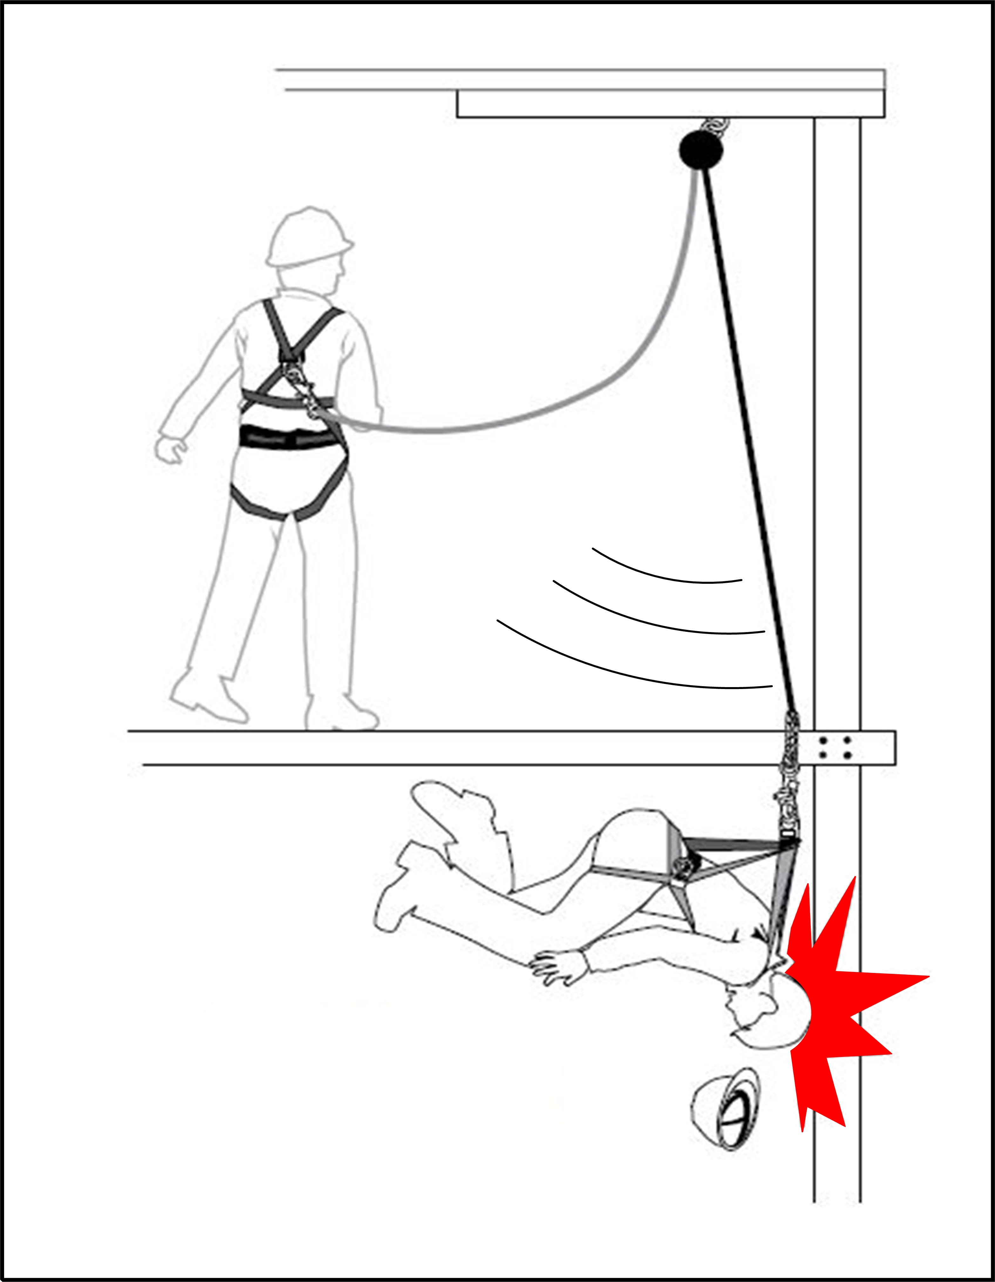

Figure 19. Example of a swing fall hazard

Appendix A – Fall Protection for Scaffolds and Related Equipment

Type of Scaffold or Equipment | Fall Protection Required
Aerial lift  (covered by ANSI A92.2-1969) | Body belt (tethering, restraint system)  See Div 3/L, 1926.453(b)(2)(v).  Personal fall arrest system or fall restraint system  See Div 2/RR, 437-002-2306(2)(d)(I)(i) (electric power transmission and distribution)
Boatswain’s chair | Personal fall arrest system  See Div 3/L, 1926.451(g)(1)(i).
Boom supporting elevating work platform  (covered by ANSI A92.5-1992) | Personal fall protection  See Div 3/L, 437-003-0073.
Catenary scaffold | Personal fall arrest system  See Div 3/L, 1926.451(g)(1)(i).
Crawling board (chicken ladder) | Personal fall arrest system, guardrail system (with a minimum 200 pound top rail capacity), or ¾ inch (1.9 centimeter) thick grab line or equivalent handhold securely fastened beside each crawling board  See Div 3/L, 1926.451(g)(1)(iii).
Float scaffold | Personal fall arrest system  See Div 3/L, 1926.451(g)(1)(i).
Ladder jack scaffold | Personal fall arrest system  See Div 3/L, 1926.451(g)(1)(i).
Needle beam scaffold | Personal fall arrest system  See Div 3/L, 1926.451(g)(1)(i).
Self-contained adjustable scaffold | Both a personal fall arrest system and a guardrail system with a minimum 200 pound top rail capacity (when the platform is supported by ropes); guardrail system only (when the platform is supported by the frame structure)  See Div 3/L, 1926.451(g)(1)(iv).
Single-point or two-point adjustable suspension scaffold | Both a personal fall arrest system and a guardrail system  See Div 3/L, 1926.451(g)(1)(ii).
Supported scaffold for overhand bricklaying operations | Personal fall arrest system or guardrail system (with a minimum 200 pound top rail capacity)  See Div 3/L, 1926.451(g)(1)(vi).
All other scaffolds not specified in Div 3/L, 1926.451(g)(1)(i) to (g)(1)(vi) | Personal fall arrest system or guardrail systems meeting the requirements of Div 3/L, 1926.451(g)(4)  See Div 3/L, 1926.451(g)(1)(vii).

Appendix B – Oregon OSHA Standards Related to Fall Protection

This appendix lists some of the Oregon OSHA standards that apply to fall protection in construction.

Construction

Div 2/RR, 437-002-2306, electric power transmission and distribution (personal protective equipment)
Div 3/E, 437-003-0134(5), personal protective equipment (fall protection)
Div 3/L, 1926.451, general requirements (scaffolding)
Div 3/L, 1926.452, additional requirements applicable to specific types of scaffolds
Div 3/L, 1926.453, aerial lifts
Div 3/L, 1926.454, training requirements (scaffolding)
Div 3/L, 437-003-0073, boom supported elevating work platforms
Div 3/M, 1926.501, duty to have fall protection
Div 3/M, 437-003-1501, general fall protection
Div 3/M, 1926.502, fall protection systems criteria and practices
Div 3/M, 437-003-0502, personal fall restraint
Div 3/M, 437-003-1502, warning line systems for roofing work
Div 3/M, 437-003-2502, safety monitoring system
Div 3/M, 437-003-3502, slide guard systems
Div 3/M, 437-003-0503, training requirements (fall protection)
Div 3/R, 1926.760, fall protection (steel erection)
Div 3/S, 1926.800, underground construction
Div 3/X, 1926.1051, general requirements (stairways and ladders)
Div 3/X, 1926.1052, stairways
Div 3/X, 1926.1053, ladders
Div 3/X, 1926.1060, training requirements (stairways and ladders)
Div 3/CC, 1926.1423, cranes and derricks in construction (fall protection)
Appendix C – Examples: Fall Protection Anchors by Type

This appendix identifies various types of anchors, how they are generally used, and shows an image of the anchor in use.

Anchor Type |  | Typical Use or Purpose | Illustration
Engineered Clamps
Engineered Clamps | I-beam clamp and structural steel  (vertical or horizontal beams) | The clamp adjusts to various steel beam sizes. | 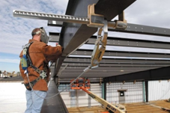
Engineered Clamps | Trolley beam anchor | Allows a worker to have greater access to a larger area without a longer lanyard. | 
Engineered Clamps | Standing seam metal roof anchor | For workers on standing seam metal roofs. This anchor clamps onto parallel seams. | 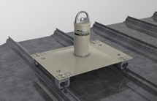
Engineered Clamps | Doorway and window opening clamp | For anchoring between interior building framing or a window opening. | 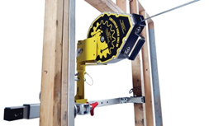
Strap Anchors
Strap Anchors | Cable anchorage sling | For use around structural steel or I-beams. | 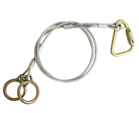
Strap Anchors | Drop-through anchor cable | Anchor point drops through a small hole in an overhead substrate (concrete or steel). | 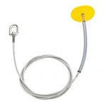
Strap Anchors | Strap anchor (web) | For sturdy horizontal structures (e.g., beams or structural steel members). Sharp or rough edges could damage the strap. | 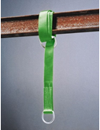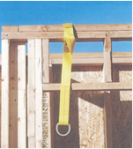
Concrete Anchors
Concrete Anchors | Concrete anchor strap with D-ring | Often used by workers conducting foundation and formwork. The concrete anchor strap has a tough sleeve or wear-pad that protects it from abrasion where it contacts concrete. The strap loop slips over rebar and is left in place (with D-ring exposed) when concrete is poured. When no longer needed, the strap is cut flush with the concrete surface. | 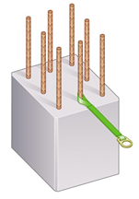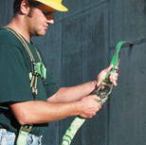  Photo: a worker connects a shock-absorbing lanyard to an embedded concrete anchor strap.
Concrete Anchors | Precast hollow core concrete anchor | For workers performing activities with precast hollow concrete. Allows a single worker to tie off. | 
Concrete Anchors | Bolt-on wall anchor | Temporary or permanent anchor point on a vertical concrete wall. | 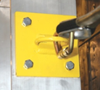
Welded Anchors
Welded Anchors | Welded D-ring anchor | Single D-ring temporary or permanent anchor point that is welded onto vertical structural steel. | 
Welded Anchors | Weld-on anchor post | This permanent anchor point is welded onto an I-beam. | 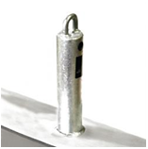
Anchors Not Bolted or Clamped in Place (N.B. or C.I.P.)
Anchors (N.B. or C.I.P.) | Mobile fall protection system | Intended for a single worker using a fall arrest system. It allows quick mobility from place to place on a job site. Larger versions allow multiple workers to anchor. | 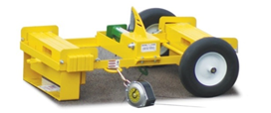
Anchors (N.B. or C.I.P.) | Rotating retractable anchor mast | For use on sloped residential roofs. Allows the worker greater range of motion (up to 360 degrees for some models) and helps elevate the anchor point above the worker. | 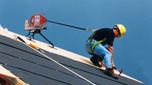
Anchors (N.B. or C.I.P.) | Dead weight anchor | For use on roofs where penetrating the surface is not an option. Anchorage is provided by the weight of heavy materials (e.g., concrete, steel, water bladder). | 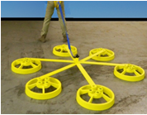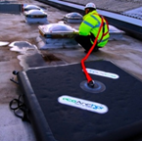
Anchors (N.B. or C.I.P.) | Bolt hole anchor | For use in horizontal steel bolt holes. | 
Other Anchors
Other Anchors | Top Plate Anchor | For activities near the framed wall top plate. | 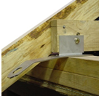
Other Anchors | Peak Anchor  (One or Two D-Rings) | Typically used on a house roof after it is sheathed or fully constructed. They are typically left in place after the job is completed for future repairs. | 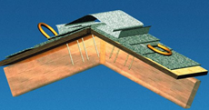
Other Anchors | Truss Anchor  (including Spreaders) | Used before a structure is fully framed. A spreader is a method a qualified person may use to improve anchor point lateral stability before trusses are fully sheathed. | 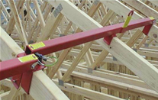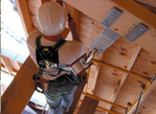
Other Anchors | Trench Box Guardrail Anchor | For performing deep excavation. The trench box guardrail is designed with an anchor point on a post near the guardrail. | 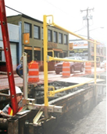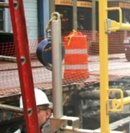
Vertical Lifelines
Vertical Lifelines | Rope grab  (with vertical lifeline) | Rope lifeline attaches to an anchorage at the top and hangs vertically down through the work area. Movable fall arrestor (rope grab) attaches to the rope. Lanyard connects the rope grab to workers’ harness. To move up and down the work area, the worker can slide the rope grab up and down the lifeline, then relock it in place. If the worker falls, the rope grab locks onto the rope to break the fall.  This system’s effectiveness depends on how well the worker is trained to reposition the rope grab while moving about. The grab can slide off the end of the rope if the rope is too short, if a knot is not tied near the end of the rope, or if the grab is not installed properly. | 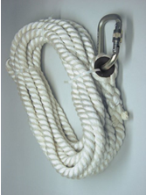
Horizontal Lifelines
Horizontal Lifelines | This hybrid system uses one line (firmly anchored at both ends) as the anchorage for another. This allows the worker greater lateral movement than a fixed anchor point. The components are the same as other personal fall protection systems. A deceleration device or rip-stitch lanyard can be included.  In some cases, more than one worker will connect to the horizontal lifeline if approved by the manufacturer and a qualified person. | This hybrid system uses one line (firmly anchored at both ends) as the anchorage for another. This allows the worker greater lateral movement than a fixed anchor point. The components are the same as other personal fall protection systems. A deceleration device or rip-stitch lanyard can be included.  In some cases, more than one worker will connect to the horizontal lifeline if approved by the manufacturer and a qualified person. | 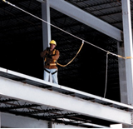  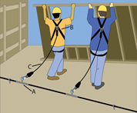
Photos used with permission by federal OSHA by the equipment manufacturers.

Appendix D – Examples: Lanyards, Deceleration Devices, Harnesses, and Body Belts

Device Type |  | Typical Use or Purpose | Illustration
Lanyards
Lanyard | Lanyard  (typical 2-foot and 6-foot lengths) | Lanyards are available in a variety of lengths. | 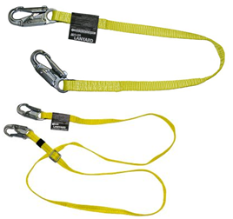
Lanyard | Y-lanyard  (or twin-leg lanyard) | Typically used during work on cranes, rebar and steel structures, and poles. By attaching and reattaching the legs in different positions, the worker can move across the work face, remaining connected by at least one leg of the lanyard at all times. | 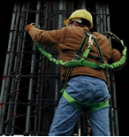
Deceleration Device
Deceleration Device | Rip-stitch-style Shock Absorbing Lanyard | These typically expand by approximately 3.5 feet during deceleration, which reduces the force on the worker. | 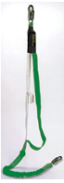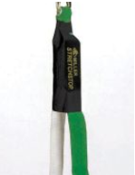
Deceleration Device | Stretch-type Shock-Absorbing Lanyard | These absorb force in a fall by stretching (or by a similar mechanism) on impact to provide a controlled deceleration. | 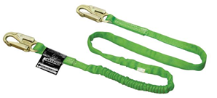
Deceleration Device | Self-retracting lifeline (SRL)  (line wound on a reel in a reel-housing) | The lifeline is wound on a reel and automatically extends or retracts to take up slack in the line as the worker moves about. A sudden extension in the line activates a locking mechanism that typically includes a deceleration device. Some self-retracting lanyards can be set to restrict the distance traveled and so can also function as part of a properly designed fall restraint system. | 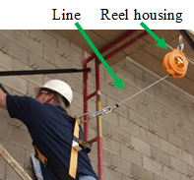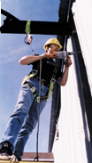
Body Belt
Body Belt | Body Belt | In general, harnesses are preferable to body belts. Body belts may be used in limited instances (e.g., as part of a positioning device system). | 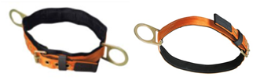
Body Harness
Body Harness | Body Harness | Used in personal fall protection systems. Has a D-ring on the back between the shoulders when used for fall arrest and fall restraint systems. Workers need to be fitted with the correct harness size. Available with special features such as an integrated high-visibility vest, extra D-rings (for use with positioning devices), life vest (for over-water work), or various buckle and closure styles. | 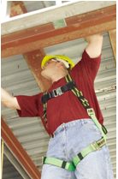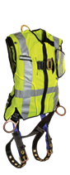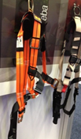
Thimble
Thimble | Thimble | Thimbles provide a protective interface between the eye of a rope loop and a connector. They are used to prevent pinching or abrasion of the rope. The thimble needs to be firmly seated in the eye of the rope loop. | 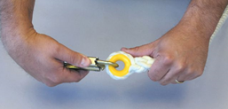
Photos used with permission by federal OSHA by the equipment manufacturers.

Appendix E – References and Resources

29 CFR 1926 Subpart M (.500, .501, .502, and appendices)
29 CFR 1926 Subpart R and appendices
ARA, AEM, AED, IPAF, and SIA. 2010. Statement of Best Practices of General Training and Familiarization for Aerial Work Platform Equipment (a joint industry initiative). 02-10-AWP-SBP001.
ARA, AEM, IPAF, and SIA. 2013. Statement of Best Practices for Workplace Risk Assessment and Aerial Work Platform Equipment Selection. 02-13-AWP-SBP003.
Bureau of Labor Statistics, 2013. Census of Fatal Occupational Injuries Summary, 2012 (preliminary results). August 22.
eLCOSH. 2007. Fall Protection: Misconceptions & Myths; Working Within the OSHA System. Originally published by American Society of Safety Engineers.
ISEA. 2015. Personal Fall Protection Equipment. Use and Selection Guide.
[NIOSH] National Institute for Occupational Safety and Health. 2000, Worker Deaths by Falls (NIOSH document 2000-116).
[NIOSH] National Institute for Occupational Safety and Health. 2004, NIOSH Alert: Preventing Falls of Workers Through Skylights and Roof and Floor Openings. DHHS (NIOSH) Publication No. 2004-156.
[NIOSH] National Institute for Occupational Safety and Health. 2011, Workplace Safety & Health Topics Page: Prevention Through Design.
[NIOSH] National Institute for Occupational Safety and Health. 2014, Workplace Safety & Health Topics Page: Fall Injuries Prevention in the Workplace. Fall-related Research Projects.
[OR-OSHA] Oregon Occupational Safety & Health Administration. 2016. Oregon OSHA Program Directive (PD), Guardrail Height in General Industry A-173. Available at: http://osha.oregon.gov/OSHARules/pd/pd-173.pdf
[OR-OSHA] Oregon Occupational Safety & Health Administration. 2016. Oregon OSHA Program Directive (PD), Fall Protection: General Industry A-197. Available at: http://osha.oregon.gov/OSHARules/pd/pd-197.pdf
[OR-OSHA] Oregon Occupational Safety & Health Administration. 2016. Oregon OSHA Program Directive (PD), Fall Protection: Personnel Lifts Used in Construction A-242. Available at: http://osha.oregon.gov/OSHARules/pd/pd-242.pdf
[OR-OSHA] Oregon Occupational Safety & Health Administration. 2016. Oregon OSHA Fact Sheet FS-26, Using Warning Lines: Construction Industry Best Practices. Available at: http://osha.oregon.gov/OSHARules/pd/pd-242.pdf
[OR-OSHA] Oregon Occupational Safety & Health Administration. 2016. Oregon OSHA Publication, Fall Protection for the Construction Industry (440-2824 - 6/16). Available at: http://osha.oregon.gov/OSHAPubs/2824.pdf
[OSHA] Occupational Safety & Health Administration. 2002, A Guide to Scaffold Use in the Construction Industry.
[OSHA] Occupational Safety & Health Administration. No date. Scaffolding. Appendix.
[OSHA] Occupational Safety & Health Administration. No date. OSHA Construction e-Tool: Personal Fall Arrest Systems.
[OSHA] Occupational Safety & Health Administration. No date. Fall Protection Information.
[OSHA] Occupational Safety & Health Administration. No date. Fall Protection.
[OSHA] Occupational Safety & Health Administration. No date. Plan. Provide. Train. Three Steps to Preventing Falls.
[OSHA] Occupational Safety & Health Administration. 2003a. Stairways and Ladders: A Guide to OSHA Rules. 3124-12R.
[OSHA] Occupational Safety & Health Administration. 2011. Suspension Trauma/Orthostatic Intolerance. SHIB 03-24-2004, updated 2011.
[OSHA] Occupational Safety & Health Administration. 2013. Communication Towers webpage.
Wilmes, LLC. 2013. Fall Protection Force Calculator.
WISHA. (Washington Industrial Safety & Health Division). No date. Fall Protection: Responding to Emergencies. F417-208-000.
WISHA. No date. Competent Person Evaluation (checklist): Fall Restraint and Fall Arrest.

