Employee May be
Struck by Something
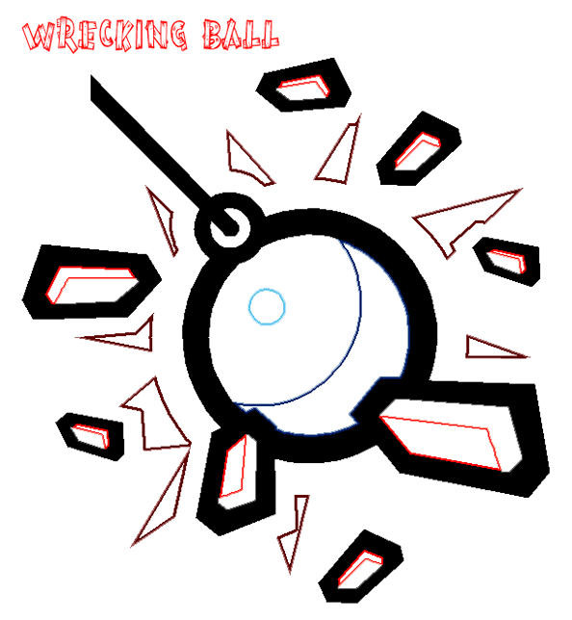

There are
Flying Debris
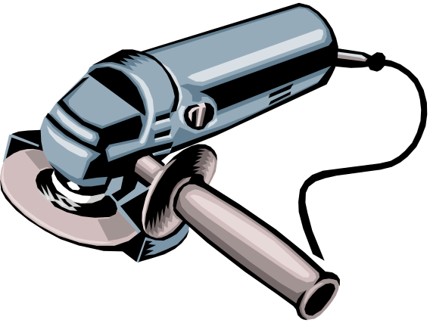

There are
Moving Vehicles

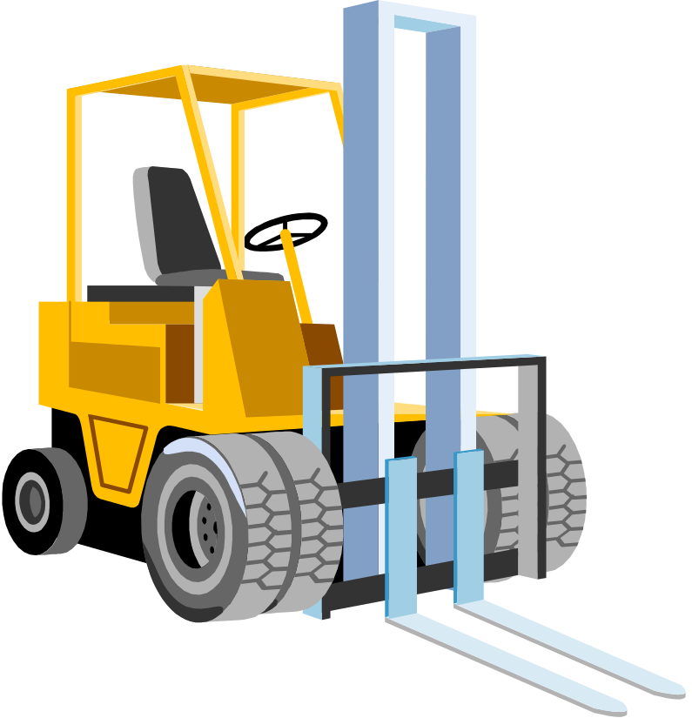

There is
Moving Equipment
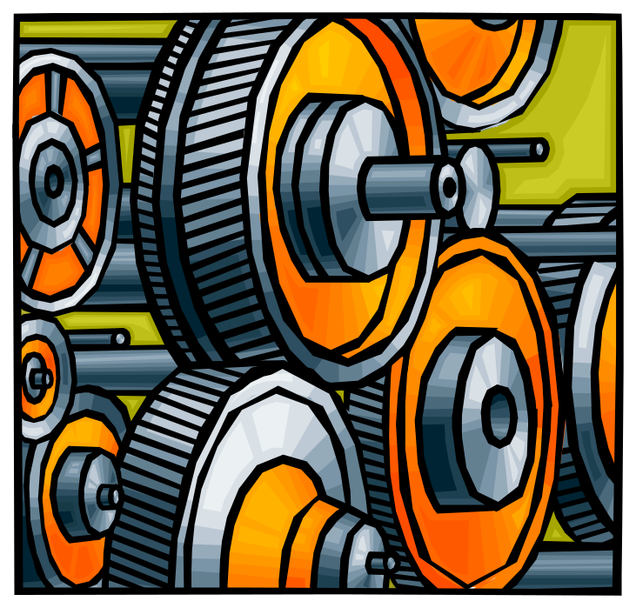

Employee may
Strike Against
Something

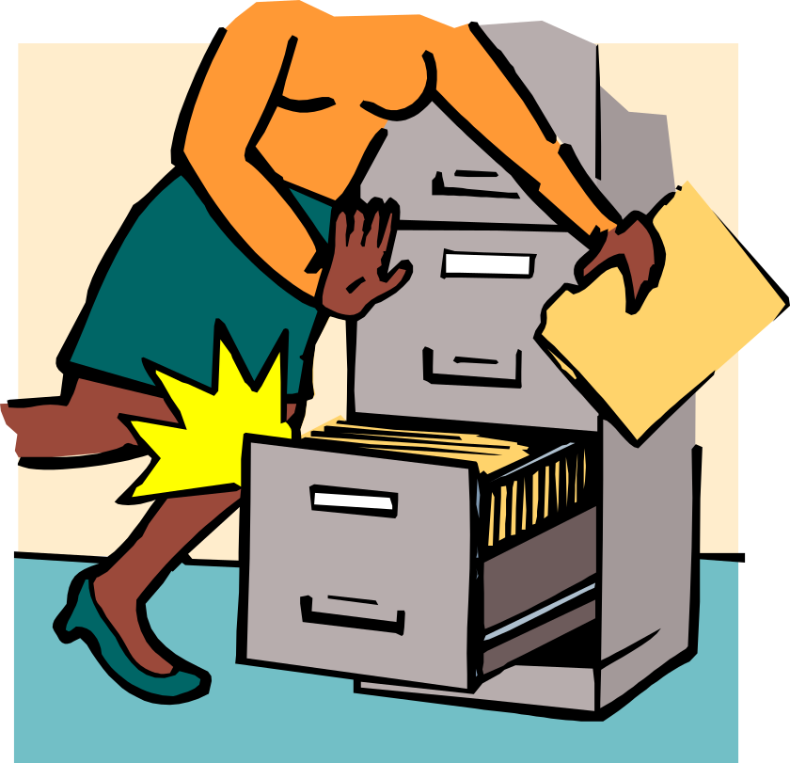

There are
Sharp Edges
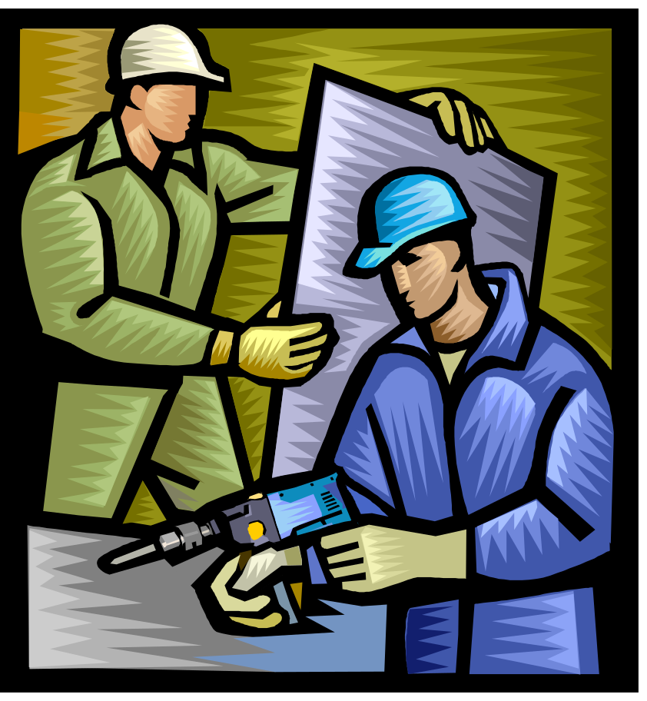

Employee may
Slip, Trip, or Fall

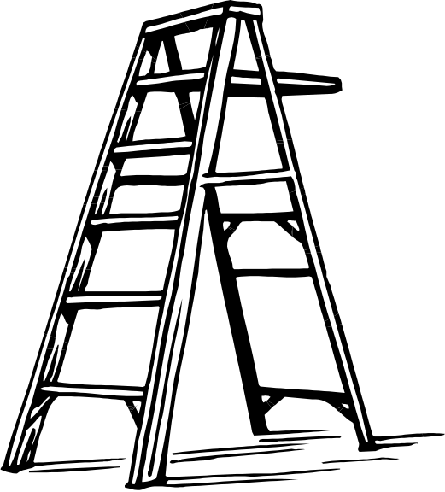

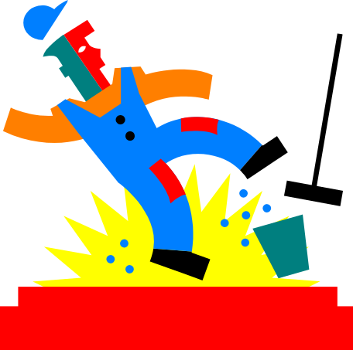
There are
Edges or Openings
in the Work Surfaces

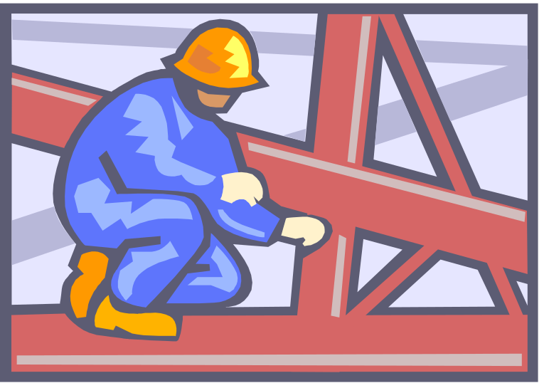

There are
Pinch Points
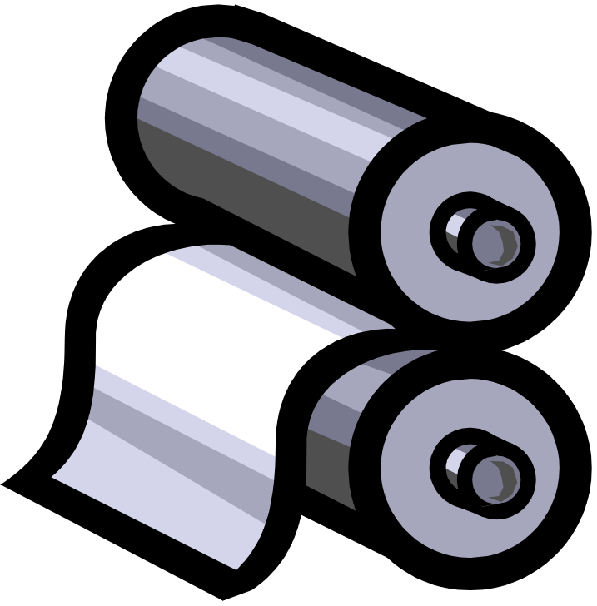

(Employee may be Caught in or Between
or be crushed)
Employee may
Over-Exert



Task involves
Lifting, Twisting, or Carrying

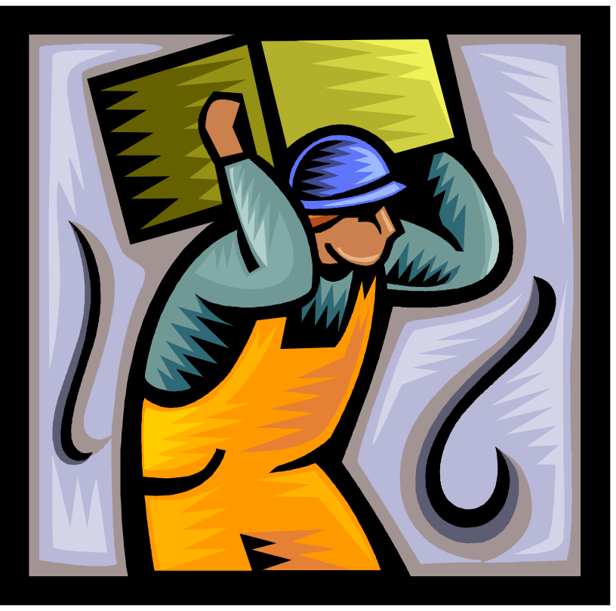

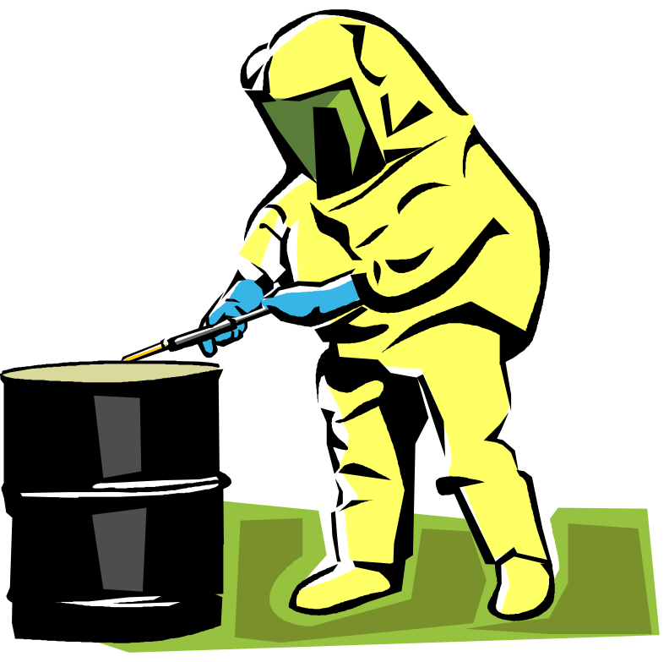
Employee may come into contact
with
Something Hazardous

(Chemicals, Radiation, Dust, Fumes, Welding rays, etc.)
Employee may need to work in a
Hazardous Location

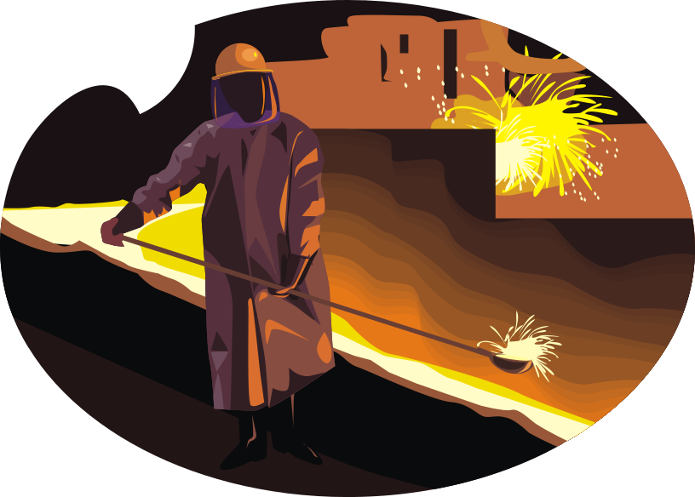

(Confined Spaces, Poorly Lit Areas, etc)
There is
Excessive Noise
in the Work Environment

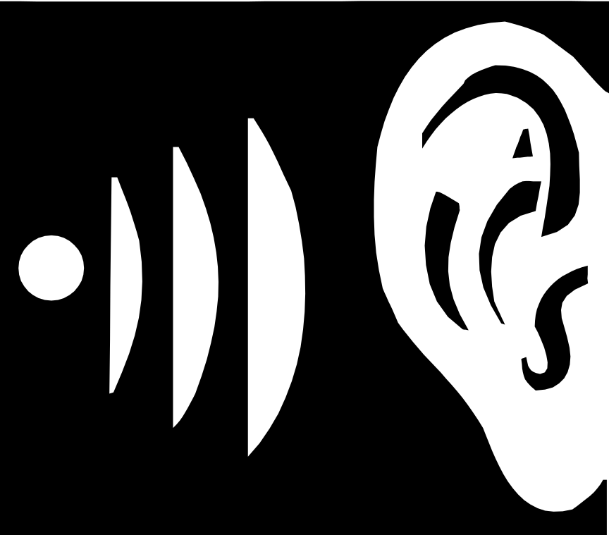

Employee could experience
a sudden or unexpected
Release of Energy

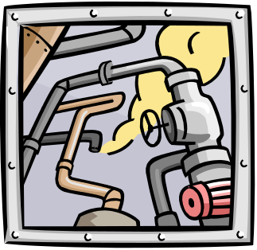

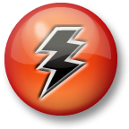

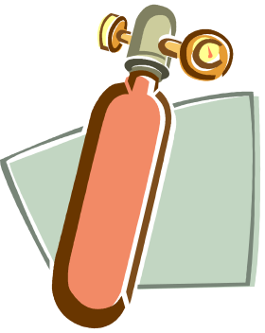

(Electrical, Heat, Pressurized Gas or Liquid, Mechanical Energy)
The employee has something that
May Get Caught
while doing the work
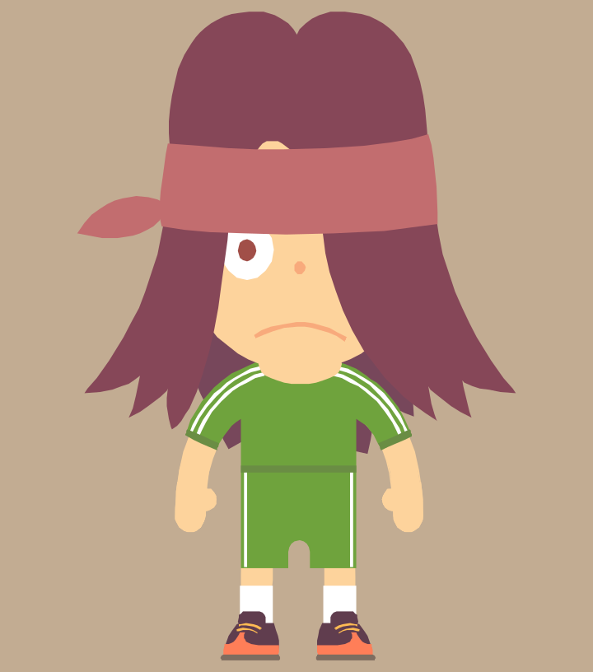


Flow of work may lead to overly
Rapid Movements
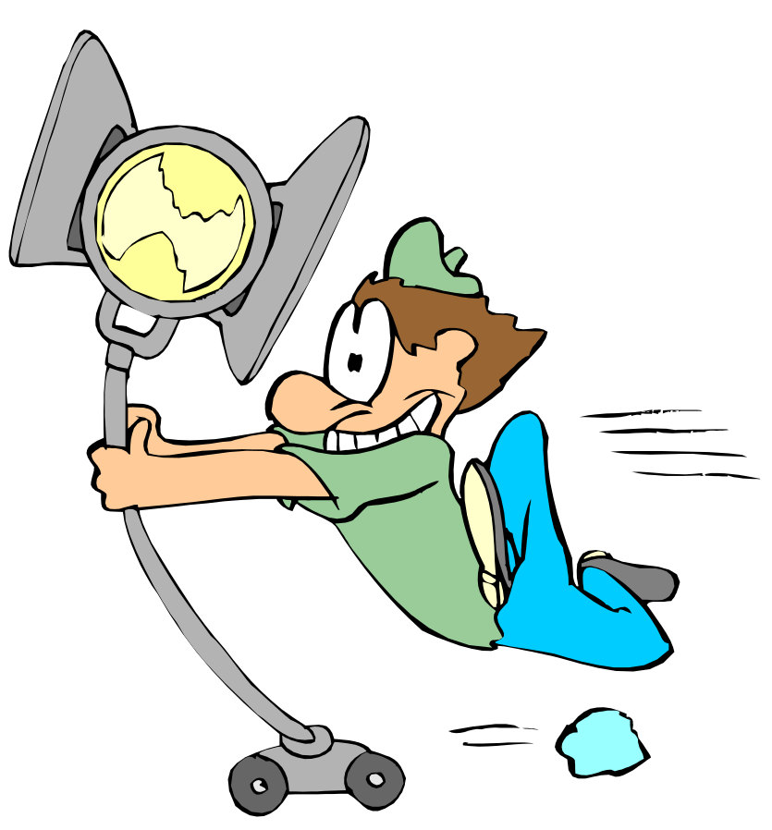

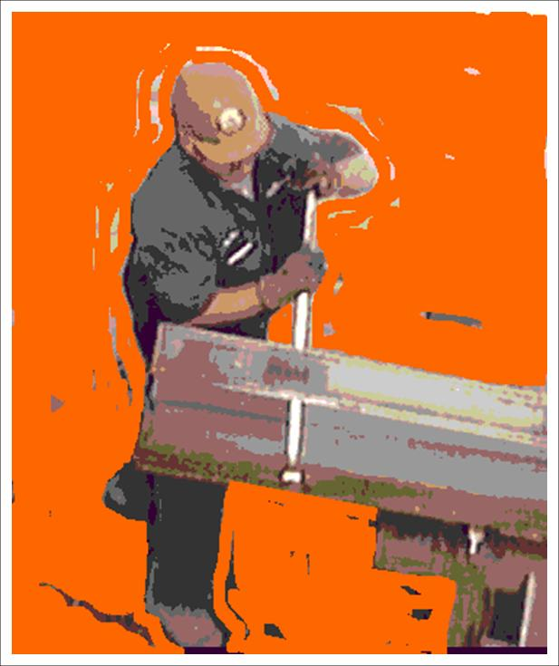
Work requires employee to perform
Repetitive Motions

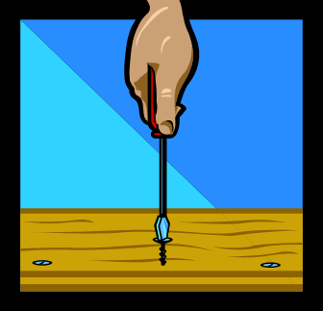


There is
Poor Housekeeping,
clutter, or disorganization

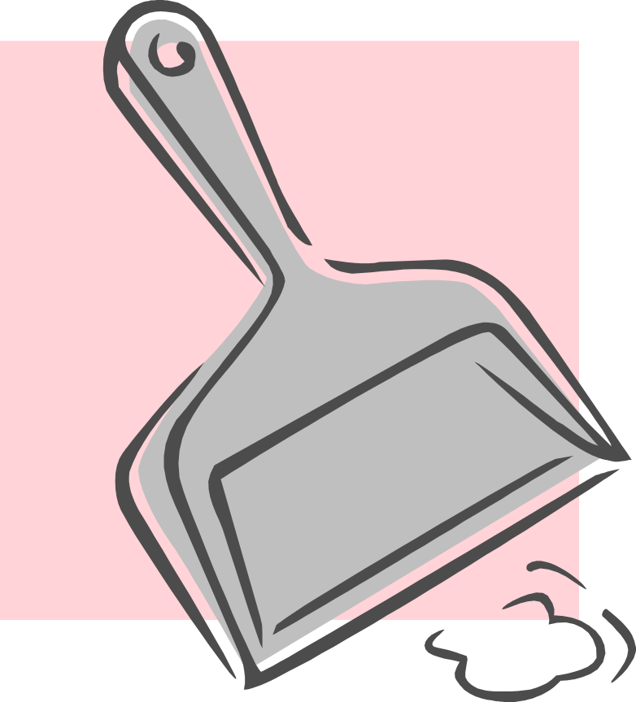

Work requires use of
Personal Protection Equipment (PPE)


